Image Recognition Analysis

Kevin Wall
Emerging Technologies - Computer Science Masters
Full Sail Univeristy
Winter Park, FL, USA
kpwall@student.fullsail.edu

Abstract— Proposal for a lightweight application using real-time face and object detection implementing a combination of Haar Cascade and MobileNet-SSD models. The system can process both static images and live webcam feeds, identifying predefined objects including people, vehicles, and common household items. The modular design separates the GUI, detection system, and application logic, allowing efficient processing and visualization. Testing demonstrates the system’s ability to annotate faces and objects in real time, highlighting challenges related to lighting, occlusion, and object size. The application provides a foundation for lightweight security, quality assurance, and traffic monitoring tools.
Keywords— Object detection, face recognition, Haar Cascade, MobileNet-SSD, OpenCV, real-time detection

Introduction
Identifying specific objects within static images or camera and labeling the identified object. Creating a simple object recognition program can help develop integral security systems, produce quality checking, and traffic decongestion systems.
Security systems can implement face detection algorithms so when break-ins, robberies, theft, or other assorted crimes take place they can track down the perpetrator for the authorities. Having a security system automatically detect the face or person in the moment could trigger a screenshot and store it to a local database for easy retrieval later on. Produce quality assurance that knocks aways rotten food are often used by farmers when sifting through large quantities of food. Object detection is used throughout the modern world to make communities safer, verify quality control, and analyze occurrences with similarities.
Face detection using Haar Cascades [1] has been widely adopted due to its speed and simplicity, while MobileNet-SSD [2] provides efficient deep-learning-based object detection capable of identifying multiple object categories in real time. By combining these models, the proposed system can recognize both faces and general objects, providing a flexible platform for everyday image and video analysis tasks. This application aims to demonstrate a lightweight and modular tool for recognizing simple objects. From vehicles to animals, this tool will attempt to highlight varying objects we see in everyday life from photos or a webcam stream.

System Overview

Installation
An attached project zip is included to reproduce setup. Open command line, navigate to the project folder, run the command: python app.py.
The system requires Python 3.x with OpenCV and Tkinter installed.

Tools
- Python: Core programming language.
- Tkinter: Lightweight GUI library for visualizing results [3].
- OpenCV: Image processing and model inference.
- MobileNet-SSD: Pre-trained deep learning model for object detection.

Architecture
The application is divided into three main components:
- GUI: Displays video frames and annotated images.
- Detector: Handles all detection logic for both Haar Cascade and MobileNet-SSD models.
- App: Manages the application loop, including image capture, preprocessing, and updating the GUI.
This modular structure ensures maintainability, allows easy future expansion, and separates responsibilities to reduce code complexity.

Detectable Objects
A predefined list of 20 objects was selected based on everyday relevance and detectability. Categories include vehicles (car, bus), animals (dog, horse), people, household items (chair, sofa, bottle), and electronics (phone). This selection allows the system to focus on commonly encountered objects for practical demonstrations.

Detection
The application detects faces and common objects in real time by running two models simultaneously: a Haar Cascade classifier for face detection [4] and a MobileNet-SSD network for general object recognition [5]. As each frame is received, both systems analyze it to identify predefined categories such as people, buses, phones, and bottles. Users may interact with the system either by loading an image for single-frame analysis or by enabling webcam mode, which processes frames continuously.

Face Detection
Frames are first converted to grayscale for the Haar Cascade classifier, which scans the image at multiple scales to locate facial patterns. Detected faces return coordinates that are then visualized in the GUI using green bounding boxes. This approach is efficient and works well for frontal faces in normal lighting conditions.
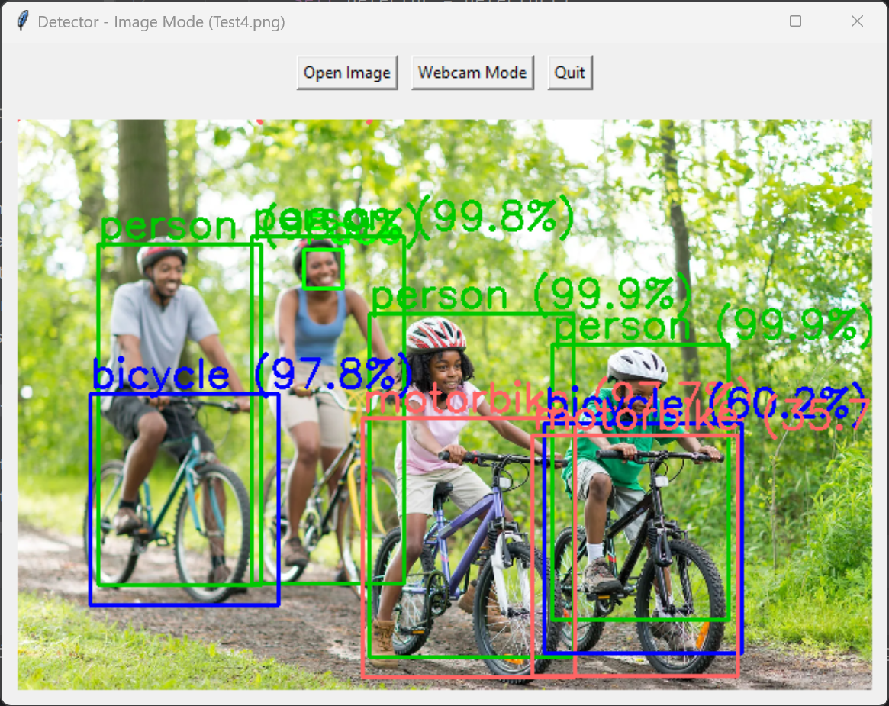
- Family biking on a trail with bicycles showing person/face highlighting.

Object Detection
The full-color frame is resized to 300×300 pixels and converted into a blob for processing by the MobileNet-SSD model using OpenCV’s DNN module. The network outputs class IDs, confidence scores, and bounding boxes for each detected object. Detections are annotated with the object name and confidence percentage. Each object is assigned a unique color for easy visualization.
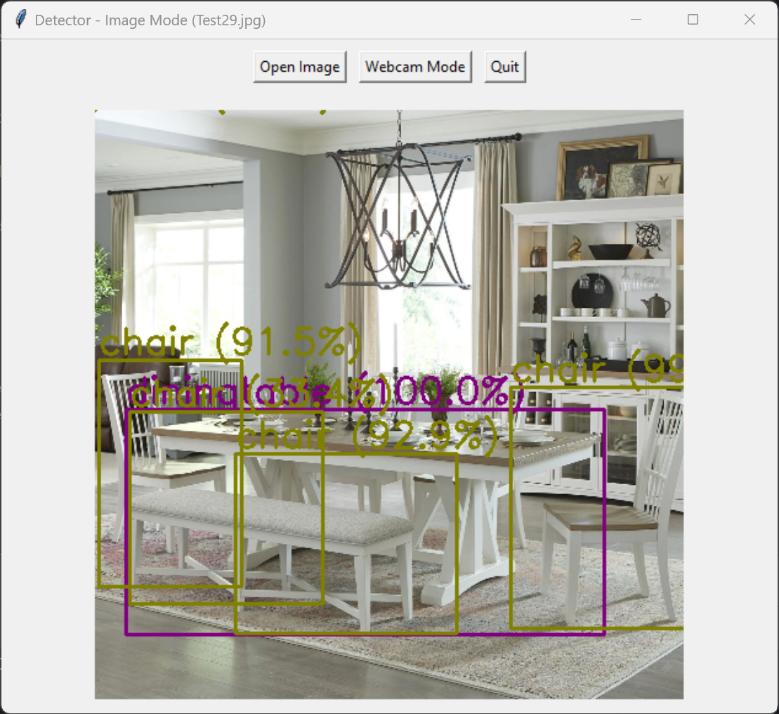
- Dining room setting detecting chairs and a dining table.

Processing
In webcam mode, this detection pipeline repeats for every frame. Faces and objects are continuously updated in the GUI, providing a live annotated feed. MobileNet-SSD efficiently detects multiple objects, while Haar Cascade ensures rapid face localization. The combination allows simultaneous detection of faces and general objects in a real-time environment.

Analysis
The system was evaluated using both static images and live webcam feeds. It was able to detect faces and objects such as people, cars, buses, bottles, phones, chairs, and animals including dogs, horses, and cats. Face detection was achieved while MobileNet-SSD correctly classified most objects within the predefined set.
Both detection models operated concurrently without significant lag, and bounding boxes with class labels were updated instantly. Faces were marked with green rectangles, while objects were displayed using color-coded boxes with confidence scores, as shown in Figure 1.
Some limitations were observed: detection accuracy decreased under low-light conditions, for profile or partially occluded faces, and for small or distant objects. Rapid motion occasionally causes temporary detection loss. Despite these constraints, the system remained stable and visually informative, demonstrating the practical feasibility of real-time face and object recognition.
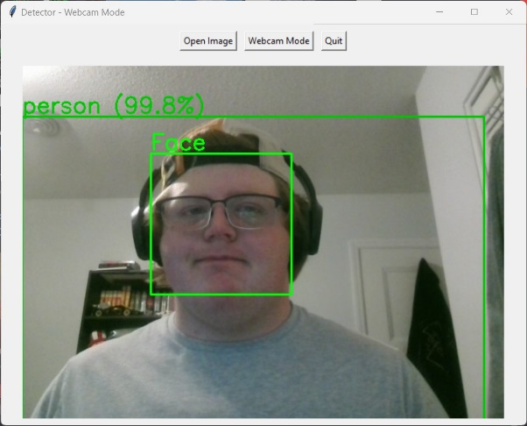
- Webcam with supplied light detecting the face.
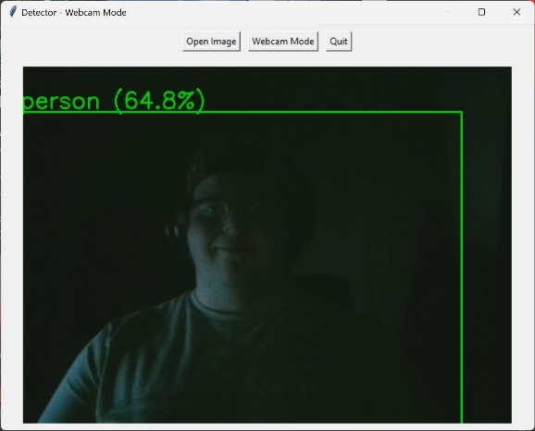
- Webcam without supplied light not detecting the face.
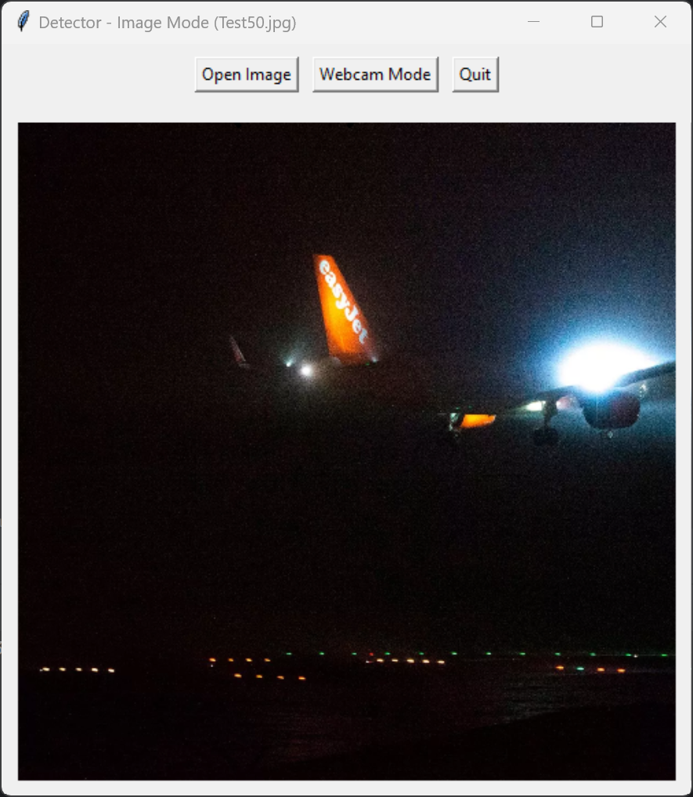
- Nighttime airport setting where a plane can be made out using silhouettes.

Discussion
The proposed system demonstrates several strengths. By combining a Haar Cascade face detector with a MobileNet-SSD object detector, it provides real-time detection of both faces and general objects in a single, lightweight application. The modular architecture allows easy integration of additional detection models or GUI enhancements. Real-time performance is generally smooth, averaging 20–30 frames per second on standard consumer hardware. The use of class-specific bounding boxes and confidence labels enhances interpretability for users.
However, several limitations were observed. Face detection accuracy decreases for profile or partially occluded faces, while low-light conditions reduce detection confidence for both faces and objects. Small or distant vehicles are occasionally missed by MobileNet-SSD, and overlapping objects may produce false positives or misclassifications. Accuracy drops noticeably when conditions deviate from optimal lighting or viewing angles.
Potential improvements include replacing the Haar Cascade with a DNN-based face detector for better robustness, incorporating object tracking to reduce flickering or missed detections, and training MobileNet-SSD on a custom dataset for improved vehicle and object recognition.

Conclusions
This paper presents a lightweight, modular application for real-time face and object detection using Haar Cascade and MobileNet-SSD. The system successfully identifies a variety of objects and front facing faces, providing real-time annotated visualizations for both static images and webcam feeds. While performance is generally robust, challenges remain under low-light conditions, with occlusions, and for small or distant objects.
The application demonstrates the feasibility of combining computer vision and deep learning models, making it suitable for practical simple tasks such as security monitoring, traffic analysis, and quality control.

References
- OpenCV, “OpenCV,” opencv.org. https://opencv.org
- K. Patel and N. Patel, “Face Recognition Using Haar Cascade Algorithm In Python,” International Journal of Current Science, vol. 13, pp. 2250–1770, 2023, Available: https://rjpn.org/ijcspub/papers/IJCSP23D1129.pdf
- Python Software Foundation, “tkinter — Python interface to Tcl/Tk — Python 3.7.2 documentation,” python.org, 2019. https://docs.python.org/3/library/tkinter.html
- A. Mittal, “Haar Cascades, Explained,” Medium, Dec. 21, 2020. https://medium.com/analytics-vidhya/haar-cascades-explained-38210e57970d
- chuanqi305, “MobileNet-SSD,” GitHub, Mar. 28, 2022. https://github.com/chuanqi305/MobileNet-SSD

