Traffic Agents Effeciency Rates in Cities Skylines

Kevin Wall
Emerging Technologies - Computer Science
Full Sail Univeristy
Winter Park, FL, USA
kpwall@student.fullsail.edu

Abstract— This study uses Cities: Skylines to analyze how road design affects traffic flow. Over nearly two in-game years, data showed moderate traffic efficiency and congestion concentrated at major entry points. Results highlight the value of varied road layouts and multiple access routes for improving urban traffic performance.
Keywords—Cities Skylines, traffic, flow, congestion

Introduction
Cities Skylines was published in the game distribution platform Steam on March 15th, 2015. It is a simulation based application that has been researched and analyzed to help urban city planners learn about development costs, transportation efforts, and various other aspects regarding city development [1]. Analyzing the affect traffic patterns have on traffic flow is important to an effective transportation infrastructure. Cities: Skylines provides a lot of tools in order to model a city, looking into how traffic potentially flows, and is able to be modded providing further information and enhancement on statistics, rates, and agent control.
The City Statistics: Easy Access mod [3] was used to give information regarding Traffic Average Flow (%), Pedestrian Traffic, and Traffic Flow among other variables. The goals are to try to make an efficient city that provides a high rate for traffic flow and pedestrian flow.

Setup

Creating the City
In order to create the “City of Kevin”, further referred to as the “City”, research had to be taken into how the simulation is setup such as how roads and zoning work. Thankfully the simulation provides an in-game tutorial which was used to learn the basics. After creating some basic roads and infrastructure, developing waste management, education, and industrial areas was needed to provide more areas to travel to. Experimentation with the types of road layouts was taken into consideration, both portions of the City use a linear path however the rural area becomes non-linear after the main entrance.

Data Collection
In order to collect the data, City Statistics: Easy Access was used which helped track data every in game day. The mod was set to track once per in-game day and another mod was used to speed up the simulation time [4] by 9 times faster. By looking at the source code we can find that the mod tracks the rates at noon or the next available frame, every set period of time, in this instance being every day [5].

Analysis and Results
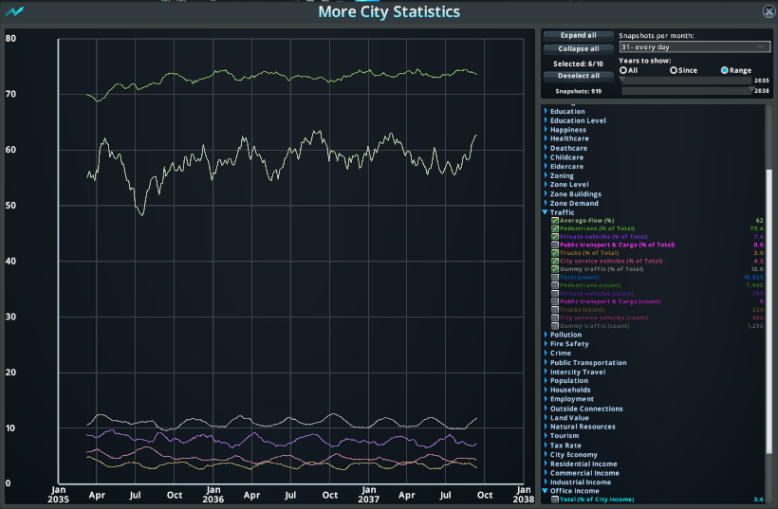
- Rates shown via the City Statistics: Easy Access mod.
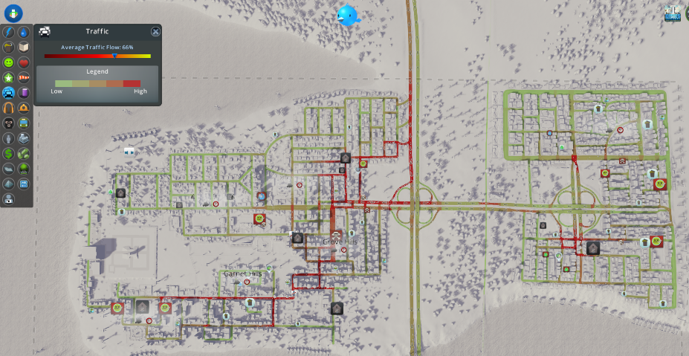
- City of Kevin traffic congestion heat map.
Before reviewing the visual data, it is important to note that the simulation remained stable throughout the entire duration, ensuring that the recorded traffic values accurately reflected consistent city activity.
After letting the simulation run for a couple of hours, the simulations dates started on March 2035 and ended in Jan 2037, showcasing 1 year 9 months of traffic flow. The average flow stayed between 55% and 63% effectiveness. Pedestrian traffic was a took up a majority of flow staying between 70% - 75% whereas Dummy Traffic took up 12%. Other variables tracked like Trucks, Private Vehicles, and City Service vehicles contributed below 10% individually towards the total rate of traffic. Figure 1 shows the traffic rates in more detail over the timespan.
Figure 2 showcases the digital congestion from road structure. We can see that there is more congestion on the entrance to the left portion of the city (North) where more residential and commercial buildings were located. This mimics how large cities like New York have heavy congestion around the heavily populated areas. Taking into account the right half of the City of Kevin we can see that there the left and right exit of the clover roundabout also has congestion for exiting the city.
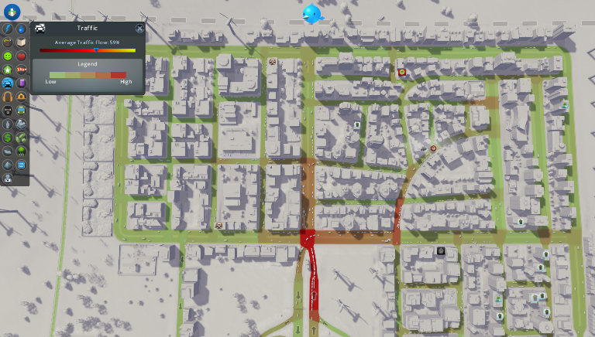
- City of Kevin (rural area) congestion heatmap.
In the rural section the roads are inside the district provide more options to maneuver meaning less congestion overall in the area. Restructuring the rural areas entrance to have 4 possible points of entry might help reduce the congestion and improve flow. The non-linear nature of the rural areas design helps avoid congestion since more destinations tend to be accessible via a different route. Non-linear road structure is more common in locations like the United Kingdom where they developed their cities over hundreds of years. The United States is relatively young compared where much of our city development was preplanned.
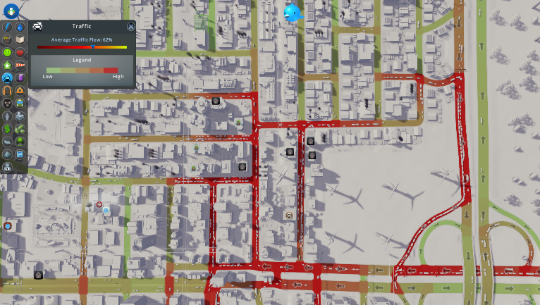
- City of Kevin (metro area) congestion heatmap.

Discussion
Using Cities: Skylines traffic agents to mimic and display how real world traffic signals, patterns, and road design affect flow can be a useful avenue for urban city planners. We think that after creating the roads to be linear in nature might have hindered an entry/exit that most travelers wish to abide by. Spending time structuring the roads to provide efficient throughput for traffic flow is vital to an optimized city.
Cities: Skylines is an interesting option when it comes to analyzing congestion and traffic flow. In terms of the assignment this was intended for, I think that it might be a bit of a stretch since it asks students to purchase the game if they do not already own it and provide an in-depth agent analysis when the game is limited in modding capabilities. Incorporating more transportation modes, such as bus routes, metro lines, or trains, could also provide additional insights into the impact of transportation types and congestion levels within the simulation.

Conclusion
Cities that provide high traffic flow can help avoid congestion. Congestion tends to lead to emergencies not being responded to. By modeling a city within a simulation device such as Cities: Skylines and recording traffic rates over a given period of time can help urban planners avoid common pitfalls and issues that come with traffic.
For a future implementation, trying to start with providing multiple entry and exit points will be a top priority. Being able to effectively move traffic throughout a city is an interesting challenge and we can see that using linear roads tends to have more congestion than non-linear road structures.

References
- L. C. Sanz, S. Martens, and T. De la Hera, “The Case of Cities: Skylines Versions—Affordances in Urban Planning Education,” Media and Communication, vol. 13, Feb. 2025, doi: https://doi.org/10.17645/mac.8747.
- “Cities: Skylines on Steam,” Steampowered.com, 2015. https://store.steampowered.com/app/255710/Cities_Skylines/
- “Steam Workshop::City Statistics Easy Access,” Steamcommunity.com, 2015. https://steamcommunity.com/sharedfiles/filedetails/?id=408613485 (accessed Dec. 01, 2025).
- “Steam Workshop::More Simulation Speed Options,” Steamcommunity.com, 2015. https://steamcommunity.com/sharedfiles/filedetails/?id=412292157 (accessed Dec. 01, 2025).
- rcav8tr, “CS1Mod-MoreCityStatistics/Snapshots.cs at master · rcav8tr/CS1Mod-MoreCityStatistics,” GitHub, 2025. https://github.com/rcav8tr/CS1Mod-MoreCityStatistics/blob/master/Snapshots.cs#L214 (accessed Dec. 01, 2025).

