 | EXPERT CONSULTATION  MNRE empanelled · Kerala-wide  +91 80890 73029  info@fgesolar.in
  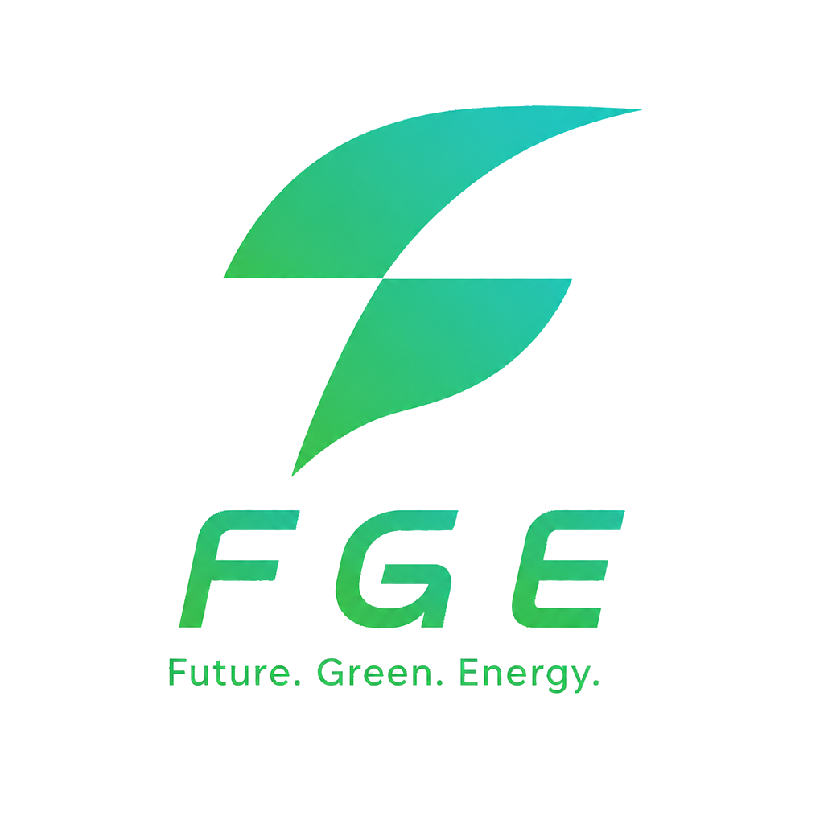 | FGE Solar  FUTURE GREEN ENERGY GROUP
OFFICIAL 2026 HOMEOWNER CHECKLIST
PM Surya Ghar Application Checklist for Kerala
Use this printable checklist before registering on the National Portal. FGE Solar — MNRE empanelled across all 14 Kerala districts — can handle your eligibility check, portal registration, installation, and KSEB net metering.
CENTRAL FINANCIAL ASSISTANCE (RESIDENTIAL)  Current CFA guideline: ₹30,000/kW for first 2 kW + ₹18,000 for the additional third kW, capped at ₹78,000. Subsidy scheme rates are revised periodically — confirm the latest CFA on the National Portal before applying. | QUICK ELIGIBILITY SELF-CHECK  ☐ Indian citizen with valid KSEB electricity connection in your name  ☐ Residential consumer applying for PM Surya Ghar rooftop subsidy  ☐ Have not already received PM Surya Ghar subsidy on this KSEB consumer number (one-time per connection)  ☐ Installing through an MNRE-empanelled vendor (e.g. FGE Solar)  ☐ ALMM-listed modules and adequate unshaded roof area  ☐ Bank account in applicant name for subsidy transfer
  System size | CFA amount
  1 kW | ₹30,000
  2 kW | ₹60,000
  3 kW and above | ₹78,000 maximum
DOCUMENTS — SUBSIDY ONLY
☐ | Latest KSEB electricity bill (consumer number visible)
☐ | Bank proof — passbook front page or cancelled cheque leaf showing applicant name, account number and IFSC (all three required)
☐ | Aadhaar card (recommended for name verification on the portal)
☐ | Mobile number linked to Aadhaar (for OTP on portal)
☐ | Email ID for portal registration
☐ | Written quotation / system proposal from empanelled installer
DOCUMENTS — IF TAKING BANK LOAN (ADDITIONAL)
☐ | Property ownership proof (sale deed / tax receipt / possession certificate)
☐ | PAN card of applicant
☐ | Bank passbook from a nationalized bank (mandatory for loan cases)
Not sure if you qualify?  WhatsApp your latest KSEB bill — FGE Solar will confirm PM Surya Ghar eligibility, recommend system size, and explain next steps. Free. No obligation. | +91 80890 73029
COMMON CONFUSION  "Subsidy is paid upfront before installation." | THE REALITY  CFA is processed after installation, DISCOM inspection/approval, and required portal checks on pmsuryaghar.gov.in.
FGE tip: Send us your document photos on WhatsApp before portal upload — we catch missing IFSC details and blurry scans early, so your application moves faster.
Portal: pmsuryaghar.gov.in · Edition: September 2026 · Page 1 of 2

 | Applicant name: ________________________________  KSEB consumer no.: _____________________________  District: _______________________________________
  FGE Solar
  PM SURYA GHAR STEP TRACKER
APPLICATION & INSTALLATION MILESTONES
1 | Register on pmsuryaghar.gov.in  Basic details + KSEB connection submitted
2 | Technical feasibility / DISCOM stage  Track live status in portal (KSERC 2025 process applies in Kerala)
3 | Select FGE Solar on the portal  Choose FGE Solar / Future Green Energy Group from the MNRE-empanelled vendor list
4 | Sign agreement & upload documents  FGE Solar prepares and submits your portal file pack
5 | Rooftop installation by FGE Solar  Panels, inverter, protections, commissioning — typically 2–4 days
6 | Project completion report filed  FGE Solar uploads completion details on the portal
7 | KSEB / DISCOM inspection  Technical inspection — FGE follows up on scheduling
8 | Net meter installed  KSEB commissions bidirectional meter for export credits
9 | CFA processed after approvals  Subsidy credited to beneficiary bank / eligible loan account — timing varies
WHY HOMEOWNERS CHOOSE FGE SOLAR FOR PM SURYA GHAR
✓ Free site assessment & system sizing for your roof
✓ Full portal registration & document submission handled
✓ KSEB net metering application & follow-up included
✓ ALMM-listed panels with written warranty & scope
✓ Serving all 14 districts across Kerala
✓ Itemised quote showing subsidy & your net cost
BEFORE YOU SIGN WITH ANY INSTALLER  ☐ Written itemised quote (capacity, brands, warranty, scope)  ☐ ALMM-listed module and inverter details confirmed  ☐ Who handles KSEB / portal paperwork clearly stated  ☐ Installer is MNRE-empanelled & selectable on pmsuryaghar.gov.in | Ready to start?  Message us on WhatsApp with:  • Your district  • Latest KSEB bill photo  • Roof photo (if available)  +91 80890 73029
Book Your Free Site Visit with FGE Solar
We handle PM Surya Ghar registration, installation, KSEB net metering, and subsidy milestone tracking — so you don't have to chase the portal alone.
WhatsApp +91 80890 73029
Say: "I want PM Surya Ghar — please check my eligibility"
Note: PM Surya Ghar subsidy rules and CFA rates are updated from time to time by MNRE. This checklist is for general guidance — always confirm the latest scheme details on the official National Portal before applying.
© FGE Solar (Future Green Energy Group) · Page 2 of 2

