**PDFViewerHost and the FlipPdfViewerControl by Paula Scholz**

Recently, for a Universal Windows Platform (UWP) C# project, I was asked to implement Adobe PDF viewing capability for small PDF files that would be attached as part of a user record. The requirements did not involve creating any PDF files, or filling out PDF Forms, or anything more complicated than viewing the PDF file pages in the user interface, and then printing them on demand. Also, in the same display space, we would need to display individual image files that might be attached to the record, like pictures of people or buildings, or scans of other documents that were not PDF files.

As always, I searched the Web for projects that might implement some aspects of the requirements that I could use as springboard for development. There were lots of commercial PDF viewers out there, but almost all were part of some overall control toolkit that cost a lot of money and came with limiting license restrictions, none of which we could live with.

But one article stood out from the rest and presented a very simple PDF viewer control that looked promising. Pieter Nijs of Belgium made a great little GitHub project that uses the Windows.Data.Pdf.PdfDocument class to render a PDF file inside a UWP application, and I thought this a great point of departure for my own work. His article shows how to download a PDF file over the Internet or from the file system and open it as a Windows.Data.Pdf.PdfDocument object, rendering pages from that document inside a ScrollViewer control. This article may be found here:

<https://blog.pieeatingninjas.be/2016/02/06/displaying-pdf-files-in-a-uwp-app/>

Also, Microsoft had thoughtfully provided their own PDF sample project as part of their Windows Universal Samples offering to Windows 10 developers. This sample provided some extra features over Pieter’s offering, like background color rendering, passwords, and error reporting, but like most Microsoft samples was not really useful as a component for my own project. The sample was more of a teaching tool, showing developers how to use features of the PDF API rather than providing a plug-in solution for your own development. Still, it was very useful and provided some great nuggets of functionality for my own efforts. This sample may be found here:

<https://github.com/Microsoft/Windows-universal-samples/tree/master/Samples/PdfDocument>

A screenshot of the Microsoft sample in action will prove instructive:

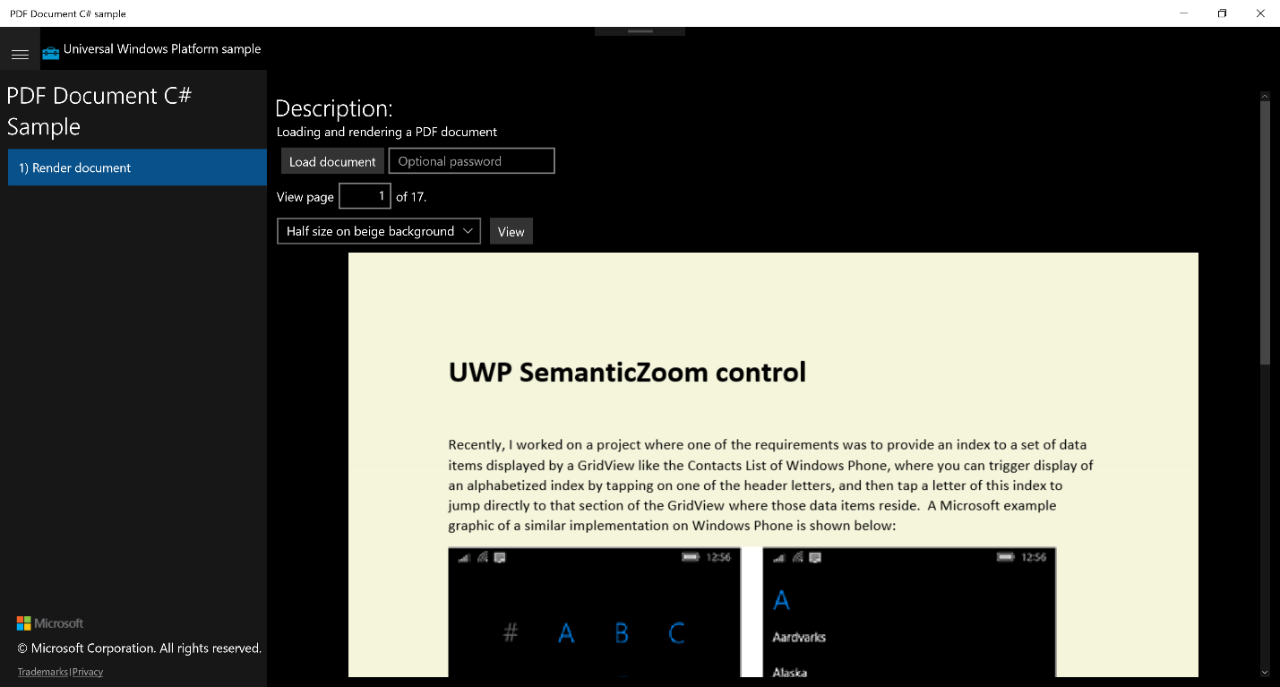

The sample consists of a MainPage containing a SplitView control, and you can see this in the screenshot. On the left pane area is a title and a single option to “Render document”, and in the SplitView’s main content area are controls to select a document to load from the file system, optional Password box, a TextBox where you can enter the page number you wish to view, a ComboBox allowing you to select options to render the page at full size, half size on beige background, or cropped to the center of the page. Once your file, page, and options are selected, you press the View button to render your page in the remaining content area. Here, we see a PDF version of my SemanticZoom control tutorial rendered at half size on a beige background as a *Windows.UI.Xaml.Media.Imaging.BitmapImage*.

The *Windows.Data.Pdf.PdfPage* object only renders the page as a *Stream* of data with its *PdfPage.GetPage(int pageIndex)* method, but this can be set as the source of a *BitmapImage* to turn into something that can be rendered in a UWP user interface, and that is the only technique Microsoft provides to get PDF pages from a document. This provides limited capability, but we can use it to view PDF pages, albeit without the ability to select individual blocks of text or manipulate that text in any way except size, rotation, or background color. Still, it is enough to provide a useful control for viewing PDF documents in a UWP application without paying large fees to a control vendor. I guess Microsoft wanted to leave a little room in its ecosystem for the many add-on control framework vendors like Symantec, Infragistics, ActiPro and others, while still providing something useful to the millions of individual developers writing for the Microsoft platform.

So, between these two projects, fruits of some of my previous work, and a little of my own magic, I decided to roll my own UWP UserControl, and because I needed a project to host it, I decided to more or less mirror the structure of a Microsoft sample. Below is the Paula PDF Viewer application, called PdfViewerHost.exe.

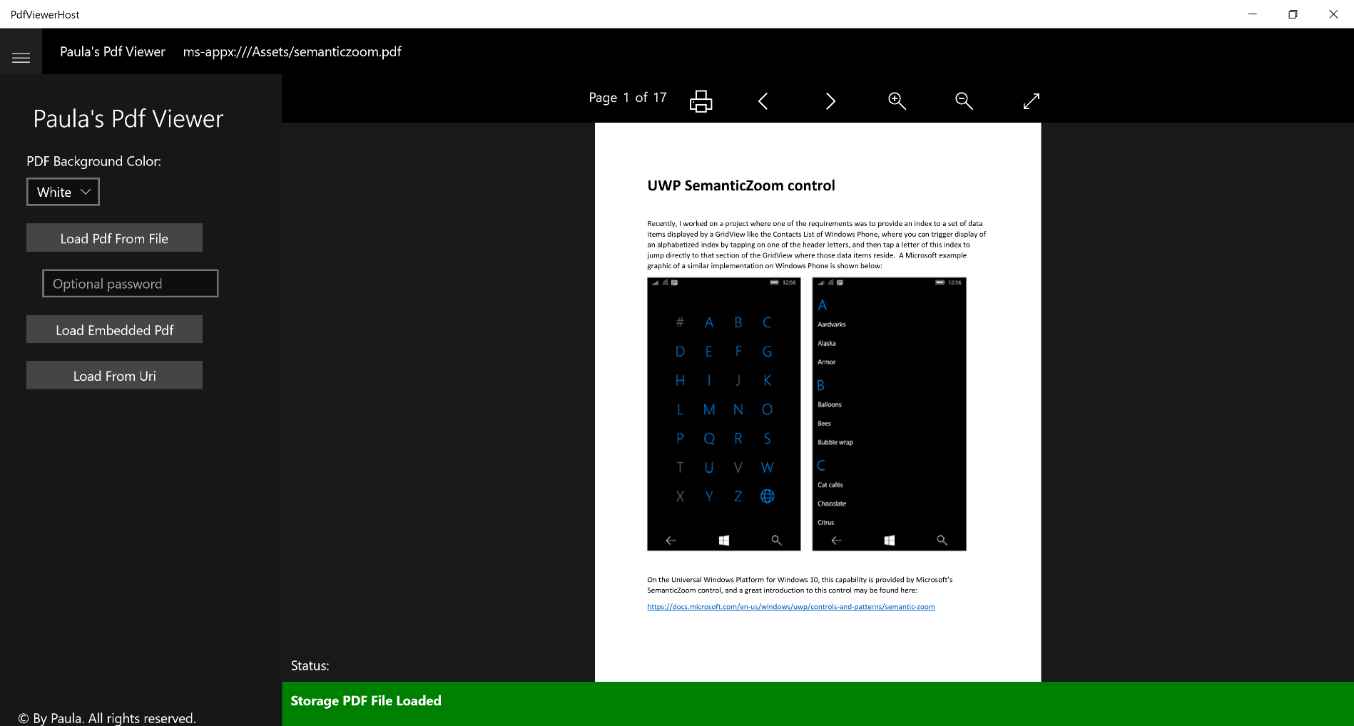

Like the Microsoft samples, I’ve divided the application with a SplitView control. In the left pane, there is a ComboBox, three buttons, and an optional Password box. These buttons, and the code behind them, illustrate the various PDF sources the control can load, to wit:

* PDF files located on the file system in Documents or other folders.
* PDF files embedded as a resource in the application (shown above)
* PDF files downloaded over the Internet

The Hamburger button at the top of the left pane will collapse the SplitView pane, leaving only the content host page and its FlipPdfViewerControl visible. The collapsed view maximizes the screen real-estate devoted to the actual document and is important when viewing the application on a monitor in Portrait mode, like this:

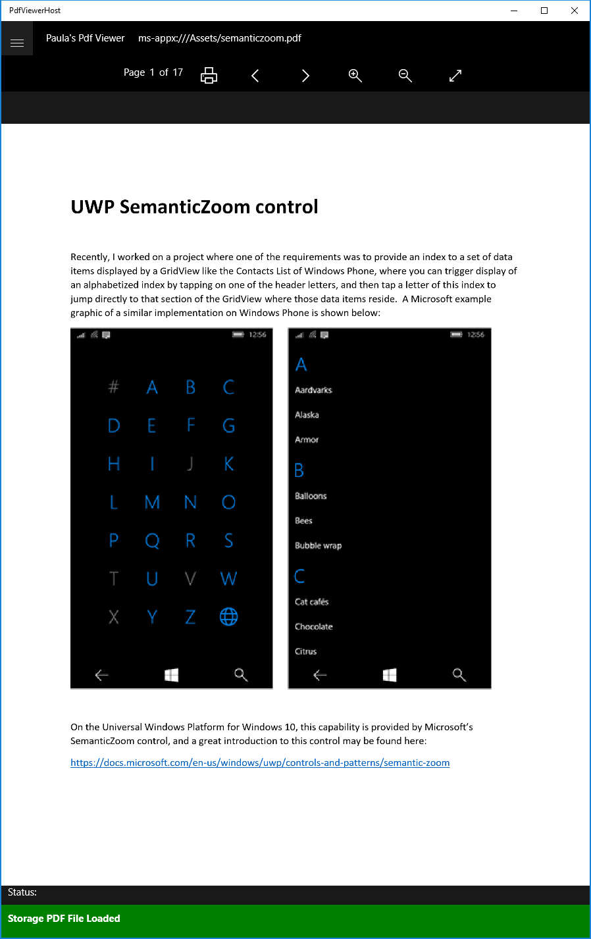

At the top of the application, we show the source of the loaded PDF file, in this case, an embedded file located in the Assets directory of the application on disk, and at the bottom we have a Status area that shows status and error messages forwarded from the control to its host page, and then to the MainPage, where the Status bar resides.

The control itself does not have any visible controls other than the PDF file content area, which is a FlipView. The page indicator, printer button, FlipView navigation and image zoom controls are part of the controls’ host page and their click event handlers call methods on the control. Let’s look at the Solution Explorer of the application’s source code in Visual Studio:

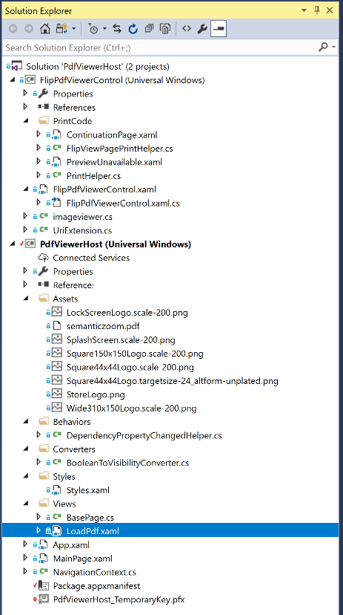

We have two projects, the PdfViewerHost application, which provides the shell, controls for loading PDF files, and controls that manipulate the PDF viewer; and the FlipPdfViewerControl, which is what actually decodes and displays the PDF files inside a FlipView control. Let’s look at these projects in detail.

The PdfViewerHost has a standard App.Xaml page, where we declare a single Resource Dictionary of control styles, a MainPage containing the shell of the application and the PDF file loading controls, a simple NavigationContext object for passing PDF file parameters to the single LoadPdf.xaml page (which has our PDF viewer controls) inside the Views folder, a single Converter for hooking changes in Dependency Properties, the ubiquitous BooleanToVisibilityConverter for our XAML pages, a Style.xaml page with visual styles for the controls, a BasePage.cs file as the INotifyPropertyChanged base class of LoadPdf.xaml, an Assets folder with Windows Store logos and an embedded PDF file, semanticzoom.pdf. There are also some Visual Studio housekeeping files, the Package.appxmanifest and temporary development key for the Windows 10 app container.

Let’s look at MainPage.xaml

<Page

x:Class="PdfViewerHost.MainPage"

xmlns="http://schemas.microsoft.com/winfx/2006/xaml/presentation"

xmlns:x="http://schemas.microsoft.com/winfx/2006/xaml"

xmlns:d="http://schemas.microsoft.com/expression/blend/2008"

xmlns:mc="http://schemas.openxmlformats.org/markup-compatibility/2006"

mc:Ignorable="d">

<!-- The structure of this page is taken directly from a Microsoft sample. -->

<Grid Background="{ThemeResource ApplicationPageBackgroundThemeBrush}">

<Grid.RowDefinitions>

<RowDefinition Height="Auto"/>

<RowDefinition Height="*"/>

</Grid.RowDefinitions>

<!-- This SplitView has the main controls for the app for loading PDF files, either from an embedded PDF file,

a URI from the Internet, or from a PDF file on the file system. See MainPage.xaml.cs click event handlers

for how each type is handled in your own programs. -->

<SplitView x:Name="Splitter" IsPaneOpen="True" Grid.Column="1" DisplayMode="Inline" Grid.Row="1">

<SplitView.Pane>

<RelativePanel Margin="10,0,0,0">

<StackPanel Orientation="Vertical" Margin="10">

<TextBlock x:Name="SampleTitle" Text="Paula's Pdf Viewer" Style="{StaticResource SampleHeaderTextStyle}" TextWrapping="Wrap" Margin="20"/>

<!-- The background color choices for the rendered PDF document. These can be changed to whatever you want. -->

<StackPanel Orientation="Vertical">

<TextBlock Text="PDF Background Color:" Style="{StaticResource BasicTextStyle}" VerticalAlignment="Center" Margin="10,0,0,0" />

<ComboBox x:Name="ColorOptions" SelectedIndex="0" Margin="10">

<ComboBoxItem>White</ComboBoxItem>

<ComboBoxItem>Wheat</ComboBoxItem>

<ComboBoxItem>Corn Silk</ComboBoxItem>

<ComboBoxItem>Ivory</ComboBoxItem>

<ComboBoxItem>Light Gray</ComboBoxItem>

<ComboBoxItem>Floral White</ComboBoxItem>

</ComboBox>

</StackPanel>

<!-- The various options for loading PDF files. The LoadButton PDF option has an optional PasswordBox

for password-protected PDF files. -->

<Button x:Name="LoadButton" Width="200" VerticalAlignment="Top" Content="Load Pdf From File" Click="{x:Bind LoadDocument}" Margin="10 "/>

<PasswordBox x:Name="PasswordBox" Width="200" Height="25" PlaceholderText="Optional password" VerticalAlignment="Top" Margin="10"/>

<Button x:Name="LoadFromAssets" Width="200" Content="Load Embedded Pdf" Click="LoadFromAssets_Click" VerticalAlignment="Top" Margin="10"/>

<Button x:Name="LoadFromUri" Width="200" Content="Load From Uri" Click="LoadFromUri_Click" VerticalAlignment="Top" Margin="10" />

</StackPanel>

<!-- This footer panel taken directly from a Microsoft sample. -->

<StackPanel x:Name="FooterPanel" Orientation="Vertical" RelativePanel.AlignBottomWithPanel="True">

<!-- This just shows how to display the Copyright symbol. You can do with this whatever you want. -->

<TextBlock x:Name="Copyright" Text="&#xA9; By Paula. All rights reserved." Style="{StaticResource CopyrightTextStyle}"

RelativePanel.Above="LinksPanel" Margin="10,10,0,0"

TextWrapping="Wrap"/>

</StackPanel>

</RelativePanel>

</SplitView.Pane>

<RelativePanel>

<!-- This Frame contains the FlipPdfViewer control, navigated to by the Button click-event handlers, above. -->

<Frame x:Name="PdfFrame" Margin="0,5,0,0" RelativePanel.AlignTopWithPanel="True" RelativePanel.Above="StatusPanel" RelativePanel.AlignRightWithPanel="True" RelativePanel.AlignLeftWithPanel="True"/>

<!-- This contains the Status panel, used to display status and error messages from the application. -->

<StackPanel x:Name="StatusPanel" Orientation="Vertical" RelativePanel.AlignBottomWithPanel="True" RelativePanel.AlignRightWithPanel="True" RelativePanel.AlignLeftWithPanel="True">

<TextBlock x:Name="StatusLabel" Margin="10,0,0,10" TextWrapping="Wrap" Text="Status:" />

<Border x:Name="StatusBorder" Margin="0,0,0,0">

<ScrollViewer VerticalScrollMode="Auto" VerticalScrollBarVisibility="Auto" MaxHeight="200">

<TextBlock x:Name="StatusBlock" FontWeight="Bold"

MaxWidth="{Binding ElementName=Splitter, Path=ActualWidth}" Margin="10,10,10,20" TextWrapping="Wrap" />

</ScrollViewer>

</Border>

</StackPanel>

</RelativePanel>

</SplitView>

<!-- This has the Header panel at the top of the document, with the Hamburger button used to toggle visibility of

the Frame containing the FlipPdfViewer control. -->

<StackPanel x:Name="HeaderPanel" Orientation="Horizontal">

<Border Background="{ThemeResource SystemControlBackgroundChromeMediumBrush}" Grid.Row="0">

<ToggleButton Style="{StaticResource SymbolButton}" Click="Button_Click" VerticalAlignment="Top" Foreground="{ThemeResource ApplicationForegroundThemeBrush}">

<ToggleButton.Content>

<FontIcon x:Name="Hamburger" FontFamily="Segoe MDL2 Assets" Glyph="&#xE700;" Margin="0,10,0,0"/>

</ToggleButton.Content>

</ToggleButton>

</Border>

<StackPanel Orientation="Horizontal">

<TextBlock x:Name="Header" Text="Paula's Pdf Viewer" Style="{StaticResource TagLineTextStyle}" Margin="20,15,0,0" />

<!-- This displays the name of the PDF file currently in the FlipPdfViewer control. -->

<TextBlock x:Name="SourceHeader" Text="{x:Bind SourceDisplayName, Mode=OneWay}" Style="{StaticResource TagLineTextStyle}" Margin="20,15,0,0" />

</StackPanel>

</StackPanel>

</Grid>

</Page>

We’re not going to go into a lot of detail on this page, which hosts the header and footer area. The main part of the page holds the SplitView control, dividing the page into a collapsible SplitView.Pane, and a content area represented by a RelativePanel. The most important aspect of the content area is the <Frame> control, which is used to navigate to the LoadPdf page inside the SplitView’s content area through the button click handlers referenced in the <Button> controls in the SplitView.Pane. Let’s look at those click handlers inside MainPage.xaml.cs. There are three of them:

/// <summary>

/// Launch the FileOpenPicker and get the name of a PDF document to load. This is

/// an async method because it awaits an async method, but it doesn't return a

/// Task so it can match the click handler signature.

/// </summary>

private async void LoadDocument()

{

LoadButton.IsEnabled = false;

var picker = new FileOpenPicker();

picker.FileTypeFilter.Add(".pdf");

StorageFile file = await picker.PickSingleFileAsync();

// if the FileOpenPicker gave us a filename, create a NavigationContext object

// and set its parameters to pass to the LoadPdf page.

if (null != file)

{

var nav = new NavigationContext();

nav.IsFile = true;

nav.PdfFile = file;

nav.BackgroundColor = GetPdfBackgroundColor();

// update the displayed loaded PDF name

SourceDisplayName = file.Name;

// navigate to the LoadPdf page

PdfFrame.Navigate(typeof(Views.LoadPdf), nav);

}

LoadButton.IsEnabled = true;

}

/// <summary>

/// This loads an embedded PDF file from the Assets directory. Remember, any PDF file

/// you want to load from Assets has to have its Build Action set to Content in Properties.

/// </summary>

/// <param name="sender"></param>

/// <param name="e"></param>

private void LoadFromAssets_Click(object sender, RoutedEventArgs e)

{

var uri = new Uri("ms-appx:///Assets/semanticzoom.pdf");

var nav = new NavigationContext();

nav.IsFile = false;

nav.PdfUri = uri;

nav.BackgroundColor = GetPdfBackgroundColor();

// update the displayed loaded PDF name

SourceDisplayName = uri.ToString();

// navigate to the LoadPdf page

PdfFrame.Navigate(typeof(Views.LoadPdf), nav);

}

/// <summary>

/// This loads a PDF file from an Internet URI.

/// </summary>

/// <param name="sender"></param>

/// <param name="e"></param>

private void LoadFromUri_Click(object sender, RoutedEventArgs e)

{

var uri = new Uri("http://www.adobe.com/content/dam/Adobe/en/accessibility/products/acrobat/pdfs/acrobat-x-accessible-pdf-from-word.pdf");

var nav = new NavigationContext();

nav.IsFile = false;

nav.PdfUri = uri;

nav.BackgroundColor = GetPdfBackgroundColor();

// update the displayed loaded PDF name

SourceDisplayName = uri.ToString();

// navigate to the LoadPdf page

PdfFrame.Navigate(typeof(Views.LoadPdf), nav);

}

The first of these, LoadDocument(), is the handler for the LoadButton in the SplitView.Pane. Pressing the button executes the click handler and launches a *FilePicker*, allowing the user to navigate the file system and choose a PDF document to load from the available choices on his system. Once chosen, we create a *NavigationContext* object and set its properties from the file chosen and then pass it as a parameter in the PdfFrame.Navigate method, which will then place the LoadPdf page into the frame.

The second click handler sets up a *NavigationContex*t object with a URI representing our embedded PDF file, and the third click handler does something similar with an Internet URI of an Adobe PDF file located on the web. Both these click handlers then tell the Frame to navigate to LoadPdf.xaml passing the created *NavigationContext*.

Let’s look at the *NavigationContext* object code:

/// <summary>

/// The parameters for navigating PDF viewer display pages. Used by MainPage.xaml.cs click-event handlers.

/// </summary>

class NavigationContext

{

/// <summary>

/// Flag to indicate if this NavigationContext represents a

/// StorageFile or Uri location.

/// </summary>

public bool IsFile { get; set; } = false;

/// <summary>

/// The StorageFile representing the PDF file to load.

/// </summary>

public StorageFile PdfFile { get; set; }

/// <summary>

/// The Uri where a remote PDF file may be found and loaded.

/// </summary>

public Uri PdfUri { get; set; }

/// <summary>

/// The Windows.UI.Color for the background when rendering the PDF file.

/// </summary>

public Color BackgroundColor { get; set; }

}

As you can see, it’s a very simple object and gets passed to the LoadPdf.xaml.cs function *OnNavigatedTo(NaviationEventArgs e)* method when that page loads, as its NavigationEventArgs parameter. Note that the background color selected in the PDF Background Color ComboBox is also passed to this function, and the *FlipPdfViewerControl* on the LoadPdf.xaml page will use that color as the background color of the PDF file it renders.

Let’s look at the XAML of the LoadPdf.xaml page:

<local:BasePage

x:Class="PdfViewerHost.Views.LoadPdf"

xmlns="http://schemas.microsoft.com/winfx/2006/xaml/presentation"

xmlns:x="http://schemas.microsoft.com/winfx/2006/xaml"

xmlns:local="using:PdfViewerHost.Views"

xmlns:pdf="using:FlipPdfViewerControl"

xmlns:d="http://schemas.microsoft.com/expression/blend/2008"

xmlns:mc="http://schemas.openxmlformats.org/markup-compatibility/2006"

mc:Ignorable="d">

<Page.Resources>

<local:BooleanToVisibilityConverter x:Key="BooleanToVisibilityConverter" />

</Page.Resources>

<!-- This page is instantiated by the Frame on the MainPage in response to a button click event loading a Pdf file. -->

<Grid Background="{ThemeResource ApplicationPageBackgroundThemeBrush}">

<!-- These provide the visual controls for the FlipPdfViewer user control. The buttons trigger event handlers which

pass on the events to that control, and the TextBlocks are fed by DependencyProperties on that control. -->

<StackPanel Orientation="Horizontal" VerticalAlignment="Top" HorizontalAlignment="Center" Margin="0,10,0,10">

<TextBlock Text="Page"

FontSize="{x:Bind TextSize, Mode=OneWay}"

Margin="20,0,6,0"

VerticalAlignment="Top" />

<!-- The CurrentPageNumber displayed in the FlipPdfViewer user control. -->

<TextBlock Text="{x:Bind FlipPdfViewer.CurrentPageNumber, Mode=OneWay}"

FontSize="{x:Bind TextSize, Mode=OneWay}"

VerticalAlignment="Top"

Margin="0,0,6,0" />

<TextBlock Text="of"

Margin="0,0,6,0"

FontSize="{x:Bind TextSize, Mode=OneWay}"

VerticalAlignment="Top" />

<!-- The PageCount of the current PDF document in the FlipPdfViewer user control. -->

<TextBlock Text="{x:Bind FlipPdfViewer.PageCount, Mode=OneWay}" Margin="0,0,6,0"

FontSize="{x:Bind TextSize, Mode=OneWay}"

VerticalAlignment="Top" />

<!-- The Print button for the contents of the FlipPdfViewer. -->

<Button Click="OnPrintButtonClick"

Background="Transparent"

Style="{StaticResource ToolButtonStyle}"

HorizontalAlignment="Left"

Margin="8,0"

Padding="12,3"

Visibility="{x:Bind PrintingIsSupported, Converter={StaticResource BooleanToVisibilityConverter}}">

<TextBlock Text="&#xE2F6;"

VerticalAlignment="Center"

Style="{StaticResource IconStyleLarge}" />

</Button>

<!-- A Navigation button to move to the previous Pdf page. The glyph is from the Segoe MLD2 Assets, a

cheatsheet for which may be found here: http://modernicons.io/segoe-mdl2/cheatsheet/ -->

<Button Click="MoveFlipViewBack"

Style="{StaticResource FlipViewControlButtonStyle}">

<TextBlock Text="&#xE973;"

VerticalAlignment="Center"

Style="{StaticResource IconStyle}" />

</Button>

<!-- A Navigation button to move to the next Pdf page. -->

<Button Click="MoveFlipViewForward"

Style="{StaticResource FlipViewControlButtonStyle}">

<TextBlock Text="&#xE974;"

VerticalAlignment="Center"

Style="{StaticResource IconStyle}" />

</Button>

<!-- A button to trigger zooming in on the current Pdf page. -->

<Button Click="ZoomIn"

Style="{StaticResource FlipViewControlButtonStyle}">

<TextBlock Text="&#xE8A3;"

VerticalAlignment="Center"

Style="{StaticResource IconStyle}" />

</Button>

<!-- A button to trigger zooming out on the current Pdf page. -->

<Button Click="ZoomOut"

Style="{StaticResource FlipViewControlButtonStyle}">

<TextBlock Text="&#xE1A4;"

VerticalAlignment="Center"

Style="{StaticResource IconStyle}" />

</Button>

<!-- A button to trigger the resize to normal of the current Pdf page. -->

<Button

Style="{StaticResource FlipViewControlButtonStyle}"

Click="DoFitDocumentImageToScreen">

<TextBlock Text="&#xE1D9;"

VerticalAlignment="Center"

Style="{StaticResource IconStyle}" />

</Button>

</StackPanel>

<!-- This grid encloses the FlipPdfViewerControl -->

<Grid x:Name="FlipPdfViewContainer" VerticalAlignment="Bottom" Margin="0,50,0,-50">

<!-- The actual PDF user control, which uses a FlipView to page through the PDF pages. -->

<pdf:FlipPdfViewerControl x:Name="FlipPdfViewer"

HorizontalAlignment="Stretch"

VerticalAlignment="Stretch"

Source="{x:Bind PdfSource, Mode=OneWay}"

IsZoomEnabled="true"/>

</Grid>

<!-- This progress ring hasn't been hooked up yet, so don't freak out. -->

<ProgressRing x:Name="ProgressControl" Height="50" Width="50" IsActive="False" Visibility="Collapsed" Margin="0,10,0,0"/>

</Grid>

</local:BasePage>

This page acts as a host and visual control wrapper for the actual *FlipPdfViewerControl* that renders the PDF document. Note that instead of being derived directly from *Page*, it is derived from *BasePage*, which itself is derived from *Page* and the INotifyPropertyChanged interface. *BasePage* is very simple and simply implements the required members of INotifyPropertyChanged in order to provide change notifications for simple .Net properties that are not Dependency Properties. We don’t happen to have any Dependency Properties in LoadPdf.xaml.cs, although there are a lot of them in the *FlipPdfViewerControl*.

Really, all we have here on LoadPdf.xaml are some buttons that wrap the *FlipPdfViewerControl’s* action methods, and the *FlipPdfViewerControl* itself.

Let’s look at the most important method in LoadPdf.xaml.cs, the *OnNavigatedTo(NaviationEventArgs e)* method:

/// <summary>

/// Triggered by the MainPage's PdfFrame.Navigate calls in the various Button

/// event handlers for loading Pdf documents from embedded PDF files, the file system,

/// or an Internet URI.

/// </summary>

/// <param name="e">NavigationEventArgs, a NavigationContext object.</param>

protected override void OnNavigatedTo(NavigationEventArgs e)

{

base.OnNavigatedTo(e);

// cast the passed parameter as a NavigationContext object

var parameters = e.Parameter as NavigationContext;

SizeChanged += LoadPdf_SizeChanged;

// if we actually have a NavigationContext object passed...

if(null != parameters)

{

// set the FlipPdfViewer's background color before rendering

FlipPdfViewer.PdfBackgroundColor = parameters.BackgroundColor;

bool isFile = parameters.IsFile;

// if the passed NavigationContext is a StorageFile

if (isFile)

{

StorageFile pdfFile = parameters.PdfFile;

// Open the Pdf file through the FlipPdfViewer's StorageFileSource

// property directly. This will trigger loading the PDF file.

FlipPdfViewer.StorageFileSource = pdfFile;

ForwardStatusMessage("Opening PDF File from Storage");

}

else

{

// It's not a file but a Uri, so set our Uri property,

// bound to the FlipPdfViewer in XAML, which will trigger

// loading the PDF file.

PdfSource = parameters.PdfUri;

}

PrintingIsSupported = FlipPdfViewer.PrintingIsSupported;

// set forward message delegate instances

FlipPdfViewer.HostStatusMsgHandler = ForwardStatusMessage;

FlipPdfViewer.HostErrorMsgHandler = ForwardErrorMessage;

// if the FlipPdfViewer supports printing, register it with the print system. We do this here

// so it can be unregisterd in OnNavigatedFrom.

if (PrintingIsSupported)

{

// register FlipPdfViewer for printing

FlipPdfViewer.RegisterForPrinting();

}

}

}

After calling the base class function, we decode the passed parameter as a *NavigationContext* object and examine it. If it represents the choice of a *StorageFile*, we assign the file to the *FlipPdfViewerControl’s* StorageFileSource Dependency Property and that properties’ change callback method will load the file, decode the first page, and display that page in the control’s FlipView. If the *NavigationContext* object represents a URI, either from the web or from a PDF file embedded in the application’s Assets folder, we take that URI and assign it to the *FlipPdfViewerControl’s* PdfSource Dependency Property, and the PDF file will be loaded from the URI, decoded, and its first page displayed.

We then set the LoadPdf.xaml page’s PrintingIsSupported property from the *FlipPdfViewerControl’s* property of the same name, and this will trigger the visibility of the Print button on the UI. Then, we hook up two simple functions that forward error and status messages to the MainPage’s status area, and then, if printing is supported, we call the *FlipPdfViewerControl’s* RegisterForPrinting() method, which does exactly as it says it does, and registers the control with the Windows 10 print system.

The *OnNavigatedFrom(NavigationEventArgs e)* override is quite simple, merely unregistering the FlipPdfViewerControl from the print system, and unhooking the Size_Changed event handler.

/// <summary>

/// When we leave the page, unregister the FlipPdfViewer from the print system.

/// </summary>

/// <param name="e">NavigationEventArgs, ignored here.</param>

protected override void OnNavigatedFrom(NavigationEventArgs e)

{

if(PrintingIsSupported)

{

FlipPdfViewer.UnRegisterForPrinting();

}

SizeChanged -= LoadPdf_SizeChanged;

}

The rest of the code-behind on this page is of little note, merely some .Net properties and click event handlers which forward events to the *FlipPdfViewerControl*.

Now we turn our attention to the *FlipPdfViewerControl* code, which is the UserControl that actually displays PDF files and that you can include in your own programs. The Xaml code of the *FlipPdfViewrControl* is also quite simple. Let’s examine it in detail:

<UserControl

x:Class="FlipPdfViewerControl.FlipPdfViewerControl"

xmlns="http://schemas.microsoft.com/winfx/2006/xaml/presentation"

xmlns:x="http://schemas.microsoft.com/winfx/2006/xaml"

xmlns:local="using:FlipPdfViewerControl"

xmlns:d="http://schemas.microsoft.com/expression/blend/2008"

xmlns:mc="http://schemas.openxmlformats.org/markup-compatibility/2006"

mc:Ignorable="d"

d:DesignHeight="300"

d:DesignWidth="400"

x:Name="root">

<Grid>

<!-- This print canvas is a target of the printer code. -->

<Canvas x:Name="PrintCanvas" Opacity="0"/>

<FlipView Name="flipView"

VerticalAlignment="Center"

ItemsSource="{x:Bind PdfPages, Mode=OneWay}">

<FlipView.ItemTemplate>

<DataTemplate>

<local:ImageViewer x:Name="flipImageViewer" Source="{Binding}" />

</DataTemplate>

</FlipView.ItemTemplate>

</FlipView>

</Grid>

</UserControl>

Here, inside an enclosing Grid, we have a *Canvas* with opacity set to zero. This *Canvas* object functions as a target for the printing code and has no visual role in our control. Then, we have the control’s primary display object, the *FlipView* control.

*Continued….*