Swiftora Brand Guidelines
v1.0 (Internal)

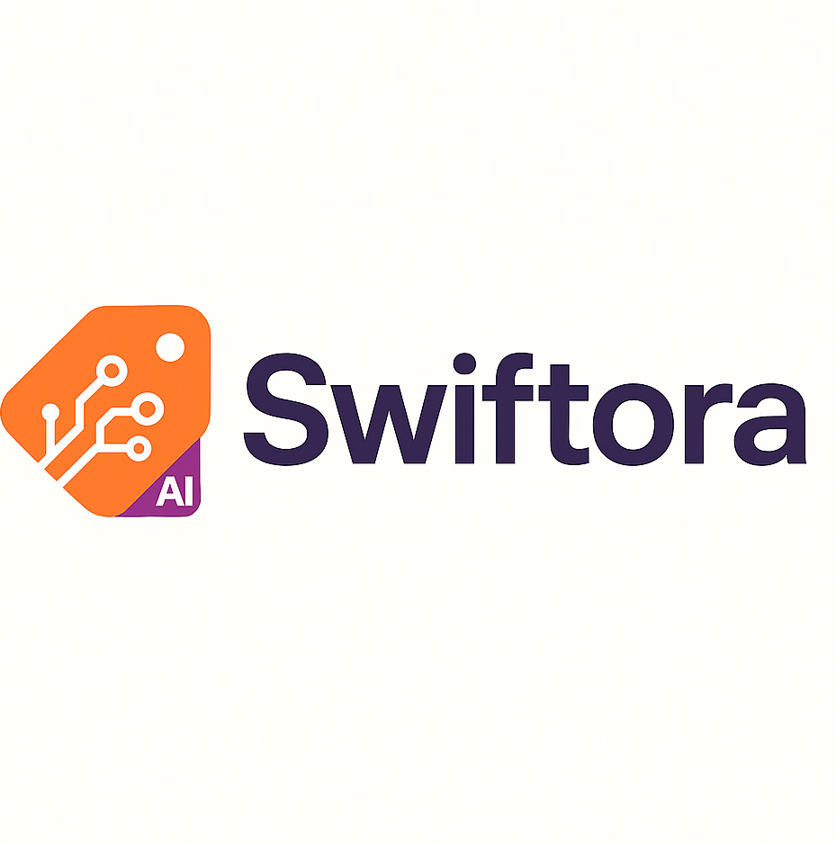
This document defines the core brand assets and usage rules for Swiftora across product UI, marketing, and developer-facing materials.

1. Brand Essentials
Positioning: AI-powered productivity platform for resellers; photo-to-listing workflow with evidence-based pricing and confidence signals.
Voice & tone: Clear, seller-first, no hype; short, scannable copy.

2. Logo System
Primary logo assets included in this repo/files:
- Primary lockup: icon + wordmark (horizontal)
- Icon-only: circuit icon with 'AI' corner
- Wordmark-only: “Swiftora”

2.1 Logo Variants
Use the primary lockup whenever space permits. Use the icon-only version for app icons, favicons, and tight spaces.
Primary lockup | Icon-only | Wordmark-only
 | 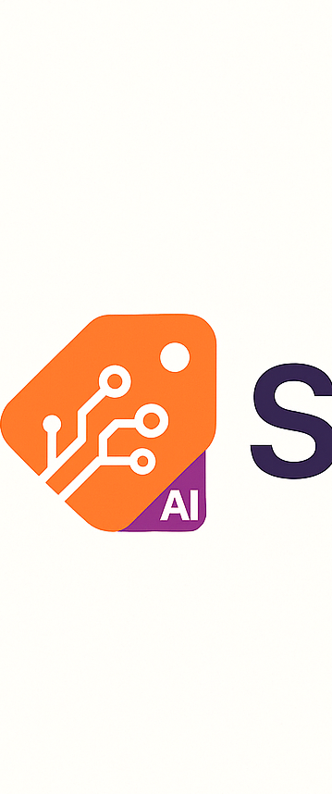 | 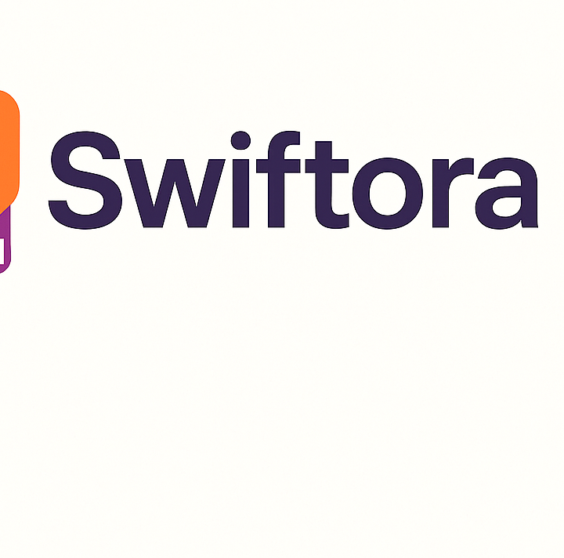

2.2 Clear Space (Minimum Margin)
Maintain clear space around the logo so it never feels cramped or visually collides with other elements.
Rule: minimum clear space = X, where X = 25% of the icon width. Apply X on all sides of the lockup or icon. Do not place other text, buttons, or edges inside this area.

2.3 Minimum Size
Recommended minimum sizes (until validated in UI/print testing):
- Primary lockup: 32 px height (digital) / 0.35 in height (print)
- Icon-only: 24 px height (digital) / 0.25 in height (print)
- Favicon: simplified icon-only at 16–32 px

2.4 Do / Don’t
Do:
- Use original proportions; scale uniformly.
- Use high-contrast placement; prefer solid backgrounds.
- Use icon-only for app icon, avatar, and small placements.
Don’t:
- Stretch, skew, rotate, or add effects (shadows/glows) to the logo.
- Recolor parts of the logo outside approved variants.
- Place on busy imagery without sufficient contrast or a container.

3. Color System
Core design tokens (light/dark) and brand colors. Use these values in CSS variables and design tools.
Swatch | Name | HEX | RGB | Primary usage
 | Brand Orange | #FF6B35 | 255,107,53 | Primary actions, highlights
 | Brand Violet | #6C63FF | 108,99,255 | Accents, links, focus states
 | Logo Purple | #372952 | 55,41,82 | Wordmark/brand type color
 | Text | #111111 | 17,17,17 | Primary text
 | Muted | #666666 | 102,102,102 | Secondary text
 | Background | #FFFFFF | 255,255,255 | App background
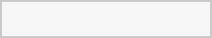 | Surface | #F7F7F8 | 247,247,248 | Cards, panels
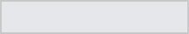 | Stroke | #E5E7EB | 229,231,235 | Borders, dividers
 | Hero Dark | #140415 | 20,4,21 | Hero gradient base
 | Hero Maroon | #5B182B | 91,24,43 | Hero gradient mid
 | Hero Highlight | #EF873E | 239,135,62 | Hero glow/accent
 | Hero Sand | #FCD297 | 252,210,151 | Hero light accent

3.1 Contrast & Accessibility
When placing text over brand colors, maintain WCAG contrast targets (AA at minimum). If contrast is uncertain, prefer dark text (#111111) on light surfaces and white text on dark hero backgrounds.

3.2 Gradients & Hero Background
The current hero/background art uses a dark-to-warm gradient family. Use it for splash screens, landing pages, and social headers.
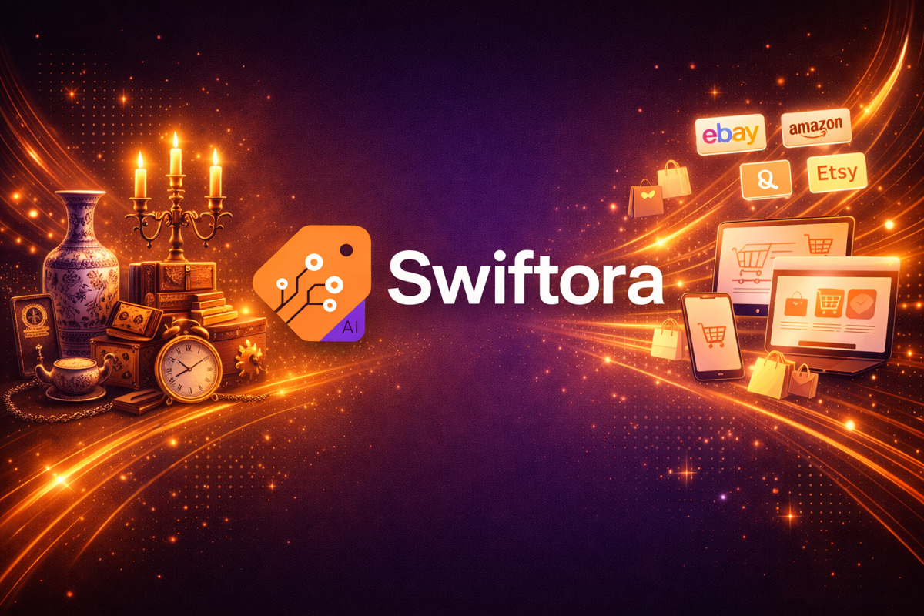

4. UI Design Tokens
Use tokens to keep the product consistent across components and pages.

4.1 Spacing
Spacing scale: 4, 8, 12, 16, 20, 24, 32 (px).

4.2 Radius
Radius: 16 (cards/buttons), 24 (modals).

4.3 Elevation
Elevation/shadows: 0 1 2 rgba(0,0,0,.06), 0 4 14 rgba(0,0,0,.10).

4.4 Component Guidance
Primary button: Brand Orange background; white text; 16 px radius.
Secondary button: transparent background; stroke #E5E7EB; text #111111.
Links/focus states: Brand Violet.

5. Typography
Typography is not yet fixed in the current project docs. Recommendation (until a final selection is made):
- UI: Inter (or system UI font stack). Marketing: Inter or a compatible geometric sans.
When a final font is selected, record: font family, weights, sizes, line heights, and fallback stack here.

6. Writing Style
Guidelines for product copy and marketing:
- Use short, scannable sentences and direct calls to action.
- Avoid hype language. Emphasize evidence, speed, and seller outcomes.
- Prefer concrete terms (median, range, sold comps) over vague claims.

7. Asset Checklist (For Engineers & Designers)
- SVG versions of icon-only, wordmark-only, and primary lockup.
- Monochrome variants (all-white and all-black).
- Favicon and app icon exports (16, 32, 48, 180, 512 px).
- CSS variables file containing tokens (colors, spacing, radius, elevation).
Owner: Swiftora (internal). Update this document whenever the logo or tokens change.

