Software Testing

Advanced Software Engineering

Flabia Shrestha  
c7189991

Bsc (hons). Computing L6

Documentation

**COMPONENT 1:**

**Circle**

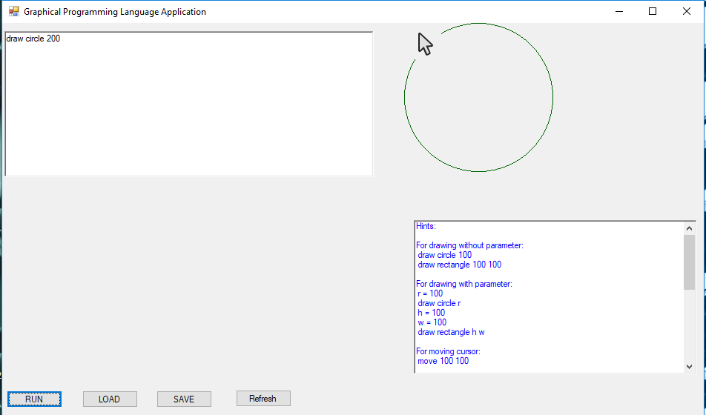

**Rectangle**

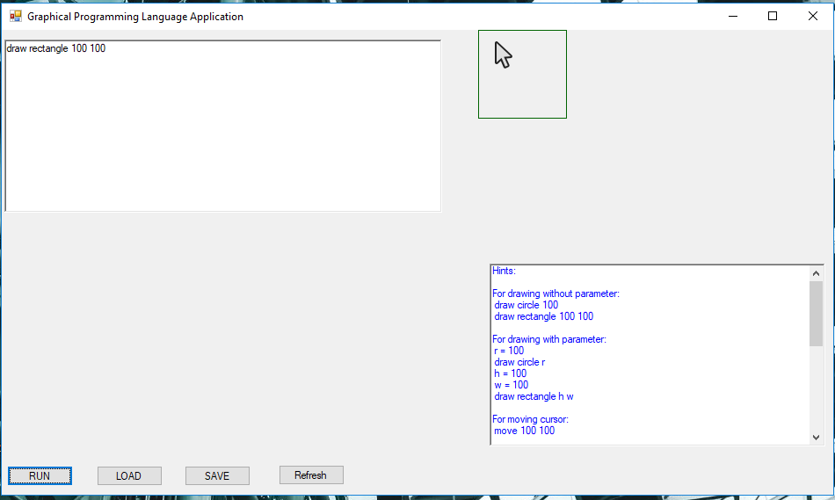

**Move to**

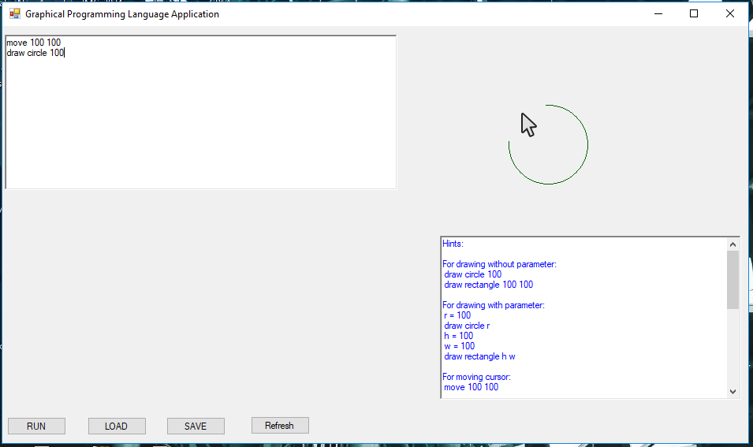

**Draw to**

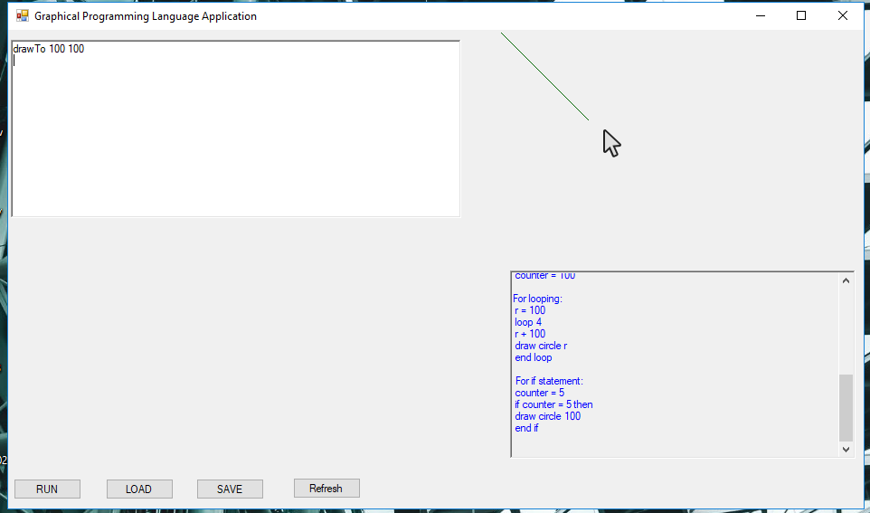

**Component 2**

**Setting Counter (r) = 250**

**Declaring variables**

**For drawing with parameter:**

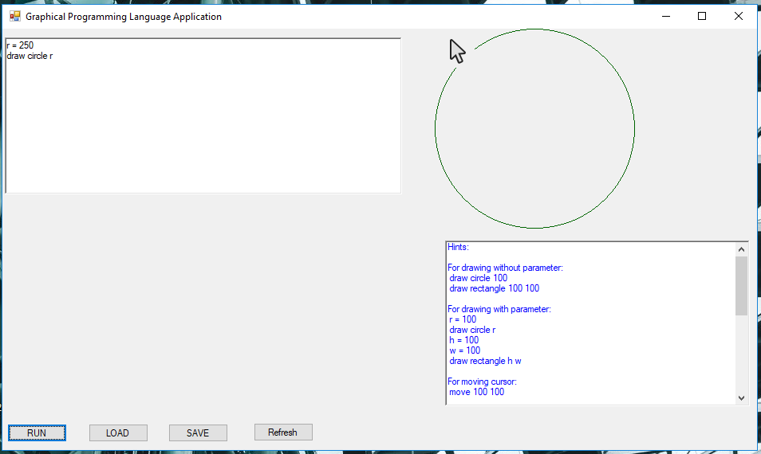

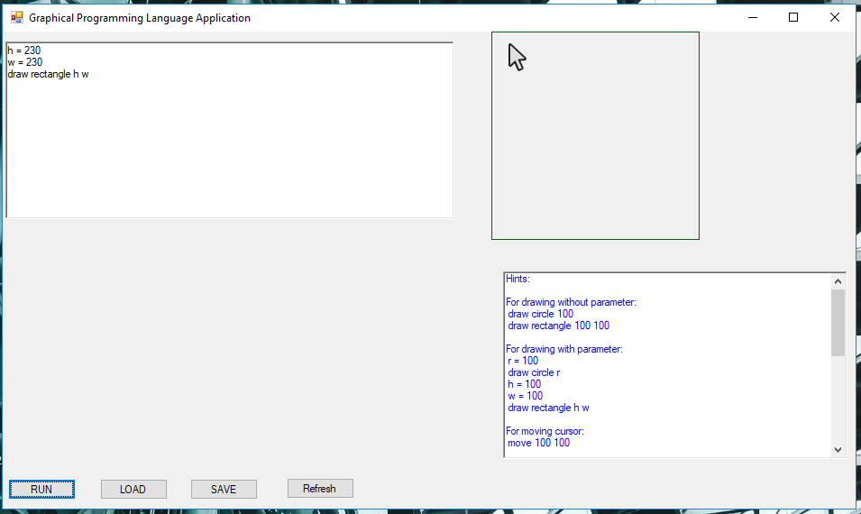

**If statement**

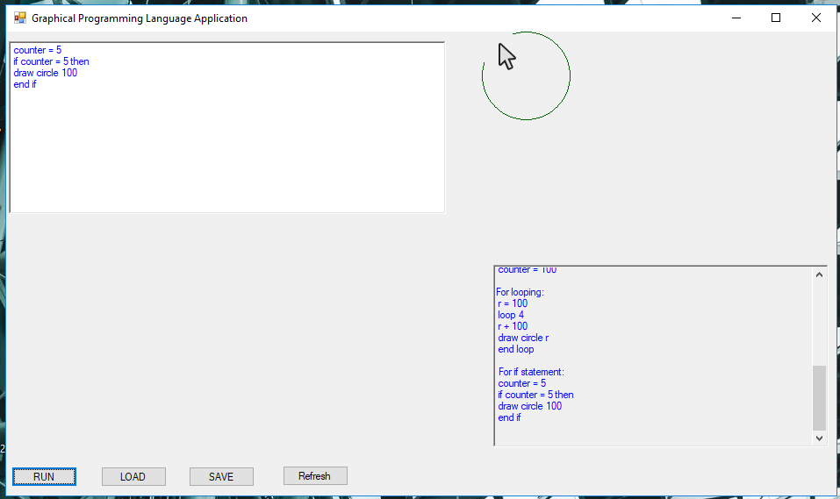

**Looping**

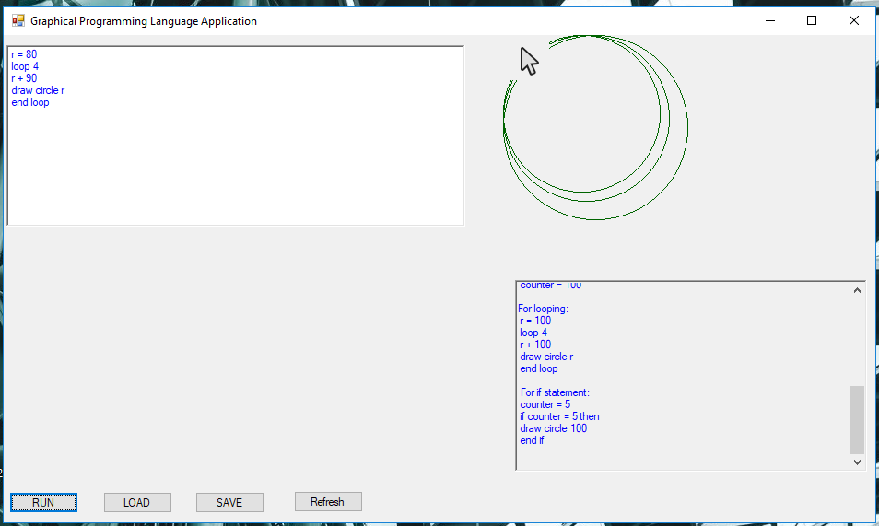

Unit Test

1. During first Testing we got 1 error out of 3 tests.

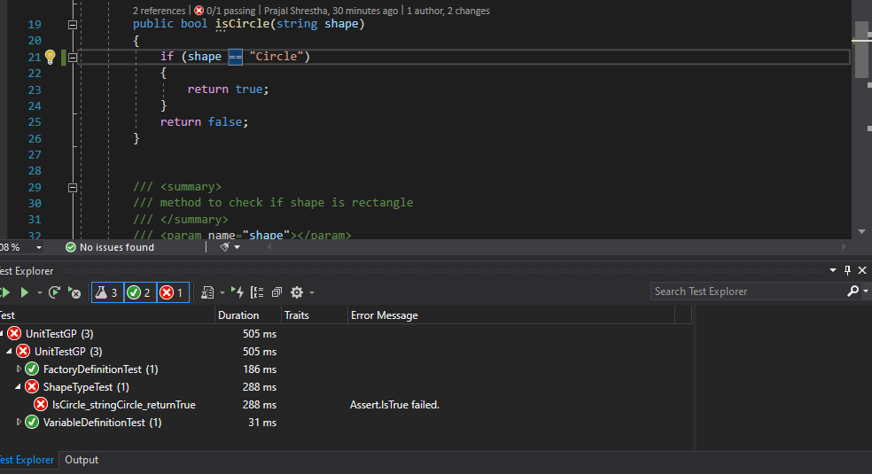The error was shown in *ShapeTypeTest.*

1. To fix the error we must find the root of the error namely *ShapeFactoryDefinition*. To fix write a simple implementation - just enough to pass the test.

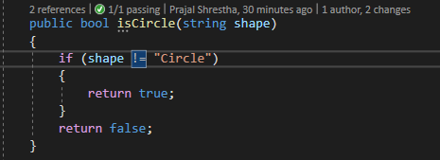

1. The final test results. All the testing was successful.

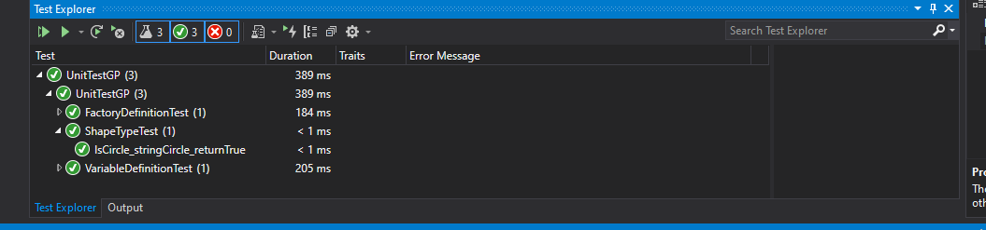

Test Case

|  |  |  |  |  |  |  |  |  |  |  |
| --- | --- | --- | --- | --- | --- | --- | --- | --- | --- | --- |
| Test Case ID | | GP_001 | Test Case Description | | Test to Draw Circle with parameter | | | | | |
| Created By | | Flabia | Reviewed By | | Devesh | | Version | | 1.0 | |
|  |  |  |  |  |  |  |  |  |  |  |
| QA Tester’s Log | | Review comments from P--l in version 1.0 | | | | | | | | |
|  |  |  |  |  |  |  |  |  |  |  |
| Tester’s Name | | Flabia | Date Tested | | 20-08-2020 | | Test Case (Pass/fail/Not) | | Pass | |
|  |  |  |  |  |  |  |  |  |  |  |
| S # | Prerequisites: | | |  | S # | Test Data | | | | |
| 1 | Drawing Circle | | |  | 1 | Draw Circle 200 | | | | |
| 2 |  | | |  | 2 | r = 200  draw circle r | | | | |
| 3 |  | | |  | 3 |  | | | | |
|  |  |  |  |  |  |  |  |  |  |  |
| Test Scenario | Validating and running to draw circle | | | | | | | | | |
|  |  |  |  |  |  |  |  |  |  |  |
| Step # | Step Details | | Expected Results | | Actual Results | | | Pass/Fail/Not executed/Suspended | | |
| 1 | Opening the program | | Application should Run | | As Expected | | | Pass | | |
| 2 | Enter code to draw circle | | Credential can be entered | | As Expected | | | Pass | | |
| 3 | Click Run | | Code is Executed | | As Expected | | | Pass | | |
| 4 | Click Clear | | Text Area and Panel cleared | | As Expected | | | Pass | | |

|  |  |  |  |  |  |  |  |  |  |  |
| --- | --- | --- | --- | --- | --- | --- | --- | --- | --- | --- |
| Test Case ID | | GP_002 | Test Case Description | | Test to Draw Rectangle with parameter | | | | | |
| Created By | | Flabia | Reviewed By | | Devesh | | Version | | 1.0 | |
|  |  |  |  |  |  |  |  |  |  |  |
| QA Tester’s Log | | Review comments from --- in version 1.0 | | | | | | | | |
|  |  |  |  |  |  |  |  |  |  |  |
| Tester’s Name | | Devesh | Date Tested | | 28-08-2020 | | Test Case (Pass/fail/Not) | | Pass | |
|  |  |  |  |  |  |  |  |  |  |  |
| S # | Prerequisites: | | |  | S # | Test Data | | | | |
| 1 | Drawing Rectangle | | |  | 1 | Draw rectangle 100 100 | | | | |
| 2 |  | | |  | 2 | h= 230  w=230  draw rectangle h w | | | | |
| 3 |  | | |  | 3 |  | | | | |
|  |  |  |  |  |  |  |  |  |  |  |
| Test Scenario | Validating and running to draw rectangle | | | | | | | | | |
|  |  |  |  |  |  |  |  |  |  |  |
| Step # | Step Details | | Expected Results | | Actual Results | | | Pass/Fail/Not executed/Suspended | | |
| 1 | Opening the program | | Application should Run | | As Expected | | | Pass | | |
| 2 | Enter code to draw rectangle | | Credential can be entered | | As Expected | | | Pass | | |
| 3 | Click Run | | Code is Executed | | As Expected | | | Pass | | |
| 4 | Click Clear | | Text Area and Panel cleared | | As Expected | | | Pass | | |

|  |  |  |  |  |  |  |  |  |  |  |
| --- | --- | --- | --- | --- | --- | --- | --- | --- | --- | --- |
| Test Case ID | | GP_003 | Test Case Description | | Test move pointer | | | | | |
| Created By | | Flabia | Reviewed By | | Devesh | | Version | | 1.0 | |
|  |  |  |  |  |  |  |  |  |  |  |
| QA Tester’s Log | | Review comments from ----- in version 1.0 | | | | | | | | |
|  |  |  |  |  |  |  |  |  |  |  |
| Tester’s Name | | Devesh | Date Tested | | 28-08-2020 | | Test Case (Pass/fail/Not) | | Fail | |
|  |  |  |  |  |  |  |  |  |  |  |
| S # | Prerequisites: | | |  | S # | Test Data | | | | |
| 1 | Moving Pointer | | |  | 1 | Moveto 100 100 | | | | |
| 2 |  | | |  | 2 | Move 10 5 | | | | |
| 3 |  | | |  | 3 |  | | | | |
|  |  |  |  |  |  |  |  |  |  |  |
| Test Scenario | Validating and running to draw rectangle | | | | | | | | | |
|  |  |  |  |  |  |  |  |  |  |  |
| Step # | Step Details | | Expected Results | | Actual Results | | | Pass/Fail/Not executed/Suspended | | |
| 1 | Opening the program | | Application should Run | | As Expected | | | Pass | | |
| 2 | Enter code to move pointer | | Credential can be entered | | As Expected | | | Pass | | |
| 3 | Enter another code to move pointer | | Credential can be entered | | Not as Expected | | | Fail | | |
| 4 | Click Run | | Code is Executed | | As Expected | | | Pass | | |
| 5 | Click Clear | | Text Area and Panel cleared | | As Expected | | | Pass | | |