library(tidyverse)

## ── Attaching packages ─────────────────────────────────────── tidyverse 1.3.1 ──

## ✔ ggplot2 3.3.6 ✔ purrr 0.3.4  
## ✔ tibble 3.1.7 ✔ dplyr 1.0.9  
## ✔ tidyr 1.2.0 ✔ stringr 1.4.0  
## ✔ readr 2.1.2 ✔ forcats 0.5.1

## ── Conflicts ────────────────────────────────────────── tidyverse_conflicts() ──  
## ✖ dplyr::filter() masks stats::filter()  
## ✖ dplyr::lag() masks stats::lag()

library(tidymodels)

## ── Attaching packages ────────────────────────────────────── tidymodels 0.2.0 ──

## ✔ broom 0.8.0 ✔ rsample 0.1.1  
## ✔ dials 0.1.1 ✔ tune 0.2.0  
## ✔ infer 1.0.0 ✔ workflows 0.2.6  
## ✔ modeldata 0.1.1 ✔ workflowsets 0.2.1  
## ✔ parsnip 0.2.1 ✔ yardstick 0.0.9  
## ✔ recipes 0.2.0

## ── Conflicts ───────────────────────────────────────── tidymodels_conflicts() ──  
## ✖ scales::discard() masks purrr::discard()  
## ✖ dplyr::filter() masks stats::filter()  
## ✖ recipes::fixed() masks stringr::fixed()  
## ✖ dplyr::lag() masks stats::lag()  
## ✖ yardstick::spec() masks readr::spec()  
## ✖ recipes::step() masks stats::step()  
## • Search for functions across packages at https://www.tidymodels.org/find/

library(GGally) #ggcorr and ggpairs

## Registered S3 method overwritten by 'GGally':  
## method from   
## +.gg ggplot2

library(ggcorrplot) #correlation plot alternative  
library(gridExtra) #create grids of plots

##   
## Attaching package: 'gridExtra'

## The following object is masked from 'package:dplyr':  
##   
## combine

ameso = read_csv("ames_student.csv")

## Rows: 2053 Columns: 81  
## ── Column specification ────────────────────────────────────────────────────────  
## Delimiter: ","  
## chr (47): MS_SubClass, MS_Zoning, Street, Alley, Lot_Shape, Land_Contour, Ut...  
## dbl (34): Lot_Frontage, Lot_Area, Year_Built, Year_Remod_Add, Mas_Vnr_Area, ...  
##   
## ℹ Use `spec()` to retrieve the full column specification for this data.  
## ℹ Specify the column types or set `show_col_types = FALSE` to quiet this message.

str(ameso)

## spec_tbl_df [2,053 × 81] (S3: spec_tbl_df/tbl_df/tbl/data.frame)  
## $ MS_SubClass : chr [1:2053] "One_Story_1946_and_Newer_All_Styles" "One_Story_1946_and_Newer_All_Styles" "One_Story_1946_and_Newer_All_Styles" "One_Story_1946_and_Newer_All_Styles" ...  
## $ MS_Zoning : chr [1:2053] "Residential_Low_Density" "Residential_High_Density" "Residential_Low_Density" "Residential_Low_Density" ...  
## $ Lot_Frontage : num [1:2053] 141 80 81 93 74 78 43 39 0 85 ...  
## $ Lot_Area : num [1:2053] 31770 11622 14267 11160 13830 ...  
## $ Street : chr [1:2053] "Pave" "Pave" "Pave" "Pave" ...  
## $ Alley : chr [1:2053] "No_Alley_Access" "No_Alley_Access" "No_Alley_Access" "No_Alley_Access" ...  
## $ Lot_Shape : chr [1:2053] "Slightly_Irregular" "Regular" "Slightly_Irregular" "Regular" ...  
## $ Land_Contour : chr [1:2053] "Lvl" "Lvl" "Lvl" "Lvl" ...  
## $ Utilities : chr [1:2053] "AllPub" "AllPub" "AllPub" "AllPub" ...  
## $ Lot_Config : chr [1:2053] "Corner" "Inside" "Corner" "Corner" ...  
## $ Land_Slope : chr [1:2053] "Gtl" "Gtl" "Gtl" "Gtl" ...  
## $ Neighborhood : chr [1:2053] "North_Ames" "North_Ames" "North_Ames" "North_Ames" ...  
## $ Condition_1 : chr [1:2053] "Norm" "Feedr" "Norm" "Norm" ...  
## $ Condition_2 : chr [1:2053] "Norm" "Norm" "Norm" "Norm" ...  
## $ Bldg_Type : chr [1:2053] "OneFam" "OneFam" "OneFam" "OneFam" ...  
## $ House_Style : chr [1:2053] "One_Story" "One_Story" "One_Story" "One_Story" ...  
## $ Overall_Qual : chr [1:2053] "Above_Average" "Average" "Above_Average" "Good" ...  
## $ Overall_Cond : chr [1:2053] "Average" "Above_Average" "Above_Average" "Average" ...  
## $ Year_Built : num [1:2053] 1960 1961 1958 1968 1997 ...  
## $ Year_Remod_Add : num [1:2053] 1960 1961 1958 1968 1998 ...  
## $ Roof_Style : chr [1:2053] "Hip" "Gable" "Hip" "Hip" ...  
## $ Roof_Matl : chr [1:2053] "CompShg" "CompShg" "CompShg" "CompShg" ...  
## $ Exterior_1st : chr [1:2053] "BrkFace" "VinylSd" "Wd Sdng" "BrkFace" ...  
## $ Exterior_2nd : chr [1:2053] "Plywood" "VinylSd" "Wd Sdng" "BrkFace" ...  
## $ Mas_Vnr_Type : chr [1:2053] "Stone" "None" "BrkFace" "None" ...  
## $ Mas_Vnr_Area : num [1:2053] 112 0 108 0 0 20 0 0 0 0 ...  
## $ Exter_Qual : chr [1:2053] "Typical" "Typical" "Typical" "Good" ...  
## $ Exter_Cond : chr [1:2053] "Typical" "Typical" "Typical" "Typical" ...  
## $ Foundation : chr [1:2053] "CBlock" "CBlock" "CBlock" "CBlock" ...  
## $ Bsmt_Qual : chr [1:2053] "Typical" "Typical" "Typical" "Typical" ...  
## $ Bsmt_Cond : chr [1:2053] "Good" "Typical" "Typical" "Typical" ...  
## $ Bsmt_Exposure : chr [1:2053] "Gd" "No" "No" "No" ...  
## $ BsmtFin_Type_1 : chr [1:2053] "BLQ" "Rec" "ALQ" "ALQ" ...  
## $ BsmtFin_SF_1 : num [1:2053] 2 6 1 1 3 3 1 3 1 3 ...  
## $ BsmtFin_Type_2 : chr [1:2053] "Unf" "LwQ" "Unf" "Unf" ...  
## $ BsmtFin_SF_2 : num [1:2053] 0 144 0 0 0 0 0 0 0 0 ...  
## $ Bsmt_Unf_SF : num [1:2053] 441 270 406 1045 137 ...  
## $ Total_Bsmt_SF : num [1:2053] 1080 882 1329 2110 928 ...  
## $ Heating : chr [1:2053] "GasA" "GasA" "GasA" "GasA" ...  
## $ Heating_QC : chr [1:2053] "Fair" "Typical" "Typical" "Excellent" ...  
## $ Central_Air : chr [1:2053] "Y" "Y" "Y" "Y" ...  
## $ Electrical : chr [1:2053] "SBrkr" "SBrkr" "SBrkr" "SBrkr" ...  
## $ First_Flr_SF : num [1:2053] 1656 896 1329 2110 928 ...  
## $ Second_Flr_SF : num [1:2053] 0 0 0 0 701 678 0 0 0 0 ...  
## $ Low_Qual_Fin_SF : num [1:2053] 0 0 0 0 0 0 0 0 0 0 ...  
## $ Gr_Liv_Area : num [1:2053] 1656 896 1329 2110 1629 ...  
## $ Bsmt_Full_Bath : num [1:2053] 1 0 0 1 0 0 0 1 1 1 ...  
## $ Bsmt_Half_Bath : num [1:2053] 0 0 0 0 0 0 0 0 0 0 ...  
## $ Full_Bath : num [1:2053] 1 1 1 2 2 2 2 2 2 1 ...  
## $ Half_Bath : num [1:2053] 0 0 1 1 1 1 0 0 0 1 ...  
## $ Bedroom_AbvGr : num [1:2053] 3 2 3 3 3 3 2 2 3 2 ...  
## $ Kitchen_AbvGr : num [1:2053] 1 1 1 1 1 1 1 1 1 1 ...  
## $ Kitchen_Qual : chr [1:2053] "Typical" "Typical" "Good" "Excellent" ...  
## $ TotRms_AbvGrd : num [1:2053] 7 5 6 8 6 7 5 5 6 5 ...  
## $ Functional : chr [1:2053] "Typ" "Typ" "Typ" "Typ" ...  
## $ Fireplaces : num [1:2053] 2 0 0 2 1 1 0 1 0 1 ...  
## $ Fireplace_Qu : chr [1:2053] "Good" "No_Fireplace" "No_Fireplace" "Typical" ...  
## $ Garage_Type : chr [1:2053] "Attchd" "Attchd" "Attchd" "Attchd" ...  
## $ Garage_Finish : chr [1:2053] "Fin" "Unf" "Unf" "Fin" ...  
## $ Garage_Cars : num [1:2053] 2 1 1 2 2 2 2 2 2 2 ...  
## $ Garage_Area : num [1:2053] 528 730 312 522 482 470 506 608 420 506 ...  
## $ Garage_Qual : chr [1:2053] "Typical" "Typical" "Typical" "Typical" ...  
## $ Garage_Cond : chr [1:2053] "Typical" "Typical" "Typical" "Typical" ...  
## $ Paved_Drive : chr [1:2053] "Partial_Pavement" "Paved" "Paved" "Paved" ...  
## $ Wood_Deck_SF : num [1:2053] 210 140 393 0 212 360 0 237 483 192 ...  
## $ Open_Porch_SF : num [1:2053] 62 0 36 0 34 36 82 152 21 0 ...  
## $ Enclosed_Porch : num [1:2053] 0 0 0 0 0 0 0 0 0 0 ...  
## $ Three_season_porch: num [1:2053] 0 0 0 0 0 0 0 0 0 0 ...  
## $ Screen_Porch : num [1:2053] 0 120 0 0 0 0 144 0 0 0 ...  
## $ Pool_Area : num [1:2053] 0 0 0 0 0 0 0 0 0 0 ...  
## $ Pool_QC : chr [1:2053] "No_Pool" "No_Pool" "No_Pool" "No_Pool" ...  
## $ Fence : chr [1:2053] "No_Fence" "Minimum_Privacy" "No_Fence" "No_Fence" ...  
## $ Misc_Feature : chr [1:2053] "None" "None" "Gar2" "None" ...  
## $ Misc_Val : num [1:2053] 0 0 12500 0 0 0 0 0 500 0 ...  
## $ Mo_Sold : num [1:2053] 5 6 6 4 3 6 1 3 3 2 ...  
## $ Year_Sold : num [1:2053] 2010 2010 2010 2010 2010 2010 2010 2010 2010 2010 ...  
## $ Sale_Type : chr [1:2053] "WD" "WD" "WD" "WD" ...  
## $ Sale_Condition : chr [1:2053] "Normal" "Normal" "Normal" "Normal" ...  
## $ Longitude : num [1:2053] -93.6 -93.6 -93.6 -93.6 -93.6 ...  
## $ Latitude : num [1:2053] 42.1 42.1 42.1 42.1 42.1 ...  
## $ Above_Median : chr [1:2053] "Yes" "No" "Yes" "Yes" ...  
## - attr(*, "spec")=  
## .. cols(  
## .. MS_SubClass = col_character(),  
## .. MS_Zoning = col_character(),  
## .. Lot_Frontage = col_double(),  
## .. Lot_Area = col_double(),  
## .. Street = col_character(),  
## .. Alley = col_character(),  
## .. Lot_Shape = col_character(),  
## .. Land_Contour = col_character(),  
## .. Utilities = col_character(),  
## .. Lot_Config = col_character(),  
## .. Land_Slope = col_character(),  
## .. Neighborhood = col_character(),  
## .. Condition_1 = col_character(),  
## .. Condition_2 = col_character(),  
## .. Bldg_Type = col_character(),  
## .. House_Style = col_character(),  
## .. Overall_Qual = col_character(),  
## .. Overall_Cond = col_character(),  
## .. Year_Built = col_double(),  
## .. Year_Remod_Add = col_double(),  
## .. Roof_Style = col_character(),  
## .. Roof_Matl = col_character(),  
## .. Exterior_1st = col_character(),  
## .. Exterior_2nd = col_character(),  
## .. Mas_Vnr_Type = col_character(),  
## .. Mas_Vnr_Area = col_double(),  
## .. Exter_Qual = col_character(),  
## .. Exter_Cond = col_character(),  
## .. Foundation = col_character(),  
## .. Bsmt_Qual = col_character(),  
## .. Bsmt_Cond = col_character(),  
## .. Bsmt_Exposure = col_character(),  
## .. BsmtFin_Type_1 = col_character(),  
## .. BsmtFin_SF_1 = col_double(),  
## .. BsmtFin_Type_2 = col_character(),  
## .. BsmtFin_SF_2 = col_double(),  
## .. Bsmt_Unf_SF = col_double(),  
## .. Total_Bsmt_SF = col_double(),  
## .. Heating = col_character(),  
## .. Heating_QC = col_character(),  
## .. Central_Air = col_character(),  
## .. Electrical = col_character(),  
## .. First_Flr_SF = col_double(),  
## .. Second_Flr_SF = col_double(),  
## .. Low_Qual_Fin_SF = col_double(),  
## .. Gr_Liv_Area = col_double(),  
## .. Bsmt_Full_Bath = col_double(),  
## .. Bsmt_Half_Bath = col_double(),  
## .. Full_Bath = col_double(),  
## .. Half_Bath = col_double(),  
## .. Bedroom_AbvGr = col_double(),  
## .. Kitchen_AbvGr = col_double(),  
## .. Kitchen_Qual = col_character(),  
## .. TotRms_AbvGrd = col_double(),  
## .. Functional = col_character(),  
## .. Fireplaces = col_double(),  
## .. Fireplace_Qu = col_character(),  
## .. Garage_Type = col_character(),  
## .. Garage_Finish = col_character(),  
## .. Garage_Cars = col_double(),  
## .. Garage_Area = col_double(),  
## .. Garage_Qual = col_character(),  
## .. Garage_Cond = col_character(),  
## .. Paved_Drive = col_character(),  
## .. Wood_Deck_SF = col_double(),  
## .. Open_Porch_SF = col_double(),  
## .. Enclosed_Porch = col_double(),  
## .. Three_season_porch = col_double(),  
## .. Screen_Porch = col_double(),  
## .. Pool_Area = col_double(),  
## .. Pool_QC = col_character(),  
## .. Fence = col_character(),  
## .. Misc_Feature = col_character(),  
## .. Misc_Val = col_double(),  
## .. Mo_Sold = col_double(),  
## .. Year_Sold = col_double(),  
## .. Sale_Type = col_character(),  
## .. Sale_Condition = col_character(),  
## .. Longitude = col_double(),  
## .. Latitude = col_double(),  
## .. Above_Median = col_character()  
## .. )  
## - attr(*, "problems")=<externalptr>

summary(ameso)

## MS_SubClass MS_Zoning Lot_Frontage Lot_Area   
## Length:2053 Length:2053 Min. : 0.00 Min. : 1300   
## Class :character Class :character 1st Qu.: 43.00 1st Qu.: 7500   
## Mode :character Mode :character Median : 62.00 Median : 9548   
## Mean : 57.38 Mean : 10258   
## 3rd Qu.: 78.00 3rd Qu.: 11600   
## Max. :313.00 Max. :215245   
## Street Alley Lot_Shape Land_Contour   
## Length:2053 Length:2053 Length:2053 Length:2053   
## Class :character Class :character Class :character Class :character   
## Mode :character Mode :character Mode :character Mode :character   
##   
##   
##   
## Utilities Lot_Config Land_Slope Neighborhood   
## Length:2053 Length:2053 Length:2053 Length:2053   
## Class :character Class :character Class :character Class :character   
## Mode :character Mode :character Mode :character Mode :character   
##   
##   
##   
## Condition_1 Condition_2 Bldg_Type House_Style   
## Length:2053 Length:2053 Length:2053 Length:2053   
## Class :character Class :character Class :character Class :character   
## Mode :character Mode :character Mode :character Mode :character   
##   
##   
##   
## Overall_Qual Overall_Cond Year_Built Year_Remod_Add  
## Length:2053 Length:2053 Min. :1875 Min. :1950   
## Class :character Class :character 1st Qu.:1953 1st Qu.:1965   
## Mode :character Mode :character Median :1972 Median :1993   
## Mean :1971 Mean :1984   
## 3rd Qu.:2000 3rd Qu.:2004   
## Max. :2010 Max. :2010   
## Roof_Style Roof_Matl Exterior_1st Exterior_2nd   
## Length:2053 Length:2053 Length:2053 Length:2053   
## Class :character Class :character Class :character Class :character   
## Mode :character Mode :character Mode :character Mode :character   
##   
##   
##   
## Mas_Vnr_Type Mas_Vnr_Area Exter_Qual Exter_Cond   
## Length:2053 Min. : 0.0 Length:2053 Length:2053   
## Class :character 1st Qu.: 0.0 Class :character Class :character   
## Mode :character Median : 0.0 Mode :character Mode :character   
## Mean : 103.8   
## 3rd Qu.: 164.0   
## Max. :1600.0   
## Foundation Bsmt_Qual Bsmt_Cond Bsmt_Exposure   
## Length:2053 Length:2053 Length:2053 Length:2053   
## Class :character Class :character Class :character Class :character   
## Mode :character Mode :character Mode :character Mode :character   
##   
##   
##   
## BsmtFin_Type_1 BsmtFin_SF_1 BsmtFin_Type_2 BsmtFin_SF_2   
## Length:2053 Min. :1.00 Length:2053 Min. : 0.00   
## Class :character 1st Qu.:3.00 Class :character 1st Qu.: 0.00   
## Mode :character Median :3.00 Mode :character Median : 0.00   
## Mean :4.21 Mean : 52.57   
## 3rd Qu.:7.00 3rd Qu.: 0.00   
## Max. :7.00 Max. :1526.00   
## Bsmt_Unf_SF Total_Bsmt_SF Heating Heating_QC   
## Min. : 0.0 Min. : 0 Length:2053 Length:2053   
## 1st Qu.: 226.0 1st Qu.: 793 Class :character Class :character   
## Median : 460.0 Median : 988 Mode :character Mode :character   
## Mean : 561.2 Mean :1055   
## 3rd Qu.: 801.0 3rd Qu.:1304   
## Max. :2336.0 Max. :5095   
## Central_Air Electrical First_Flr_SF Second_Flr_SF   
## Length:2053 Length:2053 Min. : 432 Min. : 0.0   
## Class :character Class :character 1st Qu.: 882 1st Qu.: 0.0   
## Mode :character Mode :character Median :1088 Median : 0.0   
## Mean :1168 Mean : 326.1   
## 3rd Qu.:1402 3rd Qu.: 701.0   
## Max. :5095 Max. :1862.0   
## Low_Qual_Fin_SF Gr_Liv_Area Bsmt_Full_Bath Bsmt_Half_Bath   
## Min. : 0.000 Min. : 480 Min. :0.0000 Min. :0.00000   
## 1st Qu.: 0.000 1st Qu.:1137 1st Qu.:0.0000 1st Qu.:0.00000   
## Median : 0.000 Median :1447 Median :0.0000 Median :0.00000   
## Mean : 4.973 Mean :1499 Mean :0.4301 Mean :0.05796   
## 3rd Qu.: 0.000 3rd Qu.:1737 3rd Qu.:1.0000 3rd Qu.:0.00000   
## Max. :1064.000 Max. :5095 Max. :3.0000 Max. :2.00000   
## Full_Bath Half_Bath Bedroom_AbvGr Kitchen_AbvGr   
## Min. :0.000 Min. :0.0000 Min. :0.000 Min. :1.000   
## 1st Qu.:1.000 1st Qu.:0.0000 1st Qu.:2.000 1st Qu.:1.000   
## Median :2.000 Median :0.0000 Median :3.000 Median :1.000   
## Mean :1.564 Mean :0.3751 Mean :2.855 Mean :1.047   
## 3rd Qu.:2.000 3rd Qu.:1.0000 3rd Qu.:3.000 3rd Qu.:1.000   
## Max. :4.000 Max. :2.0000 Max. :6.000 Max. :3.000   
## Kitchen_Qual TotRms_AbvGrd Functional Fireplaces   
## Length:2053 Min. : 3.000 Length:2053 Min. :0.000   
## Class :character 1st Qu.: 5.000 Class :character 1st Qu.:0.000   
## Mode :character Median : 6.000 Mode :character Median :1.000   
## Mean : 6.442 Mean :0.603   
## 3rd Qu.: 7.000 3rd Qu.:1.000   
## Max. :15.000 Max. :4.000   
## Fireplace_Qu Garage_Type Garage_Finish Garage_Cars   
## Length:2053 Length:2053 Length:2053 Min. :0.000   
## Class :character Class :character Class :character 1st Qu.:1.000   
## Mode :character Mode :character Mode :character Median :2.000   
## Mean :1.774   
## 3rd Qu.:2.000   
## Max. :5.000   
## Garage_Area Garage_Qual Garage_Cond Paved_Drive   
## Min. : 0 Length:2053 Length:2053 Length:2053   
## 1st Qu.: 320 Class :character Class :character Class :character   
## Median : 478 Mode :character Mode :character Mode :character   
## Mean : 472   
## 3rd Qu.: 576   
## Max. :1488   
## Wood_Deck_SF Open_Porch_SF Enclosed_Porch Three_season_porch  
## Min. : 0.00 Min. : 0.00 Min. : 0.00 Min. : 0.000   
## 1st Qu.: 0.00 1st Qu.: 0.00 1st Qu.: 0.00 1st Qu.: 0.000   
## Median : 0.00 Median : 27.00 Median : 0.00 Median : 0.000   
## Mean : 93.52 Mean : 48.17 Mean : 23.02 Mean : 2.799   
## 3rd Qu.: 168.00 3rd Qu.: 72.00 3rd Qu.: 0.00 3rd Qu.: 0.000   
## Max. :1424.00 Max. :742.00 Max. :584.00 Max. :407.000   
## Screen_Porch Pool_Area Pool_QC Fence   
## Min. : 0.00 Min. : 0.000 Length:2053 Length:2053   
## 1st Qu.: 0.00 1st Qu.: 0.000 Class :character Class :character   
## Median : 0.00 Median : 0.000 Mode :character Mode :character   
## Mean : 16.68 Mean : 1.339   
## 3rd Qu.: 0.00 3rd Qu.: 0.000   
## Max. :576.00 Max. :800.000   
## Misc_Feature Misc_Val Mo_Sold Year_Sold   
## Length:2053 Min. : 0.00 Min. : 1.000 Min. :2006   
## Class :character 1st Qu.: 0.00 1st Qu.: 4.000 1st Qu.:2007   
## Mode :character Median : 0.00 Median : 6.000 Median :2008   
## Mean : 60.12 Mean : 6.189 Mean :2008   
## 3rd Qu.: 0.00 3rd Qu.: 8.000 3rd Qu.:2009   
## Max. :17000.00 Max. :12.000 Max. :2010   
## Sale_Type Sale_Condition Longitude Latitude   
## Length:2053 Length:2053 Min. :-93.69 Min. :41.99   
## Class :character Class :character 1st Qu.:-93.66 1st Qu.:42.02   
## Mode :character Mode :character Median :-93.64 Median :42.03   
## Mean :-93.64 Mean :42.03   
## 3rd Qu.:-93.62 3rd Qu.:42.05   
## Max. :-93.58 Max. :42.06   
## Above_Median   
## Length:2053   
## Class :character   
## Mode :character   
##   
##   
##

ames = ameso %>% mutate(MS_SubClass = as_factor(MS_SubClass)) %>%  
 mutate(MS_Zoning = as_factor(MS_Zoning)) %>%  
 mutate(Street = as_factor(Street)) %>%  
 mutate(Alley = as_factor(Alley)) %>%  
 mutate(Lot_Shape = as_factor(Lot_Shape)) %>%  
 mutate(Land_Contour = as_factor(Land_Contour)) %>%  
 mutate(Utilities = as_factor(Utilities)) %>%  
 mutate(Lot_Config = as_factor(Lot_Config)) %>%  
 mutate(Land_Slope = as_factor(Land_Slope)) %>%  
 mutate(Neighborhood = as_factor(Neighborhood)) %>%  
 mutate(Condition_1 = as_factor(Condition_1)) %>%  
 mutate(Condition_2 = as_factor(Condition_2)) %>%  
 mutate(Bldg_Type = as_factor(Bldg_Type)) %>%  
 mutate(House_Style = as_factor(House_Style)) %>%  
 mutate(Overall_Qual = as_factor(Overall_Qual)) %>%  
 mutate(Overall_Cond = as_factor(Overall_Cond)) %>%  
 mutate(Roof_Style = as_factor(Roof_Style)) %>%  
 mutate(Roof_Matl = as_factor(Roof_Matl)) %>%  
 mutate(Exterior_1st = as_factor(Exterior_1st)) %>%  
 mutate(Exterior_2nd = as_factor(Exterior_2nd)) %>%  
 mutate(Mas_Vnr_Type = as_factor(Mas_Vnr_Type)) %>%  
 mutate(Exter_Qual = as_factor(Exter_Qual)) %>%  
 mutate(Exter_Cond = as_factor(Exter_Cond)) %>%  
 mutate(Foundation = as_factor(Foundation)) %>%  
 mutate(Bsmt_Qual = as_factor(Bsmt_Qual)) %>%  
 mutate(Bsmt_Cond = as_factor(Bsmt_Cond)) %>%  
 mutate(Bsmt_Exposure = as_factor(Bsmt_Exposure)) %>%  
 mutate(BsmtFin_Type_1 = as_factor(BsmtFin_Type_1)) %>%  
 mutate(BsmtFin_Type_2 = as_factor(BsmtFin_Type_2)) %>%  
 mutate(Heating = as_factor(Heating)) %>%  
 mutate(Heating_QC = as_factor(Heating_QC)) %>%  
 mutate(Central_Air = as_factor(Central_Air)) %>%  
 mutate(Electrical = as_factor(Electrical)) %>%  
 mutate(Kitchen_Qual = as_factor(Kitchen_Qual)) %>%  
 mutate(Functional = as_factor(Functional)) %>%  
 mutate(Fireplace_Qu = as_factor(Fireplace_Qu)) %>%  
 mutate(Garage_Type = as_factor(Garage_Type)) %>%  
 mutate(Garage_Finish = as_factor(Garage_Finish)) %>%  
 mutate(Garage_Cond = as_factor(Garage_Cond)) %>%  
 mutate(Garage_Qual = as_factor(Garage_Qual)) %>%  
 mutate(Paved_Drive = as_factor(Paved_Drive)) %>%  
 mutate(Pool_QC = as_factor(Pool_QC)) %>%  
 mutate(Fence = as_factor(Fence)) %>%  
 mutate(Misc_Feature = as_factor(Misc_Feature)) %>%  
 mutate(Sale_Type = as_factor(Sale_Type)) %>%  
 mutate(Sale_Condition = as_factor(Sale_Condition)) %>%  
 mutate(Above_Median = as_factor(Above_Median))  
 # mutate(Above_Median = fct_recode(Above_Median, "0" = "No", "1" = "Yes" ))  
   
   
   
# mutate(Survived = fct_recode(Survived, "No" = "0", "Yes" = "1" )) %>%  
# mutate(Pclass = as_factor(Pclass)) %>% mutate(Sex = as_factor(Sex))  
str(ames)

## tibble [2,053 × 81] (S3: tbl_df/tbl/data.frame)  
## $ MS_SubClass : Factor w/ 16 levels "One_Story_1946_and_Newer_All_Styles",..: 1 1 1 1 2 2 3 3 1 1 ...  
## $ MS_Zoning : Factor w/ 7 levels "Residential_Low_Density",..: 1 2 1 1 1 1 1 1 1 1 ...  
## $ Lot_Frontage : num [1:2053] 141 80 81 93 74 78 43 39 0 85 ...  
## $ Lot_Area : num [1:2053] 31770 11622 14267 11160 13830 ...  
## $ Street : Factor w/ 2 levels "Pave","Grvl": 1 1 1 1 1 1 1 1 1 1 ...  
## $ Alley : Factor w/ 3 levels "No_Alley_Access",..: 1 1 1 1 1 1 1 1 1 1 ...  
## $ Lot_Shape : Factor w/ 4 levels "Slightly_Irregular",..: 1 2 1 2 1 1 1 1 1 2 ...  
## $ Land_Contour : Factor w/ 4 levels "Lvl","HLS","Bnk",..: 1 1 1 1 1 1 2 1 1 1 ...  
## $ Utilities : Factor w/ 2 levels "AllPub","NoSewr": 1 1 1 1 1 1 1 1 1 1 ...  
## $ Lot_Config : Factor w/ 5 levels "Corner","Inside",..: 1 2 1 1 2 2 2 2 2 2 ...  
## $ Land_Slope : Factor w/ 3 levels "Gtl","Mod","Sev": 1 1 1 1 1 1 1 1 1 1 ...  
## $ Neighborhood : Factor w/ 28 levels "North_Ames","Gilbert",..: 1 1 1 1 2 2 3 3 2 2 ...  
## $ Condition_1 : Factor w/ 9 levels "Norm","Feedr",..: 1 2 1 1 1 1 1 1 1 1 ...  
## $ Condition_2 : Factor w/ 8 levels "Norm","Feedr",..: 1 1 1 1 1 1 1 1 1 1 ...  
## $ Bldg_Type : Factor w/ 5 levels "OneFam","TwnhsE",..: 1 1 1 1 1 1 2 2 1 1 ...  
## $ House_Style : Factor w/ 8 levels "One_Story","Two_Story",..: 1 1 1 1 2 2 1 1 1 1 ...  
## $ Overall_Qual : Factor w/ 10 levels "Above_Average",..: 1 2 1 3 2 1 4 4 1 3 ...  
## $ Overall_Cond : Factor w/ 9 levels "Average","Above_Average",..: 1 2 2 1 1 2 1 1 3 1 ...  
## $ Year_Built : num [1:2053] 1960 1961 1958 1968 1997 ...  
## $ Year_Remod_Add : num [1:2053] 1960 1961 1958 1968 1998 ...  
## $ Roof_Style : Factor w/ 6 levels "Hip","Gable",..: 1 2 1 1 2 2 2 2 2 2 ...  
## $ Roof_Matl : Factor w/ 6 levels "CompShg","WdShake",..: 1 1 1 1 1 1 1 1 1 1 ...  
## $ Exterior_1st : Factor w/ 16 levels "BrkFace","VinylSd",..: 1 2 3 1 2 2 4 5 4 4 ...  
## $ Exterior_2nd : Factor w/ 17 levels "Plywood","VinylSd",..: 1 2 3 4 2 2 5 6 5 5 ...  
## $ Mas_Vnr_Type : Factor w/ 5 levels "Stone","None",..: 1 2 3 2 2 3 2 2 2 2 ...  
## $ Mas_Vnr_Area : num [1:2053] 112 0 108 0 0 20 0 0 0 0 ...  
## $ Exter_Qual : Factor w/ 4 levels "Typical","Good",..: 1 1 1 2 1 1 2 2 1 1 ...  
## $ Exter_Cond : Factor w/ 5 levels "Typical","Good",..: 1 1 1 1 1 1 1 1 2 1 ...  
## $ Foundation : Factor w/ 6 levels "CBlock","PConc",..: 1 1 1 1 2 2 2 2 2 2 ...  
## $ Bsmt_Qual : Factor w/ 6 levels "Typical","Good",..: 1 1 1 1 2 1 2 2 2 2 ...  
## $ Bsmt_Cond : Factor w/ 6 levels "Good","Typical",..: 1 2 2 2 2 2 2 2 2 2 ...  
## $ Bsmt_Exposure : Factor w/ 5 levels "Gd","No","Av",..: 1 2 2 2 2 2 2 2 2 1 ...  
## $ BsmtFin_Type_1 : Factor w/ 7 levels "BLQ","Rec","ALQ",..: 1 2 3 3 4 4 3 4 3 4 ...  
## $ BsmtFin_SF_1 : num [1:2053] 2 6 1 1 3 3 1 3 1 3 ...  
## $ BsmtFin_Type_2 : Factor w/ 7 levels "Unf","LwQ","BLQ",..: 1 2 1 1 1 1 1 1 1 1 ...  
## $ BsmtFin_SF_2 : num [1:2053] 0 144 0 0 0 0 0 0 0 0 ...  
## $ Bsmt_Unf_SF : num [1:2053] 441 270 406 1045 137 ...  
## $ Total_Bsmt_SF : num [1:2053] 1080 882 1329 2110 928 ...  
## $ Heating : Factor w/ 6 levels "GasA","GasW",..: 1 1 1 1 1 1 1 1 1 1 ...  
## $ Heating_QC : Factor w/ 5 levels "Fair","Typical",..: 1 2 2 3 4 3 3 3 3 4 ...  
## $ Central_Air : Factor w/ 2 levels "Y","N": 1 1 1 1 1 1 1 1 1 1 ...  
## $ Electrical : Factor w/ 5 levels "SBrkr","FuseA",..: 1 1 1 1 1 1 1 1 1 1 ...  
## $ First_Flr_SF : num [1:2053] 1656 896 1329 2110 928 ...  
## $ Second_Flr_SF : num [1:2053] 0 0 0 0 701 678 0 0 0 0 ...  
## $ Low_Qual_Fin_SF : num [1:2053] 0 0 0 0 0 0 0 0 0 0 ...  
## $ Gr_Liv_Area : num [1:2053] 1656 896 1329 2110 1629 ...  
## $ Bsmt_Full_Bath : num [1:2053] 1 0 0 1 0 0 0 1 1 1 ...  
## $ Bsmt_Half_Bath : num [1:2053] 0 0 0 0 0 0 0 0 0 0 ...  
## $ Full_Bath : num [1:2053] 1 1 1 2 2 2 2 2 2 1 ...  
## $ Half_Bath : num [1:2053] 0 0 1 1 1 1 0 0 0 1 ...  
## $ Bedroom_AbvGr : num [1:2053] 3 2 3 3 3 3 2 2 3 2 ...  
## $ Kitchen_AbvGr : num [1:2053] 1 1 1 1 1 1 1 1 1 1 ...  
## $ Kitchen_Qual : Factor w/ 5 levels "Typical","Good",..: 1 1 2 3 1 2 2 2 1 2 ...  
## $ TotRms_AbvGrd : num [1:2053] 7 5 6 8 6 7 5 5 6 5 ...  
## $ Functional : Factor w/ 8 levels "Typ","Mod","Min2",..: 1 1 1 1 1 1 1 1 1 1 ...  
## $ Fireplaces : num [1:2053] 2 0 0 2 1 1 0 1 0 1 ...  
## $ Fireplace_Qu : Factor w/ 6 levels "Good","No_Fireplace",..: 1 2 2 3 3 1 2 3 2 4 ...  
## $ Garage_Type : Factor w/ 7 levels "Attchd","BuiltIn",..: 1 1 1 1 1 1 1 1 1 1 ...  
## $ Garage_Finish : Factor w/ 4 levels "Fin","Unf","RFn",..: 1 2 2 1 1 1 3 3 1 2 ...  
## $ Garage_Cars : num [1:2053] 2 1 1 2 2 2 2 2 2 2 ...  
## $ Garage_Area : num [1:2053] 528 730 312 522 482 470 506 608 420 506 ...  
## $ Garage_Qual : Factor w/ 6 levels "Typical","No_Garage",..: 1 1 1 1 1 1 1 1 1 1 ...  
## $ Garage_Cond : Factor w/ 6 levels "Typical","No_Garage",..: 1 1 1 1 1 1 1 1 1 1 ...  
## $ Paved_Drive : Factor w/ 3 levels "Partial_Pavement",..: 1 2 2 2 2 2 2 2 2 2 ...  
## $ Wood_Deck_SF : num [1:2053] 210 140 393 0 212 360 0 237 483 192 ...  
## $ Open_Porch_SF : num [1:2053] 62 0 36 0 34 36 82 152 21 0 ...  
## $ Enclosed_Porch : num [1:2053] 0 0 0 0 0 0 0 0 0 0 ...  
## $ Three_season_porch: num [1:2053] 0 0 0 0 0 0 0 0 0 0 ...  
## $ Screen_Porch : num [1:2053] 0 120 0 0 0 0 144 0 0 0 ...  
## $ Pool_Area : num [1:2053] 0 0 0 0 0 0 0 0 0 0 ...  
## $ Pool_QC : Factor w/ 5 levels "No_Pool","Excellent",..: 1 1 1 1 1 1 1 1 1 1 ...  
## $ Fence : Factor w/ 5 levels "No_Fence","Minimum_Privacy",..: 1 2 1 1 2 1 1 1 3 1 ...  
## $ Misc_Feature : Factor w/ 5 levels "None","Gar2",..: 1 1 2 1 1 1 1 1 3 1 ...  
## $ Misc_Val : num [1:2053] 0 0 12500 0 0 0 0 0 500 0 ...  
## $ Mo_Sold : num [1:2053] 5 6 6 4 3 6 1 3 3 2 ...  
## $ Year_Sold : num [1:2053] 2010 2010 2010 2010 2010 2010 2010 2010 2010 2010 ...  
## $ Sale_Type : Factor w/ 10 levels "WD","New","COD",..: 1 1 1 1 1 1 1 1 1 1 ...  
## $ Sale_Condition : Factor w/ 6 levels "Normal","Partial",..: 1 1 1 1 1 1 1 1 1 1 ...  
## $ Longitude : num [1:2053] -93.6 -93.6 -93.6 -93.6 -93.6 ...  
## $ Latitude : num [1:2053] 42.1 42.1 42.1 42.1 42.1 ...  
## $ Above_Median : Factor w/ 2 levels "Yes","No": 1 2 1 1 1 1 1 1 1 1 ...

should split columns into groups to make more managable - date and time -location -land -internal & external features -basement -General house stats?

amesf_date = ames %>%  
 select( Neighborhood,Year_Built, Year_Remod_Add, Mo_Sold, Year_Sold, Sale_Type, Sale_Condition, Above_Median)  
  
amesf_exft = ames %>%  
 select(Neighborhood ,Garage_Type, Garage_Finish, Garage_Cond, Garage_Qual, Garage_Cars, Garage_Area, Paved_Drive, Wood_Deck_SF, Open_Porch_SF, Enclosed_Porch, Three_season_porch, Screen_Porch, Pool_Area, Pool_QC, Fence, Misc_Feature, Misc_Val, Above_Median)  
  
amesf_house = ames %>%  
 select(Neighborhood,Bldg_Type, House_Style, Overall_Qual, Overall_Cond ,Above_Median)  
  
amesf_bas = ames %>%  
 select(Neighborhood,Foundation, Bsmt_Qual, Bsmt_Cond, Bsmt_Exposure, BsmtFin_Type_1, BsmtFin_SF_1, BsmtFin_Type_2, BsmtFin_SF_2,Bsmt_Unf_SF, Total_Bsmt_SF ,Above_Median)  
  
amesf_exhs = ames %>%  
 select(Neighborhood,Roof_Style, Roof_Matl, Exterior_1st, Exterior_2nd, Mas_Vnr_Type, Mas_Vnr_Area, Exter_Qual, Exter_Cond ,Above_Median)  
  
amesf_inft = ames %>%  
 select(Neighborhood, Heating, Heating_QC, Central_Air, Electrical, First_Flr_SF, Second_Flr_SF, Low_Qual_Fin_SF, Gr_Liv_Area, Bsmt_Full_Bath, Bsmt_Half_Bath, Bedroom_AbvGr, Kitchen_AbvGr, Kitchen_Qual, TotRms_AbvGrd, Functional, Fireplaces, Fireplace_Qu ,Above_Median)  
  
amesf_land = ames %>%  
 select(Neighborhood, Lot_Frontage, Lot_Area, Lot_Shape, Land_Contour, Lot_Config, Land_Slope ,Above_Median)  
  
amesf_location = ames %>%  
 select( Neighborhood,MS_Zoning, Street, Alley, Utilities, Condition_1, Condition_2, Longitude, Latitude ,Above_Median)  
  
amesf_ult = ames %>%  
 select(Neighborhood,Bsmt_Qual, Garage_Type, Garage_Finish, Paved_Drive, Lot_Shape, Exterior_1st, Exterior_2nd, Mas_Vnr_Type, Exter_Qual, Overall_Qual, Fireplaces, Fireplace_Qu, MS_Zoning, Above_Median)

ggpairs(amesf_land, columns = 5:8)+ theme(axis.text.x = element_text(angle = 90, vjust = 0.5, hjust=1))

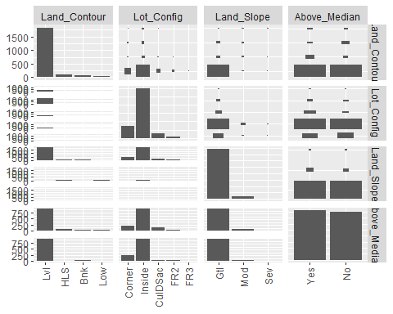

ggpairs(amesf_land, columns = c(2,3,4,8))+ theme(axis.text.x = element_text(angle = 90, vjust = 0.5, hjust=1))

## `stat_bin()` using `bins = 30`. Pick better value with `binwidth`.  
## `stat_bin()` using `bins = 30`. Pick better value with `binwidth`.  
## `stat_bin()` using `bins = 30`. Pick better value with `binwidth`.  
## `stat_bin()` using `bins = 30`. Pick better value with `binwidth`.

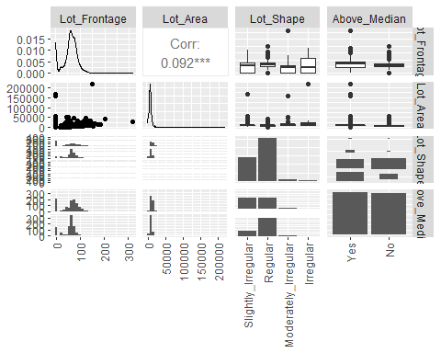

ggpairs(amesf_date, columns = c(2:4,8)) + theme(axis.text.x = element_text(angle = 90, vjust = 0.5, hjust=1))

## `stat_bin()` using `bins = 30`. Pick better value with `binwidth`.  
## `stat_bin()` using `bins = 30`. Pick better value with `binwidth`.  
## `stat_bin()` using `bins = 30`. Pick better value with `binwidth`.

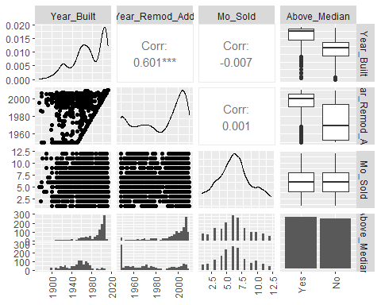

ggpairs(amesf_date, columns = c(5:8)) + theme(axis.text.x = element_text(angle = 90, vjust = 0.5, hjust=1))

## `stat_bin()` using `bins = 30`. Pick better value with `binwidth`.  
## `stat_bin()` using `bins = 30`. Pick better value with `binwidth`.  
## `stat_bin()` using `bins = 30`. Pick better value with `binwidth`.

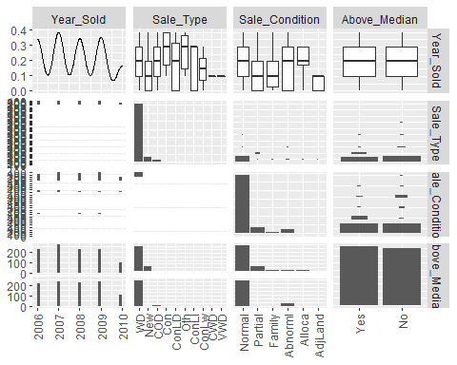

ggpairs(amesf_bas, columns = c(2:4,12)) + theme(axis.text.x = element_text(angle = 90, vjust = 0.5, hjust=1))

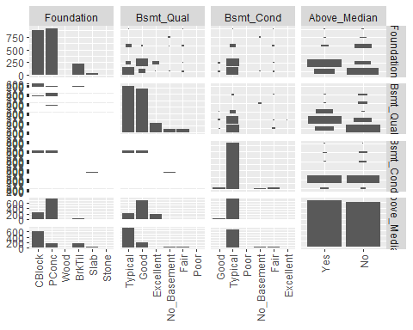

ggpairs(amesf_bas, columns = c(5:8, 12)) + theme(axis.text.x = element_text(angle = 90, vjust = 0.5, hjust=1))

## `stat_bin()` using `bins = 30`. Pick better value with `binwidth`.  
## `stat_bin()` using `bins = 30`. Pick better value with `binwidth`.  
## `stat_bin()` using `bins = 30`. Pick better value with `binwidth`.  
## `stat_bin()` using `bins = 30`. Pick better value with `binwidth`.

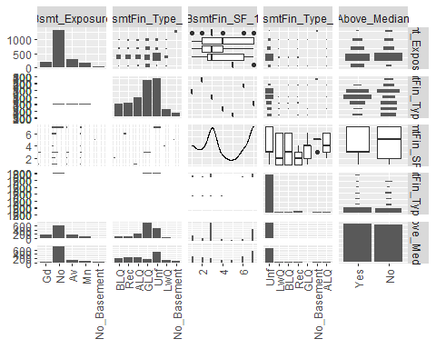

ggpairs(amesf_bas, columns = c(9:12)) + theme(axis.text.x = element_text(angle = 90, vjust = 0.5, hjust=1))

## `stat_bin()` using `bins = 30`. Pick better value with `binwidth`.  
## `stat_bin()` using `bins = 30`. Pick better value with `binwidth`.  
## `stat_bin()` using `bins = 30`. Pick better value with `binwidth`.

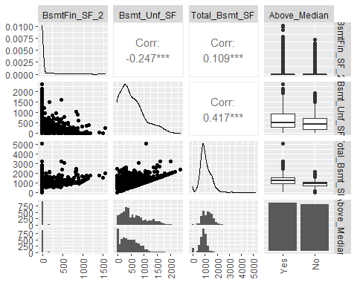

ggpairs(amesf_exft, columns = c(2:4,19)) + theme(axis.text.x = element_text(angle = 90, vjust = 0.5, hjust=1))

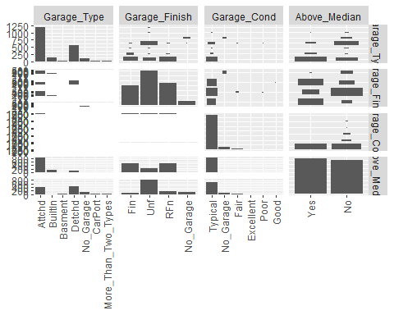

ggpairs(amesf_exft, columns = c(5:8,19)) + theme(axis.text.x = element_text(angle = 90, vjust = 0.5, hjust=1))

## `stat_bin()` using `bins = 30`. Pick better value with `binwidth`.  
## `stat_bin()` using `bins = 30`. Pick better value with `binwidth`.  
## `stat_bin()` using `bins = 30`. Pick better value with `binwidth`.  
## `stat_bin()` using `bins = 30`. Pick better value with `binwidth`.  
## `stat_bin()` using `bins = 30`. Pick better value with `binwidth`.  
## `stat_bin()` using `bins = 30`. Pick better value with `binwidth`.

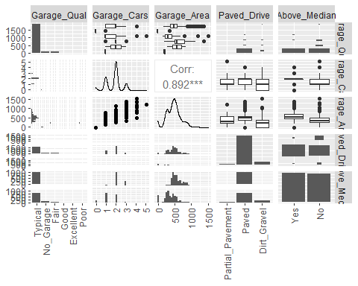

ggpairs(amesf_exft, columns = c(9:12,19)) + theme(axis.text.x = element_text(angle = 90, vjust = 0.5, hjust=1))

## `stat_bin()` using `bins = 30`. Pick better value with `binwidth`.  
## `stat_bin()` using `bins = 30`. Pick better value with `binwidth`.  
## `stat_bin()` using `bins = 30`. Pick better value with `binwidth`.  
## `stat_bin()` using `bins = 30`. Pick better value with `binwidth`.

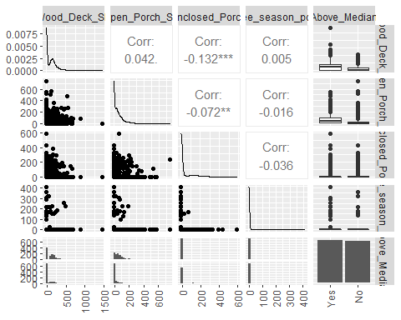

ggpairs(amesf_exft, columns = c(13:16,19)) + theme(axis.text.x = element_text(angle = 90, vjust = 0.5, hjust=1))

## `stat_bin()` using `bins = 30`. Pick better value with `binwidth`.  
## `stat_bin()` using `bins = 30`. Pick better value with `binwidth`.  
## `stat_bin()` using `bins = 30`. Pick better value with `binwidth`.  
## `stat_bin()` using `bins = 30`. Pick better value with `binwidth`.  
## `stat_bin()` using `bins = 30`. Pick better value with `binwidth`.  
## `stat_bin()` using `bins = 30`. Pick better value with `binwidth`.

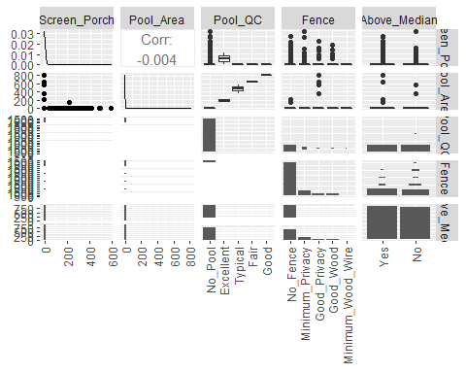

ggpairs(amesf_exft, columns = c(16:19)) + theme(axis.text.x = element_text(angle = 90, vjust = 0.5, hjust=1))

## `stat_bin()` using `bins = 30`. Pick better value with `binwidth`.  
## `stat_bin()` using `bins = 30`. Pick better value with `binwidth`.  
## `stat_bin()` using `bins = 30`. Pick better value with `binwidth`.

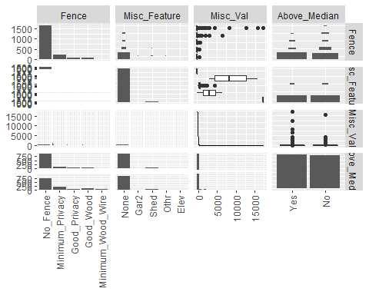

ggpairs(amesf_exhs, columns = c(2:4,10), cardinality_threshold = 16) + theme(axis.text.x = element_text(angle = 90, vjust = 0.5, hjust=1))

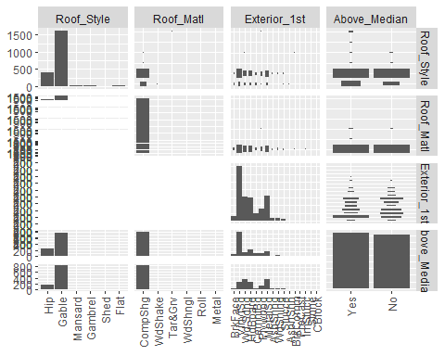

ggpairs(amesf_exhs, columns = c(5:7,10), cardinality_threshold = 17) + theme(axis.text.x = element_text(angle = 90, vjust = 0.5, hjust=1))

## `stat_bin()` using `bins = 30`. Pick better value with `binwidth`.  
## `stat_bin()` using `bins = 30`. Pick better value with `binwidth`.  
## `stat_bin()` using `bins = 30`. Pick better value with `binwidth`.

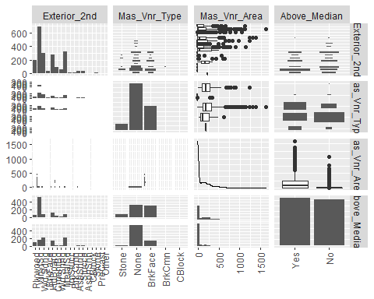

ggpairs(amesf_exhs, columns = c(8:10)) + theme(axis.text.x = element_text(angle = 90, vjust = 0.5, hjust=1))

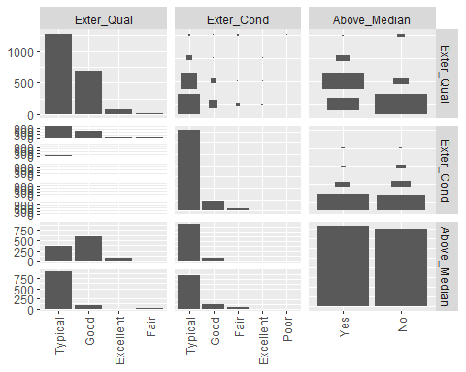

ggpairs(amesf_house, columns = c(2,3,6)) + theme(axis.text.x = element_text(angle = 90, vjust = 0.5, hjust=1))

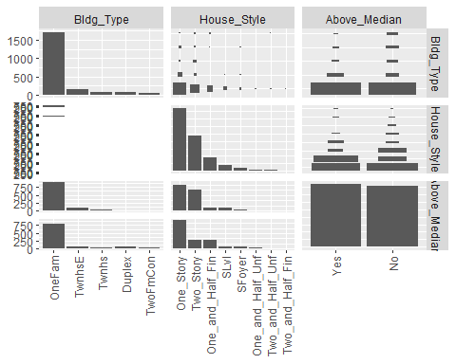

ggpairs(amesf_house, columns = c(4:6)) + theme(axis.text.x = element_text(angle = 90, vjust = 0.5, hjust=1))

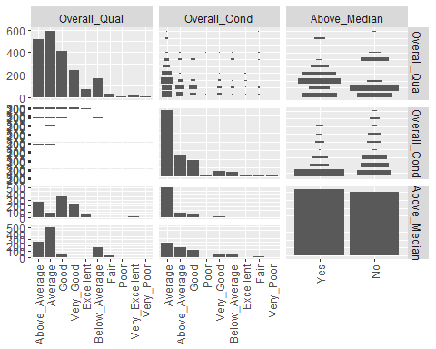

ggpairs(amesf_inft, columns = c(2:4,19)) + theme(axis.text.x = element_text(angle = 90, vjust = 0.5, hjust=1))

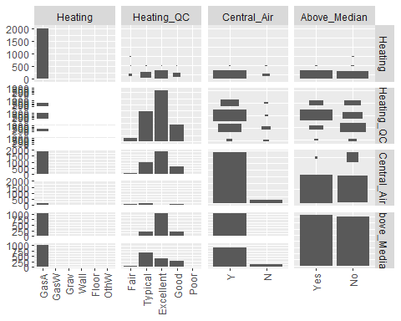

ggpairs(amesf_inft, columns = c(5:8,19)) + theme(axis.text.x = element_text(angle = 90, vjust = 0.5, hjust=1))

## `stat_bin()` using `bins = 30`. Pick better value with `binwidth`.  
## `stat_bin()` using `bins = 30`. Pick better value with `binwidth`.  
## `stat_bin()` using `bins = 30`. Pick better value with `binwidth`.  
## `stat_bin()` using `bins = 30`. Pick better value with `binwidth`.  
## `stat_bin()` using `bins = 30`. Pick better value with `binwidth`.  
## `stat_bin()` using `bins = 30`. Pick better value with `binwidth`.

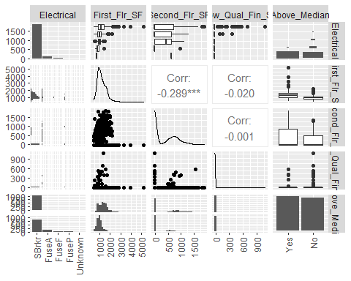

ggpairs(amesf_inft, columns = c(9:12,19)) + theme(axis.text.x = element_text(angle = 90, vjust = 0.5, hjust=1))

## `stat_bin()` using `bins = 30`. Pick better value with `binwidth`.  
## `stat_bin()` using `bins = 30`. Pick better value with `binwidth`.  
## `stat_bin()` using `bins = 30`. Pick better value with `binwidth`.  
## `stat_bin()` using `bins = 30`. Pick better value with `binwidth`.

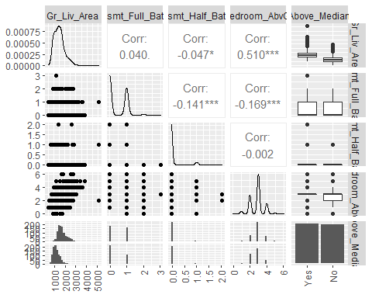

ggpairs(amesf_inft, columns = c(13:16,19)) + theme(axis.text.x = element_text(angle = 90, vjust = 0.5, hjust=1))

## `stat_bin()` using `bins = 30`. Pick better value with `binwidth`.  
## `stat_bin()` using `bins = 30`. Pick better value with `binwidth`.  
## `stat_bin()` using `bins = 30`. Pick better value with `binwidth`.  
## `stat_bin()` using `bins = 30`. Pick better value with `binwidth`.  
## `stat_bin()` using `bins = 30`. Pick better value with `binwidth`.  
## `stat_bin()` using `bins = 30`. Pick better value with `binwidth`.

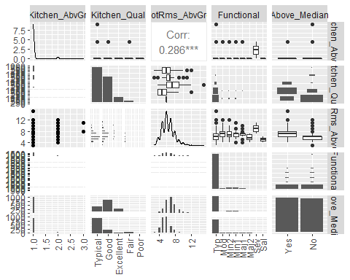

ggpairs(amesf_inft, columns = c(16:19)) + theme(axis.text.x = element_text(angle = 90, vjust = 0.5, hjust=1))

## `stat_bin()` using `bins = 30`. Pick better value with `binwidth`.  
## `stat_bin()` using `bins = 30`. Pick better value with `binwidth`.  
## `stat_bin()` using `bins = 30`. Pick better value with `binwidth`.

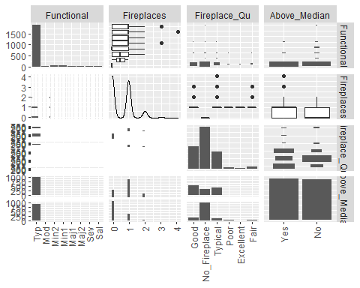

ggpairs(amesf_location, columns = c(2:4,10)) + theme(axis.text.x = element_text(angle = 90, vjust = 0.5, hjust=1))

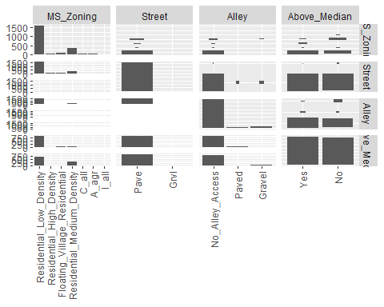

ggpairs(amesf_location, columns = c(5:7,10)) + theme(axis.text.x = element_text(angle = 90, vjust = 0.5, hjust=1))

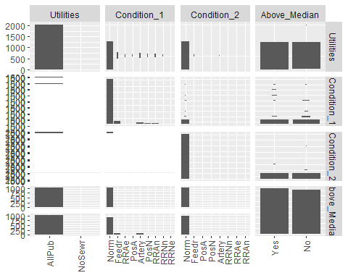

ggpairs(amesf_location, columns = c(8:10)) + theme(axis.text.x = element_text(angle = 90, vjust = 0.5, hjust=1))

## `stat_bin()` using `bins = 30`. Pick better value with `binwidth`.  
## `stat_bin()` using `bins = 30`. Pick better value with `binwidth`.

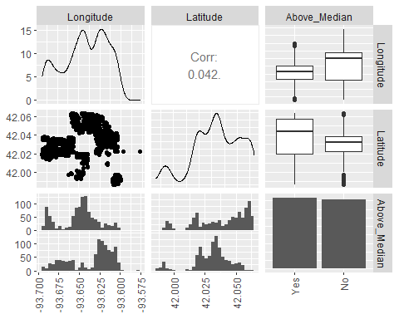

ggpairs(amesf_location, columns = c(1,10), cardinality_threshold = 28) + theme(axis.text.x = element_text(angle = 90, vjust = 0.5, hjust=1))

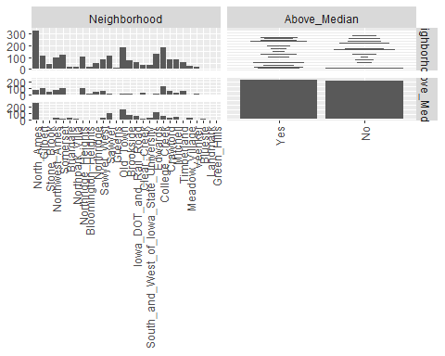

Most important variables:

Basement Quality Garage Type Garage Finish Paved Drive Lot Shape

Exterior 1? Exterior 2?

Mas_Vnr_Type External Quality Overall Quality Fireplaces Fireplace Quality Zoning Neighborhood

ggpairs(amesf_ult, columns = c(2:4,15)) + theme(axis.text.x = element_text(angle = 90, vjust = 0.5, hjust=1))

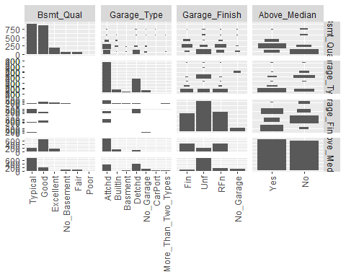

ggpairs(amesf_ult, columns = c(5:7,15), cardinality_threshold = 17) + theme(axis.text.x = element_text(angle = 90, vjust = 0.5, hjust=1))

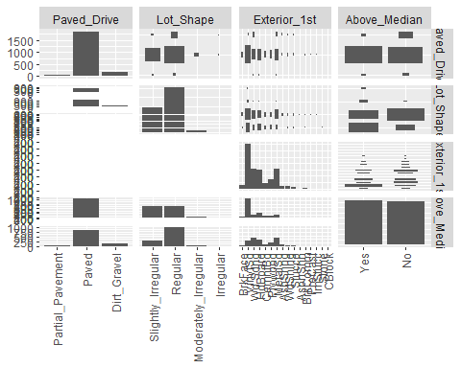

ggpairs(amesf_ult, columns = c(8:10,15), cardinality_threshold = 17) + theme(axis.text.x = element_text(angle = 90, vjust = 0.5, hjust=1))

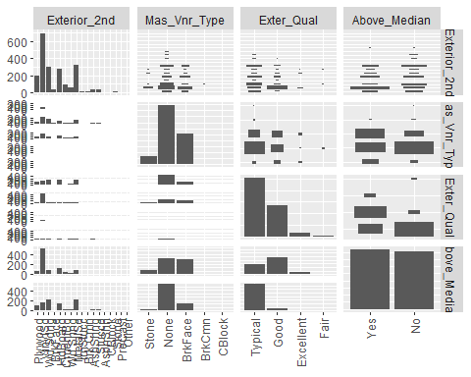

ggpairs(amesf_ult, columns = c(11:13,15)) + theme(axis.text.x = element_text(angle = 90, vjust = 0.5, hjust=1))

## `stat_bin()` using `bins = 30`. Pick better value with `binwidth`.  
## `stat_bin()` using `bins = 30`. Pick better value with `binwidth`.  
## `stat_bin()` using `bins = 30`. Pick better value with `binwidth`.

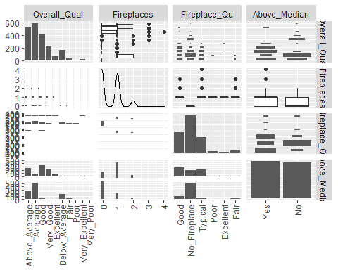

ggpairs(amesf_ult, columns = c(14:15)) + theme(axis.text.x = element_text(angle = 90, vjust = 0.5, hjust=1))

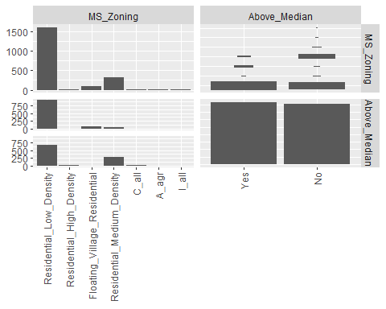

amespres = ames %>%  
 select(Overall_Qual, Exter_Qual, Bsmt_Qual,Fireplace_Qu, Above_Median)  
 ggpairs(amespres)

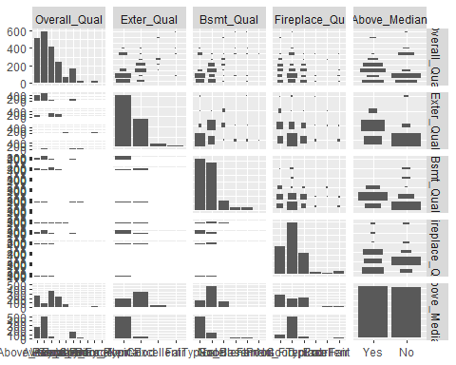

#ggplot(ames_loc2, aes(x=Neighborhood, Y= n)) +   
# geom_bar()  
#  
#ggplot(ames_loc2_y, aes(x=Neighborhood,y=n)) + geom_point(alpha=0.1)   
#  
#ggplot(ames_loc2_y, aes(x)) + geom_histogram()  
  
# Grouped  
#ggplot(data, aes(fill=condition, y=value, x=specie)) +   
 # geom_bar(position="dodge", stat="identity")  
  
# Stacked  
#ggplot(data, aes(fill=condition, y=value, x=specie)) +   
 # geom_bar(position="stack", stat="identity")  
  
# Stacked + percent  
#ggplot(data, aes(fill=condition, y=value, x=specie)) +   
 # geom_bar(position="fill", stat="identity")

ggplot(ames, aes(y=Fireplaces, fill=Above_Median, x=Fireplace_Qu)) +  
 ggtitle("Fireplaces and Quality") +  
 xlab("Fireplace Quality") + ylab("Number of Firplaces") +   
 labs(fill = "Above Median Price?") +  
 geom_bar(position="dodge", stat="identity")+   
 theme(axis.text.x = element_text(angle = 90, vjust = 0.5, hjust=1))

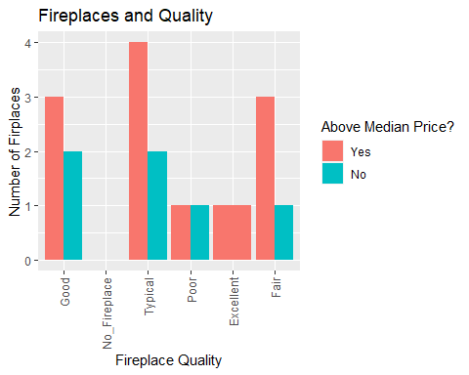

ggplot(ames, aes(fill=Above_Median, y=Garage_Type, x=Garage_Finish)) +  
ggtitle("Garage Type and Finish") +  
 xlab("Garage Finish") + ylab("Garage Type") +   
 labs(fill = "Above Median Price?") +  
 geom_bar(position="dodge", stat="identity")+   
 theme(axis.text.x = element_text(angle = 90, vjust = 0.5, hjust=1))

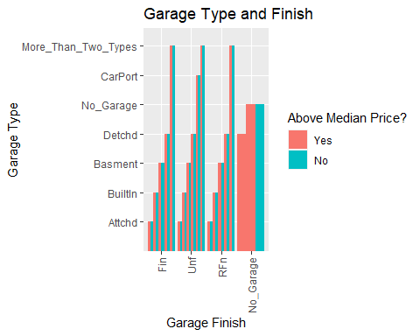

ggplot(ames, aes(fill=Above_Median, x=Exter_Qual, y=Overall_Qual)) +   
 ggtitle("External and Overall Quality of a house") +  
 xlab("External Quality") + ylab("Overall Quality") +   
 labs(fill = "Above Median Price?") +  
 geom_bar(position="dodge", stat="identity")+   
 theme(axis.text.x = element_text(angle = 90, vjust = 0.5, hjust=1))

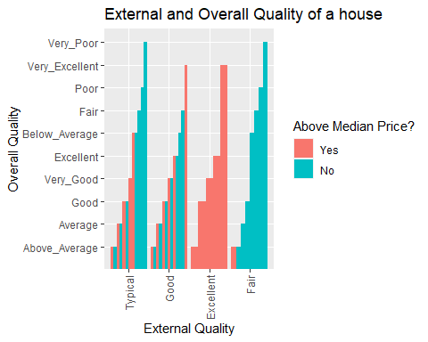

ggplot(ames, aes(fill=Above_Median, y=Exterior_1st, x=Exter_Qual)) +  
 ggtitle("Set 1 of Exterior paneling") +  
 xlab("External Quality") + ylab("Paneling Type") +   
 labs(fill = "Above Median Price?") +  
 geom_bar(position="dodge", stat="identity") +   
 theme(axis.text.x = element_text(angle = 90, vjust = 0.5, hjust=1))

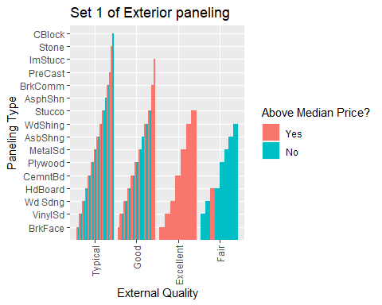

ggplot(ames, aes(fill=Above_Median, y=Garage_Type, x=Exter_Qual)) +   
 geom_bar(position="dodge", stat="identity") +   
 ggtitle("Garage Type and External Quality") +  
 xlab("External Quality") + ylab("Garage Type") +   
 labs(fill = "Above Median Price?") +  
 theme(axis.text.x = element_text(angle = 90, vjust = 0.5, hjust=1))

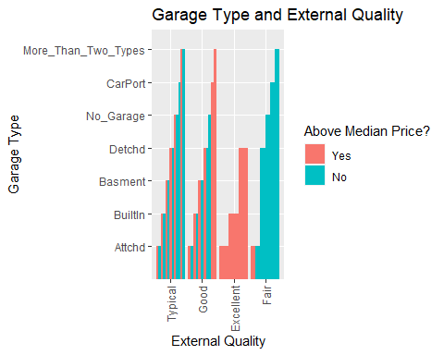

ggplot(ames, aes(fill=Above_Median, x=Exter_Qual, y=MS_Zoning)) +   
 geom_bar(position="dodge", stat="identity") +  
 ggtitle("Zoning and External Quality") +  
 xlab("External Quality") + ylab("Zone") +   
 labs(fill = "Above Median Price?") +  
 theme(axis.text.x = element_text(angle = 90, vjust = 0.5, hjust=1))

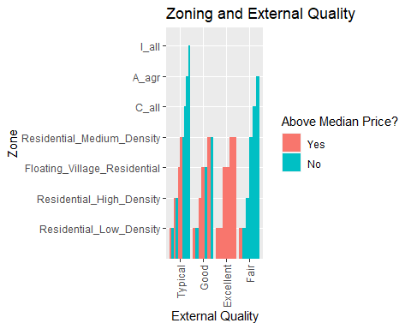

ggplot(ames, aes(fill=Above_Median, y=Neighborhood, x=Exter_Qual)) +  
 ggtitle("Neighborhoods and External Quality") +  
 xlab("External Quality") + ylab("Neighborhood") +   
 labs(fill = "Above Median Price?") +  
 geom_bar(position="dodge", stat="identity") +  
 theme(axis.text.x = element_text(angle = 90, vjust = 0.5, hjust=1))

