Course Work Submission

|  |  |  |  |
| --- | --- | --- | --- |
| Name | Shen | Wang |  |
| ID Number | 1824260 | |  |
| Programme | Information and Computing Science | |  |
| Module Title | Computer Graphics | |  |
| Module Code | CPT205 | |  |
| Assignment Title | Assessment 1 – 2D Modelling Project | |  |
| Submission Deadline | Monday, 9 November 2020 | |  |
| Lecturer Responsible | Yong Yue | |  |

I certify that:

* I have read and understood the University’s definitions of COLLUSION and PLAGIARISM (available in the Student Handbook of Xi’an Jiaotong-Liverpool University).

With reference to these definitions, I certify that:

* I have not colluded with any other student in the preparation and production of this work;
* this document has been written solely by me and in my own words except where I have clearly indicated and acknowledged that I have quoted or used figures from published or unpublished sources (including the web);
* where appropriate, I have provided an honest statement of the contributions made to my work by other people including technical and other support staff.
* I understand that unauthorized collusion and the incorporation of material from other works without acknowledgement (plagiarism) are serious disciplinary offences.

Signature Shen Wang Date 2020/11/9

|  |  |  |  |
| --- | --- | --- | --- |
| For  Academic  Office use: | Date Received | Days Late | Penalty |
|  |  |  |

# Features of the Birthday Card

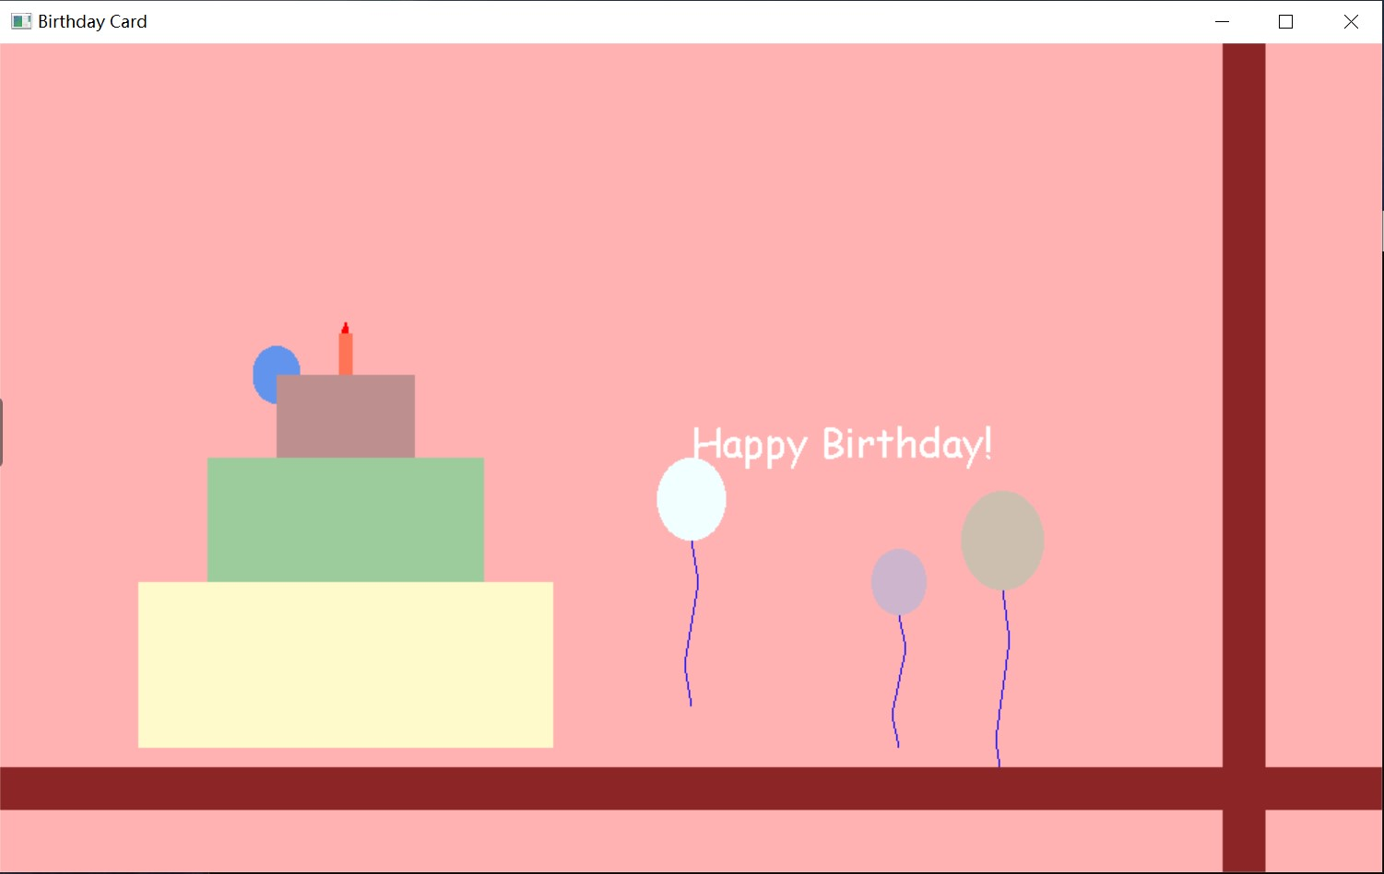

1. Balloon: The top part of the balloon is a circle and the bottom part is a broken line. A function to draw balloons is constructed to draw similar balloons of different sizes and positions.
2. Birthday cake: The birthday cake is actually made up of three quadrilaterals, each of which is given a different colour and size. The candle consists of a quadrilateral and a pentagon.
3. “Happy birthday!” text: Construct selectFont() and drawstring() two functions to display text in the window.
4. Ribbon: The ribbons in the birthday card are two lines, which are created by setting the width of the lines.
5. Animation: The variables in the balloon drawing parameters can be changed by setting steps and timer, so that the balloon has the animation effect of moving from bottom to top.
6. Interactions via keyboard:

When the S key is pressed, the balloons stops moving.

(as the picture below)

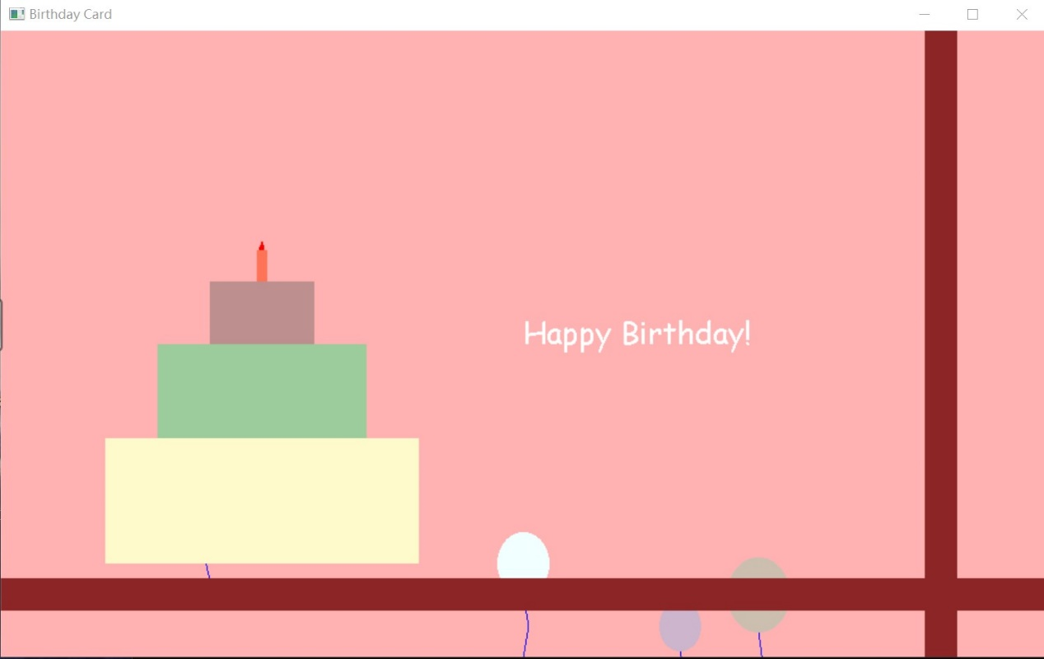

When the R key is pressed, the balloon will resume its movement.

(as the picture below)

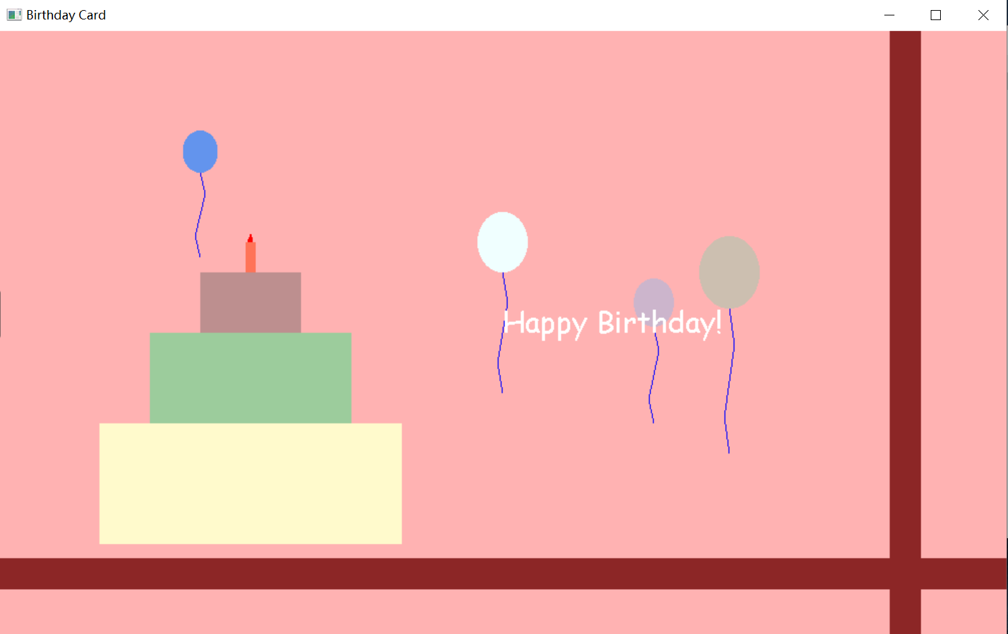

When the Q key is pressed, the running .exe application exits.

7. Window size change: Since most of the feature parameters are relative to the window size, this card has some window size flexibility.