Hiking Safety Assistant
Solution Architecture
Swiss open-data mountain safety assistant
Version 0.1 · Draft for architecture review
September 2026

Document control
Field | Value
Title | Hiking Safety Assistant — Solution Architecture
Version | 0.1 (Draft)
Status | For architecture review — precedes detailed design
Date | September 2026
Author | Systems Architecture
Audience | Engineering, product, and technical reviewers
Related documents | Requirements (FR/DR/AR/NFR/SR); Competitor coverage matrix

Contents

1 Introduction and purpose
This document defines the solution architecture for the Hiking Safety Assistant: an assistant that combines Swiss hiking-route, terrain, and weather information to help people assess and understand the conditions of a planned hike. It translates the agreed requirements (functional, data, AI, non-functional, and safety) into an architecture, and captures the structural decisions that detailed design and implementation will build on.
The assistant serves three moments — planning a hike, support during a route, and identifying risks with alternatives — and is deliberately positioned as decision-support rather than an authority. That positioning is not a disclaimer bolted on at the end; it shapes the architecture, and the sections below show where.
The scope here is structural: components, the domain model, data flow, deployment tiers, cross-cutting concerns, and the key decisions with their rationale. Detailed API contracts, schemas, and implementation specifics are out of scope and follow in detailed design.

2 Scope and context
The assistant answers questions before and during a hike, combining multiple public data sources into context-aware guidance rather than returning raw weather or map data. It is bounded to Swiss public open data: MeteoSwiss Open Data (OGD) for weather and swisstopo for terrain and routes, complemented by mountain-specialised forecasting. The coverage and update cadence of those sources bound what the system can answer.
A market review established that no existing product covers these requirements: the data, route, and weather halves are well served by existing tools, while the risk-fusion, groundedness, and fail-safe layers are unserved. The architecture therefore integrates rather than rebuilds the data and forecasting, and concentrates engineering effort on the reasoning and safety layer that is the system's reason to exist.
Two capabilities sit at the scope boundary and are treated as explicit open decisions rather than assumptions: off-grid satellite communication and active emergency escalation. These are noted in Section 12.

3 Architectural drivers and principles
A small number of requirements exert outsized influence on the architecture. They are stated here as principles so that later decisions can refer back to them.

3.1 Principles
- Separate the static plane from the live plane. Geospatial facts are slow-changing and belong in a knowledge store; weather is fast-changing and must never be cached as if it were a fact. This split (AR-1) propagates through data architecture, deployment, and offline behaviour.
- The risk layer is first-class, not a view. Hazard and risk assessment are real entities with their own inputs and reasoning trace, because the system must explain why, not only show a number (FR-7, FR-8).
- Every fact carries provenance. Provenance is a cross-cutting relation attached to every assertion, so nothing reaches a user without a traceable source, timestamp, and confidence (DR-4, NFR-3, FR-13).
- Timing is spatiotemporal. Conditions attach to a route segment at an expected time window, so the system reasons about where the user will be and when — not merely the weather today (FR-6).
- Fail safe, never falsely reassure. Under-warning is more dangerous than over-warning; low confidence or stale data must produce caution, and the system avoids definitive safe/go verdicts (NFR-1, SR-3, SR-4).

3.2 Key quality drivers
Groundedness and safety (NFR-3, SR-1 to SR-4) drive the provenance model and the invariants in Section 10. Offline and poor connectivity (NFR-4) drive the client tiering and snapshot mechanism in Section 9. Geospatial reasoning (DR-2) drives the segment-based domain model and the choice of a spatial query capability. Observability (NFR-7) and evaluation drive the inclusion of an agent-evaluation capability (AIQ) in the orchestration layer.

3.3 Constraints
- Bounded to Swiss public open data (MeteoSwiss OGD, swisstopo); source coverage limits answerable questions.
- Users may have limited or no connectivity in the field, which the in-situ experience must tolerate.
- A hackathon delivery horizon favours a demonstrable vertical slice over full breadth; a clear scoping cut is a strength.

4 Requirements traceability
The table maps requirement clusters to the architecture elements that satisfy them. Requirement identifiers refer to the requirements document.
Requirement cluster | Architecture element(s)
FR-1/2/3 route intelligence | Static plane — Route/Segment/Terrain/POI in the knowledge graph (§6, §7)
FR-4/5/6 weather & conditions | Live weather gateway; WeatherCondition bound to (segment, time window) (§6, §7)
FR-7/8 risk assessment | Fusion engine; Hazard and Risk assessment entities (§6, §8)
FR-9 user context | Context plane — Hiker/Capability/Party/HikePlan (§6, §7)
FR-10/11 recommendations | Fusion engine — Recommendation/Alternative with linked rationale (§6, §8)
FR-12/13 interaction, citation | Agentic orchestration; provenance surfaced with every claim (§8, §10)
DR-1..4 data & integration | Data architecture; source adapters; provenance model (§7, §10)
AR-1..4 AI / agentic | RAG over static plane; MCP tools; AIQ evaluation; grounded generation (§8)
NFR-1/2/3 safety, reliability | Fail-safe invariants; freshness handling (§10)
NFR-4 offline / connectivity | Client tiering; materialised offline snapshot (§9)
NFR-5/6/7 localisation, privacy, observability | Cross-cutting concerns (§10)
SR-1..4 safety & liability | Safety invariants; authoritative-channel routing; no go/no-go verdict (§10)

5 System context and high-level architecture
At the highest level the system is a set of clients over an orchestration layer, three core services, and the external open-data sources. Clients never talk to data sources directly; all access is mediated by the orchestration layer, which composes the services and applies the safety and provenance rules.
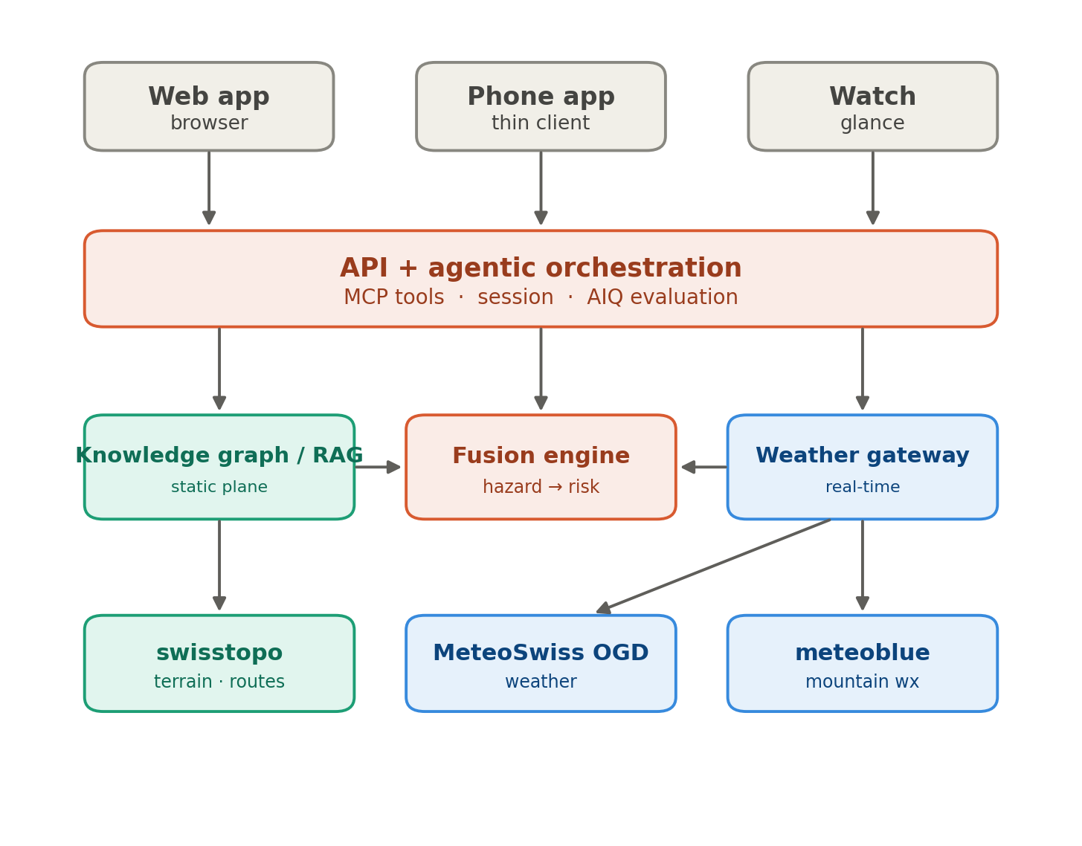
Figure 1. System context and high-level architecture.
The agentic orchestration layer decomposes a query, calls the services it needs as tools, and synthesises a grounded answer. The knowledge graph and retrieval service holds the static plane. The live weather gateway is the only path to real-time forecasts and warnings and never persists them as facts. The fusion engine is the differentiator: it reads terrain from the knowledge graph and conditions from the weather gateway and derives route-specific hazards, risk, and recommendations. The external sources — swisstopo, MeteoSwiss OGD, and meteoblue — are integrated through adapters, not rebuilt.

6 Domain ontology and semantic layer
The domain model is organised into four planes — static/geospatial, live/temporal, derived/assessment, and user context — plus a cross-cutting provenance model. The value the system adds is the derived middle, which is a spatiotemporal join across the static and live planes evaluated against the user.

6.1 The risk-fusion spine
The spine is the ontology's backbone and the chain the architecture must get right. A route is decomposed into segments; each segment carries terrain attributes and an expected traversal time window derived from the hike plan and pace. Weather conditions resolve per segment and time. A hazard arises from the combination of segment terrain, condition, and timing. A risk assessment aggregates hazards and evaluates them against the hiker's capability, carrying severity, confidence, and a reasoning trace. Recommendations derive from the assessment, each linked to the hazard that justifies it.
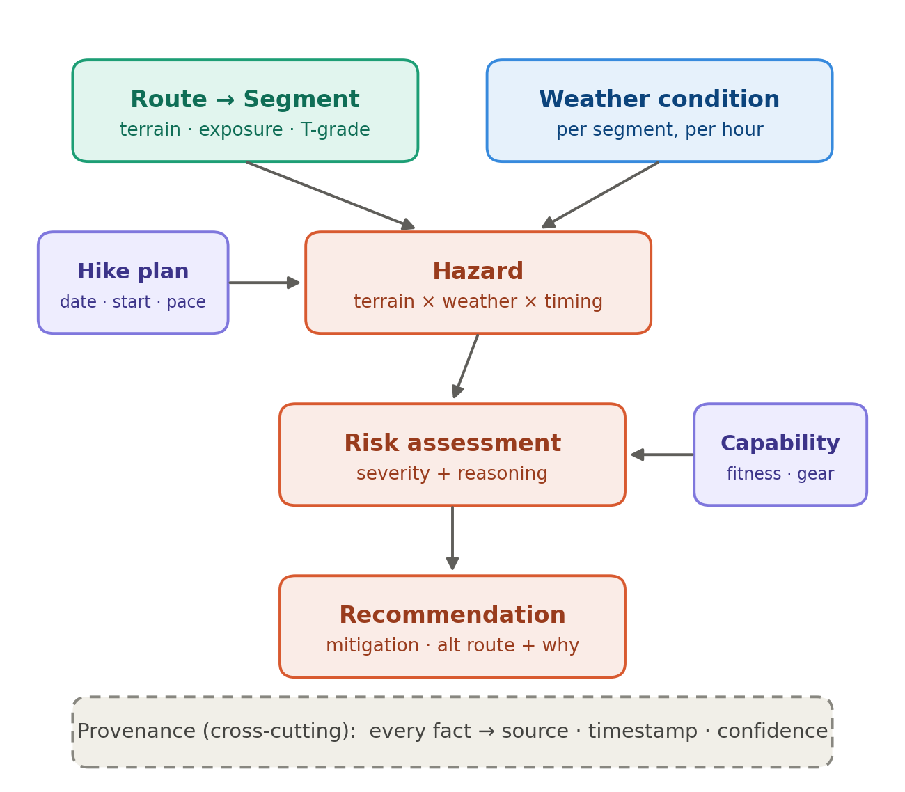
Figure 2. Ontology risk-fusion spine, coloured by plane (see Appendix A).

6.2 Semantic layer: OWL, GeoSPARQL, SHACL
The static plane and the provenance model are represented in the web-tier semantic layer using OWL/RDF. This buys three things that matter here: a shared, well-defined vocabulary; a real geospatial query capability via GeoSPARQL for the static plane; and declarable, testable safety invariants expressed as SHACL constraints rather than scattered application code. Linked-data interoperability with public Swiss and open datasets is a natural fit with the open-data framing.

6.3 What the semantic layer does not do
An OWL reasoner does not compute the risk fusion. The hazard-to-risk spine is a numeric, spatiotemporal, rule-driven join over terrain, weather, timing, and capability — that is engine code, not classification or subsumption. OWL and SHACL model the vocabulary, enforce invariants, and validate consistency; the fusion itself, and all live weather, sit outside the ontology as services. Scoping OWL to the semantic and validation layer avoids the common trap of expecting a reasoner to generate risk.

7 Data architecture
The static/live separation from Section 3 becomes a concrete storage strategy. Each plane has a distinct persistence and freshness policy, and the boundaries between them are enforced, not incidental.
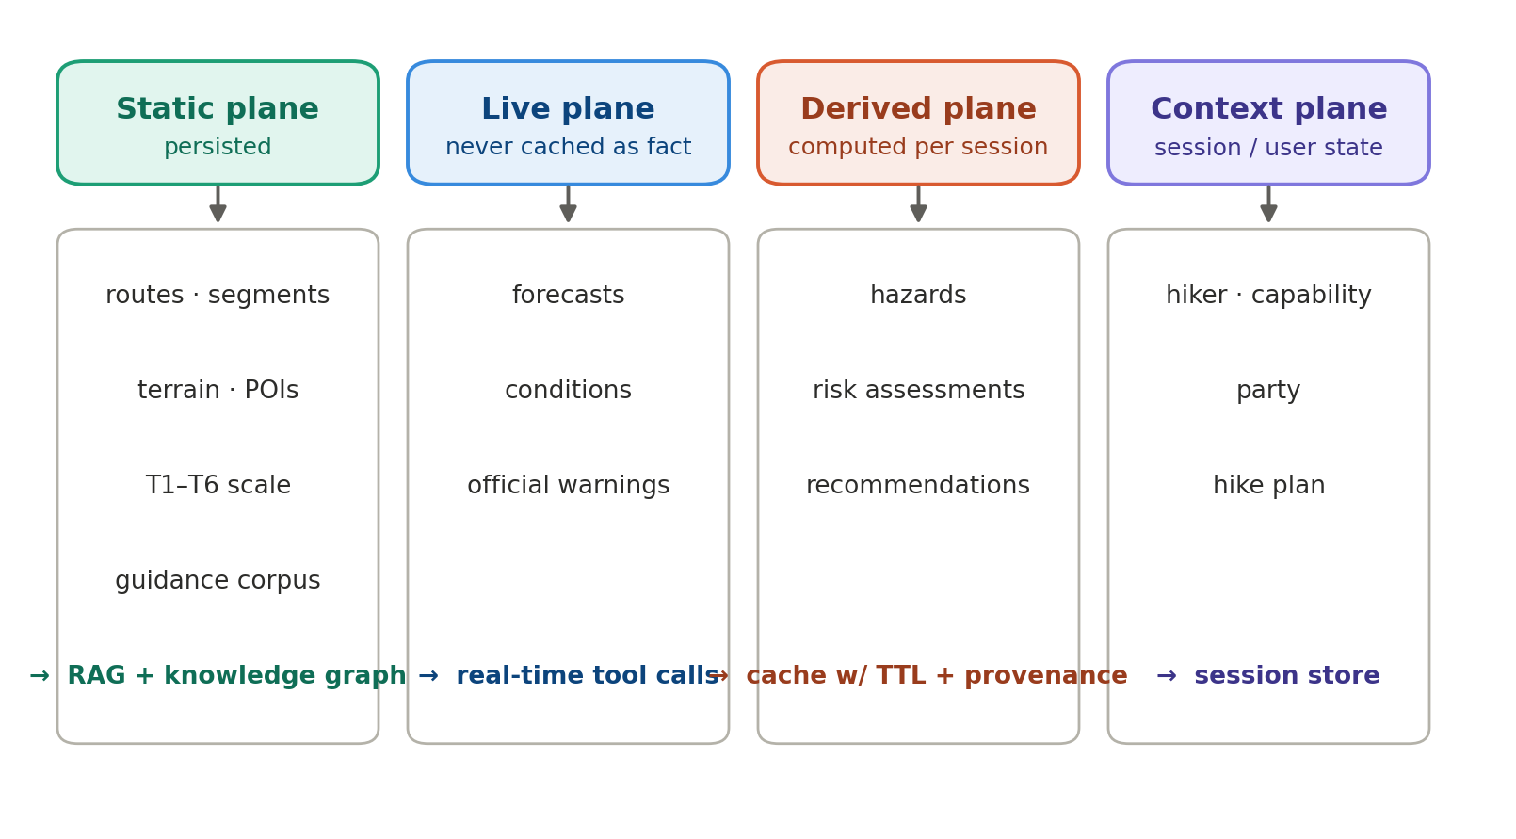
Figure 3. Data planes and their persistence strategy.
The static plane is persisted in the knowledge graph and vector store and served through RAG. The live plane is fetched through real-time tool calls and is never cached as a fact — only, at most, as a timestamped snapshot that carries its own validity. The derived plane is computed per session and cached only with its provenance and a time-to-live. The context plane holds session and user state. The seam where a segment meets a weather condition at a time window is the retrieval-time geospatial-plus-temporal join, and that join is the core service the fusion engine performs.

8 Component architecture
Three components carry most of the system's behaviour, coordinated by the orchestration layer.

8.1 Agentic orchestration
The orchestration layer receives a natural-language query, maintains multi-turn session state scoped to a hike plan (FR-12), and decomposes the request into steps. Data sources and capabilities are exposed as composable tools via MCP (AR-2), so the assistant combines weather, terrain, and reasoning rather than answering from a single lookup. Generation is grounded in retrieved data and constrained against unsupported safety claims (AR-4). An evaluation capability (AIQ) measures correctness, groundedness, and latency of the agent, giving the observability the safety posture requires.

8.2 Knowledge graph and retrieval
The static plane is retrieved through RAG over route descriptions, hut information, hiking-scale definitions, and safety guidance, with the knowledge graph providing structured, geospatially queryable access to routes, segments, terrain, and points of interest. Live weather is deliberately excluded from the vector store.

8.3 Fusion engine
The fusion engine performs the spatiotemporal join and applies the hazard rules: for each segment and its expected time window, it evaluates terrain against conditions to identify hazards, aggregates them into a risk assessment against the hiker's capability, and derives recommendations and alternatives with linked rationale. It records the inputs behind every hazard so the result is explainable, and it attaches confidence driven by source freshness and forecast predictability. It never emits a bare safe/go verdict.

9 Deployment and client tiering
The semantic layer and reasoning are heavyweight and belong on the server; phones and watches cannot host a reasoner. The architecture therefore authors the model once on the web tier and projects it downward into progressively thinner client artefacts.

9.1 Projection tiers
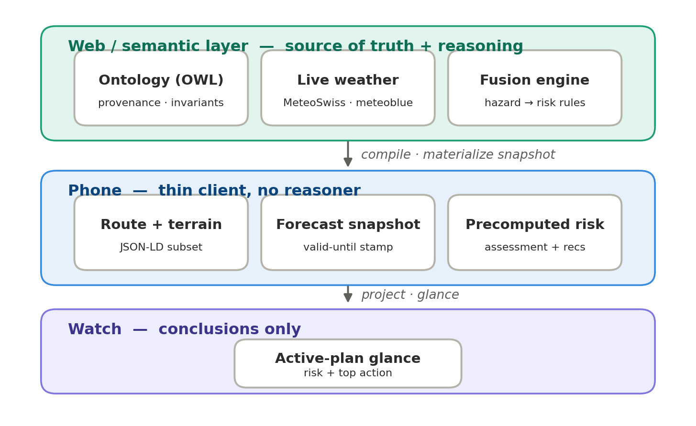
Figure 4. Web semantic layer projected to phone and watch.
OWL, triples, and the reasoner never leave the web tier. What crosses the first boundary is a compiled artefact: a JSON-LD subset of the route and terrain, a forecast snapshot, and the already-computed risk assessment and recommendations. What crosses the second boundary is thinner still — the conclusions for the active plan, rendered as a glance. The phone holds data and precomputed answers; the watch holds a glance; neither performs inference. This is what makes the split work on hardware that cannot host a reasoner.

9.2 Offline snapshot and fail-safe aging
The offline requirement (NFR-4) is satisfied by a mechanism, not a label: a materialised offline snapshot — a bounded, timestamped bundle compiled on the web tier and pre-fetched to the device at plan time. Going offline freezes that snapshot, which makes the safety invariants matter more, not less, because the device is now reasoning against frozen conditions with a fixed shelf life.
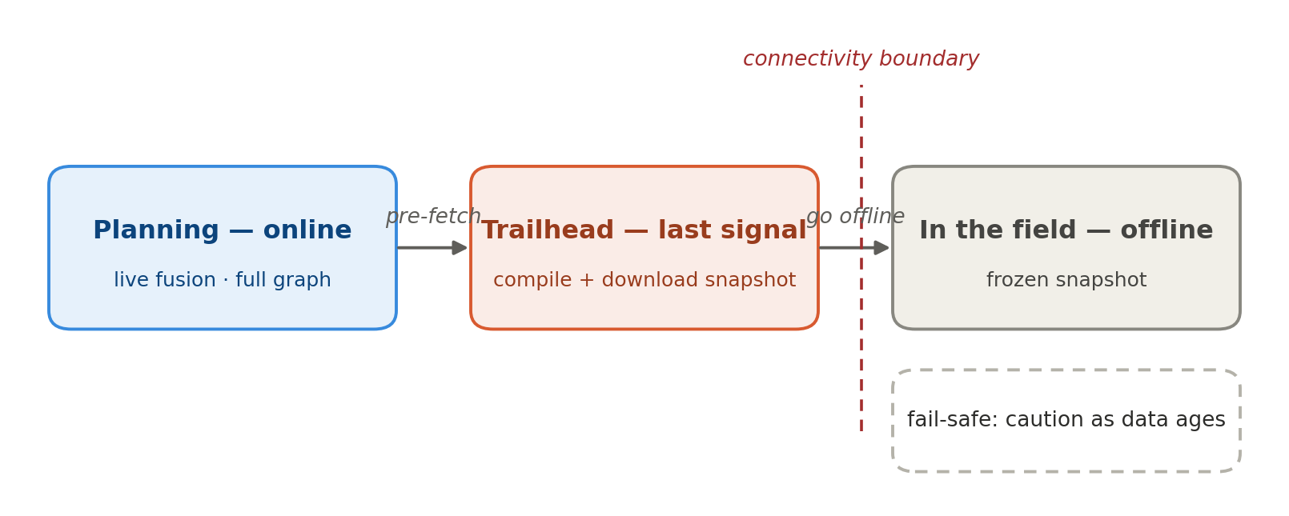
Figure 5. Online-to-offline lifecycle with fail-safe aging.
The snapshot carries its own valid-until stamp, and the device applies the same fail-safe rule baked into the ontology: as the data ages past the trip window, or if conditions were already low-confidence at compile time, the device degrades to caution rather than showing a stale, reassuring result. The provenance and timestamp fields on every fact are exactly what the offline client reads to decide whether the data can still be trusted — the invariants travel with the snapshot.

10 Cross-cutting concerns

10.1 Provenance and groundedness
Every factual claim links to its source with a timestamp, confidence, and freshness. A risk assessment may not exist without linked evidence for each hazard it aggregates. This makes groundedness (NFR-3) and citation (FR-13) mechanical rather than aspirational.

10.2 Safety invariants
The safety posture is encoded as invariants, expressed where possible as SHACL constraints on the semantic layer:
- A weather condition whose backing forecast is older than a freshness threshold is flagged stale and forces the assessment's confidence down (NFR-2).
- Low confidence propagates to cautionary framing, never reassurance; absence of a known hazard is not evidence of safety (SR-3, NFR-1).
- A recommendation must link to the hazard or assessment that justifies it (FR-11).
- An official warning outranks any derived hazard in the same category; the system surfaces the authority, not its own inference (SR-2).
- The system frames outputs as conditions, risks, and considerations, and never issues a definitive safe/go verdict (SR-4).

10.3 Observability, localisation, and privacy
Agent steps, tool calls, and data freshness are inspectable for evaluation and debugging (NFR-7), supported by the AIQ evaluation capability. The system supports the Swiss language context (DE/FR/IT/EN), at least for place names (NFR-5). Location and route data are sensitive; retention is minimised and made explicit, and personal data is kept out of URLs and logs (NFR-6).

11 Key architectural decisions
The following decisions are the load-bearing ones. Each should be revisited if its rationale changes.
ID | Decision | Rationale | Status
KAD-1 | Separate static (persisted) from live (never cached) planes | Weather must not be treated as a durable fact; enables clean RAG boundary (AR-1) | Accepted
KAD-2 | OWL/RDF for the static plane and provenance on the web tier | Shared vocabulary, GeoSPARQL, SHACL invariants, open-data interop | Accepted
KAD-3 | Risk fusion in an engine, not an OWL reasoner | Fusion is a numeric spatiotemporal rule join, not subsumption | Accepted
KAD-4 | Project the web model to thin phone and watch artefacts | Devices cannot host a reasoner; conclusions, not the graph, cross the boundary | Accepted
KAD-5 | Materialised offline snapshot with fail-safe aging | Satisfies NFR-4; carries provenance and valid-until so invariants travel with it | Accepted
KAD-6 | Property-graph runtime option vs OWL at runtime | OWL as design-time authoring is viable if runtime operation proves heavy for the delivery horizon | Open

12 Risks and open decisions
ID | Risk / open decision | Disposition
R-1 | Offline phone experience: read-only vs limited local recompute | Recommend read-only for first delivery; local recompute a fast-follow (ships a slice of fusion logic to the device)
R-2 | OWL runtime operation may be heavy for the delivery horizon | Fallback: OWL as design-time authoring, property-graph/typed-object storage at runtime (see KAD-6)
R-3 | Off-grid comms and active SOS escalation under-specified | Surfaced by market review (Garmin). Decide to scope in (consider device integration) or scope out with documented rationale
R-4 | Source coverage and update cadence bound answerable questions | Handle unavailability and staleness explicitly; never fabricate or silently substitute conditions
R-5 | False-reassurance liability if fail-safe posture is weakened for a demo | Treat NFR-1 as non-negotiable; the anti-reassurance stance is agreed and encoded as invariants

13 Glossary
- Fusion engine — the component that joins terrain and weather over time to derive hazards, risk, and recommendations.
- Materialised offline snapshot — a bounded, timestamped bundle compiled on the web tier and pre-fetched to a device for offline use.
- Provenance — the source, timestamp, confidence, and freshness attached to every factual claim.
- RAG — retrieval-augmented generation over the static-plane corpus.
- SHACL — a constraint language used here to express safety invariants over the semantic layer.
- T1–T6 — the Swiss hiking difficulty scale, from hiking to difficult alpine hiking.

Appendix A Diagram colour key
Colours are consistent across the diagrams and encode the domain plane an element belongs to:
- Teal — static / geospatial plane (routes, segments, terrain).
- Blue — live / temporal plane (weather, conditions, warnings).
- Coral — derived plane (hazards, risk, recommendations; the system computes these).
- Purple — user context (hiker, capability, party, plan).
- Grey — neutral / structural elements and external systems.

