Business Processes Risk Assessment

|  |
| --- |
| Document development, review and version history |
| ***Development and Review***   |  | Name | Date | | --- | --- | --- | | Authored/Revised by | XXXXXXXXXX | xxxx-xx-xx | | Reviewed by | YYYYYYYYYY | xxxx-xx-xx | | Released by | ZZZZZZZZZZ | xxxx-xx-xx |   ***Version History***   | Version | Date | Author | Summary of Changes | | --- | --- | --- | --- | | 0.1 | xxxx-xx-xx | XXXXXXXXXX | Initial draft | |

This is an explanation and ‘dictionary’ for the High Level Risk Assessment tool of the platform.

The file is structured as a process following the steps below:

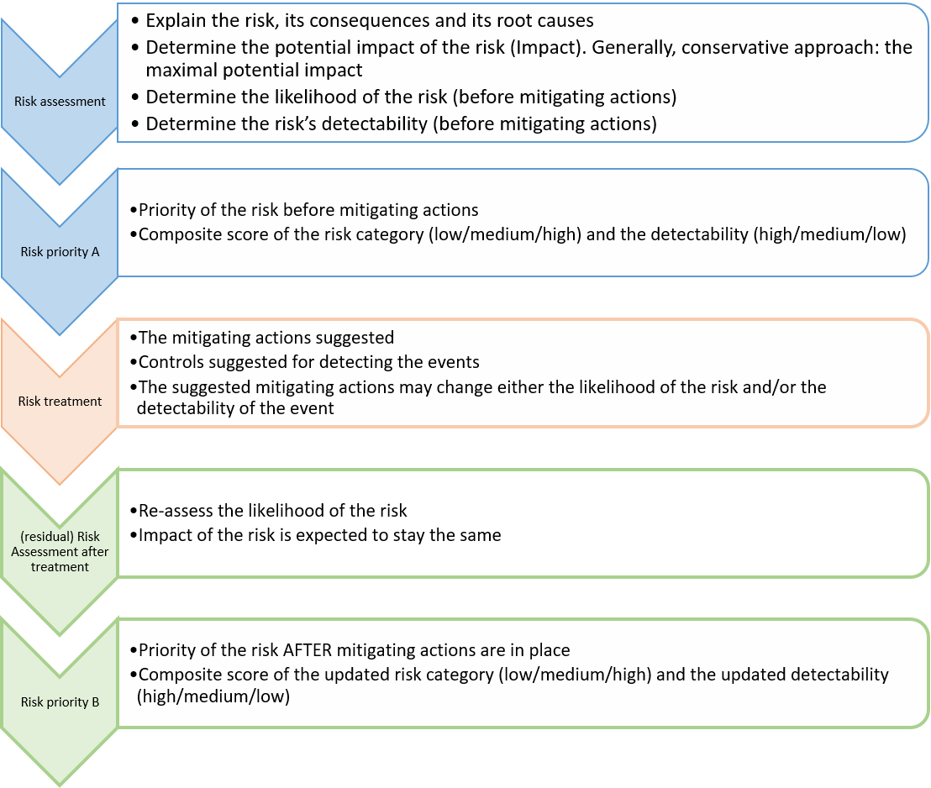

The variables of decision are:

* Risk area:
* Risk Subarea
* Impact of risk (A):
  + Minor (1 point)
  + Major (3 points)
  + Critical (6 points)
* Likelihood (A): how likely is the event to take place (before mitigating actions are in place):
  + Unlikely (1 points)
  + Possible (2 points)
  + Likely (3 points)
* Risk A = multiplication of impact x likelihood
* Risk A category: categorization of Risk according to points received in Risk A
  + 1-2: Low (green)
  + 3-8: Medium (yellow)
  + ≥9 High (red)
* Detectability A: how fast and easily is the risk effect detected, potentially before consequences (before mitigating actions are in place):
  + High (easy to detect, ‘jumps’ to the eye immediately)
  + Medium (is detectable if one pays attention or examines this point specifically with a critical eye)
  + Low (hard to detect, only detectable if rigorously and specifically looking for problems)
* Priority A: The ‘final’ risk category and priority in need for handling (i.e., before mitigating actions). Is conditional on the Risk-A category and on the Detectability A according to the PharmaSUG suggestion (Figure 2) using for “risk class” the defined Risk Category A
* Risk treatment: the mitigating actions that can be implemented. Examples of possibilities are provided. Mitigating actions may:
* Reduce the likelihood of a risk to occur
* Increase the likelihood of detection of the risk occurring
* Risk analysis after treatment:
* Impact = the same as the impact in the risk assessment (does not change)
* Likelihood B: The likelihood of the risk to happen (Once mitigating actions are in place)
* Risk B: the calculated risk based on impact and the new likelihood
* Detectability B: the new detectability (Once mitigating actions are in place)
* Priority B: Final, residual, priority of the risk (once mitigating actions are in place)
* Risk monitoring: TO BE FILLED per CTU according to local SOPs and guidelines (local QM)

The high level risk assessment is available [here](fig/RiskAssessment_SCTO_Statistics_20230502.xlsx) .