Business Processes Risk Assessment
 Document development, review and version history
Development and Review
Authored/revised by:

Name | Date
Michael Coslovsky | 2025-01-01

Version History

Version | Date | Author(s) | Summary of Changes
1.0 | 2025-01-01 | Michael Coslovsky | Initial version

This is an explanation and ‘dictionary’ for the Business Processes Risk Assessment tool of the platform.
The file is structured as a process following the steps below:
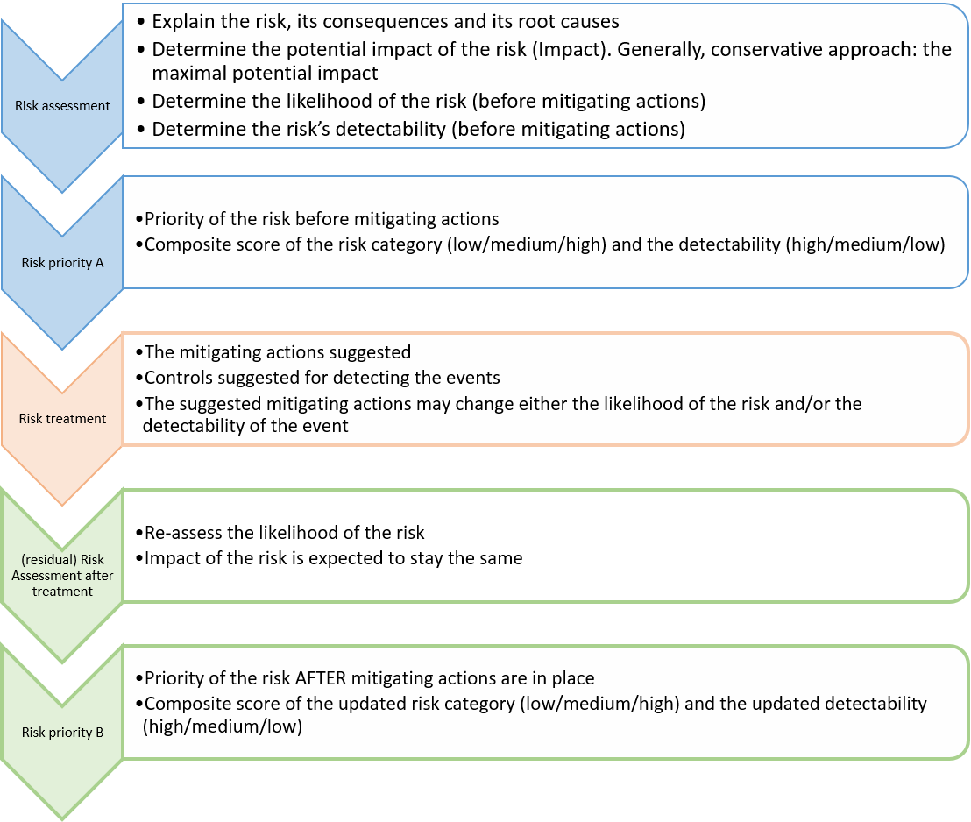
The variables of decision are:
- Risk area
- Risk Subarea
- Impact of risk (A):
  - Minor (1 point)
  - Major (3 points)
  - Critical (6 points)
- Likelihood (A): how likely is the event to take place (before mitigating actions are in place):
  - Unlikely (1 points)
  - Possible (2 points)
  - Likely (3 points)
- Risk A = multiplication of impact x likelihood
- Risk A category: categorization of Risk according to points received in Risk A
  - 1-2: Low (green)
  - 3-8: Medium (yellow)
  - ≥9 High (red)
- Detectability A: how fast and easily is the risk effect detected, potentially before consequences (before mitigating actions are in place):
  - High (easy to detect, ‘jumps’ to the eye immediately)
  - Medium (is detectable if one pays attention or examines this point specifically with a critical eye)
  - Low (hard to detect, only detectable if rigorously and specifically looking for problems)
- Priority A: The ‘final’ risk category and priority in need for handling (i.e., before mitigating actions). Is conditional on the Risk-A category and on the Detectability A according to the PharmaSUG suggestion (Figure 2) using for “risk class” the defined Risk Category A
- Risk treatment: the mitigating actions that can be implemented. Examples of possibilities are provided. Mitigating actions may:
- Reduce the likelihood of a risk to occur
- Increase the likelihood of detection of the risk occurring
- Risk analysis after treatment:
- Impact = the same as the impact in the risk assessment (does not change)
- Likelihood B: The likelihood of the risk to happen (Once mitigating actions are in place)
- Risk B: the calculated risk based on impact and the new likelihood
- Detectability B: the new detectability (Once mitigating actions are in place)
- Priority B: Final, residual, priority of the risk (once mitigating actions are in place)
- Risk monitoring: TO BE FILLED per CTU according to local SOPs and guidelines (local QM)
The business processes risk assessment is available here .

Head data-analysis, Department Clinical Research, University of Basel

