TIMCI Longitudinal Observational Study - Monitoring Report

Swiss Tropical and Public Health Institute

2021-04-01

1 Introduction 1

2 Submissions 1

2.1 Number of submissions per day 1

2.1.1 PS Malicounda Keur Maissa 1

2.1.1.1 Test 1

# Introduction

This report covers the period from **2021-02-03** to **2021-03-18**.

# Submissions

## Number of submissions per day

### PS Malicounda Keur Maissa

#### Test

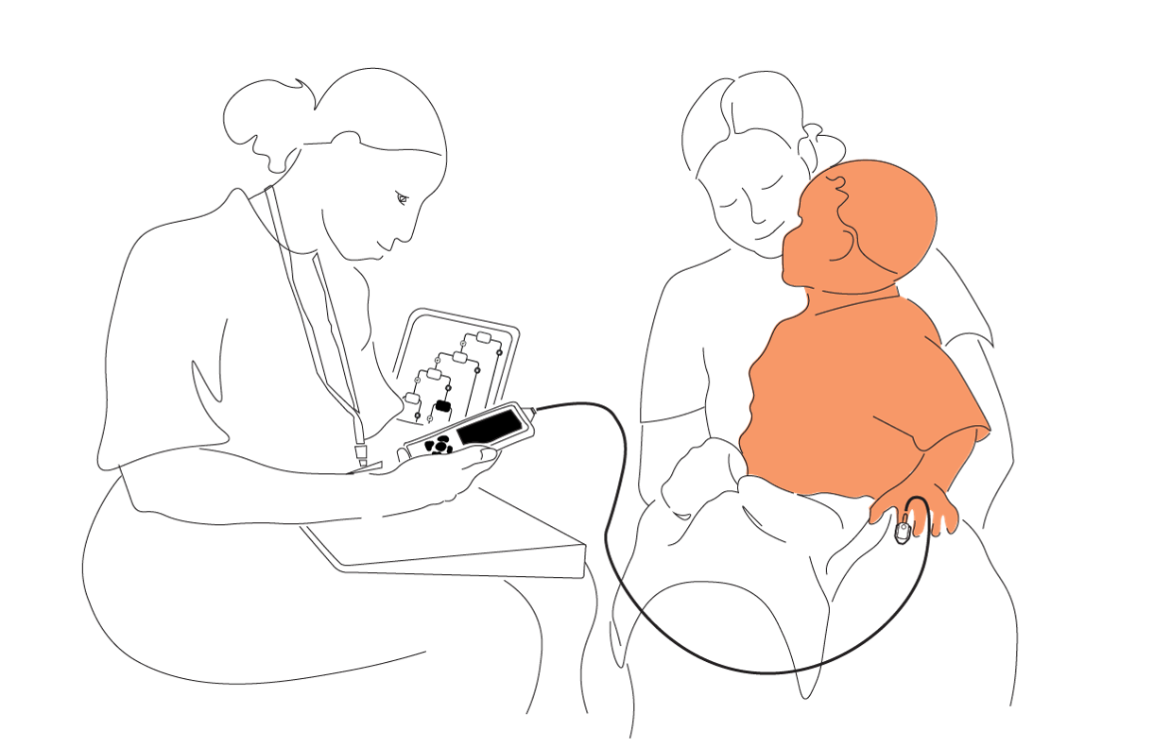

Figure . Test

| new | old |
| --- | --- |
| date_visit | date |
| device_id | deviceid |
| sys_submit_id | SubmitterID |
| submission_date | SubmissionDate |
| start | start |