Criterion B: Design

The program was designed in three parts, the back end of classes and methods, the main JFrame where the fractal was generated, and the GUI JFrame where the user would initialize the fractal

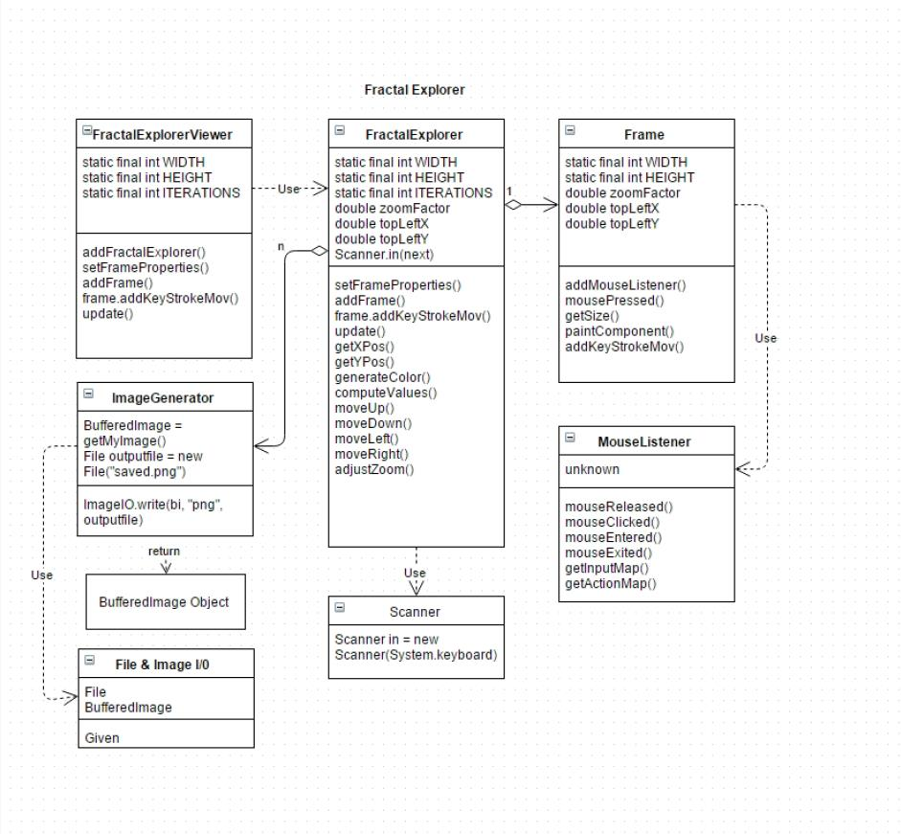

Figure 1: UML diagram showing relationships of the back-end classes

The main FractalFrenzy class would contain the majority of global variables, inner classes and methods used generate the fractal to the panel.

The viewer/main GUI contains the swing generated interface for the user to initialize and manipulate the fractal that they choose to generate.

Each point would be run through the Mandelbrot set equation for 200 iterations in computeValues() to determine placement and color in generateColor().

Each class (GUI viewer, frame, and main class) were tested separately with checkpoints and a text-based interface.

Extensibility of the product is to create an additional ImageGenerator class where the user can take snapshots of the fractal image and save them to cited location.

Figure 2: Screenshot of Initial User Interface

FractalMain.java is the entry point and a JFrame. It displays a basic JFrame with an instructionPanel, JTextField’s, and a “Start” Button.

The GUI contains user limitations on the text fields as well as action and key listeners for user events of clicking the “Start” button or pressing enter in the textfields.

The frame is also not resizable (there isn’t a reason for the user to rescale this simple GUI) and when the initializes a fractal they create a new JFrame.

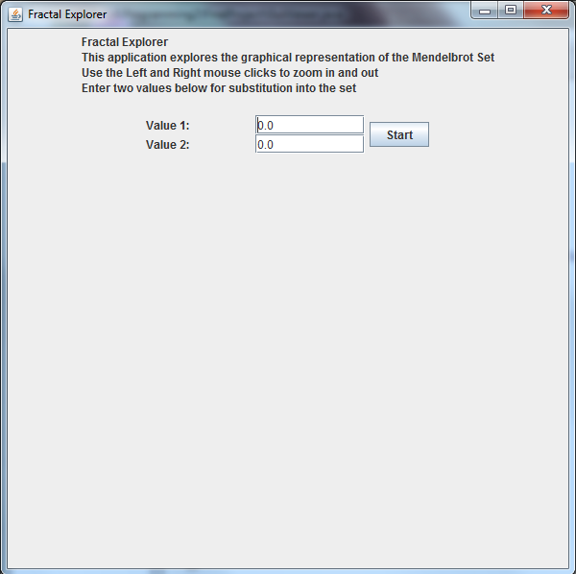

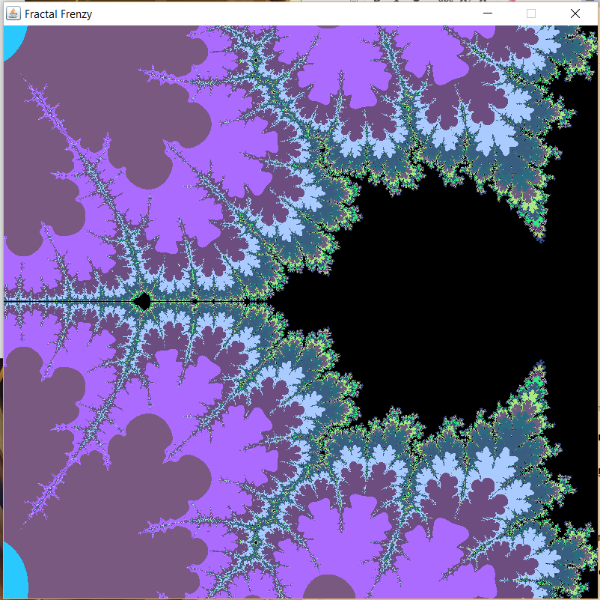

Figure 3: Fractal Image example drawn onto the JFrame

Fractal BufferedImage is drawn to screen using computeValues(), generateColor(), and update() methods that tests every single pixel in the Mandelbrot set through 200 iterations to determine compatibility then generates image.

User is allowed to manipulate image through left and right clicks of the mouse to zoom in and out as well as the W, A, S, D keys to move in the linear directions of up, left, down, and right, respectively.