CHAPTER THREE
SYSTEM ANALYSIS AND DESIGN
3.1 Research Methodology
This study adopts Object-Oriented Analysis and Design Methodology (OOADM) as the primary analytical and design methodology governing the system analysis and design work presented in this chapter. Two further instruments operationalise this methodology rather than compete with it: Agile constitutes the Software Development Life Cycle (SDLC) framework used to execute the project, and an experimental pipeline constitutes the experimental design approach used specifically to validate the NLP/machine-learning-based Evidence Score component. The three are therefore not parallel research methodologies but a single governing methodology (OOADM), an execution framework within which it was delivered (Agile), and a validation design nested within it for the one component whose correctness cannot be established by object-model inspection alone (the experimental pipeline).
As the SDLC framework governing execution, Agile was preferred over a strict Waterfall SDLC because the requirements of the system evolved substantially during development. The most significant of these changes was the translation of the conceptual Bi-Directional Identity Optimization Framework (BDIOF), proposed in earlier seminar work, into a concrete and implementable Evidence Score formula and a three-mode screening architecture. A specification fixed at the outset would have committed the project to a scoring formula whose behaviour could not be known until real candidate data had passed through it. The iterative build–test–refine cycle allowed each of the three BDIOF vectors — inbound competency evaluation, outbound recruiter screening, and the candidate-directed feedback loop — to be developed, demonstrated, and revised independently within the Agile execution framework before integration into the OOADM-modelled architecture. Agile governed delivery cadence and increment sequencing only; it did not generate the analytical or structural models presented in this chapter, which is the role OOADM alone performs.
OOADM governs the structural design artefacts presented in this chapter as the study's primary analytical methodology. The problem domain of the system — users, profiles, jobs, applications, messages, and audit events — maps naturally onto discrete objects with clearly bounded attributes and behaviours, and a relational schema in Third Normal Form (Section 3.6) follows directly from a well-formed object model. The use-case, class, activity, and sequence models presented in Section 3.5 were therefore produced under OOADM using standard Unified Modelling Language (UML) notation. Data Flow Diagrams (DFD) were deliberately retained alongside these object-oriented models as a practical modelling strategy: the two notations answer different questions, since UML describes what the system is composed of, whereas the DFD describes what the system does to data as it moves between processes and stores, and a design of this scale benefits from capturing both the object structure and the procedural data flow rather than only one. Both notations are therefore complementary instruments within the single OOADM-governed analytical approach, not separate or competing methodologies.
The experimental pipeline is the experimental design approach used specifically to validate the NLP/machine-learning-based Evidence Score component, whose object-oriented structure and interfaces were themselves defined under OOADM. Because the correctness of a similarity function is an empirical property rather than one that can be established through code review or object-model inspection alone, the Evidence Score component required a distinct validation design, nested within the OOADM-modelled architecture and executed under the Agile SDLC framework, rather than being treated as an independent research methodology in its own right. Candidate project text and job descriptions were encoded using a locally hosted Sentence Transformers model, cosine similarity was benchmarked against a small hand-labelled validation set of project-to-job pairs, and the resulting similarity function was integrated into the OOADM-defined component only once its output was judged sufficiently discriminative. The choice of a transformer-based sentence encoder over exact keyword matching follows the evidence that dense embedding representations outperform lexical matching on resume-to-vacancy alignment tasks (Bevara et al., 2025; Bian et al., 2020), and the selection of a compact, locally hosted model rather than a hosted commercial embedding service reflects both the zero-shot retrieval performance reported for models of this class (Thakur et al., 2021) and the deployment constraint discussed in Section 3.4.2.
Table 3.1 summarises how the OOADM-governed analytical methodology is operationalised through the Agile SDLC framework and validated, for the Evidence Score component specifically, through the experimental pipeline.
Table 3.1: Mapping of methodological instruments to project deliverables
Methodological role & instrument | Applied to | Justification
Agile (SDLC execution framework) | Overall build sequence; the three BDIOF vectors | Requirements changed materially during development; each vector needed independent demonstration before integration
OOADM with UML (governing analytical methodology) | Use-case, class, activity, and sequence models; relational schema derivation | Domain decomposes cleanly into objects; 3NF schema follows from the object model
DFD under OOADM (process-oriented view) | Context and Level 1 process models | Provides the data-movement view that UML structural models do not express
Experimental pipeline (validation design, nested within OOADM/Agile) | Evidence Score, and specifically the P_emb component | Correctness of a similarity function is an empirical property, not a reviewable one

The development work was executed, under the Agile SDLC framework, as eight increments, each ending in a demonstrable state: authentication and role separation; the formal (curriculum vitae) pipeline; the informal (GitHub) pipeline; the community pipeline; the Competency Engine that merges all three; the recruiter portal with anonymised screening; the Bias Audit Engine; and the candidate-directed feedback loop. Ordering the feedback loop last was deliberate rather than incidental — it consumes the outputs of every preceding increment, since a diagnostic comparison against the applicants a recruiter advanced cannot be computed until scoring, screening, and shortlisting all exist.
3.2 Analysis of the Existing System
The recruitment process currently available to African technology professionals, as characterised in the literature reviewed in Chapter Two, relies on general-purpose professional networking platforms and employer-operated Applicant Tracking Systems (ATS). In this process, a candidate creates a single static profile or curriculum vitae (CV), which is then parsed by keyword-matching, embedding-based, or graph-based ranking algorithms (Bian et al., 2020; Roy et al., 2020), whose training data and design assumptions are drawn predominantly from Western hiring contexts, a pattern documented in cross-cultural evaluations of AI-driven hiring systems (Raghavan et al., 2020; Rao et al., 2025). The output of that ranking is presented to a recruiter together with the candidate's full identity, and the recruiter's decision is recorded nowhere except as an internal status change. As illustrated in Figure 3.1: Architecture Flow of the Existing Recruitment System below, the process advances through a fixed, linear sequence of five stages, each of which entrenches a specific architectural weakness carried forward into the requirements developed in Section 3.4.
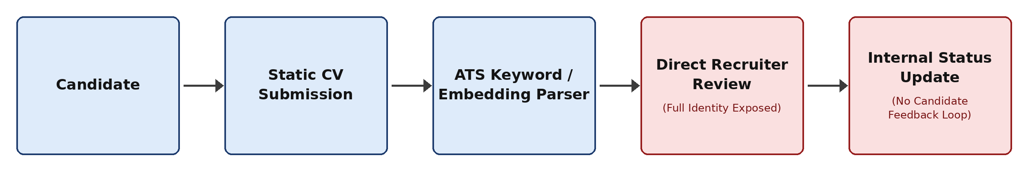
Figure 3.1: Architecture flow of the existing recruitment system, from static CV submission through to an internal status update with no return path to the candidate.
Note. Author's construct, synthesised from Bian et al. (2020) and Roy et al. (2020) for the ranking algorithms; Raghavan et al. (2020) and Rao et al. (2025) for their predominantly Western training assumptions; Robles-Carrillo (2024) and Sánchez-Monedero et al. (2020) for the identity-exposure stage; and Pasipamire and Muroyiwa (2024) for the absence of a candidate feedback loop.
Three architectural flaws are directly visible in this flow. First, the candidate submits a single static profile, which is parsed by keyword-matching, embedding-based, or graph-based ranking algorithms (Bian et al., 2020; Roy et al., 2020) whose training data and design assumptions are drawn predominantly from Western hiring contexts (Raghavan et al., 2020; Rao et al., 2025); the parsing stage is static in the sense that it evaluates a fixed document rather than a continuously verifiable body of evidence. Second, the output of that ranking is presented to the recruiter together with the candidate's full identity, so identity and location signals are exposed before any evidence-based evaluation can occur — this is the point at which the geographic and credential biases documented in the literature enter the decision. Third, the recruiter's decision terminates the flow as an internal status update, with no path back to the candidate; this absence of a feedback loop is what closes off any possibility of the candidate learning why an application failed.
Four weaknesses in this existing process are evidenced directly by the literature and are restated here because each maps to a specific design decision later in this chapter.
First, formal credentials — named universities, recognised employers, and degree titles — are weighted heavily, while informally acquired skill is either absent from the profile schema entirely or retained as unstructured, unweighted free text. Evidence of competence expressed through open-source contribution is measurable and skill-bearing (Liang et al., 2022a, 2022b), yet conventional profile schemas provide no structured field in which it can be recorded or scored, and the achievement signals that platforms such as GitHub do expose are only weakly related to the underlying contribution behaviour they appear to represent (Calefato et al., 2024). A candidate whose competence was acquired outside a formal institution is therefore not merely ranked lower; the evidence of that competence is structurally invisible to the ranking function (Robles-Carrillo, 2024).
Second, geographic location operates as an implicit risk signal that can suppress a candidate's visibility before any human recruiter reviews their skills. This effect has been documented specifically for workers in the Global South, where algorithmic management systems and platform ranking functions reproduce the geographic assumptions of the labour markets in which they were trained (Menon, 2023; Mrashui, 2024; Vivek, 2023), and it persists even where the work itself is fully remote and location is functionally irrelevant to performance (Iyoha et al., 2025; Oshioste et al., 2023).
Third, and most consequential for this project, no feedback mechanism exists to inform a rejected candidate which competencies were recognised and which were missed. The candidate receives a rejection, or more commonly no response at all, and the information asymmetry that produced the outcome is left intact. The candidate cannot correct a profile whose deficiencies are never disclosed to them, and consequently repeats the same unsuccessful application pattern indefinitely. This is a recognised structural weakness rather than an incidental one: recommendation and ranking systems that return an outcome without an explanation deny the affected party any basis for acting on it (Zhang & Chen, 2020), and the fairness literature has begun to treat the absence of actionable recourse as itself a fairness failure rather than a usability shortcoming (Albaroudi et al., 2024; Pasipamire & Muroyiwa, 2024; Sánchez-Monedero et al., 2020).
Fourth, in the recruiter-facing part of the process, there is no selectable evaluation mode. A recruiter using a conventional ATS has no built-in option to compare identity-visible ranking against an anonymised, evidence-based alternative for the same job posting, and no widely deployed tool audits its own shortlisting outcomes across such modes over time (Sigelman et al., 2024). Where fairness interventions are applied, their effectiveness is frequently asserted rather than measured, and audit studies have shown that interventions assumed to reduce disparity may not do so once outcomes are examined empirically (Sariola et al., 2026). An employer therefore has no instrument with which to detect skew in its own process.
Table 3.2 consolidates these weaknesses against the corresponding response in the proposed system, each of which is developed in the sections that follow.
Table 3.2: Weaknesses of the existing system and corresponding design responses
# | Weakness in existing system | Evidence | Response in proposed system
W1 | Formal credentials structured and weighted; informal evidence unstructured or absent | Liang et al. (2022a, 2022b); Calefato et al. (2024); Robles-Carrillo (2024) | Three-pipeline Competency Engine giving CV, GitHub, and community evidence equal architectural standing (Section 3.5.1)
W2 | Location and identity signals exposed throughout screening | Menon (2023); Mrashui (2024); Vivek (2023); Oshioste et al. (2023) | Per-job selectable screening mode with allow-list anonymisation and progressive identity reveal (Sections 3.5.6, 3.5.8)
W3 | No diagnostic feedback returned to the rejected candidate | Zhang & Chen (2020); Albaroudi et al. (2024); Sánchez-Monedero et al. (2020) | Candidate-Directed Feedback Loop generating a per-application diagnosis and growth action (Section 3.5.7)
W4 | No measurement of the screening process's own outcomes | Sigelman et al. (2024); Sariola et al. (2026) | Bias Audit Engine computing the Visibility Gap metric as a continuous time series (Section 3.5.9)

3.3 Analysis of the Proposed System
EquityEngine is a web-based recruitment platform that implements the Bi-Directional Identity Optimization Framework. The framework is bi-directional in a specific and testable sense: evidence flows inbound from the candidate to the platform, where it is converted into a structured Competency Profile; decisions flow outbound from the recruiter under a screening mode that governs what identity information is visible; and diagnostic information flows back inbound to the candidate, closing the loop that the existing system leaves open. The third vector is what distinguishes the framework from anonymised screening as it is ordinarily practised, in which the candidate remains as uninformed after the decision as before it.
The proposed system addresses each weakness identified in Section 3.2 as follows.
Where the existing system treats only formal credentials as structured and weighted input, the three-pipeline Competency Engine gives CV, GitHub, and community evidence equal architectural standing and merges them into a single Evidence Score in which the institution named on a candidate's degree carries no weight whatsoever. Educational background is retained only as a coarse, non-identifying tier (Graduate, Bootcamp, Self-Taught, or Undisclosed), and that tier is used exclusively as a measurement variable by the Bias Audit Engine — never as an input to any ranking computation. A self-taught candidate whose Python competence is corroborated by both public repository activity and a community certification therefore attains a higher verification tier than a graduate whose competence is asserted only by a CV, without any special-casing in the scoring logic.
Where the existing system exposes geographic and identity signals throughout screening, EquityEngine allows a recruiter to select a fully anonymised BDIOF mode, a Hybrid mode, or a Standard identity-visible mode on a per-job basis, and to compare shortlisting outcomes across those modes for comparable candidate pools. Identity is disclosed only through an explicit reveal action, which is itself recorded.
Where the existing system returns nothing to a rejected candidate, EquityEngine generates a diagnosis automatically at the moment of rejection. The diagnosis compares the candidate's three pipeline scores against the median of the applicants the recruiter actually advanced for that same job, identifies the pipeline on which the candidate falls furthest behind, and returns a plain-language statement of the deficit together with a specific and actionable growth instruction. This mechanism is specified in full in Section 3.5.7 and is the principal design contribution of the project.
Where no widely available tool audits its own outcomes, the Bias Audit Engine computes and tracks the Visibility Gap metric continuously across screening modes and recruiters, exposing it to platform administrators as a time series rather than as a single unsupported claim. The engine additionally reports sample-size warnings and an explicit methodological caveat alongside every figure it produces, so that a small or confounded result cannot be presented as a strong one.
Table 3.3 compares the two systems across the criteria that follow from the weaknesses in Table 3.2.
Table 3.3: Comparative analysis of the existing and proposed systems
Criterion | Existing system | Proposed system (EquityEngine)
Evidence sources accepted | CV or profile text only | CV, GitHub, and community evidence, none of which is mandatory
Weight of institution named on credential | High, whether explicit or learned | Zero; education retained only as a non-identifying tier for audit
Skill verification | Self-asserted | Tiered by count of corroborating independent pipelines (Declared, Confirmed, Verified)
Identity during screening | Always visible | Governed by per-job screening mode; disclosed only on explicit reveal
Ranking basis | Keyword or embedding match against full profile | Job-specific Evidence Score computed over anonymised competency evidence
Feedback to rejected candidate | None | Automated per-application diagnosis and growth action
Self-audit of outcomes | None | Visibility Gap metric, time series, diversity report, per-recruiter bias score
Recruiter accountability | None recorded | Every view, shortlist, reveal, and rejection logged with anonymisation state

3.4 System Requirements
The requirements below were elicited from the problem statement in Chapter One and the gaps identified in Chapter Two, and were refined across the eight development increments described in Section 3.1. Functional and non-functional requirements are stated separately, and each functional requirement is given an identifier so that it can be traced to a design artefact in Section 3.5 and to a test case in Chapter Four.
3.4.1 Functional Requirements
Table 3.4 lists the functional requirements elicited for the system, each traced to the design artefact in Section 3.5 that satisfies it.
Table 3.4: Functional requirements of the EquityEngine system
ID | Requirement | Traced to
FR1 | The system shall allow a candidate to register, authenticate, and build a Competency Profile from any combination of CV upload, GitHub URL, and community or certification input, with no single pipeline mandatory. | Figures 3.2, 3.7
FR2 | The system shall parse an uploaded CV using natural language processing to extract skills, projects, ATS-relevant terms, regional terminology, experience level, and education tier. | Figure 3.7; Algorithm 3.1
FR3 | The system shall retrieve and analyse a linked GitHub account's public, non-forked repositories, languages, activity, and trend. | Equation (3.5)
FR4 | The system shall compute a candidate's Evidence Score using the weighted formula in Equation (3.1). | Algorithm 3.2; Figure 3.8
FR5 | The system shall assign a Competency Verification Badge of Declared, Confirmed, or Verified to each claimed skill according to the number of independent pipelines corroborating it. | Equation (3.9); Algorithm 3.3
FR6 | The system shall allow a recruiter to register a company profile, post a job, and select a screening mode of Standard, BDIOF, or Hybrid for that job. | Figure 3.2
FR7 | The system shall present recruiters operating in BDIOF mode with an anonymised Competency Dossier ranked by job-specific Evidence Score, withholding name, electronic mail address, photograph, institution, location, and every other identity-bearing field. | Algorithm 3.4; Figure 3.9
FR8 | The system shall support a shortlisting workflow with the status transitions Applied, Viewed, Shortlisted, Interview, Rejected, and Offered. | Figure 3.10
FR9 | The system shall support progressive identity reveal, disclosing candidate identity to a recruiter only upon an explicit reveal action. | Figure 3.10
FR10 | The system shall limit a recruiter to a defined number of views of an undecided candidate before a decision is required. | Section 3.5.6
FR11 | The system shall log every recruiter–candidate interaction to the audit trail, recording the action, the screening mode, and whether the interaction occurred under anonymised conditions. | Table 3.11
FR12 | The system shall, at the moment an application is rejected, automatically generate and store a candidate-directed diagnosis identifying the evidence pipeline on which the candidate fell furthest behind the applicants advanced for that job, together with a specific growth action. | Algorithm 3.6; Figures 3.5, 3.11
FR13 | The system shall present that diagnosis to the candidate, and shall never present it to a recruiter as a justification for the recruiter's decision, nor allow it to influence that decision. | Section 3.5.7
FR14 | The system shall compute and display the Visibility Gap metric to administrators, comparing shortlisting outcomes between anonymised and identity-visible screening, together with a time series and sample-size warnings. | Algorithm 3.7; Equation (3.11)
FR15 | The system shall support real-time messaging with file attachment between a candidate and a recruiter once a chat channel has been opened by a reveal. | Figure 3.4
FR16 | The system shall provide an artificial-intelligence-assisted mock interview, using a primary provider with an automatic fallback provider. | Section 3.7
FR17 | The system shall issue in-app notifications for application status changes, interview requests, invitations, and messages. | Figure 3.4
FR18 | The system shall allow a recruiter to search an identity-visible talent pool for proactive sourcing, from which an invitation produces an ordinary application that re-enters the anonymised pipeline. | Section 3.5.6
FR19 | The system shall provide administrators with a diversity report, per-recruiter bias scores, and a downloadable audit report. | Equation (3.12)

Requirements FR12 and FR13 are emphasised because they constitute the feedback vector of the BDIOF framework. They are stated as two separate requirements rather than one because the second is a negative constraint on the first: the value of the diagnosis depends not only on its being generated and delivered to the candidate, but on its being architecturally incapable of reaching the recruiter as post-hoc justification. A diagnosis that a recruiter could see, or that could be computed before a decision, would convert a candidate-support mechanism into a decision-support mechanism, which is the opposite of the framework's intent.
3.4.2 Non-Functional Requirements
Table 3.5 states the non-functional requirements governing performance, security, privacy, and the remaining quality attributes of the system.
Table 3.5: Non-functional requirements of the EquityEngine system
ID | Category | Requirement
NFR1 | Performance | The system shall return ranked candidate results for a job posting of up to 500 applicants within 3 s under typical load. Batch encoding shall be used wherever several candidates are scored against one job, so that job requirement text is encoded once per batch rather than once per candidate.
NFR2 | Security | The system shall authenticate all Application Programming Interface (API) requests using JSON Web Tokens (JWT) and enforce role-based access control across the candidate, recruiter, and administrator roles. Passwords shall be stored only as salted hashes.
NFR3 | Privacy | Anonymisation shall be implemented as an allow-list of permitted fields rather than a block-list of excluded fields, so that any field subsequently added to the candidate profile is excluded from anonymised views by default.
NFR4 | Usability | The system shall be responsive across mobile and desktop viewports and installable as a Progressive Web App (PWA), for access over the intermittent and low-bandwidth connectivity documented for the target population (Oshioste et al., 2023).
NFR5 | Scalability | The service layer shall be structured so that the embedding and Evidence Score services can be scaled independently of the API layer as candidate and job volume grows.
NFR6 | Availability | The mock-interview feature shall degrade to a fallback provider, and then to a rule-based mode, rather than failing the request. An outage in any single external service shall degrade only the feature that depends on it.
NFR7 | Data integrity | The schema shall enforce referential integrity across all foreign-key relationships defined in Section 3.6 and shall be normalised to Third Normal Form.
NFR8 | Auditability | Audit records shall be written at the point of action and shall not be reconstructible or editable after the fact, so that the audit trail cannot be retrospectively adjusted.
NFR9 | Independence from external inference services | Semantic similarity shall be computed by a locally hosted model, so that ranking remains available, reproducible, and free of per-query cost or third-party data disclosure.

Requirement NFR9 warrants a short justification, since a hosted embedding API would have been simpler to integrate. Three considerations decided the matter. Ranking is the core function of the platform and cannot be permitted to fail because an external provider is unreachable; transmitting candidate project descriptions to a third-party inference service would disclose the personal data of users to a processor outside the scope of the consent obtained at registration; and a locally pinned model produces byte-identical embeddings across runs, which is a precondition for the reproducibility that examiners expect and for any subsequent re-analysis of the results reported in Chapter Four.
3.5 System Design (Models)
This section presents the design models of the system: the use-case model, the data-flow models, the class model, the activity model, the sequence models, and the algorithmic designs with their accompanying flowcharts. Each model is captioned, called out in the text before it appears, and explained in relation to the requirements listed in Section 3.4. All diagrams were prepared in vector form using draw.io notation; the diagram sources accompanying this report may be re-rendered without loss of quality.
3.5.1 Use-Case Model
The system has three actors, corresponding to the three authenticated roles enforced by the access-control layer, together with four external service actors that participate in specific use cases without holding accounts. Figure 3.2 presents the use-case diagram, and Table 3.6 lists each use case against the actor that initiates it and the functional requirement it satisfies.
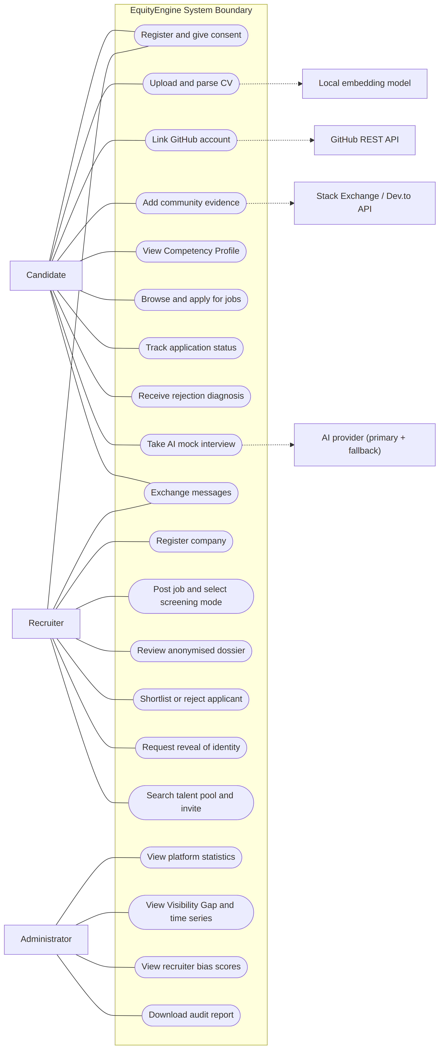
Figure 3.2: Use-case diagram showing candidate, recruiter, and administrator interactions with EquityEngine.
Table 3.6: Use cases mapped to actors and functional requirements
Use case | Primary actor | Requirement | Notes
Register and give consent | Candidate, Recruiter | FR1, FR6 | Consent is recorded with a timestamp before any pipeline may run
Upload and parse CV | Candidate | FR2 | Extends into human-in-the-loop confirmation
Link GitHub account | Candidate | FR3 | Forked repositories excluded from scoring
Add community evidence | Candidate | FR1 | Certifications, Stack Overflow, Dev.to, peer endorsements
View Competency Profile | Candidate | FR4, FR5 | Shows score decomposition and badge tiers
Browse and apply for jobs | Candidate | FR8 | Screening mode is captured onto the application at this point
Track application status | Candidate | FR8 | Status transitions surfaced with notifications
Receive rejection diagnosis | Candidate | FR12, FR13 | Generated automatically; visible only to the candidate
Take AI mock interview | Candidate | FR16 | Degrades to fallback provider, then to rule-based mode
Exchange messages | Candidate, Recruiter | FR15 | Available only after a reveal has opened the channel
Register company | Recruiter | FR6 | One company per recruiter account
Post job and select screening mode | Recruiter | FR6 | Standard, BDIOF, or Hybrid, chosen per job
Review anonymised dossier | Recruiter | FR7 | Allow-list projection; ranked by job-specific Evidence Score
Shortlist or reject applicant | Recruiter | FR8, FR11 | Writes an audit record; rejection triggers the feedback loop
Request reveal of identity | Recruiter | FR9 | The only path to identity in BDIOF and Hybrid modes
Search talent pool and invite | Recruiter | FR18 | Identity-visible sourcing; invitation yields an ordinary application
View platform statistics | Administrator | FR19 | Aggregate counts by role, job, and mode
View Visibility Gap and time series | Administrator | FR14 | Reported with sample-size warnings
View recruiter bias scores | Administrator | FR19 | Never exposed to the recruiter concerned
Download audit report | Administrator | FR19 | Portable Document Format export

Table 3.7 expands the single most design-significant use case in full, following the standard expanded use-case format, because its alternate flows encode the anonymisation guarantee and the feedback trigger on which the project's contribution rests.
Table 3.7: Expanded use-case description for "Shortlist or reject applicant"
Field | Description
Use-case name | Shortlist or reject applicant
Primary actor | Recruiter
Secondary actors | Candidate (recipient of outcome), Bias Audit Engine, Feedback Service
Preconditions | The recruiter is authenticated, owns the job, and the application exists
Postconditions | The application status is updated; an audit record is written; if the outcome is a rejection, a candidate-directed diagnosis is stored on the application
Main flow | 1. Recruiter opens the dossier for a job. 2. System resolves the screening mode and constructs each candidate view accordingly. 3. System ranks views by job-specific Evidence Score. 4. Recruiter selects a candidate and sets a status. 5. System records whether the decision was made under anonymised conditions. 6. System writes the audit record. 7. System notifies the candidate.
Alternate flow A (BDIOF mode) | At step 2, identity fields are excluded by allow-list projection; the candidate appears under a deterministic pseudonym
Alternate flow B (rejection) | At step 5, the Feedback Service computes the diagnosis and stores it on the application; at step 7 the candidate is notified that feedback is available
Alternate flow C (status corrected off rejection) | Any previously stored diagnosis is cleared, so that stale text cannot explain a rejection that no longer exists
Exception E1 (view limit reached) | If the recruiter has viewed this candidate more than the permitted number of times without deciding, further views are refused until a decision is recorded
Business rule | The diagnosis is generated strictly after the status has been set, and is never returned to the recruiter as a justification

3.5.2 Data Flow Diagrams
The use-case model presented in Section 3.5.1 establishes what actors can do with the system, but not how data actually moves through it once a request is made, so a process-oriented view is developed alongside the object-oriented models to close that gap. Figure 3.3 presents the context diagram, which fixes the system boundary and identifies the external entities that exchange data with the system.
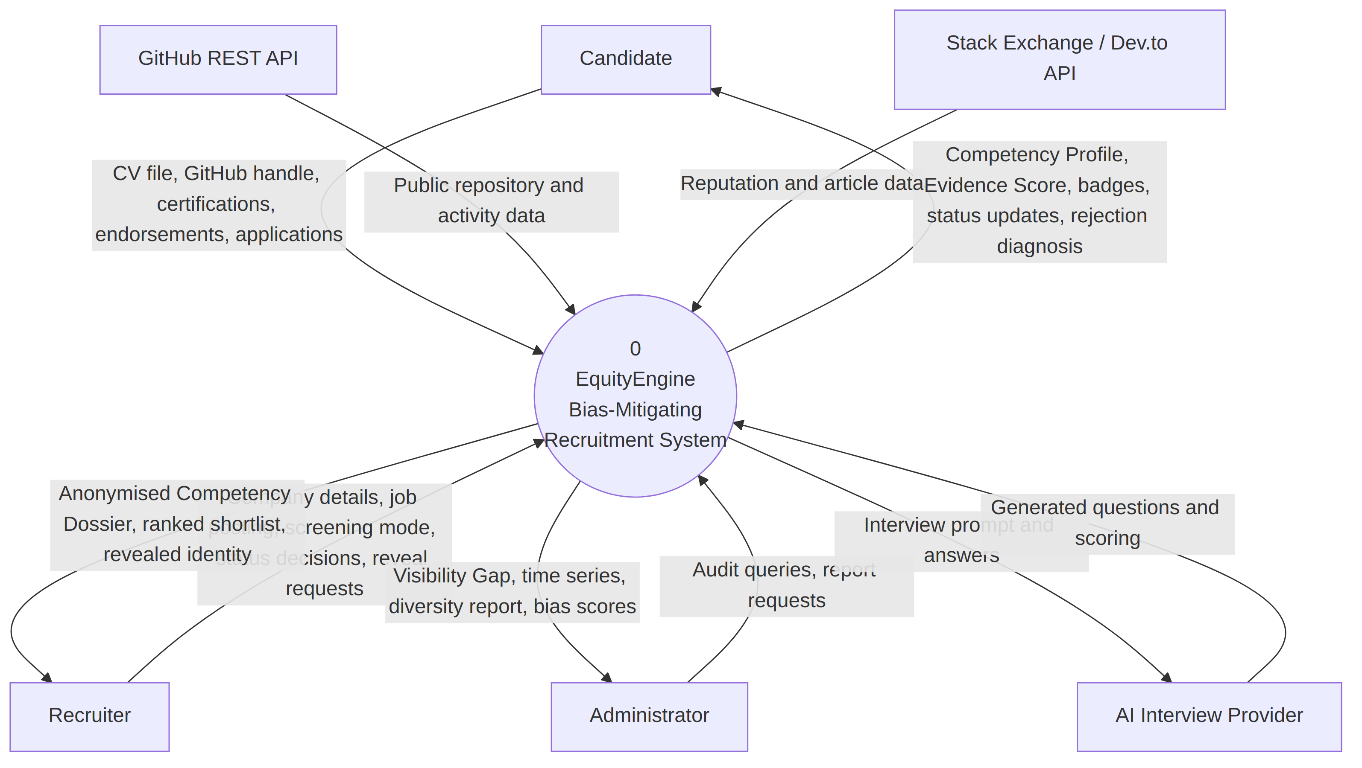Figure 3.3: Context-level (Level 0) data flow diagram of the EquityEngine system.
Figure 3.4 decomposes the single process of Figure 3.3 into the seven major processes of the system, together with the six data stores they read from and write to. The numbering of processes in Figure 3.4 is retained in the discussion throughout the remainder of this chapter.
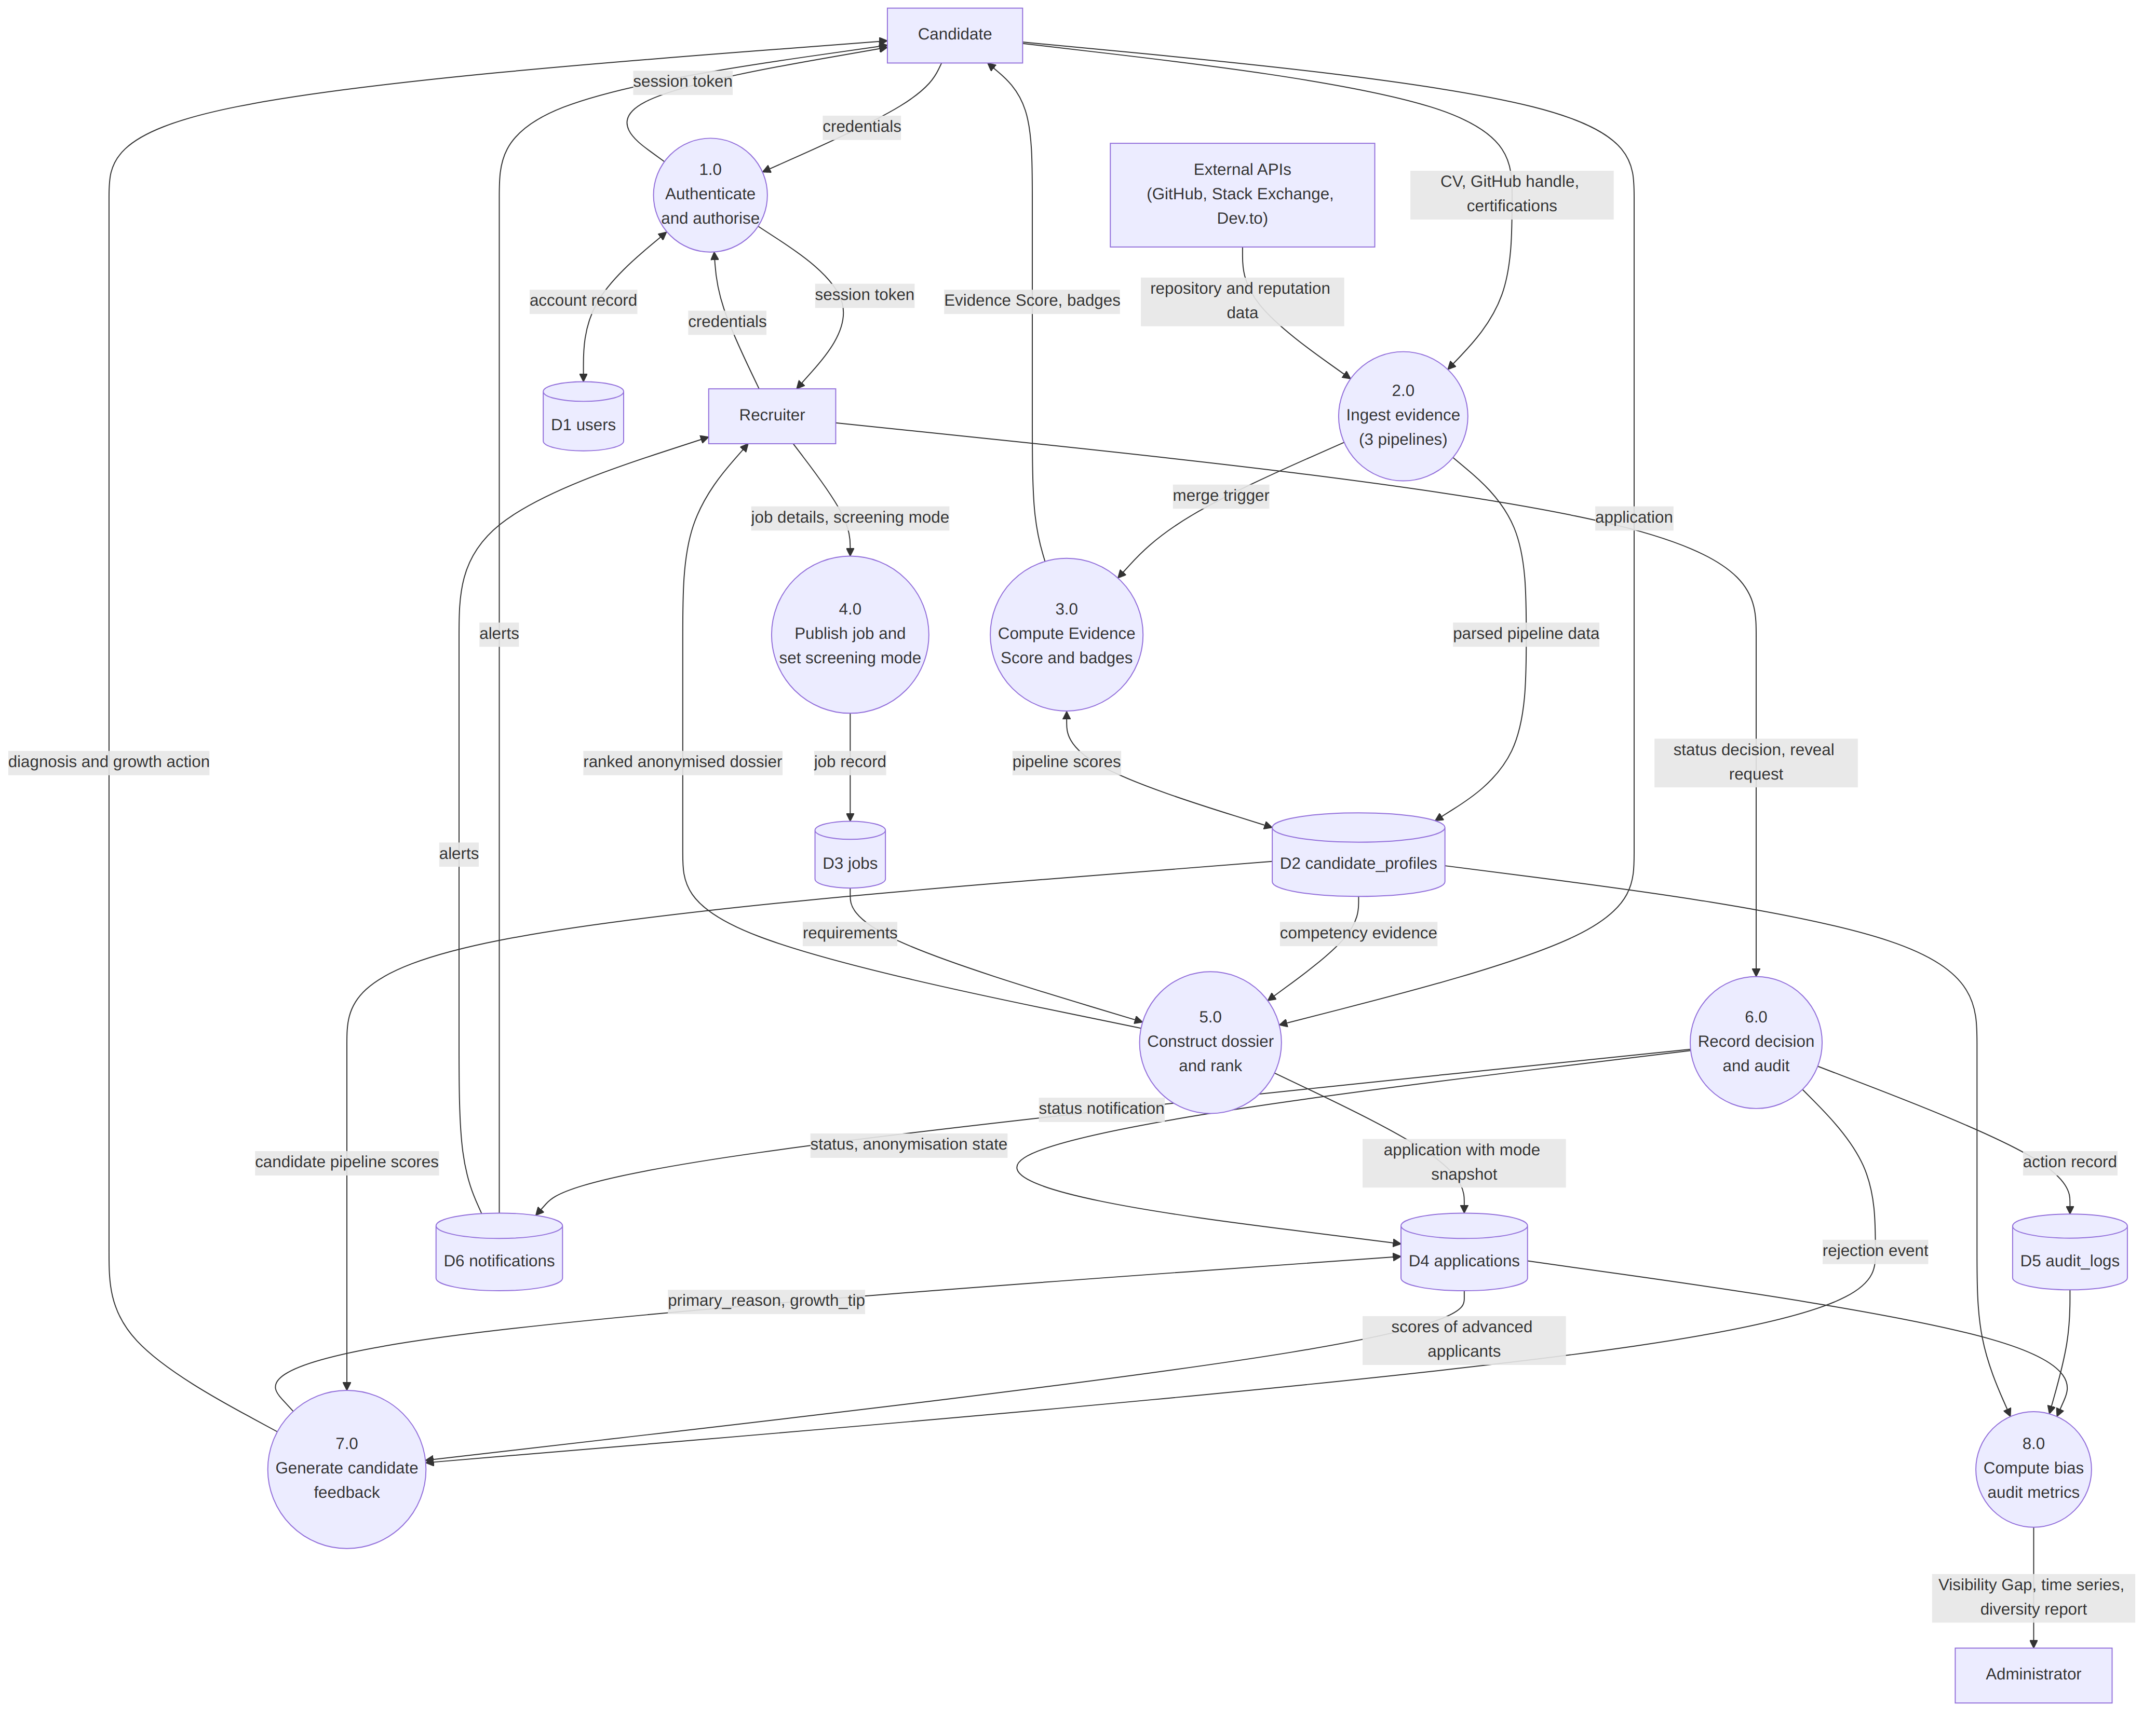Figure 3.4: Level 1 data flow diagram showing the eight major processes and six data stores.
Two properties of Figure 3.4 are worth drawing out because they are design decisions rather than notational accidents. First, process 7.0 receives its trigger only from process 6.0 and never from process 5.0, which enforces the constraint stated in FR13: the diagnosis cannot be computed before a decision has been recorded, and therefore cannot inform it. Second, the only flow leaving process 7.0 towards a human actor terminates at the candidate. No arc runs from 7.0 to the recruiter, and this absence is the diagrammatic statement of the framework's feedback direction.
Figure 3.5 decomposes process 7.0 to Level 2, since it is the process that carries the project's principal contribution.
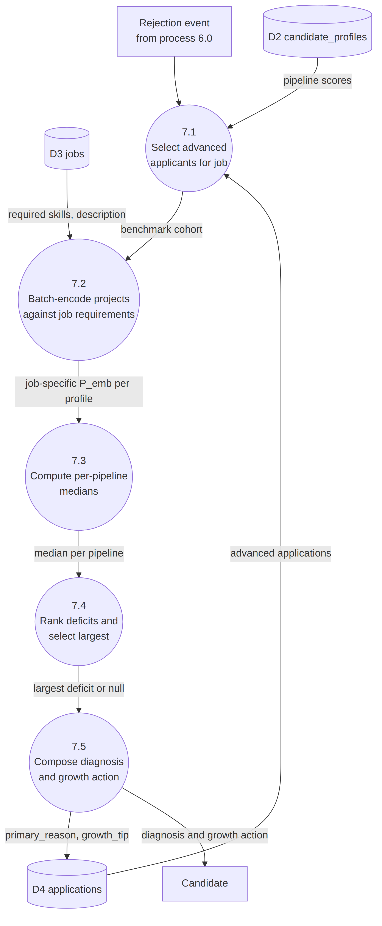
Figure 3.5: Level 2 data flow diagram of process 7.0, the candidate-directed feedback loop.
Table 3.8 cross-references each data store shown in Figure 3.4 against the processes that write to and read from it.
Table 3.8: Data stores referenced in the data flow diagrams
Store | Table | Written by | Read by
D1 | users | 1.0 | 1.0, 5.0, 6.0, 8.0
D2 | candidate_profiles | 2.0, 3.0 | 3.0, 5.0, 7.0, 8.0
D3 | jobs | 4.0 | 5.0, 7.0, 8.0
D4 | applications | 5.0, 6.0, 7.0 | 6.0, 7.0, 8.0
D5 | audit_logs | 6.0 | 6.0, 8.0
D6 | notifications | 6.0, 7.0 | Candidate and recruiter clients

3.5.3 Class Model
Figure 3.6 presents the principal domain classes, their attributes, and their associations. Attributes are shown in abbreviated form; the complete field definitions appear in the data dictionary in Section 3.6.
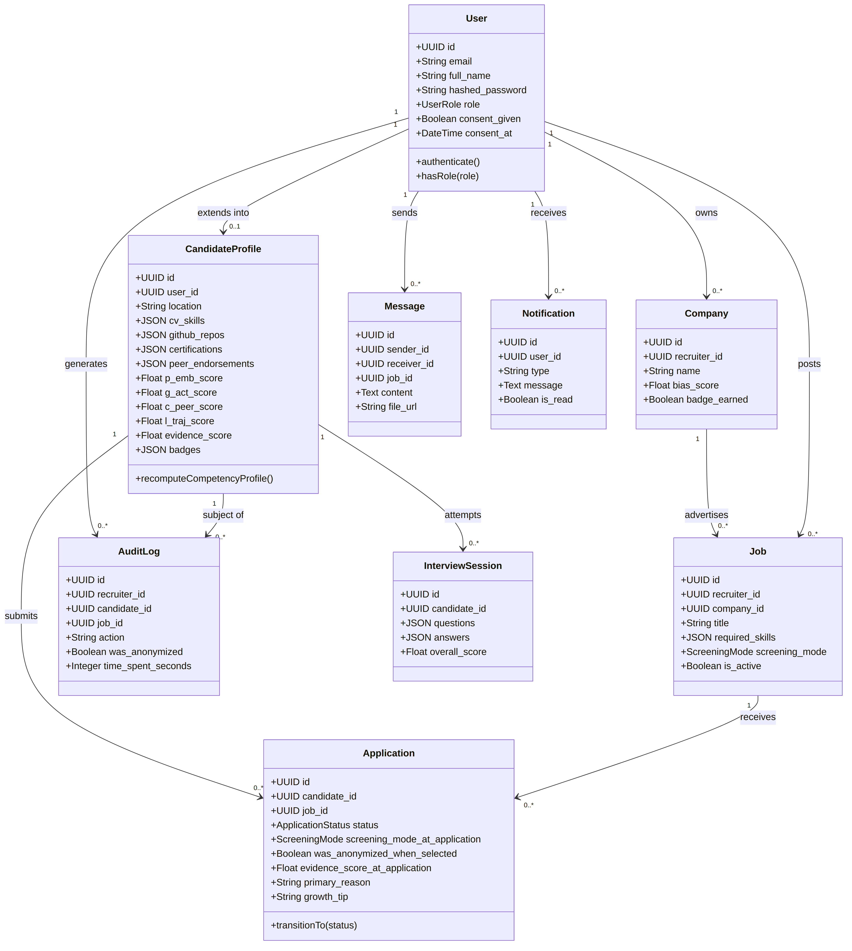
Figure 3.6: Class diagram of the core domain entities.
Three modelling decisions in Figure 3.6 require justification. The CandidateProfile class is deliberately separated from User so that a single authentication identity may be extended with role-specific data: a recruiter's User record extends into a Company rather than a CandidateProfile, and the shared authentication attributes are not duplicated across two tables. The Application class holds the denormalised attributes evidence_score_at_application, screening_mode_at_application, and was_anonymized_when_selected. These are temporal snapshots rather than redundant copies: the screening mode of a job may be changed by its owner after applications have been received, and a candidate's live Evidence Score changes whenever they add evidence, so an audit computed from current values would attribute past decisions to conditions that did not obtain when those decisions were made. Finally, the primary_reason and growth_tip attributes are held on Application rather than recomputed on demand, for reasons developed in Section 3.5.7.
3.5.4 Activity Model
Figure 3.7 models the inbound vector of the framework: the construction of a Competency Profile from any combination of the three evidence pipelines.
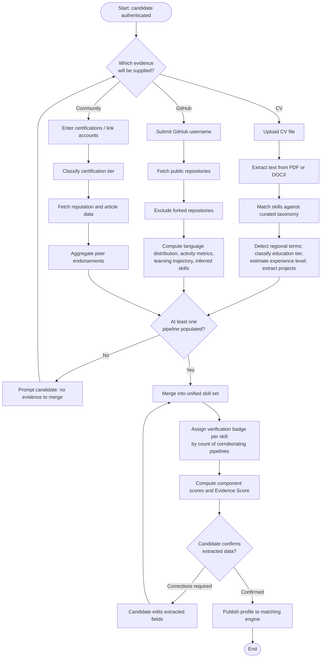
Figure 3.7: Activity diagram for candidate competency profile building.
The guard condition after the three parallel pipelines enforces FR1: any single pipeline is sufficient, but at least one is necessary before the Competency Engine may proceed. The human-in-the-loop confirmation step is not a courtesy but a designed correction point. Curriculum vitae formats vary widely and rule-based extraction is known to be imperfect, so the candidate is given the opportunity to correct the data extracted about them before it is published to the matching engine. Placing a human decision at exactly the point where automated extraction is least reliable is the mechanism by which a known limitation of the parser is prevented from silently propagating into the score.
3.5.5 Algorithmic Design of the Competency Engine
The Evidence Score is the quantity on which all ranking in the system depends. It is defined in Equation (3.1) as a fixed-weight linear combination of four components, each normalised to the interval [0, 1].
$E_{s} = 0.40 P_{emb} + 0.25 G_{act} + 0.20 C_{peer} + 0.15 L_{traj}$ (3.1)
where:
- $P_{emb}$ is the semantic project-evidence score;
- $G_{act}$ is the GitHub activity score;
- $C_{peer}$ is the community standing score;
- $L_{traj}$ is the learning-trajectory score.
Because each component lies in [0, 1] and the weights sum to unity, $E_{s}$ is bounded in [0, 1] by construction. The weights were assigned by design judgement rather than fitted to labelled outcome data, which is a limitation disclosed here and revisited in Chapter Five. The ordering reflects the framework's premise: demonstrated project evidence is weighted most heavily, sustained public activity next, corroboration by a community third, and growth trajectory last.
The component $P_{emb}$ is computed by Equation (3.2). Let $P=\{p_{1},…,p_{m}\}$ be the set of the candidate's project and repository descriptions, and let $R=\{r_{1},…,r_{n}\}$ be a set of reference texts. Let $v_{x}$ denote the unit-normalised embedding of text $x$ produced by the sentence encoder.
$P_{emb} = \frac{1}{|R|}\sum_{r∈R}{ \max_{p∈P}{ cos(v_{p},v_{r})}}$ (3.2)
Because the encoder returns unit-normalised vectors, the cosine similarity in Equation (3.2) reduces to the inner product, as shown in Equation (3.3), which is what permits the entire similarity matrix to be obtained by a single matrix multiplication.
$cos(v_{p},v_{r}) = \frac{v_{p}⋅v_{r}}{‖v_{p}‖ ‖v_{r}‖} = v_{p}⋅v_{r} when‖v_{p}‖=‖v_{r}‖=1$ (3.3)
The structure of Equation (3.2) is a design decision that merits explicit defence, since a plain mean over all pairs would have been equally implementable. The maximum is taken over candidate texts for each reference, and the mean is then taken over references. The expression therefore asks, for each claimed skill or stated job requirement, whether at least one project provides strong evidence for it. A plain average over all pairs would instead ask how relevant the candidate's projects are on average, which penalises a candidate who has one excellent, highly relevant project alongside several unrelated ones — even though the unrelated projects do not undermine the evidence provided by the relevant one. The alternative formulation is defensible on different grounds, and the choice is recorded here as a design decision with a stated rationale rather than as the only reasonable option.
Two distinct instantiations of Equation (3.2) are used, and conflating them would be an error. The profile-level baseline sets $R$ to the candidate's own claimed skills, and therefore measures the internal coherence of the profile — whether the projects substantiate the claims. The job-specific instantiation, given in Equation (3.4), sets $R$ to the requirements of a particular job, and is the quantity used for ranking within a dossier.
$P_{emb}^{(j)} = \frac{1}{|R_{j}|}\sum_{r∈R_{j}}{ \max_{p∈P}{ (v_{p}⋅v_{r}), R_{j}=required\backslash _skills(j)∪\{description(j)\}}}$ (3.4)
The remaining three components are heuristic composites, each capped at unity. $G_{act}$ is defined in Equation (3.5) over the candidate's non-forked repositories, where $N$ is the repository count, $S$ the total stars received, $N_{12}$ the number of repositories pushed to within the last twelve months, $D$ the number of distinct languages, and $τ$ a trajectory bonus taking the value 0.10 for an increasing trend, 0.05 for a stable trend, and 0 otherwise.
$G_{act} = min\left(0.25min\left(\frac{N}{15},1\right)+0.20min\left(\frac{S}{50},1\right)+0.30 \frac{N_{12}}{N}+0.15min\left(\frac{D}{5},1\right)+τ, 1\right)$ (3.5)
$C_{peer}$ is defined in Equation (3.6), where $c_{t}$ is the point value of a certification of tier $t$ (0.15 for tier 1, 0.08 for tier 2, and 0.03 otherwise) counted over at most three certifications, $ρ$ is Stack Overflow reputation, and $E$ is the number of distinct peer endorsements.
$C_{peer} = min\left(min\left(\sum_{i=1}^{min(3,|C|)}{c_{t_{i}}, 0.40}\right)+0.35min\left(\frac{\log_{10}{(ρ+1)}}{4},1\right)+0.25min\left(\frac{E}{10},1\right), 1\right)$ (3.6)
The logarithmic scaling of reputation in Equation (3.6) is necessary rather than cosmetic. Stack Overflow reputation is extremely right-skewed: the majority of accounts hold reputation in the single or double digits while the highest-ranked accounts hold hundreds of thousands. Under a linear scale, the component would be indistinguishable from zero for almost every candidate the platform serves, and the term would contribute nothing.
$L_{traj}$ combines the activity trend with a skill-acquisition rate, as given in Equations (3.7) and (3.8), where $T$ maps the trend label to a value in [0, 1] and $A$ is the proportion of the candidate's distinct languages first observed within the preceding two years.
$L_{traj} = 0.6 T + 0.4 A$ (3.7)
$A = min\left(\frac{\left|\{ ℓ∈L : firstSeen(ℓ)≥Y_{now}−2 \}\right|}{|L|}, 1\right)$ (3.8)
Finally, the verification badge assigned to a skill is a function purely of the number of independent pipelines that surface it, as given in Equation (3.9), where $S_{k}⊆\{CV,GitHub,Community\}$ is the set of pipelines corroborating skill $k$.
$badge(k) = \left\{\begin{aligned}Declared |S_{k}|=1 \\ Confirmed |S_{k}|=2 \\ Verified |S_{k}|=3\end{aligned}\right.$ (3.9)
Equation (3.9) is the point at which the framework's central claim becomes mechanical rather than rhetorical. The badge depends on how many independent sources corroborate a skill, not on which sources they are and not on the prestige of any institution attached to them. A self-taught candidate with Python evidenced on GitHub and a Python-bearing community certification reaches Confirmed without ever uploading a curriculum vitae, and therefore outranks, on that skill, a graduate of a well-known institution whose Python competence is asserted by a CV alone and remains Declared.
Algorithm 3.1 states the formal pipeline, Algorithm 3.2 the unified score computation, and Algorithm 3.3 the badge assignment.
Algorithm 3.1: Formal pipeline — curriculum vitae parsing
Input: file_bytes, filename
Output: parsed record {skills, regional_terms, experience_level,
education_tier, projects, ats_score}

1 text ← EXTRACT_TEXT(file_bytes, filename) // PDF or DOCX branch
2 if text is empty then
3 return EMPTY_RECORD with extraction_failed flag
4 end if
5 skills ← ∅
6 for each phrase match m in PHRASE_MATCH(text, SKILL_TAXONOMY) do
7 skills ← skills ∪ { CANONICAL(m) }
8 end for
9 regional ← PHRASE_MATCH(text, REGIONAL_TAXONOMY)
10 experience_level ← ESTIMATE_EXPERIENCE(text) // regex over "X years"
11 education_tier ← CLASSIFY_TIER(text, regional) // Graduate | Bootcamp |
12 // Self-Taught | Undisclosed
13 projects ← ∅
14 for each section s in SPLIT_BY_HEADER(text) do
15 if IS_PROJECT_HEADER(s.header) then
16 for each bullet b in BULLETS(s.body) do
17 projects ← projects ∪ { {title: TITLE(b), description: b} }
18 end for
19 end if
20 end for
21 ats_score ← ATS_COMPLIANCE(text, skills)
22 return {skills, regional, experience_level, education_tier,
23 projects, ats_score}
Algorithm 3.2: Computation of the unified Evidence Score
Input: profile
Output: profile with component scores, evidence_score, badges,
profile_completeness updated

1 L_traj ← 0.6 · TREND_VALUE(profile.learning_trajectory.trend)
2 + 0.4 · SKILL_ACQUISITION_RATE(profile.github_repos) // Eq (3.7),(3.8)
3 competency ← BUILD_COMPETENCY_PROFILE(profile) // Algorithm 3.3
4 P_emb ← BEST_MATCH_SIMILARITY(PROJECT_TEXTS(profile),
5 KEYS(competency)) // Eq (3.2)
6 G_act ← profile.g_act_score // set by the GitHub pipeline
7 C_peer ← profile.c_peer_score // set by the community pipeline
8 E_s ← 0.40·P_emb + 0.25·G_act + 0.20·C_peer + 0.15·L_traj // Eq (3.1)
9 profile.p_emb_score ← P_emb
10 profile.l_traj_score ← L_traj
11 profile.evidence_score ← ROUND(E_s, 3)
12 profile.badges ← { k ↦ competency[k].tier : k ∈ KEYS(competency) }
13 profile.profile_completeness ← (100/3) · |{ pipelines with any data }|
14 return profile
Algorithm 3.3: Assignment of competency verification badges
Input: profile
Output: map skill ↦ {tier, sources}

1 cv_skills ← { NORMALISE(s) : s ∈ profile.cv_skills }
2 github_skills ← { NORMALISE(s) : s ∈ INFERRED(profile.github_activity)
3 ∪ KEYS(profile.github_languages) }
4 community_skills ← ∅
5 cert_text ← LOWER(CONCAT(name, issuer) for each certification)
6 for each (term, canonical) in SKILL_TAXONOMY do
7 if REGEX_SEARCH("\b" + ESCAPE(term) + "\b", cert_text) then
8 community_skills ← community_skills ∪ { canonical }
9 end if
10 end for
11 for each endorsement e in profile.peer_endorsements do
12 community_skills ← community_skills ∪ { NORMALISE(e.skill) }
13 end for
14 result ← empty map
15 for each skill k in SORT(cv_skills ∪ github_skills ∪ community_skills) do
16 S ← ∅
17 if k ∈ cv_skills then S ← S ∪ {"CV"} end if
18 if k ∈ github_skills then S ← S ∪ {"GitHub"} end if
19 if k ∈ community_skills then S ← S ∪ {"Community"} end if
20 result[k] ← { tier: BADGE_TIER(|S|), sources: S } // Eq (3.9)
21 end for
22 return result
The word-boundary match at line 7 of Algorithm 3.3 is not incidental. Plain substring containment would match the single-letter language name "R" inside ordinary words such as "Engineering" or "Software", awarding community corroboration for a skill the candidate never claimed. In a system whose purpose is to measure bias, a silent false positive of this kind would corrupt the measurement instrument itself.
Figure 3.8 presents the corresponding flowchart for the Evidence Score computation.
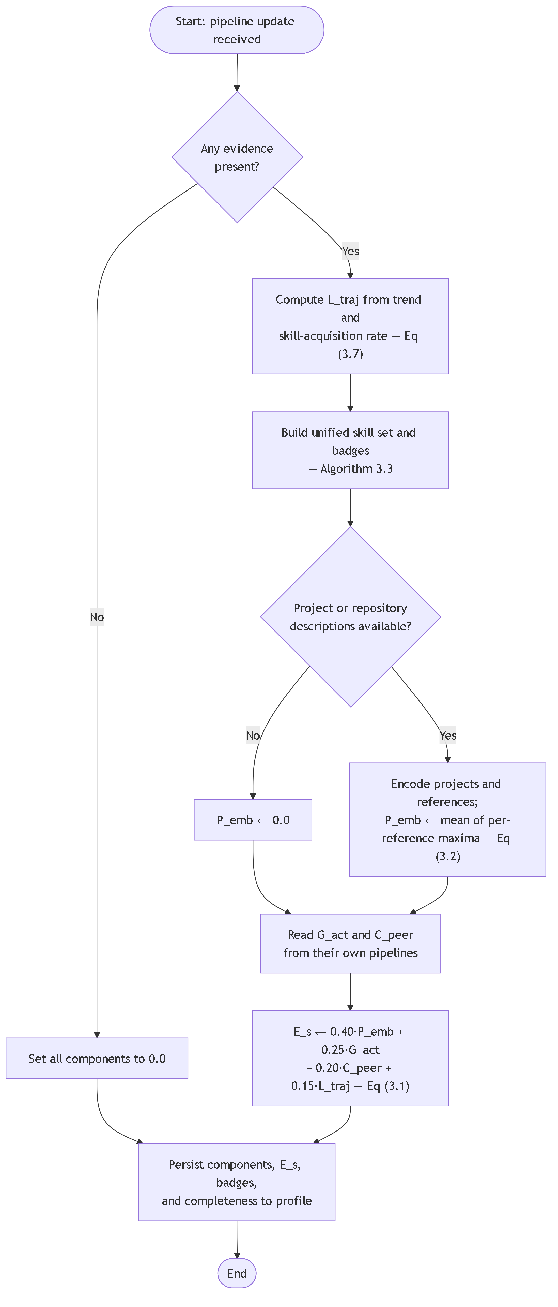
Figure 3.8: Flowchart of the Evidence Score computation procedure.
3.5.6 Screening Mode Resolution and Anonymised Dossier Construction
A recruiter reviewing applicants sees a Competency Dossier rather than a set of curricula vitae. Whether that dossier carries identity depends on the screening mode of the job and, for BDIOF and Hybrid jobs, on whether a reveal has already occurred. Table 3.9 states the anonymisation allow-list together with the fields deliberately excluded and the reason for each exclusion, and Algorithm 3.4 states the construction and ranking procedure.
Table 3.9: Anonymisation allow-list and excluded fields
Disposition | Field | Rationale
Permitted | pseudonym | Deterministic hash of the profile identifier; stable across repeated views without exposing the database key
Permitted | evidence_score_breakdown | The ranking basis; contains no identity
Permitted | skills with badge tier and sources | The competency evidence itself
Permitted | experience_level | Coarse band
Permitted | education_tier | Already generalised to four non-identifying categories
Permitted | profile_completeness, status, applied_at | Process metadata
Permitted | primary_reason, growth_tip | Composed from the candidate's own scores and an aggregate median; names no other candidate and no institution
Excluded | full_name, email | Direct identity
Excluded | location | The precise signal the framework exists to suppress during screening
Excluded | cv_file_url | File names frequently embed the candidate's real name
Excluded | github_username, repository URLs | Handles are commonly real names; repository names can identify
Excluded | regional_terms | Contains specific institution and programme names, which is the institutional signal being suppressed
Excluded | bio | Free text that is commonly self-identifying; not scrubbed of personal data, and disclosed as a limitation
Excluded | external account display names and profile URLs | Identity by way of a linked third-party account

Algorithm 3.4: Construction and ranking of the Competency Dossier
Input: job, applications, requesting recruiter
Output: ranked list of candidate views

1 views ← empty list
2 for each application a in applications do
3 profile ← PROFILE_OF(a)
4 breakdown ← JOB_SPECIFIC_EVIDENCE_SCORE(profile, job) // Eq (3.4),(3.1)
5 if job.screening_mode = STANDARD then
6 v ← BUILD_REVEALED_VIEW(profile, USER_OF(profile), job, a)
7 else if HAS_BEEN_REVEALED(recruiter, profile, job) then
8 v ← BUILD_REVEALED_VIEW(profile, USER_OF(profile), job, a)
9 else
10 v ← ALLOW_LIST_PROJECTION(profile, breakdown, a) // Table 3.9
11 v.pseudonym ← "Candidate-" + UPPER(SHA256(profile.id)[0..5])
12 end if
13 views ← views ∪ { v }
14 end for
15 return SORT_DESCENDING(views, key = v.evidence_score_breakdown.evidence_score)
Line 10 constructs the anonymised view by building a fresh record from an explicit list of permitted fields, rather than by copying the profile and removing identity-bearing ones. This satisfies NFR3 and is the single most important defensive decision in the design. A block-list would silently disclose any field added to the profile in future and forgotten from the removal list, whereas an allow-list can only ever under-include. The failure direction of an allow-list is a missing attribute in a dossier; the failure direction of a block-list is the disclosure of the identity the system exists to protect.
Ranking at line 15 occurs identically in every screening mode. This is deliberate and is what makes the Visibility Gap interpretable: because the ordering presented to the recruiter is the same regardless of mode, any systematic difference in outcomes between modes must arise from the recruiter's decisions relative to that ordering, not from the ordering itself. Algorithm 3.5 states the reveal and view-limiting procedure that governs the transition out of anonymity.
Algorithm 3.5: Progressive identity reveal and view limiting
Input: recruiter, candidate profile, job, application, requested action
Output: permission decision and, where granted, revealed identity

1 if requested action = VIEW and application.status ∈ {APPLIED, VIEWED} then
2 n ← COUNT(audit_logs where recruiter, candidate, action = "viewed")
3 if n ≥ MAX_VIEWS_BEFORE_DECISION_REQUIRED then
4 return DENY("a decision is required before further views")
5 end if
6 end if
7 if requested action = REVEAL then
8 if job.screening_mode = STANDARD then
9 identity is already visible; no reveal is required
10 end if
11 WRITE_AUDIT(recruiter, candidate, job, action = "revealed",
12 was_anonymized = TRUE, mode = job.screening_mode)
13 NOTIFY(candidate, "your profile has been revealed to a recruiter")
14 OPEN_MESSAGE_CHANNEL(recruiter, candidate, job)
15 return ALLOW(BUILD_REVEALED_VIEW(profile, USER_OF(profile), job, application))
16 end if
The reveal state is derived from the audit trail at line 2 and line 7 rather than from a stored flag on the application. An application that was revealed, interviewed, and subsequently rejected must remain revealed, yet "rejected" is not itself a reveal-triggering status; the current status alone therefore cannot answer whether a reveal has occurred. Deriving the answer from the immutable record of actions gives one authoritative source, which the dossier view and the messaging subsystem both consult.
3.5.7 The Candidate-Directed Feedback Loop
This subsection specifies the mechanism that constitutes the third vector of the BDIOF framework and the principal design contribution of the project. Rejection is ordinarily the point at which a candidate learns nothing. The design converts it into the point at which the candidate learns the most.
At the moment an application is set to the rejected status, the system compares the rejected candidate's three evidence pipelines against the median of the applicants the recruiter actually advanced for the same job, identifies the pipeline carrying the largest deficit, and writes a plain-language reason and a specific growth action onto the application record. The comparison quantities are defined in Equations (3.10) and (3.11). Let $B$ be the set of profiles advanced for job $j$, that is, those whose application status lies in {Shortlisted, Interview, Offered}, excluding the application under diagnosis. For each pipeline $k∈\{P_{emb},G_{act},C_{peer}\}$:
$μ_{k} = median\{ score_{k}(b) : b∈B \}$ (3.10)
$δ_{k} = μ_{k} − score_{k}(candidate), k^{∗} = arg\max_{k}{ δ_{k}}$ (3.11)
Four properties of Equations (3.10) and (3.11) are design decisions rather than arbitrary choices, and each is defensible on stated grounds.
The comparison group is the applicants advanced for this job, rather than a fixed platform-wide threshold. A fixed bar would return the same message to every rejected candidate on every job. A per-job comparison group answers the question the candidate actually holds — what did the people who progressed have that I did not — and answers it in the terms the platform already measures, so that the resulting advice points at something the candidate can act upon.
The median is used rather than the mean because the comparison group is frequently very small. Two or three advanced applicants is a typical size on an ordinary posting, and that is precisely the size at which one exceptional candidate drags the mean far above anything the remainder of the group needed to clear. The median remains representative at $n=2$ and $n=3$.
The deficit in Equation (3.11) is ranked on the raw gap rather than on the gap weighted by each pipeline's share of the Evidence Score. The candidate is being told which pipeline they are furthest behind on, which is the question they can act on; how much each pipeline contributes is then stated within the growth action itself.
The learning-trajectory component is deliberately excluded from the set of diagnosable pipelines. It is derived from the same GitHub data as $G_{act}$, so a candidate behind on both would be told about GitHub twice, and there is no distinct action available to a candidate on $L_{traj}$ beyond what the GitHub advice already prescribes.
A deficit smaller than a defined threshold, $δ_{min}=0.05$, is treated as noise rather than as a finding. On the 0–100 scale the candidate sees, five points is the smallest difference that can be described as being "behind" without the description being technically true and practically misleading. Table 3.10 states the three outcome cases, each of which is an ordinary situation on a young platform rather than an error condition.
Table 3.10: Outcome cases of the candidate-directed feedback loop
Case | Condition | Response
Diagnosed deficit | $B≠∅$ and $δ_{k^{∗}}≥δ_{min}$ | Names the pipeline $k^{∗}$, states the candidate's score and the cohort median on the 0–100 scale, and gives the growth action for that pipeline together with its weight in the Evidence Score
No comparison group | $B=∅$ (the role was closed without a shortlist) | States explicitly that no comparison group existed, then falls back to the candidate's own weakest pipeline in absolute terms, so that the feedback remains actionable without implying a comparison that did not occur
Competitive pool | $B≠∅$ and $δ_{k^{∗}}<δ_{min}$ | States that the evidence was competitive and that the outcome reflects a final choice among strong applications; directs improvement advice at the lowest absolute pipeline as margin-building rather than as the cause of rejection

The competitive-pool case deserves particular emphasis. Where a candidate has matched or exceeded the cohort median on every pipeline, inventing a deficit would be dishonest, and instructing them to improve something on which they were already competitive would waste the single piece of feedback they receive. The system therefore says plainly that the evidence was competitive. A feedback mechanism that always finds fault is not a diagnostic instrument; it is a formality, and candidates would learn to disregard it.
Algorithm 3.6 states the procedure in full, and Figure 3.9 presents the corresponding flowchart.
Algorithm 3.6: Candidate-directed feedback loop (post-rejection diagnosis)
Input: application a, job j, database session
Output: {primary_reason, growth_tip} stored on a
Precondition: a.status has ALREADY been set to REJECTED by the recruiter

1 profile ← a.candidate
2 B ← SELECT profiles p JOIN applications x ON x.candidate_id = p.id
3 WHERE x.job_id = j.id
4 AND x.status ∈ {SHORTLISTED, INTERVIEW, OFFERED}
5 AND x.id ≠ a.id
6 // One batched encode for the candidate and every peer, so the job's
7 // requirement text is encoded once rather than once per peer.
8 R_j ← j.required_skills ∪ {j.description}
9 Π ← BEST_MATCH_SIMILARITY_BATCH(
10 [PROJECT_TEXTS(p) for p in ([profile] ++ B)], R_j) // Eq (3.4)
11 cand ← { P_emb: Π[0], G_act: profile.g_act_score,
12 C_peer: profile.c_peer_score }
13 peers ← [ { P_emb: Π[i+1], G_act: B[i].g_act_score,
14 C_peer: B[i].c_peer_score } for i = 0 .. |B|−1 ]
15
16 if peers is empty then // Case: no comparison group
17 k ← ARGMIN over pipelines of cand[k]
18 return NO_COMPARISON_GROUP_MESSAGE(k, cand[k], j)
19 end if
20
21 for each pipeline k ∈ {P_emb, G_act, C_peer} do
22 μ[k] ← MEDIAN({ q[k] : q ∈ peers }) // Eq (3.10)
23 δ[k] ← μ[k] − cand[k] // Eq (3.11)
24 end for
25 k* ← ARGMAX over k of δ[k]
26
27 if δ[k*] < 0.05 then // Case: competitive pool
28 k ← ARGMIN over pipelines of cand[k]
29 return COMPETITIVE_POOL_MESSAGE(k, cand[k], |peers|)
30 end if
31
32 primary_reason ← FORMAT(TEMPLATE_REASON[k*],
33 candidate = ROUND(100 · cand[k*]),
34 benchmark = ROUND(100 · μ[k*]))
35 growth_tip ← FORMAT(TEMPLATE_TIP[k*],
36 weight = 100 · EVIDENCE_WEIGHTS[k*],
37 requirements = FORMAT_REQUIREMENTS(j))
38 return {primary_reason, growth_tip}
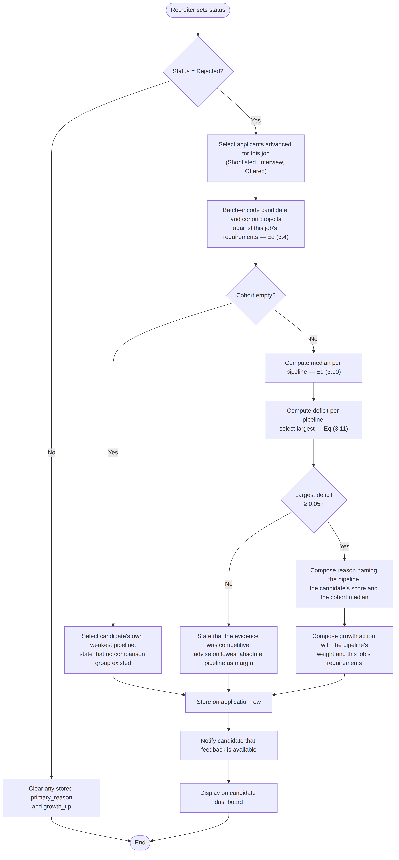
Figure 3.9: Flowchart of the candidate-directed feedback loop.
Two boundaries are enforced architecturally rather than by convention, and they are what make the mechanism a candidate-support instrument rather than a decision-support one.
The diagnosis is generated after the recruiter's decision has already been recorded. It is therefore incapable of influencing that decision, and it is never returned to the recruiter as a justification for it. The direction of the arrow in Figure 3.5 is the whole point of the design: information flows from the decision to the candidate, and nowhere else.
The generated text names pipelines, scores, and the job's own stated requirements. It never names another candidate. The comparison group is referenced only as an aggregate median, so the mechanism cannot become a channel through which the identity or the standing of other applicants leaks — the same discipline applied to the dossier projection in Table 3.9.
A third property follows from where the result is stored rather than from how it is computed. The diagnosis is persisted onto the application row at the moment of rejection rather than recomputed whenever the candidate opens their dashboard, for two reasons. The benchmark in Equation (3.10) moves continuously as the recruiter works through the applicant pool, so a value recomputed weeks later would explain a different decision from the one that was actually taken. And persisting it makes the feedback auditable: what the candidate was told is durable, and is not a function of current database state. Conversely, when a recruiter moves a status off rejection — correcting a misselection, or reconsidering — the stored diagnosis is cleared, since the candidate's dashboard renders the card whenever those fields are populated and stale text would continue to explain a rejection that no longer exists.
3.5.8 Sequence Models
Figure 3.10 traces a complete application lifecycle under BDIOF screening, from submission through anonymised presentation, shortlisting, audit logging, and the progressive reveal that opens the messaging channel.
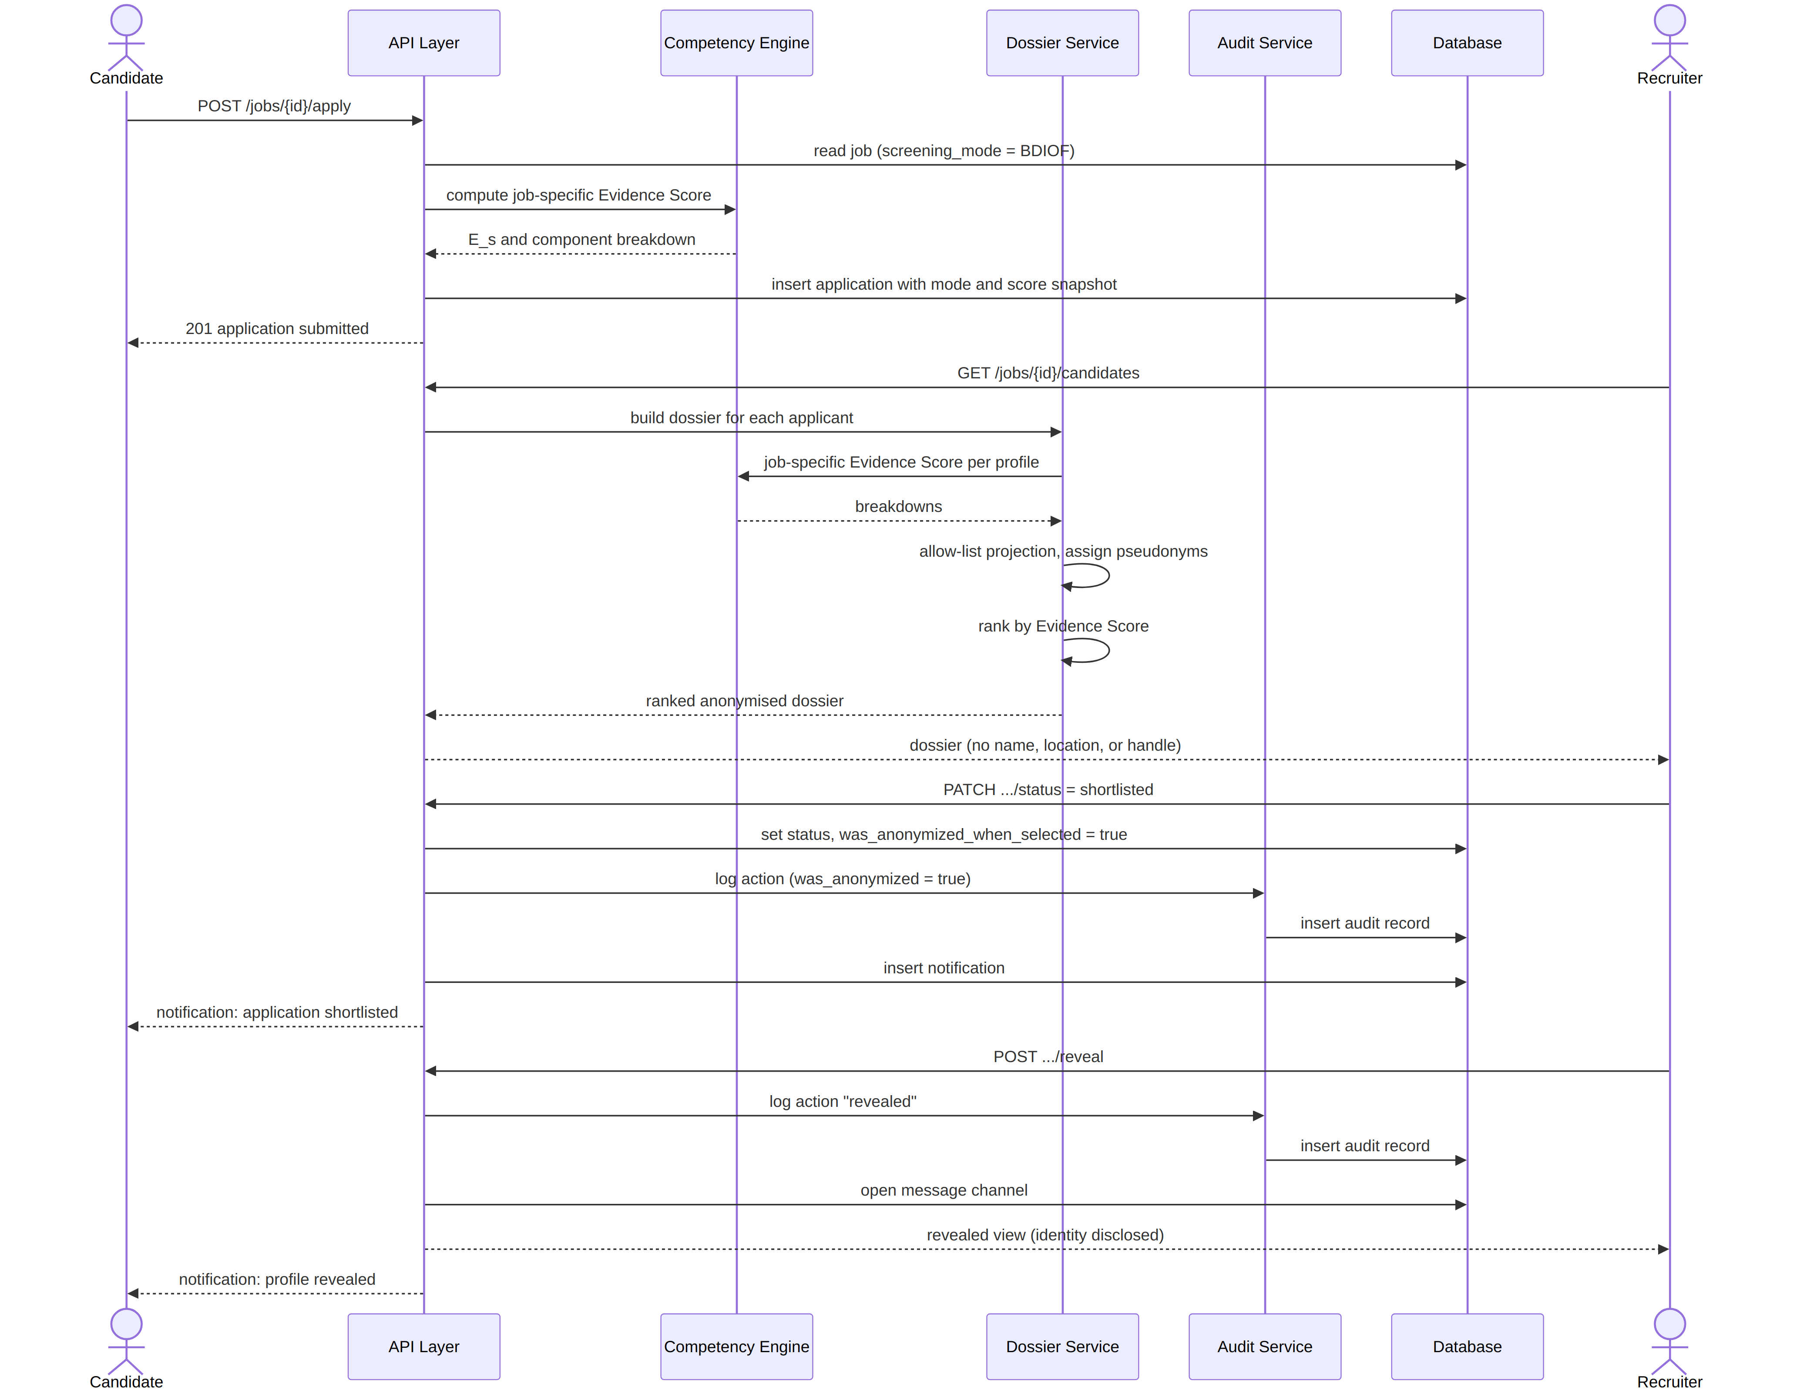
Figure 3.10: Sequence diagram for job application, anonymised screening, and progressive identity reveal.
Figure 3.11 traces the feedback vector, which begins where Figure 3.10 would otherwise end.
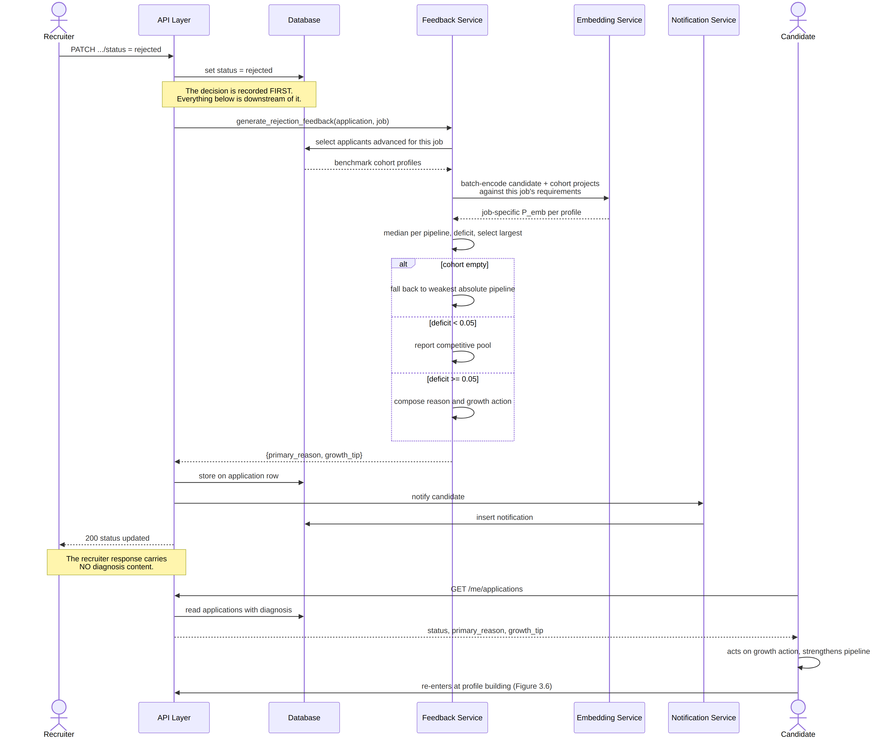
Figure 3.11: Sequence diagram for the candidate-directed feedback loop.
The final two interactions in Figure 3.11 are what make the framework a loop rather than a terminating pipeline. The candidate acts on the growth action, strengthens the identified pipeline, and re-enters the process at the profile-building activity of Figure 3.7 with a higher Evidence Score than they held before. The annotation on the recruiter's response is equally deliberate: the recruiter receives an acknowledgement that the status was updated and nothing more, since returning the diagnosis to the recruiter would violate FR13.
3.5.9 Algorithmic Design of the Bias Audit Engine
The Bias Audit Engine measures the system's own outcomes. Let $M$ denote a screening mode, $n_{M}$ the number of applications submitted under that mode, and $s_{M}$ the number of those whose status lies in {Shortlisted, Interview, Offered}. The shortlist rate is given in Equation (3.12) and the Visibility Gap in Equation (3.13).
$SR_{M} = \frac{s_{M}}{n_{M}}, n_{M}>0$ (3.12)
$VG = SR_{BDIOF} − SR_{Standard}, VG_{\backslash \%} = \frac{VG}{SR_{Standard}}×100$ (3.13)
A per-recruiter composite score is computed as shown in Equation (3.14), where $g$ is the internal gap between a recruiter's shortlist rate under identity-visible and anonymised conditions, and $σ$ is the absolute difference between the graduate share of the candidates that recruiter shortlisted and the graduate share of everyone who applied to their postings.
$BiasScore = min(200|g|, 60) + min(100σ, 40)$ (3.14)
Algorithm 3.7: Computation of the Visibility Gap metric
Input: database session
Output: rates by mode, Visibility Gap, warnings, methodology note

1 for each mode M ∈ {STANDARD, BDIOF, HYBRID} do
2 n[M] ← COUNT(applications where screening_mode_at_application = M)
3 s[M] ← COUNT(same, and status ∈ {SHORTLISTED, INTERVIEW, OFFERED})
4 SR[M] ← (n[M] > 0) ? s[M] / n[M] : NULL // Eq (3.12)
5 small_sample[M] ← (0 < n[M] < 10)
6 end for
7 if SR[STANDARD] ≠ NULL and SR[BDIOF] ≠ NULL then
8 VG ← SR[BDIOF] − SR[STANDARD] // Eq (3.13)
9 VG_pct ← (SR[STANDARD] > 0) ? 100 · VG / SR[STANDARD] : NULL
10 else
11 VG ← NULL ; VG_pct ← NULL
12 end if
13 warnings ← { "sample for mode M below 10 — preliminary"
14 : M where small_sample[M] }
15 return { rates: SR, visibility_gap: VG, percent: VG_pct,
16 warnings: warnings, methodology_note: BETWEEN_GROUPS_CAVEAT }
The methodology note returned at line 16 is part of the algorithm's output rather than a comment on it, and the reason is a matter of research integrity. The Visibility Gap as computed here is a between-groups comparison of shortlist rates across different job postings, not a matched-pairs comparison of the same candidates evaluated under both modes. A recruiter chooses the mode for each job, so jobs using different modes may differ in other respects — different roles, different applicant pools, and different recruiters with different baseline standards. This is confounding in the ordinary statistical sense, and it means the metric constitutes correlational evidence consistent with the bias-mitigation hypothesis rather than proof that anonymisation alone caused any observed difference. Audit studies of fairness interventions have shown that this distinction is not pedantic: interventions widely assumed to reduce disparity have failed to do so when their outcomes were examined under controlled conditions (Sariola et al., 2026). A properly controlled comparison would require randomising the assignment of screening mode across otherwise identical postings, which lies outside the scope declared in Chapter One. Emitting the caveat alongside the number, rather than leaving it to the reader, ensures that the figure cannot be quoted from the administrator interface without the qualification that governs its interpretation.
3.6 Database Design
The database comprises nine relations implemented in PostgreSQL through an object-relational mapping layer. This section presents the entity-relationship model, the normalisation argument, and the complete data dictionary. Figure 3.12 presents the entity-relationship diagram; the cardinalities shown are enforced by foreign-key constraints and, where a relationship is one-to-one, by a uniqueness constraint on the referencing column.
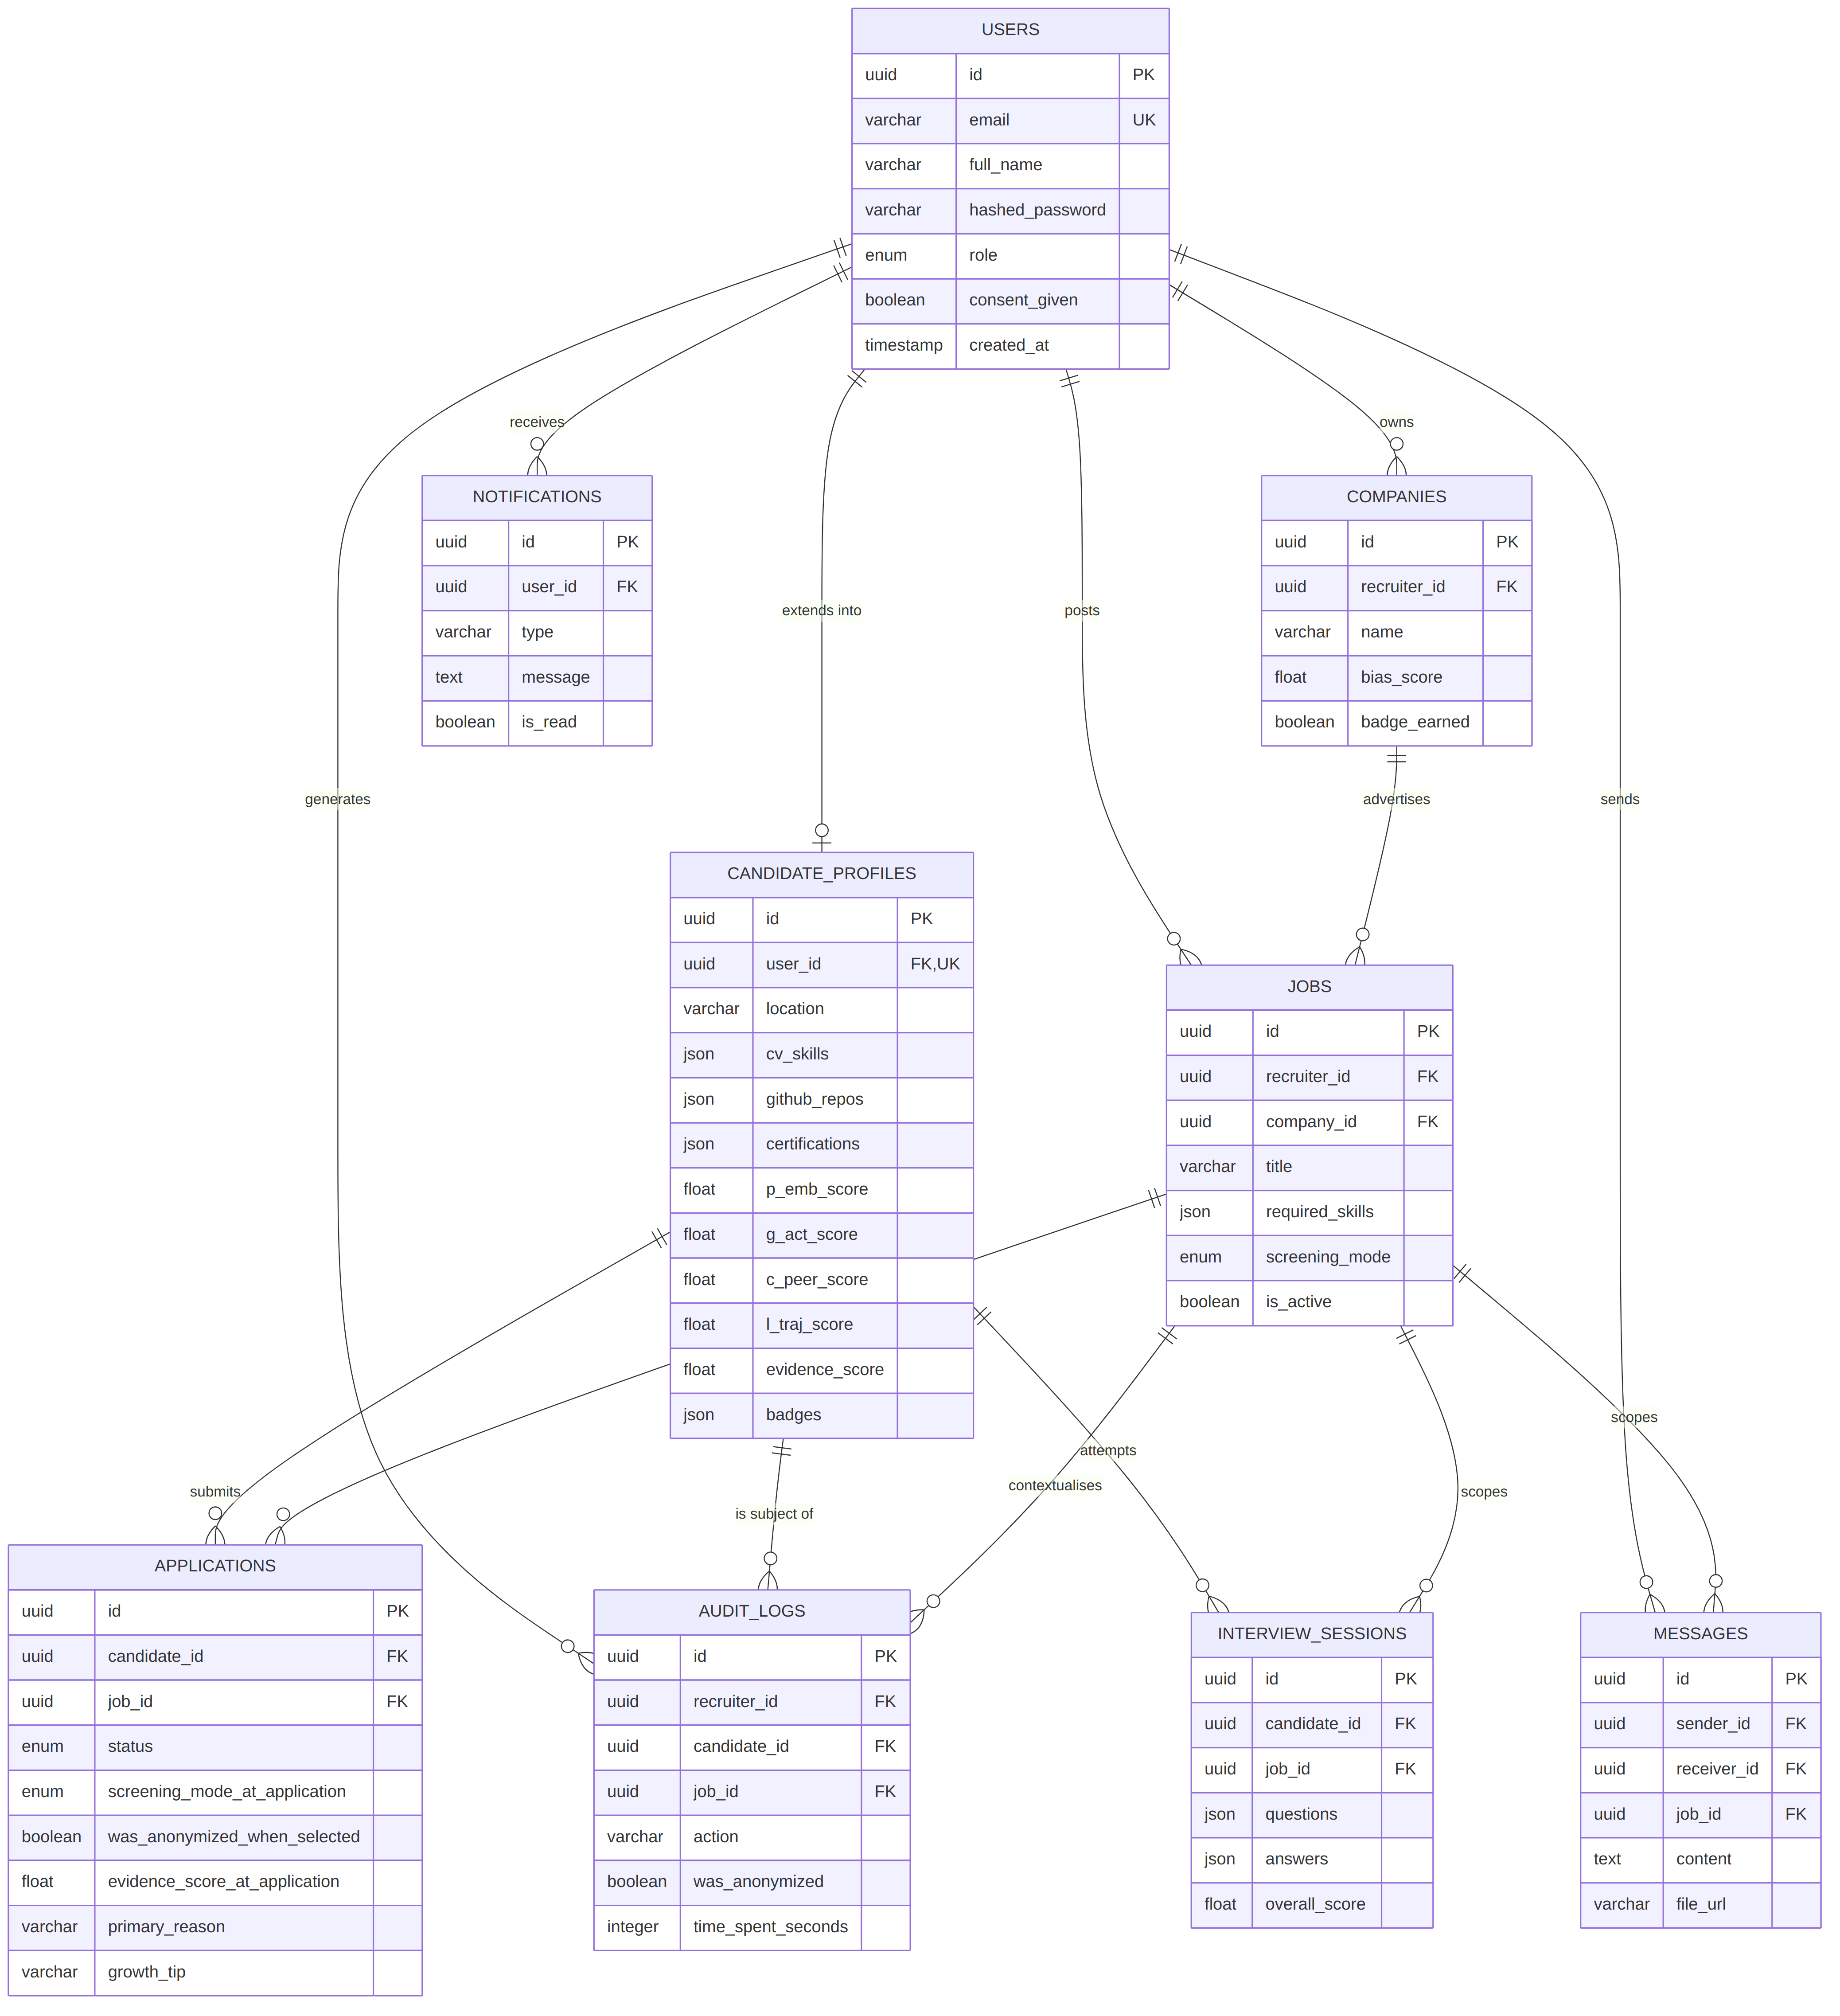
Figure 3.12: Entity-relationship diagram of the EquityEngine database.
3.6.1 Normalisation
The schema was normalised to Third Normal Form. The argument is stated for each stage rather than asserted, since normalisation is an assessed element of the design.
The schema satisfies First Normal Form in that every relation has a declared primary key and no repeating groups are held in ordinary scalar columns. Nine attributes are declared as JSON documents, and these require explicit defence because a JSON column can be used to conceal a repeating group. They are not so used here. Each JSON attribute stores the whole output of one evidence pipeline — the parsed skill list, the repository summary, the certification list, and so forth — and each is read and written as a complete document by the Competency Engine rather than queried field by field. No query in the system filters, joins, or orders on a value nested inside one of these documents. Decomposing them into separate relations would therefore introduce nine additional tables and their joins in exchange for no query capability the system uses, while the aggregate-valued attributes that genuinely participate in ranking and audit — the four component scores, the Evidence Score, the education tier, and the completeness measure — are all held as first-class scalar columns precisely because they are queried. This is a deliberate and bounded denormalisation, and the boundary is the rule that any attribute the system needs to query is promoted out of the document and into a column of its own.
The schema satisfies Second Normal Form because no relation has a composite primary key. Every relation is keyed on a single surrogate UUID, so no non-key attribute can be partially dependent on part of a key. Surrogate keys were chosen over natural keys throughout: a candidate's electronic mail address is unique and would serve as a natural key, but it is also mutable and identity-bearing, and propagating it as a foreign key into the applications and audit relations would embed direct identity into the very tables the anonymisation design exists to keep free of it.
The schema satisfies Third Normal Form in that no non-key attribute is transitively dependent on the primary key through another non-key attribute. The case that most obviously invites a transitive dependency is jobs, which holds both recruiter_id and company_id. A company is owned by exactly one recruiter, so it might appear that recruiter_id is determined by company_id and should be removed. It is retained deliberately, because company_id is nullable — a recruiter may post a job before completing a company profile — and the job must remain attributable to its owner in that case for authorisation to function. The dependency is therefore not transitive across all rows of the relation, and removing the attribute would make ownership underivable exactly where the system most needs it.
Three attributes on applications are intentional denormalisations and are not normalisation failures, because they record historical fact rather than duplicating current state. The attributes screening_mode_at_application, evidence_score_at_application, and was_anonymized_when_selected capture the conditions under which a decision was taken. Their live counterparts on jobs and candidate_profiles may change afterwards — a recruiter may switch a job's mode, and a candidate's score changes whenever evidence is added — so a normalised join to the current values would attribute a past decision to conditions that did not obtain when it was made, and would silently invalidate every figure the Bias Audit Engine produces. The same reasoning governs primary_reason and growth_tip, as set out in Section 3.5.7.
3.6.2 Data Dictionary
Tables 3.11 to 3.19 define every attribute of the nine relations, giving the data type, the constraint, and a description. Types are given in the PostgreSQL forms actually created by the mapping layer.
Table 3.11: Data dictionary — users
Field | Type | Constraint | Description
id | UUID | Primary key | Generated in the application layer, so that no database extension is required
email | VARCHAR | Unique, not null, indexed | Login identifier
full_name | VARCHAR | Not null | Withheld from anonymised dossiers
hashed_password | VARCHAR | Not null | Salted hash; the plain password is never stored
role | ENUM | Not null | candidate, recruiter, or admin; the basis of access control
is_active | BOOLEAN | Not null, default true | Permits suspension without deletion
consent_given | BOOLEAN | Not null, default false | Terms and data-processing consent
consent_at | TIMESTAMP | Nullable | Time at which consent was recorded
reset_token | VARCHAR | Nullable | Single-use password-reset token
reset_token_expires | TIMESTAMP | Nullable | Expiry of the reset token
created_at | TIMESTAMP | Not null | Registration time
Table 3.12 details the schema constraints of the companies relation.

Table 3.12: Data dictionary — companies
Field | Type | Constraint | Description
id | UUID | Primary key
recruiter_id | UUID | Foreign key → users.id, not null | Owning recruiter
name | VARCHAR | Not null | Company name
website | VARCHAR | Nullable
industry | VARCHAR | Nullable
bias_score | FLOAT | Nullable | Administrator-only composite of Equation (3.14); never exposed to the owning recruiter
badge_earned | BOOLEAN | Not null, default false | Bias-neutral employer badge
created_at | TIMESTAMP | Not null
Table 3.13 details the schema constraints of the candidate_profiles relation, the largest of the nine and the source of the fields governed by the anonymisation allow-list in Table 3.9.

Table 3.13: Data dictionary — candidate_profiles
Field | Type | Constraint | Description
id | UUID | Primary key
user_id | UUID | Foreign key → users.id, unique, not null | Enforces the one-to-one extension of User
bio | TEXT | Nullable | Excluded from anonymised views; commonly self-identifying
location | VARCHAR | Nullable | Stored, but withheld from anonymised dossiers
cv_file_url | VARCHAR | Nullable | Withheld; file names frequently embed real names
cv_skills | JSON | Nullable | Skills extracted by the formal pipeline
cv_projects | JSON | Nullable | Project titles and descriptions; input to Equation (3.2)
ats_score | FLOAT | Nullable | Applicant-tracking-system compliance measure
regional_terms | JSON | Nullable | Detected regional terminology; withheld from anonymised views
experience_level | VARCHAR | Nullable | Heuristic band
education_tier | VARCHAR | Nullable | Graduate, Bootcamp, Self-Taught, or Undisclosed; an audit variable only
github_username | VARCHAR | Nullable | Withheld from anonymised views
github_repos | JSON | Nullable | Non-forked repository summary
github_languages | JSON | Nullable | Language distribution
github_activity | JSON | Nullable | Counts, stars, recency, inferred skills
learning_trajectory | JSON | Nullable | Trend label and window counts; input to Equation (3.7)
certifications | JSON | Nullable | Name, issuer, tier, date
stackoverflow_data | JSON | Nullable | Reputation and identifiers; display name withheld
devto_data | JSON | Nullable | Article data; username withheld
peer_endorsements | JSON | Nullable | Endorser identifier retained for duplicate prevention; stripped before any recruiter-facing response
p_emb_score | FLOAT | Not null, default 0.0 | Baseline self-consistency score, 0.0–1.0
g_act_score | FLOAT | Not null, default 0.0 | Equation (3.5)
c_peer_score | FLOAT | Not null, default 0.0 | Equation (3.6)
l_traj_score | FLOAT | Not null, default 0.0 | Equation (3.7)
evidence_score | FLOAT | Not null, default 0.0 | Equation (3.1), 0.0–1.0
badges | JSON | Nullable | Skill-to-tier map from Equation (3.9)
profile_completeness | FLOAT | Not null, default 0.0 | Percentage of pipelines populated
created_at | TIMESTAMP | Not null
updated_at | TIMESTAMP | Not null | Automatically updated on modification
Table 3.14 details the schema constraints of the jobs relation.

Table 3.14: Data dictionary — jobs
Field | Type | Constraint | Description
id | UUID | Primary key
recruiter_id | UUID | Foreign key → users.id, not null | Retained even when company_id is null; see Section 3.6.1
company_id | UUID | Foreign key → companies.id, nullable | A job may precede a completed company profile
title | VARCHAR | Not null
description | TEXT | Not null | Reference text in Equation (3.4)
required_skills | JSON | Nullable | Reference text in Equation (3.4)
location | VARCHAR | Nullable
screening_mode | ENUM | Not null, default standard | standard, bdiof, or hybrid
is_active | BOOLEAN | Not null, default true
created_at | TIMESTAMP | Not null
Table 3.15 details the schema constraints of the applications relation, including the temporal snapshot attributes discussed in Section 3.5.3.

Table 3.15: Data dictionary — applications
Field | Type | Constraint | Description
id | UUID | Primary key
candidate_id | UUID | Foreign key → candidate_profiles.id, not null
job_id | UUID | Foreign key → jobs.id, not null
status | ENUM | Not null, default applied | applied, viewed, shortlisted, interview, rejected, offered
screening_mode_at_application | ENUM | Not null | Snapshot of the job's mode when the application was made
was_anonymized_when_selected | BOOLEAN | Nullable | True where the decision preceded any identity reveal
evidence_score_at_application | FLOAT | Nullable | Snapshot of the job-specific Evidence Score, 0.0–1.0
primary_reason | VARCHAR | Nullable | Candidate-directed diagnosis written at rejection; cleared if the status moves off rejection. Null for applications never rejected
growth_tip | VARCHAR | Nullable | Candidate-directed growth action written at the same moment and under the same rule
applied_at | TIMESTAMP | Not null
updated_at | TIMESTAMP | Not null | Automatically updated on status change
Table 3.16 details the schema constraints of the audit_logs relation.

Table 3.16: Data dictionary — audit_logs
Field | Type | Constraint | Description
id | UUID | Primary key
recruiter_id | UUID | Foreign key → users.id, not null | Acting recruiter
candidate_id | UUID | Foreign key → candidate_profiles.id, not null | Subject of the action
job_id | UUID | Foreign key → jobs.id, nullable | Context of the action
action | VARCHAR | Not null | viewed, shortlisted, revealed, rejected, offered
was_anonymized | BOOLEAN | Not null | Whether the action occurred under anonymised conditions
screening_mode | ENUM | Nullable | Mode in force at the time of the action
time_spent_seconds | INTEGER | Nullable | Recruiter dwell time on the record
created_at | TIMESTAMP | Not null | Written at the point of action; not reconstructed later
Table 3.17 details the schema constraints of the messages relation.

Table 3.17: Data dictionary — messages
Field | Type | Constraint | Description
id | UUID | Primary key
sender_id | UUID | Foreign key → users.id, not null
receiver_id | UUID | Foreign key → users.id, not null
job_id | UUID | Foreign key → jobs.id, nullable | Scopes the thread to a posting
content | TEXT | Nullable | Null where the message carries only an attachment
file_url | VARCHAR | Nullable | Stored attachment path
file_name | VARCHAR | Nullable
file_type | VARCHAR | Nullable
is_read | BOOLEAN | Not null, default false
created_at | TIMESTAMP | Not null
Table 3.18 details the schema constraints of the interview_sessions relation.

Table 3.18: Data dictionary — interview_sessions
Field | Type | Constraint | Description
id | UUID | Primary key
candidate_id | UUID | Foreign key → candidate_profiles.id, not null
job_id | UUID | Foreign key → jobs.id, nullable | Session may be unattached to a posting
questions | JSON | Nullable | Generated question set
answers | JSON | Nullable | Candidate responses
scores | JSON | Nullable | Per-question scoring
overall_score | FLOAT | Nullable | Aggregate for the session
created_at | TIMESTAMP | Not null
Table 3.19 details the schema constraints of the notifications relation, the last of the nine.

Table 3.19: Data dictionary — notifications
Field | Type | Constraint | Description
id | UUID | Primary key
user_id | UUID | Foreign key → users.id, not null | Recipient
type | VARCHAR | Not null | Status change, interview request, message, invitation, feedback available
message | TEXT | Not null | Rendered notification text
is_read | BOOLEAN | Not null, default false
related_id | UUID | Nullable | Identifier of the related application, job, or thread
created_at | TIMESTAMP | Not null

3.7 System Architecture
EquityEngine follows a four-layer architecture. Figure 3.13 presents the architectural design, showing the components of each layer and the direction of interaction between them.
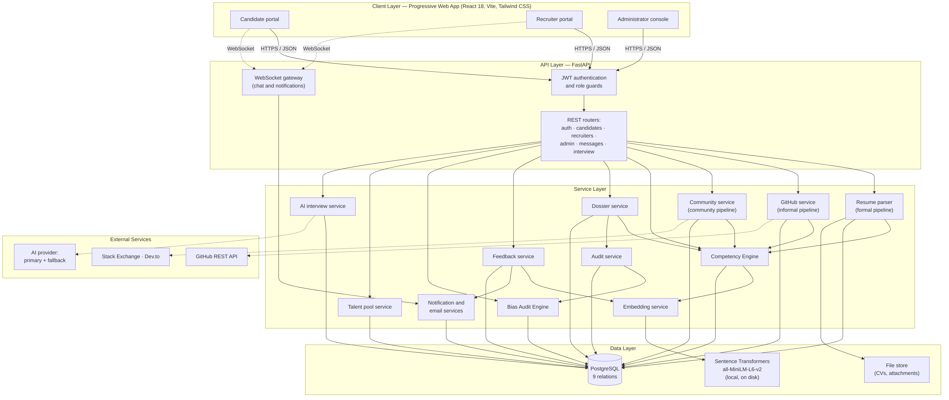Figure 3.13: Layered system architecture of EquityEngine.
The Client Layer consists of three role-specific interfaces delivered as a single Progressive Web App, so that the platform is installable and usable over the intermittent connectivity documented for the target population (NFR4). Routing is guarded on the client for user experience and re-verified on the server for security, since a client-side guard is a convenience and never a control.
The API Layer exposes JSON over HTTPS through role-scoped routers, together with a WebSocket gateway for chat and notification delivery. Every request passes through JWT verification and a role dependency before reaching a router, which places authorisation at a single chokepoint rather than distributing it across handlers where an omission would be invisible.
The Service Layer holds the domain logic as independently addressable modules. The three pipeline services feed the Competency Engine, which depends on the embedding service for the similarity computation of Equation (3.2). The dossier service composes recruiter-facing views and is the only module permitted to construct a revealed view. The feedback service is invoked exclusively from the status-transition path, after the transition has been persisted, which is the architectural expression of the constraint in FR13. The audit service writes at the point of action and the Bias Audit Engine reads only what the audit service has written, so that no aggregate can be produced from a record that was not created contemporaneously with the action it describes (NFR8).
The Data Layer combines a PostgreSQL database with a locally hosted sentence-transformer model and a file store. The model is loaded once per process and cached in memory, and is resolved from an absolute path on disk so that it can never be mistaken for a remote repository identifier and silently trigger a network fetch. Holding the model locally satisfies NFR9 and removes the ranking function's dependence on any third-party inference service, which matters both for availability and because candidate project descriptions would otherwise be transmitted to a processor outside the scope of the consent obtained at registration. The choice of a compact bidirectional-encoder model of this family reflects the retrieval performance such models achieve on unseen domains without task-specific fine-tuning (Liu et al., 2020; Thakur et al., 2021), which is the operating condition here, since no labelled corpus of African technology curricula vitae was available on which to fine-tune.
External Services are reached only by the single service that requires each of them. This confinement satisfies NFR6: an outage of the GitHub API degrades the informal pipeline while leaving scoring, screening, audit, and feedback fully operational, and an outage of both artificial-intelligence providers degrades the mock interview to a rule-based mode rather than failing the request. No external service participates in ranking, in anonymisation, or in the feedback loop, so no third party can affect the measurements on which the project's claims rest.
The separation of the service layer into independently addressable modules also satisfies NFR5. The embedding service performs the most computationally intensive work in the system and can be scaled independently of the lighter routing and notification services as candidate and job volume grows. It is for the same reason that batch encoding is used wherever several candidates are scored against a single job, as at line 9 of Algorithm 3.6: encoding the job's requirement text once per batch rather than once per candidate removes the dominant cost from the feedback computation, which is the operation most exposed to growth in the size of an applicant pool.
Two architectural properties follow from the design rather than from any single component, and both are central to the framework's claims. The first is that bias-mitigation logic is concentrated in the service layer rather than distributed through the interface, which is what allows the anonymisation guarantee of Table 3.9 to be stated as a property of one function instead of a property that must hold across every screen; this containment is consistent with design guidance for auditable hiring systems, in which fairness mechanisms are held at a single enforceable boundary rather than diffused across a user interface (Agbasiere & Nze-Igwe, 2025; Akter et al., 2022). The second is that the feedback service occupies a position in the dependency graph that makes the framework's third vector structural rather than procedural: it is reachable only from the status-transition path, it reads the decision after that decision has been committed, and its only outward path towards a human actor terminates at the candidate. A system in which the candidate's evidence improves in response to a measured deficit, and is then re-evaluated on the strengthened pipeline, implements in the recruitment setting the skill-evolution loop that recent work on adaptive and fair job recommendation identifies as necessary for durable rather than one-off fairness gains (Berhe et al., 2026).
3.8 Summary of the Chapter
This chapter presented the methodology, analysis, and design of the EquityEngine system. OOADM governed the analysis and design work as the study's primary methodology, on the strength of the object-like structure of the domain; Agile served as the SDLC framework within which that design was executed, chosen because the requirements evolved substantially during development; and an experimental pipeline supplied the validation design for the Evidence Score component, whose empirical character could not be established through object-model inspection alone. Four weaknesses of the existing recruitment process were established from the literature and traced to four specific design responses. Nineteen functional and nine non-functional requirements were stated and given identifiers so that each can be traced onwards to a test case in Chapter Four.
The design models comprised a use-case model with an expanded description of the decision use case, a three-level set of data flow diagrams, a class model, an activity model of profile building, two sequence models, and seven algorithms with their accompanying flowcharts and fourteen numbered equations. The database design was presented as an entity-relationship model with a normalisation argument for Third Normal Form, an explicit defence of the bounded denormalisations the audit function requires, and a complete data dictionary across all nine relations. The architecture was presented as four layers with confined external dependencies.
The design decision that carries the chapter is the candidate-directed feedback loop specified in Section 3.5.7. It is the vector that distinguishes the Bi-Directional Identity Optimization Framework from anonymised screening as ordinarily practised, and it is realised not as an interface feature but as a structural property of the system: computed only after a decision has been committed, derived from an aggregate that names no other applicant, stored so that what a candidate was told remains auditable, and directed by construction to the candidate alone.
References
Agbasiere, C., & Nze-Igwe, G. (2025). Algorithmic fairness in recruitment: Designing AI-powered hiring tools to identify and reduce biases in candidate selection. Path of Science, 11(4), 5001–5021. https://doi.org/10.22178/pos.116-10
Akter, S., Dwivedi, Y. K., Sajib, S., Biswas, K., Bandara, R. J., & Michael, K. (2022). Algorithmic bias in machine learning-based marketing models. Journal of Business Research, 144, 201–216. https://doi.org/10.1016/j.jbusres.2022.01.083
Albaroudi, E., Mansouri, T., & Alameer, A. (2024). A comprehensive review of AI techniques for addressing algorithmic bias in job hiring. AI, 5(1), 383–404. https://doi.org/10.3390/ai5010019
Berhe, R. S., Sinha, G., Ambelo, D. K., Getachew, B. A., Birhanu, S. G., Hassen, R. A., & Gebre, H. W. (2026). Adaptive and fair job recommendation system using skill evolution and bias mitigation techniques. In Nagaraja & Kannadhasan (Eds.), Information and communication systems (pp. 1–5). Taylor & Francis. https://doi.org/10.1201/9781003650201-1
Bevara, R. V. K., Mannuru, N. R., Karedla, S. P., Lund, B., Xiao, T., Pasem, H., Dronavalli, S. C., & Rupeshkumar, S. (2025). Resume2Vec: Transforming applicant tracking systems with intelligent resume embeddings for precise candidate matching. Electronics, 14(4), Article 794. https://doi.org/10.3390/electronics14040794
Bian, S., Chen, X., Zhao, W. X., Zhou, K., Hou, Y., Song, Y., Zhang, T., & Wen, J.-R. (2020). Learning to match jobs with resumes from sparse interaction data using multi-view co-teaching network. In Proceedings of the 29th ACM International Conference on Information and Knowledge Management (pp. 65–74). Association for Computing Machinery. https://doi.org/10.1145/3340531.3411929
Calefato, F., Quaranta, L., & Lanubile, F. (2024). A lot of talk and a badge: An exploratory analysis of personal achievements in GitHub. Information and Software Technology, 176, Article 107561. https://doi.org/10.1016/j.infsof.2024.107561
Iyoha, E., Amoussou, O., & Okundaye, P. (2025). The role of African fintechs in facilitating telemigration (Harvard Business School Working Paper No. 26-010). Harvard Business School. https://www.hbs.edu/faculty/Pages/item.aspx?num=67874
Liang, J. T., Zimmermann, T., & Ford, D. (2022a). Understanding skills for OSS communities on GitHub. In Proceedings of the 30th ACM Joint European Software Engineering Conference and Symposium on the Foundations of Software Engineering (pp. 101–112). Association for Computing Machinery. https://doi.org/10.1145/3540250.3549082
Liang, J. T., Zimmermann, T., & Ford, D. (2022b). Towards mining OSS skills from GitHub activity. In Proceedings of the 44th International Conference on Software Engineering: New Ideas and Emerging Results (pp. 106–110). Association for Computing Machinery. https://doi.org/10.1145/3510455.3512772
Liu, Y., Ott, M., Goyal, N., Du, J., Joshi, M., Chen, D., Levy, O., Lewis, M., Zettlemoyer, L., & Stoyanov, V. (2020). RoBERTa: A robustly optimized BERT pretraining approach (arXiv:1907.11692). arXiv. https://arxiv.org/abs/1907.11692
Menon, S. (2023). Postcolonial differentials in algorithmic bias: Challenging digital neo-colonialism in Africa. SCRIPTed, 20(2). https://doi.org/10.2218/scrip.20.2.2023.8980
Mrashui, K. (2024). Algorithmic bias in hiring algorithms: A Kenyan perspective. Strathmore Law Review, 9(1), 13–36. https://doi.org/10.52907/slr.v9i1.480
Oshioste, E., Eigbadon, M., Nwankwo, T., Okoye, C., & Udokwu, S. (2023). The implications of remote work: An analysis of Nigeria and the USA. Social Values and Society, 5(1), 4–12. https://doi.org/10.26480/svs.01.2023.04.12
Pasipamire, N., & Muroyiwa, A. (2024). Navigating algorithm bias in AI: Ensuring fairness and trust in Africa. Frontiers in Research Metrics and Analytics, 9, Article 1486600. https://doi.org/10.3389/frma.2024.1486600
Raghavan, M., Barocas, S., Kleinberg, J., & Levy, K. (2020). Mitigating bias in algorithmic hiring: Evaluating claims and practices. Proceedings of the 2020 Conference on Fairness, Accountability, and Transparency, 469–481. https://doi.org/10.1145/3351095.3372828
Rao, P. S. B., Nagarajan Venkatesan, L., Cherubini, M., & Jayagopi, D. B. (2025). Invisible filters: Cultural bias in hiring evaluations using large language models. Proceedings of the AAAI/ACM Conference on AI, Ethics, and Society, 8(3), 2164–2176. https://doi.org/10.1609/aies.v8i3.36703
Robles-Carrillo, M. (2024). Digital identity: An approach to its nature, concept, and functionalities. International Journal of Law and Information Technology, 32(1), Article eaae019. https://doi.org/10.1093/ijlit/eaae019
Roy, P. K., Chowdhary, S. S., & Bhatia, R. (2020). A machine learning approach for automation of resume recommendation system. Procedia Computer Science, 167, 2318–2327. https://doi.org/10.1016/j.procs.2020.03.284
Sánchez-Monedero, J., Dencik, L., & Edwards, L. (2020). What does it mean to "solve" the problem of discrimination in hiring? Social, technical and legal perspectives from AI decision-making. In Proceedings of the 2020 Conference on Fairness, Accountability, and Transparency (pp. 458–468). Association for Computing Machinery. https://doi.org/10.1145/3351095.3372849
Sariola, D., Button, P., Culotta, A., & Mattei, N. (2026). The illusion of fairness: Auditing fairness interventions in algorithmic hiring with audit studies. Proceedings of the AAAI Conference on Artificial Intelligence, 40(46), 39191–39200. https://doi.org/10.1609/aaai.v40i46.41267
Sigelman, M., Fuller, J., & Martin, A. (2024). Skills-based hiring: The long road from pronouncements to practice. Burning Glass Institute & Harvard Business School Project on Managing the Future of Work. https://www.burningglassinstitute.org/research/skills-based-hiring-2024
Thakur, N., Reimers, N., Rücklé, A., Srivastava, A., & Gurevych, I. (2021). BEIR: A heterogeneous benchmark for zero-shot evaluation of information retrieval models. In Proceedings of the 35th Conference on Neural Information Processing Systems (pp. 1–15). https://arxiv.org/abs/2104.08663
Vivek, S. (2023). Algorithmic management and its impact on Global South labor markets. Foundation for Labor Research. https://hdl.handle.net/10520/ejc-aa_jgida1_v15_n1_a15
Zhang, Y., & Chen, X. (2020). Explainable recommendation: A survey and new perspectives. Foundations and Trends in Information Retrieval, 14(1), 1–101. https://arxiv.org/abs/1804.11192

