BobaTrader: Guide to Consistent Daytrading


My Trading Journey
Year 1: I discovered daytrading from reddit. I deposited $20k I had saved up from my job and found some alert groups. Before I knew it had almost doubled my account. Mostly from going all in on penny stocks with my whole account. “This is easy” I thought. I think you know what comes after this. A few months later my account is at about $5k, down almost 90% from doing the same things that had made me double my account before. “This is just gambling” I thought. I withdrew the money I had left and vowed off trading forever.
A few months later a friend told me about options trading and showed me the type of money he was making with relatively little capital and so I decided to give it a shot and see if I could make an extra few hundred dollars a week.
I deposited $10k into my account and joined some options trading groups i found and started my journey. I quickly fell back into the same path as I had before. I would go all in with my account, always trying to double my account on each trade. I would make $5k in a day, then lose $5k the next, then another $5k the next day, etc. This continued for a few more months, my account resembling a roller coaster, The most i was ever up in a day was $25k, from going all in on next day expiration Tsla calls. I tried it again the next week and it wiped out about 80% of my account. Meanwhile Im seeing people on twitter and online making $20k a day, $50k a day,, and its making me more and more frustrated. I remember the day I just got so mad I yolod the rest of my account on more tsla options and completely drained it. I was defeated.
Its now a year after I first deposited money into my account. Im down $30k (most of my savings) and my confidence is at an all time low.
Year 2: Im never the type of person to give up, so I decided Id do everything in my power to succeed at this. I decided to approach it in a smarter fashion. I decided to do something I had never done before. I decided to LEARN. Up until that point all I had done was follow other peoples calls or just buy calls whenever something was green on the day and hope it kept going up.
I started researching technical analysis, learning how to chart, how to find supports and resistances, key levels, and learning candle patterns. This is when something started to click in my head, and I realized there may be a more systematic approach to trading, unlike the erratic actions I had been doing the previous year. I started to notice the same patterns happening over and over again in stocks, and I figured if the same pattern is likely to repeat, then there has to be a way to capitalize on it each time I see it happening.
I started hitting a few good trades here and there, trying to catch the same move I saw happening every now and then. It was the first time I really felt like I was making GOOD trades, trades that I had actually managed to find myself and execute them on my own terms.
I was till losing a lot though. If the trade didnt go my way, i refused to accept the loss and kept holding, hoping for it to come back green. And on the chance that it did, Id cut the trade as soon as it did, and then just watched as it kept going up without me. And when it wouldnt come back my way, I would take a big loss that was atleast 2-3x what my wins would be.
Just when I thought I was making some progress, my p/l curve showed the exact opposite.
This is the point in my trading journey that I realized the importance of risk management. I was able to find winning trades, but i wasnt able to make them larger than my loser trades. Which, though it sounds obvious. is something most people struggle with.
I started implementing stop losses into my trading, id set a hard stop at 15% everytime, for every trade, no matter what. Id never move my stop, Id never adjust it, and would let the trades play out. After about two months of doing this, i realized I had managed to keep my losses small, but my stop was getting triggered too much, especially on trades that ended up going my way almost immediately after I was stopped out. I realized my method of simply putting a stop at 15% doesnt always work, and decided to rely mostly on the technicals to tell me where to cut the trade.
I also decided to let my winners go a bit more. Instead of closing out my whole position I would only close one portion of it and allow the rest to keep going. I slowly realized I could squeeze out more profits from my winning trades, while lowering the risk of a big loss if the trade then decided to go against me.
Im happy to say this is when I first became consistently profitable. I had mastered a setup, learned to stick to only that setup, built enough discipline to cut my losses without bagholding, and built the courage to allow my green trades to continue going.
Year 3-5: This is where I began to scale up. Increasing my position sizes slowly, giving myself time to get adjusted to the new numbers on the screen. My $150 losses became $300 losses, and this was a bit too much for me, so I sized down a little bit to keep them at $200. And continued in this pattern. Id size up to a specific risk level, then adjust from there depending on how emotionally impacted I was on the number. My one edge here, which allowed me to size up without blowing up, was that I was patient. I didnt try to double my size every week. I took it slow and steady, knowing that if i trusted in the process eventually Id be doing bigger numbers. And it paid off.
So you know my story now, how I went from blowing up multiple accounts, to developing consistency and managing to become a profitable trader. Now lets talk about how I trade.

Options Trading
I am strictly an options trader, that means when I go long on a stock I buy Calls, and when I go short on a stock, I buy Puts.
Strike & Expiration
How I usually choose my option expiration dates & strikes:
Monday - Wednesday
- Same week Friday expiration, at the money (closer to the current price of stock)
Example: On this trade, it was 10/18/21, a Monday. When I entered my trade I picked up the 10/22/21 (same week friday) $444 Calls ($0.50 out of the money)
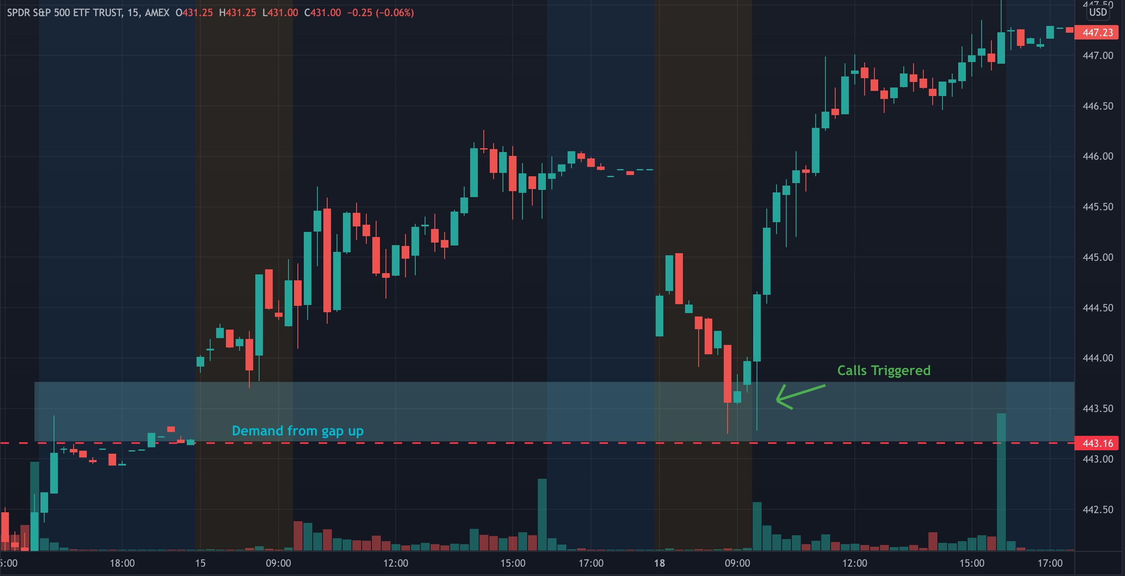
Thursday-Friday
- Next week expiration, slightly out the money strike (a bit farther from current price of the stock)
Example: This trade was taken on 1/28/22, a Friday. When $SPY hit my entry, I picked up the next week Friday expiration (2/4/22) $430 calls ($2 out of the money)
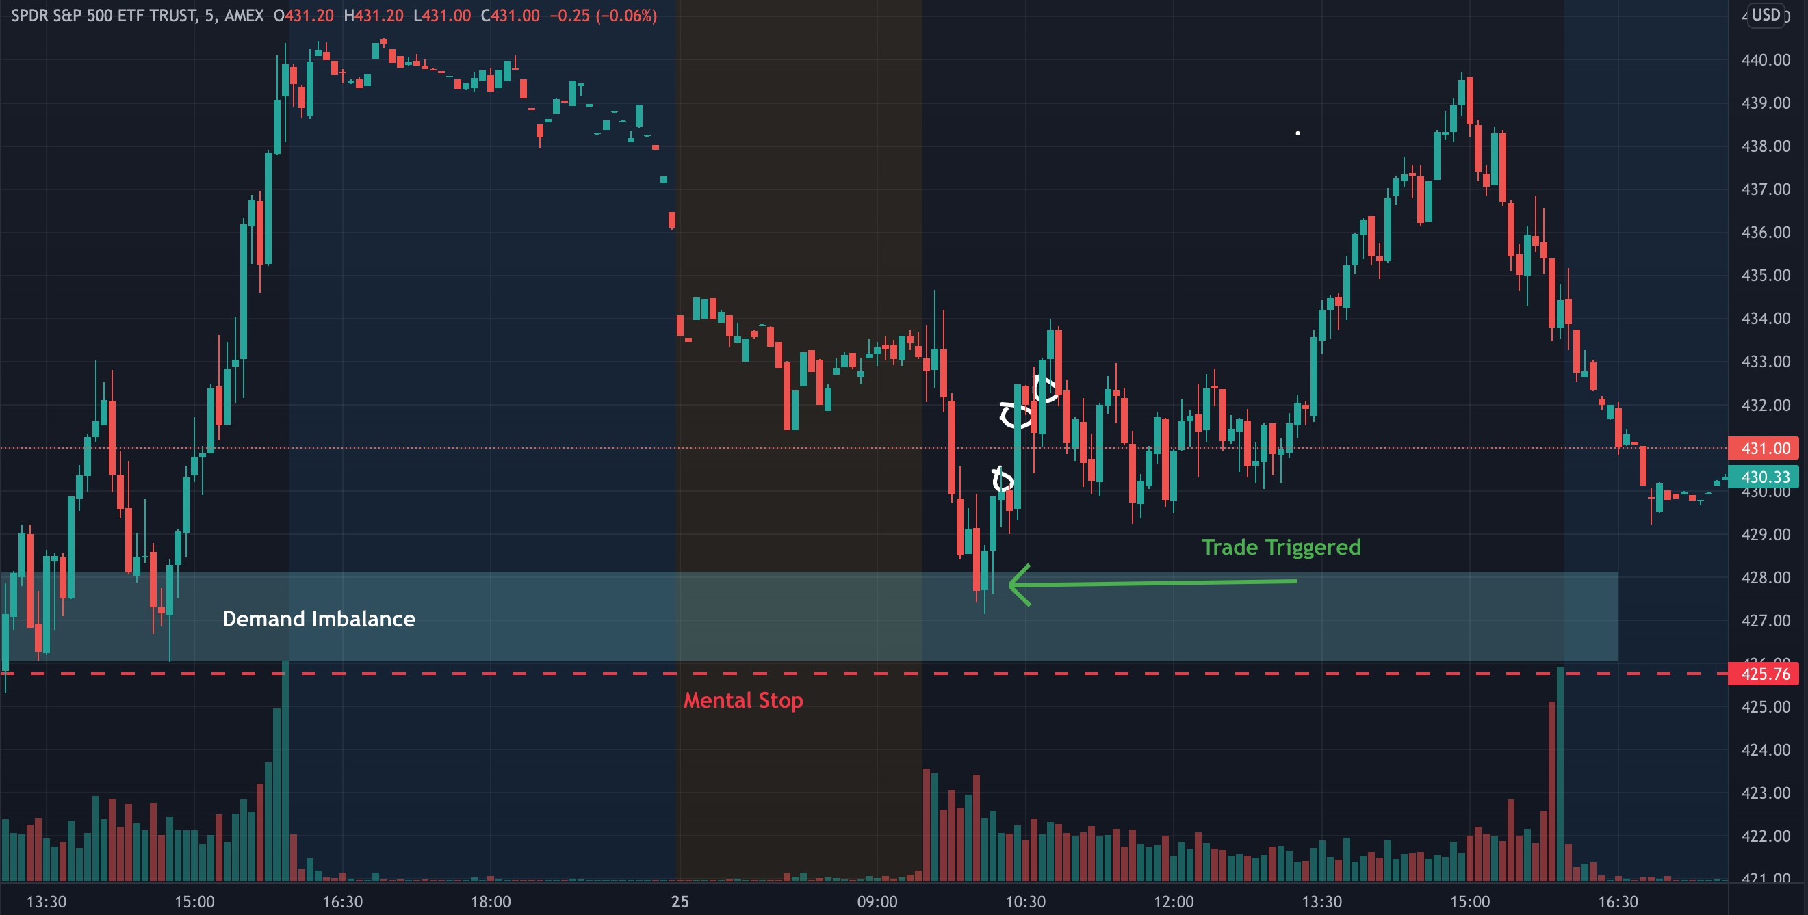

How I Trade
I think how I trade is a little different from many other people. I dont use any indicators, I dont do any candlestick analyzing, I stick to price, volume, supply/ demand, and supports/resistances. This clears out the noise for me and allows me to simplify my trading.

Supports & Resistances (Key levels)
Supports and resistances are probably the two most important aspects of technical analysis. They refer to price levels that act as “barriers”, stopping a stock from going beyond them.
A support is a price level at which you can expect a downtrending stock to stop and most likely bounce off at, as it indicates an area where there is a lot of buying pressure. A resistance is the price level at which you can expect a stock going up to hit a ceiling, as it has heavy selling pressure.
These levels can be good entries and exits for scalpers, as stocks have a high chance of bouncing at historical support and resistances levels.
These levels wont always be respected however. If buying pressure increases at a resistance and overcomes the selling pressure, we get a “breakout”, and the stock goes through the resistance and continues uptrending. In many cases, that previous resistance now becomes a support, as the buying pressure is now the majority at that level.
Here is an example of a support on $TSLA on the daily timeframe. You can see after the initial breakout of the $540 level, it came back down to test it three times and each time was met with enough buyers to keep bouncing off of it. Next time it approaches this level, a good trade would be to go long off the support. looking for another bounce.
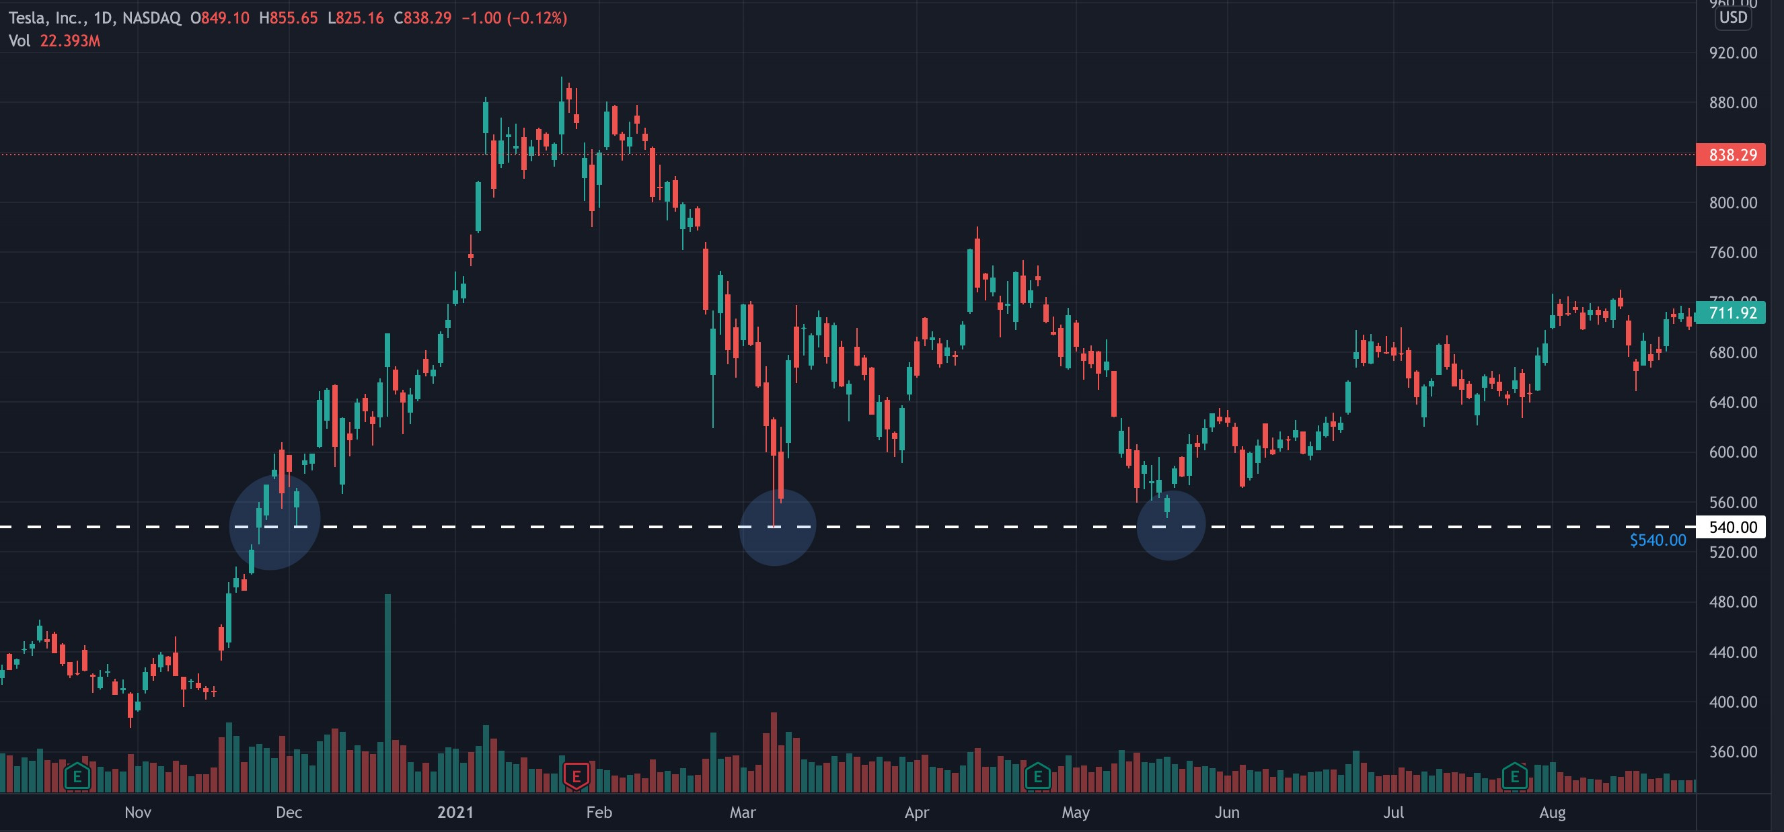
Heres another example of a support on $AAPL on a smaller time frame (1hr). You can see the same instance of the stock not being able to go under the level.
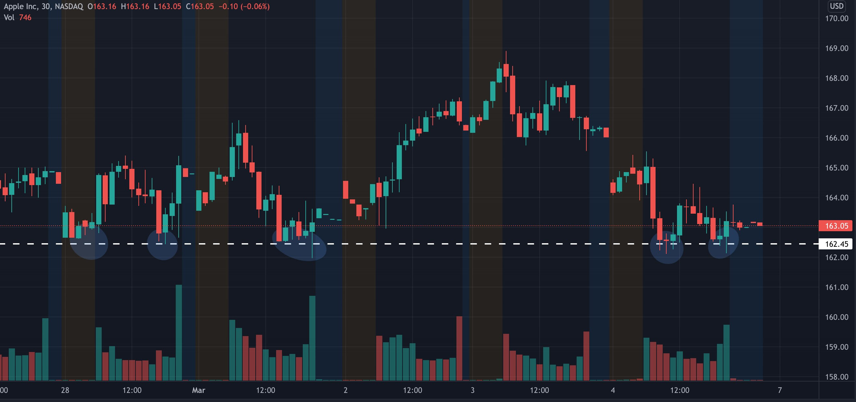
Now heres an example of a resistance on the $TSLA daily chart being tested multiple times, then later after it is broke, the same resistance then becomes a support.
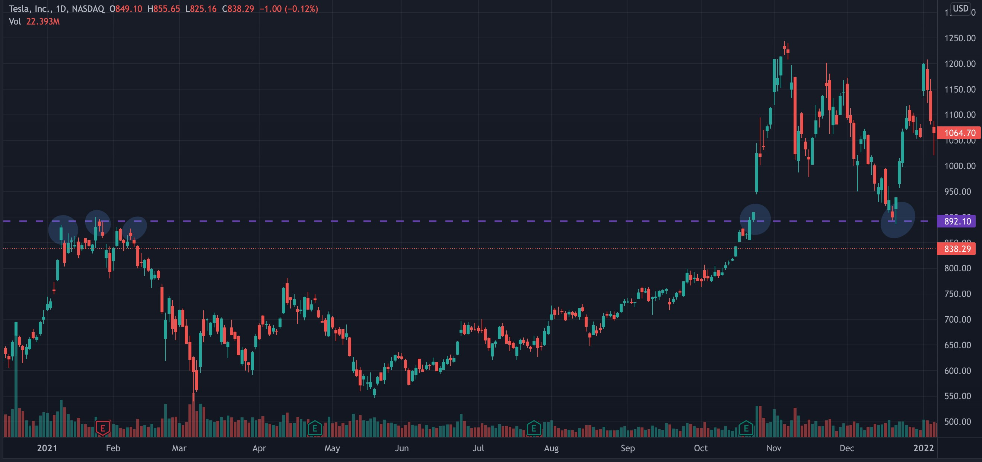
I like to find key levels of support and resistance on larger time frames such as the 1D, and then go down to the 15M chart to find more local levels I can use for daytrading.

Supply & Demand
Supply and demand is similar to supports and resistances, as its a concept that indicates certain zones in the chart where a stock will reverse due to an imbalance of buying / selling pressures.
These zones are not exact numbers as key levels are, but represent a general area where a previous imbalance led to a large move in a certain direction.
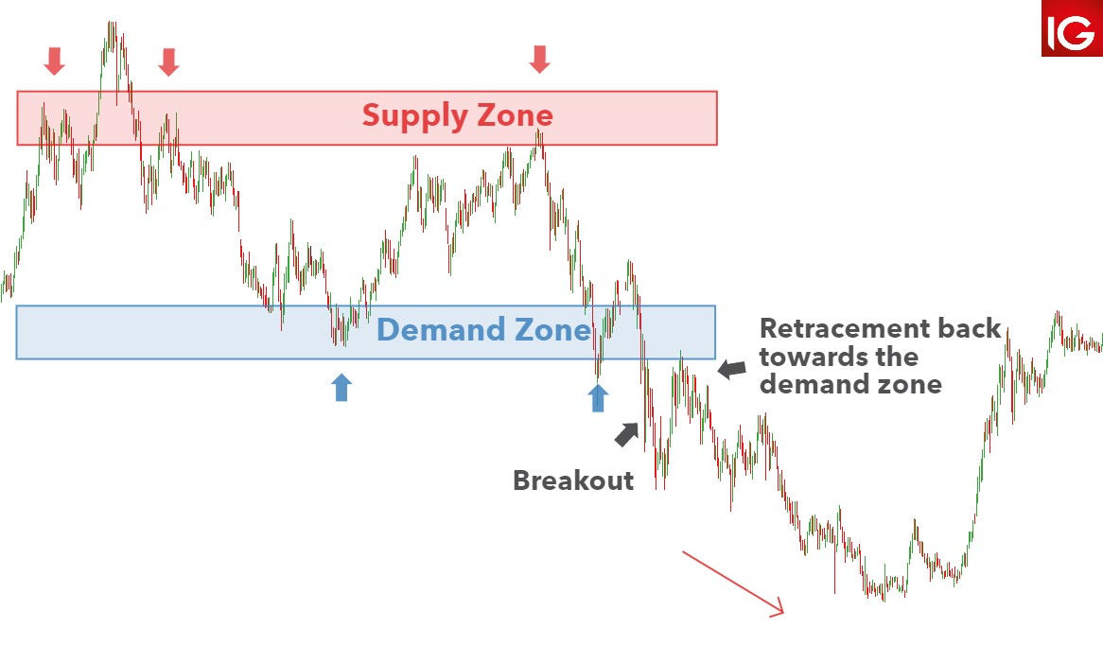
(Heres a great diagram via dailyfx.com)
You can spot these by looking for areas where a stock had a relatively strong movement upwards or downwards after a period of consolidation.
I use these to trade reversals as they are good indicators of where the imbalance of supply/demand will make a stock change directions.
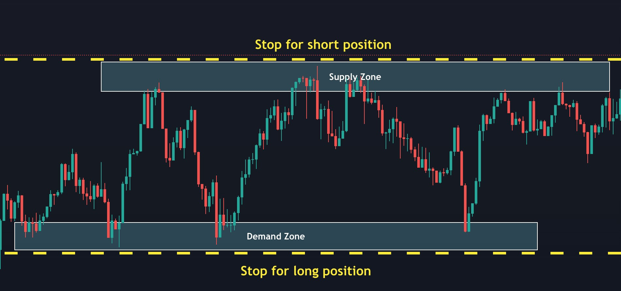
This diagram shows how I use demand/supply zones to determine where Id take a long or short position for a reversal trade, as well as where I would cut the trade for a loss if it went against me
You can find these zones on any time frame. If you are a swing trader, finding these zones on a daily or weekly chart will give you the best indication of where a stocks overall trend can change.
For my methods, I find these zones on a smaller time frame. While the volume and strength of these smaller timeframe zones may not be as powerful as those on a larger time frame, they work for my daytrading style.

Reversals vs Breakouts
A reversal is when the trend of a stock changes direction. It means that the price is likely to continue in that reversal direction for an extended period. These directional changes can happen to the upside after a downward trend or the downside after an upward trend. These tend to happen in areas where there was previously an imbalance in supply/demand. When a stock reaches an area where there was heavy demand previously, it is likely to reverse there as the buyers get their orders filled, causing the price to bounce. And vice versa in a supply zone where sellers are waiting.
Most often the change is a large shift in price. However, there may be pullbacks where the price recovers the previous direction.
I like to find and trade these trend reversals on small time frames, as I am a daytrader, but this can apply to swing traders as well who look to capitalize on a stock reversing over a larger time period.
The risk to reward on a reversal is less than breakout, but has a higher winrate.
A breakout is when a stock breaks past a support or resistance with big volume. This is the result of buyers beating sellers or vice versa. You can trade this by going long (buying calls) when the stock breakout up over a resistance, or going short (buying puts) when it breaks under a support.
The risk to reward on a breakout is better than a reversal, but it has a lower winrate due to false breakouts.

My Bread & Butter Setup
Now that weve gone over the important technical aspects of my trading methods, Im ready to show you the setups I use that allowed me to consistently make profits and grow my account over time while keeping my losses minimal.
There are countless different setups and patterns that you can trade, but I learned that if I stick to mine and only trade those, thats where I have my edge. Over time I grew familiar with the setup, that allowed me to know much more quicker if the trade is going my way, resulting in smaller losses.

Setup #1: Morning 15 Min S/D Zone Reversal
My favorite trade to take, the setup I look for everyday when coming to the market, and the one I take 90% of the time, is a 15-min supply/demand zone reversal.
I start by checking my watchlist and plot out my supply & demand zones as well as key levels on the 15 minute time frame, looking back to the last 2-5 days to find the best areas where there might be an imbalance, causing the stock to reverse. I
plot out my zones and levels, and wait to see how the market reacts at open.
Below is an example of $SPY trade from on February 1st. I checked the 15 minute time frame to find the zones, marking the imbalance from the previous day where the stock reversed. (red circle).
Just a reminder, i go LONG (Calls) in Demand zones, and SHORT (Puts) in Supply zones.
(15 minute chart)
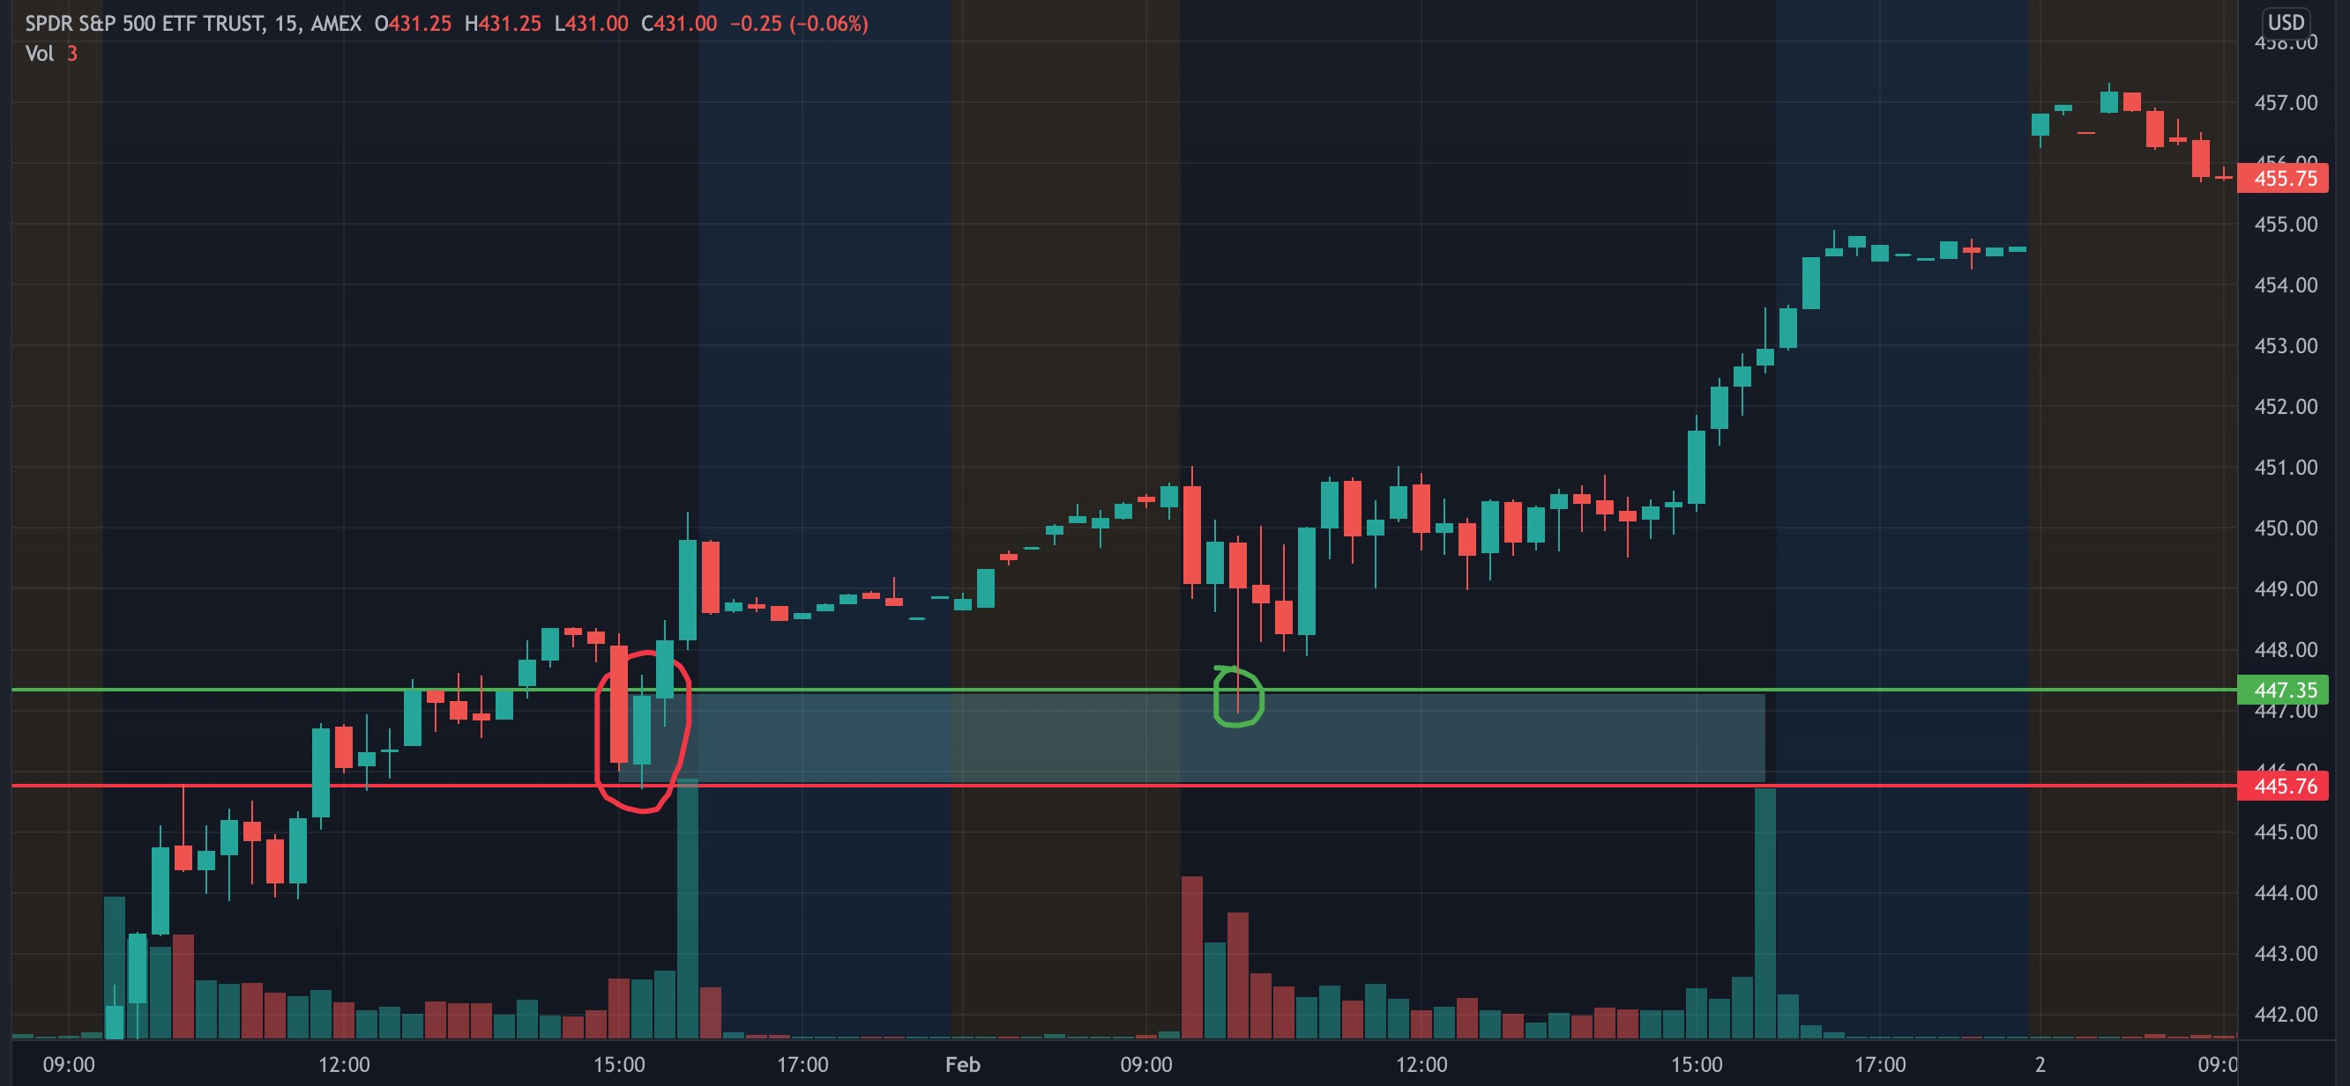
Then when the market opened, I watched on the 5 minute chart and waited to see if $SPY would come down to my zone. As soon as it did, I entered into the 2/4 $448 Calls on what ended up being the wick (green circle), as $SPY bounced heavily in this zone. I began to scale my calls out as $SPY bounced, beginning to take profit once my calls were up over 20%. The red line at the bottom of the zone marked the support for me, and was where I would be ready to exit my calls if it began to break under that level. On this trade it never even reached near it. If the stock had never entered my zone, I wouldve never gotten into the trade.
(5 minute chart)
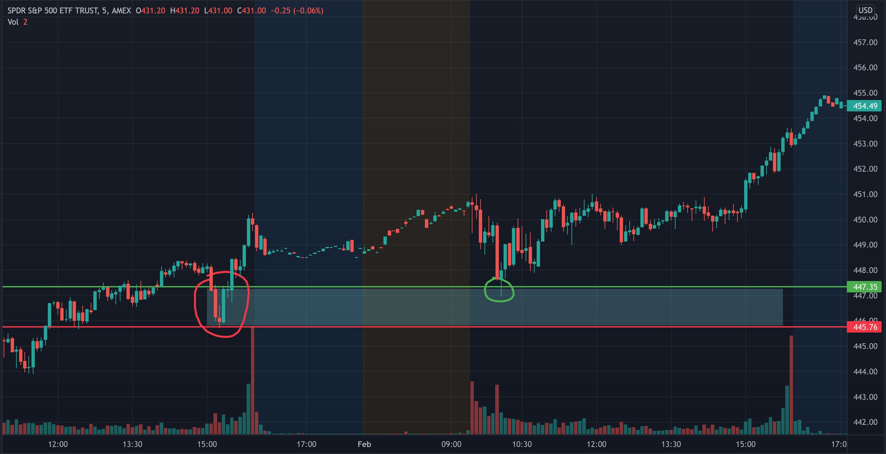
My favorite time to take a trade is between 9:30 and 11 am EST, as thats usually when there is the most volume present in the market and the zones are more likely to react.
Heres another example on a $SPY trade I made just the other day. I marked out the demand zone that was created earlier, and used that as the entry trigger for my trade.
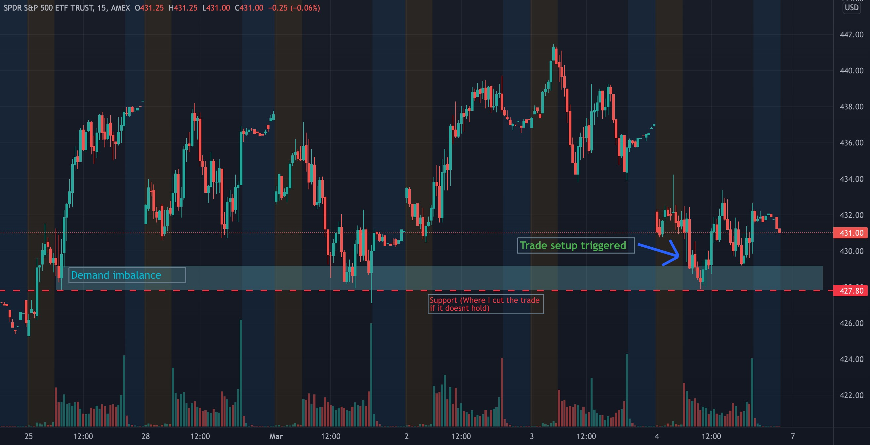
I took the trade ($SPY $430C) when it entered my zone, and waited to see how it would react at the red support line. It bounced off clean and I let the trade ride and began to scale out at 15% profit, and finally exiting completely for a 25% profit trade.
Here is another example of a reversal trade in a 15 minute SUPPLY zone this time, where I take Puts instead of Calls
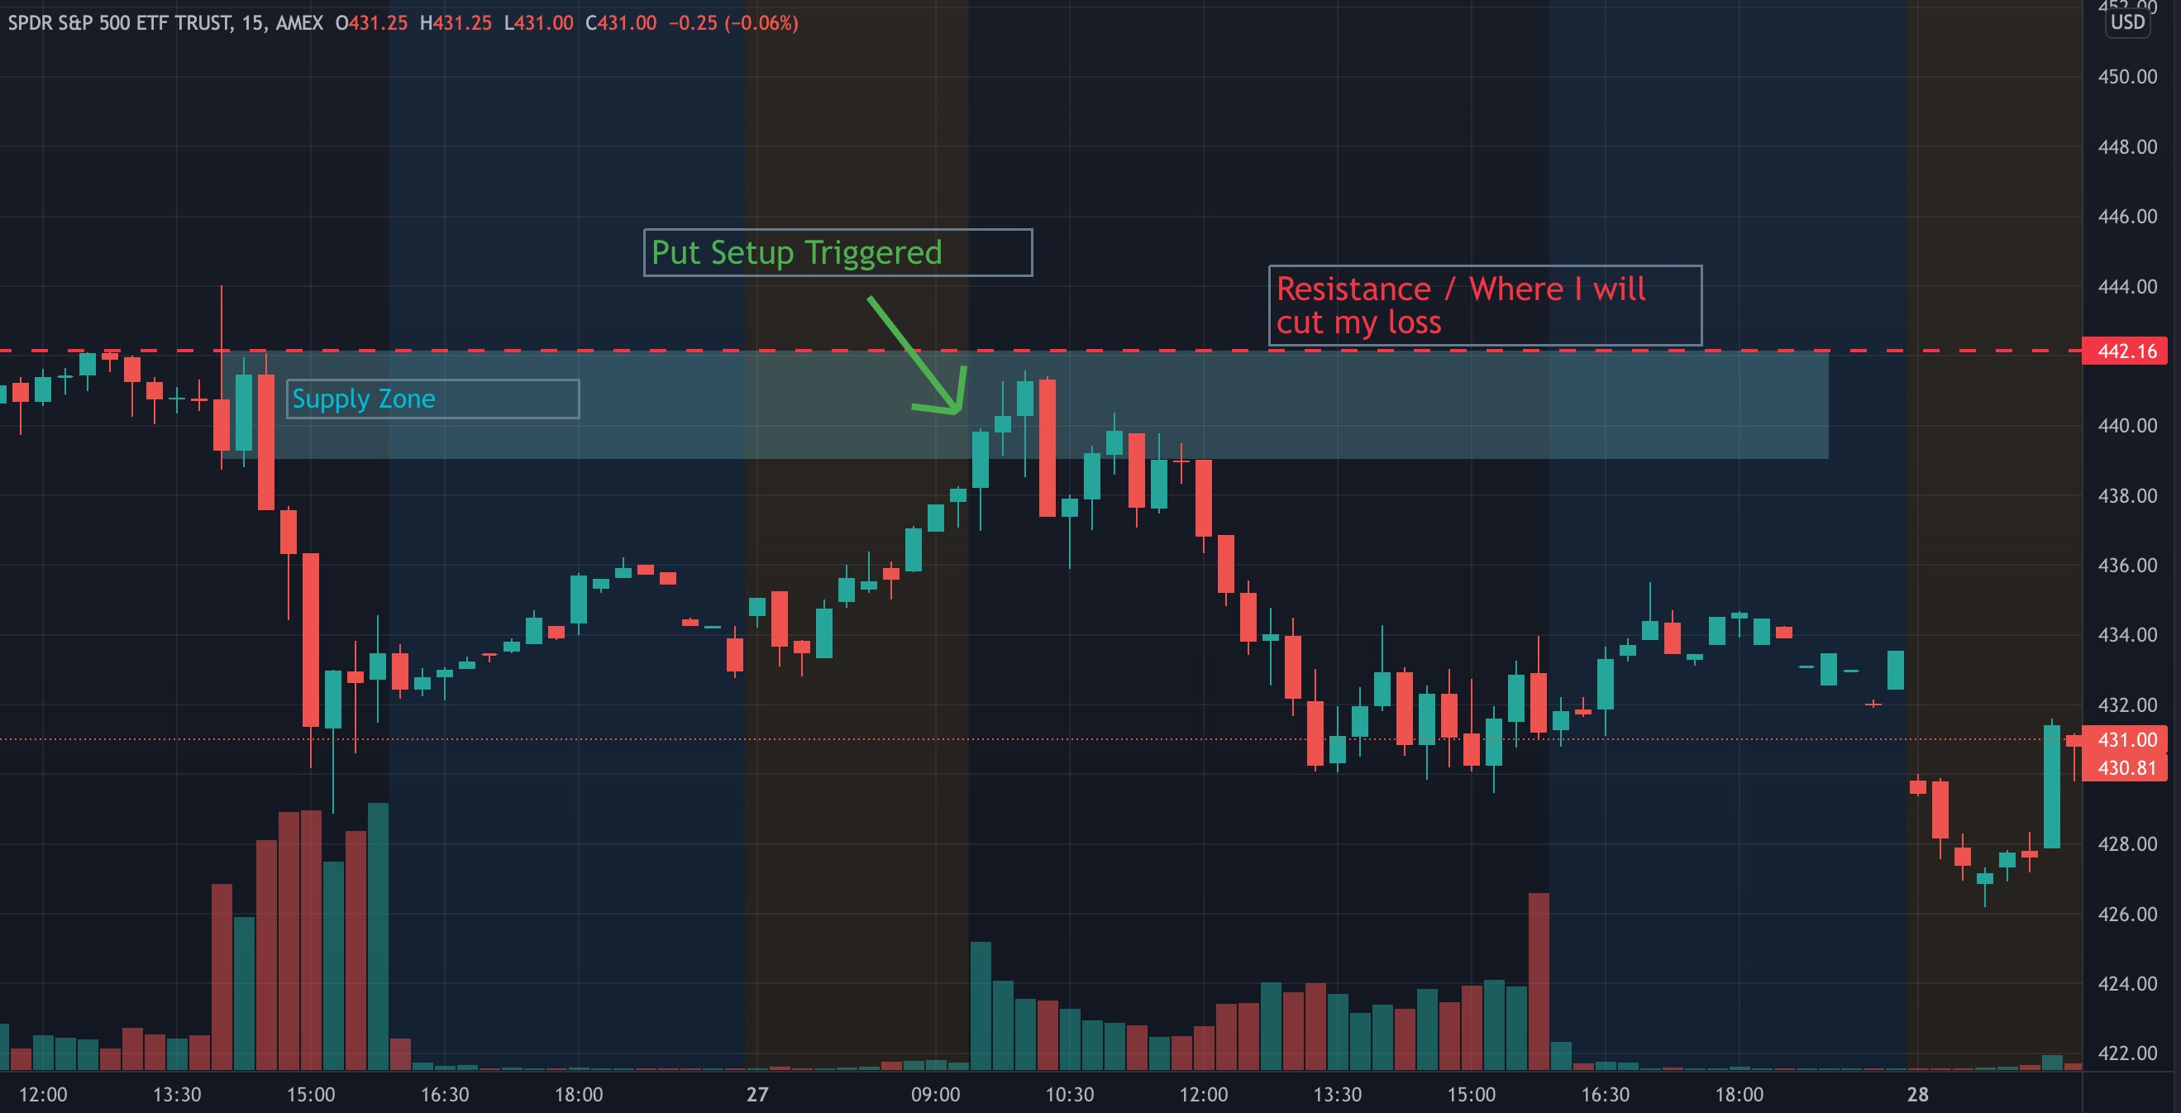
When $SPY came into my zone, I took the $438 Puts. The stock came a bit deeper into the zone, but then reversed and began to go in my direction. It retested the zone after the initial bounce but then continued to trend lower. I scaled out of the trade on the initial red candle, then continued to close the position after the downtrend strengthened.
One thing you may notice is that my entries arent perfect, i dont catch the exact bottom of a reversal, but my zones are tight enough that as long as it happens within it, the trade will go green once it leaves the zone.

Profit Taking
When trading this type of setup, a reversal, I dont expect big volume moves like a breakout would have, as those demand more volume to break a significant support / resistance. Thus, whenever Im up over 15-20%, or when there is an immediate strong candle in my direction, I begin to take profits off the table. This way, even if the stock starts turning against me, I would have secured some profits and will still be able to end up green, or in the case the trade goes red, it wont be as big of a loss.
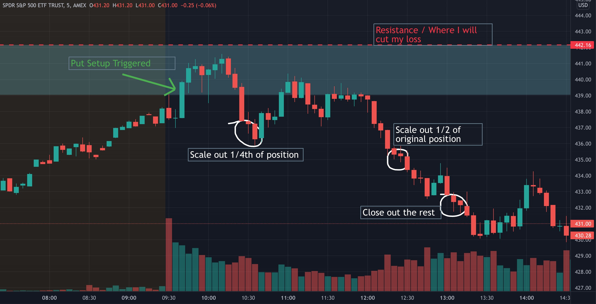
IIf I am in a winning position Ill begin cutting 1/4th of them once Im up 15% on the trade. Once Im up over 20-25% I cut another 50% (of original position), and then let the remaining 25% run up to significant levels where I will cut depending on how the stock reacts. This way, even if the trade ends up turning against me, I have secured some profits already and I may still end up green, or atleast my potential loss will not be as large as it couldve been.
Here is an example of exactly that:
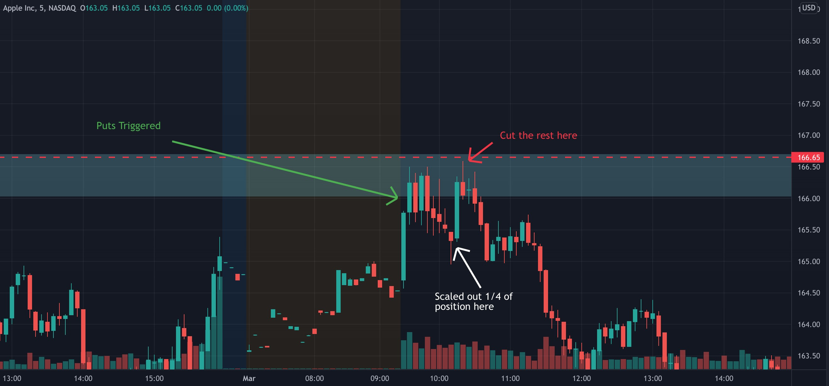
This was a trade that went my way at first, I scaled some out as planned, but then it reversed on me. I decided to cut the whole trade as it reached my mental stop area. It ended up reversing again and going my way very strongly. I ended up only taking a small loss on this trade. I couldve made a good amount of profit on it had I held, but seeing the strength with which it was approaching my stop I decided to be proactive and prevent further losses. This usually works for me, in this case it did not.

Doubling Down
I rarely “double down” on trades, or add to losing positions. I know the zone where Im going to enter, and I know where Im going to cut the trade. Adding to a losing trade takes away my edge for me, as it changes my risk to reward that I had determined when going into the trade. Continuing to average down on a losing trade will just lead to larger losses down the line.

Cutting Losses
My mental stoploss for my full position on reversals is 15%. I dont usually set hard stops with big size because I can get slipped a lot or filled on a bad wick. I rely more on technical signals to decide when to cut. As you have seen above, i always have my level marked where I will cut the trade, and I will cut if the stock starts approaching the level. If it breaks through my stop level, I dont try to find another level where it could bounce and add more to try and turn the trade green.
I cut the trade, accept the loss, and move on.
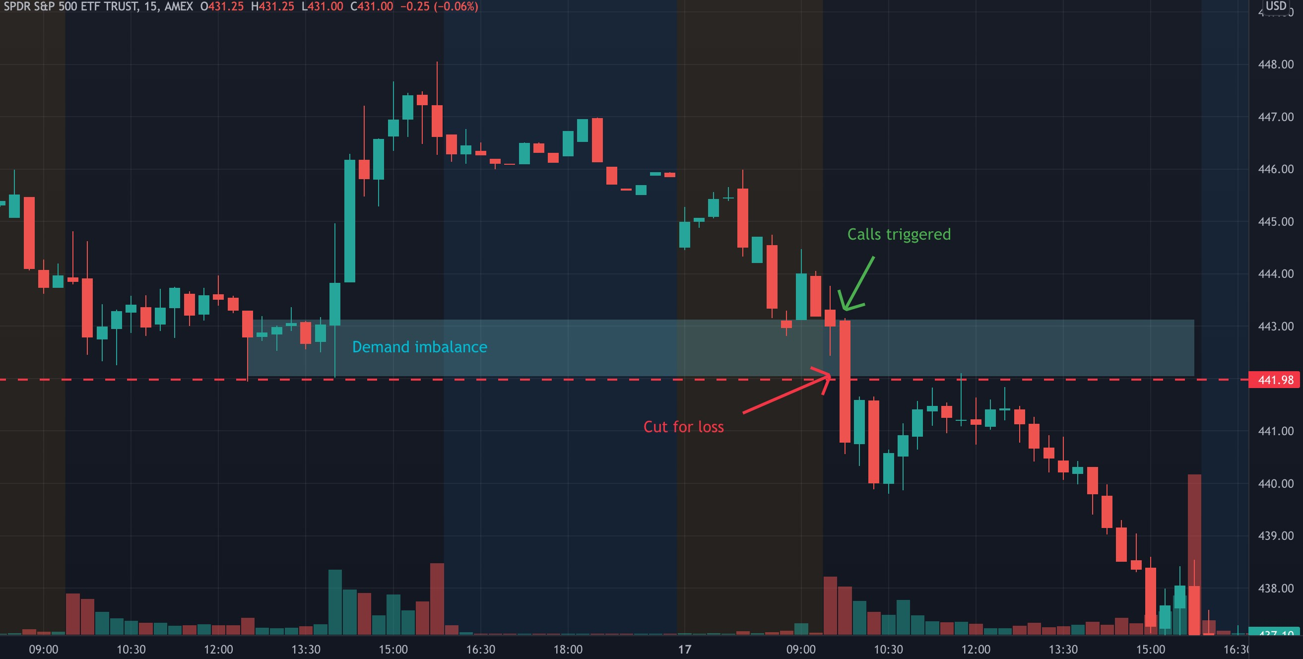

Setup #2: Key Level Breakout
I trade breakouts maybe 10-15% of the time. Theyre a great trade to take because of the high volume and speed of which the stock moves with. Heres how I identify and take them:
I identify a key level from the previous few days of a stock, and wait to see how the price will react when it reaches there. I never try to enter before a breakout, I wait for the breakout to occur and enter Calls (if long) or Puts (if short).
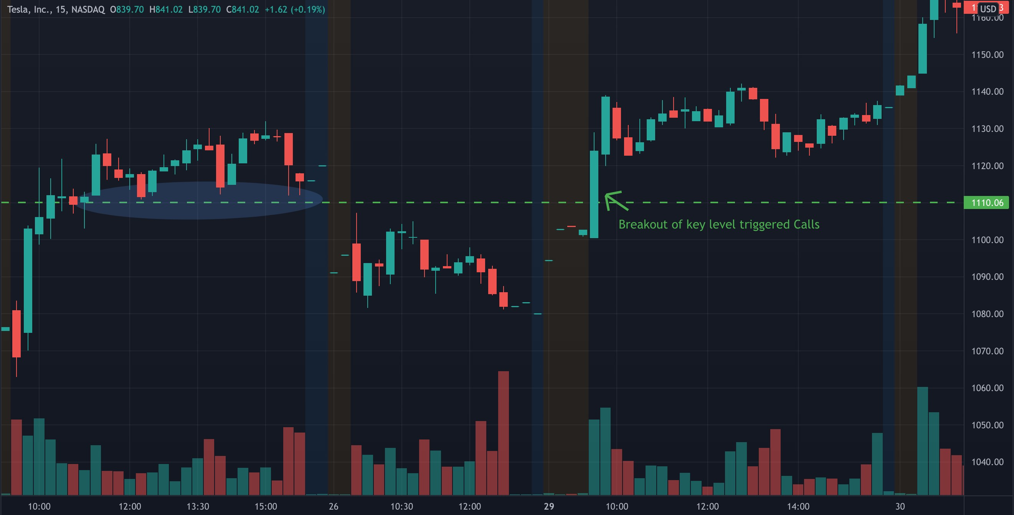
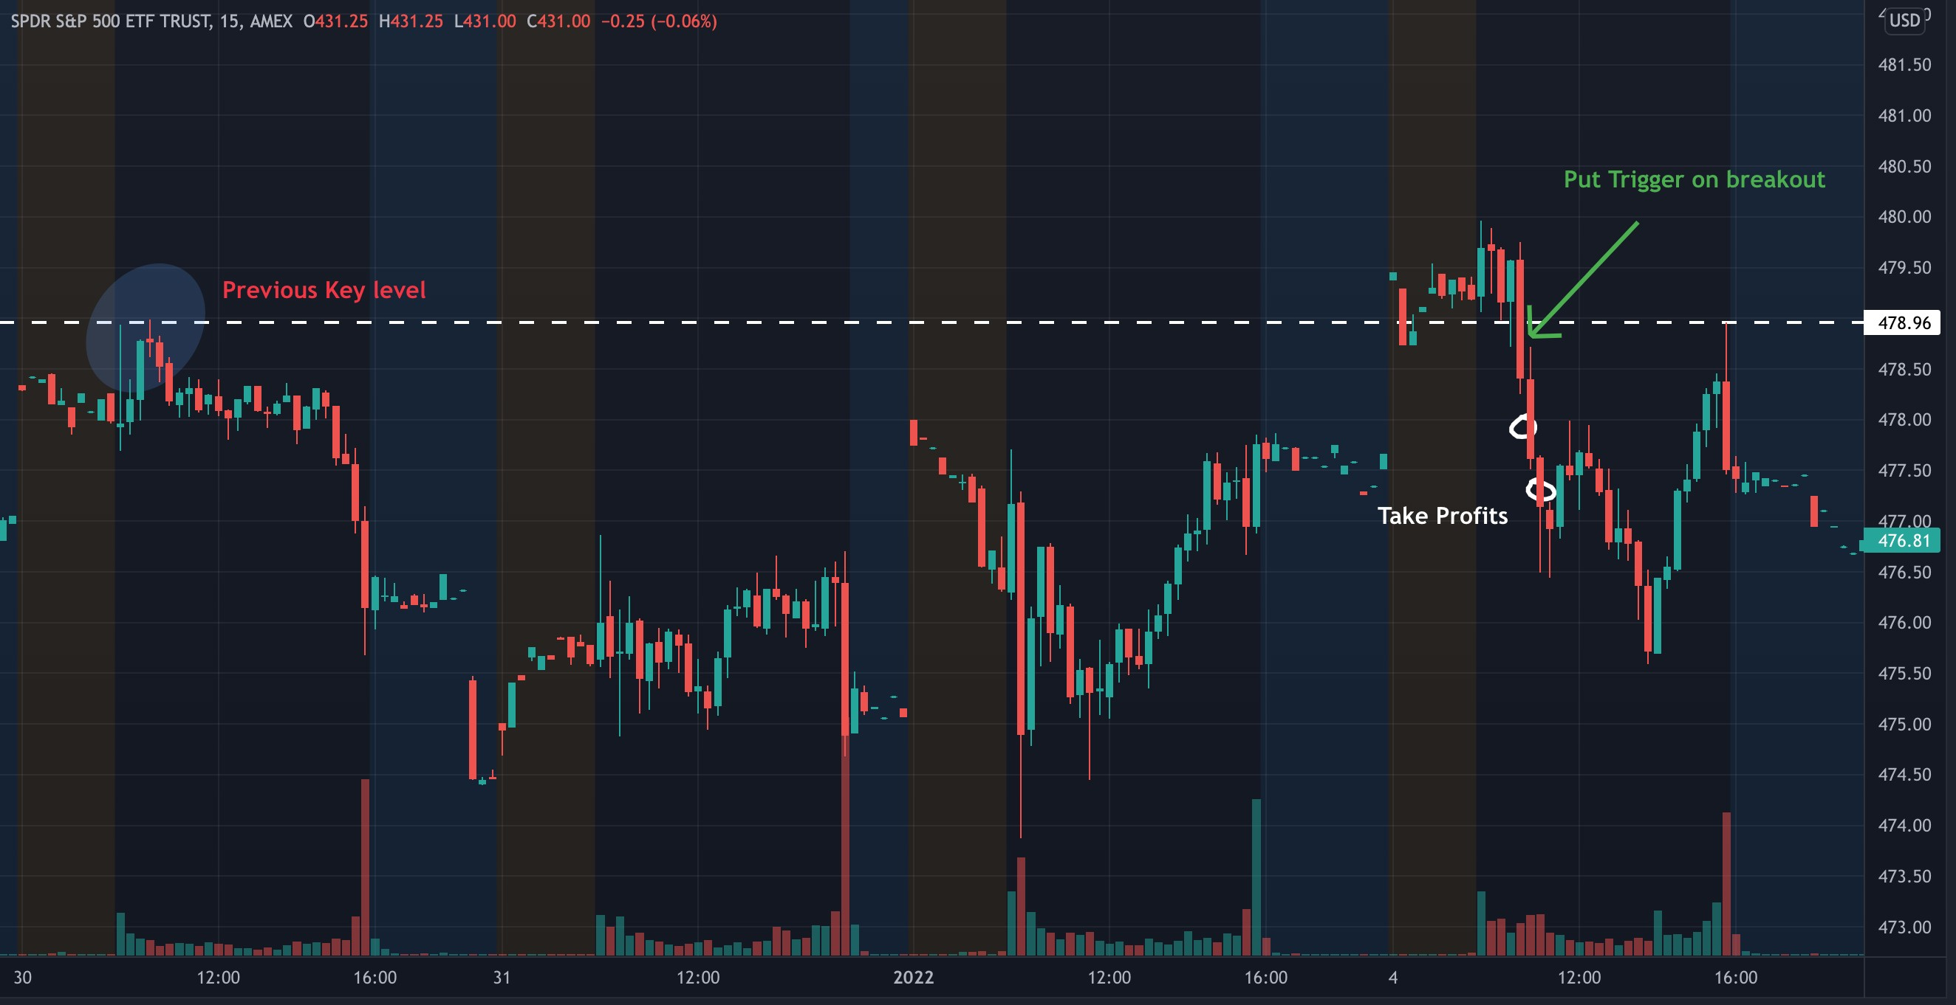

Risk Management
DONT BAG HOLD!
I wish it was that simple. In some way it is. A lot of daytraders take big losses simply because they refuse to cut a trade in the hopes it will turn green again. Now there will be situations where that does happen, but this is a probability game, and the chances of profitability in the long run are more in your favor if you cut trades where you planned to cut them. You cant get married to one specific trade, its just one out of thousands you will inevitably take.
A common theme I notice amongst traders is that they:
- Let trades go red without cutting, hoping for them to turn back green. Results in BIG losses most of the time.
- Cut green trades too fast, because theyre scared for it to turn red again. Results in SMALL wins.
This mentality seems to be engrained in most new traders heads. You are scared to let profits go, and refuse to cut trades for a loss. Switching this mentality is what will lead you to success. You should be scared to let your losses grow, and refuse to cut trades for small profits.

Sizing
Never use more than 10% of your account in a position. This doesnt mean you need to use 10% every trade, you can use less as well, it all depends on your risk tolerance. On a $25,000 account, your max position size should be under $2,500. This helps you to manage your losses, and keep them at only 1-2% of your total account size, which greatly reduces your “risk of ruin”, aka how many losses it would take to blow up your account.
R/R
Risk to Reward. If I am risking $150 on a trade, I want to make atleast $200 - $300 on it. Or if Im risking $1000, I want to make atleast $2000-$3000 on it.
This way, even if i only win 50% of my trades, I am still able to be profitable.
The good part about my setup is that most of the time this is feasible since when I play reversals, my entry is near the point where the stock starts to change its trend and go my way, so my downside risk is not too much, and if the volume in the demand zone is high enough, my profit goals can easily be realized.
On a breakout, my stop loss is right under the key level that was just broken. This way, if it is a false breakout and the stock goes back down under the level, I
quickly am able to cut my losses and prevent any further drawdown.
Example: I have a $10,000 account. I use $1,000 in a position (10%). I am willing to risk a 15% loss (-$150) in order to make a 20-30% win ($200-$300).

Developing Consistency
This is the hardest part. How to do this day in day out, for weeks, months, years. You dont want to just make some money this week, you are doing this to try and change your life. To be able to leave your job, support your family, and have financial freedom.
Consistency means being able to profit in the markets over a large sample size, even taking into account the losing trades you will inevitably have.
Making $100 a day consistently is harder than making $10000 once in one trade, but it is more sustainable in the long run, and less reliant on luck.
So many people made large amounts of money on the $AMC and $GME squeezes, only to squander it in the next few weeks - months, trying to catch the same type of explosive move.
You want to focus on the process, instead of the profits, if you intend to do this profitably over a long period of time.
A big part of developing consistency with the method I used was having the discipline to follow my setup, and the patience to not size up too fast.
These two factors are all that any trader needs to take their trading to another level. Its very easy to sit at the screen and take 100 trades in a day. Do you have the discipline to take just the ONE trade you know gives you the highest chance of winning?
After a few wins its easy to imagine how much profits you could be making if you just used more size. But do you have the patience to stick to the size you are using until you are mentally ready with sizing up, as well as the patience to size up incrementally?
These are the things you need to keep in mind when you begin to win trades.
Best Ways to Stay Consistent
- Set realistic goals for each day / week. If you have a $10,000 account, dont set a goal of making $5000 in one week.
- stick to your setups. If my trade isnt there, neither am I.
- No impulse trades. I plan out my trades every morning by mapping my zones and levels. I know what Ill take and where Ill cut it.
- No FOMO. If i take profit on a trade, or cut for a loss, and it keeps going up, I never “jump back in”. I am happy with my decision, because I followed my rules.
- Dont compare yourself to others. Their journey and path is not the same as yours.
Process. Over. Profits.

Trading Psychology
Theres a point in every traders journey where they realize that theres more to it than just the technicals and fundamentals.
Theres a mental aspect to it that you hear many traders talking about, how its almost more mental than technical. But you never really believe it until youve experienced the reality of it yourself.
Most traders after taking some time to learn even just the basics, dont have much of an issue finding good trades. They just have a problem with capitalizing on it properly.
Think about just how many times youve cut a trade for a loss, just to watch it immediately go in the opposite direction, feeling angry about yourself, and swearing youll do it differently next time.
Then the next time when youre in a similar trade, you refuse to cut it for a loss, waiting to catch the move you missed last time. Except this time it just keeps going down, down, down.
I think everyone can relate to this. I probably have been in situations like that hundreds of times. Theres absolutely nothing more frustrating. You feel like the whole market is against you in moments like those. You begin to lose your discipline and start taking trades you know you shouldnt take.
Things that help me stay disciplined:
- Remembering that this is just ONE trade out of thousands I will take. Whether it is a win or a loss, do not dwell.
- Remembering that trading my setup is all I need.
- Even if the trade goes my way after I cut for a loss, theres no way I couldve known that. I protected myself from potential large losses.
- Never try to “make back” a loss. Each trade is a new one, not connected to the previous one.
- You want catch every trade. Even if you have everything planned out perfectly, maybe you simply miss the entry, or are looking at another stock. Dont chase. More trades will come.

Small Account Method
I get this question many times, “Can i start with only $1000?”. The answer honestly is yes you can but you must be realistic about the results you will get. I see many people wanting to do a $1000 -> $10k challenge and it just consists of them taking highly unlikely and risky plays hoping to 5x or 10x their money in one trade. Id like to approach this in a more reasonable manner.
Lets say you have $1000 - $3000 deposited in a cash account. (Cash account gets rid of the PDT restriction, and options settle overnight, allowing you to take as many trades as your account size lets you) Using proper risk management, making $100-$300 a week is not an unfeasible task. For this I would stick primarily to $SPY and $QQQ contracts, since they have three expiration dates per week, meaning you can trade cheaper contracts that fit in your “budget”, and can buy multiple contracts at once, allowing you to scale out on plays and secure profits as I stated earlier.
For this method, I would trade the next available expiration date (that isnt the same day), and go a bit more out the money to get a cheaper contract price. If youre new to this in general, Id suggest only getting one or two contracts ($0.70 -> $1.00 range) to abide by my previously mentioned rule of never putting more than 10% of your account in a position.
Always use hard stops for this, at -15%, and begin to take profits past 20%. The dollar amounts may not be large, but by doing this you are building good habits from the beginning that will help as you scale up in the future.
The concept of this is pretty simple, but I find that where people have an issue with this is the raw numbers themselves. The idea of only making $20-40 a day isnt appealing, especially from the position of a smaller account where you figure you arent really risking that much. But this is the moment where I think it really defines the type of trader you are. If you can understand that the PROCESS is more important in the beginning than the PROFITS, you will be able to practice patience and focus on building the skills that can eventually help you achieve your bigger goals.
For anyone else, they are welcome to go all in with their account on a few plays, maybe they double or triple it, but chances are they wont, and theyll end up with an even SMALLER account and would have learned nothing in the process.

Scaling Up
Okay, now youre able to consistently find and make winning trades with small size, youre getting better at cutting your losses relatively fast, and youre feeling less FOMO and self sabotaging thoughts during trading. Youre able to make some consistent profits and youre ready to move on to the next level.
The one advice I have for scaling up is to take it as slow as possible. The psychological impact of seeing a larger $ amount is something that takes time to adjust to, no matter what % of your account it is. Your brain isnt wired to think of percentages, since in the real world you know the value of the dollar amount.
I cannot give anyone a chart or graph of at what rate they should size up. It all has to do with their mental ability to handle the larger numbers on the screen.
The one thing to keep in mind is the size of your account. On a $10,000 account I would not be using more than $1,000 in a position (10%). So as you make profits and limit your losses, your account will grow. When your account is at $11,000, your max size can be $1,100 now, and so forth. This may seem like a slow process but that is the best way to mentally adjust with each increment.
Thats the key to it, take it step by step. The biggest mistake people make is scaling too much, too fast. I get it, you want to make $100k as soon as possible, but it simply isnt likely to happen if you use too much size before you are ready. Even if a novice has a $100k account, the chances they will be able to make large profits right off the bat is very unlikely, even considering the size of their account.
This is because they havent put in the mental work, and dont have a proper base before using large size.

Trade Recaps
Here are some annotated trades Ive taken over the last few months, both wins and losses.
12/17/22 $SPY $461 Calls (REVERSAL) (WIN)
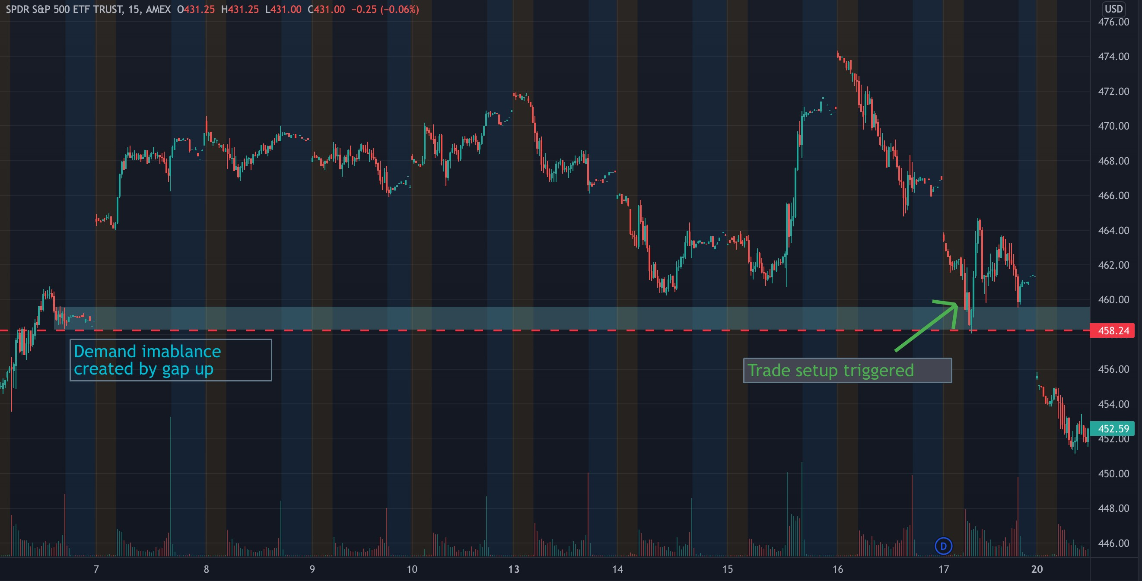
2/4/22 $SPY Calls (REVERSAL) (WIN)
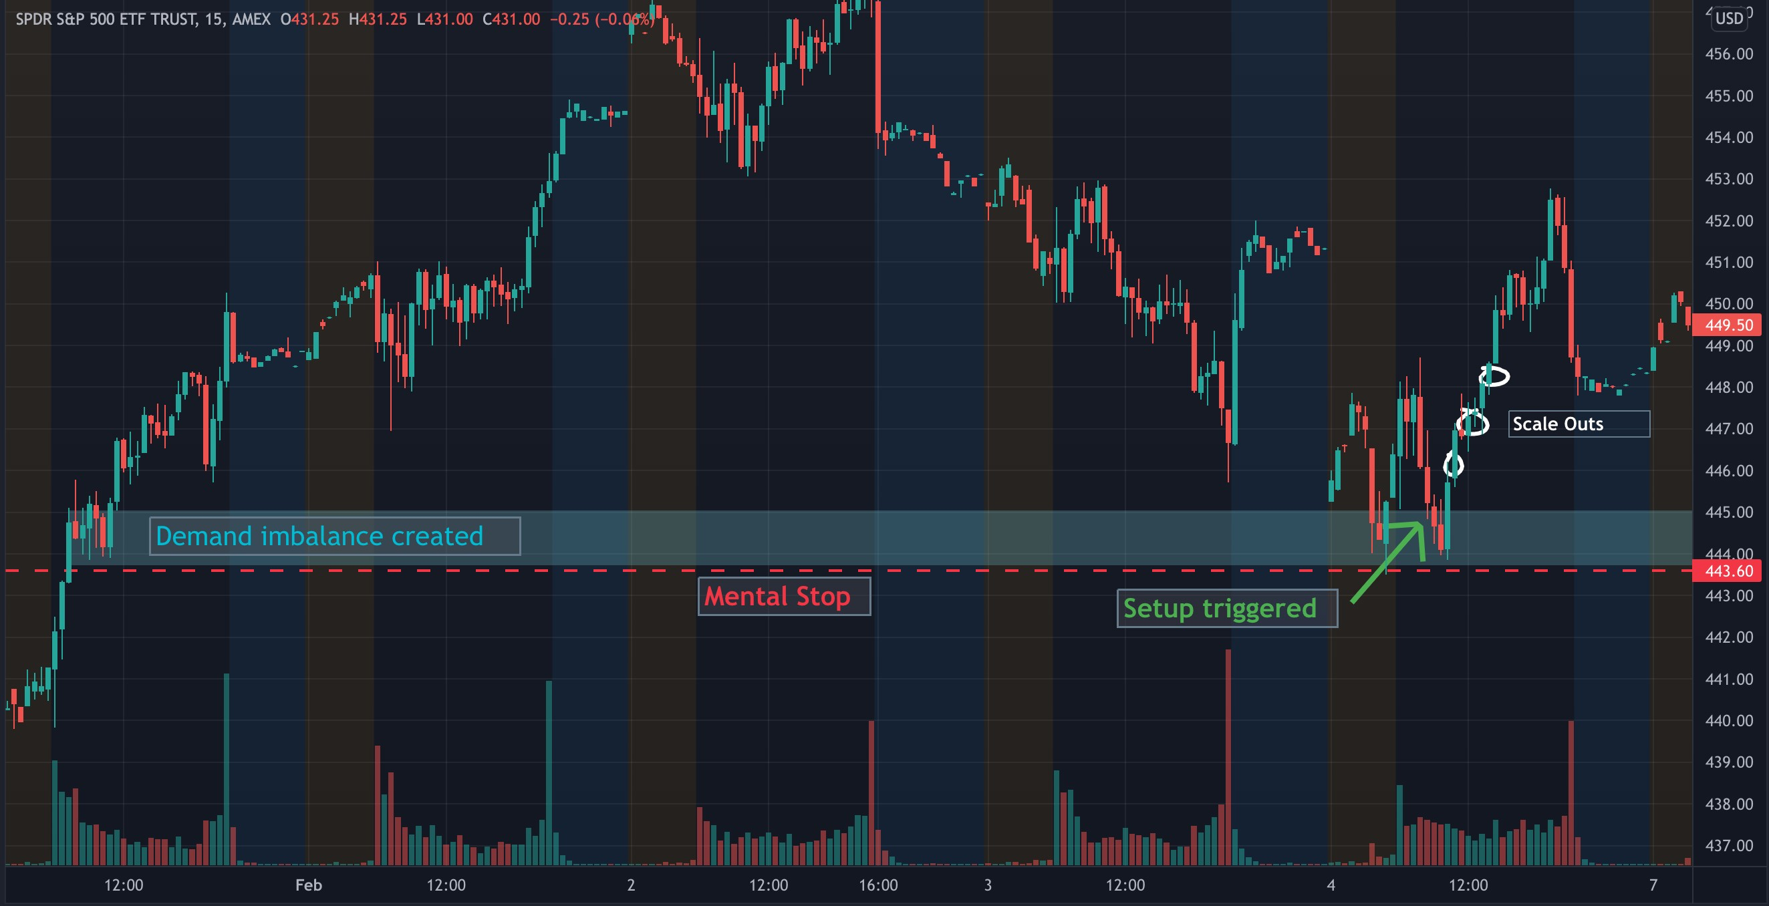
1/28/22 $SPY Calls (REVERSAL) (WIN)
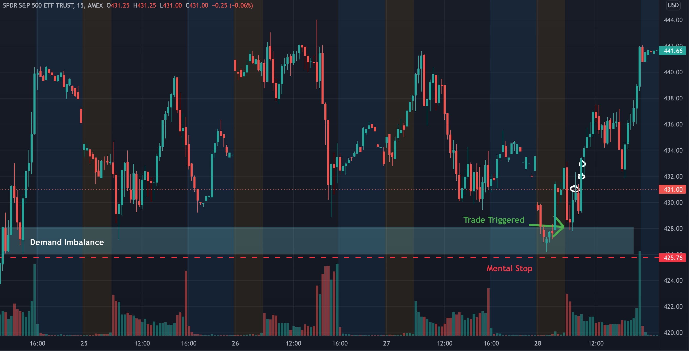
1/25/22 $SPY Calls (REVERSAL) (WIN)

1/4/22 $SPY Puts (BREAKOUT) (WIN)

1/4/22 $TSLA Puts (BREAKOUT) (WIN)
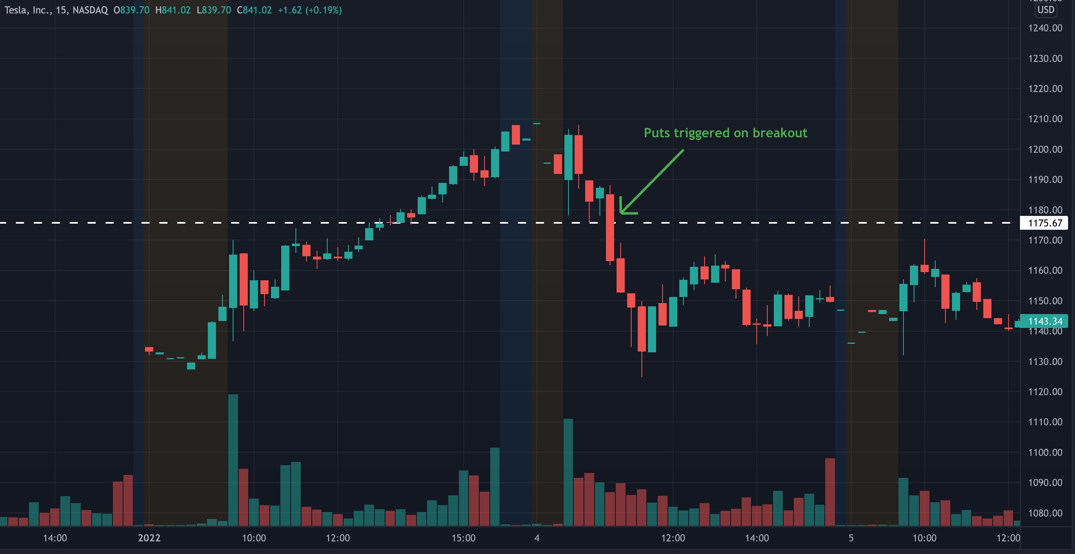
12/9/21 $AMD Puts (REVERSAL) (WIN)
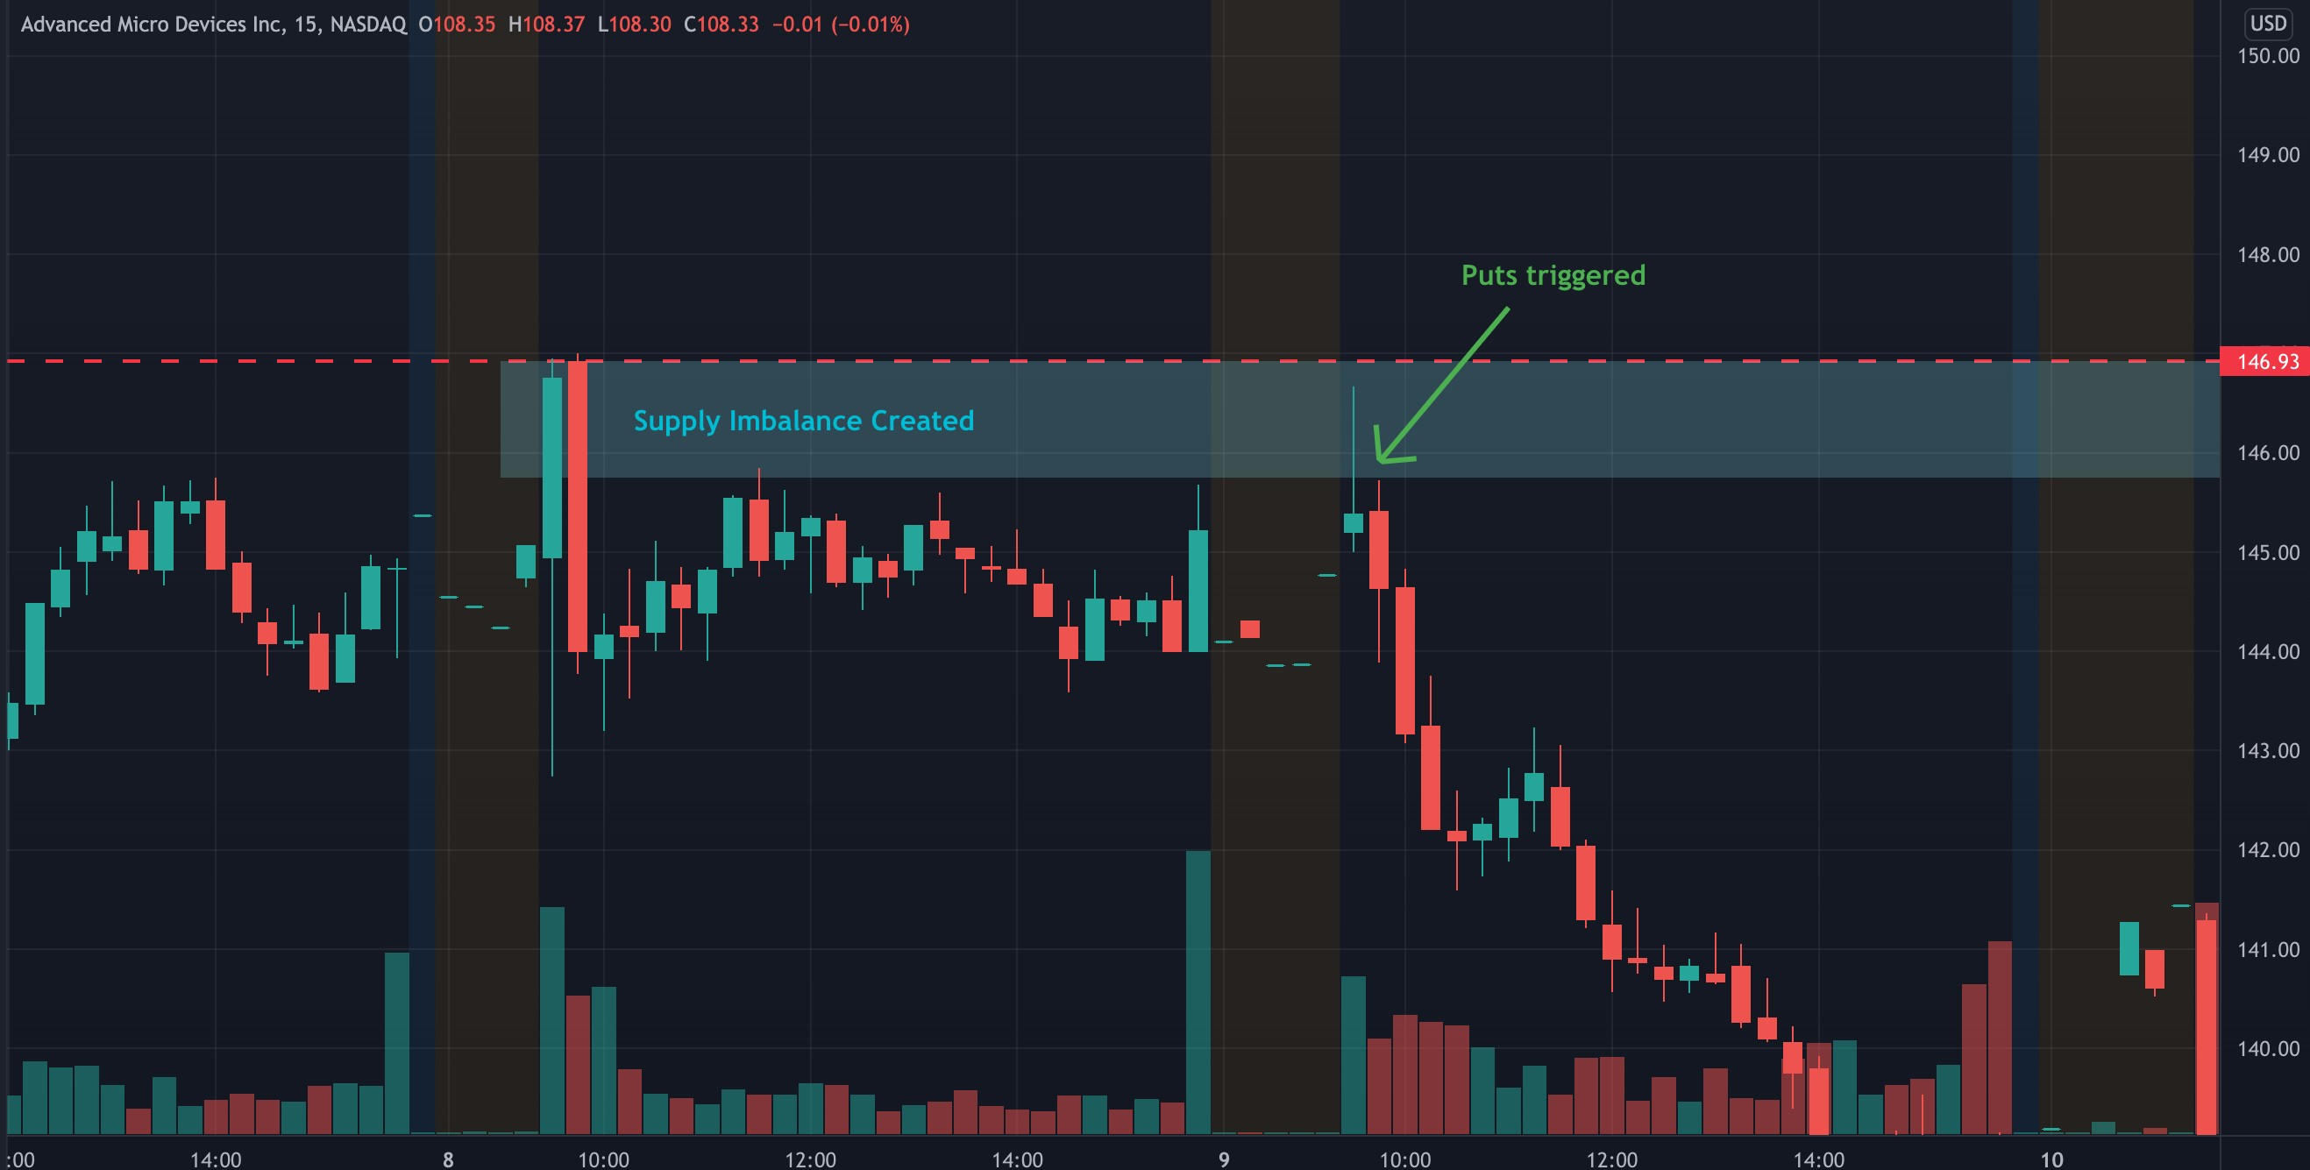
10/27/21 $SPY Puts (REVERSAL) (WIN)
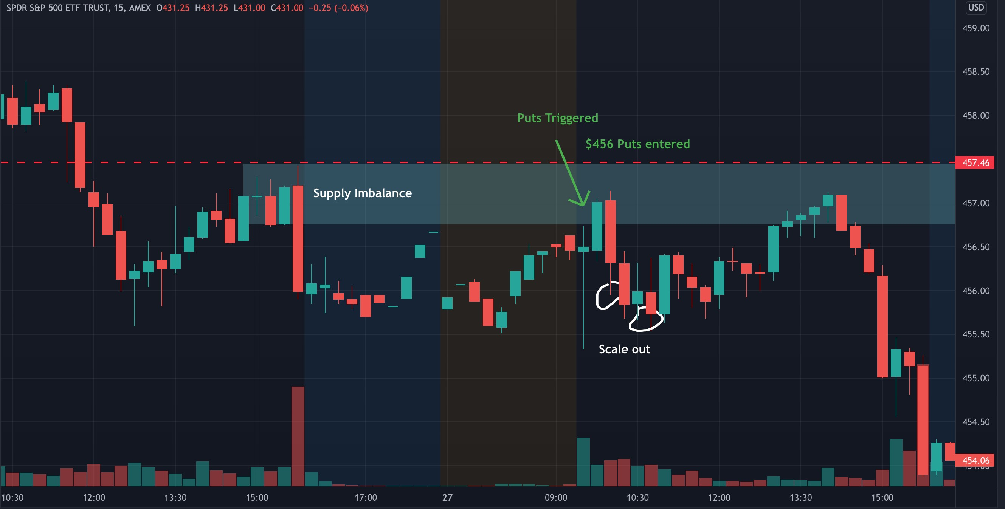
12/03/21 $SPY Puts (REVERSAL) (WIN)
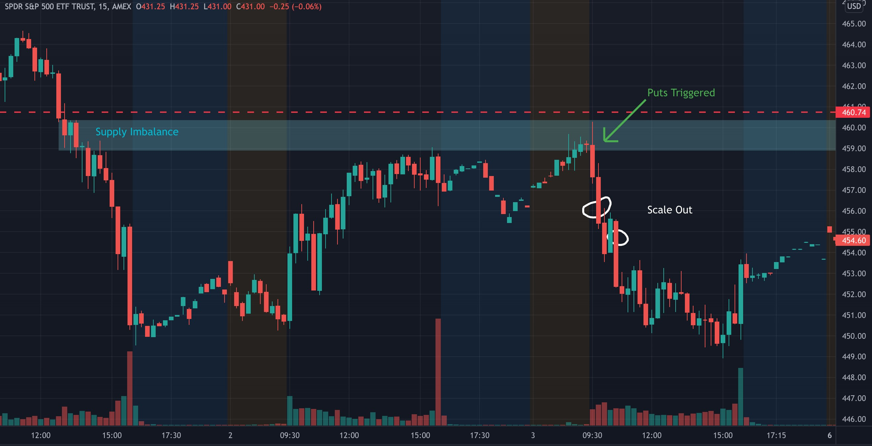
12/01/21 $SPY Puts (REVERSAL) (WIN)
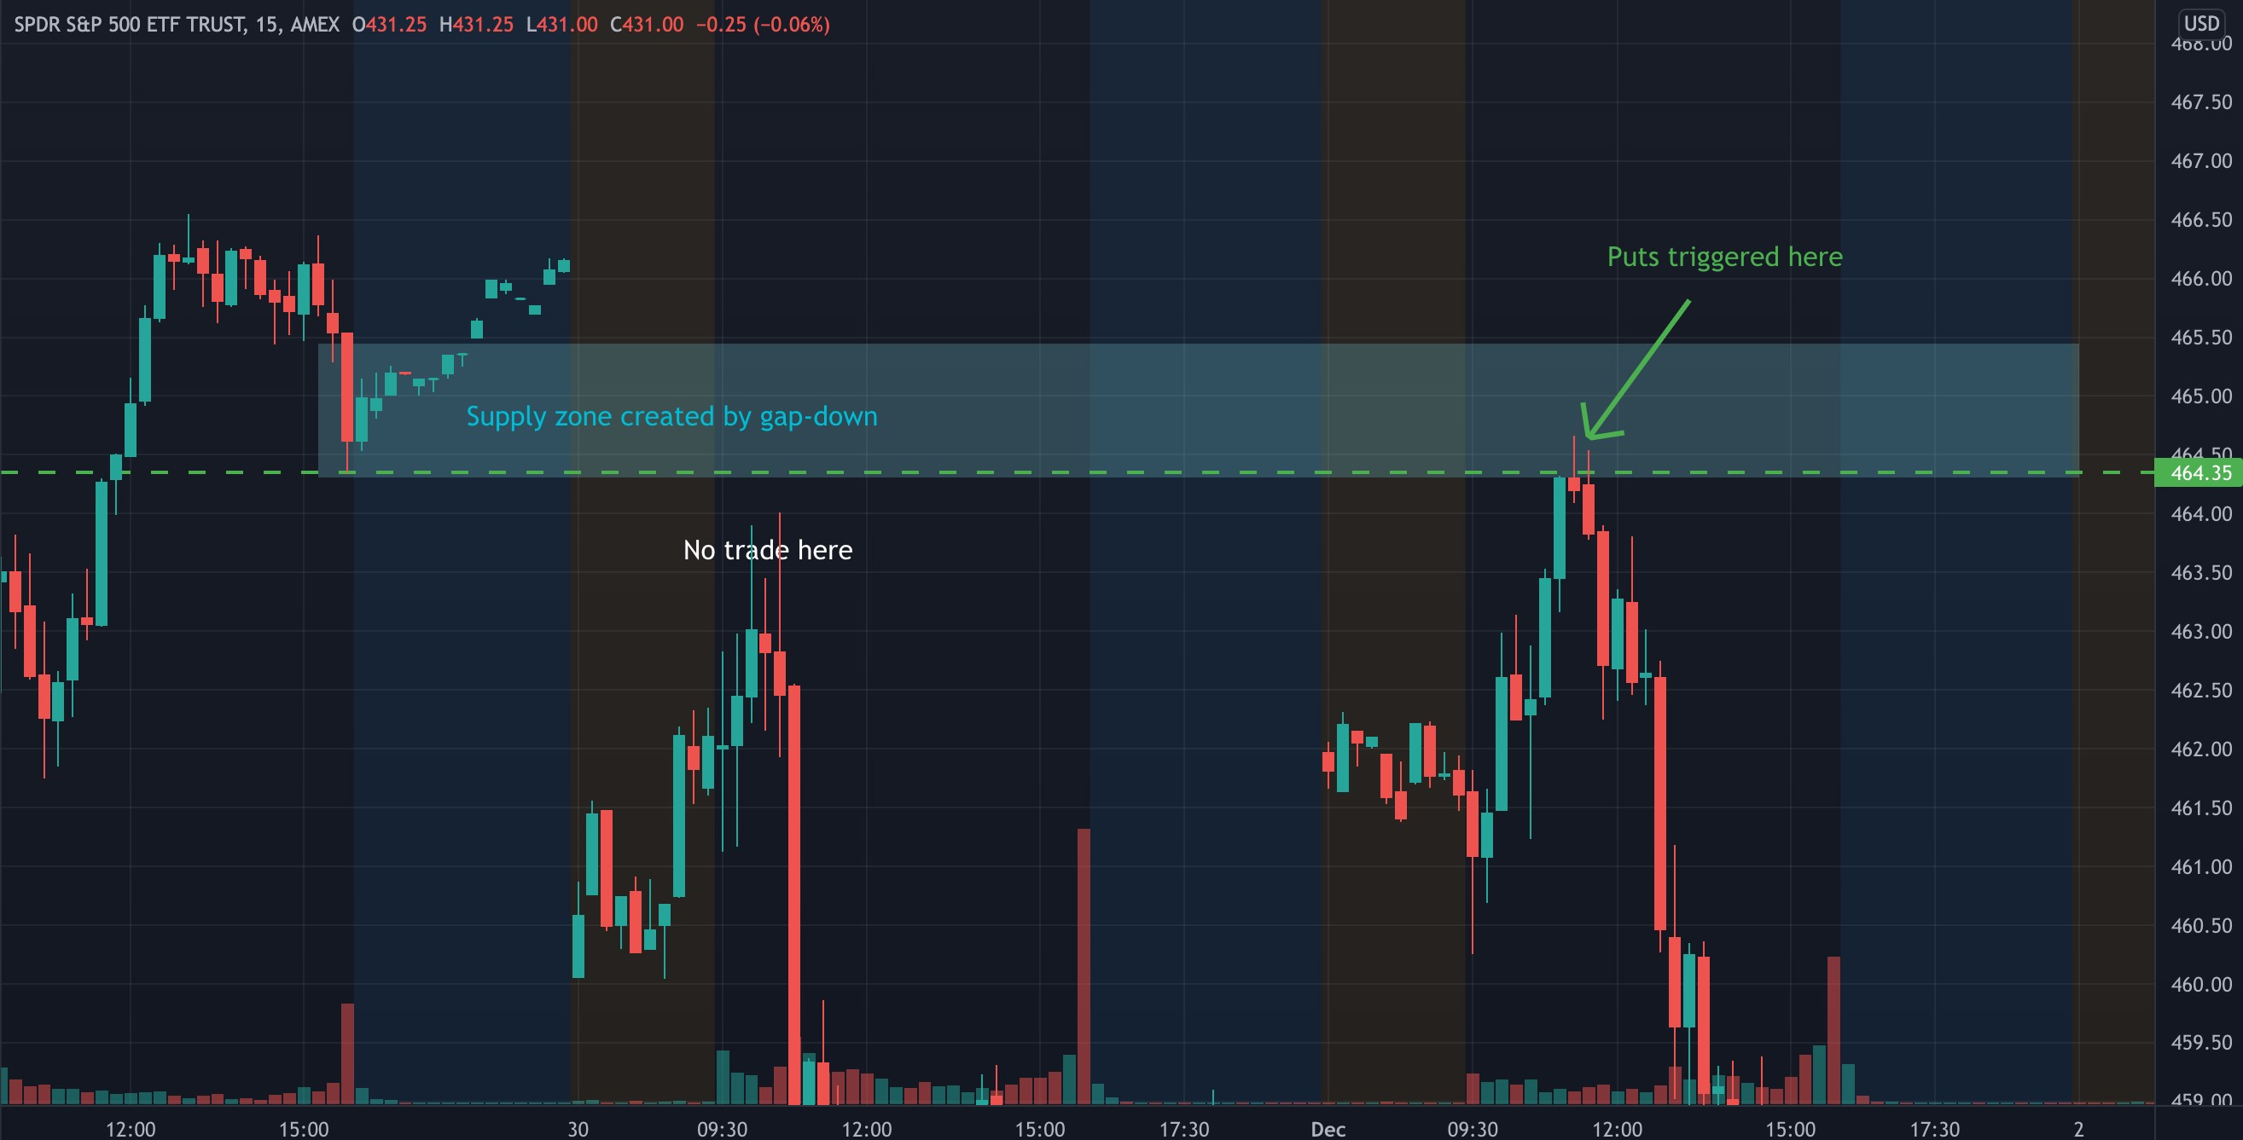
11/29/21 $TSLA Calls (BREAKOUT) (WIN)

3/4/22 $AMD Puts (REVERSAL) (WIN)
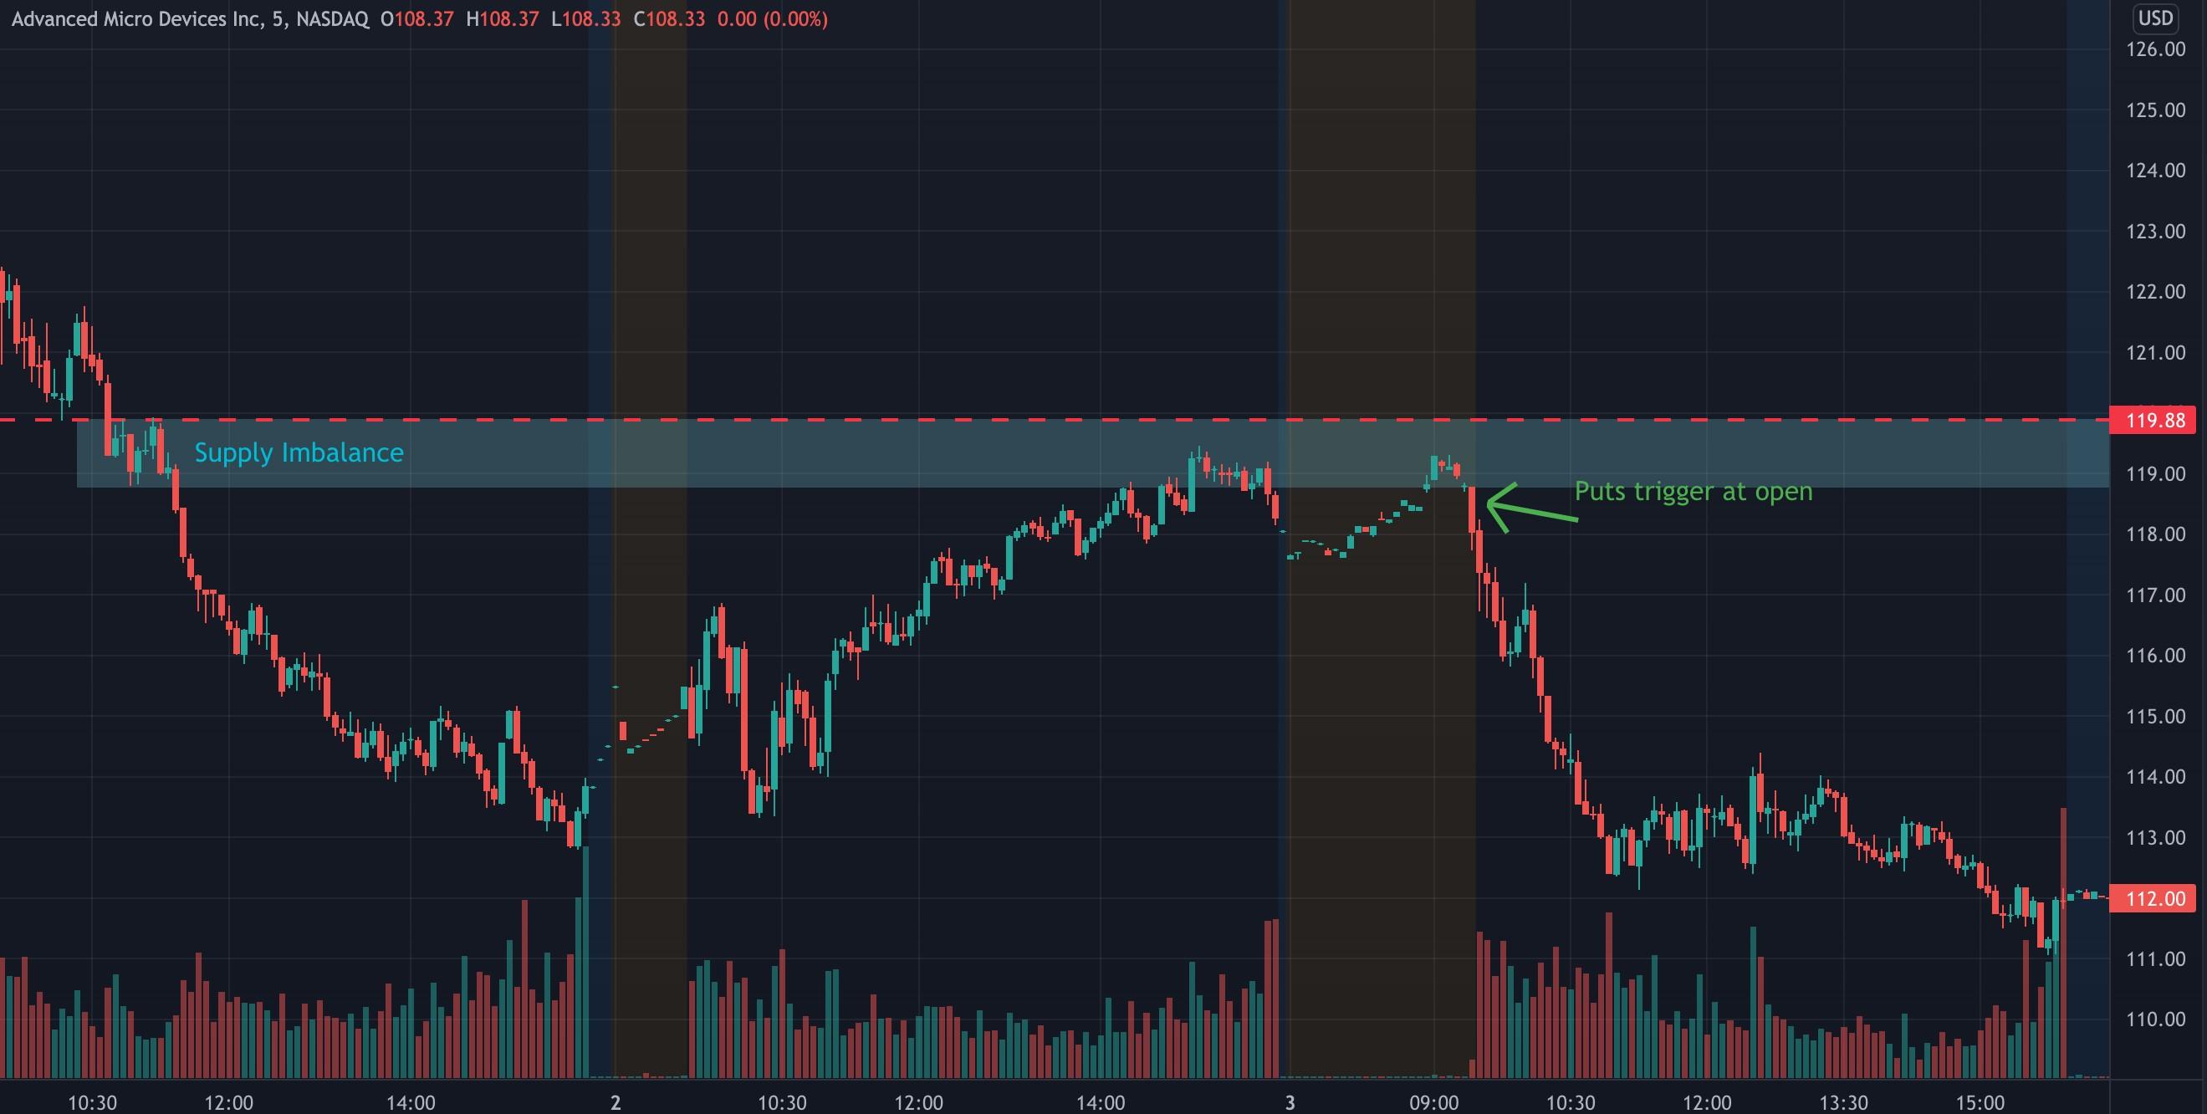
3/1/22 $AAPL Puts (REVERSAL)
This was a trade that went my way at first, I scaled some out as planned, but then it reversed on me. I decided to cut the whole trade as it reached my mental stop area. It ended up reversing again and going my way very strongly. I ended up only taking a small loss on this trade. I couldve made a good amount of profit on it had I held, but seeing the strength with which it was approaching my stop I decided to be proactive and prevent further losses. This usually works for me, in this case it did not.

12/21/21 $SPY Calls (Reversal) (WIN)
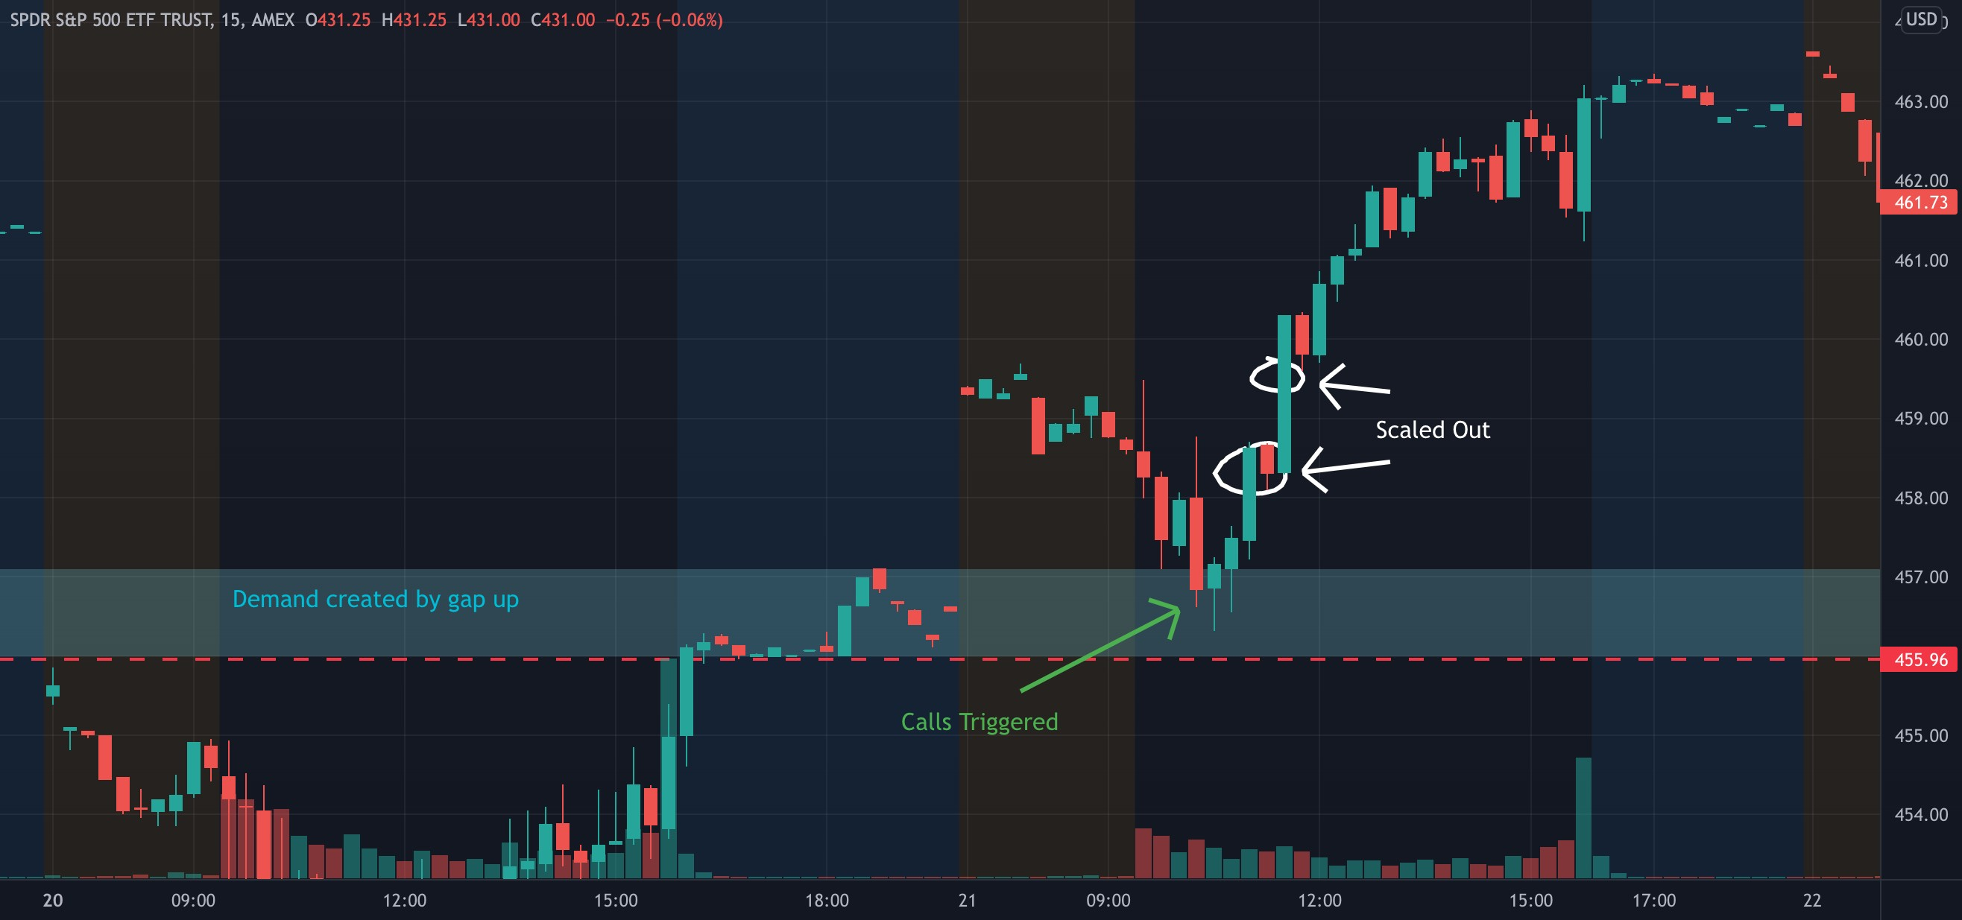
12/08/21 $SPY Calls (REVERSAL)
Another trade I cut for a loss that ended up going my way. Was green after my entry but didnt take any off the table. DIdnt want to risk holding it to the support because of the final wick during the last market session.
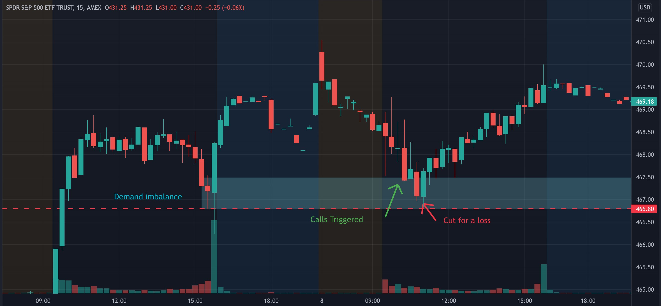
12/10/21 $SPY Calls (REVERSAL) (WIN)
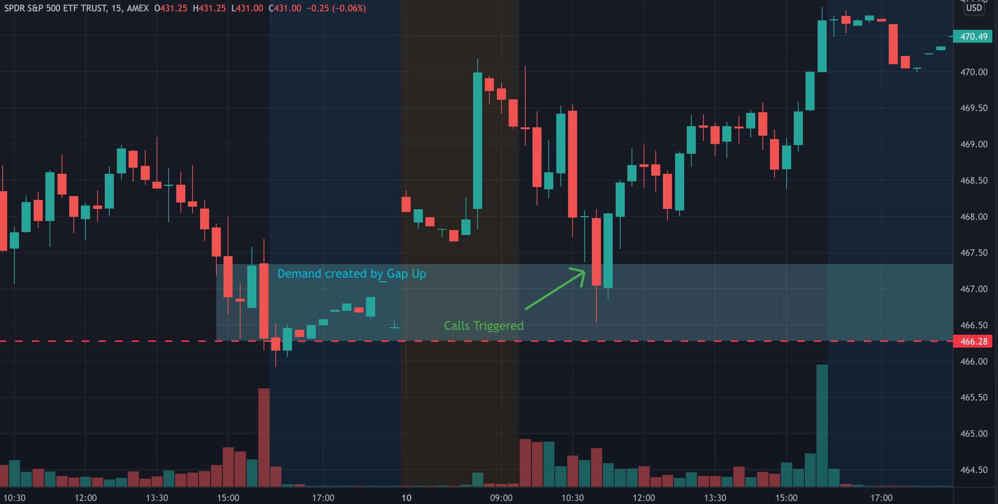
12/15/21 $SPY Calls (REVERSAL) (Loss)
I took my profits as planned then cut for a loss as the trade went back against me. I dont stick around to find out. This works for me in the long run.
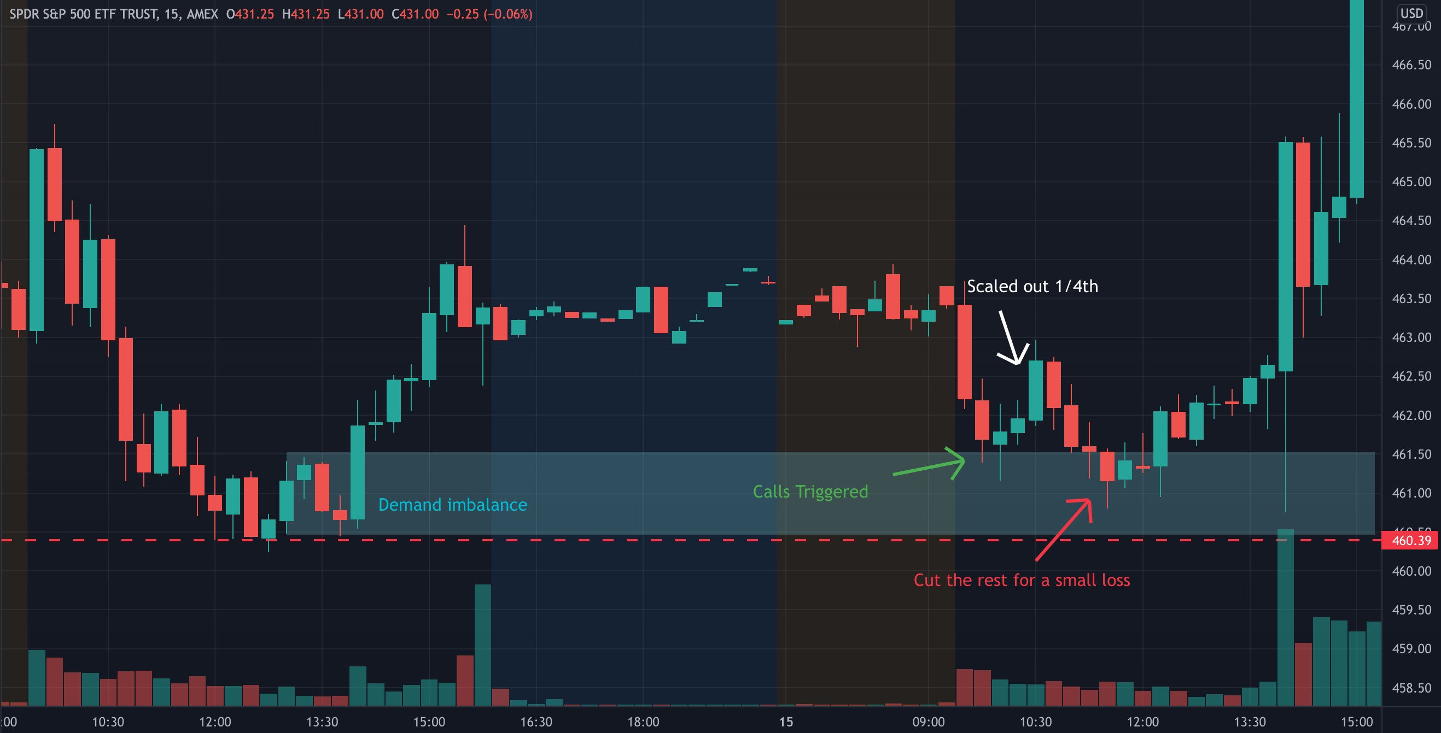
2/17/22 $SPY Calls (REVERSAL) (LOSS)

10/29/21 $SPY Calls (Reversal) (WIN)
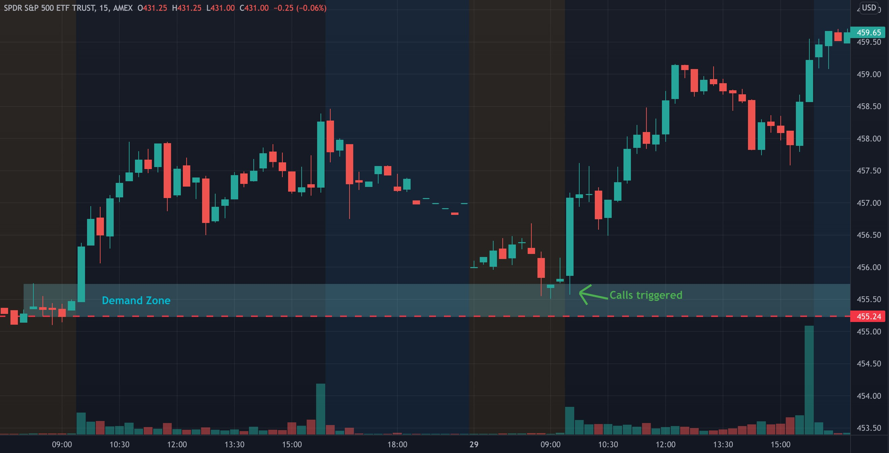
10/18/21 $SPY Calls (WIN)

2/18/22 $TSLA Calls (LOSS)
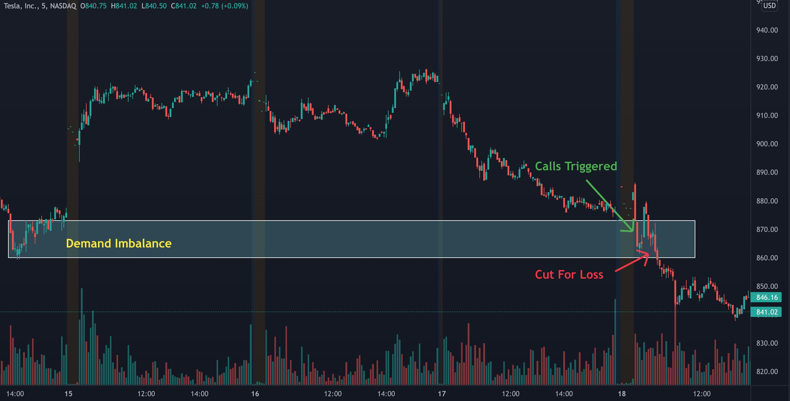
2/18/22 $AMD Puts ( win )
