实验五  游标

**一．上机目的**

1．了解游标的概念。

2．熟悉游标的基本用法。

**二．实验主要内容**

编写PL/SQL存储过程与函数，利用游标实现以下功能**，**存储过程与函数依次命名为obj5_1**、**obj5**_2、…**

1. 用显式游标输出emp表的所有信息。

DECLARE

CURSOR obj5_1 IS SELECT * FROM EMP;

emp_record obj5_1%ROWTYPE;

BEGIN

OPEN obj5_1 ;

LOOP

FETCH obj5_1 INTO emp_record;

EXIT WHEN obj5_1%NOTFOUND;

dbms_output.put_line('EMPNO:'||emp_record.EMPNO||',ENAME:'||emp_record.ENAME

||',JOB:'||emp_record.JOB||',MGR:'||emp_record.MGR||

',HIREDATE:'||emp_record.HIREDATE||',SAL:'||emp_record.SAL||

',COMM:'||emp_record.COMM||',DEPTNO:'||emp_record.DEPTNO);

END LOOP;

dbms_output.put_line('row count:'||obj5_1%rowcount);

CLOSE obj5_1;

END;

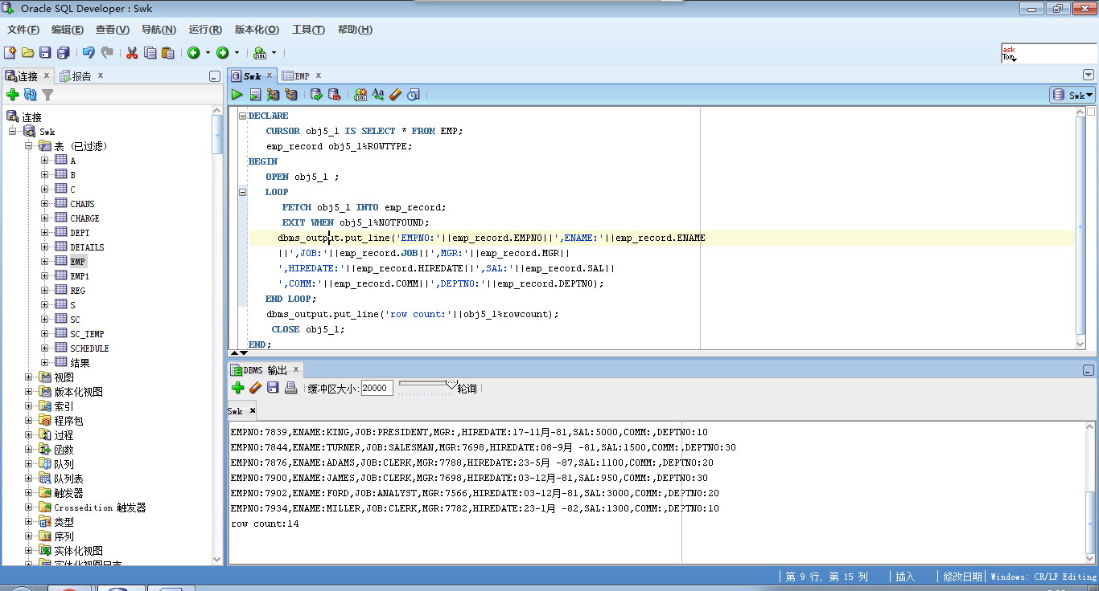

1. 用隐式游标输出dept表的所有信息。

BEGIN

FOR emp_record IN (SELECT * FROM DEPT)

LOOP

dbms_output.put_line('DEPTNO:'||emp_record.DEPTNO||',DNAME:'||emp_record.DNAME

||',LOC:'||emp_record.LOC);

END LOOP;

END; 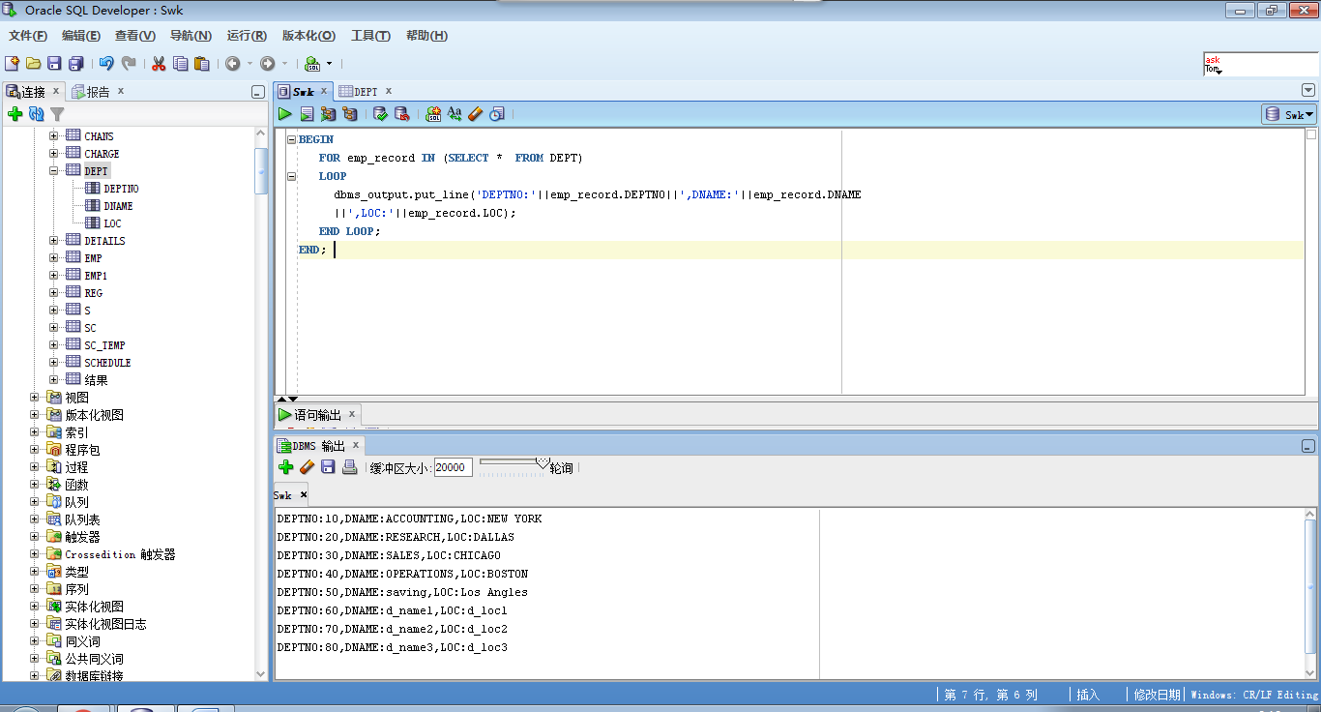

3．  利用游标，修改员工工资。根据job不同，为员工增加相应的sal：

    Job         raise

    clerk      +500

    salesman   +1000

    analyst    +1500

otherwise  +2000

declare

temp EMP1.SAL%type;

BEGIN

FOR emp_record IN (SELECT EMPNO,JOB,SAL FROM EMP1)

LOOP

update EMP1 set SAL=(

case

when emp_record.JOB= 'CLERK' then emp_record.SAL + 500

when emp_record.JOB= 'SALESMAN' then emp_record.SAL + 1000

when emp_record.JOB= 'ANALYST' then emp_record.SAL + 1500

else emp_record.SAL + 2000

end)

where EMPNO=emp_record.EMPNO;

select sal into temp from emp1 where EMPNO=emp_record.EMPNO;

dbms_output.put_line('员工：'||emp_record.EMPNO||'职业：'||emp_record.JOB||'原工资:'||emp_record.SAL||'更新后：'||temp);

END LOOP;

END;

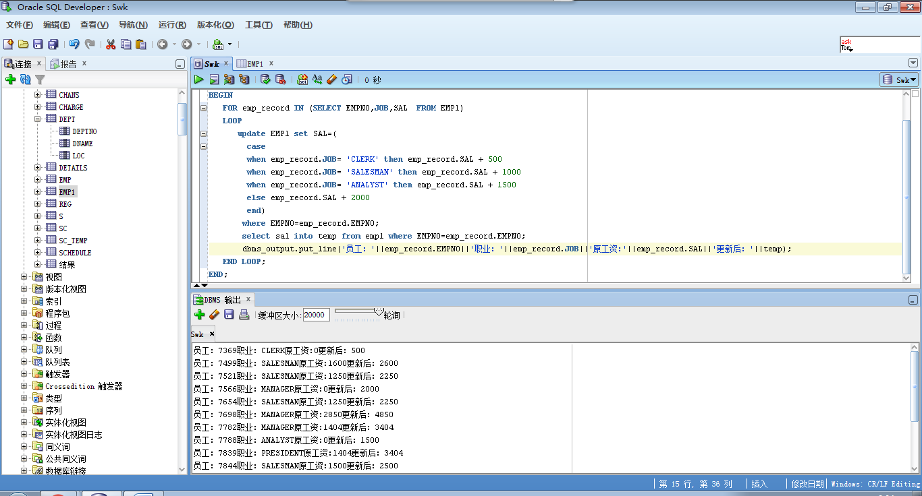

4．用显式游标输出指定学年欠费的学生名单（含姓名、专业、欠费金额）。

create or replace

procedure obj5_4(year charge.SHYEAR%type)

as

cursor obj5_4 is select SNO,TUITION,BALANCE from charge where SHYEAR = year ;

qianfei charge.tuition%type;

r_tuition charge.tuition%type;

r_balance charge.balance%type;

r_sno charge.sno%type;

r_name s.name%type;

r_speciality s.speciality%type;

begin

open obj5_4;

fetch obj5_4 into r_sno,r_tuition,r_balance;

while obj5_4% found

LOOP

qianfei := r_tuition - r_balance;

if qianfei > 0 then select name,speciality into r_name,r_speciality from S where SNO = r_sno;

dbms_output.put_line('name:'||r_name||',speciality:'||r_speciality||',qianfei:'||qianfei);

end if;

fetch obj5_4 into r_sno,r_tuition,r_balance;

end loop;

close obj5_4;

end;