ASTANA IT UNIVERSITY

Airfare Monitoring KZ
PROBATIONARY PERIOD 1
CONSOLIDATED PROJECT REPORT
Development of a Mobile Application for Monitoring and Analyzing Airfare Dynamics on Domestic Routes in Kazakhstan

Educational Programme: Software Engineering
Students: Yessenkhossov Dinmukhammed and Bekbauly Galymzhan
Academic Group: SE-2419
Supervisor: Senior Lecturer Arailym Zhanbolatkyzy Orazova
Reporting Period: October 2026
Report Date: 24 October 2026
Repository: https://github.com/Swoksaar0/airfare-monitoring-kz
GitHub Projects: https://github.com/users/Swoksaar0/projects/2/views/1

Table of Contents
1 Project Proposal 3
2 Evidence of Relevance 7
3 Literature Review 9
4 Existing System Comparison 17
5 Technology Comparison 20
6 Requirements Specification 24
7 Architecture and Diagrams 27
8 UX and Prototype 34
9 Verification and Evaluation Plan 38
10 Project Management and Risks 42
11 Supervisor Feedback 47
Appendix A Repository evidence 48

1 Project Proposal
We are developing a Flutter mobile application and supporting backend to monitor repeated airfare observations on selected domestic routes in Kazakhstan. The current result is a reviewable interface demonstration, server scaffolding, and the research and design package for the first probationary period. Reliable live data collection, native deployment, push delivery and useful predictive accuracy remain to be demonstrated.

1.1 Topic
English: Development of a Mobile Application for Monitoring and Analyzing Airfare Dynamics on Domestic Routes in Kazakhstan. Русский: Разработка мобильного приложения для мониторинга и анализа динамики цен на авиабилеты по внутренним маршрутам Казахстана. Қазақша: Қазақстанның ішкі әуе бағыттары бойынша авиабилеттер бағасының динамикасын бақылауға және талдауға арналған мобильді қосымшаны әзірлеу.

1.2 Team and supervisor
Member | Account | Engineering responsibility
Bekbauly | @Bekbauly | Sources, collection, backend, database, analytics and ML experiments
Dinmukhammed | @Swoksaar0 | User research, requirements, mobile interface/client, visualization and notification functionality

Supervisor: Senior Lecturer Arailym Zhanbolatkyzy Orazova, as listed in the repository README. Both students review requirements, interfaces, integration, tests, and documentation.

1.3 Problem and target users
The project investigates whether repeated airfare observations can support understandable price-history views and threshold tracking for people planning domestic flights in Kazakhstan. One search result does not show how an offer has changed over time.
The intended users are travelers selecting a route and departure date, comparing available observed prices, and deciding whether to track an offer. These needs are initial assumptions. Real discussions and a supported comparison of existing services are required; neither the need nor uniqueness of the proposed solution is asserted as already verified.

1.4 Aim
Develop and evaluate a mobile application and supporting backend that collect, retain, and analyze airfare observations for selected domestic directional routes, with explicit data provenance, freshness, and limitations.

1.5 Objectives
- Collect user evidence and define prioritized, testable requirements.
- Select 10–15 directional domestic routes and verify source coverage for route/date combinations.
- Preserve observations with separate departure dates, collection timestamps, and source timestamps when available.
- Provide a route/date-specific history and statistical assessment through an API.
- Implement mobile route/date selection, history visualization, and tracking scenarios.
- Implement threshold checks, duplicate suppression, and verifiable notification delivery.
- Compare a simple baseline and candidate statistical/ML approaches on time-ordered real observations.
- Evaluate data quality, functional behavior, and completion of user scenarios.

1.6 Scope and initial route selection
The current backend seeds 12 directions: ALA→NQZ, NQZ→ALA, ALA→CIT, ALA→SCO, ALA→GUW, ALA→AKX, NQZ→CIT, NQZ→SCO, NQZ→GUW, NQZ→AKX, NQZ→UKK, and ALA→KGF. Reverse directions count separately.
These are candidate monitoring directions, not a verified coverage claim. Retain a final set of 10–15 only after the data pilot; record unavailable combinations rather than inventing offers. Current collector parameters are one-way and KZT, with one selected departure date per run and a 1–60-day horizon. The monitoring design should support repeated observations of fixed departure dates as well as explicitly labeled rolling horizons.
Android is the initial mobile target; Flutter/Dart is selected and a Web demo is available in mobile/. The title does not promise an iOS release.
Outside scope: booking/payment, complete flight inventory, guaranteed coverage of all carriers/fare families, real-time repricing, and guaranteed advice about the best purchase date.

1.7 Expected deliverables
- Mobile client and scenario prototype.
- Backend API, documented storage model, and controlled collector.
- Real observations with known provenance and explicit missing/error states.
- Route/date-specific history and baseline assessment.
- Threshold tracking with documented delivery/deduplication behavior.
- Requirements, diagrams, research/comparison documents, test plan, measured results, and reproducible submission instructions.

1.8 Current implementation and technical feasibility
Published code contains FastAPI endpoints, PostgreSQL configuration, ORM models, a 12-direction seed list, collection scaffolding, and median/linear assessment. An offline review exercised the API with temporary SQLite and mocked provider responses.
This is a backend prototype. Missing/error API responses currently fall back to unmarked generated quotes; source-time mapping and UTC conversion are incorrect. These defects must be corrected before a real collection pilot or an ML dataset can be trusted. Flutter/Dart source and a Web demo are available, with explicitly synthetic fixtures. Actual push delivery, native builds, a scheduler, backend integration and validated prediction performance are not established.

1.9 Evaluation approach
Link each requirement to checks in VERIFICATION_PLAN.md. Evaluate source coverage/freshness, distinct observations, storage integrity, API behavior, user scenario completion, and baseline comparison. Define numerical success targets before measurement. No accuracy or usability outcome is claimed yet.

1.10 Review gate
Bekbauly checks technical feasibility and data claims; Dinmukhammed checks scope and user scenarios; the supervisor reviews the substance. Record comments and resulting decisions. This draft remains open until real user evidence and review are attached.

1.11 Engineering complexity and expected contribution
The engineering difficulty is preserving comparable observations while integrating asynchronous collection, storage, analytical grouping and mobile presentation. A source may return an old cached minimum, omit a route or switch the cheapest itinerary. Our system must distinguish these conditions before drawing a price curve or evaluating a model. The intended academic contribution is an implemented and measured monitoring workflow for a bounded route sample; global inventory coverage or a new neural architecture is not claimed.

2 Evidence of Relevance

2.1 Evidence status
No completed discussions with potential users and no substantive client agreement have been supplied for this project at the reporting date. The relevance section therefore records the problem hypotheses and the planned validation method. It does not contain interview findings or quotations.

2.2 Problem hypotheses to examine
Hypothesis | Question to examine | Evidence needed
H1 Price uncertainty affects planning | How do travelers currently decide when to purchase a domestic ticket? | Concrete account of a recent booking and the information used.
H2 Observation history is understandable | Can a traveler distinguish observation date from departure date? | Explanation after viewing a labeled prototype graph.
H3 A numeric threshold is useful | Would a specified price threshold fit an actual planning decision? | A realistic route/date/amount and the reason for selecting it.
H4 Source freshness affects trust | How does the traveler interpret an older cached price? | Correct interpretation of stale, unknown and demo examples.

2.3 Planned discussion method
Conduct 3–5 semi-structured discussions with people who have recently searched for domestic flights or expect to do so. Include different travel purposes where recruitment permits. Ask about an actual recent experience before demonstrating the proposed application. Use anonymized participant identifiers and obtain permission for recording or quotation separately. A small convenience sample provides exploratory evidence rather than a population-level demand estimate.
- Describe your most recent domestic flight search and the services you used.
- What information made you purchase immediately or wait?
- Have you used a price alert, and what was useful or confusing about it?
- What do the graph dates and the freshness label in this prototype mean to you?
- Would you use a route/date threshold, and under what conditions?
- Which information or action is missing from the demonstration?

2.4 Analysis and requirement changes
For each completed discussion, preserve date, participant category, questions, anonymized answers and permission status. Separate participant statements from the interviewer’s suggestions. Group recurring needs, record contradictory feedback, and link any resulting change to the relevant FR or NFR identifier. Discuss route/date selection, freshness, historical interpretation and tracking without describing proposed functions as already delivered.

2.5 Pending evidence and acceptance
This requirement remains open. Completion requires 3–5 substantive real discussion records or the permitted real-client alternative, a short synthesis, and traceable requirement or interface changes. The user-discussion protocol is available in the repository; the presence of a protocol is not completed research.

3 Literature Review

3.1 Purpose and selection
This review supports a Flutter application for monitoring and analyzing airfare dynamics on 10–15 selected domestic directions in Kazakhstan. It asks how to obtain interpretable observations, evaluate forecasts without future information, and communicate price histories on a phone.
The selection is a targeted narrative review, not a systematic review. Searches covered airfare prediction, forecast evaluation, mobile time-series visualization, accessibility, and provider data semantics. Publisher pages, author/institutional copies, and official product documentation were checked. No reproducible search-result count or exhaustive coverage is claimed.
The corpus contains 14 distinct sources: ten scholarly publications [P1–P10] and four technical documents [D1–D4]. The author-deposited dataset linked under P2 is supporting material, not an extra publication. Eight of the ten scholarly publications appeared in 2022–2025. Two 2019 airfare studies considered during drafting were excluded from this corpus in favor of the 2023 studies P1 and P10. P6 (2019) is retained specifically for its controlled mobile chart experiment, not as evidence about current airfares or technology. P5 (2021 issue, first published in 2019) remains a foundational taxonomy of prediction targets; its issue year does not make it a recent discovery.
Access was rechecked on 24 October 2026. P7 now uses the complete author-linked paper, including Sections 3–5. P2 combines the publisher abstract with the author's dataset description; its full methods remain unverified. The older P1 preview is no longer part of the corpus. Open full texts or author copies support P1 and P3–P10, with relevant methods and limitations inspected. This does not claim that either student has independently read, reproduced or approved every paper.

3.2 Structured analysis: scientific publications
Reported findings below belong to the cited authors. Limitations and project applications are our critical assessment unless explicitly attributed.
ID / evidence inspected | Approach and reported result | Limits and application to this project
P1 Degife and Lin, 2023. Open full article, Sections 3–5 and Table 6. | Uses 1,032,215 Ethiopian Airlines records from 2018–July 2022 and 44 decision features. GRU outperforms MLP, LSTM, ARIMA and SVR in the reported comparison; the authors also explore 7/14/30-step horizons. | Airline-provided data differ from our small, source-dependent quote history. Section 3.3 describes train/validation/test sets without reproducible date boundaries, and no open dataset is supplied. Treat GRU as an optional later candidate, with independent temporal validation and simpler baselines.
P2 Bülbül, 2025. Publisher abstract plus author-deposited Mendeley dataset description, version 2. | Predicts US market-level airfares; the abstract favors Random Forest. The dataset combines DB1B and T-100 and documents 1,581,278 records with 26 columns, including Average_Fare, market share, HHI and circuity. | This is a market-level prediction problem, unlike our next daily offer observation. The dataset page verifies data structure, not the article's split, preprocessing or scores. Use features only when available at prediction time; exclude the target and later-realized information.
P3 Hewamalage et al., 2023. Open article: evaluation guidance and discussion of partitioning, errors and leakage. | Tutorial-style synthesis explains how non-stationarity, data partitions and metric choices can distort forecasting comparisons. Recommends evaluation suited to the series and task. | General guidance does not establish an airfare model's accuracy. Use chronological backtesting, fit preprocessing on training data only, and compare against naïve forecasts. This does not imply that random cross-validation is invalid for every possible time-series setting.
P4 Zeng et al., 2023. Conference article/author abstract and available proceedings text. | Compares one-layer LTSF-Linear models with selected Transformer forecasting models on nine real-world datasets; the reported experiments favor the linear alternatives. | Long-horizon benchmarks differ from short airfare histories. Their architecture is not identical to ordinary linear regression. Justifies strong simple baselines before complex models, not a universal claim that Transformers fail or that linear models will win here.
P5 Abdella et al., 2021 issue / 2019 online. Open survey, abstract and relevant discussion. | Classifies customer-side optimal-purchase-time/minimum-price prediction separately from airline demand/revenue objectives. Reviews features and discusses external information such as social media. | The survey predates current services; proposed external features are not evidence of improvement on our data. Use it to define the target and available features. External signals remain optional rather than an unsupported requirement.
P6 Brehmer et al., 2019 issue / 2018 online. Author/institutional paper copy and abstract. | Phone-based experiment with 87 crowdworkers compares linear and radial range layouts. Linear layouts enabled faster tasks; error-rate differences were limited. | Temperature ranges and controlled tasks differ from airfare histories. Begin with readable chronological plots and explicit values, then measure our users' ability to retrieve and compare prices. Does not prove every linear chart is superior.
P7 Snyder et al., 2024. Full author-linked paper, Sections 3–5, pp. 2–4. | Interviews about thirteen candidate interactions informed precise inspection, single-finger support and menu-based undo/redo. | This formative qualitative study iteratively revised its prototype. It does not establish speed gains, long-term learnability or suitability for travelers. Test direct price inspection and recoverable navigation in our app.
P8 Elavsky et al., 2022. Author full text and institutional publication record. | Chartability organizes accessibility checks into testable visualization heuristics. Its preliminary practitioner evaluation reports usefulness for organizing and conducting audits. | Practitioner feedback is not proof that every resulting chart is accessible. Use a text alternative, meaningful labels, non-color cues and assistive-technology checks; record actual failures and retest repairs.
P9 Leffrang and Müller, 2025 issue / 2024 online. Open article, study and conclusions. | Online study with 239 participants compares point forecasts, 95% prediction intervals and ensemble plots. Interval plots supported advice use/performance in that study; confidence and perceived uncertainty affected decisions. | Context-dependent human judgment results do not validate our forecast intervals. Present a forecast as an estimate; add intervals only when statistically justified. More visually apparent uncertainty does not automatically improve decisions.
P10 Aliberti et al., 2023. Complete author copy, Sections IV–VI and Tables III–IV. | Compares twelve models on 10,683 Indian fare records from 2019, using 70% for training and 30% for test/validation. Random Forest leads MAE/MAPE; Bayesian CNN leads RMSE/R² in Table III. | The paper explicitly notes non-sequential input; its Transformer uses replicated inputs to simulate sequences. The stated split does not establish a future-date holdout. This is useful model-comparison evidence, not proof of forecasting our daily price histories.

3.3 Details verified in the new source checks
P7's twelve participants comprised ten graduate students, one undergraduate and one software engineer, all in computer science. Approximately one-hour remote sessions tested individual interactions on scatter, bar and multi-line charts. The first author coded qualitative feedback; open-ended analysis tasks and longitudinal retention were not tested. For our Flutter chart, we therefore propose visible controls and portrait-friendly value inspection, then measure travelers' task completion and errors independently [P7, Section 4].
P2's author deposit lists Average_Fare as well as passenger counts and market descriptors. Column availability alone does not establish when a value became observable. Our feature audit must record each candidate's source and earliest availability; contemporaneous or later passenger totals cannot be assumed available to a customer before departure [P2 supporting dataset].
P1's large airline dataset and P10's tabular benchmark illustrate different conditions for model comparisons. Their rankings do not establish the best learner for a sparse Kazakhstan quote history; the relevant comparison must use our target and earlier-only inputs.

3.4 Structured analysis: technical sources
These sources describe tools or services. They do not count toward the scientific-publication minimum and do not demonstrate our integration.
ID | Verified content | Consequence and limitation
D1 Skyscanner Indicative Prices | Indicative results use cached searches and approximate lowest prices; the guide describes cache ages up to four days and contrasts indicative with live pricing. | A cheap-calendar result is not a guaranteed current purchasable fare. Preserve price kind and provenance; separate departure-date calendars from observation-time histories. Documentation does not prove access or domestic Kazakhstan coverage.
D2 Aviasales Data API | Official guidance describes a search cache retaining data for seven days, with endpoint-specific data and API access requirements. | A successful download may contain an older observation. Store collection time separately from any supplied source time; unknown time stays unknown. Do not infer complete flight inventory, baggage or fare families from a cached minimum. No live provider calls were made for this review.
D3 Flutter accessibility | Official guidance addresses semantics, screen readers, contrast, touch targets and text scaling. | Apply the checks to the actual Flutter screens, including the price chart and errors. A framework capability is not proof that this app passes an audit; native screen-reader checks remain outstanding.
D4 Flutter testing | Official guidance distinguishes unit, widget and integration tests and their different scope/cost. | Keep calculation checks, interaction checks and device/integration evidence separate. The two existing Flutter checks and a Web build do not establish Android/iOS operation, backend connectivity or push delivery.

3.5 Synthesis and decisions

3.5.1 Define what is being predicted
The distinction between customer purchase decisions, airline demand and market-level averages is central [P2, P5, P10]. Our proposed experimental target is the next daily observed price for a fixed direction, departure date and declared comparable offer group. If only a source-specific minimum is available, the label must say so. Such a minimum can switch between flights or tariffs; it is not automatically the price trajectory of one seat or fare class.
This target is a proposed project choice, not a result reported by those papers. A claim about cheap fare classes disappearing would require observed class-level inventory, not merely declining availability in a cached calendar.

3.5.2 Collect a history that can answer the question
Fixed departure cohorts plus optional rolling horizons are our collection design choice. The scope of 10–15 directions must be agreed with the supervisor; it is not a sample-size requirement derived from the papers. Preserve route, departure date, source, offer identity when known, currency, collection time, supplied source time and cache status. Keep missingness and failures explicit [D1, D2].
A repeated cached quote may confirm continued availability of the same source record but must not be presented as a newly independent price observation. Do not manufacture a source timestamp from a flight's departure time. These are project design inferences from the source semantics.

3.5.3 Evaluate before making purchase recommendations
Following the evaluation principles in P3, the baseline lesson in P4 and the model comparison in P10, compare a last-observed-price baseline, a prior-history median and a simple fitted candidate. For each evaluation origin, train only on earlier information; tune on earlier validation periods and keep the final period untouched until evaluation. A feature's value must have been available at the forecast time.
Report MAE in KZT, sample count, collection span, routes, horizons, missingness and comparison with the same baseline on the same cases. Evaluate threshold crossings separately if they become a prediction task. No paper supplies a defensible accuracy target for our dataset, and no reported foreign-market score is adopted as our expected result.

3.5.4 Design for reading and acting on a phone
The mobile studies favor testing concrete retrieval and navigation tasks rather than adding decorative chart interactions [P6, P7]. Proposed tasks are: find the latest observed price, identify the departure date, compare two observations, distinguish stale/demo data, and save a threshold. Record completion, errors and time on declared devices.
Use Chartability and Flutter guidance together for labels, readable text alternatives, non-color cues, scaling and assistive-technology checks [P8, D3]. Scientific study participants are not substitutes for our own required 3–5 user discussions.
Uncertainty presentation is a separate design question from model accuracy [P9]. A descriptive median is not a forecast guarantee; a synthetic five-point demo does not justify a calibrated 95% interval or a confident “buy now” recommendation.

3.6 Traceability to project artifacts
These are proposed changes/checks, not a claim that all requirements are implemented.
Decision or check | Supporting sources | Requirements / planned verification
Preserve source semantics; separate cache age, collection time and demo data | D1, D2 | FR-03/05/11/12; VT-03/05/06
Keep histories for fixed departure dates; report horizon and coverage | P1, P2, P5 | FR-04/06; VT-04/07 and live-source pilot
Compare simple forecasts using earlier information only | P3, P4, P10 | FR-06; statistical/ML evaluation plan
Test value reading, navigation, no-data and error states | P6, P7, D4 | FR-02/04/09; VT-02/10
Provide readable chart alternatives and audit real screens | P8, D3 | NFR-08; extend VT-10 with accessibility checks
Label forecast uncertainty and avoid unsupported certainty | P9 | FR-06, NFR-08; understanding assessment

See requirements, verification plan, existing systems and technology comparison. Provider coverage and source access must be established separately.

3.7 Division of review work
This is a proposed allocation for student review, not a record of completed individual contributions.
Student | Non-overlapping sources | Review deliverable
Dinmukhammed, @Swoksaar0 | P6–P9, D3–D4: six sources, four scientific | Verify UI/accessibility findings, inspect available papers, relate them to Flutter screens and update user-test tasks.
Bekbauly, @Bekbauly | P1–P5, P10, D1–D2: eight sources, six scholarly | Verify prediction/data assumptions, obtain fuller methods where access was limited, define observation identity and review the temporal evaluation protocol.

Each student should record actual reading notes, corrections and a peer review from their own account. P1/P7 full texts and P10's author copy are linked for this review. Resolve or retain P2's access limit explicitly; a dataset description does not substitute for the article's methods. Student reading and peer review remain separate work.

3.8 Implementation boundary and remaining evidence
The current Flutter demo contains synthetic observations and device-local thresholds/favorites. It supplies no training dataset or measured forecast accuracy. The GitHub backend still has documented provenance/time/history defects; the literature does not repair them. No provider integration, native accessibility result, delivered push or user-study result follows from this document.
Before acceptance: both students review the sources and synthesis; incorporate real user and supervisor comments; confirm the final route sample and forecast target; run the documented checks after implementation. No interviews, supervisor approval or publication reproduction is claimed here.

3.9 References
Publication year means issue/proceedings year where stated. Technical pages were consulted on 23 October 2026; the P1/P2/P7 access checks and the newer-paper selection were updated on 24 October 2026.

[P1] Degife, W. A., and Lin, B.-S. (2023). Deep-Learning-Powered GRU Model for Flight Ticket Fare Forecasting. Applied Sciences, 13(10), 6032. Publisher and DOI; complete publisher PDF.

[P2] Bülbül, K. G. (2025). Airfare prediction: Leveraging market data for better decision-making. Research in Transportation Business & Management, 61, 101408. Publisher; DOI. Supporting material: Bülbül, K. G. (2025), Airline_Market_Fare_Prediction_Data, version 2, author-deposited dataset description, DOI 10.17632/m5mvxdx2wp.2.

[P3] Hewamalage, H., Ackermann, K., and Bergmeir, C. (2023; online 2022). Forecast evaluation for data scientists: common pitfalls and best practices. Data Mining and Knowledge Discovery, 37, 788–832. Open publisher article / DOI.

[P4] Zeng, A., Chen, M., Zhang, L., and Xu, Q. (2023). Are Transformers Effective for Time Series Forecasting? Proceedings of the AAAI Conference on Artificial Intelligence, 37(9), 11121–11128. Proceedings article / DOI.

[P5] Abdella, J. A., Zaki, N. M., Shuaib, K., and Khan, F. (2021; online 2019). Airline ticket price and demand prediction: A survey. Journal of King Saud University—Computer and Information Sciences, 33(4), 375–391. Open publisher article / DOI.

[P6] Brehmer, M., Lee, B., Isenberg, P., and Choe, E. K. (2019; online 2018). Visualizing Ranges over Time on Mobile Phones: A Task-Based Crowdsourced Evaluation. IEEE Transactions on Visualization and Computer Graphics, 25(1), 619–629. Author-institution record; author copy; DOI.

[P7] Snyder, L. S., Rossi, R. A., Koh, E., Heer, J., and Hoffswell, J. (2024). Interaction Techniques for Exploratory Data Visualization on Mobile Devices. EuroVis 2024 — Short Papers. Author-institution record; DOI; University of Washington author page; complete author-linked paper.

[P8] Elavsky, F., Bennett, C., and Moritz, D. (2022). How accessible is my visualization? Evaluating visualization accessibility with Chartability. Computer Graphics Forum, 41(3), 57–70. Author-institution record; author full text; DOI.

[P9] Leffrang, D., and Müller, O. (2025; online 2024). Visualizing Uncertainty in Time Series Forecasts: The Impact of Uncertainty Visualization on Users' Confidence, Algorithmic Advice Utilization, and Forecasting Performance. Journal of Forecasting, 44(4), 1235–1246. Open publisher article / DOI.

[P10] Aliberti, A., Xin, Y., Viticchiè, A., Macii, E., and Patti, E. (2023). Comparative analysis of neural networks techniques to forecast Airfare Prices. 2023 IEEE 47th Annual Computers, Software, and Applications Conference (COMPSAC), 1023–1029. DOI; university publication record; complete author-hosted paper.

[D1] Skyscanner. Flights Indicative Prices API — Overview. Official documentation.

[D2] Travelpayouts. Aviasales Data API. Official documentation.

[D3] Flutter. Accessibility. Official documentation.

[D4] Flutter. Testing overview. Official documentation.

4 Existing System Comparison

4.1 Method and limits
Compare three relevant consumer services using the same eight criteria: Google Flights, Aviasales and Skyscanner. These were selected because they provide flight discovery and price tracking, which overlap with our intended scenarios. The prototype is assessed separately below the service matrix.
Evidence is official product/help documentation reviewed on the date above. This is a document-based comparison, not a hands-on market-coverage or performance benchmark. Not established means that the reviewed sources do not establish the capability; it does not mean the product lacks it. No numerical score or claim of superiority is assigned.
A calendar/graph comparing different departure dates is not proof of a chronological history of repeated observations for one departure date. Likewise, a saved flight is not evidence of a user-configurable numeric alert threshold.

4.2 Comparison against consistent criteria
Criterion | Google Flights | Aviasales | Skyscanner
C1 Route and departure date | Route/date and one-way search [G1]. | Route, dates, passengers and cabin [A1]. | Route/date search in alert workflow [S1].
C2 Flexible departure dates | Date grid and price graph [G1]. | Calendar and flexible dates [A1]. | Indicative monthly calendar/grid [S2].
C3 Price notifications | Email tracking for routes/flights and selected or flexible dates [G2]. | Favorite a ticket for price changes [A1]. | Account-based route/date email alerts [S1].
C4 Tracking management | View, toggle and remove tracked options [G2]. | Ticket favorites documented; management details not evaluated [A1]. | Remove alerts via profile/email [S1].
C5 Fixed-departure observation history | Historical insights on some routes; full raw series not established [G3]. | Not established by reviewed guide; calendar compares departure dates [A1]. | Not established by reviewed guides; monthly grid compares departure dates [S1, S2].
C6 Baggage context | Partner-data bag-fee filter [G4]. | Baggage information and filter [A1]. | Allowance/fees depend on provider and fare; confirm inclusions [S3].
C7 Freshness and availability | Incomplete partner inventory and booking-price discrepancies [G1]. | Timestamp/freshness interval not established by reviewed guide [A1]. | Indicative calendar and alert snapshots may differ later [S2, S4].
C8 User interface channels | Browser, including mobile browser [G1]. | Website and mobile app [A1]. | Desktop/mobile website and app [S1, S2].

The Flutter demo is narrower than these services. It has twelve candidate directions, a future-date selector, route/date-specific synthetic history and persistent device-local favorites and threshold rules. It does not offer flexible-date comparison, baggage data or delivered notifications. Its explicit demo banner is evidence of labeling, not source freshness. A capability marked “not established” above was not established by the reviewed pages; it is not asserted absent from the service.

4.3 Interpretation for this diploma
Established overlap: price alerts, saved options and flexible-date tools already exist. A defensible proposal must not describe these as unique inventions.
Different research focus: our intended contribution is a bounded, reproducible monitoring pipeline for selected domestic Kazakhstan directions: retain source provenance, collection/source times, missing outcomes and fixed-departure histories; then evaluate a documented statistical baseline. These are project aims, not evidence that other services cannot do them.
Prototype gap: our demo is substantially narrower than the existing services. Its synthetic graph proves a screen interaction, not actual market coverage, useful forecasting or reliable notifications. A numeric threshold is shown locally; backend persistence and delivery still require verification.
Design implications:
- FR-02 has a checked client date selector; server filtering and real route/date integration still require verification.
- FR-04/05 must distinguish observation time, departure time and indicative/cached/live status.
- FR-07 has device-local rule management; server rules and FR-08 delivery still need verification. A threshold state update is not a sent notification.
- Baggage should remain unknown until a source supplies its unit, quantity, weight and applicability.
- User discussions must establish whether these explanations help the target users; product documentation cannot substitute for interviews.

4.4 Kazakhstan coverage follow-up — not performed
For a later bounded pilot, use the same passenger/currency/one-way conditions and agreed future departure dates on ALA→NQZ, NQZ→ALA and ALA→CIT. Record the actual observation time, carrier, itinerary, baggage terms, availability and redirect/final-price differences where available. Respect each source's access conditions. Do not translate a missing search result into “no flight exists.”
No searches, bookings, accounts, alert subscriptions or provider API calls were made for this document. Carrier inventory, app usability and performance have not been tested.

4.5 Official sources
All accessed/reviewed 23 October 2026. These are product references, not scientific publications or the required literature-review dataset.
G1 — Google: find plane tickets, search/date tools and coverage limitations.
G2 — Google: track flights and prices, manage tracking.
G3 — Google: historical insights are available on some routes.
G4 — Google: filter flight prices by bag fees.
A1 — Aviasales: how the website and application work.
S1 — Skyscanner: set up/cancel email price alerts.
S2 — Skyscanner: monthly search and indicative-price explanation.
S3 — Skyscanner: baggage information before booking.
S4 — Skyscanner: price/alert snapshot limitations.

5 Technology Comparison
Compare three key decisions with three candidates each. Capabilities below come from official documentation; project fit, migration effort and the resulting choices are engineering judgments based on this repository. No competing implementation, speed test, learning-time measurement or cost benchmark was performed.

5.1 Decision T1 — mobile client
Requirements: route/date input and history (FR-01/02/04), clear demo/error states (FR-09/11), reproducible verification (NFR-05), and a path to Android first.
Candidate | Documented model | Fit for this project | Trade-off / work required
Flutter / Dart — selected | Shared application code with mobile and Web targets; platform features may require plugins/native integration [T-F1] / [T-F2] | Existing Dart source, Material UI, a Web build and 17 passing tests provide a checked starting point | Native build environments and device testing remain necessary; a successful Web build does not verify Android/iOS behavior
React Native / JavaScript or TypeScript | React components use Android/iOS native capabilities; native modules/components cover platform integration [T-R1] / [T-R2] | Viable for the same route/history/notification scenarios | Would replace the current Dart client and require verifying native libraries; migration effort is inferred, not measured
Kotlin Multiplatform, optionally Compose Multiplatform | Can share selected logic and, with Compose, UI; native UI is also possible [T-K1] | Viable if Kotlin/shared-domain or native-UI integration becomes a priority | Requires choosing a sharing boundary and establishing its platform/build setup; no KMP prototype was implemented here

Rationale: retain Flutter because a checked Dart prototype already exists and the selected requirements do not demonstrate a need to discard it. This is a project-specific reuse decision, not a claim that Flutter is universally faster or more accurate. The HTML sketch is a visual reference, not an alternative application framework.
Acceptance before treating this decision as validated: Dinmukhammed reviews the screens and build workflow; both students verify the route/date API contract. Configure the Android SDK and test on a real/emulated target. Only plan an iOS deliverable after establishing the required macOS build environment and device workflow [T-F2].

5.2 Decision T2 — backend framework
Requirements: typed route/date/threshold inputs, explicit provider outcomes (FR-03/07), API traceability, controlled collection (NFR-03), and repeatable checks (NFR-05).
Candidate | Documented capability | Fit for this project | Trade-off / work required
FastAPI / Python — selected | Python type-based validation, OpenAPI/JSON Schema, interactive API docs and dependency injection [T-B1] | Existing backend/collector code can evolve without changing language/framework | The current app still needs collection authorization, truthful source handling and DB validation; framework features do not enable these automatically
Django + Django REST framework / Python | Serialization, authentication policies, browsable API and viewsets/routers [T-B2] | A reasonable alternative if the project needs more Django-centered model/account administration | Would require adapting the existing API/model organization; no Django implementation or migration estimate was measured
Express / Node.js | Minimal web/API framework with routing and middleware [T-B3] | A reasonable choice for a JavaScript/TypeScript server | Schema validation, API contracts and data-access components need explicit choices; replacing the Python backend would add integration/migration work in this project

Rationale: keep FastAPI for the existing small JSON API and Python data/analysis pipeline. Prefer documented DTOs and error outcomes over a framework rewrite. This does not settle scheduling, source permission, credentials, deployment or push delivery; each requires separate implementation and verification.
Acceptance: verify validation/authorization with mocked outcomes, map missing records to client errors, and run storage/deployment checks. Current successful offline diagnostics are not proof of trustworthy live data.

5.3 Decision T3 — observation storage
Requirements: exact money and currency (NFR-02), route/date history (FR-04), observation identity (FR-12), and recoverable writes (NFR-04).
Candidate | Documented storage model | Fit for this project | Trade-off / work required
PostgreSQL — selected for the shared backend | Exact numeric types and CHECK/UNIQUE/foreign-key constraints [T-D1] / [T-D2] | Matches existing relational Route → PriceSnapshot/PriceAlert models and Compose configuration | Requires a running DB service, migrations and tested backup/restore; existing Float fields do not become exact money simply because PostgreSQL is selected
SQLite — retain for isolated tests / a small local pilot | Embedded storage; local application use is a primary fit; client/server systems suit some centralized/concurrent workloads better [T-D3] | Disposable tests and a low-overhead, serialized local collector are viable uses | SQLite is not ruled out for a small backend. Revisit only if measured access/concurrency needs justify a shared DB service
MongoDB | Embedding/references, schema validation and transaction options [T-D4] | Flexible provider response documents could fit a document model | Our relational access pattern and existing SQLAlchemy models would need redesign; references, growth and consistency need deliberate handling. This is not a claim that MongoDB lacks transactions

Rationale: retain the repository's PostgreSQL direction for a shared service while keeping SQLite as a useful test/pilot tool. No measured workload proves that PostgreSQL is required for 10–15 directions. The choice follows current schema/reuse and anticipated shared access; revisiting it is legitimate if the pilot supports a simpler deployment.
Implementation consequences: choose an exact money representation and currency rules; define observation identity carefully so an identical cached quote is not mistaken for a new independent observation. Test constraints, timezone handling and failure rollback. These are planned changes, not an applied migration.

5.4 Decision summary and current evidence
Decision | Selected | Evidence currently available | Still required
T1 | Flutter/Dart | Source in mobile/, static analysis, 17 tests, Web release build and browser persistence checks | Native builds, real API integration, screen-reader/user checks and delivered push
T2 | FastAPI/Python | Published endpoints and mocked/offline API diagnostics | Data-trust fixes, authorization, real source pilot, production deployment
T3 | PostgreSQL for shared backend; SQLite for isolated tests | ORM/Compose configuration; disposable SQLite used in review | PostgreSQL deployment/migrations and integrity/recovery checks

The listed checks verify parts of the selected implementation, not a comparative benchmark against the alternatives. The required scientific literature review remains separate.

5.5 Revisit triggers and review
- Revisit T1 if native integrations or device results reveal a requirement that the chosen client cannot reasonably meet.
- Revisit T2 if administration/authentication requirements materially change the server scope.
- Revisit T3 after measuring pilot write/read patterns and deployment effort; do not add distributed infrastructure merely to make the project appear larger.
- Dinmukhammed reviews mobile implications; Bekbauly reviews backend/data implications; both record agreement and any supervisor changes. Review has not yet been recorded.

5.6 Official references
Reviewed 23 October 2026. Documentation supports capability claims; it is not counted as scientific publication evidence.
T-F1 — Flutter FAQ: language, shared targets and plugins.
T-F2 — Flutter setup: target platform environments.
T-R1 — React Native core/native components.
T-R2 — React Native native modules/components.
T-K1 — Kotlin Multiplatform sharing options.
T-B1 — FastAPI features.
T-B2 — Django REST framework.
T-B3 — Express.
T-D1 — PostgreSQL 16 numeric types.
T-D2 — PostgreSQL 16 constraints.
T-D3 — Appropriate uses for SQLite.
T-D4 — MongoDB data-modeling practices, consistency and validation.

6 Requirements Specification
Priorities: Must = essential for the intended MVP, Should = valuable extension. These are acceptance targets, not claims of current completion. The 24 October checkpoint requires this specification and prototype materials; it does not require the whole MVP.

6.1 Actors and main scenario
A traveler selects a directional route and departure date, views available observations and their freshness, inspects history/assessment, and creates a price-threshold rule. An operator controls collection and reviews failures. The published collector currently lacks operator access controls.

6.2 Functional requirements
ID | Prio. | Requirement | Acceptance criteria
FR-01 | Must | List selected domestic routes | Return the configured active directions with origin/destination codes and names; inactive directions are excluded; reverse directions remain distinct.
FR-02 | Must | Select a departure date | The client accepts a valid future date for the selected direction; invalid/past input is explained; selected route/date persists across relevant screens.
FR-03 | Must | Collect source observations | A controlled run records its target, source, outcome and collection time; unavailable/error responses do not become generated market prices.
FR-04 | Must | Show route/date-specific history | Given observations for two departure dates, requesting either date returns only that date's observations in collection-time order; no-data is represented explicitly.
FR-05 | Must | Explain freshness and unknowns | Show collection time and source time if supplied; missing source time remains unknown; a departure timestamp is never used as price-observation time.
FR-06 | Must | Provide descriptive assessment | Compute a documented median/baseline on the declared group; prior-history comparisons exclude the current assessed observation; insufficient data is explicit.
FR-07 | Must | Manage a threshold rule | A valid route/date/positive-price rule can be created and deactivated; invalid references return a documented client error rather than HTTP 500.
FR-08 | Must | Deliver and deduplicate notifications | A qualifying new observation causes a logged delivery attempt; repeating the same observation does not cause another notification; failures remain distinguishable from delivery success.
FR-09 | Must | Present loading, missing and error states | The prototype/client demonstrates each state without stale or simulated data appearing as a successful new live result.
FR-10 | Should | Save favorite directions | Favorites survive an application restart and can be removed; this does not imply server-side alert creation.
FR-11 | Must | Separate demonstration data | Generated observations are explicitly labeled and isolated from real collection, history-based conclusions and reported ML evaluation.
FR-12 | Must | Preserve source identity/provenance | Reimporting the same source observation does not create a new independent price-change/ML example; a later distinct observation can extend history.

6.3 Non-functional requirements
ID | Prio. | Requirement and proposed acceptance
NFR-01 | Must | Store instants consistently in UTC; equivalent timestamps with different offsets yield the same quote age; future/invalid source times are flagged.
NFR-02 | Must | Preserve exact monetary values with currency; reject negative/non-finite prices; verify round trips using boundary and decimal examples.
NFR-03 | Must | Control collection load and access: one operator-triggered run has a documented request budget; no unbounded polling; unauthorized triggering is rejected before any provider call.
NFR-04 | Must | Recover predictably from failure: a provider timeout/empty response is logged distinctly, failed transactions roll back, and previous valid observations remain readable.
NFR-05 | Must | Support reproducibility: documented dependencies/configuration and tests let another team member reproduce checks without real credentials or paid requests.
NFR-06 | Must | Protect credentials/device identifiers: real secrets stay out of Git; logs and public examples contain no device tokens or authentication material.
NFR-07 | Should | Initial performance target: history response p95 ≤2 s with 1,000 observations under a declared local test setup; this is a proposed target requiring review and measurement.
NFR-08 | Must | Keep the interface understandable: label currency, route/date and freshness; show a readable alternative when no assessment can be justified.

6.4 Present-code gap assessment
FR-01 has implementation evidence. Flutter revision d14b0d8a now verifies future-date selection, prior-only median, persistent device-local favorites/rules and loading/empty/error/stale/single states through 17 tests and browser checks. These support client portions of FR-02/04/05/06/07/09/10/11; they do not establish server acceptance or native behavior. Backend diagnostics on 24 October record 6 PASS and 10 FAIL; source integrity, UTC semantics, history isolation, identity, access and validation need #20–#22. Actual FR-08 delivery is absent. See VERIFICATION_RESULTS.md for the measured boundary.
The code uses floating-point prices, invents missing metadata, stores repeated quotes, mixes departure dates in the history endpoint, and lacks collection authentication. Listing these requirements does not mean those gaps have been fixed.

6.5 Traceability
The use cases and components are described in ARCHITECTURE.md. Test cases are mapped to these identifiers in VERIFICATION_PLAN.md. Record user-discussion findings and supervisor changes before treating this specification as agreed.

6.6 Example acceptance scenarios
Scenario | Expected acceptance behavior
Different departure dates | Given one route with observations for two departure dates, selecting one date shows only that group in collection-time order.
Provider error | Given a timeout or empty provider result, the run records the outcome and the UI does not present an invented market price.
Repeated cached result | Given the same source observation twice, reimporting it does not create a newly independent price-change or evaluation example.
Threshold saving | Given a positive finite threshold and a valid route/date, save a rule. Reject invalid input clearly and distinguish local demo saving from server saving and delivery.

7 Architecture and Diagrams

7.1 Architectural boundary and implementation status
The product boundary includes the Flutter application and supporting backend. Flutter exists in the mobile-app branch; default demo mode reads local fixtures. Experimental HTTP methods exist, but integration with the server is unverified. FastAPI and ORM/service code exist in the backend branch. Travelpayouts is the external cached-price API referenced by collection code; its adapter belongs inside the backend. Scheduler and push delivery are planned.
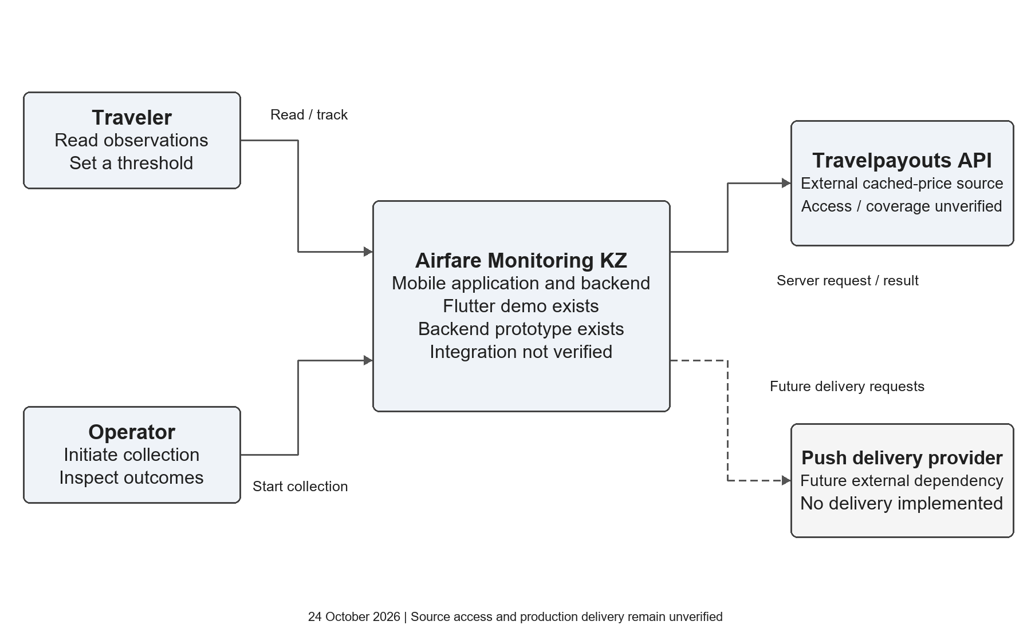
Figure 7.1 System context and external dependencies

7.2 Use cases
The traveler selects a route and departure date, reads history and freshness, inspects an assessment and manages a tracking threshold. The updated client implements date selection and persistent local rules. Receiving a qualifying notification remains planned and requires delivery evidence. Loading, empty, stale and error states are demonstrated. Operator authorization and real server integration still require implementation and verification.
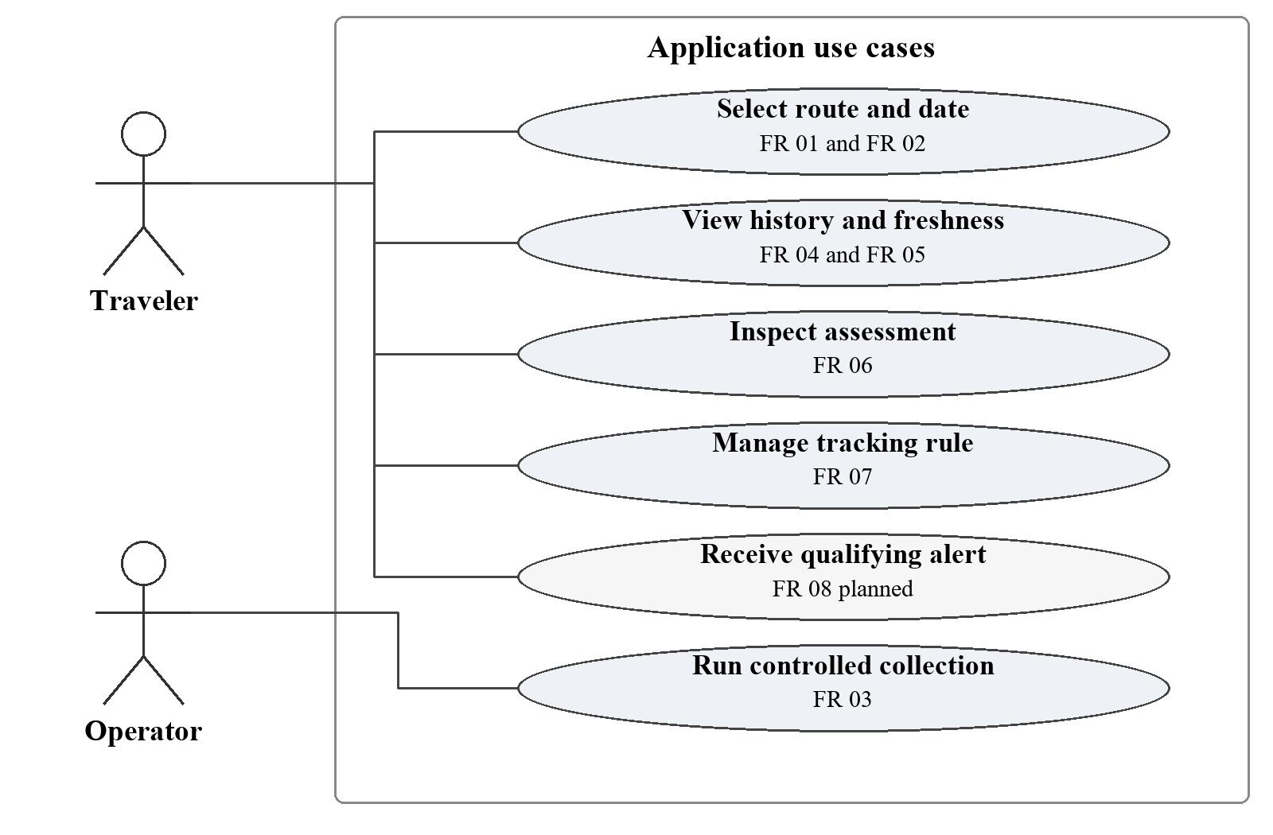
Figure 7.2 Main use cases and requirement identifiers

7.3 Component responsibilities
Solid arrows identify code dependencies; the dashed client connection identifies an experimental API path. FastAPI calls collection and analytics services and uses SQLAlchemy for persistence. These are modules in one backend, not independently deployed microservices. Default Flutter demo data do not pass through this pipeline.
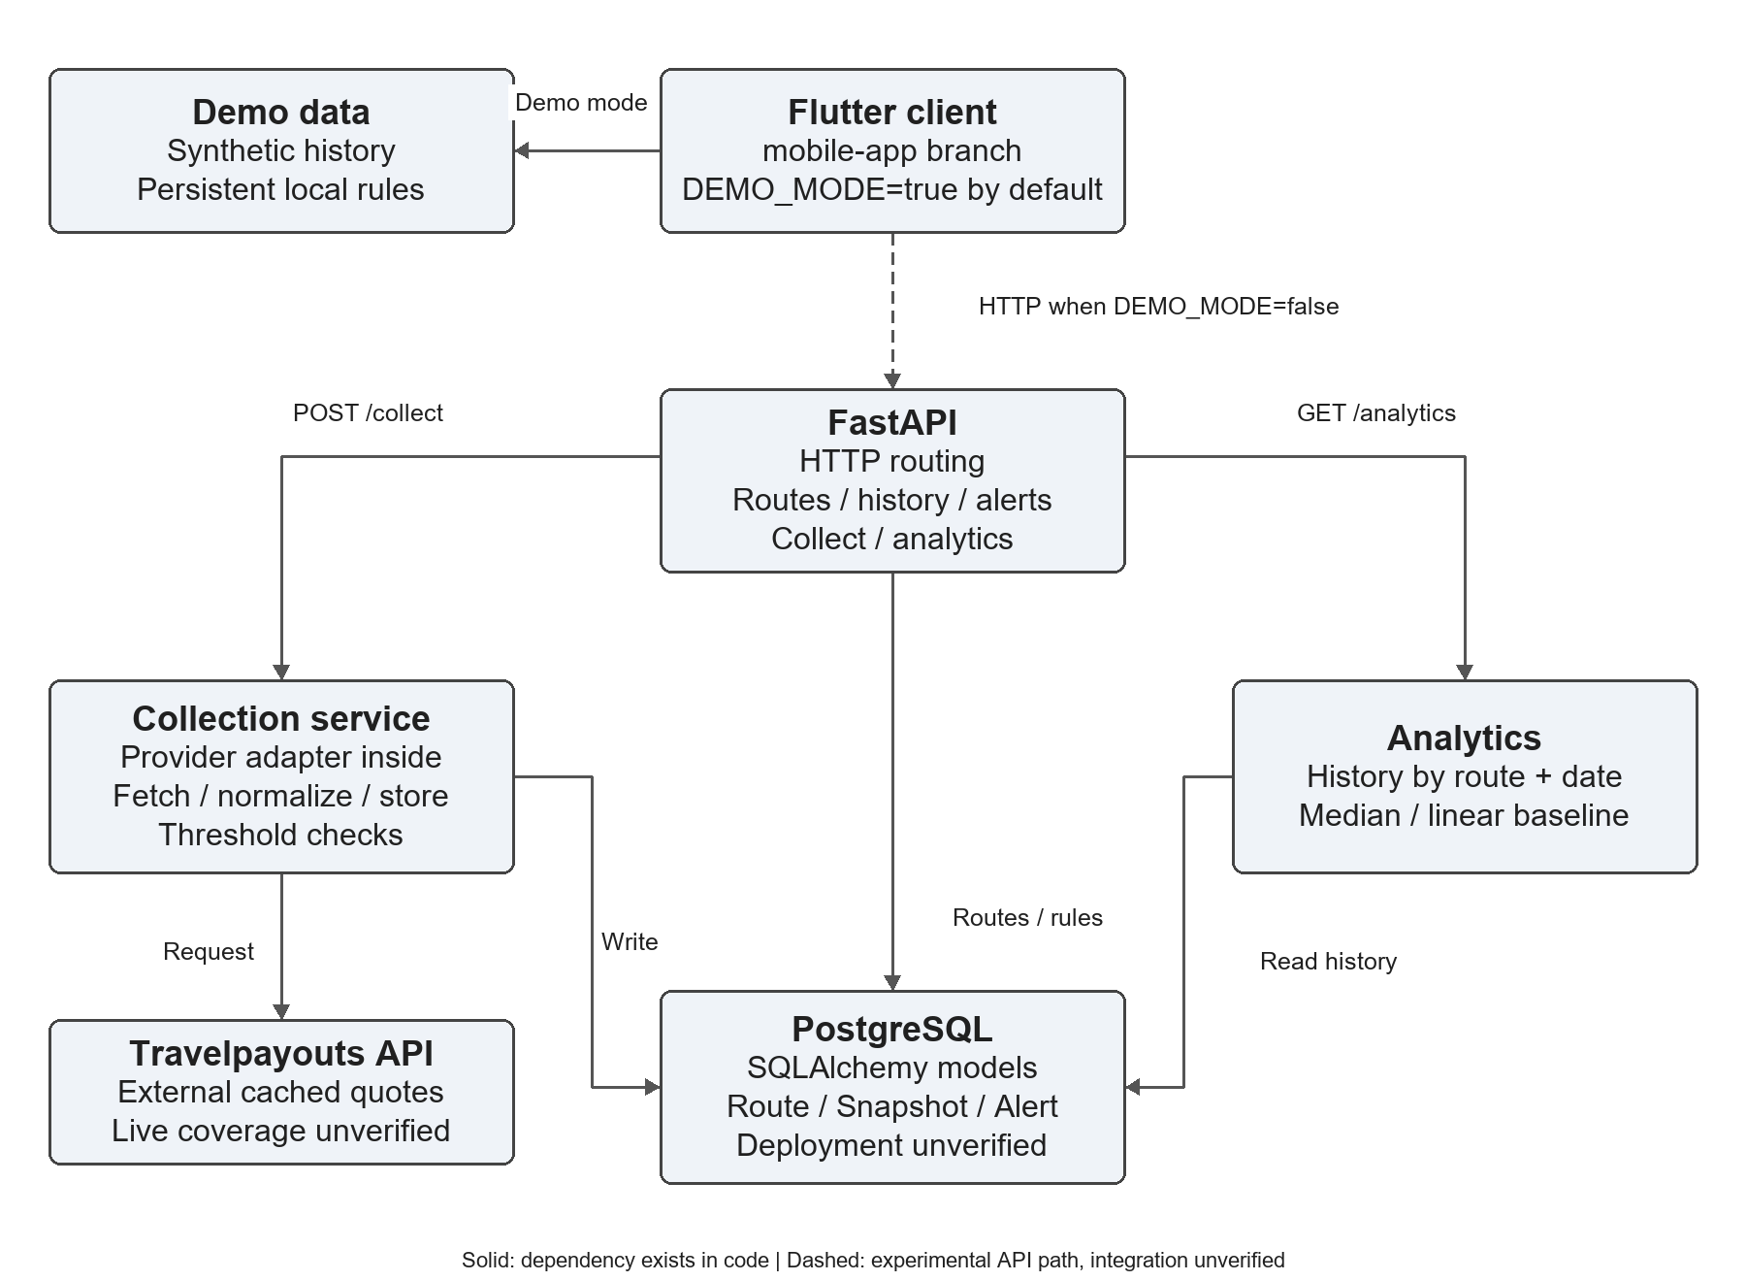
Figure 7.3 Current component dependencies and experimental client API path
Component | Responsibility | Current state
Flutter client and ApiService | Present routes, history, assessment and threshold feedback | In mobile-app; DEMO_MODE=true uses fixtures. HTTP methods exist for API mode; end-to-end integration remains unverified.
Demo fixtures and local preferences | Supply synthetic route/date history; persist date, favorites and rules | SharedPreferences on the device/browser, with demo/API scopes separated; no server alert creation.
FastAPI endpoints | Route HTTP requests, validate payloads and obtain a DB session | backend/app/main.py; calls collector and analytics functions, and queries/writes ORM models.
Collection service and provider adapter | Request cached quotes, normalize, add snapshots and check rules | services/collector.py; the adapter function is inside this service. Fallback and timestamp defects remain.
Analytics service | Read history for a route/departure and calculate an assessment | services/analytics.py; median and linear baseline, with no validated forecast accuracy.
SQLAlchemy and PostgreSQL | Persist routes, snapshots and alert rules | Models and Compose configuration exist; deployment was not verified in this review.
Scheduler | Select bounded repeated work | Planned; no scheduler service or persistent run queue exists in the inspected code.
Push adapter and provider | Attempt delivery and record outcomes | Planned; current threshold checks update fields without sending a push.

7.4 Data flow
The diagram below is the target behavior after correcting data trust. Run outcomes, provenance fields and real delivery still require implementation. The current and target execution paths are described separately.
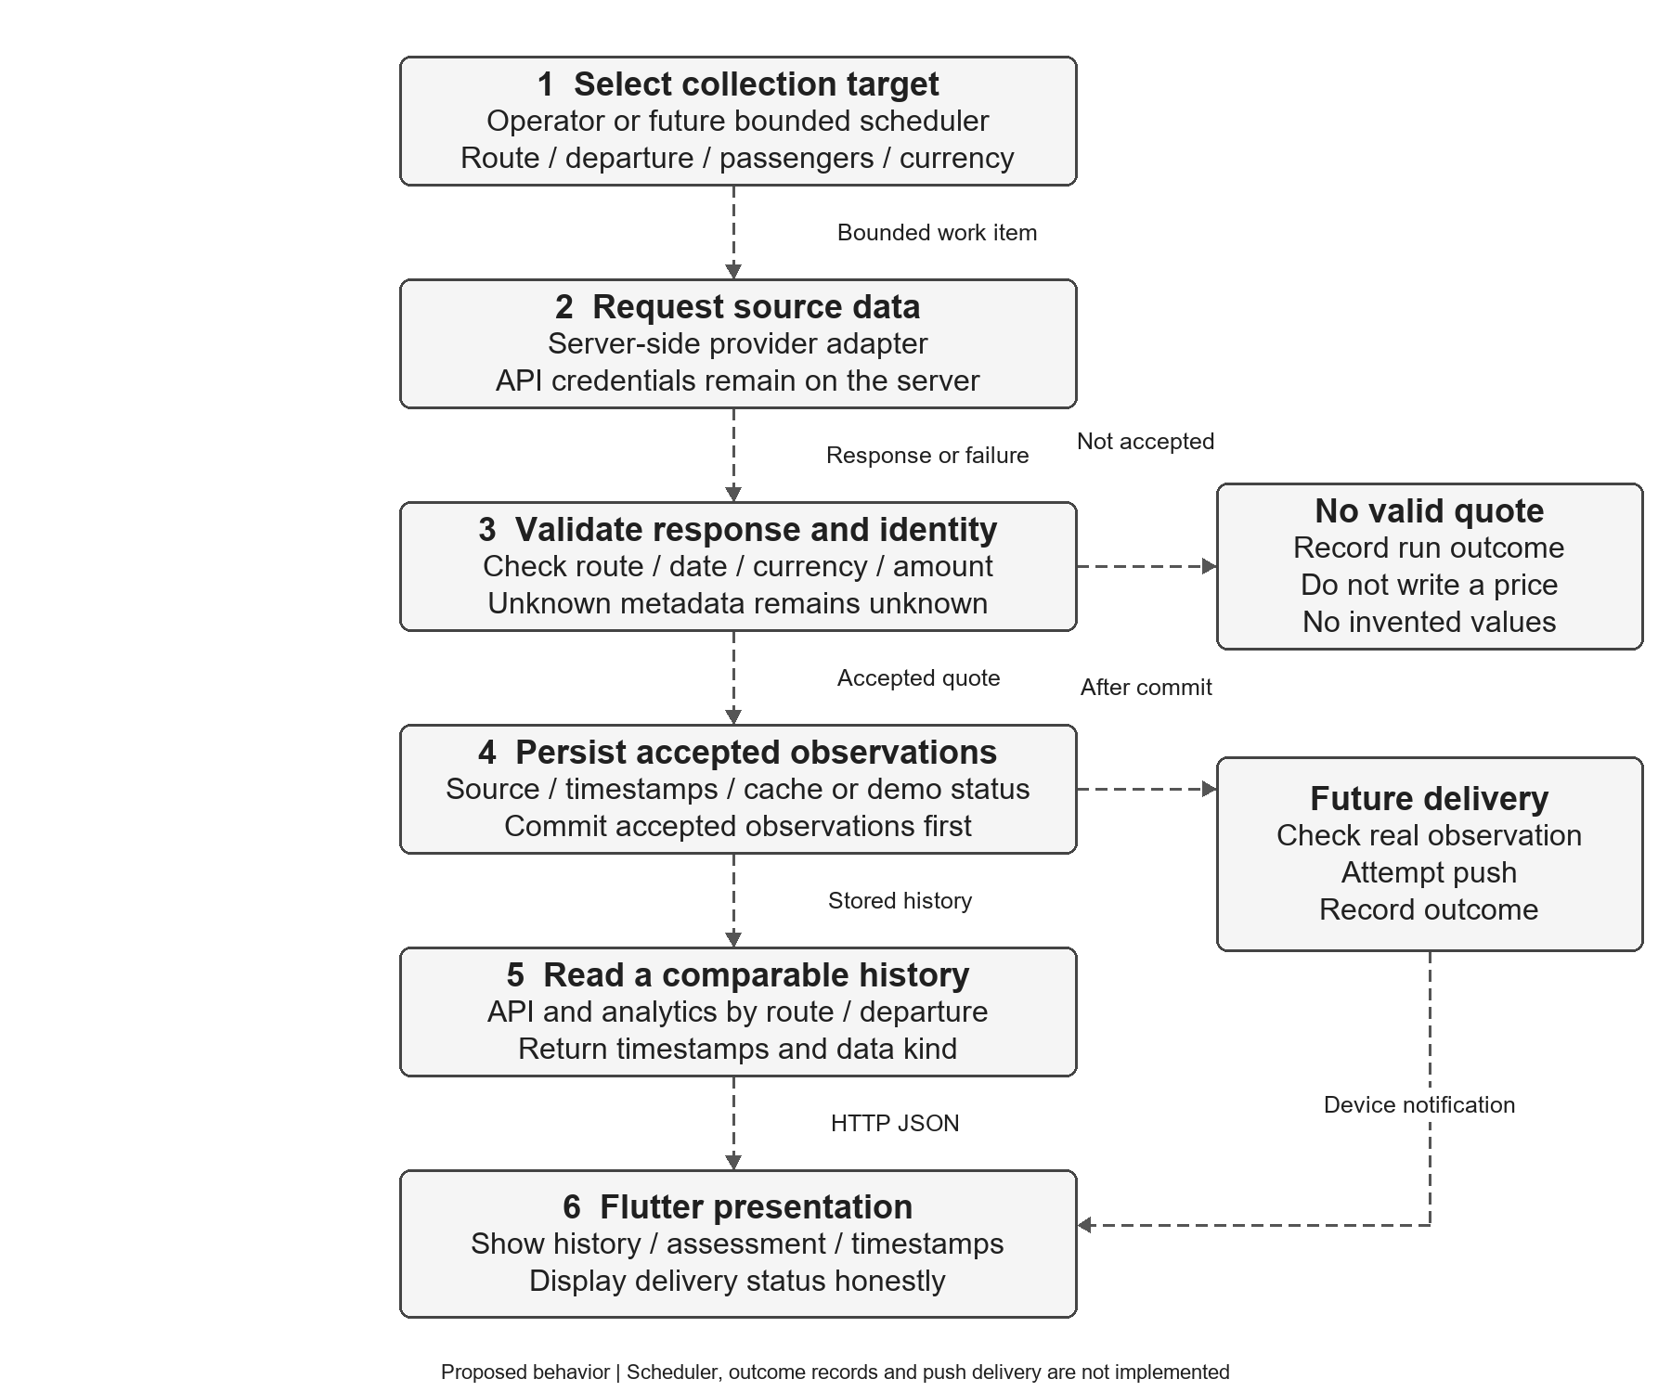
Figure 7.4 Target collection and delivery flow with explicit failure handling

7.4.1 Current execution
- Backend import creates ORM tables; startup seeds 12 candidate directions.
- POST /api/v1/collect synchronously calls the collector for all active routes and one date derived from days_ahead.
- The adapter calls Travelpayouts when configured. Missing data, missing credentials or request failure can produce a random fallback quote.
- The collector adds snapshots, changes qualifying alert state and commits. No push request is sent.
- Read endpoints query history or invoke analytics. Flutter's default demo bypasses these endpoints entirely.
This is the existing execution path, including its defects. It is not suitable evidence of trustworthy live observations.

7.4.2 Target collection and delivery
An operator or future bounded scheduler selects a route, departure date and comparison context. Server validation distinguishes accepted quotes, no results and failures. Failed or missing results create run outcomes, not prices. Store accepted observations with source identity, collection time, supplied source time and cache/demo status; retain unknown source times as unknown.
Read APIs and analytics use comparable histories grouped by route, departure and offer context. A future worker evaluates qualifying real observations, attempts push delivery and records outcomes separately; last_notified_at does not prove delivery.
The target flow requires code changes and migrations. Its outcome records, source/demo fields, scheduler and delivery log are not present in the current schema.

7.5 Current API contract
Verb | Path | Current behavior
GET | /health | Application status and version.
GET | /api/v1/routes | Active seeded directions.
POST | /api/v1/collect?days_ahead=7 | Collection or current simulation fallback. Horizon accepts 1–60 days; endpoint lacks operator authorization.
GET | /api/v1/routes/{id}/history | History ordered by collection time; only_fresh filter exists, departure-date filter is missing.
GET | /api/v1/routes/{id}/analytics | Departure-date-specific current quote, median and linear assessment; validated predictive performance absent.
POST | /api/v1/alerts | Creates a rule; unknown-route validation and actual notification delivery are incomplete.

7.6 Database entities and relationships
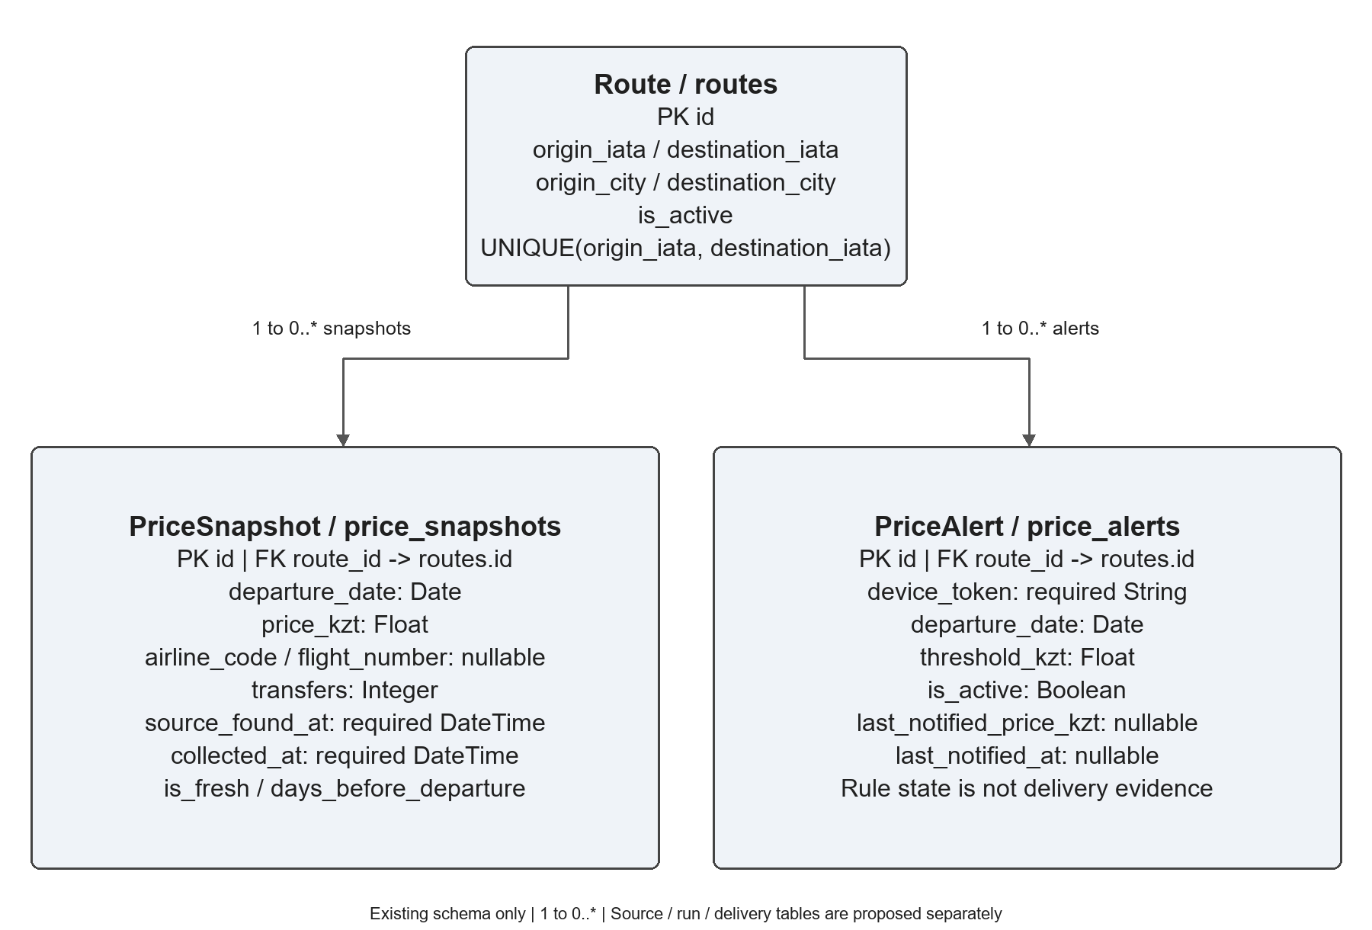
Figure 7.5 Existing ORM entities and one to many relationships
Entity | Purpose and constraints
Route / routes | Directional origin/destination pair with city names and activity flag. The pair is unique. It owns snapshots and alerts.
PriceSnapshot / price_snapshots | Observed amount, departure date and carrier/flight metadata with source/collection time, freshness flag and booking horizon. route_id references Route.
PriceAlert / price_alerts | Device token, route/date, threshold, activity and last-notified state. It records rule state, not verified delivery evidence.

7.7 Storage limitations and planned improvements
The ORM uses floating-point money and a required source timestamp. It lacks observation identity, source/demo/cache markers, collection outcomes and delivery logs. Proposed migrations introduce exact money, nullable unknown source time, provenance and separate delivery evidence. No migration is applied here. Keep provider credentials on the server.

8 UX and Prototype

8.1 Prototype scope and implementation
Flutter/Dart revision d14b0d8a provides the Web prototype on mobile-app. It supports twelve directional routes, a future-date selector, route/date-specific synthetic history, persistent local preferences and threshold management. Default demo mode labels generated data and makes no backend/provider requests. Flutter 3.47.5 and Dart 3.13.4 were checked; native builds and production integration remain unverified.

8.2 Route selection and persistent preferences
Search accepts city names or IATA codes. A calendar and 7/14/30-day shortcuts select future departure dates; invalid or past input is explained. Date, favorites and local rules persist in SharedPreferences, with demo/API storage scopes separated. The Russian interface shows an explicit demo banner. Browser reload verified restoration; this is not proof of native-device behavior.
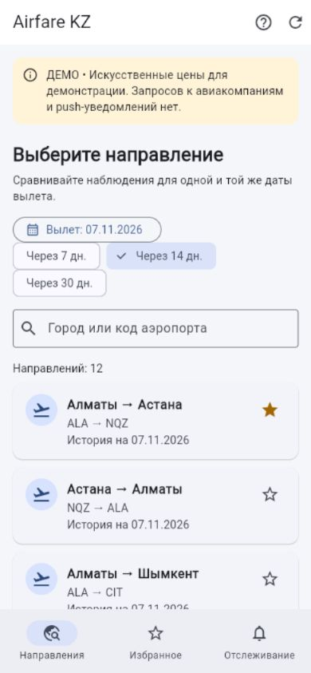
Figure 8.1 Flutter route search with departure date and demo labeling

8.3 History and descriptive assessment
The details screen presents the selected direction and departure date, collection time, source time when known, current synthetic minimum, prior-history median, chart and readable observations. Synthetic histories differ by route/date. The captured ALA to NQZ example for 7 November shows 19,449 KZT and a prior median of 21,153 KZT. The assessed point is excluded from the baseline; these values demonstrate calculations and are not market prices or a forecast.
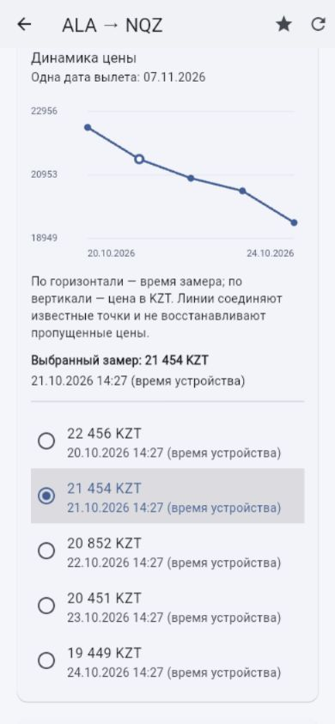
Figure 8.2 Date-specific synthetic history and prior observation selection

8.4 Persistent local tracking and validation
Thresholds use integer hundredths of KZT. Zero, negative, non-finite or malformed input is rejected. A rule is keyed by directional route and departure date; the tracking tab supports editing, deactivation, reactivation and deletion. Serialized preference writes prevent rapid changes from overwriting each other. Successful saving means a device-local rule, including in experimental API mode; no server alert or delivered push is claimed.

Figure 8.3 Local tracking rule restored after browser reload

8.5 States and accessibility checks
Demo scenarios expose normal, empty, error, stale and single-observation states, with loading during requests. Generation counters stop older responses replacing a newer date selection. Tests exercise a 390 by 844 layout and text scale 1.6; the chart also has readable observation rows. Screen-reader, keyboard and real-user checks remain outstanding, so accessibility conformance is not asserted. API failures remain errors; they do not silently fall back to demo prices.

8.6 Reproducibility and remaining client work
Switch to mobile-app, then run from the repository root. No source credential or database is required for demo mode.
cd mobile
flutter pub get
flutter --no-version-check run -d web-server --web-hostname=127.0.0.1 --web-port=8767 --dart-define=DEMO_MODE=true
Open http://127.0.0.1:8767/ and stop the process with Ctrl+C. Native wrappers/device checks, a verified real API read path, full offer inventory and push delivery remain further work. Flutter API-mode filtering is a client safeguard while the server departure-date contract is repaired.

9 Verification and Evaluation Plan
Owner: Bekbauly; reviewer: Dinmukhammed. Related issue: #14.

9.1 Purpose and acceptance rules
Verify the requirements through traceable evidence. A completed test run can contain failed acceptance checks. Use PASS for the tested condition, FAIL for a reproduced violation, PARTIAL for a limited layer, and NOT RUN for missing evidence. A mocked provider, SQLite check or Web demo does not establish live fare coverage, PostgreSQL deployment, native behavior or delivered push.
The detailed results and reproduction commands, backend JSON and Flutter evidence summary identify revisions and conditions. Preserve the evidence from failed checks when a later repair is verified.

9.2 Requirements and test matrix
Test | Requirements and expected behavior | Recorded status on 24 October
VT-01 | FR-01: seed twice; 12 unique directional routes, reverse direction distinct | PASS in disposable SQLite
VT-02 | FR-02/09: future date accepted, past/malformed rejected; invalid collection horizon rejected | PASS for Flutter input and backend horizon; backend alert past-date check fails under VT-08
VT-03 | FR-03/11, NFR-04: missing token, empty response, timeout and HTTP failure create no market quote | FAIL: all four return an unlabeled generated price; #20
VT-04 | FR-04: histories isolate route and departure date and sort observations | Backend FAIL: requested date ignored; Flutter mocked filtering PASS; #21
VT-05 | FR-05, NFR-01: preserve unknowns; equivalent instants agree; future source time flagged | Backend FAIL on three subchecks; Flutter metadata checks PASS; #20
VT-06 | FR-12: replay does not create an independent source observation | FAIL: two rows for one replayed quote; #21
VT-07 | FR-06: prior median excludes current; insufficient data explicit | Backend PARTIAL: empty case passes, prior median fails; Flutter prior median PASS; #21
VT-08 | FR-07: positive threshold and valid route/date; invalid input returns 4xx | Backend FAIL: missing route 500, past date 200; Flutter local rule validation PASS; #22
VT-09 | FR-08: logged delivery attempt, replay suppression and separate failure outcome | State-update suppression PASS only; real delivery NOT RUN and absent in code
VT-10 | FR-09/10/11: route/date flow, loading, empty/error/stale/single states, persistent local rules/favorites | PASS within Flutter Web/tests; native accessibility and real users NOT RUN
VT-11 | NFR-03/06: unauthorized collection rejected before work; finite request budget | FAIL: unauthenticated call writes 12 rows; authorized budget and secret-log audit NOT RUN; #22
VT-12 | NFR-02: exact money/currency persistence and invalid values rejected | Backend FAIL: normalizer accepts negative/NaN/infinity; decimal DB migration NOT RUN; client hundredths checks PASS; #20
VT-13 | NFR-04/05: reproducible setup, rollback and deployed storage/API readiness | PARTIAL: health, syntax, Web build and recorded environments; clean install/PostgreSQL/rollback NOT RUN
VT-14 | NFR-07: provisional history p95 <=2 s for 1,000 observations | Local PASS: p95 42.81 ms, 30 serial ASGI samples after 3 warmups; production acceptance NOT RUN

9.3 Executed verification
Backend revision 4c16b32647e9dc780eec368a4ce20f015986c539 was downloaded from GitHub and checked in an isolated Python 3.12.14 environment on Windows. Sixteen diagnostics completed: 6 PASS and 10 FAIL. These counts refer to individual subchecks, not fourteen fully accepted requirements. Nine Python files parsed successfully. HTTP providers were mocked, credentials were placeholders, and the temporary SQLite database enabled foreign keys. No external provider requests or attempted external connections occurred.
Flutter revision d14b0d8ae006b84e34b33470ba1b168849222057 passed 17 tests, static analysis and a release Web build using Flutter 3.47.5/Dart 3.13.4. Browser checks at 390 by 844 pixels verified route/date selection, history, failure states and restoration of date, favorites and local tracking after reload. A widget check also exercised text scale 1.6. This is limited evidence, not an accessibility compliance finding. The previous 23 October diagnostic review is historical evidence; the results above are the newer check.

9.4 Reproduction and defect handling
Run the committed offline runner against the exact backend revision using the documented dependencies and commands in VERIFICATION_RESULTS.md. It refuses external socket connections and writes a new JSON report. Expected backend failures are preserved as failures; exit code zero means the diagnostic run completed, not that acceptance passed. Inspect the summary.
Fix priorities are #20 source integrity and exact-money validation, #22 collection access and alert validation, then #21 history/identity/baseline consistency. Bekbauly implements backend repairs; Dinmukhammed checks the client contract. Rerun affected tests after each repair and retain the original evidence. Both students review before changing a task to Done. Do not trigger live collection while these gates fail.

9.5 Evaluation protocol
After data-trust and access repairs, approve a finite pilot budget and a source-specific route/date list. Record collection outcome, source/cache status, request count, collection time, supplied source time, raw-response hash and distinct observation identity. Repeat fixed departure dates on later days; rolling horizons alone do not establish one flight's price trajectory. Missing results do not prove that no flight exists.
For a future price experiment, predict the next daily observation for a fixed route, departure and comparable context. Compare last observed price and prior median with the candidate on the same chronological cases. Fit features and baselines using earlier observations only; exclude synthetic data and replayed cached quotes from independent examples. Report MAE in KZT, sample count, coverage, span, horizons and missingness. Training and measured accuracy remain deferred until real distinct history supports a meaningful split. No minimum number of records alone guarantees suitability.
For usability, recruit 3–5 real participants and use a consistent route/date → history → local rule script. Record completion, errors, elapsed time and understanding of demo/freshness labels; anonymize answers and summarize changes. No participants or supervisor feedback have been supplied, so this study is NOT RUN.

9.6 Outstanding acceptance gates
Remaining checks cover clean setup, PostgreSQL migration/rollback, source limits and permissions, fixed-date live coverage, native Android/iOS behavior, screen-reader and keyboard use, logged push delivery and retry/deduplication failures, and user/supervisor review. Gate the live-data pilot on #20/#21/#22. Gate public deployment on access control and configuration hygiene. Gate notification claims on actual delivery evidence. The checkpoint can present the verified demo and honest limitations while these MVP items remain open.

9.7 Recorded backend outcomes
The table preserves the actual outcomes: six passes and ten failures. A PASS concerns only the tested local condition. Detailed results and runner include hashes, environment, expectations and actual results. These checks do not establish public-deployment, live-collection or prediction acceptance.
Check | Outcome | Observed condition
VT-01 | PASS | Unique idempotent route seed
VT-13a | PASS | Health endpoint
VT-07a | PASS | Empty analytics
VT-02a | PASS | Collection horizon validation
VT-03 | FAIL | Missing and failed provider responses
VT-05a | FAIL | Departure is not source observation time
VT-05b | FAIL | Equivalent UTC and offset timestamps
VT-05c | FAIL | Unknown and future source metadata
VT-11 | FAIL | Operator authorization
VT-08 | FAIL | Alert input validation
VT-06 | FAIL | Replayed source observation
VT-09a | PASS | Repeated threshold state update suppression
VT-04 | FAIL | History departure-date isolation
VT-07b | FAIL | Prior median excludes current
VT-12a | FAIL | Reject invalid quote money
VT-14-local | PASS | Local history latency characterization

10 Project Management and Risks
Baseline: 24 October 2026; technical evidence recorded, student/supervisor agreement pending.

10.1 Responsibilities and coordination
Dinmukhammed (@Swoksaar0) owns requirements, user discussions, UX, Flutter, local tracking and future notification presentation. Bekbauly (@Bekbauly) owns provider access, backend, data storage and analytics. Backend commits already contain Bekbauly's implementation; the review identifies repairs to that work, not an absence of contribution. Both review the API contract, research, integration and submission materials. Ownership and an assistant-prepared draft are not proof that an individual completed reading or review.
Use a short daily issue update during active work: evidence produced, next action, blocker and requested decision. Review risks after every source/API change and before collection or submission. Do not send participant or supervisor messages automatically; the students arrange those discussions themselves.

10.2 Checkpoint status and remaining work
Work package | Evidence or current state | Owner and next gate
Proposal, requirements, comparisons and diagrams; #1/#3/#4/#5/#11/#12 | Drafts available in documentation PR #18; acceptance review pending | Both: cross-check claims and agree scope
Literature; #7/#13 | 14 sources, 10 scholarly; synthesis available, reading and peer review unconfirmed | Both: review the allocated sources
Flutter prototype; #6 | Revision d14b0d8a; 17 passing tests, Web build and browser evidence | Dinmukhammed; Bekbauly reviews scenarios
Verification; #14 | Plan plus executed offline results, 6 passed and 10 failed backend diagnostics | Bekbauly; Dinmukhammed reviews evidence
Management; #8 | Owners, staged milestones, risks and linked defect issues prepared | Dinmukhammed; Bekbauly reviews; board fields/access unverified
User discussions; #2 | No real responses supplied | Dinmukhammed: conduct and record 3–5 discussions
Supervisor review; #15 | No substantive comments or approval supplied | Bekbauly: arrange consultation and record real decisions
Final submission; #16 | No agreed submission tag | Both: review package, access and remaining evidence

Original issue targets were 23–24 October. Materials still awaiting human evidence or review are not retroactively complete. Keep original deadlines in issue history and record revised estimates separately. The checkpoint requires a justified plan and prototype; the entire production service is not claimed complete.

10.3 Next milestones and dependencies
Stage | Proposed target or trigger | Owner | Exit condition
M0 Checkpoint review | 24 October; human availability determines completion | Both | Reviewed documents/demo, real missing evidence identified, accessible links
M1 Data trust and collection control | Proposed 25 October; agree with team | Bekbauly | #20 and #22 repaired, affected checks pass and peer review recorded
M2 Comparable history and client contract | Proposed 26 October, after M1 | Bekbauly with Dinmukhammed | #21 passes, route/date fixtures agree, failures remain explicit
M3 Controlled source pilot | After M1/M2, source permission and quota approval | Bekbauly | Request budget recorded; fixed dates observed on multiple days with provenance
M4 Integrated mobile and delivery | After stable API and native setup | Dinmukhammed with Bekbauly | Real API read path and native persistence checked; delivery attempts/outcomes verified
M5 Analysis and final evaluation | When sufficient distinct real history exists | Both | Chronological baseline comparison, usability results and limitations reported

These dates are estimates prepared for agreement, not promises attributed to either student. If a prerequisite fails, update the dependent estimate and preserve the blocker. Do not rush an unbounded source poll to recover schedule.

10.4 Risk register and response actions
Score likelihood L and impact I from 1 to 3; risk score is L × I. Scores 6–9 are high, 3–4 medium, 1–2 low. These are qualitative planning judgments. For an observed defect, L=3 means it is already happening. Residual risk stays open until the stated evidence exists.
Risk and score | Trigger or current evidence | Response and closure evidence | Owner
R1 Invalid observations; L3 I3 = 9 high | Generated prices, false source times and accepted invalid amounts reproduced | #20: explicit outcomes, UTC/unknown validation, demo isolation, exact money; affected tests pass | Bekbauly
R2 Uncontrolled collection; L3 I3 = 9 high | Unauthenticated collect succeeds; #22 | Keep collection private; authorize before work and enforce finite budget; denied requests make zero provider calls | Bekbauly
R3 Misleading history; L3 I3 = 9 high | Date mixing, replayed rows and current-inclusive median; #21 | Route/date/context grouping, identity and prior-only baseline; fixture regression passes | Bekbauly
R4 Missing source access/coverage; L2 I3 = 6 high | Quota/restriction, missing route/date result or stale cache during future pilot | Stop at configured budget; log errors, retain unknowns; pilot proves measured scope, no completeness claim | Bekbauly
R5 Insufficient real history; L3 I2 = 6 high | No trusted multi-day dataset verified | Accumulate fixed-date cohorts after repairs; defer ML when evidence is insufficient; report descriptive results | Bekbauly
R6 Mobile/server mismatch; L2 I2 = 4 medium | Client tests pass while backend contract fails | Shared fixtures and integration check after #21; native setup and persistence checked separately | Swoksaar0
R7 False notification expectation; L3 I2 = 6 high | Local rules and last-notified fields exist; push delivery absent | Keep local-only label; add delivery adapter/log and failure/replay checks before notification claims | Swoksaar0 with Bekbauly
R8 Missing human evidence; L3 I3 = 9 high | Interviews, peer review and supervisor feedback outstanding | Students arrange real sessions; record anonymized findings and actual comments; preserve unresolved decisions | Both
R9 Unverifiable release/access; L2 I2 = 4 medium | Board access, submission tag and clean setup unverified | Check links/permissions and clean setup; agree exact reviewed revision, then tag once | Both

10.5 Task workflow and change control
Use existing issue ownership and acceptance criteria. Statuses are Planned → In progress → In review → Done; blocked items include a named dependency. The document package and prototype are ready for student review, not automatically Done. Three reproduced defect tasks, #20–#22, are open and assigned to Bekbauly with priorities and proposed dates in their descriptions.
For any scope, source or schema change, record the reason, affected requirement/test, owner, review and effect on the next milestone. Keep backend fixes on backend, mobile changes on mobile-app and report changes on pre-defense-documents. Review each diff before integration; branches still share a common Git baseline.
GitHub Projects is the team's selected alternative tracker. Issue descriptions hold traceable owner/priority/date information, but that does not set structured Project fields. Board membership, columns, edit permissions and the supervisor's access have not been verified here. Both students must check the board before claiming issue #8 complete. The reported permission to use an analogue should be retained when available.

10.6 Submission and completion gate
Before submission, both students check proposal, source analysis, comparisons, requirements, editable diagrams/exports, Flutter walkthrough, verification outcomes, risks, real human feedback and links. Link unresolved defects rather than concealing them. Agree what is submitted and record the reviewers; only then create the exact pre-defense-1 revision/tag. Do not move a submitted tag. No supervisor approval, completed user study, production deployment or final acceptance is asserted by this package.

10.7 Current issue ownership
The GitHub snapshot contains the sixteen original assigned tasks plus three open backend defect tasks, all open. The table reports issue state, not the GitHub Projects column, which was not independently inspected for this report. Draft files and PRs do not by themselves satisfy acceptance criteria or peer review.
Issue | Task | Assigned account
1 | Define the project proposal and scope | Swoksaar0
2 | Conduct discussions with potential users | Swoksaar0
3 | Compare existing airfare applications and services | Swoksaar0
4 | Specify functional and non-functional requirements | Swoksaar0
5 | Create the Use Case Diagram | Swoksaar0
6 | Create a clickable mobile application prototype | Swoksaar0
7 | Review literature on mobile applications and data visualization | Swoksaar0
8 | Organize the project plan and GitHub Projects board | Swoksaar0
9 | Prepare the README and repository structure | Bekbauly
10 | Document the existing SCAT parser and data storage | Bekbauly
11 | Compare technologies and justify the selected stack | Bekbauly
12 | Create the System Context and Component Diagrams | Bekbauly
13 | Review literature on data collection and airfare analysis | Bekbauly
14 | Prepare the verification and evaluation plan | Bekbauly
15 | Obtain and document supervisor feedback | Bekbauly
16 | Prepare the pre-defense submission | Bekbauly
20 | Prevent fabricated market prices and correct source-time validation | Bekbauly
21 | Isolate departure-date history and deduplicate source observations | Bekbauly
22 | Protect collection and validate alert route and departure date | Bekbauly

Issue 10 still refers to an existing SCAT parser. The current published backend uses Travelpayouts request scaffolding and does not contain that parser integration. The team should reconcile the issue scope with the actual repository before marking it complete.

10.8 Branches and review scopes
Branch | Purpose | Snapshot commit
backend | Bekbauly server/data workspace; currently main baseline | 4c16b32647e9
main | Shared integration baseline | 4c16b32647e9
mobile-app | Flutter-only additions relative to main; draft PR 19 | d14b0d8ae006
pre-defense-documents | Docs and root README changes; draft PR 18 | ce8977e2afe1

PR 18 changes documentation; PR 19 changes mobile files. Both retain the shared backend baseline. Main is unchanged. Individual reading and peer review remain unverified.

11 Supervisor Feedback

11.1 Feedback received
No substantive supervisor comments or approval record have been supplied at the reporting date. The repository contains an unfilled feedback protocol. This section therefore records the review agenda and the evidence still needed; it does not attribute statements or approval to the supervisor.

11.2 Proposed review agenda
Review topic | Decision to request
Scope and feasibility | Agree the final 10–15 directions, first mobile target and the boundary between cached minima and full fare inventory.
Data access and quality | Review a bounded provider pilot and require real/demo separation, valid source-time semantics and explicit missing outcomes.
Research and evaluation | Confirm the prediction target, baseline, chronological evaluation and conditions under which ML is meaningful.
Prototype and requirements | Review the updated date selection, persistent local tracking, error states and limitations; agree priorities for integration, notifications and user findings.
Checkpoint acceptance | Review individual contributions, source analysis, diagrams, open defects and the exact revision for submission.

11.3 Recording decisions and changes
After consultation, record the actual date, substantive comment, response, responsible student and resulting change. Distinguish unresolved requests from accepted decisions. Update requirements, diagrams and tasks together; retain the genuine review record.

11.4 Overall checkpoint status
The project has research and comparison drafts, testable requirements, architecture diagrams, a Flutter Web demonstration and a verification plan. User discussions, student peer review and supervisor feedback remain pending. Engineering priorities are trustworthy observations, route/date-specific history and controlled integration. A live airfare service and useful forecasting performance have not yet been demonstrated.

Appendix A Repository evidence
Repository resources below locate the implementation and research package described in this report. Snapshot commits identify the reviewed source state; branch links may change as work continues.
Repository https://github.com/Swoksaar0/airfare-monitoring-kz
Project board https://github.com/users/Swoksaar0/projects/2/views/1
Documentation PR 18 https://github.com/Swoksaar0/airfare-monitoring-kz/pull/18
Flutter PR 19 https://github.com/Swoksaar0/airfare-monitoring-kz/pull/19
Literature review https://github.com/Swoksaar0/airfare-monitoring-kz/blob/pre-defense-documents/docs/LITERATURE_REVIEW.md
Flutter launch and verification notes https://github.com/Swoksaar0/airfare-monitoring-kz/blob/mobile-app/mobile/README.md

A.1 Source snapshots
backend 4c16b32647e9dc780eec368a4ce20f015986c539
main 4c16b32647e9dc780eec368a4ce20f015986c539
mobile-app d14b0d8ae006b84e34b33470ba1b168849222057
pre-defense-documents ce8977e2afe1e7009047e4b19c04d2840d74b672

A.2 Evidence boundaries
The report date is 24 October 2026. The latest recorded Flutter and isolated backend checks were performed on 24 October 2026 under the conditions stated in Section 9; earlier 23 October checks remain historical evidence. Branch reorganization was checked structurally rather than by repeating runtime tests. Source-backed service comparisons and literature findings are distinguished from original user research, live-provider validation and measured application performance. Those missing results remain explicit.

