CMM词法分析器

1. 背景

完成人:袁浩

学号:2013302580115

班级:国际软件学院软件工程3班

提交日期:2015-09-30

完成CMM词法分析器

1. 功能实现描述
2. 综述

主要实现词法分析的类是:

com.yuanhonglong.analysis.lexical_analysis.LexicalAnalysis

主要的函数是startAnalysis,此函数模拟的是有穷自动机(不完全是有穷自动机),还有numbers(),symbols(),keywordAndIdentifier()等函数,分别用于识别数字,符号,关键字和标识符,至于注释和空白符则在startAnalysis()函数中进行分析.

1. 辅助函数

isKeyword()判断是否关键字,isSymbol()判断字符是否是特殊符号,isLetter()判断字符是否是字母,isNumber()判断字符是否是数字

1. 数据结构

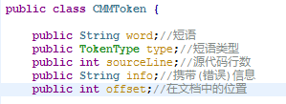

CMMToken存储的是分词结果,其中还携带了代码行数和短语在文档中的位置等信息,是给调试做准备的.

1. 特殊符号和关键字表

**public static final char** SKIP_SPACE = ' ';  
**public static final char** SKIP_TAB = '**\t**';  
**public static final char** SKIP_RETURN = '**\r**';  
**public static final char** SKIP_NEW_LINE = '**\n**';  
**public static final char** UNDER_LINE = '_';  
//public static final String SKIP_LINE_COMMENT = "//";  
//public static final String SKIP_COMMENT_START = "/*";  
**public static final String** SKIP_COMMENT_END = "*/";  
//public static final String DECIMAL_NUMBER =;  
//public static final String REAL_NUMBER =;  
**public static final String** TRUE_KEYWORD = "true";  
**public static final String** FALSE_KEYWORD = "false";  
**public static final String** REAL_KEYWORD = "real";  
**public static final String** INT_KEYWORD = "int";  
**public static final String** BOOLEAN_KEYWORD = "boolean";  
**public static final String** VOID_KEYWORD = "void";  
**public static final String** IF_KEYWORD = "if";  
**public static final String** ELSE_KEYWORD = "else";  
**public static final String** READ_KEYWORD = "read";  
**public static final String** WRITE_KEYWORD = "write";  
**public static final String** WHILE_KEYWORD = "while";  
**public static final String** FOR_KEYWORD = "for";  
**public static final String** BREAK_KEYWORD = "break";  
**public static final String** CONTINUE_KEYWORD = "continue";  
**public static final String** RETURN_KEYWORD = "return";  
//public static final String IDENTIFIER = ;  
**public static final char** LEFT_SMALL_BRACKET = '(';  
**public static final char** RIGHT_SMALL_BRACKET = ')';  
**public static final char** LEFT_LARGE_BRACKET = '{';  
**public static final char** RIGHT_LARGE_BRACKET = '}';  
**public static final char** LEFT_MIDDLE_BRACKET = '[';  
**public static final char** RIGHT_MIDDLE_BRACKET = ']';  
**public static final char** SEMICOLON = ';';  
**public static final char** COMMA = ',';  
**public static final char** DOT = '.';  
**public static final char** ASSIGN = '=';  
**public static final char** GREATER_THAN = '>';  
**public static final char** LESS_THAN = '<';  
**public static final char** BANG = '!';  
**public static final char** TILDE = '~';  
**public static final String** DOUBEL_EQUAL = "==";  
**public static final String** LESS_EQUAL = "<=";  
**public static final String** GREATER_EQUAL = ">=";  
**public static final String** NOT_EQUAL = "!=";  
**public static final String** DOUBLE_OR = "||";  
**public static final String** DOUBLE_AND = "&&";  
**public static final String** INCREMENT = "++";  
**public static final String** DECREMENT = "--";  
**public static final char** PLUS = '+';  
**public static final char** MINUS = '-';  
**public static final char** STAR = '*';  
**public static final char** SLASH = '/';  
**public static final char** AND = '&';  
**public static final char** OR = '|';  
**public static final char** XOR = '^';  
**public static final char** PERCENT = '%';  
**public static final String** LEFT_SHIFT = "<<";  
**public static final String** RIGHT_SHIFT = ">>";  
**public static final String** PLUS_ASSIGN = "+=";  
**public static final String** MINUS_ASSIGN = "-=";  
**public static final String** STAR_ASSIGN = "*=";  
**public static final String** SLASH_ASSIGN = "/=";  
**public static final String** AND_ASSIGN = "&=";  
**public static final String** OR_ASSIGN = "|=";  
**public static final String** XOR_ASSIGN = "^=";  
**public static final String** PERCENT_ASSIGN = "%=";  
**public static final String** LEFT_SHIFT_ASSIGN = "<<=";  
**public static final String** RIGHT_SHIFT_ASSIGN = ">>=";

1. 种类码表

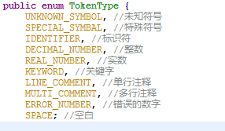

定义在TokenType类中

1. 使用说明

本程序提供的是可执行的.jar包,需要使用JDK7及以上版本的Java虚拟机才能运行.

1. 参考资料

<<编译原理及实践>>

1. 运行说明

词法分析快捷键Ctrl+L,或者使用菜单(分析->词法分析)

本程序不但可以在界面中显示分词结果,还可以根据分词结果对源代码进行高亮处理.

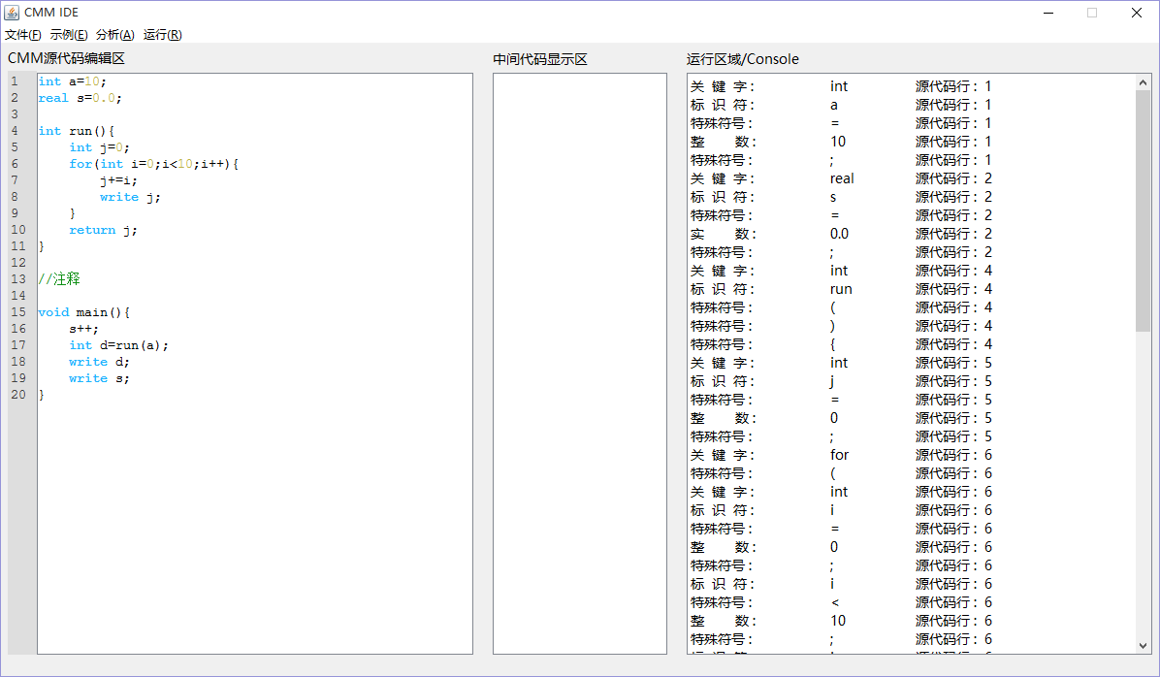

中间代码显示区是给语法分析和运行调试预留的,现在还没有内容

1. 测试数据

在tests文件夹下

正确的和错误的CMM文件都提供了四个,以下是部分截图:

正确:

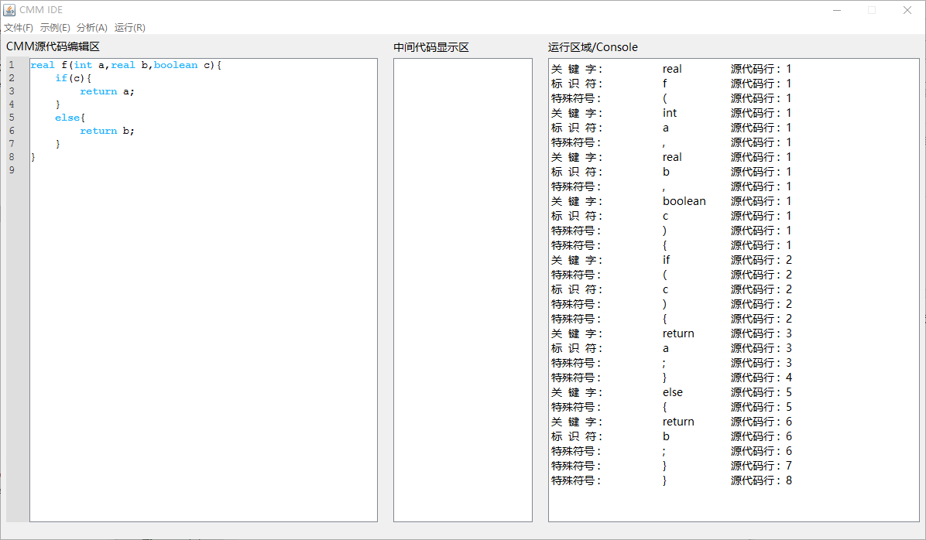

错误:

