

**Weather Forecast App – Prototype 3**

**Submitted by:**

**Name:** Swornim Sanjel

**Student ID:** 2501430

**Email:** np03cs4a240023@heraldcollege.edu.np

**Module Details:**

**Module:** Internet Software Architecture

**Module Code:** 4CS017

**Module Leader:** Bishal Khadka

**Group:** L4C616

My final weather forecast app is designed to enhance the user-experience by fetching data from multiple resources. The app fetches the weather data from local storage. If it’s not available there, it searches in the MySQL database and at last fetches from the API if data is not available. Still, there are many strengths and weaknesses in the app’s architecture.

**Strengths:**

To enhance the user-experience and to reduce the unnecessary API calls, the app is designed in such a way that the weather data of the searched city is fetched from the local storage at first and the data are also stored in the local storage. If the data is not available in the local storage, data is fetched from the database. Lastly, it fetches from OpenWeatherMap API if data is found anywhere. The app still fetches the weather data even if the user is offline by retrieving the data from local storage which improves the overall experience. The data are also stored in the database if the data is older than 2 hours. Data are also stored dynamically without the need of page refreshing. If the data request from API is failed, try-catch block is used to handle the errors efficiently. To make the website appealing, details like weather icons, temperature, pressure, humidity and weather descriptions are used.

**Weaknesses:**

When an error occurs, the app only displays “Data could not be fetched due to an error”. To improve the overall experience, informative error messages like “City not available” or “Connection Error” could be displayed to the user. If the website is busy or if it’s taking time to fetch the weather data, loading indicator or spinner is not used which makes the website less responsive. Also, there is a risk of data being steal or misused as the OpenWeatherMap’s API key is directly used in our code. There is no input validation used so if the user enters invalid characters, numbers or symbols, error occurs while fetching data. We have used local storage to store our data but no expiry time is set so outdated weather data could be shown. The app shows temperature in Celsius by default so we could improve it by adding conversion between Celsius and Fahrenheit, light mode and dark mode options, favourite cities options.

**YouTube link:**

<https://youtu.be/Bi4BNCqqaMU>

**Website link:**

<http://swornimsanjelprototype2.free.nf/prototype2/swornim_sanjel_2501430.html?i=2>

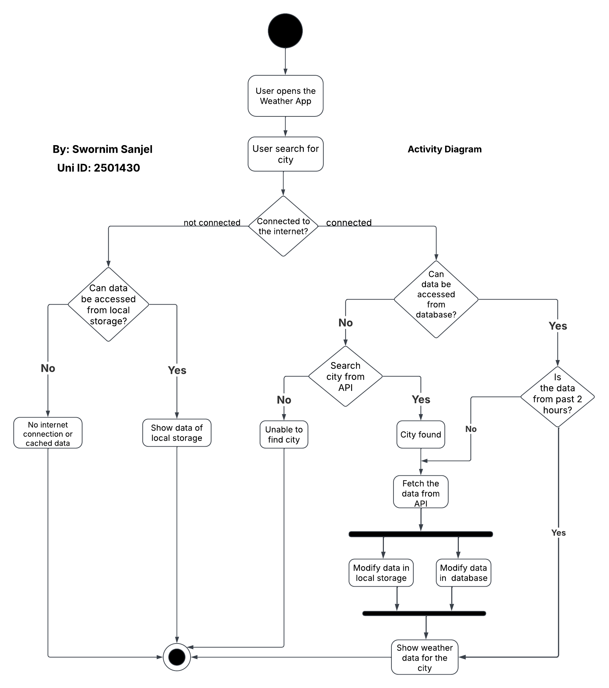

**Activity Diagram:**

**Sequence Diagram:**

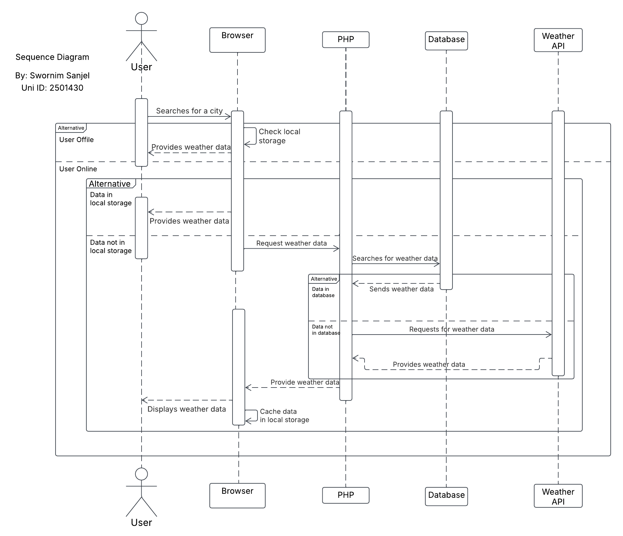

**Deployment Diagram:**

