

System Design Document

<Joy’s Toys>

<Seth White>

CSC-289 Programming Capstone Project

Guilford Technical Community College

Professor Scott Ilkenhons, MS

|  |  |
| --- | --- |
| Document ID | SYSTEM DESIGN-v0.1 |
| Version Number | 0.1 |
| Issue Date | Friday, November 4, 2022 |
| Classification | Private |

**Table of Contents**

List of Tables 3

List of Figures 4

1 Introduction 5

1.1 Purpose of Document 5

1.2 Acronyms and Abbreviations 5

2 SWOT Analysis 5

2.1 5

3 Database Design 5

4 Application Detailed Design 5

5 External Interface Design 5

5.1 Interface Architecture 5

5.2 Interface Detailed Design 5

6 Network and Physical Architecture Design Overview 6

6.1 Background Information 6

6.2 System Evolution Description 6

7 Training Plan 6

# List of Tables

2.1 SWOT Analysis

# List of Figures

3 Database Design

6.1 System Evolution Description

# Introduction

This is the Software Design Document for the development of the Web/Mobile Application for Joy’s Toys. Refer to this document for the list of concerns that will be/have been addressed.

## Purpose of Document

This SDD will identify opportunities that our application will address for the business *Joy’s Toys.* Throughout the development process this document will serve as a source of guidance. This document divides itself into a SWOT Analysis, Database Design, Application/Website Detailed Design, External Interface Design, an overview of Network and Physical Architecture Design, and a Training Plan.

The SWOT Analysis identifies the Strengths, Weaknesses, Opportunities, and Threats of our application.

The Database Design provides an abstract overview of our database.

The Application/Website Detailed Design will contain an abstract overview/layout of the design of the application.

The External Interface Design section will describe the architecture and design of the External Interface.

The overview of the Network and Physical Architecture Design will address the hardware requirements and network design and set up for this application.

Finally, the Training Plan will include a structured plan to train employees on how to use this system. Training will be broken down into sessions that employees will attend.

The system name is Joy’s Toys. The app will be identifiable through key features of Inventory Tracking, Customer Account creation and management as well as access for customers to product availability, Organization for Employees, eCommerce, and a system to access and modify financial data for specified employees.

## Acronyms and Abbreviations

|  |  |
| --- | --- |
| GUI | Graphical User Interface |
| SDD | System Design Document |
| ERD | Entity Relationship Diagram |
| APP | Web/Mobile Application |

# SWOT Analysis

|  |  |
| --- | --- |
| Strengths   * Good reputation among local community * Familiarity with customer base | Weaknesses   * Organization/Structure * Tracking * Accessibility for customers and employees |
| Opportunities   * Inventory tracking * eCommerce(selling, buying, etc) * Daily Balancing(reconciling credits and debits) * Payroll * Accounts Receivable * Accounts Payable * Order forms * Customer receipt generator * Customer Request form * New Customers * Memoization for employees * Customer Accounts (online accounts, buying history, etc) | Threats   * Other online competitors * Supplier shortages/lack of storage space * Losing employees to other businesses |

# Database Design

*Entity Relationship Diagram*

*this design is outdated and has been changed in miro

This ERD details the tables and illustrates the relationships between these tables. This will be the overall organization of Joy’s Toys database thus far.

Customers can have multiple Orders, but only one Customer per Order. Orders may also contain many Products, and many Products can be in many Orders. Many Products can be in one Category, but only one Category per Product. Finally, one Employee may have many Job Roles, but one Job Role may only be assigned one Employee.

# Application/Website Detailed Design

The application will follow the Client-Server Architecture. The Server will manage the database and expose the web APIs for which the Clients will then talk to. The Client being the web application and the mobile app.

# External Interface Design

## Interface Architecture

<Describe the interface architecture>

## Interface Detailed Design

<Describe the interface detailed design>

# Network and Physical Architecture Design Overview

## Background Information

Currently, Joy’s Toys do not have any computers in the building, as well as no app that customers/employees can access and make purchases, changes, or track history with. We are attempting to build an app that will do the aforementioned for Joy’s Toys. The app will require certain hardware to be introduced to the business.

In order to create the app for Joy’s Toys, the hardware will include a Server, a network firewall, a modem and router, 4-5 tablets, and a thin-client desktop for data entry. The mobile app will be accessed through a mobile phone.

## System Evolution Description

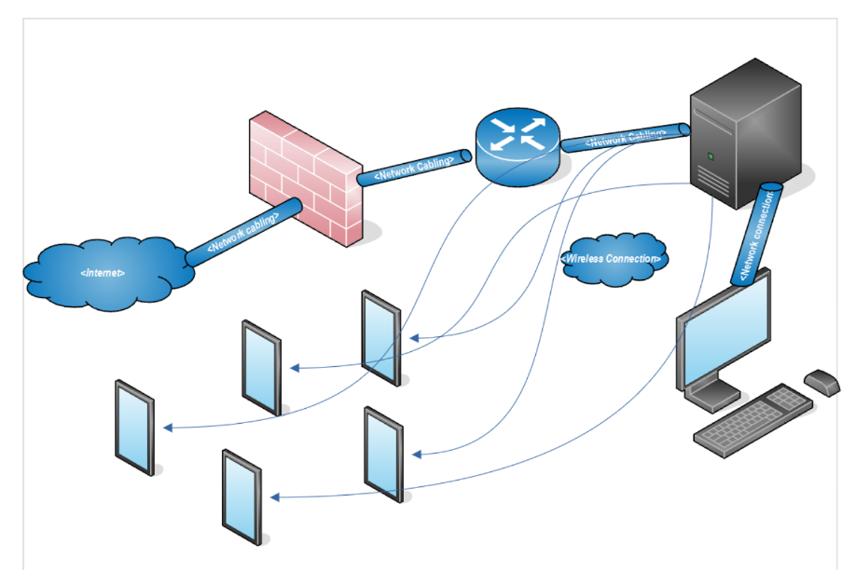*Network Diagram*

Currently, Joy’s Toys Network Architecture is nonexistent. A Server will be added to provide services to the app, while the modem and router shall provide access to the internet. The network firewall will be placed in between the internet and the Server for extra protection. Clients will then be able to access the Server via wireless and wired connection.

# Training Plan

Joy Johnson: Joy will have full access to the application. Therefore, she will require the most training out of all the employees, save for Bea.

The training will include

* Computer Training
* Mobile phone training
* Application training
  + How to use both the web application and the mobile application
  + Admin role creation and assignment
  + Security Training

Bea Bernard: Bea is the accountant, so she will have full access to the information the database holds. This will include special authorization within the app itself, where she will be able to access financial tables and records, stock and inventory, as well as employee data. Bea’s training will include:

* Application Training
  + How to use both the web application and the mobile application
  + Admin role creation and assignment
  + Security Training
* Security Training

Peter Parker: Peter will be responsible for stock/inventory. He will be able to access and order inventory through the app. Peter’s training will include:

* Application training
  + How to use the web and mobile application
  + How to access inventory information and make orders
* Customer Service
  + Customer training and support

Gwen Stacy: Gwen will be the Customer Sales Representative, so she will be the first point of contact between customers and Joy’s Toys. Therefore, she will need:

* Application Training
  + Sales
  + Stock
  + Receipt
* Customer Service support
  + Helping customers use the app