**JavaScript**

**1. Prepare an HTML document to insert JavaScript script in 3 different ways.**

Here’s an HTML document demonstrating how to insert JavaScript in three different ways:

1. **Inline**: JavaScript code directly within an HTML tag.
2. **Internal**: JavaScript code within a <script> tag inside the HTML document.
3. **External**: JavaScript code stored in a separate .js file and linked to the HTML document.

**Source Code :**

<!DOCTYPE html>

<html>

<head>

<title>JavaScript in 3 Ways</title>

<!-- Internal JavaScript -->

<script>

function showInternalMessage() {

alert("This is an Internal JavaScript example!"); }

</script>

<style>

body {

font-family: Arial, sans-serif;

margin: 20px;

}

button {

margin: 5px;

padding: 10px 20px;

font-size: 16px;

color: white;

background-color: #007BFF;

border: none;

border-radius: 4px;

cursor: pointer;

}

button:hover {

background-color: #0056b3;

}

</style>

</head>

<body>

<h1>JavaScript Inserted in 3 Ways</h1>

<!-- Inline JavaScript -->

<button onclick="alert('This is an Inline JavaScript example!')">Click for Inline Script</button>

<!-- Call Internal JavaScript -->

<button onclick="showInternalMessage()">Click for Internal Script</button>

<!-- External JavaScript -->

<button onclick="showExternalMessage()">Click for External Script</button>

<!-- Linking External JavaScript -->

<script src="script.js"></script>

</body>

</html>

**script.js**

function showExternalMessage() {

alert("This is an External JavaScript example!");

}

**OUTPUT :**

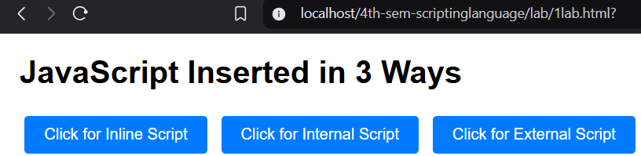

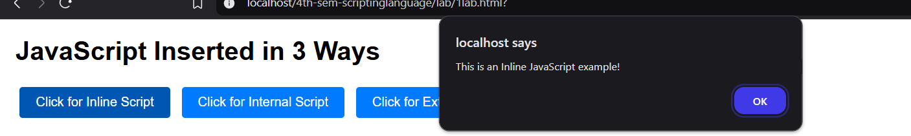

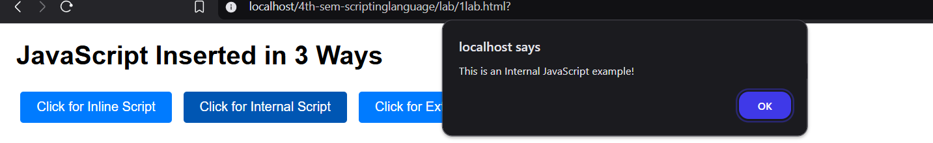

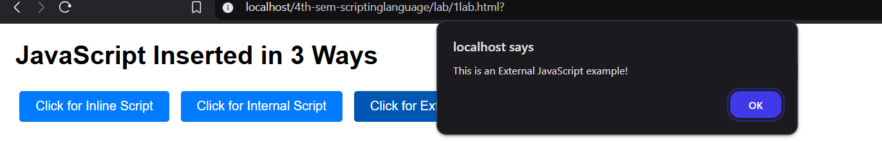

**2. Show an example of the use of NoScript.**

**Source Code :**

<!DOCTYPE html>

<html>

<head>

<title>NoScript Example</title>

<style>

body {

font-family: Arial, sans-serif;

margin: 20px;

}

.noscript-message {

color: red;

font-weight: bold;

text-align: center;

}

</style> <script>

function showMessage() {

alert("JavaScript is enabled. This is a JavaScript-based message!");

}

</script>

</head>

<body>

<h1>Example of NoScript</h1>

<p>If JavaScript is enabled in your browser, click the button below:</p>

<button onclick="showMessage()">Click Me</button> <noscript>

<div class="noscript-message">

<p>It seems that JavaScript is disabled in your browser.</p>

<p>Please enable JavaScript to fully experience this page.</p>

</div>

</noscript> </body> </html>

**OUTPUT :**

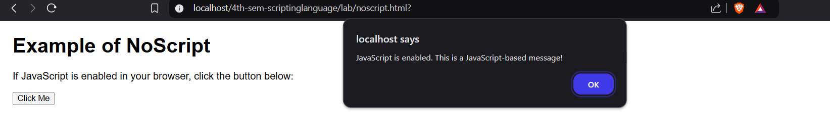

**3. Write a program to read an element DIV in an HTML document using querySelector()**

**method and change its text content.**

**Source Code :**

<!DOCTYPE html>

<html lang="en">

<head>

<meta charset="UTF-8">

<meta name="viewport" content="width=device-width, initial-scale=1.0">

<title>Change DIV Text</title>

</head>

<body>

<div id="myDiv">This is the original text.</div>

<button id="changeTextButton">Change Text</button>

<script>

const myDiv = document.querySelector("#myDiv");

const changeTextButton = document.querySelector("#changeTextButton");

changeTextButton.addEventListener("click", () => {

myDiv.textContent = "This is the new text!";

});

</script>

</body>

</html>

**OUTPUT :**

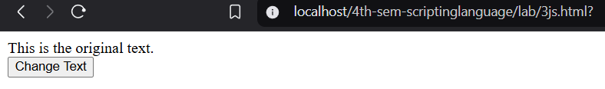

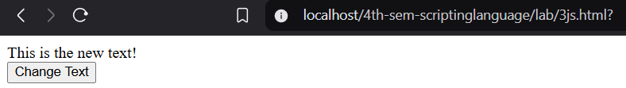

**4. Write a function to add two numbers and display the result in a text box.**

**Source Code :**

<!DOCTYPE html>

<html>

<head>

<title>Add Two Numbers</title>

<script>

function addNumbers() {

let num1 = parseFloat(document.getElementById('number1').value);

let num2 = parseFloat(document.getElementById('number2').value);

if (isNaN(num1) || isNaN(num2)) {

alert('Please enter valid numbers.');

return;

}

let sum = num1 + num2;

document.getElementById('result').value = sum;

}

</script>

</head>

<body>

<h1>Add Two Numbers</h1>

<label for="number1">Number 1:</label>

<input type="text" id="number1" placeholder="Enter first number">

<br><br>

<label for="number2">Number 2:</label>

<input type="text" id="number2" placeholder="Enter second number">

<br><br>

<button onclick="addNumbers()">Add</button>

<br><br>

<label for="result">Result:</label>

<input type="text" id="result" readonly>

</body>

</html>

**OUTPUT :**

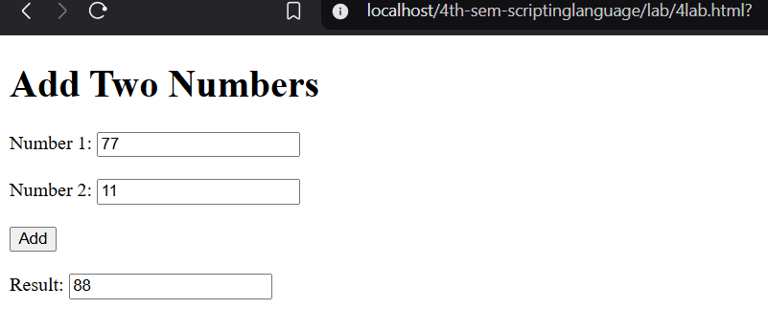

**5. Write a function to validate a form with the fields; student name, email and address.**

**Source Code :**

<!DOCTYPE html>

<html>

<head>

<title>Form Validation</title>

<style> body {

font-family: Arial, sans-serif;

max-width: 400px;

margin: 20px auto;

padding: 10px;

}

h1 {

text-align: center;

font-size: 1.5em;

margin-bottom: 20px;

}

label {

display: block;

margin-bottom: 5px;

font-weight: bold;

}

input[type="text"] {

width: 100%;

padding: 8px;

margin-bottom: 10px;

border: 1px solid #ccc;

border-radius: 4px;

}

button {

width: 100%;

padding: 10px;

background-color: #007BFF;

color: white;

border: none;

border-radius: 4px;

cursor: pointer;

}

button:hover {

background-color: #0056b3;

}

</style>

<script> function validateForm() {

let name = document.getElementById('studentName').value.trim();

let email = document.getElementById('email').value.trim();

let address = document.getElementById('address').value.trim();

if (name === '') {

alert('Please enter the student name.');

return false;

}

if (email === '') {

alert('Please enter the email address.');

return false;

}

let emailPattern = /^[^\s@]+@[^\s@]+\.[^\s@]+$/;

if (!emailPattern.test(email)) {

alert('Please enter a valid email address.');

return false;

}

if (address === '') {

alert('Please enter the address.');

return false;

}

alert('Form submitted successfully!');

return true; }

</script>

</head>

<body>

<h1>Form Validation</h1>

<form onsubmit="return validateForm();">

<label for="studentName">Student Name:</label>

<input type="text" id="studentName" placeholder="Enter student name">

<label for="email">Email:</label>

<input type="text" id="email" placeholder="Enter email">

<label for="address">Address:</label>

<input type="text" id="address" placeholder="Enter address">

<button type="submit">Submit</button>

</form> </body> </html>

**OUTPUT :**

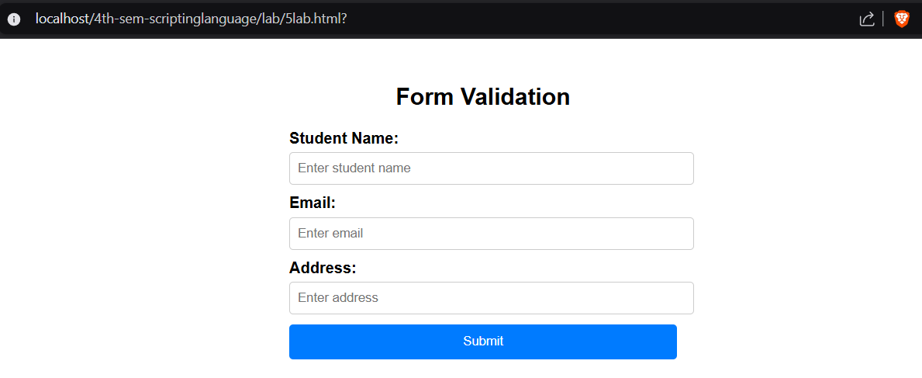

**6. Write a function that creates an HTML element and invoke that function upon clicking on a button.**

**Source Code :**

<!DOCTYPE html>

<html lang="en">

<head>

<title>Create HTML Element</title>

</head>

<body>

<h2>Create HTML Element</h2>

<button id="createBtn">Create Element</button>

<script>

document.getElementById('createBtn').addEventListener('click', function () {

var paragraph = document.createElement('p');

paragraph.textContent = 'This paragraph is dynamically created using JavaScript!';

document.body.appendChild(paragraph);

});

</script>

</body>

</html>

**OUTPUT :**

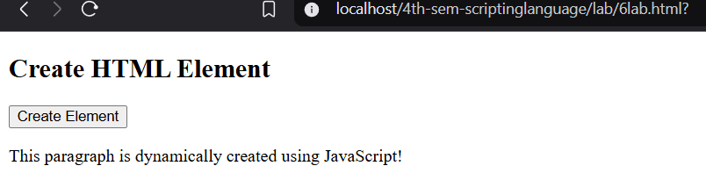

**7. Prepare an array as a collection of mixed types of data i.e. string, number, boolean.**

**Source Code :**

<!DOCTYPE html>

<html lang="en">

<head> <title>JavaScript Array Example</title> </head>

<body>

<h1>JavaScript Array Example</h1>

<script>

var mixedArray = ["samsung", 6.33, true, "apple", 4.22, false];

console.log(mixedArray);

console.log(mixedArray[0]);

console.log(mixedArray[1]);

console.log(mixedArray[2]);

</script>

</body>

</html>

**OUTPUT :**

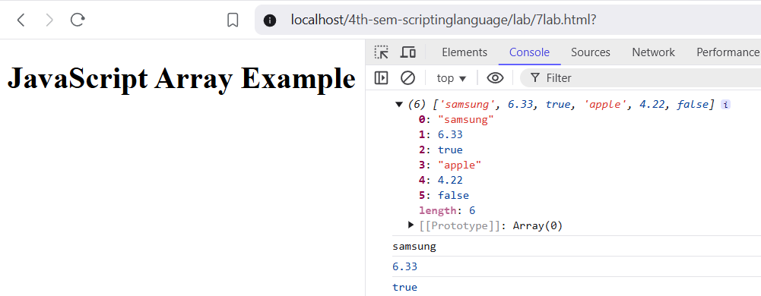

**8. Write a program to show a loop using while, for and forEach.**

**Source Code :**

<!DOCTYPE html>

<html lang="en">

<head> <title>Loop Examples</title> </head>

<body>

<h1>Loop Examples</h1>

<script> const numbers = [11, 12, 13, 14, 15];

console.log("Using while loop:");

let i = 0;

while (i < numbers.length) {

console.log(numbers[i]);

i++; }

console.log("\nUsing for loop:");

for (let j = 0; j < numbers.length; j++) {

console.log(numbers[j]); }

console.log("\nUsing forEach loop:");

numbers.forEach(function(number) {

console.log(number);

});

</script>

</body>

</html>

**OUTPUT :**

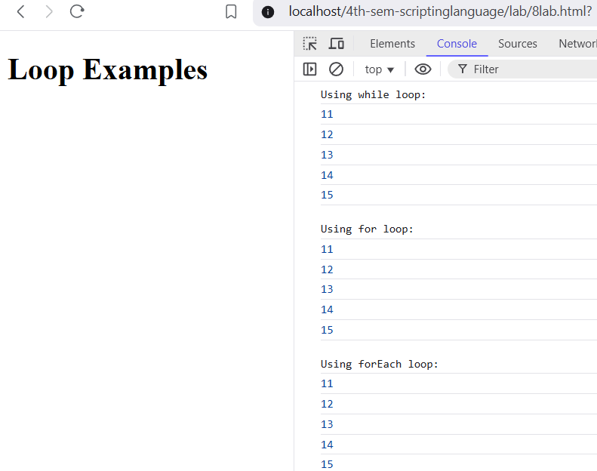

**9. Write a program to log array element values in the console.**

**Source Code :**

<!DOCTYPE html>

<html lang="en">

<head> <title>Logging Array Elements</title> </head>

<body>

<h1>Logging Array Elements</h1>

<script>

const array = [11, 12, 13, 14, 15];

console.log("Using for loop:");

for (let i = 0; i < array.length; i++) {

console.log(array[i]); }

console.log("\nUsing forEach loop:");

array.forEach(function(element) {

console.log(element);

});

console.log("\nUsing for...of loop:");

for (const element of array) {

console.log(element); }

</script>

</body>

</html>

**OUTPUT :**

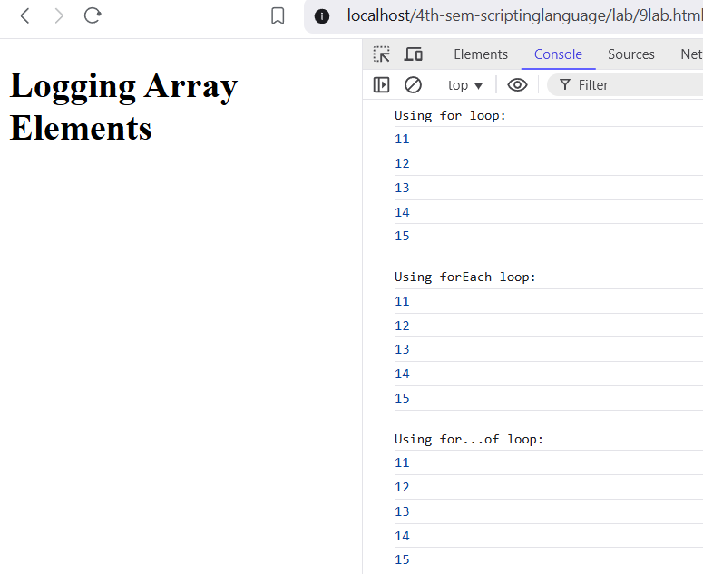

**10. Prepare an object of an employee with properties;**

**Source Code :**

<!DOCTYPE html>

<html lang="en">

<head> <title>Employee Details</title> </head>

<body>

<h1>Employee Details</h1>

<script>

var employee = {

firstName: "Amy",

lastName: "Martin",

age: 28,

department: "Doctor",

position: "Doctor",

salary: 100000,

isFullTime: true,

startDate: "2022-04-01",

endDate: null,

};

console.log(employee);

</script>

</body>

</html>

**OUTPUT :**

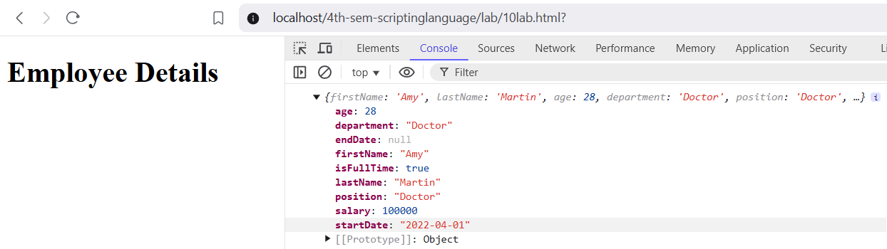

**11. Prepare an array of objects and print the values in an HTML element ul/li.**

**Source Code :**

<!DOCTYPE html>

<html lang="en">

<head> <title>Employee List</title> </head>

<body>

<h1>Employee List</h1>

<ul id="employeeList"> </ul>

<script>

var employees = [{

firstName: "Amy",

lastName: "Martin",

age: 28,

department: "Doctor",

position: "Doctor",

salary: 100000

},

{

firstName: "Jonathon",

lastName: "Smith",

age: 25,

department: "Marketing",

position: "Marketing Specialist",

salary: 45000

},

{

firstName: "Luffy",

lastName: "Rogger",

age: 35,

department: "Finance",

position: "Financial Analyst",

salary: 50000

}

];

function displayEmployeeList() {

const employeeListUl = document.getElementById("employeeList");

employees.forEach(function(employee) {

const li = document.createElement("li");

li.textContent = `${employee.firstName} ${employee.lastName} | Age: ${employee.age} | Department: ${employee.department} | Position: ${employee.position} | Salary: ${employee.salary}`;

employeeListUl.appendChild(li);

});

}

displayEmployeeList();

</script>

</body>

</html>

**OUTPUT :**

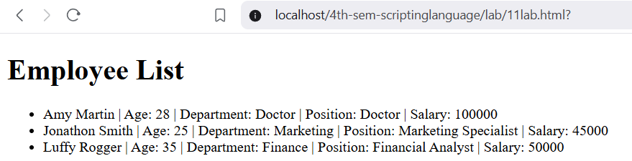

**12. Write a program using jQuery to show and hide an element.**

**Source Code :**

<!DOCTYPE html>

<html lang="en">

<head>

<title>Show/Hide Example</title>

<script src="https://code.jquery.com/jquery-3.6.0.min.js"></script>

<style>

.hidden { display: none; }

</style>

</head>

<body>

<button id="toggleButton">Toggle Element</button>

<div id="elementToToggle" class="hidden">

This is the element to show/hide.

</div>

<script>

$(document).ready(function(){

$("#toggleButton").click(function(){

// Toggle the visibility of the element

$("#elementToToggle").toggle();

}); });

</script>

</body> </html>

**OUTPUT :**

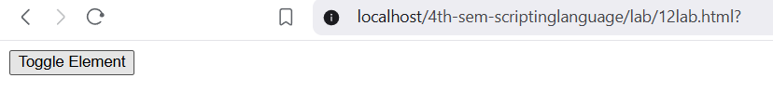

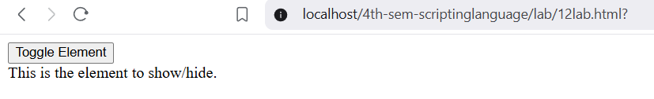

**13. Write a program to write a cookie.**

**Source Code :**

<!DOCTYPE html>

<html lang="en">

<head> <title>Write Cookie Example</title> </head>

<body> <script>

function setCookie(name, value, days) {

var expires = "";

if (days) {

var date = new Date();

date.setTime(date.getTime() + (days * 24 * 60 * 60 * 1000));

expires = "; expires=" + date.toUTCString(); }

document.cookie = name + "=" + value + expires + "; path=/"; }

setCookie("username", "Yash", 7);

</script>

</body>

</html>

**OUTPUT :**

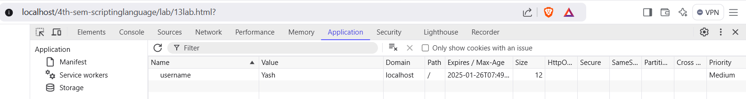

**PHP**

**1. Write a program to write HTML using/inside PHP.**

**Source Code :**

<!DOCTYPE html>

<html lang="en">

<head> <title>PHP HTML Example</title> </head>

<body> <h1> PHP HTML Example</h1>

<?php

$name = "Swosti";

$age = 20;

$city = "Bhaktapur";

echo "<p>Name: $name</p>";

echo "<p>Age: $age</p>";

echo "<p>City: $city</p>";

?>

<p>This is HTML outside of PHP.</p>

</body>

</html>

**OUTPUT :**

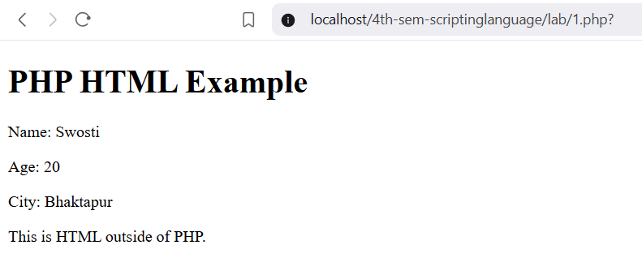

**2. Write a program to subtract two numbers and display the result in an HTML text box.**

**Source Code :**

<!DOCTYPE html>

<html lang="en">

<head> <title>Subtraction Result</title> </head>

<body>

<h1>Subtraction Result</h1>

<form method="post">

<label for="num1">Enter first number:</label>

<input type="number" id="num1" name="num1" required> <br>

<label for="num2">Enter second number:</label>

<input type="number" id="num2" name="num2" required> <br>

<input type="submit" value="Subtract">

</form>

<?php

if ($_SERVER["REQUEST_METHOD"] == "POST") {

$num1 = $_POST["num1"];

$num2 = $_POST["num2"];

$result = $num1 - $num2;

echo "<p>The result of $num1 - $num2 is: $result</p>"; }

?>

</body>

</html>

**OUTPUT :**

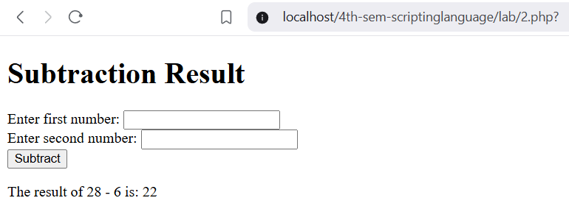

**3. Write a program using if..elseif...else.**

**Source Code :**

<!DOCTYPE html>

<html lang="en">

<head> <title>Grade Calculator</title> </head>

<body>

<h1>Grade Calculator</h1>

<form method="post">

<label for="score">Enter your score:</label>

<input type="number" id="score" name="score" required>

<input type="submit" value="Calculate Grade">

</form>

<?php

if ($_SERVER["REQUEST_METHOD"] == "POST") {

$score = $_POST["score"];

if ($score >= 90) {

$grade = 'A';

} elseif ($score >= 80) {

$grade = 'B';

} elseif ($score >= 70) {

$grade = 'C';

} elseif ($score >= 60) {

$grade = 'D';

} else {

$grade = 'F';

}

echo "<p>Your grade is: $grade</p>";

}

?>

</body>

</html>

**OUTPUT :**

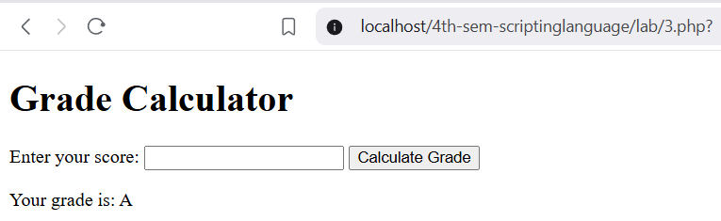

**4. Write a program using switch statements.**

**Source Code :**

<!DOCTYPE html>

<html lang="en">

<head> <title>Days in Month</title> </head>

<body>

<h1>Days in Month</h1>

<form method="post">

<label for="month">Enter the month (1-12):</label>

<input type="number" id="month" name="month" min="1" max="12" required>

<input type="submit" value="Check">

</form>

<?php

if ($_SERVER["REQUEST_METHOD"] == "POST") {

$month = $_POST["month"];

switch ($month) {

case 1:

case 3:

case 5:

case 7:

case 8:

case 10:

case 12: $days = 31;

break;

case 4:

case 6:

case 9:

case 11: $days = 30;

break;

case 2:

$year = date("Y");

if ((($year % 4 == 0) && ($year % 100 != 0)) || ($year % 400 == 0)) {

$days = 29;

} else { $days = 28; }

break;

default:

$days = "Invalid month";

} echo "<p>Number of days in month $month: $days</p>"; }

?> </body> </html>

**OUTPUT :**

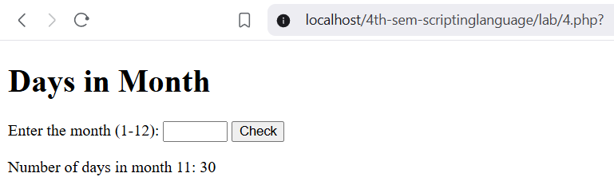

**5. Prepare a collection of student records in an associative array with first name, last name,email and date of birth and print in HTML table using foreach.**

**Source Code :**

<!DOCTYPE html>

<html lang="en">

<head>

<title>Student Records</title>

<style>

table {

border-collapse: collapse;

width: 100%; }

th, td {

border: 1px solid black;

padding: 8px;

text-align: left; }

th { background-color: #f2f2f2; }

</style>

</head>

<body>

<h1>Student Records</h1>

<?php

$students = array(

array(

"first_name" => "Anshu",

"last_name" => "Thapa",

"email" => "anshu@gmail.com",

"date_of_birth" => "2003-05-15"

),

array(

"first_name" => "Rubina",

"last_name" => "Magar",

"email" => "rubi@gmail.com",

"date_of_birth" => "2004-05-15"

),

array(

"first_name" => "Binu",

"last_name" => "Shrestha",

"email" => "binu@gmail.com",

"date_of_birth" => "2005-03-08"

)

);

?>

<table>

<tr>

<th>First Name</th>

<th>Last Name</th>

<th>Email</th>

<th>Date of Birth</th>

</tr>

<?php

foreach ($students as $student) {

echo "<tr>";

echo "<td>" . $student["first_name"] . "</td>";

echo "<td>" . $student["last_name"] . "</td>";

echo "<td>" . $student["email"] . "</td>";

echo "<td>" . $student["date_of_birth"] . "</td>";

echo "</tr>";

}

?>

</table>

</body>

</html>

**OUTPUT :**

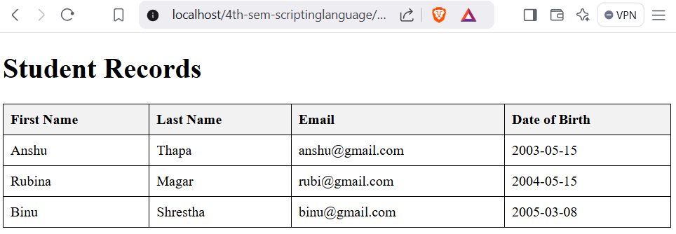

**6. Write a program to GET (HTTP method) HTML form values and display them in HTML**

**h1 tag.**

**Source Code :**

<!DOCTYPE html>

<html lang="en">

<head> <title>Display Form Values</title> </head>

<body>

<h1>Display Form Values</h1>

<form method="get">

<label for="name">Enter your name:</label>

<input type="text" id="name" name="name" required> <br>

<label for="age">Enter your age:</label>

<input type="number" id="age" name="age" required> <br>

<input type="submit" value="Submit">

</form>

<?php

if (isset($_GET["name"]) && isset($_GET["age"])) {

$name = $_GET["name"];

$age = $_GET["age"];

echo "<h1>Hello, $name!</h1>";

echo "<h1>Your age is $age.</h1>"; }

?>

</body>

</html>

**OUTPUT :**

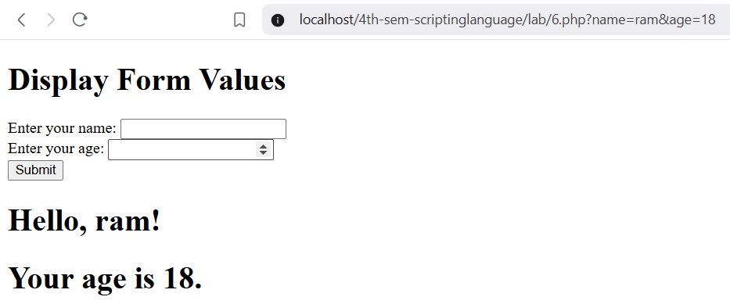

**7. Prepare a HTML form to register a student with name (text box), email (text box with**

**type email) using $_POST (HTTP method POST)**

**Source Code :**

<!DOCTYPE html>

<html lang="en">

<head> <title>Student Registration Form</title> </head>

<body>

<h2>Student Registration Form</h2>

<form method="post" action="process_registration.php">

<label for="name">Name:</label><br>

<input type="text" id="name" name="name" required><br>

<label for="email">Email:</label><br>

<input type="email" id="email" name="email" required><br>

<input type="submit" value="Register">

</form> </body> </html>

process_registration.php:

<?php

if ($_SERVER["REQUEST_METHOD"] == "POST") {

$name = htmlspecialchars($_POST['name']);

$email = htmlspecialchars($_POST['email']);

echo "<h2>Registration Successful</h2>";

echo "<p><strong>Name:</strong> $name</p>";

echo "<p><strong>Email:</strong> $email</p>";

} else { echo "Invalid request."; }

?>

**OUTPUT :**

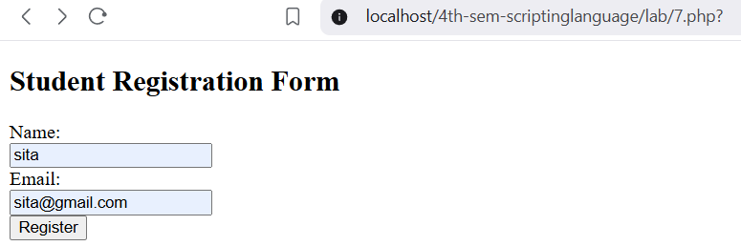

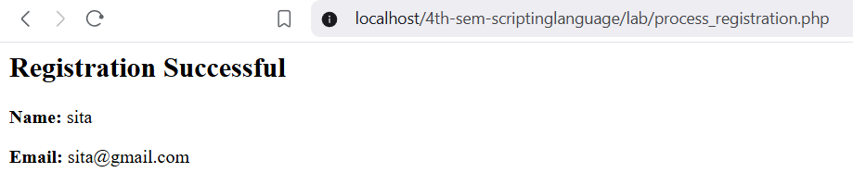

**8. Write a program using $_SESSION to show a simple login system (at least three pages;**

**login, dashboard and logout).**

**Source Code :**

**login.php:**

<?php

session_start();

if (isset($_SESSION['username'])) {

header("Location: dashboard.php");

exit; }

if (isset($_POST['username']) && isset($_POST['password'])) {

$username = $_POST['username'];

$password = $_POST['password'];

if ($username === 'user' && $password === 'password') {

$_SESSION['username'] = $username;

header("Location: dashboard.php");

exit;

} else { $error = "Invalid username or password!";

} }

?>

<!DOCTYPE html>

<html lang="en">

<head> <title>Login</title> </head>

<body>

<h2>Login</h2>

<?php if (isset($error)) echo "<p style='color:red'>$error</p>"; ?>

<form method="post">

<label for="username">Username:</label> <br>

<input type="text" id="username" name="username" required> <br>

<label for="password">Password:</label> <br>

<input type="password" id="password" name="password" required> <br>

<input type="submit" value="Login">

</form> </body> </html>

**dashboard.php:**

<?php

session_start();

if (!isset($_SESSION['username'])) {

header("Location: login.php");

exit; }

?>

<!DOCTYPE html>

<html lang="en">

<head> <title>Dashboard</title> </head>

<body>

<h2>Welcome to the Dashboard, <?php echo $_SESSION['username']; ?>!</h2>

<p>This is the dashboard page. You are logged in.</p>

<a href="logout.php">Logout</a>

</body> </html>

**logout.php:**

<?php

session_start();

session_destroy();

header("Location: login.php");

exit;

?>

**OUTPUT :**

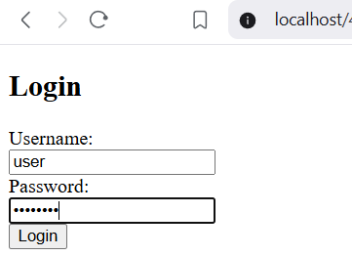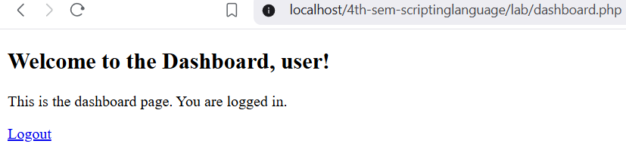

**9. Write a program to write a cookie to store a string value for the next 24 hours.**

**Source Code :**

<?php

$cookieValue = "Hello, this is a cookie!";

$expirationTime = time() + (24 * 60 * 60); // 24 hours * 60 minutes * 60 seconds

setcookie("myCookie", $cookieValue, $expirationTime, "/");

echo "Cookie 'myCookie' is set with value: $cookieValue";

?>

**OUTPUT :**

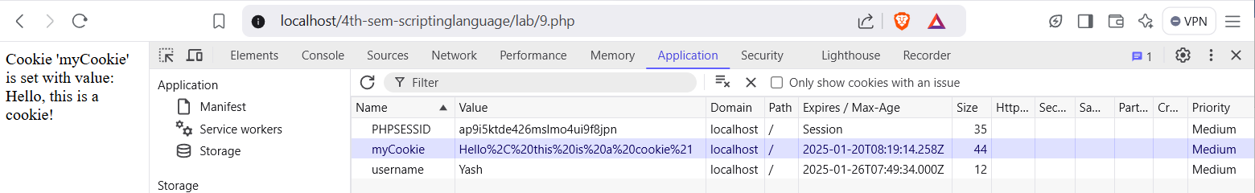

**10. Write a program to upload a file.**

**Source Code :**

<!DOCTYPE html>

<html lang="en">

<head> <title>File Upload</title> </head>

<body>

<h2>Upload a File</h2>

<form method="post" enctype="multipart/form-data">

<input type="file" name="file" required> <br>

<input type="submit" value="Upload">

</form>

<?php

if ($_SERVER["REQUEST_METHOD"] == "POST") {

if (isset($_FILES["file"]) && $_FILES["file"]["error"] == UPLOAD_ERR_OK) {

$target_dir = "uploads/";

$target_file = $target_dir . basename($_FILES["file"]["name"]);

if (move_uploaded_file($_FILES["file"]["tmp_name"], $target_file)) {

echo "<p>The file " . basename($_FILES["file"]["name"]) . " has been uploaded.</p>";

} else {

echo "<p>Sorry, there was an error uploading your file.</p>";

}

} else {

echo "<p>Please select a file to upload.</p>";

} }

?>

</body>

</html>

**OUTPUT :**

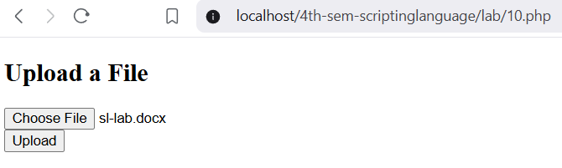

**11. Write a program to write a string to a file and read from the same file and display.**

**Source Code :**

<!DOCTYPE html>

<html lang="en">

<head> <title>File Read/Write</title> </head>

<body>

<h2>File Read/Write</h2>

<?php

$file_name = "file.txt";

$content_to_write = "Hello, this is a string written to a file!";

if (file_put_contents($file_name, $content_to_write)) {

echo "<p>Content has been written to the file '{$file_name}'.</p>";

} else {

echo "<p>Failed to write content to the file '{$file_name}'.</p>"; }

$read_content = file_get_contents($file_name);

if ($read_content !== false) {

echo "<p>Content read from the file '{$file_name}':<br>{$read_content}</p>";

} else {

echo "<p>Failed to read content from the file '{$file_name}'.</p>";

}

?>

</body>

</html>

**OUTPUT :**

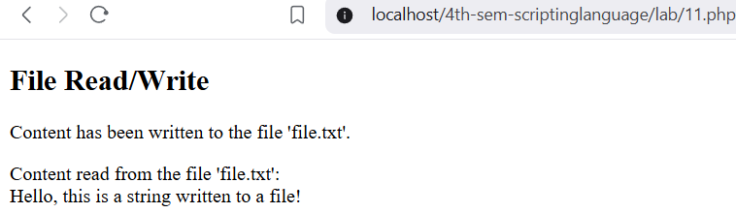

**12. Write a program to connect to a database.**

**Source Code :**

<?php

$servername = "localhost";

$username = "root";

$password = "";

$database = "test";

$conn = new mysqli($servername, $username, $password, $database);

if ($conn->connect_error) {

die("Connection failed: " . $conn->connect_error);

} else {

echo "Connected successfully";

}

$conn->close();

?>

**OUTPUT :**

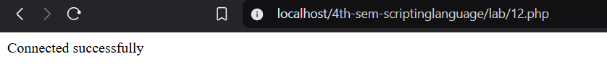

**13. Write a program to list students record from a database;**

**Database Name: swastik**

**Table Name: students**

**Columns: id (int), name (varchar), email (varchar), address (text), date_of_birth (date)**

**Source Code :**

<!DOCTYPE html>

<html lang="en">

<head> <title>Student Records</title> </head>

<body>

<h2>Student Records</h2>

<?php

$servername = "localhost";

$username = "root";

$password = "";

$database = "swastik";

$conn = new mysqli($servername, $username, $password, $database);

if ($conn->connect_error) {

die("Connection failed: " . $conn->connect_error); }

$sql = "SELECT * FROM students";

$result = $conn->query($sql);

if ($result->num_rows > 0) {

echo "<table border='1'>";

echo"<tr><th>ID</th><th>Name</th><th>Email</th><th>Address</th><th>Date of Birth</th></tr>";

while($row = $result->fetch_assoc()) {

echo "<tr>";

echo "<td>" . $row["id"] . "</td>";

echo "<td>" . $row["name"] . "</td>";

echo "<td>" . $row["email"] . "</td>";

echo "<td>" . $row["address"] . "</td>";

echo "<td>" . $row["date_of_birth"] . "</td>";

echo "</tr>";

} echo "</table>";

} else {

echo "No student records found"; }

$conn->close();

?>

</body>

</html>

**Database: sql**

CREATE DATABASE swastik;

CREATE TABLE students (

id INT AUTO_INCREMENT PRIMARY KEY,

name VARCHAR(100) NOT NULL,

email VARCHAR(100) NOT NULL,

address VARCHAR(255) NOT NULL,

date_of_birth DATE NOT NULL

);

INSERT INTO students (name, email, address, date_of_birth)

VALUES

('Alice Johnson', 'alice@example.com', '123 Main St', '2000-05-15'),

('Bob Smith', 'bob@example.com', '456 Elm St', '1999-08-22'),

('Charlie Brown', 'charlie@example.com', '789 Maple St', '2001-12-10');

**OUTPUT :**

