

Tribhuvan University
Faculty of Humanities and Social Sciences

A PROJECT REPORT
On
Vehicle Rental System

In partial fulfillment of the requirements for the degree of Bachelor of Computer Applications

Submitted to Department of Computer Application
Swastik College Chardobato, Bhaktapur

Submitted by
Swosti Makaju (113102097)
Thomas Bhattarai (113102098)

4 Feb 2026

Tribhuvan University
Faculty of Humanities and Social Sciences

A PROJECT REPORT
On
Vehicle Rental System

Submitted to Department of Computer Application
Swastik College Chardobato, Bhaktapur

In partial fulfillment of the requirements for the degree of Bachelor of Computer Applications

Submitted by
Swosti Makaju (113102097)
Thomas Bhattarai (113102098)

Under the Supervision
Sagar Rana Magar

4 Feb 2026

Tribhuvan University
Faculty of Humanities and Social Sciences

SUPERVISOR’S RECOMMENDATION

I hereby recommend that this project prepared under my supervision by Swosti Makaju & Thomas Bhattarai entitled “VEHICLE RENTAL SYSTEM” in partial fulfillment of the requirements for the degree of Bachelor of Computer Application is recommended for the final evaluation.

……………………………
Sagar Rana Magar
Lecturer
Swastik College

Tribhuvan University
Faculty of Humanities and Social Sciences

LETTER OF APPROVAL

This is to certify that this project prepared by Swosti Makaju & Thomas Bhattarai entitled “VEHICLE RENTAL SYSTEM” in partial fulfillment of the requirements for the degree of Bachelor in Computer Application has been evaluated. In our opinion, it is satisfactory in the scope and quality as a project for the required degree.

……………………………  Sagar Rana Magar  Supervisor  Lecturer, Swastik College | ……………………………  Susan Sunuwar  Coordinator  Swastik College
……………………………  Internal Examiner | ……………………………  External Examiner

AKNOWLEDGEMENT
We would like to extend our heartfelt gratitude to our supervisor Mr. Sagar Rana Magar for his invaluable guidance and support throughout our project. His expertise, dedication, valuable encouragement and friendly environment with us have played a vital role in shaping the successful completion of this project.

We would also like to express our deepest sense of gratitude and thanks to our coordinator Mrs. Susan Sunuwar for her constant guidance and supervision as well as for providing necessary information and ICT infrastructure relevant to the project.

At the end, we would like to express our sincere thanks to all the friends, seniors and others who helped us directly or indirectly during this project work.

With Regards:
Swosti Makaju
Thomas Bhattarai

ABSTRACT
Velorent is an innovative vehicle rental company based in Bhaktapur, Nepal, dedicated to providing seamless and reliable transportation solutions. Specializing in the rental of motorbikes, cars, and scooters, Velorent offers a wide range of vehicles tailored to meet the diverse needs of its customers. The company is committed to delivering exceptional service quality by maintaining a fleet that emphasizes safety, affordability, and convenience.

With an intuitive online booking platform, Velorent ensures that users can easily browse available vehicles, make reservations, and manage their bookings. The platform incorporates robust user authentication processes and secure payment options to enhance trust and reliability. Velorent’s customer-centric approach focuses on flexibility, transparent pricing, and personalized support, making it a trusted partner for daily commutes, weekend getaways, or long-term rentals.

By blending technology with customer-focused services, Velorent aims to set a new benchmark in the vehicle rental industry in Nepal. This abstract highlights Velorent’s mission to simplify transportation, prioritize customer satisfaction, and contribute to sustainable, efficient mobility solutions.

Keywords: HTML, CSS, JavaScript, MySQL, Xampp, phpMyAdmin

Table Of Contents

AKNOWLEDGEMENT i
ABSTRACT ii
Table Of Contents iii
LIST OF ABBREVIATIONS v
List Of Tables vi
List Of Figure vii
CHAPTER-1 INTRODUCTION 1
1.1 Introduction 1
1.2 Problem Statement 1
1.3 Objectives 2
1.4 Scope and Limitation 2
1.4.2 Limitation of the Project 3
1.5 Report Organization 3
CHAPTER-2 BACKGROUND STUDY AND LITERATURE REVIEW 4
2.1 Background 4
2.2 Literature Review 5
CHAPTER 3: SYSTEM ANALYSIS AND DESIGN 6
3.1 System Analysis 6
3.1.1 Requirement Analysis 6
3.2 System Design 10
3.2.1 Data Modeling: E-R Diagram 10
3.2.2 Process Modeling (DFD) 12
3.2.3 Architectural design 13
3.2.4 Database Schema Design 13
3.3 Interface Design (UI Interface) 14
3.4 Physical DFD 16
3.5 Algorithm Used 16
CHAPTER 4: IMPLEMENTATION AND TESTING 18
4.1 Implementation 18
4.1.1 Tools Used 18
4.1.2 Implementation Details of Modules 19
4.2 Testing 20
4.2.1 Test cases for Unit Testing 20
4.2.2 Test Cases for System Testing 21
CHAPTER 5: CONCLUSION AND RECOMMENDATION 22
5.1 Lesson Learnt/Outcome 22
5.3 Recommendation 23
References 24
APPENDIX 25

LIST OF ABBREVIATIONS

CASE | Computer Aided Software Engineering
CSS | Cascading Style sheets
DFD | Data Flow Diagram
ERD | Entity Relation Diagram
HTML | Hypertext Markup Language
ICT | Information Technology
INFO | Information
IDE | Integrated Development Environment
JS | JavaScript
MYSQL | My Structured Query Language
PHP | Hypertext Preprocessor
SDLC | Software Development Life Cycle
UI | User Interface

List Of Tables
Table 4.1: Test Case for Login 20
Table 4.2: Test Cases for Sign Up 20
Table 4.3: Test Cases for Payment 20
Table 4.4: Test Cases for Booking 21
Table 4.5 Test Cases for system testing of the Vehicle Rental System 21

List Of Figure
Figure 3.1: Use Case Diagram of Vehicle Rental System 8
Figure 3.2: Gantt Chart 10
Figure 3.3: ER Diagram of Vehicle Rental System 11
Figure 3.4: Level 0 DFD of Vehicle Rental System 12
Figure 3.5: Level 1 DFD of Vehicle Rental System 12
Figure 3.6: Architectural Design of Vehicle Rental System 13
Figure 3.7: Database Schema Design of Vehicle Rental System 13
Figure 3.8: User login page UI 14
Figure 3.9: Admin Login Page UI 14
Figure 3.10: Admin Dashboard 15
Figure 3.11: User Dashboard 15
Figure 3.12: Physical DFD of Vehicle Rental System 16

CHAPTER-1 INTRODUCTION
1.1 Introduction
A vehicle rental system is a digital platform or software solution designed to facilitate the process of renting vehicles to customers in an efficient, reliable, and user-friendly manner. With rapid urbanization, rising fuel costs, and the increasing need for flexible transportation options, the vehicle rental industry has experienced significant growth in recent years. Customers now prefer rental services as they provide convenience, affordability, and freedom from long-term ownership responsibilities such as maintenance, insurance, and depreciation.
Velorent is a modern vehicle rental company that offers a wide range of vehicles including motorbikes, cars, and scooters to meet the diverse needs of its customers. Whether for daily commuting, short trips, tourism, or business travel, Velorent aims to provide safe, well-maintained vehicles at competitive prices. However, managing vehicle availability, bookings, customer details, and payments manually can be time-consuming and error-prone, highlighting the need for a robust digital system.
The objective of this project is to design and develop a comprehensive vehicle rental system tailored specifically for Velorent. The system will automate key processes such as vehicle listing, customer registration, booking management, rental duration tracking, and billing. It will also provide real-time information about vehicle availability, helping customers make informed choices and ensuring efficient utilization of resources for the company.
Additionally, the proposed system focuses on enhancing user experience by offering an intuitive interface, secure data handling, and streamlined operations. By digitizing the rental workflow, Velorent can improve operational efficiency, reduce paperwork, minimize human errors, and deliver better customer service. This project not only demonstrates the practical application of software development concepts but also addresses real-world challenges faced by the vehicle rental industry.

1.2 Problem Statement
The traditional vehicle rental process at many rental agencies, including Velorent, often relies on manual or semi-digital methods for managing bookings, vehicle availability, customer records, and payment details. These methods are inefficient, time-consuming, and prone to errors such as double bookings, incorrect billing, and loss of customer data. As the number of customers and vehicles increases, managing rental operations manually becomes increasingly complex and difficult.
Customers also face challenges such as limited access to real-time vehicle availability, lack of transparency in pricing, and delays in the booking and confirmation process. On the administrative side, rental staff struggle with tracking vehicle usage, maintenance schedules, and rental histories, which can lead to poor resource utilization and reduced customer satisfaction.
Therefore, there is a need for a centralized, automated vehicle rental system for Velorent that can efficiently manage vehicles, customers, bookings, and payments in real time. The absence of such a system affects operational efficiency, data accuracy, and overall service quality. This project aims to address these challenges by developing a reliable and user-friendly vehicle rental system that streamlines operations, enhances customer experience, and supports the growing demands of the vehicle rental business.

1.3 Objectives
The main objectives/features of the system are:
- To offer a diverse selection of vehicles suitable for various transportation needs.
- To ensure safety and maintenance standards for all vehicles in the fleet.
- To streamline the rental process through an intuitive online booking system.
- To build trust through transparent pricing and secure payment options
- To provide a reliable and user-friendly vehicle rental platform.
1.4 Scope and Limitation
1.4.1 Scope of the Project
The Velorent project focuses on creating an efficient vehicle rental platform that simplifies the booking process and enhances user satisfaction. The system will include an online booking portal, a database for managing vehicle and user information, Additionally, the project will support admin capabilities for fleet management and data oversight.

1.4.2 Limitation of the Project
      - Limited scalability for large organizations as the system does not include the advanced features or complex functionalities required to handle large-scale operations.
      - Absence of performance tracking for employees as the system does not track work output, goals, or key performance indicators (KPIs).

1.5 Report Organization
The report organization is divided into five different chapters. The five chapters of the report are:
Chapter 1 includes the introduction of the system the problem statement, objectives, the scope and the limitations of the ‘Vehicle Rental System’.
Chapter 2 includes the description of fundamental theories, general concepts and terminologies related to the project. It also consists the review of the similar literature and works carried out by different authors, publishers in past.
Chapter 3 summarizes the functional and the non-functional requirements of the project. Different diagrams like use case diagram, DFD, Gantt chart, E-R diagram, schema design etc. are used to give the structure or design for the system.
Chapter 4 describes the different technologies or tools used for the entire development process of the Front-end as well as the Back-end development of the application. It also defines the different implementation details of the modules and the testing cases such as unit Testing and system Testing.
Chapter 5 provides a brief summary of the Vehicle Rental System (VRS) project, encapsulating its main objectives, key features, and overall significance of the system. It also mentions about the future recommendations and improvements for the system that can be done in the near future.

CHAPTER-2 BACKGROUND STUDY AND LITERATURE REVIEW
2.1 Background
Velorent should provide a comprehensive understanding of the vehicle rental industry, user expectations, market trends, and competitive insights. The vehicle rental market has experienced significant growth globally, driven by the increasing demand for flexible, cost- effective transportation. Urbanization, the rise in tourism, and shifting consumer preferences toward short-term vehicle use over ownership are major contributors to this growth. [1] To achieve this, Velorent must focus on creating a seamless digital experience, incorporating features such as real-time vehicle availability checks and transparent pricing. Mobile optimization, and automated booking systems can enhance user convenience, while data analytics can offer personalized services by understanding user preferences. Studying competitors’ strengths and weaknesses is vital to identify opportunities, such as offering a diverse fleet that includes premium and eco-friendly vehicles like electric scooters, implementing loyalty and referral programs, and providing flexible rental terms. Ensuring high-quality service is essential, with vehicle maintenance and user safety prioritized alongside responsive customer support to handle issues efficiently. Building trust through security measures like verified user profiles, encrypted data handling, and robust login systems is crucial.
Additionally, adopting eco-friendly practices, such as expanding the fleet with electric or low-emission vehicles, can attract environmentally conscious users and align with sustainability trends. Technological integration should be a focal point, incorporating features like GPS tracking for real-time updates and a dedicated mobile app for managing bookings and notifications to boost user retention. By leveraging local market insights and aligning with global best practices, Velorent can differentiate itself as a modern, customer- focused platform. This approach will position it to meet market demands effectively and maintain a competitive edge, ensuring steady growth and enhanced user satisfaction. [2]

2.2 Literature Review
The vehicle rental sector has evolved considerably, driven by urbanization, tourism, and shifting consumer behavior that favors short-term access over ownership. Studies highlight that consumers prioritize convenience, affordability, and flexibility, making digital transformation a vital element for success in this industry. Research also points to the significant impact of high service quality on consumer loyalty, with reliable vehicles, and transparent rental policies being key contributors to user trust. Incorporating user feedback mechanisms and post-rental support enhances satisfaction and encourages repeat business, while loyalty and referral programs have proven effective in fostering customer retention by adding value. Competitive analysis within the literature underscores the rise of peer-to- peer rental platforms, which have reshaped the industry by leveraging community trust and transparent practices. [3]
To compete, traditional rental services must adapt, offering platforms that are user-friendly and ensure a comparable level of transparency. The literature also stresses the critical importance of security, highlighting that encrypted data handling, secure payment processing, and verified user accounts build trust and protect users from fraud. Moreover, the push for eco-friendly practices is becoming more pronounced, with studies noting that incorporating electric or low-emission vehicles appeals to environmentally conscious consumers and aligns with global sustainability trends that influence market preferences. Technological integration is cited as a major differentiator, where features like GPS tracking, real-time updates, and data-driven personalization enhance the user experience and improve engagement. In conclusion, the literature review for Velorent underlines the importance of digital transformation, strong service quality, security measures, and sustainability efforts. Leveraging these insights, Velorent can build a platform that meets current consumer expectations and stands out in the competitive vehicle rental market in Nepal. By incorporating user-friendly digital tools, loyalty initiatives, flexible rental options, and eco-conscious practices, Velorent can position itself as a modern, trustworthy, and forward-thinking service provider that appeals to both locals and tourists alike. [4]

CHAPTER 3: SYSTEM ANALYSIS AND DESIGN

3.1 System Analysis

3.1.1 Requirement Analysis
3.1.1.1 Functional Requirements
The functional requirements of the Vehicle Rental System are:
- Users should be able to register and log in to the system securely using valid credentials.
- Users should be able to recover forgotten passwords through email and license number verification.
- Users should be able to browse and view available vehicles with complete details such as type, fuel, capacity, price, and images.
- Users should be able to filter vehicles based on availability and vehicle attributes.
- Users should be able to view detailed vehicle information before making a booking.
- Users should be able to book vehicles by selecting pickup location, rental date, duration, and destination.
- The system should automatically calculate rental costs using dynamic pricing and discount rules based on rental duration.
- Users should be able to make payments using integrated payment methods such as eSewa or card payments.
- Users should be able to view booking status and booking history, including payment details.
- Users should be able to cancel bookings that are pending or not yet approved.
- Users should be able to return rented vehicles after completion of the rental period.
- Users should be able to submit ratings and reviews for completed bookings.
- Users should be able to view and update their profile information, excluding email address.
- Users should be able to change their account passwords with proper verification.
- Administrators should be able to log in to the system securely using admin credentials.
- Administrators should be able to view, monitor, and manage registered users.
- Administrators should be able to delete user accounts when required.
- Administrators should be able to add new vehicles with complete rental details and images.
- Administrators should be able to update vehicle information including price, availability, and specifications.
- Administrators should be able to delete vehicles from the system inventory.
- Administrators should be able to view all bookings made by users.
- Administrators should be able to approve or reject booking requests.
- Administrators should be able to update booking status such as approved, returned, or canceled.
- Administrators should be able to manage vehicle availability automatically based on booking and return actions.
- Administrators should be able to view booking statistics and reports for system monitoring.
- Administrators should be able to manage payment records linked to user bookings.
- Administrators should be able to manage system settings including business rules, currency, and contact details.
- Administrators should be able to enforce security controls such as session validation and access restrictions.
- The system should allow administrators to perform transaction-safe operations with rollback support in case of errors.

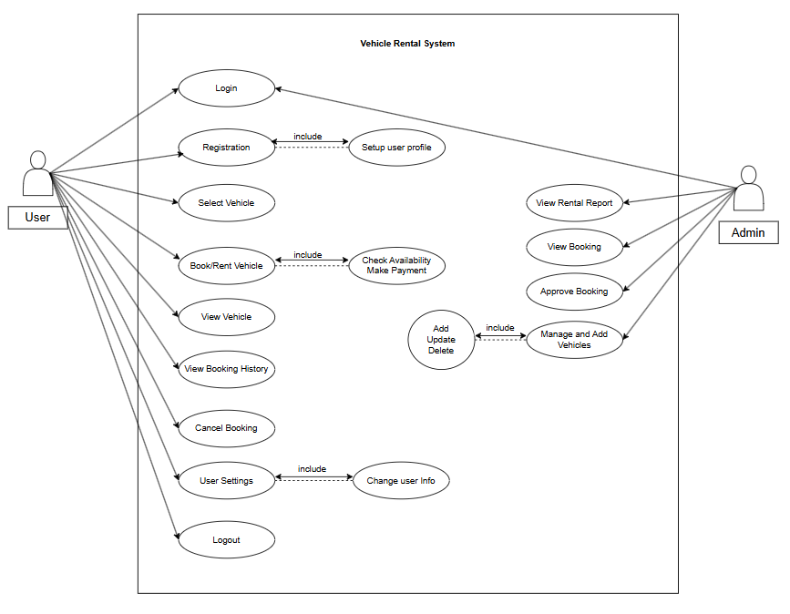

Figure 3.1: Use Case Diagram of Vehicle Rental System

3.1.1.2 Non-Functional Requirements
The non – functional requirements of the projects are:
- The system should respond to user actions within milliseconds.
ii. Velorent should scale to handle a growing number of users, vehicle listings, and bookings.
Iii. All sensitive information, including user credentials, payment details, and personal information, should be encrypted and stored securely.
3.1.2 Feasibility Analysis
- Technical Feasibility
The Vehicle Rental System is technically feasible because everything needed for its development is easy to get. We have access to essential software like HTML, CSS, JS, and PHP for building the system. The required libraries can do what we need them to do. Using free IDE like VS Code and XAMPP makes it even easier to create the system. In simple terms, the technical side of things is well-supported, so we can confidently develop and implement the system.
- Economic Feasibility
Building this system comes with minimal expenses. Since we're handling all the coding internally and using free tools like VS code and XAMPP, there's no initial financial burden. Utilization of the free and widely available development environments ensures that the project is economically viable and feasible.
- Operational Feasibility
The system convincingly showcases its operational feasibility through its user-friendly design, ensuring that anyone can navigate and utilize its features effortlessly. The operations are not only smooth but also well-organized with minimum maintenance challenges, enhancing overall efficiency in managing tasks and processes of vehicle system.
- Schedule Feasibility
The project is schedule-feasible, with an estimated timeline of 3-4 months for development, testing, and launch. The timeline is realistic and achievable with proper resource allocation and planning.

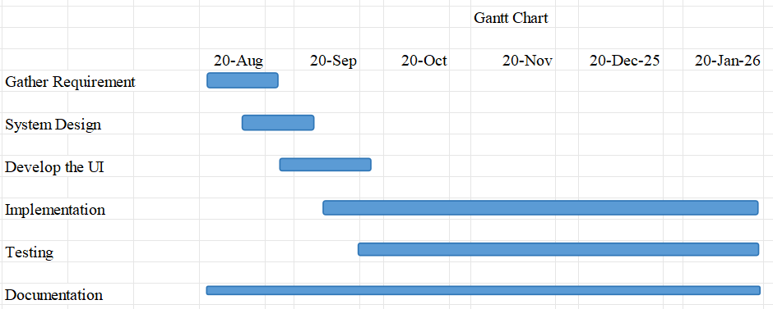

Figure 3.2: Gantt Chart

3.2 System Design

3.2.1 Data Modeling: E-R Diagram

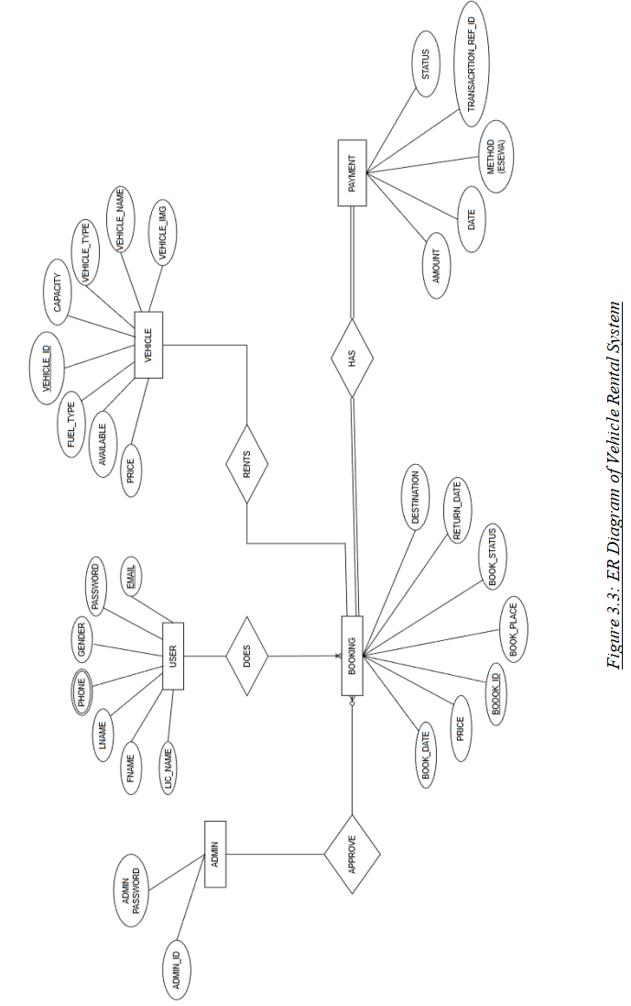

3.2.2 Process Modeling (DFD)
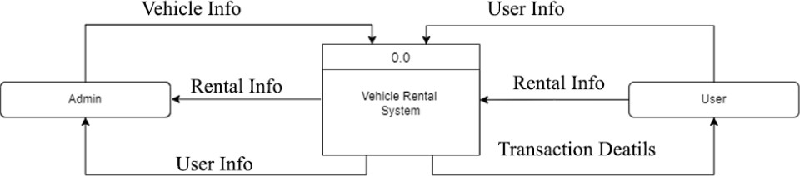

Figure 3.4: Level 0 DFD of Vehicle Rental System

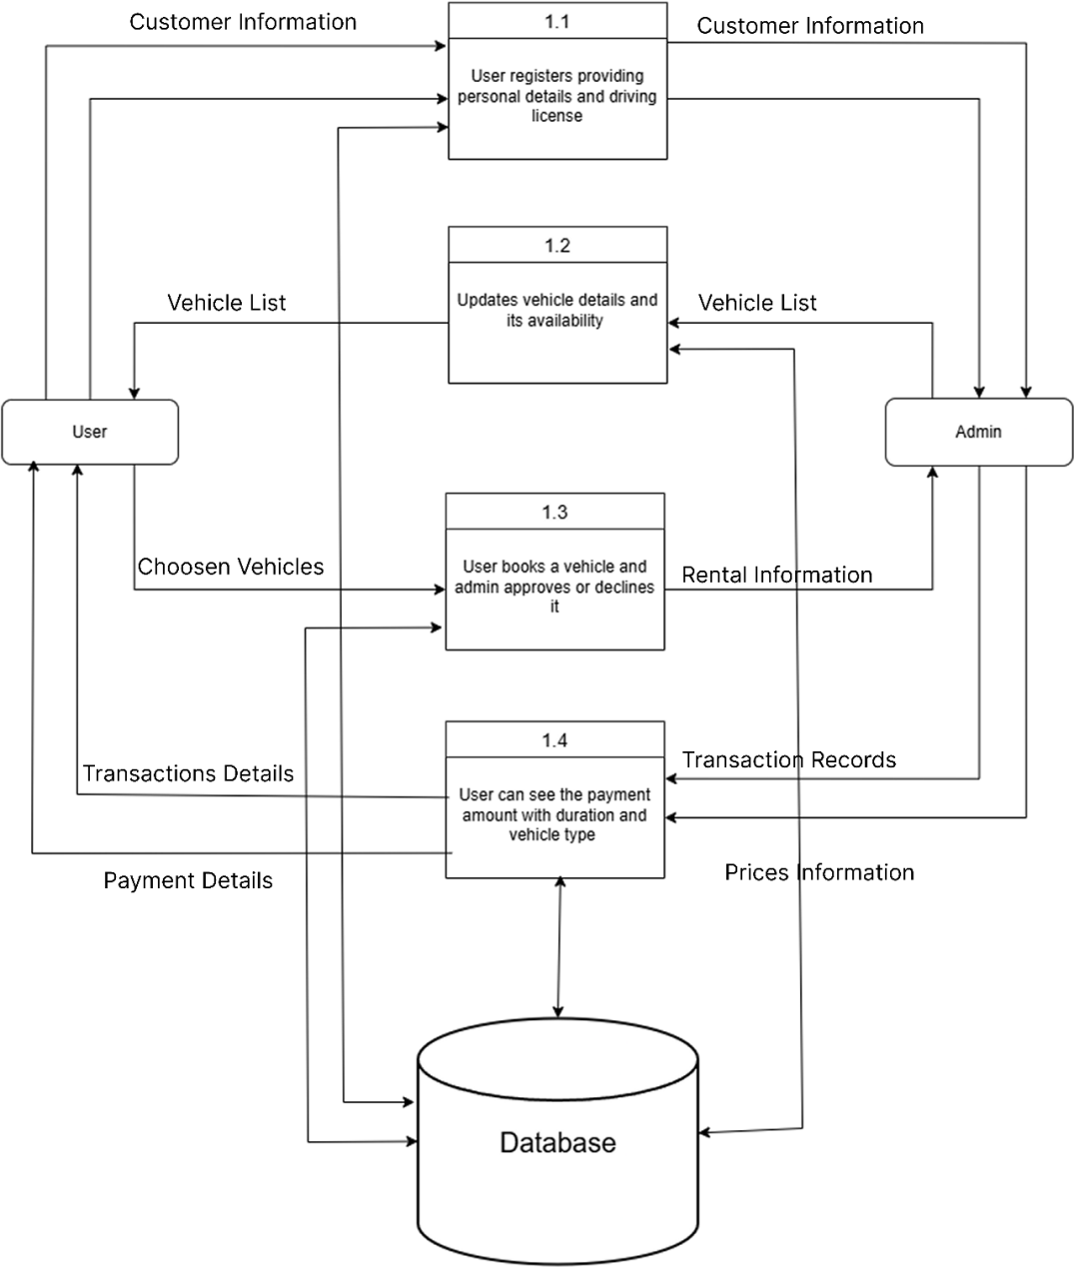

Figure 3.5: Level 1 DFD of Vehicle Rental System

3.2.3 Architectural design

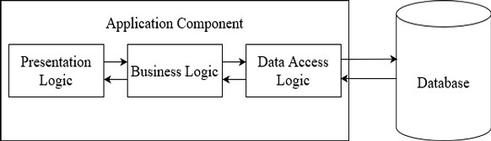

Figure 3.6: Architectural Design of Vehicle Rental System

3.2.4 Database Schema Design
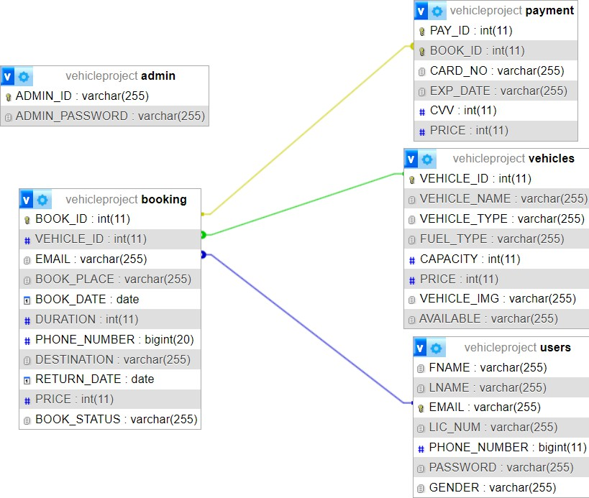

Figure 3.7: Database Schema Design of Vehicle Rental System

3.3 Interface Design (UI Interface)
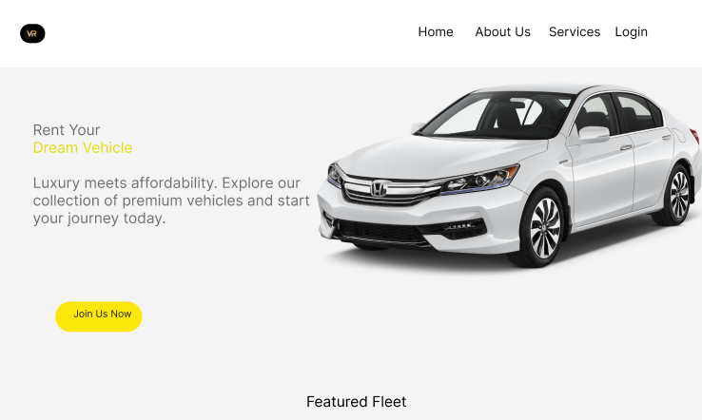
Figure 3.8: User login page UI

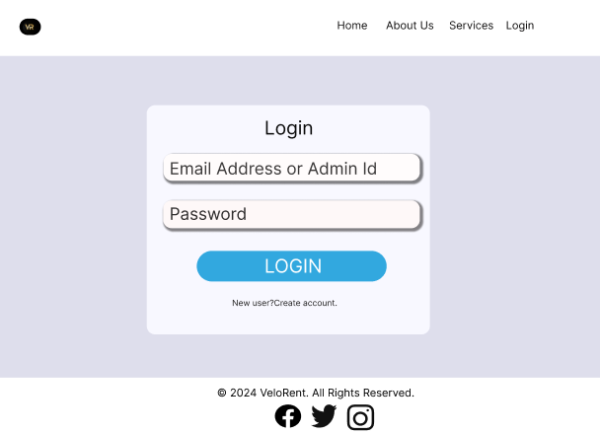

Figure 3.9: Admin Login Page UI

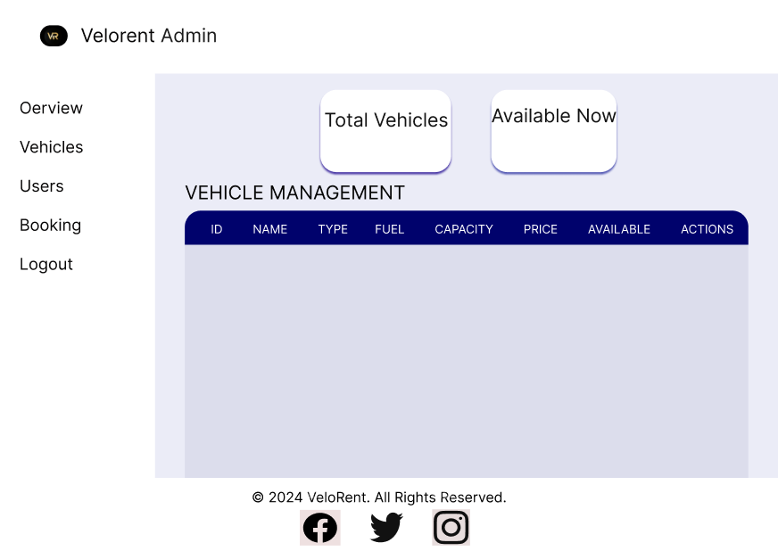
Figure 3.10: Admin Dashboard
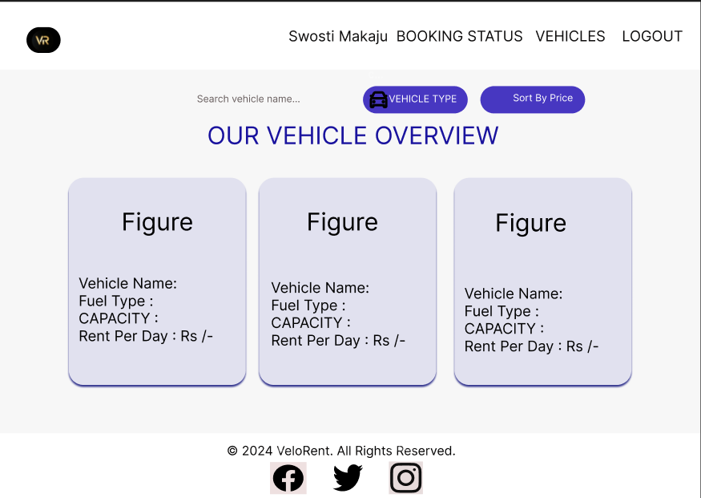

Figure 3.11: User Dashboard

3.4 Physical DFD

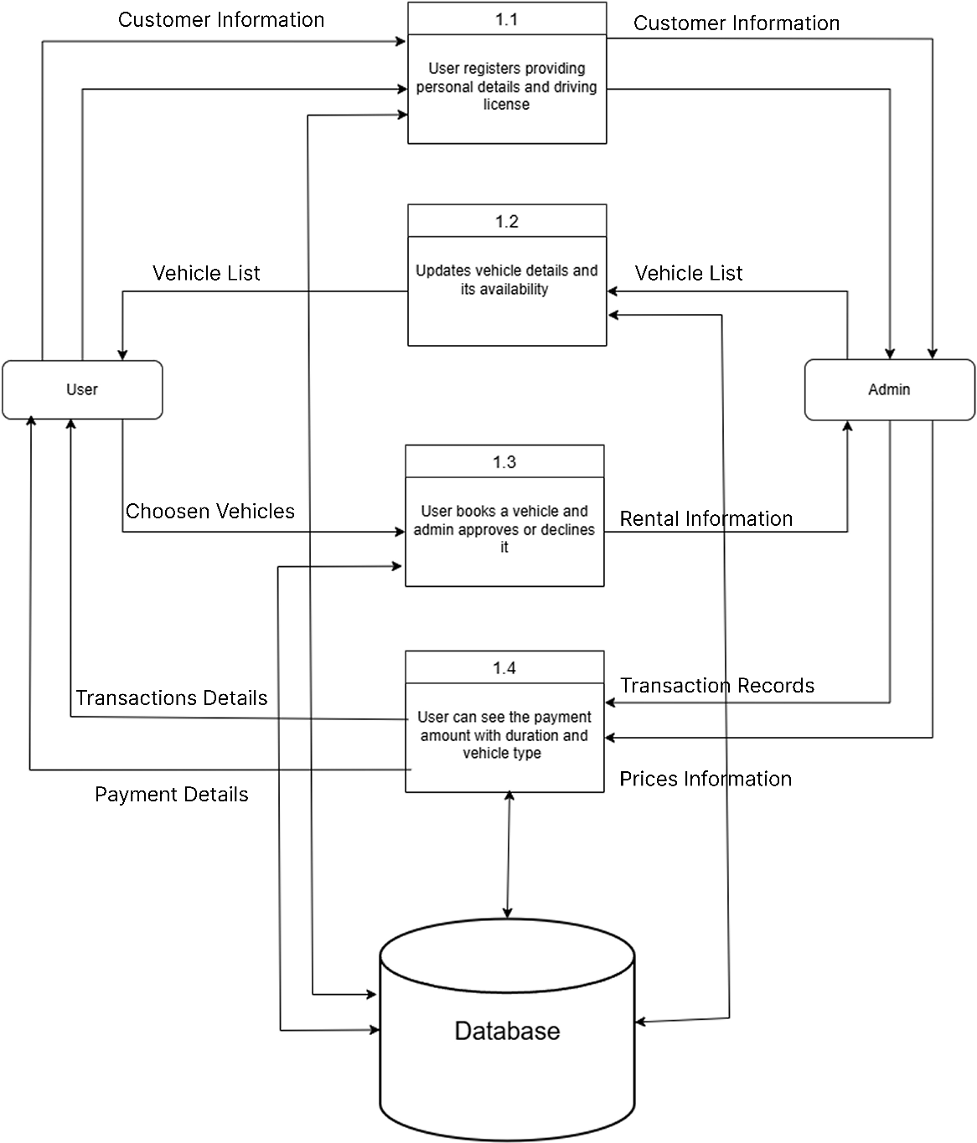
Figure 3.12: Physical DFD of Vehicle Rental System

3.5 Algorithm Used
The Vehicle Rental System implements efficient algorithms to enhance vehicle discovery, comparison, and selection for users. A search algorithm is used to allow users to quickly find vehicles based on specific criteria such as vehicle type, availability, and keywords. When a user enters search input, the system scans the vehicle records stored in the database and retrieves only those entries that match the user’s requirements. This reduces unnecessary data display and helps users find suitable vehicles in a faster and more organized manner.
In addition to searching, the system applies a sorting algorithm that enables users to arrange vehicles according to price preferences. Users can choose to sort vehicles either from low to high price or high to low price. Based on the selected option, the system orders the vehicle list accordingly before displaying it to the user. This feature helps users easily compare vehicles based on affordability or premium pricing, supporting better and quicker decision-making.
Furthermore, the system includes a recommendation algorithm that suggests vehicles based on user reviews and overall experience. This algorithm analyzes customer ratings, feedback, and past booking popularity to identify highly rated and frequently used vehicles. Vehicles with better reviews and positive user experience are prioritized and recommended to users. This approach increases trust, improves user satisfaction, and assists new users in selecting reliable vehicles based on previous customer experiences.
Overall, these algorithms collectively improve system usability by providing faster search results, flexible price comparison, and intelligent vehicle recommendations, resulting in a more user-friendly and efficient vehicle rental platform.

CHAPTER 4: IMPLEMENTATION AND TESTING

4.1 Implementation

4.1.1 Tools Used
i. Front End Tools
The front-end part of application is designed using HTML, CSS and JavaScript.
- HTML
Html, which stands for Hypertext Markup Language, is a foundational language used in web development for creating web pages and websites. In our project, we used html to create and structure sections, headings, links, paragraphs using various tags and elements. HTML ensures structured content, compatibility, accessibility, search engine optimization, integration, scalability, and community support in web development. As, HTML is fast, easy and gives good ser interface, we chose it as a front-end tool. [3]
- JavaScript
JavaScript is a programming language used in web development to make the website responsive and interactive by adding different functionalities of it. Mainly, JavaScript was used for client-side validation, animations and to add the dynamic behavior to the web page. [4]
- CSS
CSS (Cascading Style Sheets) is a language used to make web pages look nice. It controls things like colors, fonts, layouts, and spacing. By using CSS, you can change how your website appears without changing the content. This helps keep your website organized and makes it easier to update the look of multiple pages at once. CSS is also important for making websites work well on different devices, like phones and tablets. [5]
- Back End Tools
- PHP
Php is used in web development to create dynamic web page and to add connectivity to database. It is also used for server-side validation. In this project, PHP as backend language to connect to database and to help in performing the CRUD operations. [6]

- DATABASE TOOLS
- MYSQL
We used MySQL for storing all the information about the library system. Also, the crude operations in this project are performed with the aid of it. XAMPP, a software distribution which provides the Apache web server, MySQL and database all in one package was used. XAMPP was used to develop a local server for data storage and providing base for database. [7]
- DESIGN TOOLS
        - Draw.io:
        - This tool was used to create diagramming tool like DFD, ER diagram for system analysis and design.
        - Figma
        - This tool was used to create design of the Website.

4.1.2 Implementation Details of Modules
Different modules of Vehicle Rental System are:
User Registration & Authentication Module
The User Registration & Authentication Module allows users to create accounts, and log in. Users can register by filling out personal details. Upon successful verification, their data is stored in the database with encrypted passwords. For login, users provide their credentials, and the system authenticates them by checking against the stored data.
Booking & Reservation Module
The Booking & Reservation Module handles the process of booking vehicles and managing reservations Users select their desired vehicle, rental duration, and pickup location, after which the system checks the availability and confirms the booking. Payment details are collected, and once processed, the booking is confirmed. Users can view their booking history and upcoming reservations from their account dashboard. Key functions include creating, viewing, cancelling bookings, and processing payments.

4.2 Testing
Testing part includes making sure all features do what they are supposed to, that the system is easy to use, secure, and performs well. It's done to find and fix problems before the system is used by others.

4.2.1 Test cases for Unit Testing
Table 4.1: Test Case for Login

Test case  No. | Test Case | Expected results | Status
1 | Logging into website | Email and password provided  correct | Successful
2 | Logging into website | Email incorrect | Unsuccessful
3 | Logging into website | Password Incorrect | Unsuccessful
4 | Logging into website | Any field left empty | Unsuccessful

Table 4.2: Test Cases for Sign Up

Test cases No. | Test Case | Expected results | Status
1 | Registration for new user | All details provided correctly | Successful
2 | Registration for new user | Any one field is incorrect | Unsuccessful
3 | Registration for new user | Any field left empty | Unsuccessful

Table 4.3: Test Cases for Payment

Test cases  No. | Test Case | Expected results | Status
1 | Payment | All details provided  correctly | Successful
2 | Payment | Any one field is  incorrect | Unsuccessful
3 | Payment | Any field left empty | Unsuccessful

Table 4.4: Test Cases for Booking

Test cases No. | Test Case | Expected results | Status
1 | Booking | All details provided correctly | Successful
2 | Booking | Any one field is incorrect | Unsuccessful
3 | Booking | Any field left empty | Unsuccessful

4.2.2 Test Cases for System Testing
Table 4.5 Test Cases for system testing of the Vehicle Rental System

Test Case  ID | Test Name | Test case Details | Expected Result | Test Result | Status
1 | Application Launch Test | Open the application | System Login Page opens | System Login Page opens | Pass
2 | Registration Functionality Test | Enter Valid user  credentials | Registration Successful | Registration Successful | Pass
3 | Login Functionality Test | Provide  Correct login credentials | Login successful | Login successful | Pass
4 | Add Product Functionality Test | Click on add  product and enter details | Product  added successfully | Product added successfully | Pass
5 | Delete Product Functionality Test | Select product and delete  details | Product deleted  successfully | Product deleted successfully | Pass
6 | Logout functionality Test | Click on logout button | System Login page  opens | System login page opens | Pass

CHAPTER 5: CONCLUSION AND RECOMMENDATION

5.1 Lesson Learnt/Outcome
The Velorent project provided several key lessons and outcomes. First, it reinforced the importance of a user-centric design, with a seamless, intuitive interface that directly impacts customer satisfaction and retention. Managing real-time data for vehicle availability proved crucial for avoiding booking conflicts and ensuring accurate information. Additionally, efficient fleet management emerged as essential for maintaining high service quality and minimizing operational disruptions. The project also highlighted how effective marketing strategies, both online and offline, play a significant role in customer acquisition and brand visibility.
Financially, the project underscored the importance of balancing initial investments, operational costs, and revenue streams, while careful financial management ensures long- term viability. Providing excellent customer support proved to be a key factor in building loyalty and improving the overall experience.
Moreover, understanding legal and compliance requirements, such as insurance, rental agreements, and data privacy laws, was vital for operating within legal boundaries. Finally, the need for scalability became apparent, as the system should be built to handle growing traffic, more vehicle listings, and increased bookings without compromising performance. Ultimately, Velorent demonstrated that a strong business model, efficient operations, and customer engagement are essential for success in the competitive vehicle rental market.
5.2 Conclusion
In conclusion, Velorent is a promising vehicle rental platform with significant potential for growth and success. By focusing on user-centric design, real-time data management, efficient fleet operations, and strong financial planning, the platform can deliver a seamless and satisfying customer experience. Effective marketing strategies, excellent customer support, and adherence to legal and regulatory standards will be key drivers of its success. Additionally, the ability to scale and adapt to increasing demand ensures that Velorent can continue to thrive in a competitive market. With careful execution and continuous improvement, Velorent is poised to become a leading player in the vehicle rental industry, offering value to both customers and stakeholders.

5.3 Recommendation
VeloRent goes beyond seamless vehicle rentals, it is built on continuous innovation. Secure and fast digital payment systems have already been successfully integrated, ensuring a smooth transaction experience for users. Looking ahead, the platform will evolve further with advanced algorithms and AI-driven features. Future enhancements include intelligent vehicle recommendation systems, real-time availability optimization, automated booking confirmations, and AI-powered customer support to handle user queries instantly. To support increasing demand and high traffic, scalable dedicated servers will be implemented, ensuring performance, reliability, and uninterrupted service. VeloRent’s future roadmap focuses on smarter automation, enhanced user experience, and technology-driven growth.

References

[1] | K. Acharya, "Research Gate," [Online]. Available: https://www.researchgate.net/publication/380835687_Online_Vehicle_Rental_Syste m_Project_Report.
[2] | "Types of Feasibility Study in software project deavelopmeint," GeeksforGeeks, [Online]. Available: https://en.wikipedia.org/wiki/MySQL. [Accessed 05 September 2024].
[3] | W3Schools, "W3Schools," [Online]. Available: https://www.w3schools.com/html/. [Accessed 20 August 2024].
[4] | "Tutorials Point," [Online]. Available: www.tutorialspoint.com/javascript/index.html. [Accessed 28 08 2024].
[5] | R. E. Shamkanth, in Fundamental Of Database System, Pearson.
[6] | A. Forbes, "The Joy of PHP Programming," Plum Island.
[7] | "Wikipedia," Wikipedia, [Online]. Available: https://en.wikipedia.org/wiki/MySQL. [Accessed 30 August 2024].

APPENDIX

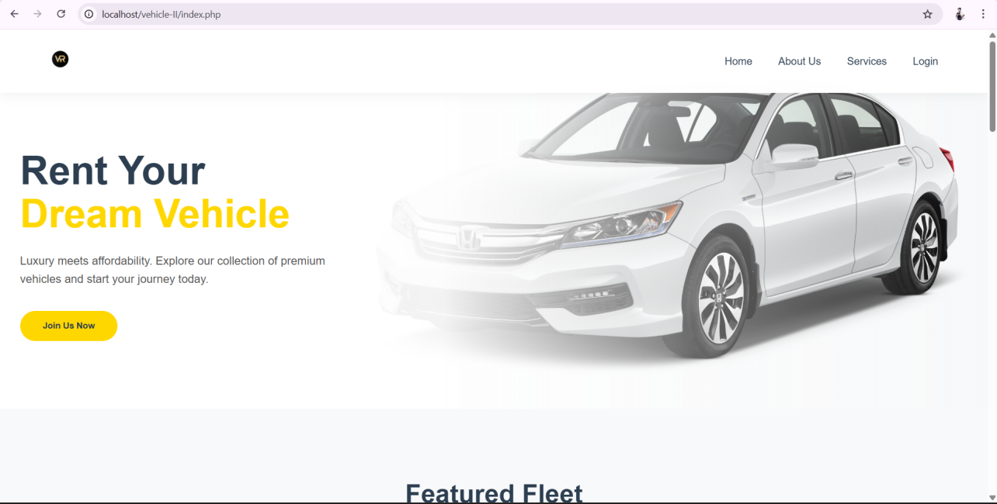
Appendix-A1 Home Page

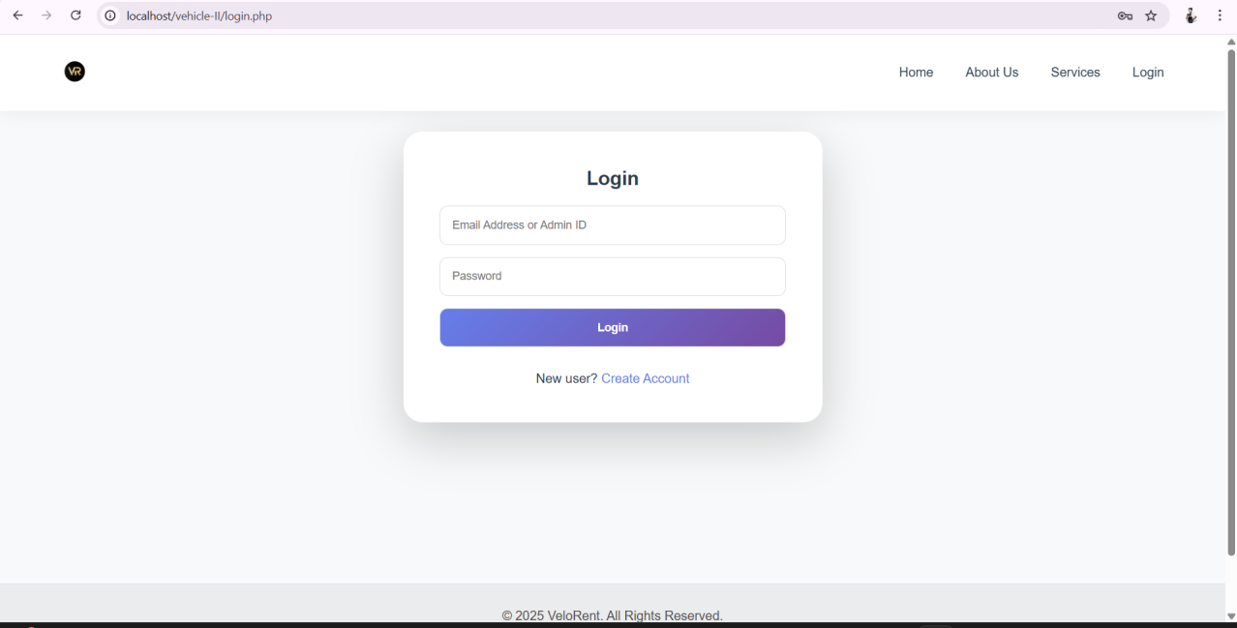
Appendix-A2 Admin Login

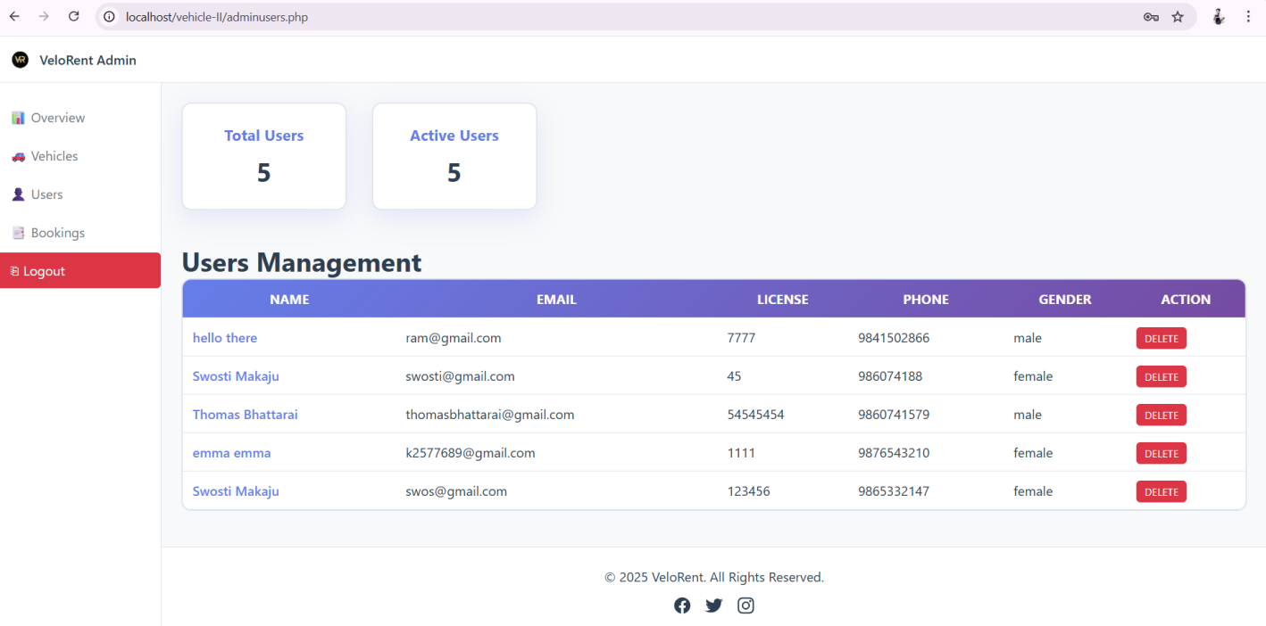
Appendix-A3 User Details

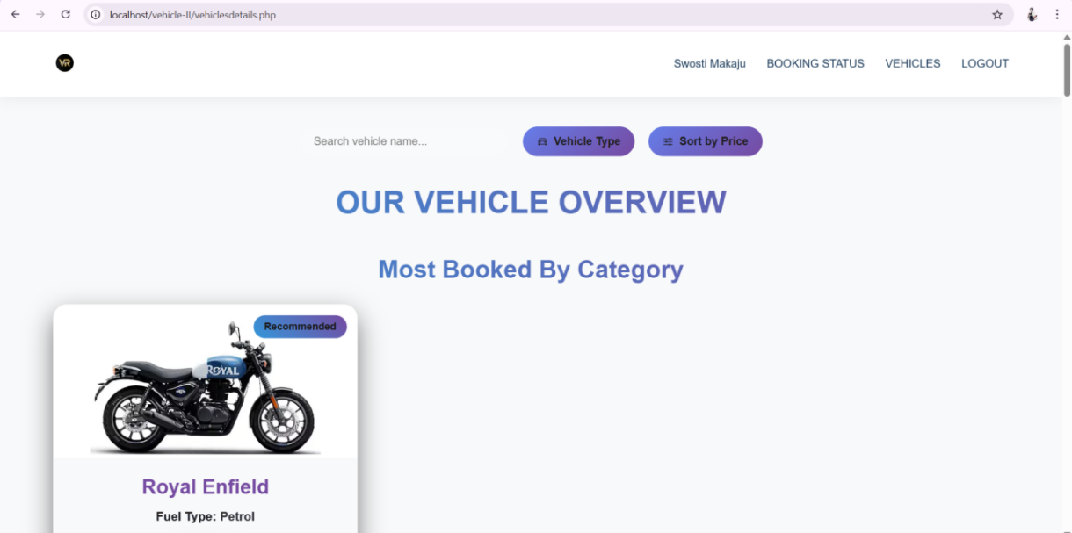

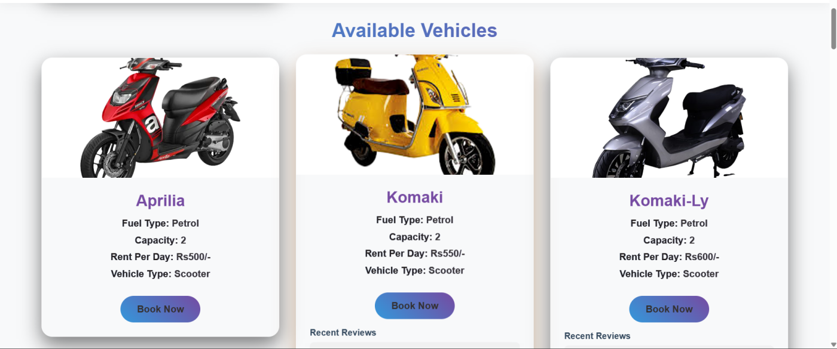

Appendix-A3 User Dashboard

