# 

**C++ Worksheet Task_1**

**ASSESSMENT**

**WEIGHTAGE AND TYPE: 12.5%**

**YEAR: 2024-25**

**STUDENT NAME: SWOYAMRAJ SHRESTHA**

**STUDENT ID:** **24030185**

**Question_1.1**

Write a program that takes a temperature value from the user. It should then allow the user to choose between Celsius (C) and Fahrenheit (F) for conversion. After the user selection, it should then convert the entered temperature to the chosen scale and display the result.

Use appropriate data types for temperature and handle error like non-numeric input. Use the following formula for conversion:

F = (C x 9/5) + 32

C = (F - 32) x 5/9

#include<iostream>

using namespace std;

int main()

{

double temp;

char choice;

cout << "Enter the temperature: ";

cin >> temp;

cout << "Convert it to Celsius (C) or Fahrenheit (F)? ";

cin >> choice;

if (choice == 'C' || choice == 'c')

{

double celsius = (temp - 32) * 5 / 9;

cout << "Temperature in Celsius: " << celsius << "C" << endl;

}

else if (choice == 'F' || choice == 'f')

{

double fahrenheit = (temp * 9 / 5) + 32;

cout << "Temperature in Fahrenheit: " << fahrenheit << "F" << endl;

}

else

{

cout << "Invalid choice! Please enter 'C' or 'F'." << endl;

}

return 0;

}

**Output:**

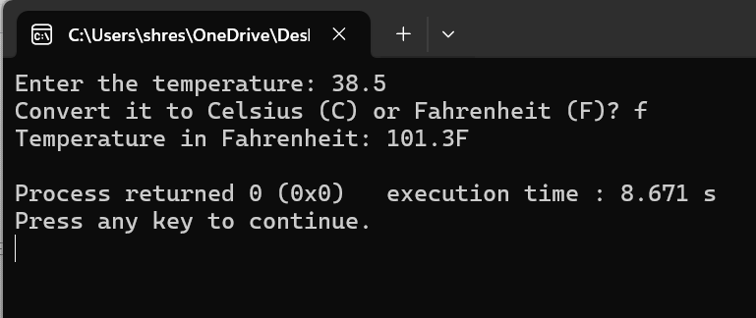

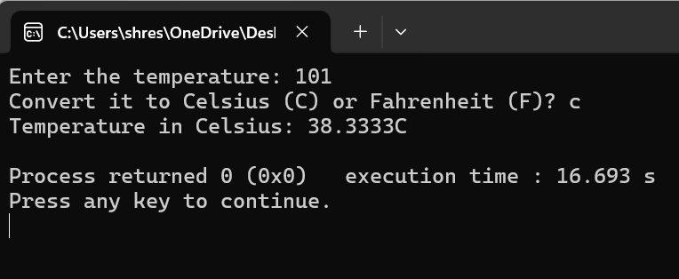

**Question_1.2**

Write a C++ program to implement a number guessing game with different difficulty levels.

Easy difficulty ranges from 1-8, medium from 1-30, hard from 1-50. Then, generate a random number to check if the guess is correct based on the user's selection.

#include <iostream>

#include <ctime> //generates random numbers

using namespace std;

int main()

{

srand(time(0));

int easy = rand() % 8 + 1;

int medium = rand() % 30 + 1;

int hard = rand() % 50 + 1;

int guess;

char difficulty;

cout << "******************* Number Guessing Game *******************" << endl;

cout << "" << endl;

cout << "Choose the level: Easy (e), Medium (m), Hard (h): ";

cin >> difficulty;

switch (difficulty)

{

case 'e': case 'E':

cout << "Guess a number between 1 to 8: ";

cin >> guess;

if (guess == easy)

{

cout << "Congratulations! You guessed the correct number." << endl;

}

else

{

cout << "Wrong guess! The correct number was " << easy << "." << endl;

}

break;

case 'm': case 'M':

cout << "Guess a number between 1 and 30: ";

cin >> guess;

if (guess == medium)

{

cout << "Congratulations! You guessed the correct number." << endl;

}

else

{

cout << "Wrong guess! The correct number was " << medium << "." << endl;

}

break;

case 'h': case 'H':

cout << "Guess a number between 1 and 50: ";

cin >> guess;

if (guess == hard)

{

cout << "Congratulations! You guessed the correct number." << endl;

}

else

{

cout << "Wrong guess! The correct number was " << hard << "." << endl;

}

break;

default:

cout << "Invalid input! Kindly choose a valid difficulty." << endl;

}

return 0;

}

**Output:**

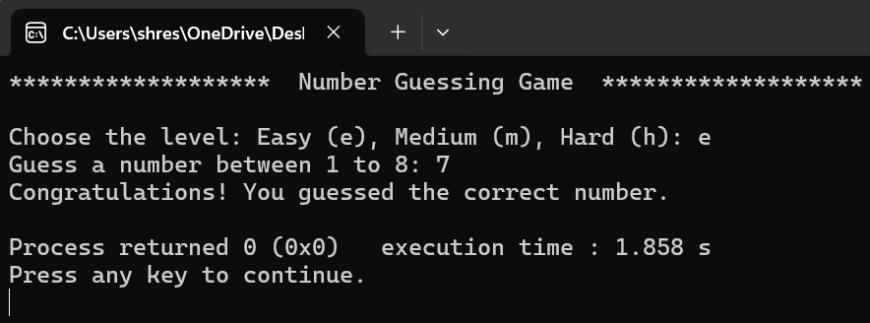

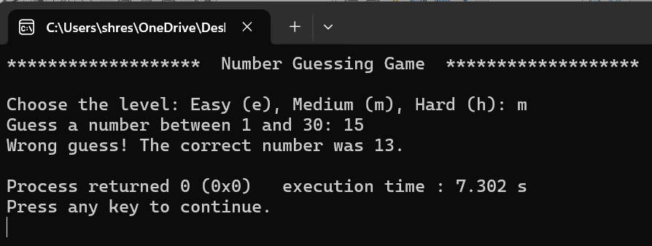

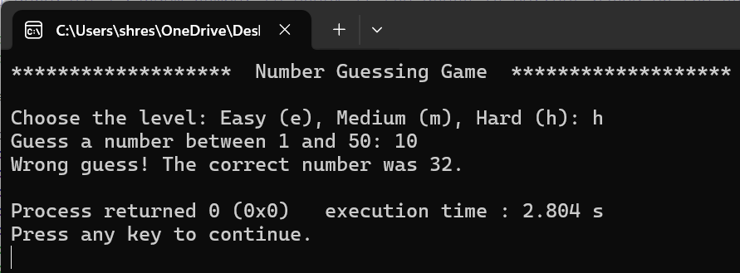

**Question_1.3**

Write a program that reads an array of integer numbers from the user and sorts the numbers in the ascending order.

#include <iostream>

#include <algorithm>

using namespace std;

int main()

{

int n, arr[100];

cout << "Enter number of element: ";

cin >> n;

if (n > 100 || n <= 0)

{

cout << "Invalid input! Please enter a number between 1 and 100." << endl;

return 1; //quits Program

}

cout << "Enter numbers: ";

for (int i = 0; i < n; i++)

{

cin >> arr[i];

}

sort(arr, arr + n);

cout << "Sorted numbers: ";

for (int i = 0; i < n; i++)

{

cout << arr[i] << " ";

}

cout << endl;

return 0;

}

**Output:**

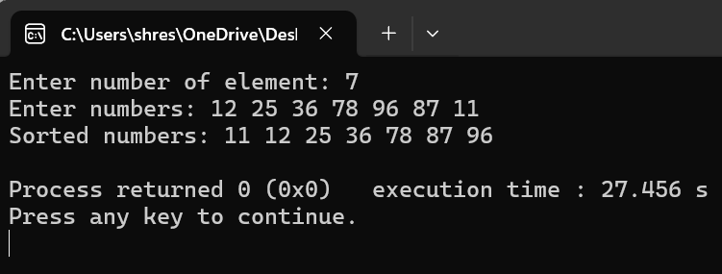

**Question_1.4**

Write a program that reads a number from the user and based on the user input, it says what day of the week it is, Sundays being 1 and Saturdays being 7.

Your system should give appropriate response for invalid input entries.

#include <iostream>

using namespace std;

int main()

{

int day;

cout << "Enter the day of the week (1-7): ";

cin >> day;

switch (day)

{

case 1:

cout << "Sunday" << endl;

break;

case 2:

cout << "Monday" << endl;

break;

case 3:

cout << "Tuesday" << endl;

break;

case 4:

cout << "Wednesday" << endl;

break;

case 5:

cout << "Thursday" << endl;

break;

case 6:

cout << "Friday" << endl;

break;

case 7:

cout << "Saturday" << endl;

break;

default:

cout << "Invalid! Please enter a number between 1 and 7." << endl;

}

return 0;

}

**Output:**

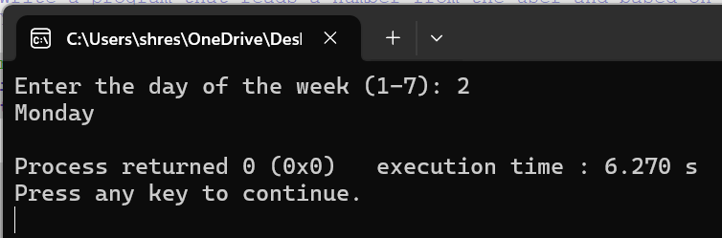

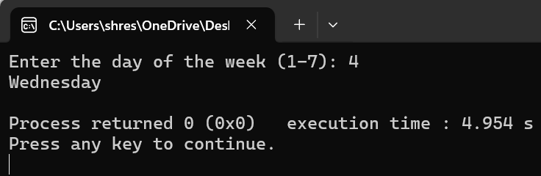

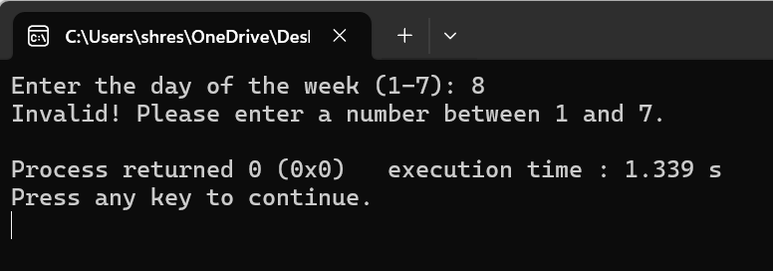

**Question_2.1**

Create a program that takes a positive integer as input and determines whether it's a "bouncy number". A bouncy number is one where the digits neither consistently increase nor consistently decrease when read from left to right. For example:

*123 is NOT bouncy (digits consistently increase)

*321 is NOT bouncy (digits consistently decrease)

*120 is bouncy (neither consistently increasing nor decreasing)

#include <iostream>

using namespace std;

bool BouncyNum(int num)

{

if (num < 100) return false;

bool increasing = false, decreasing = false;

int lastDigit = num % 10;

num /= 10; //removes last digit

while (num > 0)

{

int currentDigit = num % 10;

if (currentDigit < lastDigit) increasing = true;

if (currentDigit > lastDigit) decreasing = true;

if (increasing && decreasing) return true; //if both are true, it's bouncy

lastDigit = currentDigit;

num /= 10;

}

return false;

}

int main()

{

int num;

cout << "Enter a positive integer: ";

cin >> num;

if (BouncyNum(num))

{

cout << num << " is a bouncy number." << endl;

}

else

{

cout << num << " is not a bouncy number." << endl;

}

return 0;

}

**Output:**

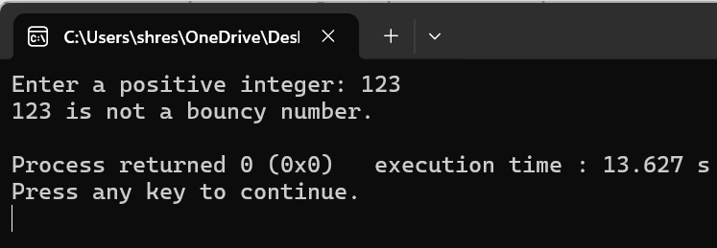

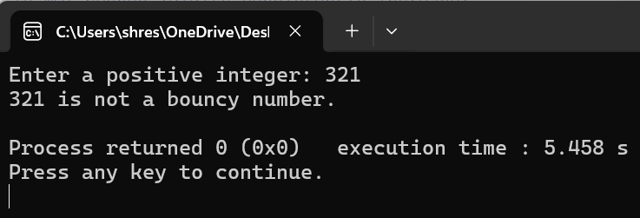

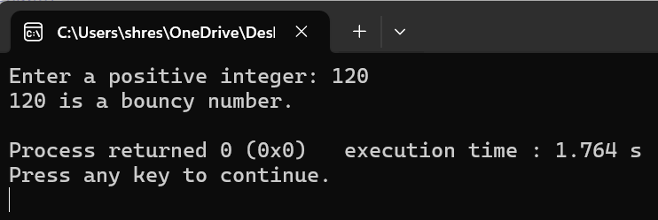

**Question_3.1**

Write a program that manages a cinema ticket booking system. The program should display a 5x5 seating arrangement.

#include <iostream>

using namespace std;

int main()

{

char tbs[5][5] = //5x5 seat

{

{'O', 'O', 'O', 'O', 'O'},

{'O', 'O', 'O', 'O', 'O'},

{'O', 'O', 'O', 'O', 'O'},

{'O', 'O', 'O', 'O', 'O'},

{'O', 'O', 'O', 'O', 'O'}

};

while (true)//looping for seat booking

{

cout << "****** Cinema Seat Reservation ******:\n";

for (int row = 0; row < 5; row++)//shows current seat

{

for (int col = 0; col < 5; col++)

{

cout << tbs[row][col] << " "; //shows seat availability status

}

cout << endl;

}

cout << "Select a Row (1-5)? ";

int row;

cin >> row;

cout << "Select a Column (1-5)? ";

int col;

cin >> col;

if (row == 0 && col == 0)

{

cout << "Exit\n";

break;

}

if (row < 1 || row > 5 || col < 1 || col > 5) //checks if row and column are within valid range

{

cout << "Please select between 1 and 5.\n";

continue;

}

row--;

col--;

if (tbs[row][col] == 'X') { //Checks if the seat is already booked

cout << "The seat is already reserved. Try another\n";

continue;

}

tbs[row][col] = 'X';

cout << "Seat booked successfully!\n";

char choice;

cout << "Do you want to book more seats? (y/n): ";

cin >> choice;

if (choice == 'n' || choice == 'N') {

cout << "Thank you for booking, Enjoy watching!\n";

break;

}

}

return 0;

}

**Output:**

