# 

**C++ Worksheet Task_3**

**ASSESSMENT**

**WEIGHTAGE AND TYPE: 12.5%**

**YEAR: 2024-25**

**STUDENT NAME: SWOYAMRAJ SHRESTHA**

**STUDENT ID:** **24030185**

**Question_1.1**

Create a Time class to store hours and minutes. Implement:

1.Overload the + operator to add two Time objects

2.Overload the > operator to compare two Time objects

3.Handle invalid time (>24 hours or >60 minutes) by throwing a custom exception

#include <iostream>

#include <stdexcept>

using namespace std;

class ITE : public exception

{

public:

const char* what() const noexcept override

{

return "Invalid time! Time Hours must be less than or equals to 24 and minutes must be less than 60.";

}

};

class Time

{

private:

int hours;

int minutes;

void validate()

{

if (hours > 24 || minutes >= 60)

{

throw ITE();

}

}

public:

Time(int h = 0, int m = 0) : hours(h), minutes(m) // Constructor with default values

{

validate();

}

Time operator+(const Time& other) const

{

int totalHours = hours + other.hours;

int totalMinutes = minutes + other.minutes;

if (totalMinutes >= 60)

{

totalHours += totalMinutes / 60;

totalMinutes %= 60;

}

return Time(totalHours, totalMinutes);

}

bool operator>(const Time& other) const

{

return (hours * 60 + minutes) > (other.hours * 60 + other.minutes);

}

void display() const

{

cout << hours << " hours " << minutes << " minutes" << endl;

}

};

int main()

{

try

{

int h1, m1, h2, m2;

cout << "Enter first time (hours minutes): ";

cin >> h1 >> m1;

Time t1(h1, m1);

cout << "Enter second time (hours minutes): ";

cin >> h2 >> m2;

Time t2(h2, m2);

Time sum = t1 + t2; //sum of times

cout << "Sum: ";

sum.display();

if (t1 > t2) //comparing time

{

cout << "First time is greater." << endl;

}

else

{

cout << "Second time is greater or equal." << endl;

}

}

catch (const exception& e)

{

cout << "Error: " << e.what() << endl;

}

return 0;

}

**Output:**

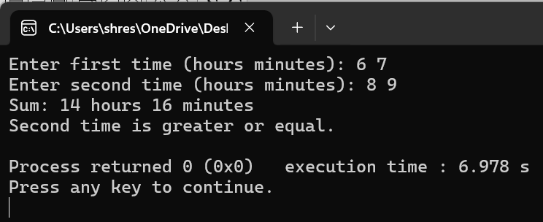

**Question_2.1**

Create a base class Vehicle and two derived classes Car and Bike:

1.Vehicle has registration number and color

2.Car adds number of seats

3.Bike adds engine capacity

4.Each class should have its own method to write its details to a file

5.Include proper inheritance and method overriding

#include <iostream>

#include <fstream>

#include <memory>

using namespace std;

class Vehicle // Base Class

{

protected:

string regNo;

string paint;

public:

Vehicle(const string& reg, const string& clr) : regNo(reg), paint(clr) {}

virtual void saveToFile(ofstream& out) const

{

out << "Vehicle - Reg: " << regNo << ", Color: " << paint << endl;

}

virtual void print() const

{

cout << "Vehicle -> Reg No: " << regNo << ", Color: " << paint << endl;

}

virtual ~Vehicle() {}

};

class FourWheeler : public Vehicle // Derived Class - Four Wheeler

{

int seatCount;

public:

FourWheeler(const string& reg, const string& clr, int seats) : Vehicle(reg, clr), seatCount(seats) {}

void saveToFile(ofstream& out) const override

{

out << "Car - Reg: " << regNo << ", Color: " << paint << ", Seats: " << seatCount << endl;

}

void print() const override

{

cout << "Car Reg No: " << regNo << ",\nColor: " << paint << ",\nSeats: " << seatCount << endl;

}

};

class TwoWheeler : public Vehicle // Derived Class - Two Wheeler

{

int cc;

public:

TwoWheeler(const string& reg, const string& clr, int engineCC) : Vehicle(reg, clr), cc(engineCC) {}

void saveToFile(ofstream& out) const override

{

out << "Bike - Reg: " << regNo << ", Color: " << paint << ", Engine: " << cc << "cc" << endl;

}

void print() const override

{

cout << "Bike Reg No: " << regNo << ",\nColor: " << paint << ",\nEngine: " << cc << "cc" << endl;

}

};

int main()

{

ofstream record("Vehicle's Registration.txt", ios::app);

if (!record.is_open())

{

cerr << "The file does not exist!" << endl;

return -1;

}

int option = 0;

do

{

cout << "\n******* Vehicle Entry Menu *******" << endl;

cout << "1. Add Car\n2. Add Bike\n3. Save & exit\nSelect Option: ";

cin >> option;

cin.ignore(); //clears the input buffer

string rno, col;

unique_ptr<Vehicle> ptr = nullptr;

switch (option)

{

case 1:

{

int seats;

cout << "Enter Car Registration Number: ";

getline(cin, rno);

cout << "Enter Car Color: ";

getline(cin, col);

cout << "Enter Seat Count: ";

cin >> seats;

cin.ignore(); //clears newline from buffer

ptr = make_unique<FourWheeler>(rno, col, seats);

break;

}

case 2:

{

int engine;

cout << "Enter Bike Registration Number: ";

getline(cin, rno);

cout << "Enter Bike Color: ";

getline(cin, col);

cout << "Enter Engine Capacity (cc): ";

cin >> engine;

cin.ignore();

ptr = make_unique<TwoWheeler>(rno, col, engine);

break;

}

case 3:

cout << "Saving and exiting program..." << endl;

break;

default:

cout << "Invalid input! Please choose 1, 2, or 3." << endl;

}

if (ptr)

{

ptr->saveToFile(record);

cout << "Vehicle registration successfully recorded:\n";

ptr->print();

}

} while (option != 3);

record.close();

return 0;

}

**Output:**

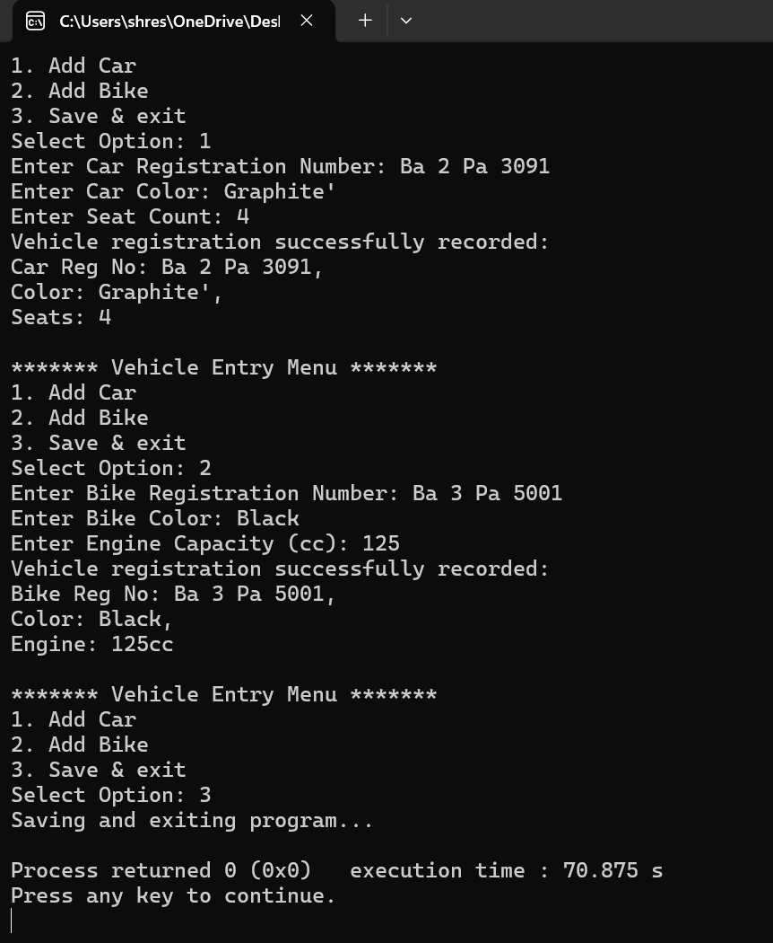

**Question_2.2**

#include <iostream>

#include <fstream>

#include <stdexcept>

#include <string>

#include <vector>

using namespace std;

struct Student

{

int roll;

string name;

int marks;

};

void validateMarks(int marks)

{

if (marks < 0 || marks > 100)

{

throw out_of_range("Marks should be between 0 and 100.");

}

}

vector<Student> readRecords(string fileName)

{

vector<Student> records;

ifstream File(fileName);

if (!File)

{

cout << "The file does not exist.\n";

return records;

}

Student student;

while (File >> student.roll >> student.name >> student.marks)

{

records.push_back(student);

}

File.close();

return records;

}

void saveStdRecords(string fileName, vector<Student> records)

{

ofstream File(fileName);

if (!File)

{

cout << "Error opening file for writing!\n";

return;

}

for (const auto& records : records)

{

File << records.roll << " " << records.name << " " << records.marks << endl;

}

File.close();

}

int main()

{

string fileName = "Student's Record.txt";

vector<Student> studentlist = readRecords(fileName);

if (!studentlist.empty())

{

cout << "Existing Student Records:\n";

for (const auto& student : studentlist)

{

cout << "Roll: " << student.roll << ", Name: " << student.name << ", Marks: " << student.marks << endl;

}

}

else

{

cout << "No records found.\n";

}

bool running = true;

while (running)

{

int userchoice;

cout << "\nChoose an option:\n";

cout << "1. Add new student record\n";

cout << "2. Modify existing student record\n";

cout << "3. Save and Exit\n";

cout << "Enter choice: ";

cin >> userchoice;

if (userchoice == 1)

{

Student newStudent; // Option to add a new student

cout << "Enter Roll: ";

cin >> newStudent.roll;

cin.ignore(); // To clear the buffer after taking integer input

cout << "Enter Name: ";

getline(cin, newStudent.name);

cout << "Enter Marks: ";

cin >> newStudent.marks;

try

{

validateMarks(newStudent.marks);

studentlist.push_back(newStudent);

cout << "New student record added successfully.\n";

}

catch (const out_of_range& e)

{

cout << "Error: " << e.what() << endl;

}

}

else if (userchoice == 2)

{

int rollNoToModify;

cout << "Enter Roll No of student to modify: ";

cin >> rollNoToModify;

bool recfound = false;

for (auto& student : studentlist)

{

if (student.roll == rollNoToModify)

{

recfound = true;

cout << "Enter new marks: ";

int newMarks;

cin >> newMarks;

try

{

validateMarks(newMarks);

student.marks = newMarks;

cout << "Marks updated successfully.\n";

}

catch (const out_of_range& e)

{

cout << "Error: " << e.what() << endl;

}

break;

}

}

if (!recfound)

{

cout << "Student with Roll No " << rollNoToModify << " not found.\n";

}

}

else if (userchoice == 3)

{

saveStdRecords(fileName, studentlist);

cout << "Records saved successfully! Exiting program.\n";

running = false;

}

else

{

cout << "Invalid choice. Please try again.\n";

}

}

return 0;

}

**Output:**

