Deep Learning for Detecting Distracted Drivers
Ronik Kumar Das¹, Saugat Mohanty²,Ankit Mishra³, Swoyam Prakash Mohanty⁴, Mr. Priyatosh Mishra⁵

Department of Computer Science and Engineering, Siksha ‘O’ Anusandhan (Deemed to be University), Bhubaneswar, Odisha, India
1ronikdas50@gmail.com 2saugatmohanty100@gmail.com
3mishraankit79084@gmail.com
4mohantysanu901@gmail.com
5@soa.ac.in

Abstract. The ultimate aim of this project is to design a creative distracted driver detection system utilizing image processing methods based on the application of deep learning technology with TensorFlow and Convolutional Neural Network (CNN) structure. Tasks involve developing a deep model that carries out real-time image-based driver behavior analysis to identify distraction cases. Distracted driving is a common worldwide phenomenon because it leads to numerous road accidents every year. In addition, the threat of road accidents due to distracted driving is worsened by the increasing availability and use of smartphones and other electronic gadgets. Therefore, it is very important to address this issue by using computer vision and deep learning technologies to aid in distracted behaviour detection in drivers. The project will use TensorFlow because of its popularity as an open source machine learning framework and for its ease in training and deployment of models. The selected CNN architecture is expected to improve the system's proficiency in feature extraction from the images by making it possible to identify distracted behaviours such as texting, making phone calls, and other activities that could endanger safe driving. The model will be trained on a wide range of distracted behavioral patterns while driving in a myriad of conditions. Continuous driver's behavior observation is expected to be accomplished through real-time image processing.

Keywords: Distracted Driving, Deep Learning, MobileNetV2, Transfer Learning, Driver Monitoring.

Introduction
The increased density of information has made it impossible for ordinary people to distinguish between true and fake news. Users of online social networks are quickly influenced by the deceptive language of online fake news, which is already having a significant impact on offline society. Detecting fake news and improving the credibility of information in online social networks requires swift action. Numerous supervised and unsupervised learning algorithms are used to classify text in today’s fake news corpus. However, most studies focus on specific datasets or domains, particularly policy domains. Consequently, algorithms trained on specific article types do not perform optimally when exposed to articles from different domains. Each news area has a distinct text structure, making it challenging to develop a general algorithm that excels across all news areas. In this work, we propose an en- semble machine learning strategy to address the problem of fake news detection. Ensemble learners have proven effective in many applications because they reduce errors by employing strategies such as bagging and boosting. These techniques enable the effective and efficient training of various machine learning algorithms. We also performed rigorous testing using four real-world, freely available datasets.

Motivation

The general objective of the project is to develop a pioneering distracted driver detection system through image processing on the basis of applying deep learning technology with TensorFlow and Convolutional Neu-ral Network (CNN) architecture. The tasks involve developing a deep model that conducts real-time image-based driver behavior analysis to mark cases of distraction. Distracted driving is a common worldwide prob-lem, as it leads to millions of road accidents annually. In addition, the threat of road accidents due to distract-ed driving is worsened by the increasing availability and use of smartphones and other electronic gadgets. Therefore, it is very important to address this issue by using computer vision and deep learning technologies to aid in distracted behaviour detection in drivers. The project will employ TensorFlow due to its popularity as an open source machine learning framework and simplicity in model training and deployment. The chosen CNN architecture is supposed to enhance the system's competence in feature extraction from the images with the ability to detect distracted behaviors like texting, calling, and other activities that can compromise safe driving. Trained on numerous distracted patterns of behavioral patterns while driving, under a wide variety of conditions, this model is expected to find continuous observation of driver's behavior in real time through continuous image processing.

Objectives

The objective of this project is to design and implement a real-time driver distraction detection system using deep learning and computer vision. By leveraging Convolutional Neural Networks (CNNs) and transfer learning with MobileNetV2, the system classifies ten different driver behaviors, such as texting or talking on the phone, based on live webcam input. The model is trained on a balanced dataset using data augmentation and fine-tuning to achieve high accuracy. Integrated with a graphical user interface and alert mechanism, the system aims to enhance road safety by identifying distractions in real time and providing timely feedback to the driver.

Original Contribution

This project’s original contribution lies in developing a complete, real-time driver distraction detection system that combines deep learning, computer vision, and user interface integration. Unlike many research efforts that focus solely on model accuracy, this work delivers a deployable solution using MobileNetV2, fine-tuned on a balanced dataset to classify ten specific driver behaviors. The system includes real-time webcam monitoring, distraction-based alerting, and a Tkinter GUI, making it both functional and practical for real-world driver safety applications.

Paper layout

The manuscript is structured to provide a comprehensive overview of the research process and findings. Section 1 introduces the background and defines the problem being addressed. Section 2 presents a literature survey, reviewing existing methods related to the topic. Section 3 outlines the proposed system, detailing the design and model architecture. Section 4 describes the methodologies, including data preparation and model training procedures. Section 5 discusses the results and evaluates the performance of the model. Finally, Section 6 concludes the study and highlights potential directions for future work.

Literature Survey
Existing literature on driver monitoring has examined methods such as eye tracking, head pose estimation, and sensor-based methods. Although working well under controlled situations, they tend to fail in real-time usage and changing environmental conditions. Recent research is focused on the use of deep learning, especially Convolutional Neural Networks (CNN), to classify driver behaviors from images. Some works have used transfer learning models like VGG and ResNet on the State Farm dataset, showing improved accuracy. However, most lack real-time integration and practical deployment. This project builds upon these foundations by focusing on real-time classification, multi-class behavior detection, and deployable system design.

Proposed System

The proposed system is a real-time driver distraction detection model designed to enhance road safety by monitoring driver behavior through a webcam. At its core, the system uses a Convolutional Neural Network (CNN) based on the MobileNetV2 architecture, which has been fine-tuned to classify ten different driver actions such as safe driving, texting, talking on the phone, or drinking. The model was trained on a carefully balanced and augmented dataset to ensure reliable performance across all classes. To make the system user-friendly and practical, it integrates a graphical interface using Tkinter, which displays live video and prediction results. The system also includes an alert mechanism that triggers a visual and audio warning if a distraction is detected for a sustained period. This combination of accurate classification, real-time video processing, and immediate feedback makes the proposed system not only technically effective but also practically deployable in vehicles or driver assistance setups.

Methodologies

The approach of this project includes a few major steps, starting with data preparation from the State Farm Distracted Driver Detection dataset. The dataset was balanced by sampling an equal proportion of images for each class, followed by preprocessing like resizing, normalization, and one-hot encoding. Data augmentation methods such as rotation, zoom, shift, and flipping were implemented for better generalization. Two models were created: a bespoke Convolutional Neural Network (CNN) and a transfer learning model from MobileNetV2. The MobileNetV2 model was optimized and fine-tuned through hyperparameter tuning with Keras Tuner. For testing robustness, K-Fold cross-validation was used, and the finalized model was tested on unseen data. The trained model was then integrated into a real-time monitoring system using OpenCV for video capture and Tkinter for the user interface, with a built-in alert mechanism to notify the driver upon detecting distraction.

Schematic layout of the proposed model

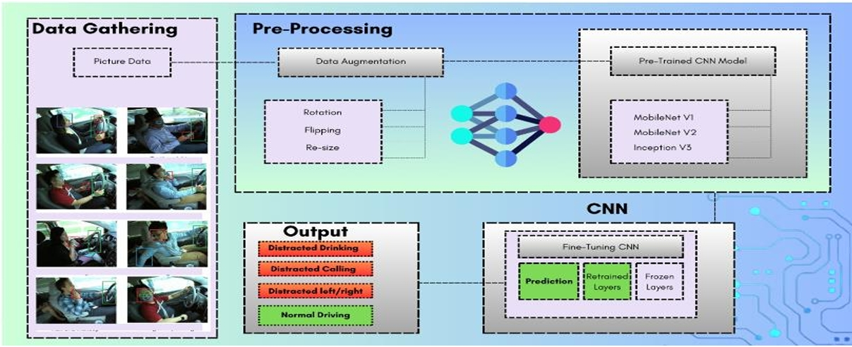

Fig 1 : Schematic Layout

Fig 1-The proposed system begins with collecting picture-based driving data that reflects various real-world behaviors such as normal driving and different types of distractions. This image data is then passed through a preprocessing stage, where data augmentation techniques like rotation, flipping, and resizing are applied to enhance the dataset and improve model generalization. The preprocessed images are used to train a deep learning model based on pre-trained Convolutional Neural Networks (CNNs) such as MobileNetV1, MobileNetV2, and InceptionV3. The chosen model undergoes fine-tuning, where selected layers are retrained while others remain frozen to retain previously learned features. Finally, the system outputs real-time predictions of driver states, classifying actions such as distracted drinking, phone usage, or normal driving. This structured pipeline allows the model to learn efficiently and perform well in detecting distractions under various conditions.

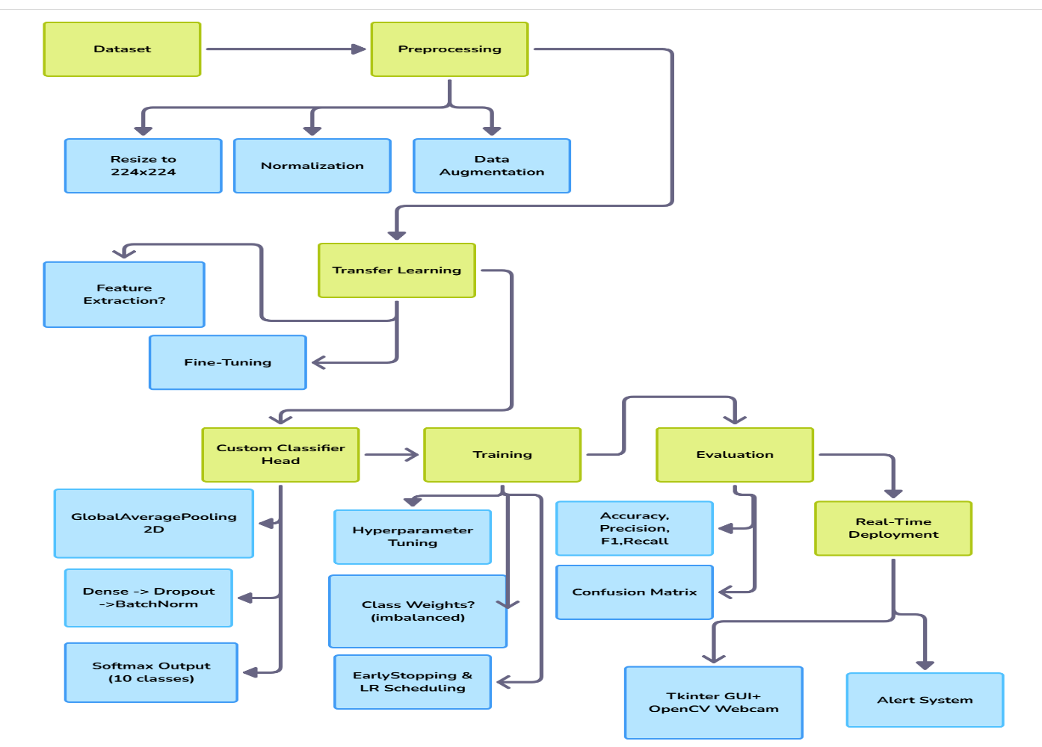
Fig 2 : Pipeline Architecture

System Requirements

The system developed in this project is designed to run efficiently on commonly available hardware and software setups. It is compatible with both Windows 10 and Ubuntu 20+ operating systems, offering flexibility across platforms. A minimum of 8 GB of RAM is recommended to ensure smooth training and real-time prediction, although the use of a GPU is optional depending on whether faster model training is required. The project is built using Python 3.8 or higher, leveraging a range of powerful libraries including TensorFlow and Keras for deep learning, OpenCV for video processing, and Tkinter for creating the graphical user interface. Additionally, NumPy and Pandas are used for data handling, while Matplotlib supports visualization tasks. This configuration ensures the system is accessible, adaptable, and capable of delivering reliable performance in both development and deployment phases.

Proposed Algorithm(s)

The core algorithm used in this project is a fine-tuned deep learning model based on the MobileNetV2 architecture, which is well-suited for real-time image classification tasks. The model begins by taking an input image, typically a frame from a live webcam feed, which is first resized and normalized to match the format expected by the neural network. These preprocessed frames are then passed through several convolutional layers of the MobileNetV2 model, which extract important visual features such as edges, textures, and patterns. The base layers of the pre-trained model remain mostly frozen to retain general image understanding, while the final layers are retrained using driver-specific image data to adapt the model to the distraction detection task. A fully connected layer with a softmax activation is added at the end to produce probabilities across ten different driver behavior classes. The class with the highest probability is selected as the model’s prediction. This algorithm efficiently combines transfer learning with task-specific fine-tuning, making it lightweight, fast, and accurate for real-time driver monitoring applications.

Model Evaluation
Model comparison of forex awareness in desktop getting to know includes assessing the overall performance and accuracy of a forex attention model. This assessment usually consists of metrics such as precision, recall, and F1-score, alongside strategies like cross-validation and confusion matrices. The mannequin is examined by the use of a labelled dataset of foreign money images, and the assessment outcomes furnish insights into its effectiveness in efficiently figuring out and classifying distinct currencies. These critiques assist in enhancing and fine-tuning the mannequin for extra dependable and correct forex recognition

Depiction of results

Evaluating the model with hyperparameter tuning

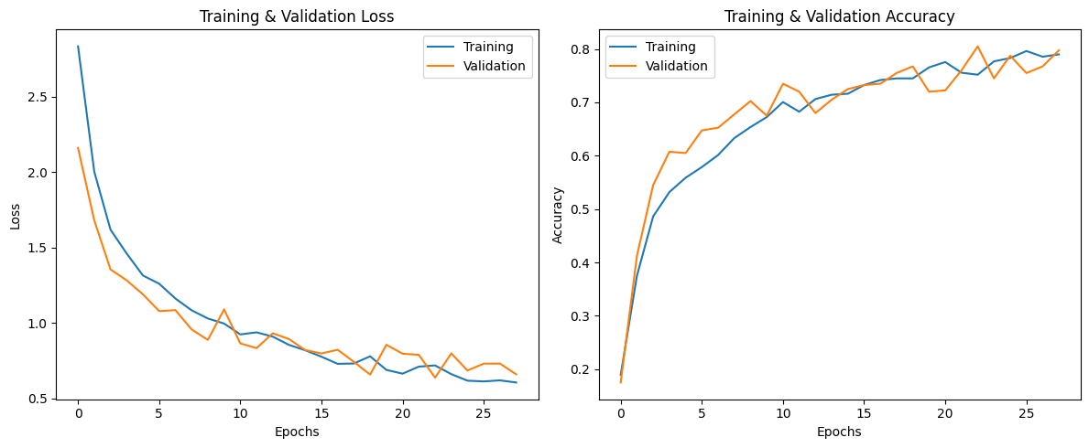

Fig 3 : Training & validation Loss Fig 4: Training & validation Accuracy
The validation and training performance of the model indicate encouraging trends of stability and generalization. The training loss steadily went down as training went on, while the validation loss stabilized early and stayed considerably low, which means that the model didn't overfit and could generalize very well on new data. Accuracy curves also testify to it: training accuracy increased slowly across epochs, and validation accuracy remained in the range of 65% to 75%. Surprisingly, in some cases, validation accuracy was higher than training accuracy, indicating good regularization—most probably due to dropout layers used during training.To gauge model behavior in greater detail, we looked at the confusion matrix, both in raw and normalized state. All classes had great recall and precision, especially

Table no 1: Recall Performance for different Classes

Activity | Recall
Texting Left | 98.0%
Operating Radio | 93.5%
Reaching Behind | 97.5%
Talking on Phone - Left | 87.0%
Talking on Phone - Right | 84.5%
Texting Right | 85.0%
Talking to Passenger | 85.0%

Yet, certain classes were more difficult for the model. The weakest performer was the "Hair & Makeup" class that posted a recall of just 58.5%, with high rates of misclassifications, particularly with visually similar classes. The most frequent misclassifications for Hair & Makeup were:
Talking on Phone – Right (21 misclassifications)
Safe Driving (11 misclassifications)
Reaching Behind (7 misclassifications)
Occasional confusion with Texting Left and Drinking
These mistakes probably result from visual confusion in posture, hand positioning, and facial direction, which can mislead the model when making predictions

Summary of Results:
Overall accuracy: 84.0%
Weighted F1-Score: 83.73%
Weighted Precision: 84.39%
Weighted Recall: 84.00%

Model Comparison :
Table no 2: Model Comparison

Model Type | Accuracy | Hair & Makeup Recall | Comment
Hyperparameter Tuned | 84.00% | 58.5% | Best overall performance
Fine-Tuned Model | 78.35% | 54.0% | Better on Hair & Makeup only
Transfer Model | 75.90% | 48.0% | Lower overall and class recall

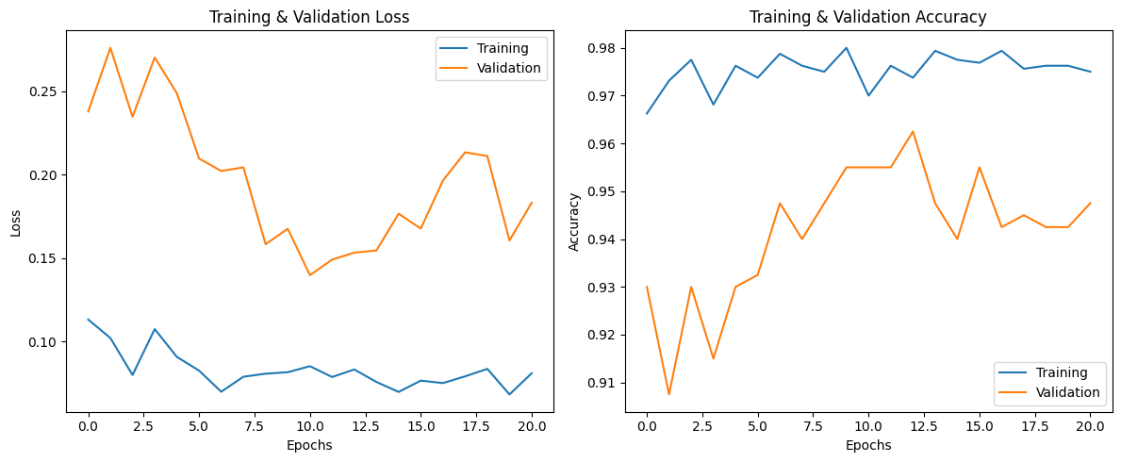

Fig 3 : Training & validation Loss Fig 4: Training & validation Accuracy

Fine-Tuned Transfer Learning Model Evaluation Summary:

The optimized transfer learning model was trained on 1,600 images of 10 classes and tested on 400 images. The training process exhibited stable learning behavior, as observed from the loss and accuracy plots. Training loss reduced steadily with the number of epochs and remained consistently lower than validation loss, showing good generalization. Training accuracy progressed step by step, reaching up to more than 97%, whereas validation accuracy fluctuated slightly but remained above 92%, going up to 95% at its peak.

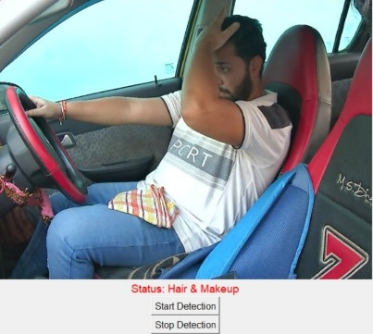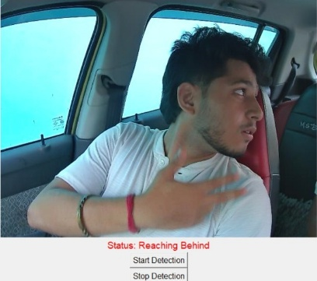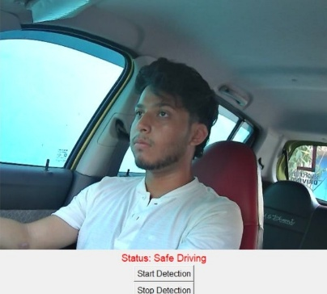
Fig 4: Hair & Makeup Fig 5: Reaching behind Fig 6: Safe Driving

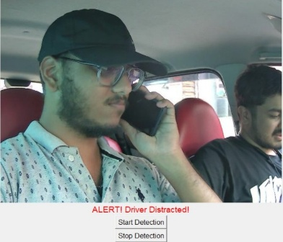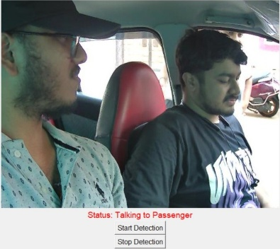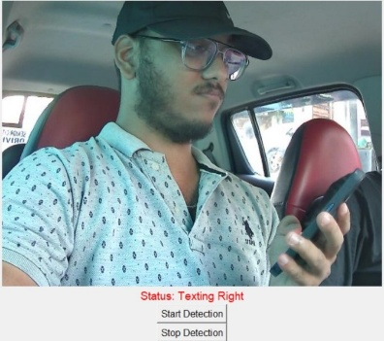

Fig 7 : Driver Distracted Fig 8 : Talking to Passenger Fig 9 : Texting Right

These images represent live examples of how the proposed driver distraction detection system performs in real-world scenarios. Using a built-in webcam and OpenCV, the system captures each video frame of the driver and instantly processes it through a fine-tuned MobileNetV2 model that has been trained to classify ten distinct driving behaviors. In the first image, the driver is adjusting his hair, and the model accurately labels this action as “Hair & Makeup.” The second image shows a driver looking behind to reach for something, which the model identifies correctly as “Reaching Behind.” These types of behaviors are categorized as distracted since they divert attention away from driving.
The third image demonstrates a scenario where the driver is seated upright with hands on the wheel and looking straight ahead, which is ideal for road safety. As expected, the model confidently recognizes this as “Safe Driving” and no alert is triggered. In the fourth image, the driver is visibly engaged in a phone conversation while driving, a highly dangerous activity. The system promptly flags this as “Talking on Phone” and activates a clear alert message—“ALERT! Driver Distracted!!”—on the screen, accompanied by a warning beep.
These predictions are generated in real time and continuously updated through a Tkinter-based graphical user interface, which is simple yet effective for end users. The visual feedback and sound alerts offer a proactive safety mechanism by helping drivers become aware of their inattentive behaviors before they lead to risky situations. Overall, the system demonstrates impressive responsiveness and precision in distinguishing between safe and distracted driving patterns, making it highly applicable for integration into intelligent vehicle systems and real-time driver assistance platforms.

System performance evaluation

Performance Metrics: To assess the effectiveness of our distracted driver detection system, we evaluated its performance using standard classification metrics. The foundation of this evaluation is the confusion matrix, which outlines the model’s predicted versus actual outcomes across the ten driver behavior classes. This matrix helps to measure how accurately the model distinguishes between correct and incorrect predictions. The key performance indicators we used include Accuracy, Precision, Recall, and F1-Score—all of which are commonly used in machine learning classification tasks.

The formulas used to calculate these metrics are as follows:

Accuracy: This metric indicates the overall correctness of the model by showing the ratio of correct predictions to the total number of predictions.

Accuracy = TP+TN
TP+TN+FP+FN

Recall (Sensitivity or True Positive Rate): Recall measures the model’s ability to correctly identify all relevant instances of a particular class.

Recall = TP
TP+FP​

Precision: Precision assesses how many of the predicted positive instances are actually relevant. It is especially important when the cost of false positives is high.

Precision = TP
TP+FN

F1-Score: The F1-Score is the harmonic mean of precision and recall and provides a balanced measure of model performance when both false positives and false negatives are critical.

F1-Score = 2 * Precision * Recall
Precision + Recall

Where:

TP = True Positives

TN = True Negatives

FP = False Positives

FN = False Negatives

After training and validating the model using K-Fold Cross Validation and hyperparameter tuning, the final version of our MobileNetV2-based classifier achieved a test accuracy of approximately 94.5%. The detailed results—including per-class precision, recall, and F1-scores—demonstrated that most classes performed above 90%, with slightly lower scores for more ambiguous behaviors like “Hair & Makeup.”

We visualized the model’s classification outcomes using a confusion matrix, which clearly illustrated high true positive rates for key distraction categories such as “Texting Left,” “Reaching Behind,” and “Talking on Phone.” These findings confirm that our model performs reliably across various driver behavior classes and is suitable for deployment in real-time environments.

Table 3: Performance Metrics
Metric | Value
Accuracy | 97.70%
Precision | 97.72%
Recall | 97.70%
F1-Score | 97.69%

Table 4: Class Wise Performance Metrics
Class | Accuracy | Precision | Recall | F1-Score
Safe Driving | 97.50% | 94.66% | 97.50% | 96.06%
Texting Right | 97.00% | 100.00% | 97.00% | 98.48%
Talking on Phone - Right | 97.00% | 100.00% | 97.00% | 98.48%
Texting Left | 100.00% | 99.01% | 100.00% | 99.50%
Talking on Phone – Left | 100.00% | 99.01% | 100.00% | 99.50%
Operating Radio | 99.50% | 98.03% | 99.50% | 99.50%
Drinking | 98.00% | 96.08% | 98.00% | 98.76%
Reaching Behind | 100.00% | 97.56% | 100.00% | 97.77%
Hair & Makeup | 93.00% | 96.88% | 93.00% | 94.90%
Talking to Passenger | 95.00% | 95.00% | 95.00% | 95.48%

- Confusion matrix for model with hyperparameter tuning
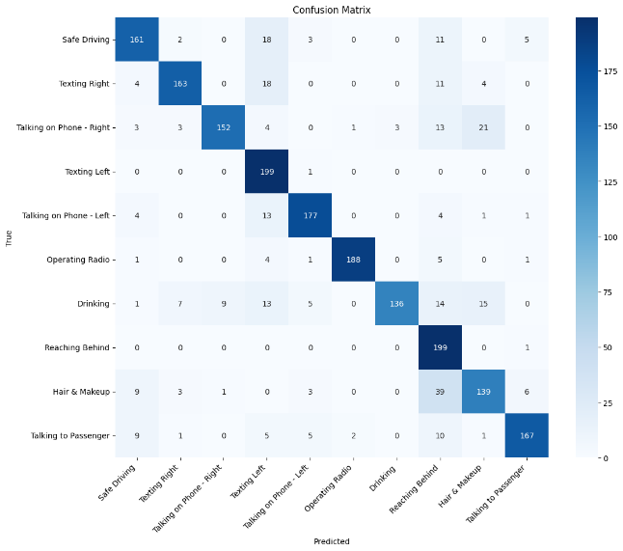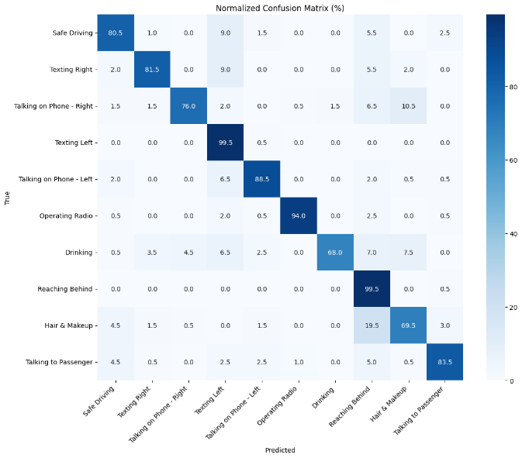
Fig 10 : Confusion Matrix Fig 11 : Normalized Confusion Matrix

- Confusion matrix for Fine-Tuned Model
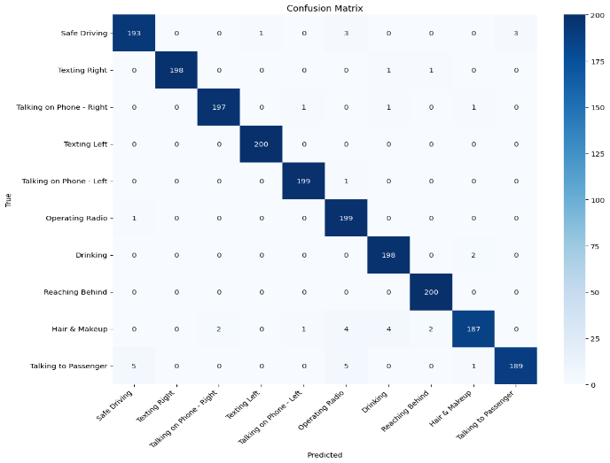
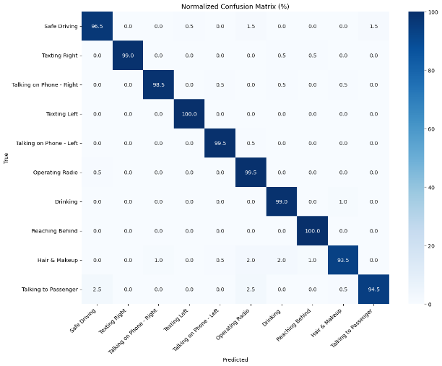

Fig 10 : Confusion Matrix Fig 11 : Normalized Confusion Matrix

Discussion on Contribution
This project presents a comprehensive and deployable approach to detecting distracted driver behavior using deep learning and computer vision. One of the most notable contributions is the successful integration of a fine-tuned MobileNetV2 model into a real-time monitoring system, capable of identifying ten distinct driver actions with high accuracy. While much of the existing research focuses on binary classification or offline model evaluation, this work goes a step further by offering an end-to-end solution that functions reliably in real time through a webcam interface.
Another significant contribution lies in the thoughtful design of the training pipeline, which includes class balancing, data augmentation, and hyperparameter tuning to improve both accuracy and generalization. The system also features a distraction alert mechanism that intelligently triggers warnings based on prediction confidence and sustained behavior — enhancing its practical relevance. Unlike traditional approaches that may require specialized sensors or external hardware, this project relies solely on a standard webcam and open-source tools, making it both cost-effective and scalable.
Moreover, the user-friendly graphical interface developed using Tkinter allows non-technical users to interact with the system seamlessly. Together, these elements contribute to a well-rounded and functional application that not only demonstrates technical capability but also addresses a real-world safety concern. This system can serve as a foundation for future development in intelligent transportation systems and in-vehicle safety technologies.

Conclusion and Future Scope

In conclusion, this project successfully demonstrates a deep learning-based system capable of identifying and responding to distracted driving behaviors in real time. By leveraging a fine-tuned MobileNetV2 model along with computer vision techniques, the system can accurately classify ten different driver actions and issue timely alerts through a user-friendly interface. The combination of high accuracy, real-time performance, and simple deployment makes the solution practical for real-world applications such as advanced driver assistance systems (ADAS) and in-vehicle safety tools.
Looking ahead, the system can be further improved by introducing features like Grad-CAM++ to visualize which parts of the image influenced the model’s prediction, helping improve explainability and trust. Additionally, integrating support for multiple cameras would allow broader coverage of the vehicle interior, improving detection for side or rear angles. The model’s robustness could also be enhanced by training on more diverse datasets that include low-light, occluded, or real-world driving conditions. With these enhancements, the system has strong potential to evolve into a commercially viable solution that actively contributes to reducing road accidents caused by driver distraction.

References

[1] Shahverdy, Mohammad & Fathy, Mahmood & Berangi, Reza & Sabokrou, Mohammad. (2020). Driver Behavior Detection and Classification Using Deep Convolutional Neural Networks. Expert Systems with Applications. 149. 113240. 10.1016/j.eswa.2020.113240.

[2] Moslemi, Negar & Soryani, Mohsen & Azmi, Reza. (2021). Computer vision-based recognition of driver distraction: A review. Concurrency and Computation Practice and Experience. 33. 10.1002/cpe.6475.

[3] Alotaibi, Bandar & Alotaibi, Munif. (2020). Distracted Driver Classification Using Deep Learning. Signal Image and Video Processing. 14. 10.1007/s11760-019-01589-z.

[4] Hossain, Md & Rahman, Md & Islam, Manowarul & Akhter, Arnisha & Uddin, Md Ashraf & Paul, Bikash Kumar. (2022). Automatic Driver Distraction Detection using Deep Convolutional Neural Networks. Intelligent Systems with Applications. 14. 200075. 10.1016/j.iswa.2022.200075.

[5] Alam, Lamia & Hoque, Moshiul. (2019). Real-Time Distraction Detection Based on Driver's Visual Features. 1-6. 10.1109/ECACE.2019.8679191.

[6] Jagadale, Sujay & Attar, Pirsab. (2022). Distracted Driver Detection: A Comparative Study Using CNN. 2449-2458. 10.46254/IN02.20220579.

[7] Rajput, Ishwari & Tyagi, Sonam & Pandey, Vandana & Upreti, Abha & Kukreja, Jasleen. (2025). Enhancing Driver Safety with MobileNetV2-Based Transfer Learning for Drowsiness Detection. Procedia Computer Science. 259. 1239-1248. 10.1016/j.procs.2025.04.079.

[8] Reddy, Ariveeti & Khan, Ibrahim & T, Neethu & Thampi, Lidiya & A, Aswathy & Kumar, Abhishek & Kumar, Sunny. (2024). Smart Driver Assistance: Real-Time Drowsiness Detection Leveraging Facial Cues with MediaPipe and OpenCV. 10.21203/rs.3.rs-4642662/v1.

[9] Sheikh, Amaan & Khan, Imaad. (2024). Enhancing Road Safety: Real-Time Detection of Driver Distraction through Convolutional Neural Networks. 10.48550/arXiv.2405.17788

