Endpoint 1: GET THE LOGO OF THE INSTITUTE

This endpoint returns the logo of the institute as an image file.

Example:

https://localhost:8080/api/GetLogo

Endpoint 2: GET THE VERSION OF THE WEB API

This endpoint returns a string “V1” which represents the version of the APIs.

Example:

https://localhost:8080/api/GetVersion

Endpoint 3: GET THE INFORMATION OF ALL STAFF

This endpoint returns the information of all the staff.

Example:

https://localhost:8080/api/GetAllStaff

Endpoint 4: GET THE PHOTO OF A STAFF

This endpoint returns the photo of the staff with a given ID.

If the photo cannot be found, the API should return the photo in file “default.png”.

Examples:

https://localhost:8080/api/GetStaffPhoto/1145344

https://localhost:8080/api/GetStaffPhoto/1

Endpoint 5: GET THE VCARD OF A STAFF

This endpoint returns the vCard of the staff with a given ID.

If the staff cannot be found, the API should return an empty vCard of the institute.

In an empty vCard, apart from the required properties of a vCard, i.e., BEGIN, END and VERSION, only the LOGO property of the vCard needs to be set.

Examples:

https://localhost:8080/api/GetCard/1145344

https://localhost:8080/api/GetCard/1

Endpoint 6: LIST ITEMS/ITEM SOLD IN THE INSTITUE’S SHOP

This endpoint returns the information of the products/product sold in the institute’s shop.

If GetItems is followed by the name of an item/the partial name of some items, the API returns the information of the named item/items. Otherwise, the API returns the descriptions of all the items sold by the shop.

The partial name of an item is a string that appears in the name of an item. A partial name is case-insensitive. For example, “b” is regarded as the partial name of items “Water Bottle” and “Umbrella”.

Examples:

https://localhost:8080/api/GetItems/b

https://localhost:8080/api/GetItems

Endpoint 7: GET THE PHOTO OF AN ITEM

This endpoint returns the photo of an item with a given ID.

If the photo cannot be found, the API should return the photo in the file “default.png”.

Examples:

https://localhost:8080/api/GetItemPhoto/156571347

https://localhost:8080/api/GetItemPhoto/1

Endpoint 8: WRITE COMMENT

This endpoint allows the users to write comments.

The user only needs to provide values for the Comment and Name fields when calling this API.

The endpoint should be called using the POST method.

Example: enter the request in POSTMAN as shown below

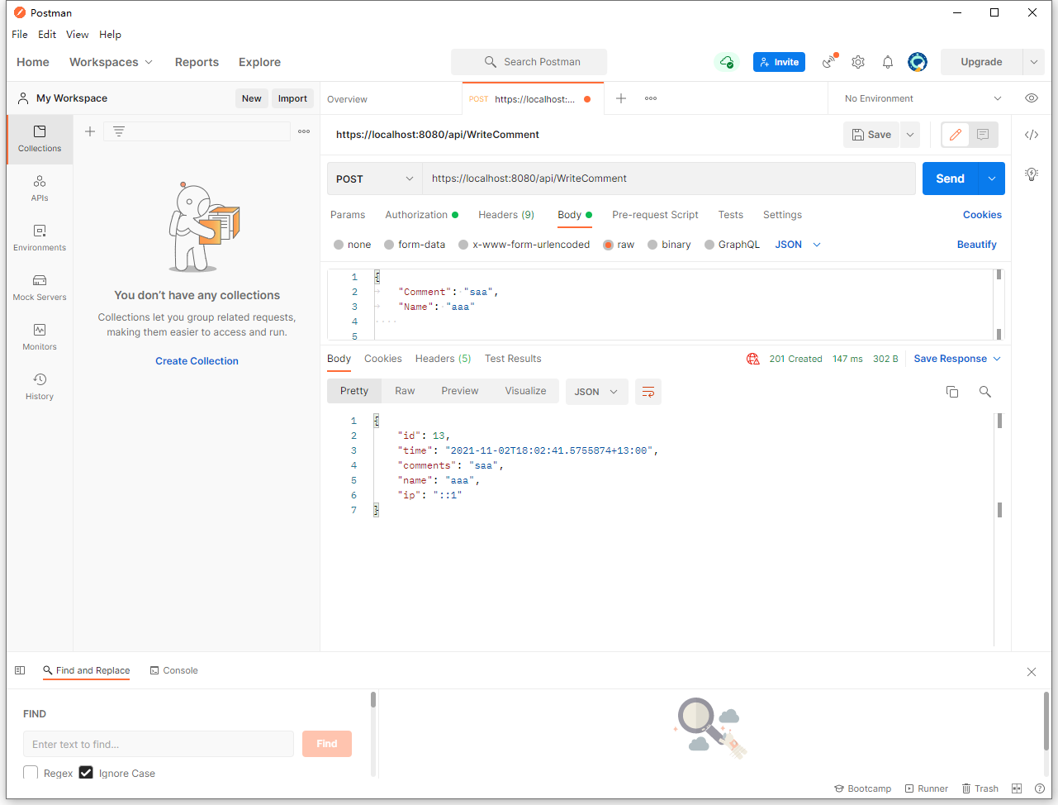

Endpoint 9: GET COMMENTS (3 marks)

This endpoint allows the user to retrieve the last 5 comments made by users.

The comments should be returned in HTML format.

Each comment and the name of the user who entered the comment should be placed between a pair of paragraph tags <p> </p>.

The comment and the name of the user should be separated by an em dash “—” (HTML code &mdash;).

If the user has not entered a name, the name value is empty.

Example:

https://localhost:8080/api/GetComments