“Online bus ticket booking system”
A
CDAC Project
submitted in fulfilment for the post-graduation program under CDAC
Submitted to
Sunbeam Infotech, Pune

Submitted By
Bagul Amol Manohar– 220944220037
Akshay Ashok Chopade – 220944220014
Ronit Paul – 220944220174
Suyash Jain – 220944220220
Puneet Kandpal – 220944220165

Under the Guidance of
Ms. Pooja Jaiswal
Sunbeam Infotech, Pune

Sunbeam Infotech, Pune
Post-graduation Diploma in Advance Computing
CERTIFICATE
This is to certify that CDAC project entitled “Online Bus Ticket Booking System” submitted to Sunbeam, Pune by _______ for fulfilment for the post-graduation program under CDAC.

Amol Bagul – 220944220037
Akshay Chopade – 220944220014
Ronit Paul – 220944220174
Suyash Jain – 220944220220
Puneet Kandpal – 220944220165

Yogesh Kolhe,
Course Coordinatior

Post-graduation Diploma in Advance Computing

APPROVAL CERTIFICATE

This is hereby certified that the CDAC project entitled “Online Bus Ticket Booking System” being submitted by <Name>,<PRN> to Sunbeam, Pune is a genuine work performed by him.

Internal Examiner

Date: 10/03/2023

ACKNOWLEDGEMENT

This is one of the best moments of our PGDAC program to publicly acknowledge those who have contributed in many different ways to make our success a part of their own. The completion of the PGDAC Project depends upon the co-operation, coordination and combined effects of several resources of knowledge energy.

We heartily thank Ms. Pooja Jaiswal, our project mentor for accepting us to work under her valuable guidance. She closely supervised this work over the past month and offering many innovative ideas and helpful suggestions, which led to the successful completion of this dissertation work.

We are especially thankful to Mr. Nitin Kudhale, CEO, and Mr. Yogesh Kolhe (Course Coordinator) Sunbeam Infotech, for their kind co-operation and rendering us all possible facilities.

We are also thankful to all staff members of the PGDAC and our group members for their timely help co-operation and suggestion for the project work. Lastly but not the least, must express thanks to our family, without their moral support it would be impossible to complete this project.

Amol Bagul
Akshay Chopade
Ronit Paul
Suyash Jain
Puneet Kandpal

Introduction

The web based “Online Bus Ticket Booking System” project is an attempt to stimulate the basic concepts of bus reservation system. The system enables the customer to do the things such as search for buses for two travel cities on a specified date, choose a bus based on the details and its reservation.
The system provides you quick search facility that provides you details about buses between cities without login. But if user want to book ticket, then it must require to login into your account.
The system allows the bus passenger to search for routes that are available between the two travel cities, namely the “Departure city” and “Destination city” for a particular departure. The system allows the customer to select the bus of their types (A/C, Sleeper). The system displays all the bus’s details such as bus number, name, price and time of journey, seat number, etc.
Here we provided quick search facility which displays list of available buses and allows customer to choose a particular route. Then the system checks for the availability of seats on the bus. If the seats are available then the system allows the passenger to book a seat. Otherwise, it asks the user to choose another bus.
To book a bus, the system asks the customer to enter his details such as name, address, city, state, credit card number and contact number. Then it checks the validity of card and book the bus and update the bus database and user database.
The customer can also take a printout of the invoice of the ticket, which prints all the necessary information which is needed for a ticket.

Scope

Online Bus Ticket Reservation System is a web-based application which facilitates and provide functionalities such as reservation of seats, cancellation of reservation and different types of route enquiries used on securing quick reservations, ticket booking and tracking bus. It maintains all customer details, bus details, reservation details.

ReactJS framework is used for the front-end of the software while the back-end was designed using JavaEE, Spring Boot, JPA (Java Persistence API) and MySQL as database. This project is built by incorporating Agile principles using Scrum framework.

- User: Users can search for buses based on date, boarding position, and drop location. Users can also book tickets after logging in and they can also cancel tickets.

- Operator: Operators can register on the website and enter details about new buses, including the route and timings. Once the operator adds a bus, the request goes to the admin for approval or rejection.

- Admin: Admin can approve or reject new buses added by operators. Admin can also see the buses running and people who have booked tickets.

- Additional features: The system has a user-friendly interface, multiple online payment options like credit cards/debit cards, and an email system for booking and cancellation of the tickets.

- Security: Spring security will be used to provide security, authentication and authorization, and all the data will be properly secured with encryption.

- User-friendly interface: The system should be easy to navigate and understand for the users.

- Responsive design: The system should be responsive and accessible on various devices like mobile, tablet, and desktop.

- Compatibility: The system should be compatible with various web browsers and platforms.

- Scalability: The system should be scalable to support a high number of users and transactions.

- Front-end: The project will use ReactJS as the front-end framework for building the user interface.

- Back-end: The project will use Spring Boot, JPA (Java Persistence API) and Java EE as the back-end technologies for building the server-side logic and handling database operations.

- Database: The project will use MySQL as the database management system to store and manage the data.

- Integration: The front-end and back-end will be integrated to ensure seamless communication and flow of data between the client and server-side.

- Deployment: The application will be deployed on a web service like AWS (Amazon Web Services).

- Testing: The application will be tested using JUnit for unit testing.

Use-Case Diagram
User

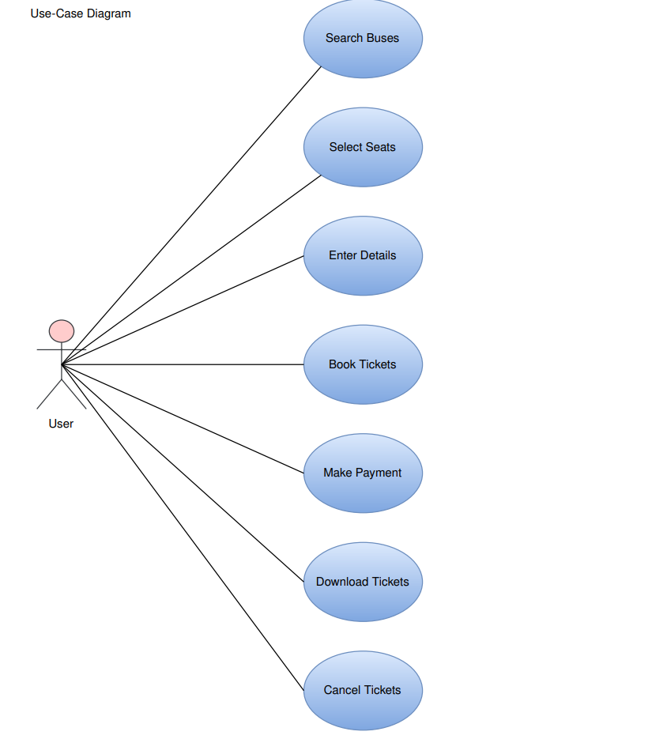

The use case diagram for the User actor in this project highlights the different interactions between the user and the system. The diagram outlines the various steps involved in the booking process, from searching for available buses to cancelling tickets if necessary.
The first use case listed in the diagram is "search buses." This use case allows the user to search for available buses based on their preferred travel date, time, and destination. Once the user has found a suitable bus, they can select their seats using the "select seats" use case. This use case allows the user to view the available seats on the bus and choose the ones they want.
After selecting seats, the user is required to enter their personal and payment details using the "enter details" use case. This use case allows the user to input their name, contact information, and payment information so that the system can process their booking. Once the details have been entered, the user can proceed to the "book tickets" use case to confirm their booking and reserve their seats.
After booking their tickets, the user can make payment using the "make payment" use case. This use case allows the user to pay for their tickets using a secure payment gateway. Once payment has been made, the user can download their tickets using the "download tickets" use case. This use case allows the user to access their tickets electronically and print them if necessary.
Finally, if the user needs to cancel their tickets, they can do so using the "cancel tickets" use case. This use case allows the user to cancel their booking and receive a refund if applicable.
Overall, this use case diagram provides a clear overview of the different steps involved in the booking process for the User actor in this project. It ensures that the system can provide a seamless booking experience for users while also ensuring that their personal and payment details are kept secure.

Operator
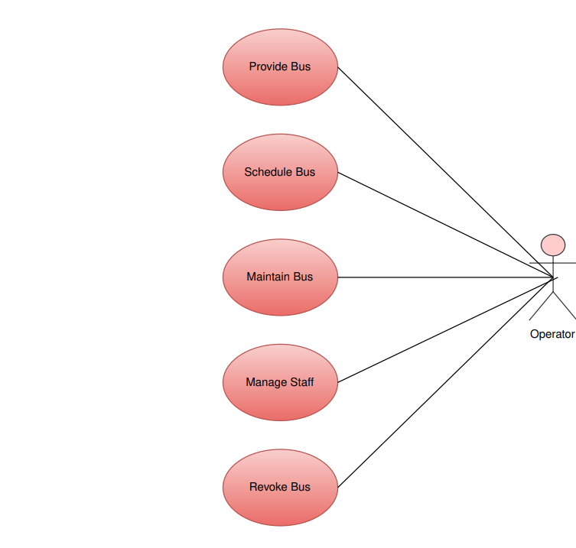

The use case diagram for the Operator actor in this project outlines the various interactions between the operator and the system. The diagram highlights the different tasks that the operator needs to perform in order to manage the buses and staff effectively.
The first use case listed in the diagram is "provide bus." This use case allows the operator to add new buses to the system. This includes providing information such as the make and model of the bus, its seating capacity, and any other relevant details.
Once the buses have been added to the system, the operator can schedule them using the "schedule bus" use case. This use case allows the operator to create a timetable of when the buses will be available for booking. The operator can also specify the route and destination of each bus.
The "maintain bus" use case allows the operator to ensure that the buses are in good condition and ready for use. This includes regular maintenance such as oil changes and tire rotations, as well as repairs as needed.
The "manage bus" use case allows the operator to view and update information about the buses in the system. This includes details such as the current location of the bus, its availability for booking, and any maintenance or repair work that needs to be done.
The "manage staff" use case allows the operator to manage the staff who work on the buses. This includes assigning drivers to specific routes and ensuring that they have the necessary training and qualifications.
Finally, if the operator needs to remove a bus from the system, they can do so using the "revoke bus" use case. This use case allows the operator to remove the bus from the system and update the timetable accordingly.
Overall, this use case diagram provides a clear overview of the different tasks involved in managing the buses and staff for the Operator actor in this project. It ensures that the system can operate efficiently and effectively, providing a positive experience for both users and operators alike.

Admin
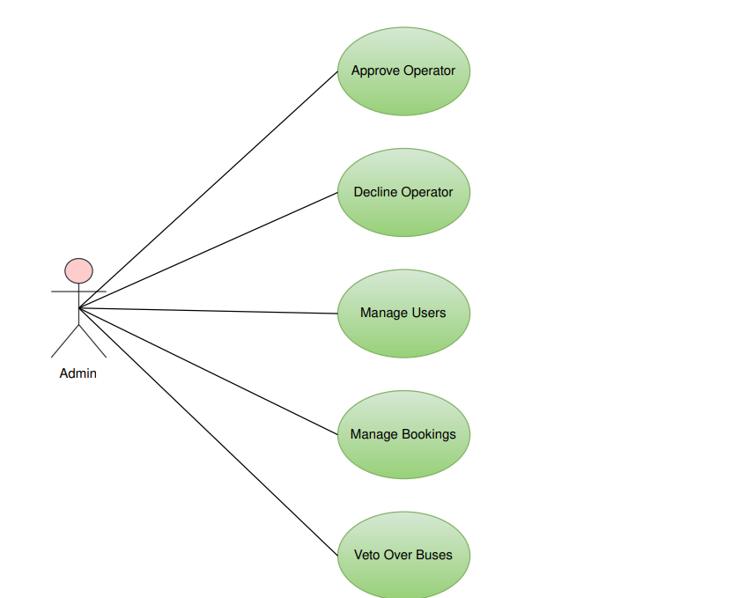

The use case diagram for the Admin actor in this project outlines the various interactions between the administrator and the system. The diagram highlights the different tasks that the administrator needs to perform in order to manage the system effectively.
The first use case listed in the diagram is "approve operator." This use case allows the administrator to review the details of new operators who want to register with the system. The administrator can then approve or decline their application based on their qualifications and credentials.
The "decline operator" use case allows the administrator to decline an operator's application if they do not meet the necessary qualifications or if there are any red flags with their application.
The "manage users" use case allows the administrator to view and manage information about the users of the system. This includes details such as their personal and contact information, their booking history, and any issues or complaints that they may have.
The "manage bookings" use case allows the administrator to view and manage information about the bookings made by users. This includes details such as the route, date, time, and number of seats booked, as well as the payment and refund history.
The "veto over buses" use case allows the administrator to have the final say over the addition or removal of buses from the system. If an operator wants to add or remove a bus, the administrator can review the request and decide whether or not to approve it based on factors such as availability, safety, and customer demand.
Overall, this use case diagram provides a clear overview of the different tasks involved in managing the system for the admin actor in this project. It ensures that the system operates efficiently and effectively while maintaining the highest standards of safety and customer satisfaction.

Data-flow Diagram

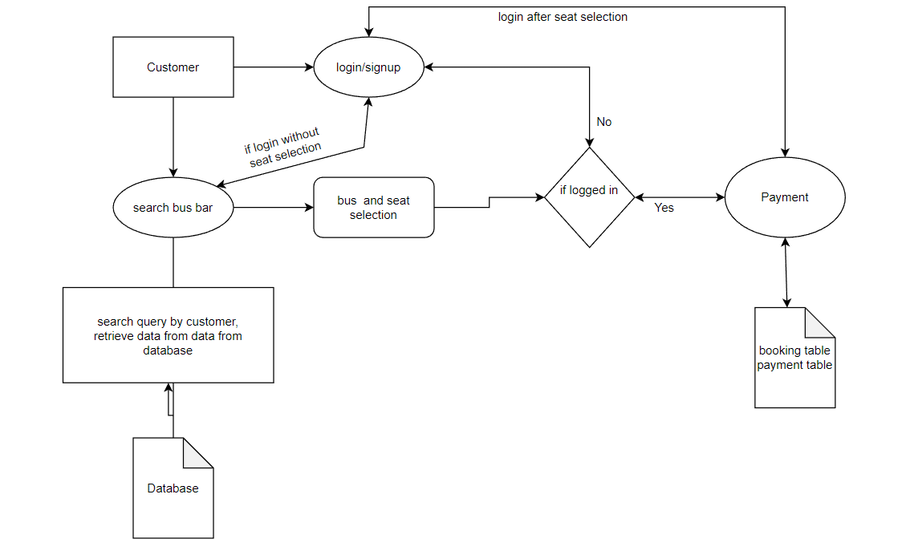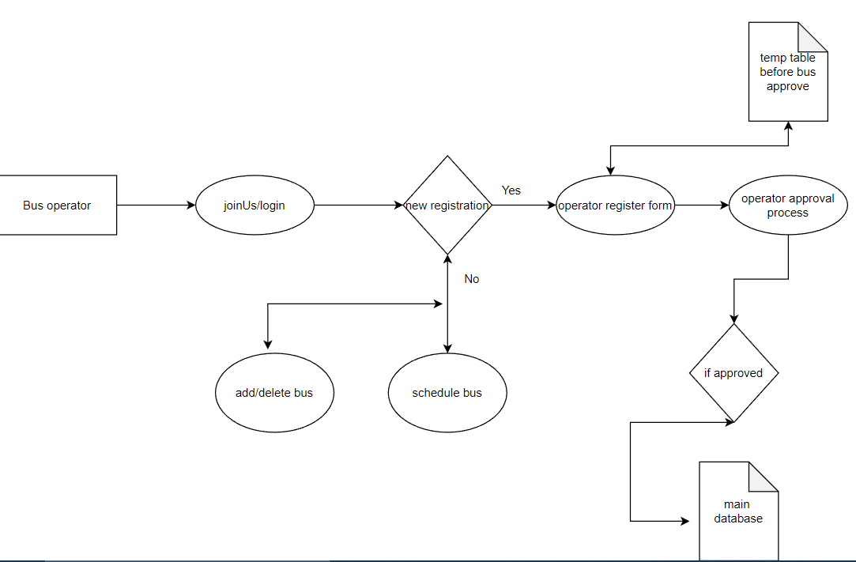
ER Diagram
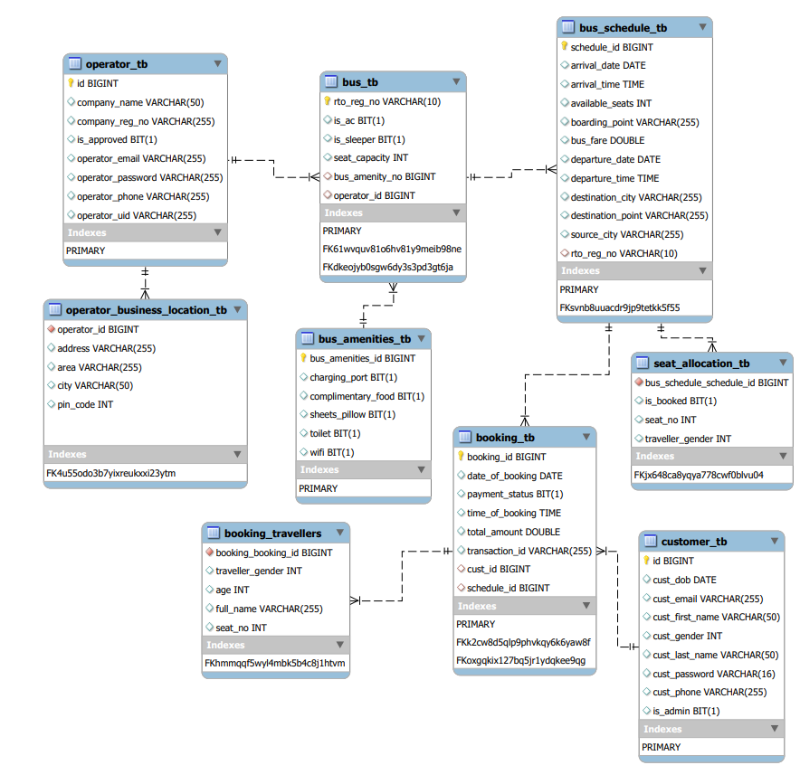

Database Design
- booking_tb
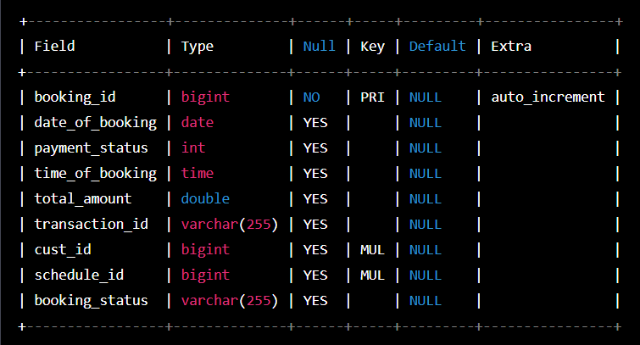
This table stores information related to the booking of bus tickets. The booking_id field is the primary key for the table and is auto-incremented for each new booking. The date_of_booking field stores the date on which the booking was made. The payment_status field stores information about the payment status of the booking. The time_of_booking field stores the time at which the booking was made. The total_amount field stores the total amount paid for the booking. The transaction_id field stores the unique identifier for the payment transaction. The cust_id field is a foreign key that references the customer table and stores the ID of the customer who made the booking. The schedule_id field is a foreign key that references the schedule table and stores the ID of the schedule for which the booking was made. The booking_status field stores the status of the booking, such as "confirmed", "cancelled", or "pending".

- booking_travellers
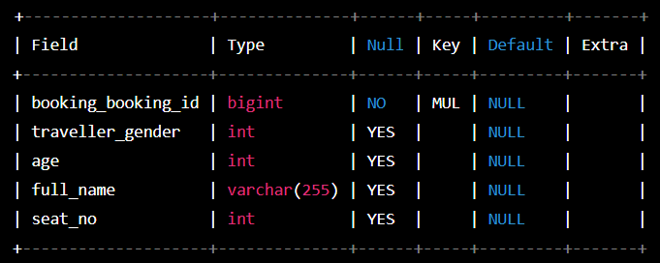

This table stores information related to the travellers associated with a particular booking. The booking_booking_id field is a foreign key that references the booking table and stores the ID of the booking with which the traveller is associated. The traveller_gender field stores the gender of the traveller, using an integer code (e.g. 0 for male, 1 for female, 2 for non-binary). The age field stores the age of the traveller. The full_name field stores the full name of the traveller. The seat_no field stores the seat number associated with the traveller.
Overall, this table allows for the efficient storage and retrieval of traveller information associated with a booking. It is an important part of the system as it allows for the management of multiple travellers associated with a single booking.

- bus_amenities_tb
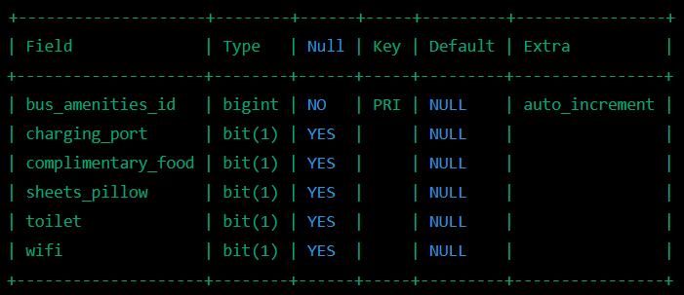
This table stores information about the amenities available on a bus. The bus_amenities_id field is a primary key and is automatically generated for each new record in the table. The remaining fields are boolean values (bit(1)) that indicate whether or not a particular amenity is available on the bus.
For example, the charging_port field indicates whether or not the bus has charging ports for electronic devices. The complimentary_food field indicates whether or not the bus provides complimentary food to passengers. The sheets_pillow field indicates whether or not the bus provides sheets and pillows for passengers. The toilet field indicates whether or not the bus has a toilet on board. The wifi field indicates whether or not the bus provides wifi for passengers.
This table is important as it allows operators to manage and communicate the available amenities on their buses to potential passengers. It is also important for users who are looking for specific amenities when searching for and selecting a bus for their journey.

- bus_schedule_tb
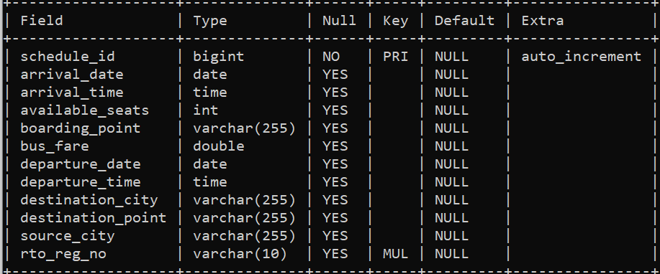
The table above shows the proper table format for a database table named 'schedule'. The table has 12 fields/columns. Here's a brief explanation of each field:
- schedule_id: A unique ID assigned to each schedule.
- departure_date: The date when the bus will depart from the source city.
- departure_time: The time when the bus will depart from the source city.
- arrival_date: The date when the bus will arrive at the destination city.
- arrival_time: The time when the bus will arrive at the destination city.
- source_city: The city from where the bus will start its journey.
- destination_city: The city where the bus will end its journey.
- boarding_point: The point where the passengers will board the bus.
- destination_point: The point where the passengers will get off the bus.
- available_seats: The number of seats available for booking on this particular schedule.
- bus_fare: The fare/cost of the bus ticket for this schedule.
- rto_reg_no: The RTO registration number of the bus that will operate on this schedule.
Having a table like this can help in keeping track of all the schedules and their details, making it easier for the operator to manage and maintain the bus services efficiently

- bus_tb
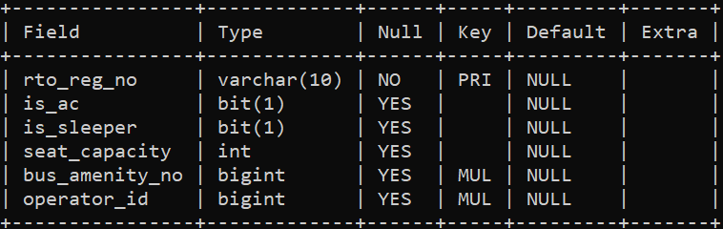
rto_reg_no: This is a unique identifier for the bus, assigned by the Regional Transport Office (RTO). It's a varchar type with a maximum length of 10 characters and is the primary key of the table.
is_ac: This is a bit field that indicates whether the bus has air conditioning (AC) or not. A value of 1 indicates that the bus has AC, while a value of 0 indicates that it doesn't. The field is nullable (YES).
is_sleeper: This is another bit field that indicates whether the bus has sleeper seats or not. A value of 1 indicates that the bus has sleeper seats, while a value of 0 indicates that it doesn't. The field is nullable (YES).
seat_capacity: This field indicates the total number of seats available in the bus. It's an int type and is nullable (YES).
bus_amenity_no: This is a foreign key that references the bus_amenities table. It indicates the amenities available on the bus.
operator_id: This is a foreign key that references the operator table. It indicates the operator who owns the bus.

- Customer_tb
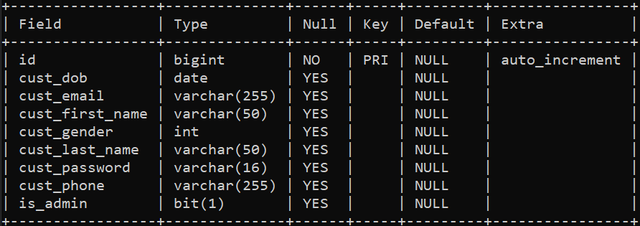

This is a table called "customers" with the following fields:
id: a bigint, which is the primary key of the table and auto-increments with each new record.
cust_dob: a date, which stores the date of birth of the customer.
cust_email: a varchar(255), which stores the email address of the customer.
cust_first_name: a varchar(50), which stores the first name of the customer.
cust_gender: an int, which stores the gender of the customer.
cust_last_name: a varchar(50), which stores the last name of the customer.
cust_password: a varchar(16), which stores the password of the customer.
cust_phone: a varchar(255), which stores the phone number of the customer.
is_admin: a bit(1), which is used to indicate whether the customer is an administrator or not. A value of 1 means the customer is an administrator, while a value of 0 means they are not.

- operator_business_location_tb
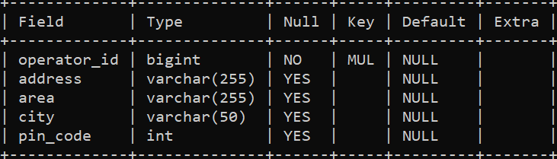
This table has the following fields:
operator_id: a foreign key referencing the id field of the operators table.
address: a nullable string field representing the street address of the operator.
area: a nullable string field representing the area of the operator's address.
city: a nullable string field representing the city of the operator's address.
pin_code: a nullable integer field representing the PIN code of the operator's address.

- operator_tb
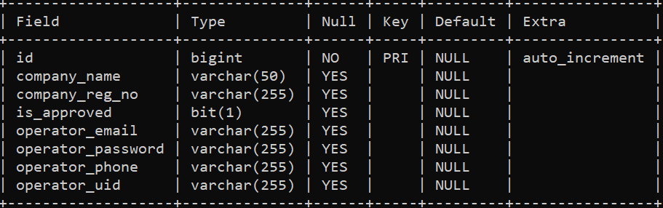

This is a table called operators with the following columns:
id: a unique identifier for each operator, auto-incremented.
company_name: the name of the bus company associated with the operator.
company_reg_no: the registration number of the bus company associated with the operator.
is_approved: a boolean value indicating whether the operator's account has been approved.
operator_email: the email address associated with the operator's account.
operator_password: the password associated with the operator's account.
operator_phone: the phone number associated with the operator's account.
operator_uid: the unique identifier associated with the operator's account.

- seat_allocation_tb
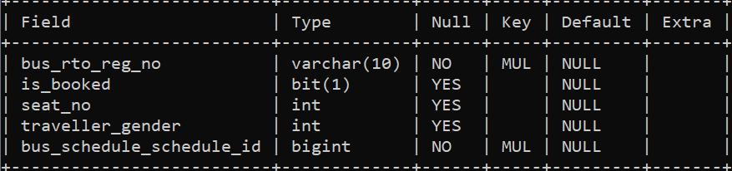
This table seems to be representing the individual bookings made for a particular bus schedule, with information on the traveller, the seat booked, and the status of the booking.
bus_rto_reg_no: a string representing the registration number of the bus associated with this booking.
is_booked: a boolean value indicating whether this seat has been booked or not.
seat_no: an integer representing the seat number of this booking.
traveller_gender: an integer representing the gender of the traveller associated with this booking.
bus_schedule_schedule_id: a foreign key referencing the schedule_id column of the bus_schedule table, indicating the schedule associated with this booking.

Implementation Requirement
Software used:
- Windows OS 11
- Java EE (Enterprise Edition)
Spring Tool Suite: v3.9.18
- MySQL: v8.0.30
- ReactJS: 18.2.0
Visual Studio Code: V1.75.1
Hardware used:
- 11th Gen Intel(R) Core (TM) i5-1135G7 @ 2.40GHz 2.42 GHz
- 64-bit operating system, x64-based processor
- RAM: 8 GB

Java EE (Enterprise Edition)



J2EE (Java 2 Platform, Enterprise Edition) is a widely used platform for developing and deploying large-scale, multi-tiered, distributed, and web-based applications in Java. It provides a comprehensive set of technologies, APIs, and services for building enterprise applications.
J2EE consists of a number of Java APIs, including Servlets, Java Server Pages (JSP), Java Message Service (JMS), Java Database Connectivity (JDBC), Java Naming and Directory Interface (JNDI), Enterprise JavaBeans (EJB), Java Transaction API (JTA), Java Mail, and others. These APIs enable developers to create robust and scalable web applications that can handle high loads and provide high availability.
J2EE also includes a number of services such as security, transaction management, resource management, and messaging, which are essential for enterprise applications. These services are provided by J2EE containers such as Servlet containers, EJB containers, and Web containers.
J2EE applications are typically deployed on application servers such as IBM WebSphere, Oracle WebLogic, or Apache Tomcat, which provide the necessary runtime environment for running J2EE applications.
Overall, J2EE provides a powerful and flexible platform for building enterprise applications that can be easily deployed and scaled to meet the demands of modern businesses.

MySQL

MySQL is a popular open-source relational database management system (RDBMS) that provides a scalable and secure platform for storing and managing data. It is widely used by web developers for building robust and scalable web applications. MySQL is known for its ease of use, reliability, and performance, and it supports a wide range of programming languages such as PHP, Java, and Python.
MySQL offers various storage engines that allow developers to optimize performance and storage requirements for their applications. InnoDB, the default storage engine for MySQL, provides ACID (Atomicity, Consistency, Isolation, Durability) compliance, which ensures data integrity and reliability. MyISAM is another popular storage engine for MySQL, which is suitable for read-heavy applications.
MySQL also provides advanced features like replication, clustering, and partitioning, which enable developers to build highly available and scalable applications. Replication allows for data to be replicated across multiple servers, providing redundancy and high availability. Clustering allows for load balancing across multiple servers, improving performance and scalability.
Overall, MySQL is a powerful and versatile RDBMS that provides a robust platform for storing, managing, and retrieving data. Its open-source nature, extensive documentation, and large community of developers make it a popular choice for web applications of all sizes and complexities.

ReactJS



ReactJS is an open-source JavaScript library used for building fast, interactive, and scalable user interfaces (UIs) for web applications. Developed and maintained by Facebook, ReactJS is widely used by developers worldwide due to its simplicity, flexibility, and performance. It provides a component-based architecture that allows developers to create reusable UI components and efficiently manage complex UIs.
ReactJS uses a virtual DOM (Document Object Model) to efficiently update and render changes to the UI, resulting in a faster and smoother user experience. It also provides features such as server-side rendering, which improves the performance of web applications by rendering HTML on the server instead of the browser.
ReactJS works seamlessly with other libraries and frameworks, making it easy to integrate with existing web applications. It supports various tools and libraries for state management, routing, and testing, making it a versatile and flexible option for building complex and scalable web applications.
In a nutshell, ReactJS is a powerful and popular JavaScript library for building scalable, fast, and interactive user interfaces for web applications. Its flexibility, performance, and extensive community support make it a preferred choice for developers worldwide.

CODING STANDARDS IMPLEMENTED

Naming and Capitalization
Below summarizes the naming recommendations for identifiers in Pascal casing is used mainly (i.e. capitalize first letter of each word) with camel casing (capitalize each word except for the first one) being used in certain circumstances.
Identifier | Case | Examples | Additional Notes
Class | Pascal | Person, BankVault, SMSMessage, Dept | Class names should be based on "objects" or "real things" and should generally be nouns. No ‘_’ signs allowed. Do not use type prefixes like ‘C’ for class.
Method | Camel | getDetails, updateStore | Methods should use verbs or verb phrases.
Parameter | Camel | personName, bankCode | Use descriptive parameter names. Parameter names should be descriptive enough that the name of the parameter and its type can be used to determine its meaning in most scenarios.
Interface | Pascal with "I" prefix | Disposable | Do not use the ‘_’ sign
Property | Pascal | ForeColor, BackColor | Use a noun or noun phrase to name properties.
Associated private member variable | _camelCase | _foreColor, _backColor | Use underscore camel casing for the private member variables
Exception Class | Pascal with "Exception" suffix | WebException,

Snapshots of UI
Front page
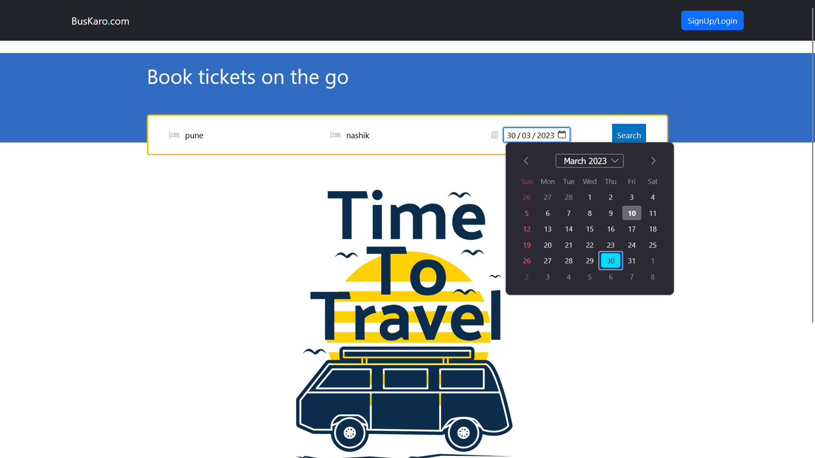

Search Results
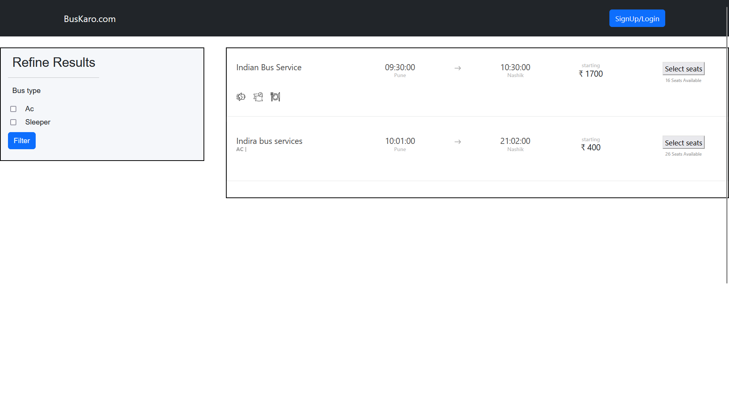

Seat Selection page
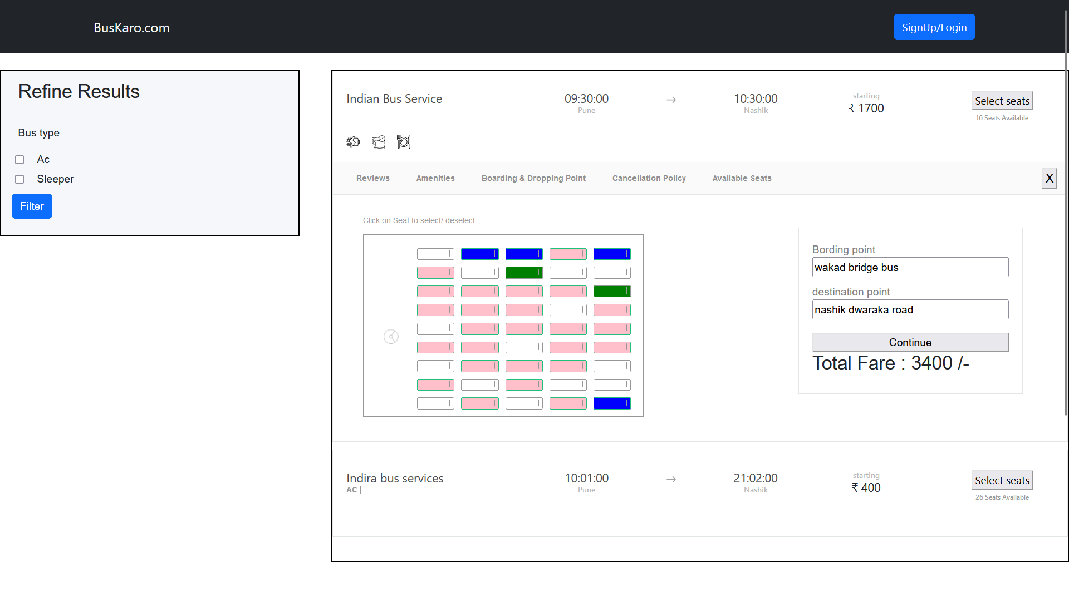
Login and Register Page
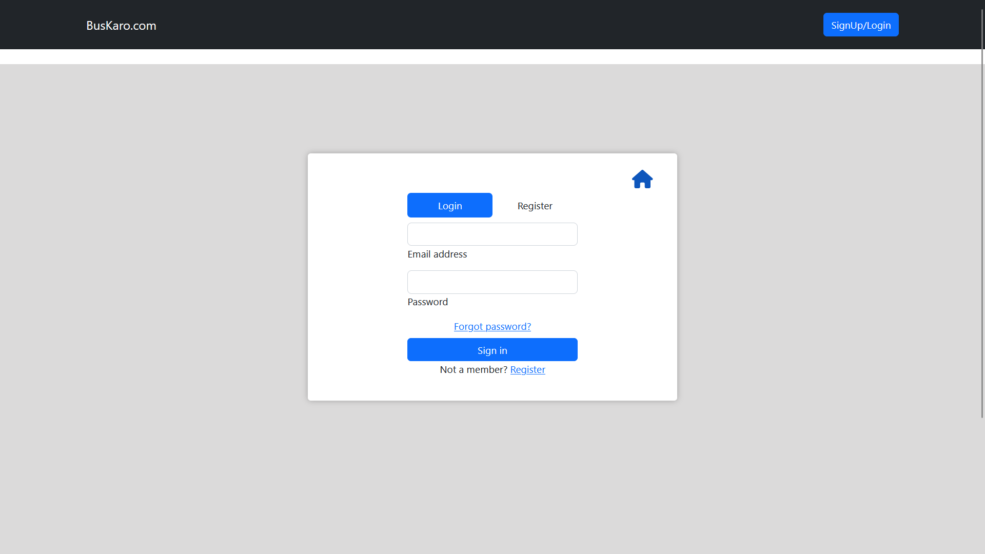

Passenger Details
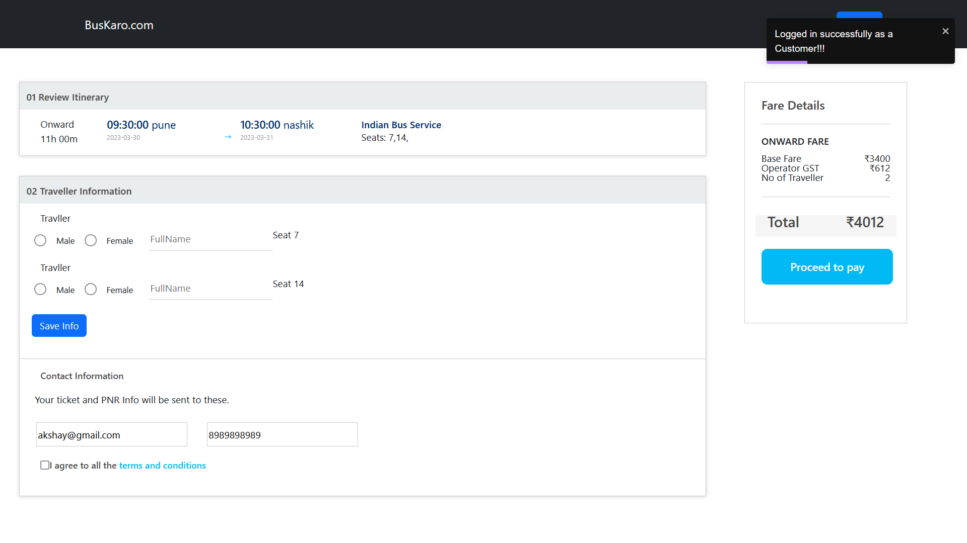
Credit Card Credentials page
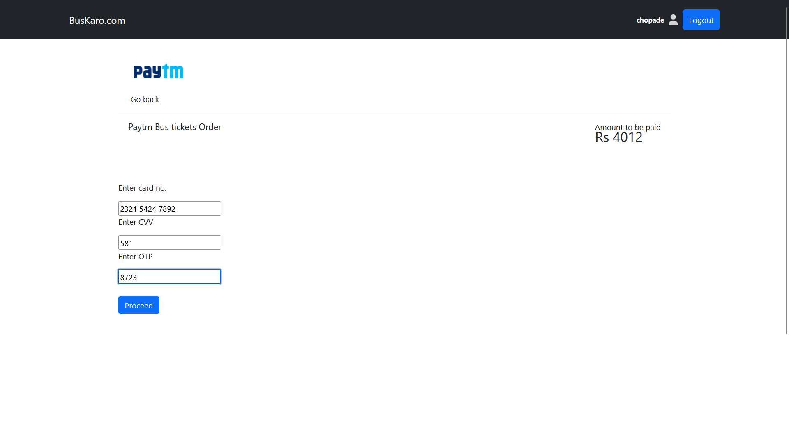

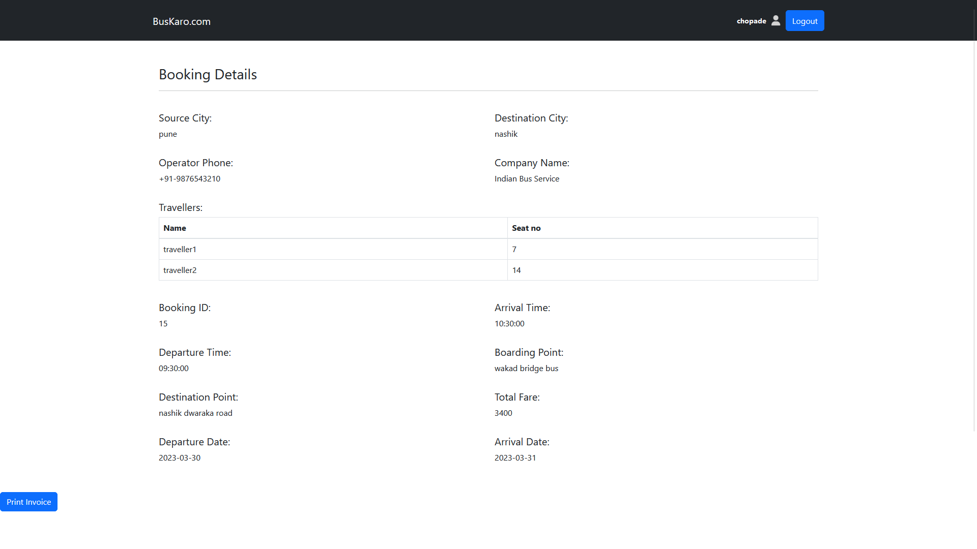

Booking Page
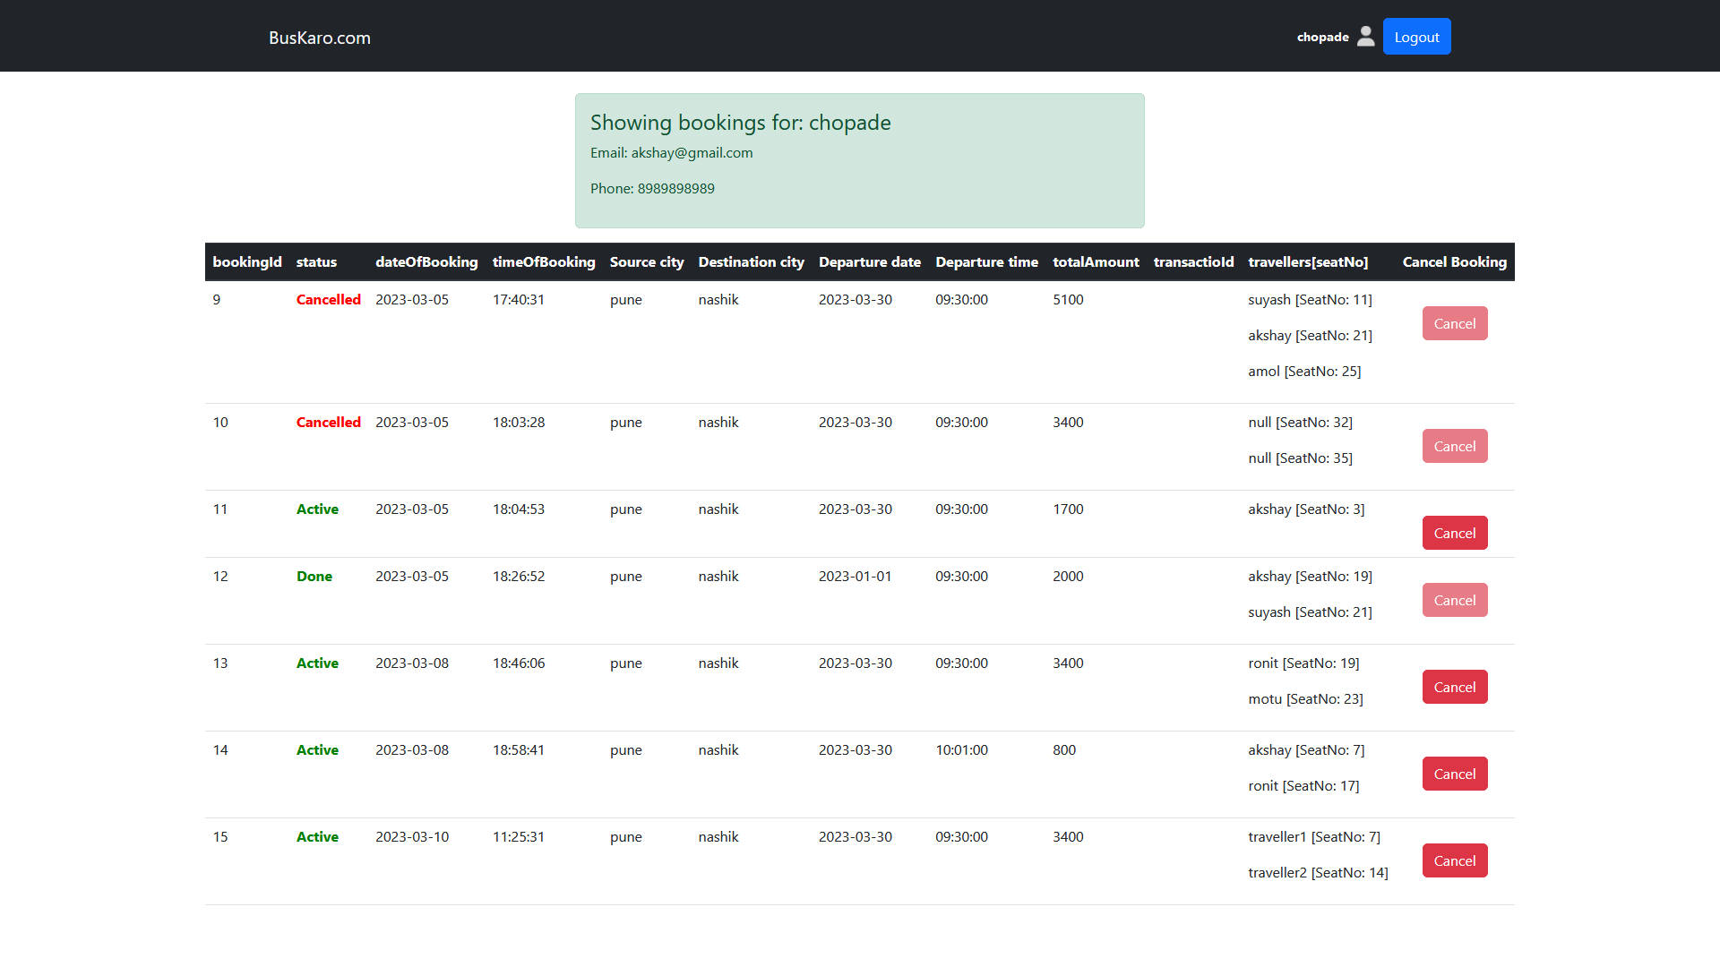

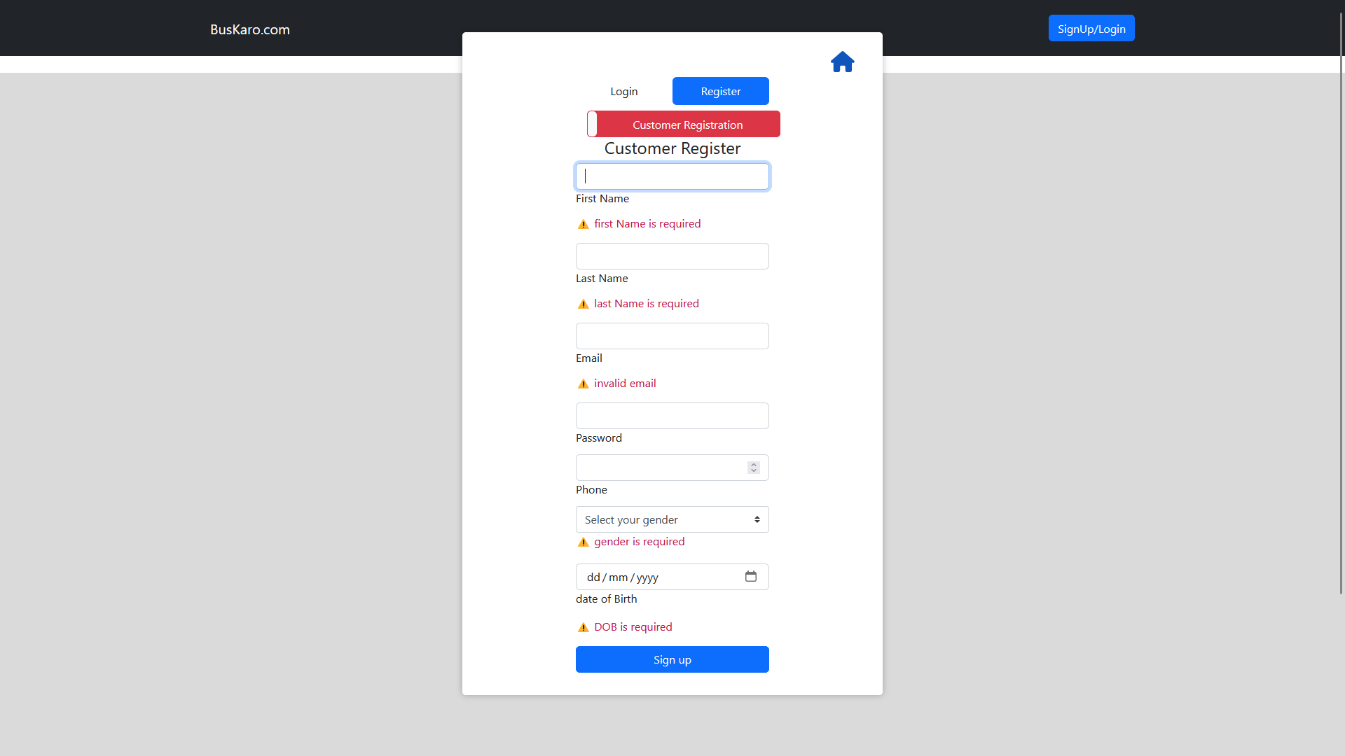

Operator Register Page
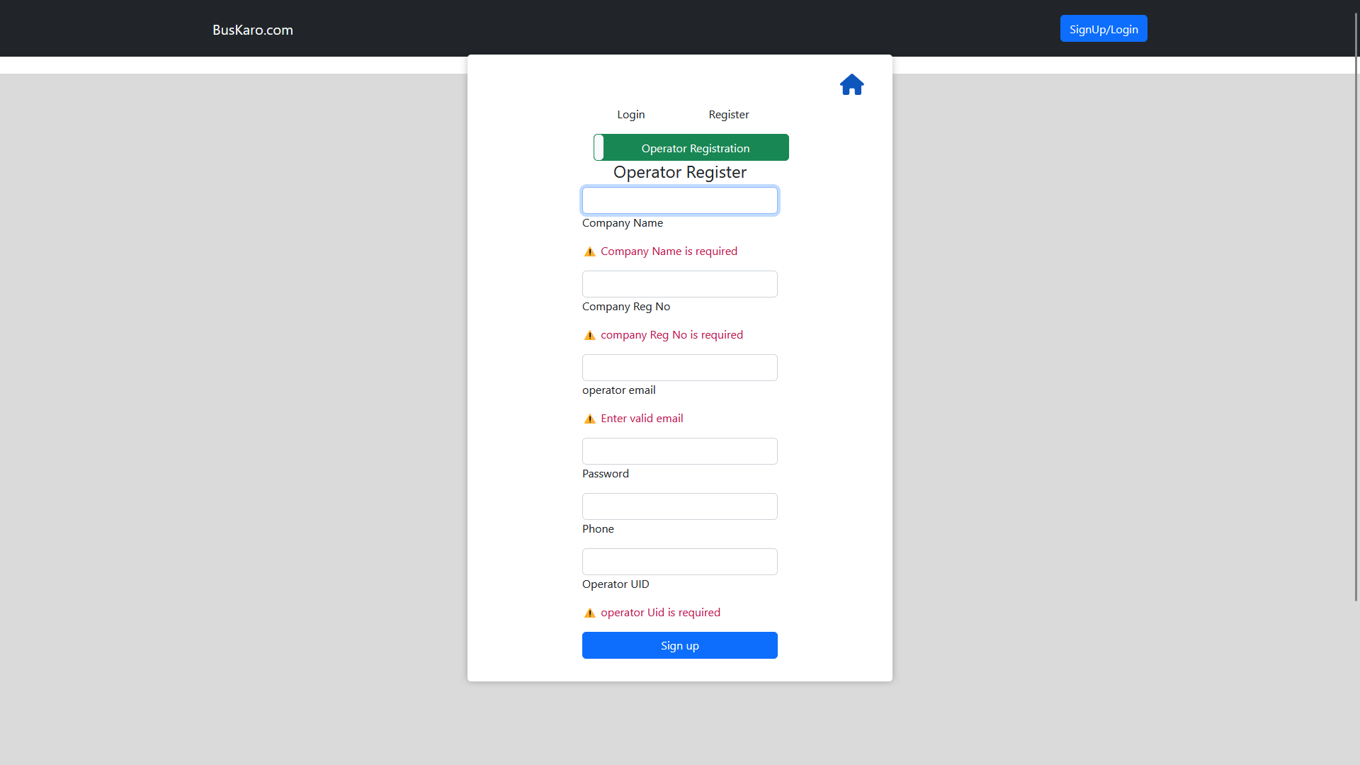

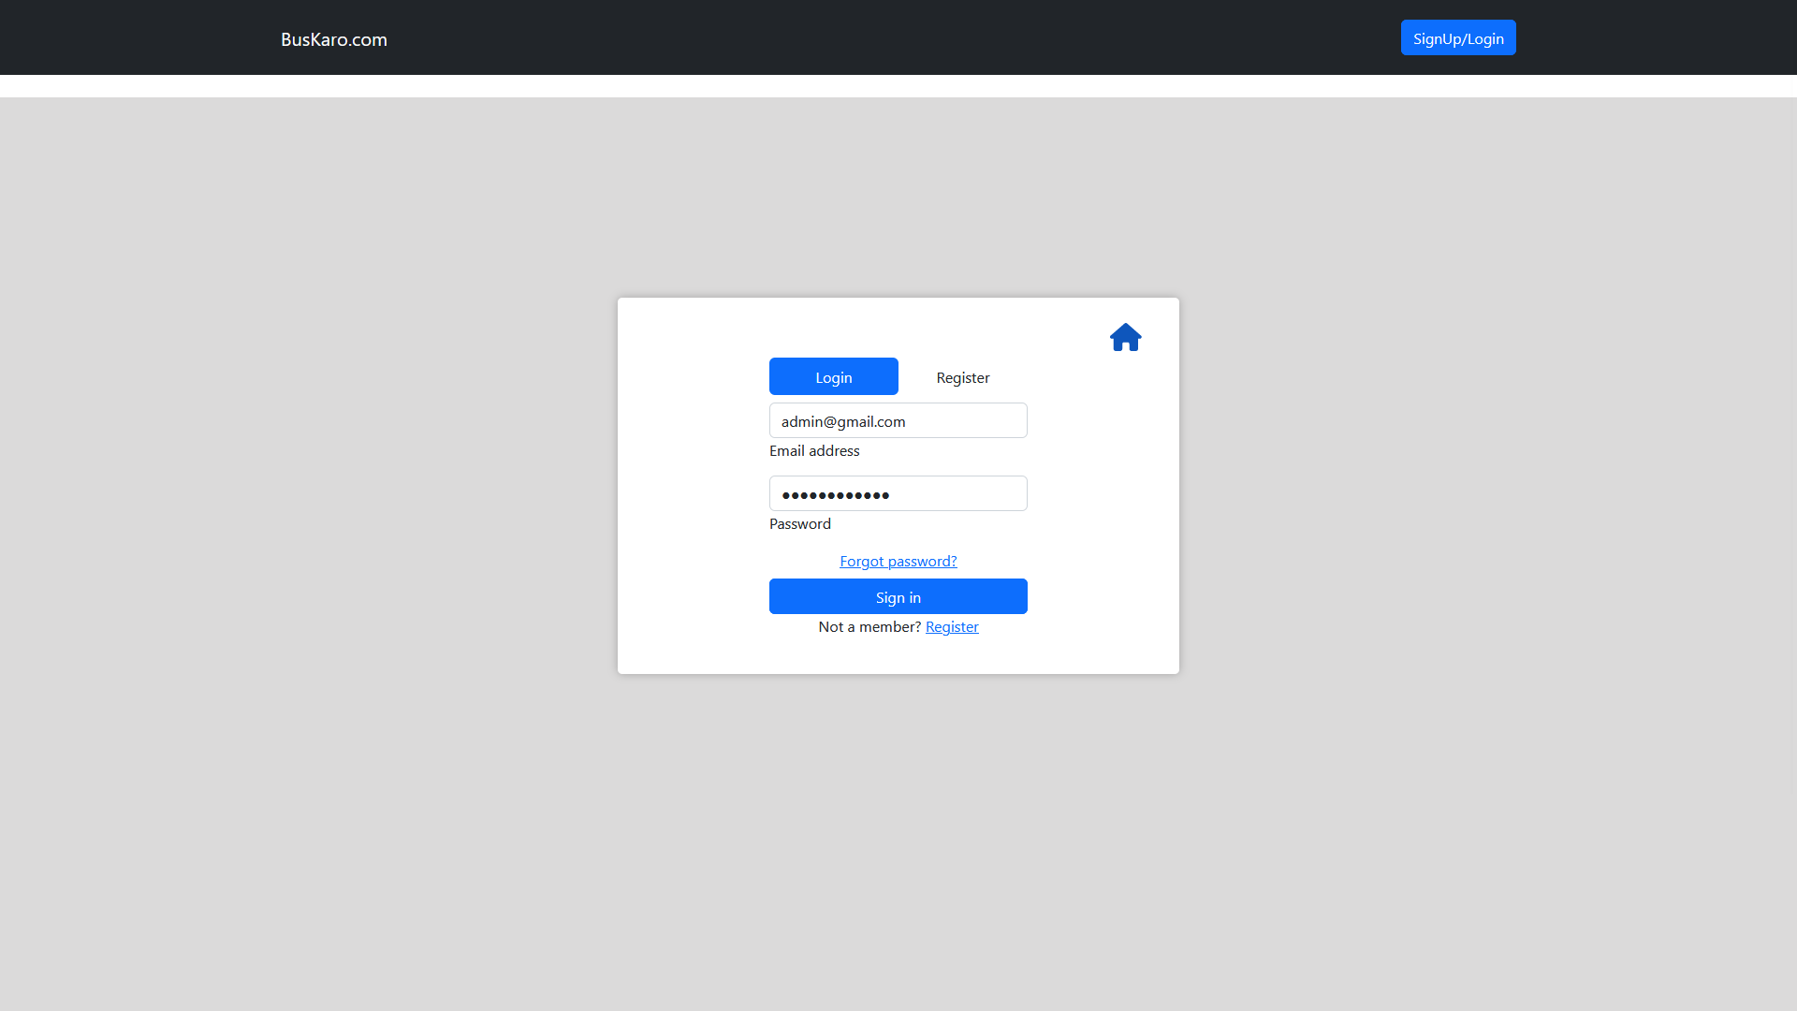
Admin Dashboard Page

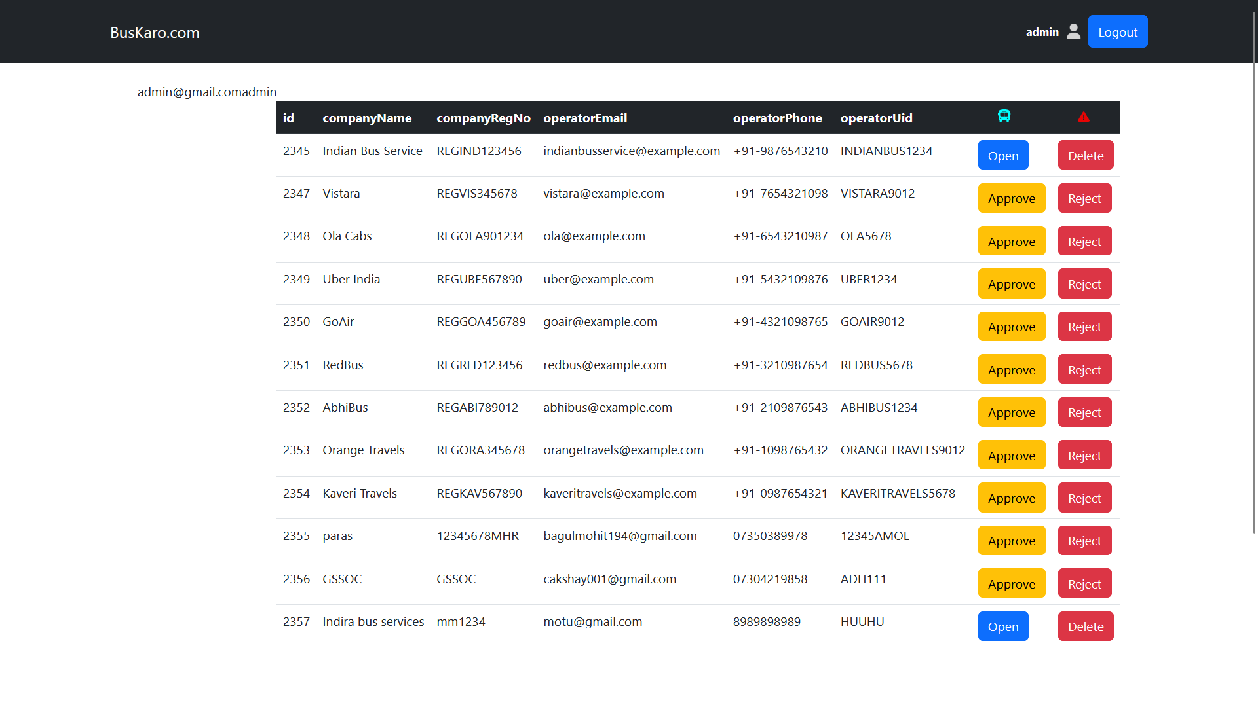

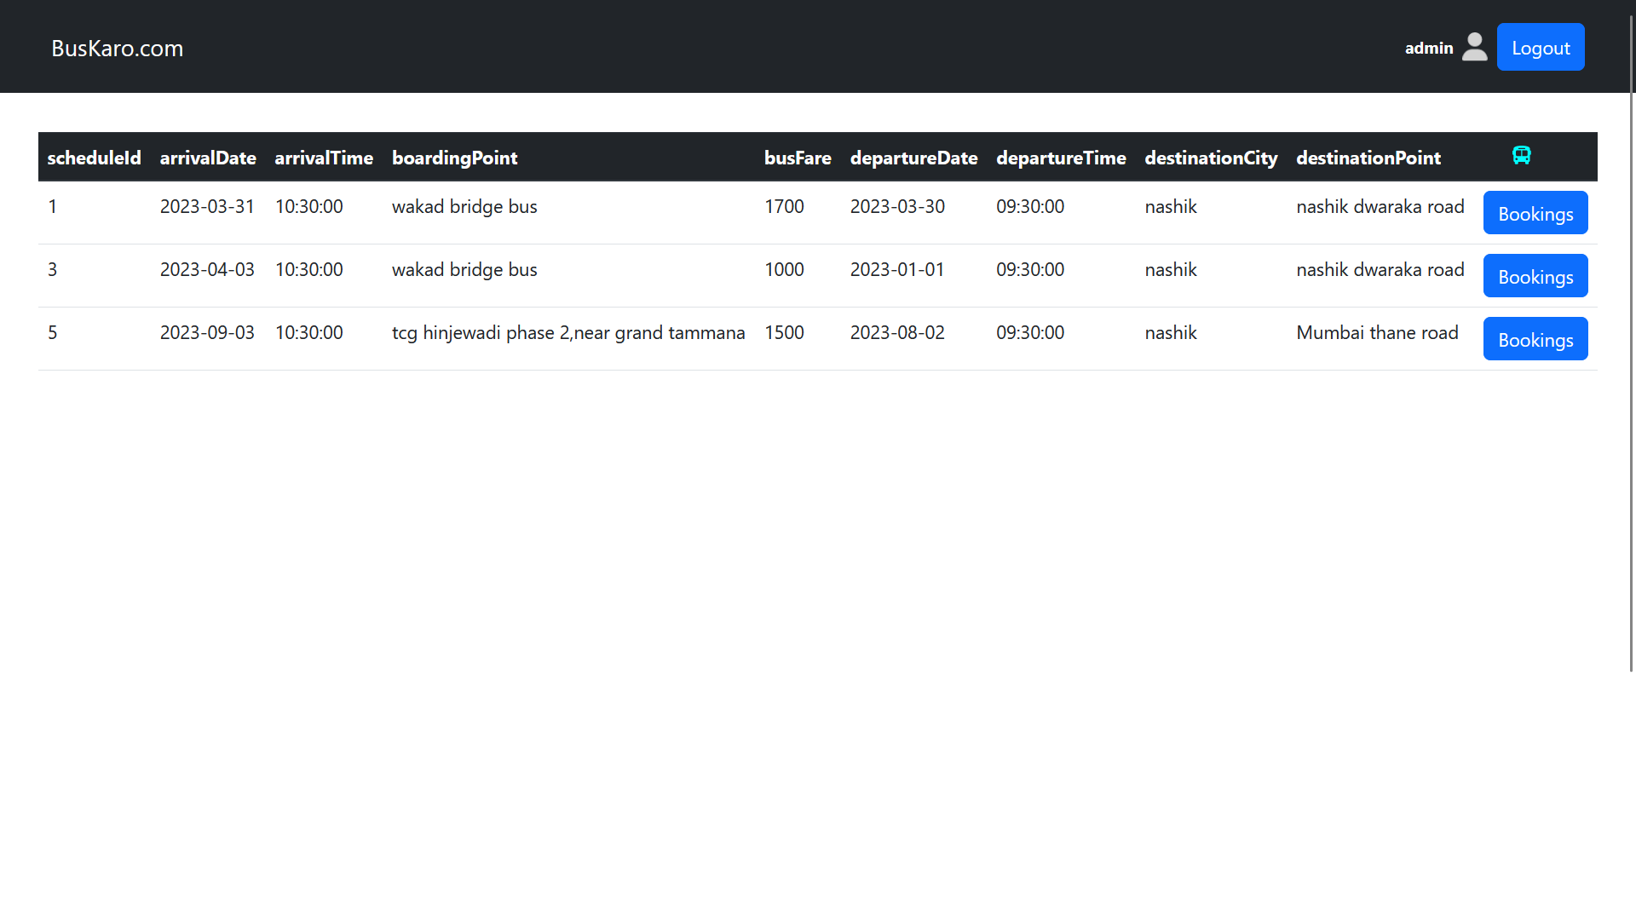
Admin View of bus bookings related to particular bus id
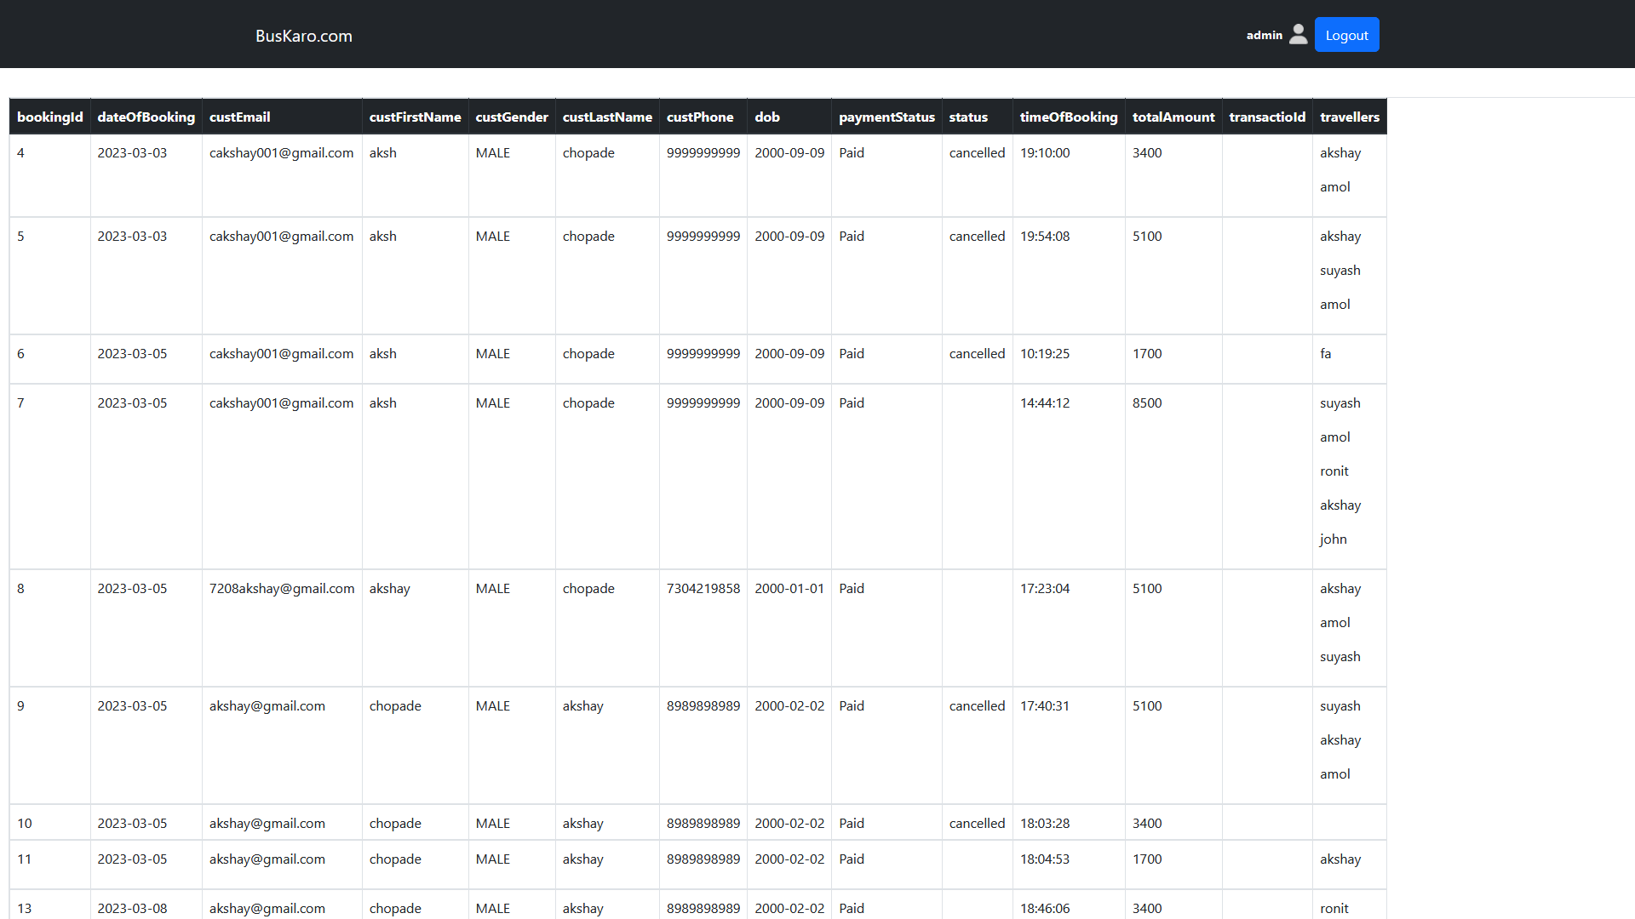

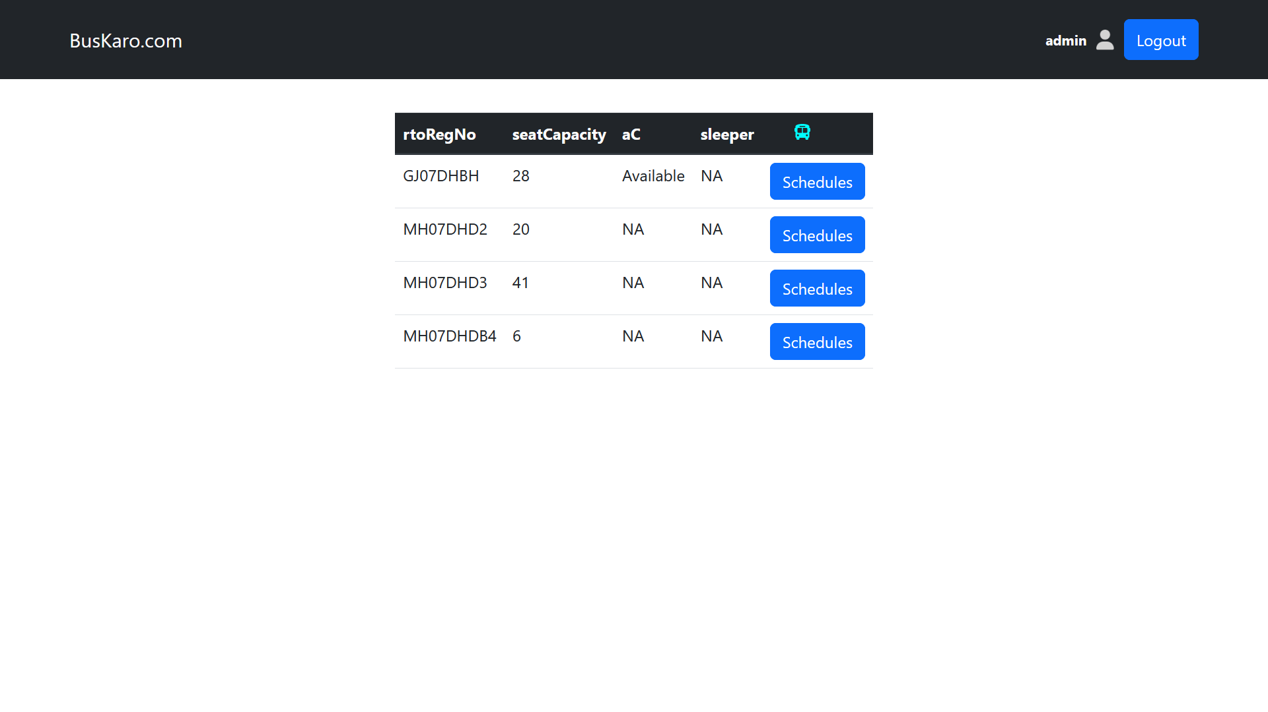
Operator Login
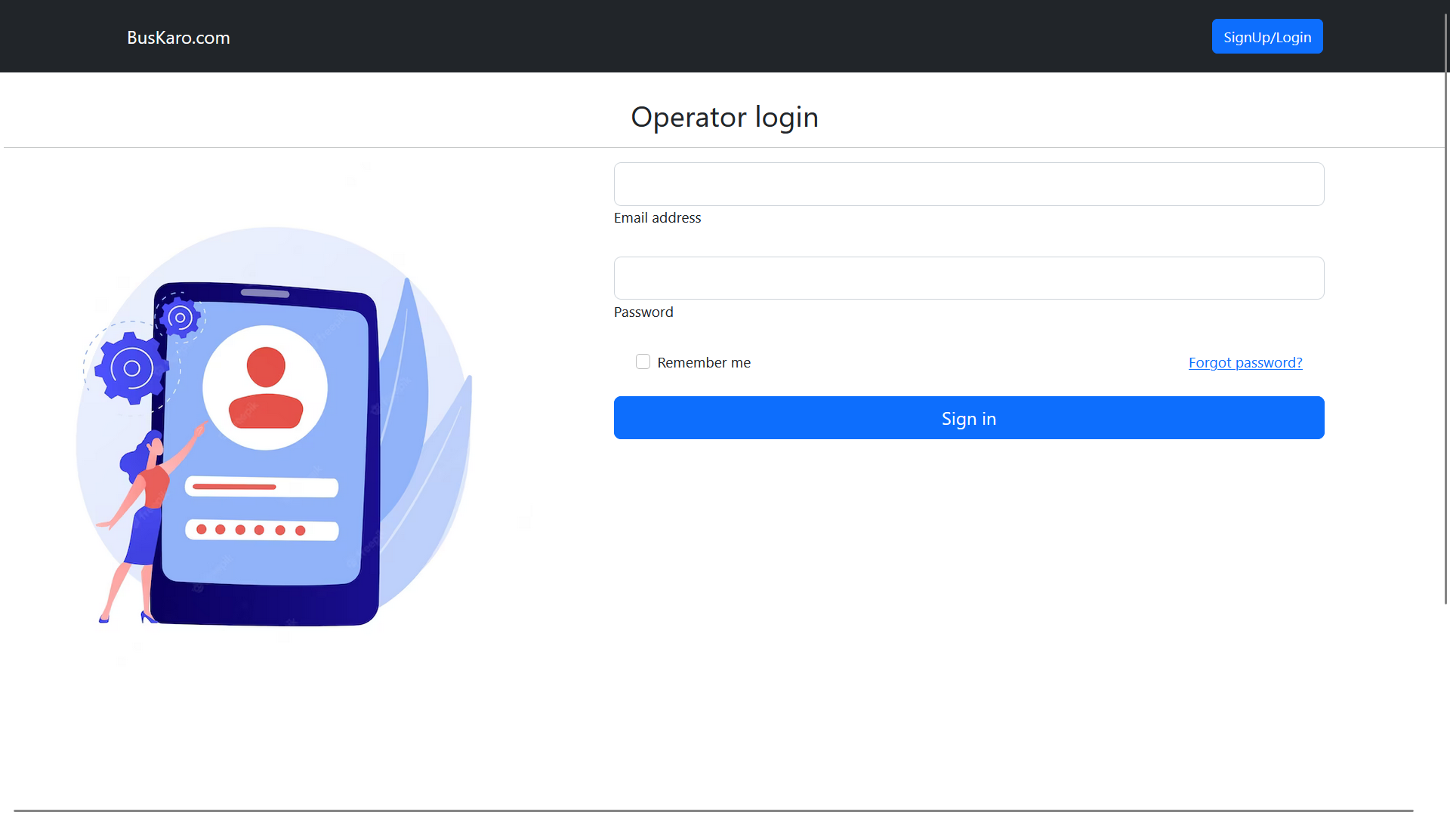

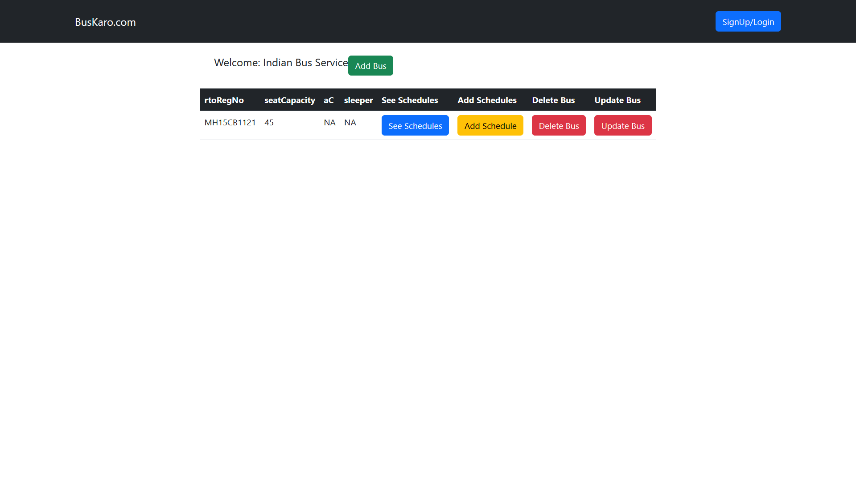

Adding Bus page
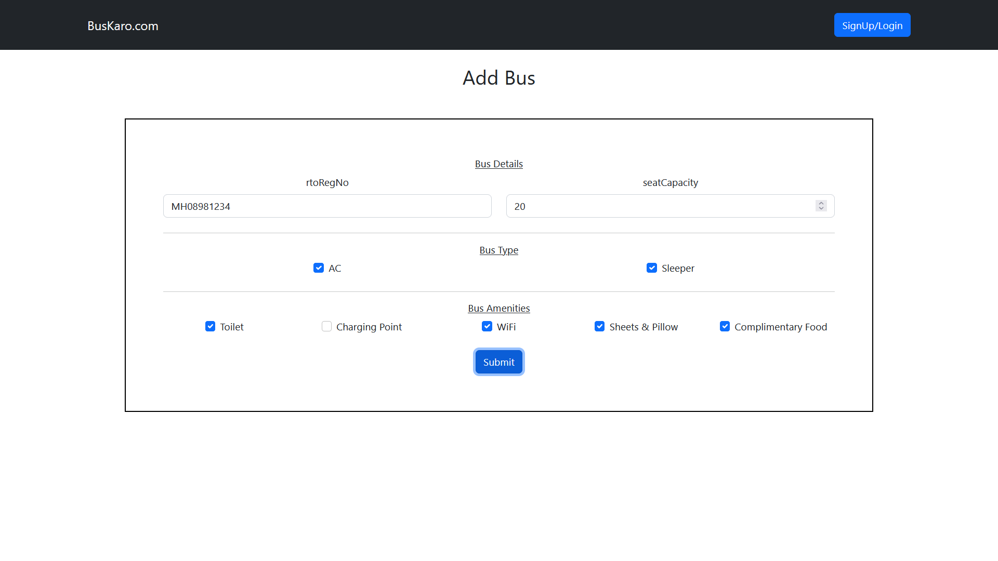

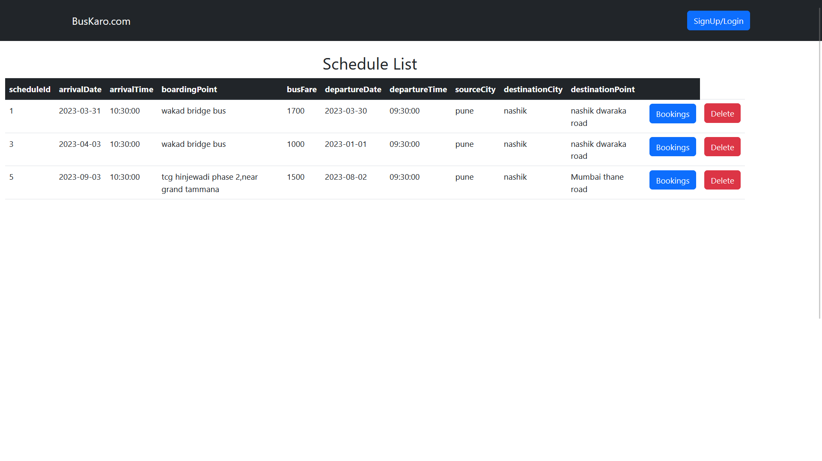
Add Schedule Page
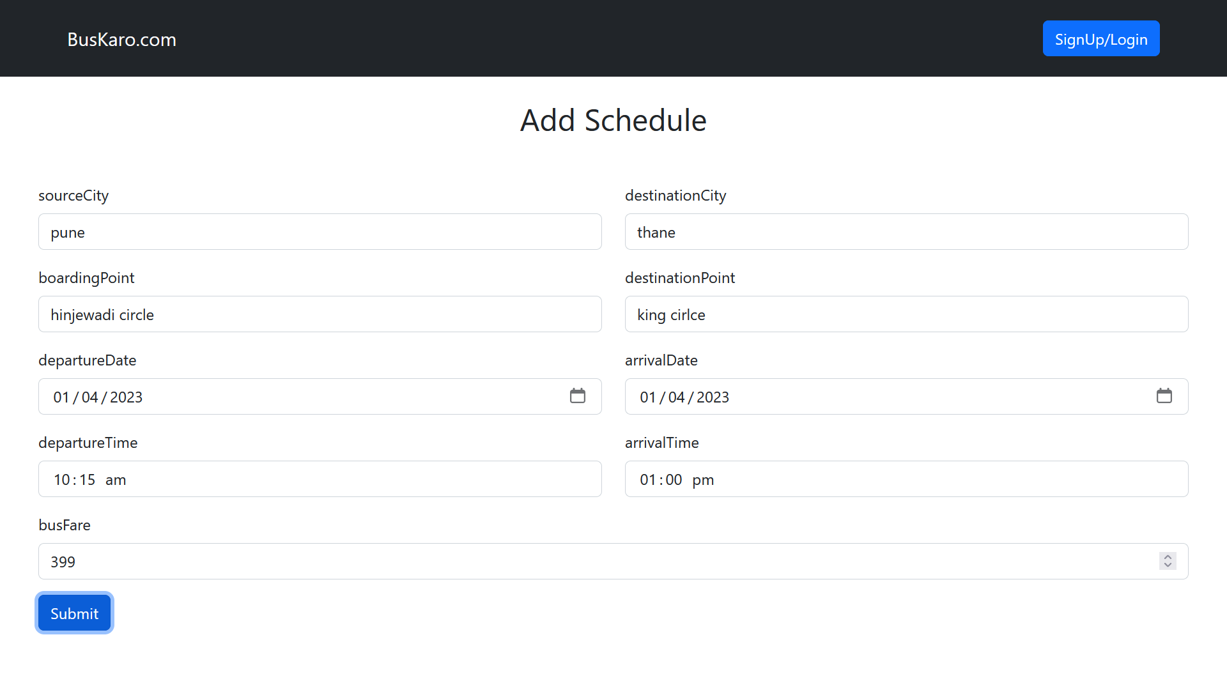

References
- "Building RESTful Web Services with Spring Boot and Spring Data JPA" by Greg L. Turnquist
- Oracle Corporation. (n.d.). Java Platform, Enterprise Edition (Java EE) Documentation. Oracle. Retrieved from https://docs.oracle.com/en/java/java-ee.html
- "Spring Boot Cookbook" by Alex Antonov
- "Java Persistence with Hibernate, Second Edition" by Christian Bauer and Gavin King
- "MySQL Explained: Your Step By Step Guide" by Mr Andrew Comeau
- "Java Server Faces 2.0, The Complete Reference" by Ed Burns and Chris Schalk
- React. (n.d.). React documentation. Facebook. Retrieved from https://reactjs.org/docs/getting-started.html

