Game Design Document

Fill up the following document

1. Write the title of your project.

Vault Opening Game

1. What is the goal of the game?

Ultimately, the goal of this game is to unscramble the letters and find the answer to each question in order to open the vault.

1. Write a brief story of your game.

My game features three questions, the answer to each of which is a coding concept. By finding the answer to each question, you can open the bank vault and collect the money inside. The player will have to use their knowledge of various coding concepts in order to complete this game.

1. Which are the playing characters of this game?

* Playing characters are the ones who respond to the user based on the input from the user.
* Cars, monkeys, dinos, wizards, etc., are the playing characters in the game.

|  |  |  |
| --- | --- | --- |
| Number | Character Name | What can this character do? |
| 1 | button1 | This element checks whether the user’s answer is the same as the input created. |
| 2 | button2 | This element checks whether the user’s answer is the same as the input created. |
| 3 | button3 | This element checks whether the user’s answer is the same as the input created. |
| 4 | access1 | This element allows the user to type in their answer to the first question. |
| 5 | access2 | This element allows the user to type in their answer to the second question. |
| 6 | access3 | This element allows the user to type in their answer to the third question. |

1. Which are the Non-Playing Characters of this game?

* Non-Playing characters are the ones that don't have an action or behavior when the user interacts with the game.
* Hurdles, stones, bananas, coins, etc., are non-playing characters in the game.

|  |  |  |
| --- | --- | --- |
| Number | Element Name | What can this element do? |
| 1 | background | This element serves as the underlying layer of the game before the vault is opened. |
| 2 | background2 | This element serves as the underlying layer of the game after the vault is opened. |
| 3 | score | This element keeps track of the number of questions the user gets correct. |

1. Draw your imagination of this game. What does this game look like?

* Draw the game either on your computer or on paper.
* Add images of the game scenes to show each of the playing and non-playing characters at least once.

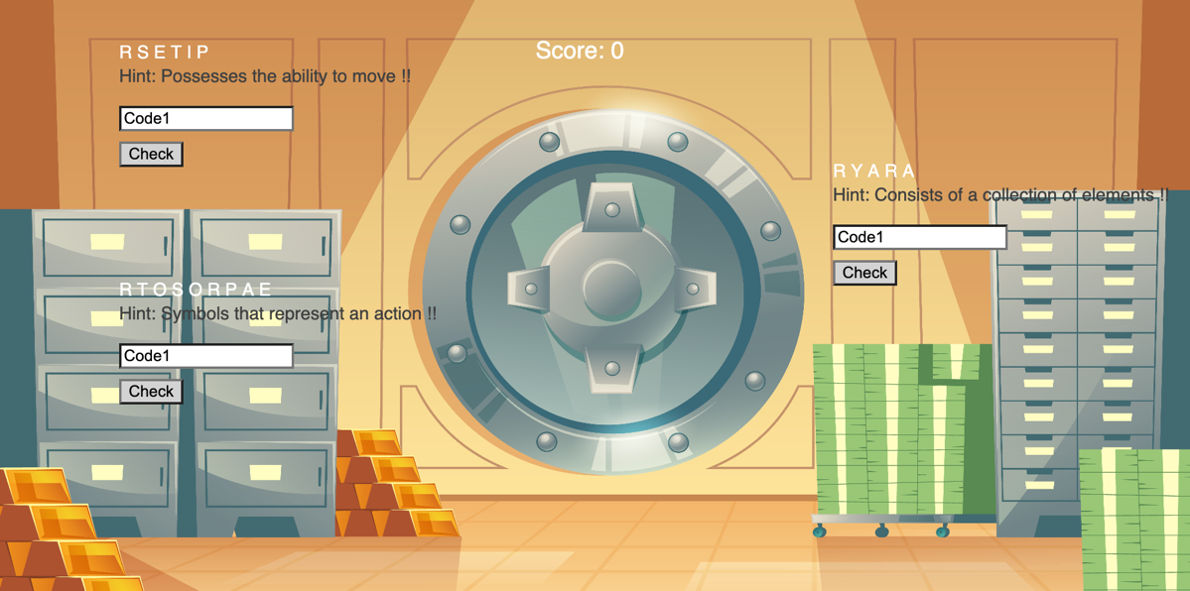



How do you plan to make your game engaging?

I plan to make my game engaging by creating three questions that the user will have to answer in order to open the vault and complete the game. This will allow the user to ultimately engage in my game.