Name : Samarth Gupta
UID : 2021600023
Subject : Design and analysis of algorithms
Experiment No. : 0

Aim : To implement various functions and study their graphs

Problem statement :

1) (3/2)^n
2) n^3
3) n
4) (n)^2n
5) log(n)
6) (log(n))^2
7) log(n!)
8) 2^log(n)
9) log(n)^log(n)
10) e^n
11) n!
Implementation in excel :
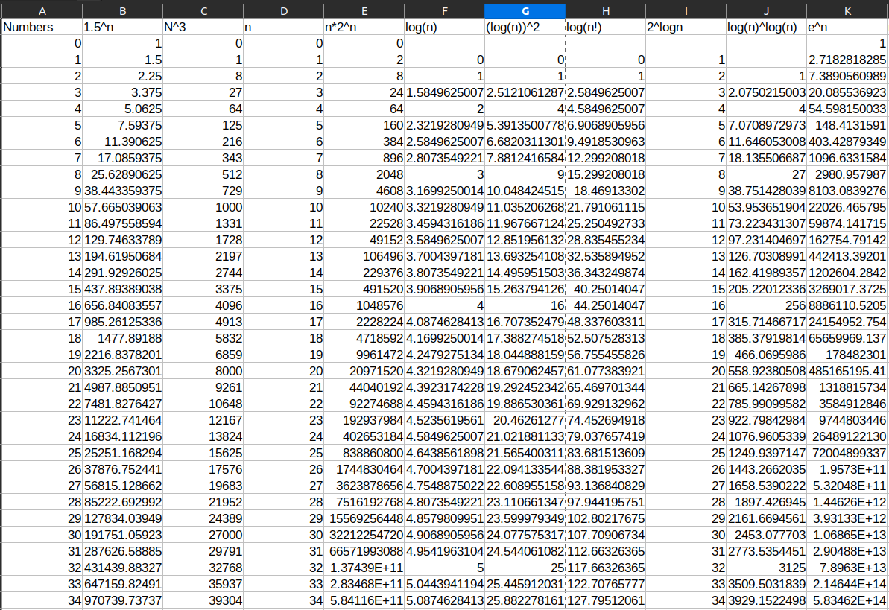
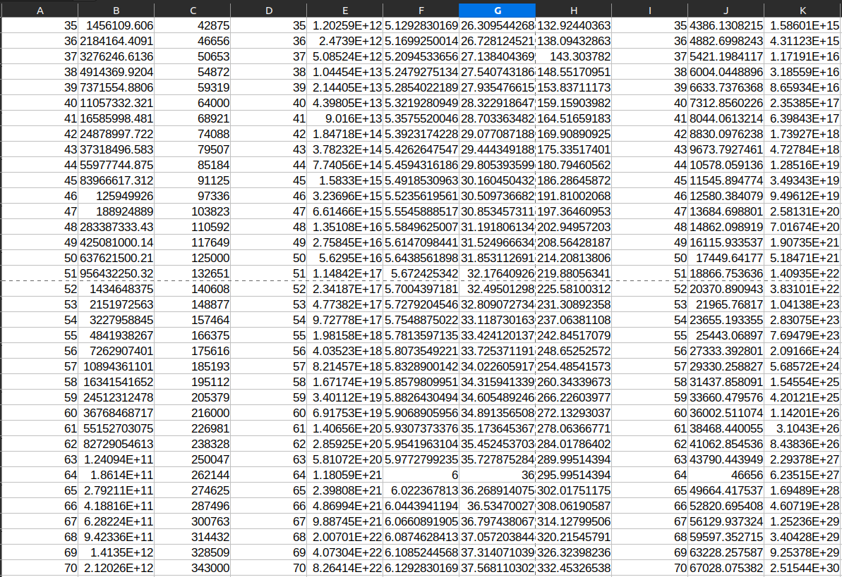

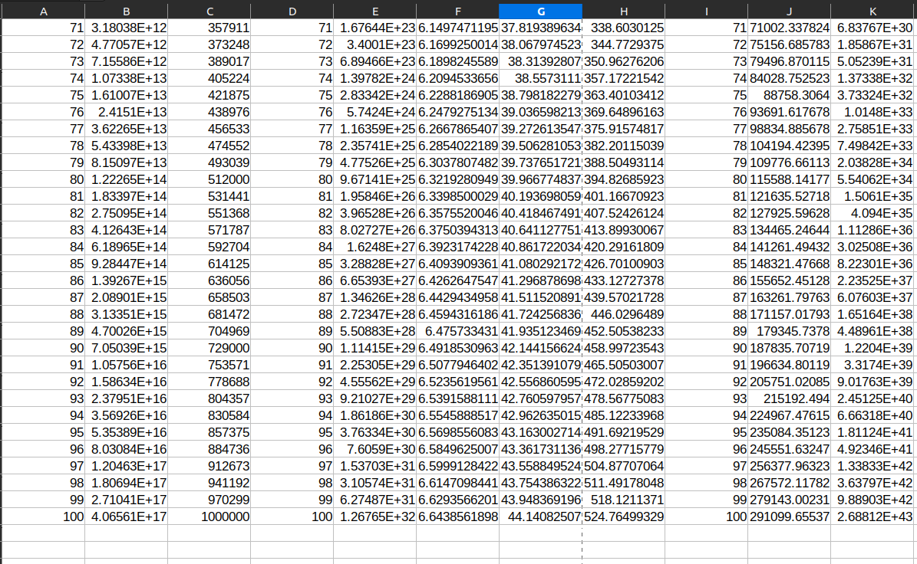
Graph 1 :

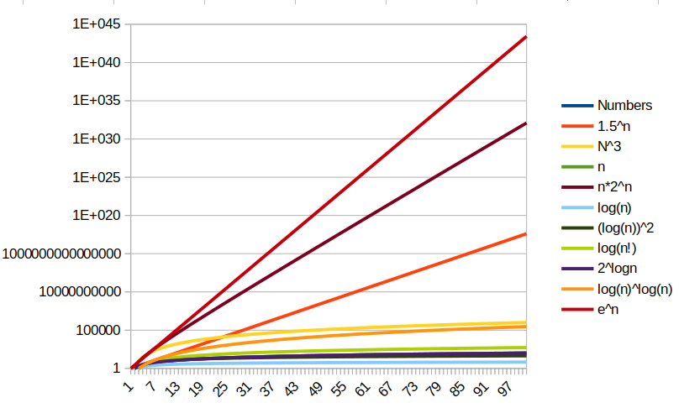
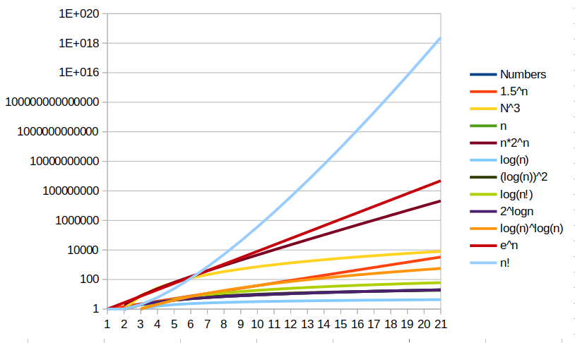
Graph 2 :

code :
public class functions {
public static void main(String[] args) {
for (int i = 0; i < 100; i++) {
//Calling all 10 functions with n as the argument

}
for (int i = 0; i < 20; i++) {
//calling all 11 functions with n! as the argument
}
}

public static double first(int n){
return Math.pow(1.5, n);
}

public static double second(int n){
return Math.pow(n, 3);
}

public static double third(int n){
return Math.pow(2, Math.pow(2, n));
}

public static double fourth(int n){
return n * Math.pow(2, n);
}

public static double fifth(int n){
return Math.pow((Math.log(n)/Math.log(2)), 2);
}

public static double sixth(int n){
int s = 1;
for (int i = 1; i <= n ; i++) {

s = s * n;

}
return Math.log(s)/Math.log(2);
}

public static double seventh(int n){
return Math.log(n)/Math.log(2);
}

public static double eigth(int n){
return Math.pow(2, (Math.log(n)/Math.log(2)));
}

public static double ninth(int n){
return Math.pow(Math.log(n)/Math.log(2), Math.log(n)/Math.log(2));
}

public static double tenth(int n){
return Math.pow(2.718, n);
}
}

Output :

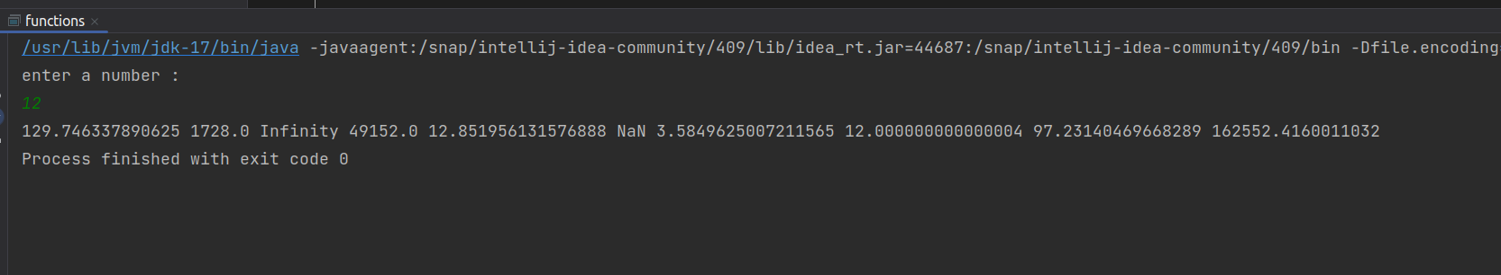
Conclusion :

Learnt how implement the various graphs of functions in excel.
Learnt about the various and their domains and ranges respectively.

