**Experiment number 1 a**

**Aim**: Write a program using classes and objects to print all even and odd numbers in the range of 1-100 as well as the total number of even and odd numbers in the given range. The range has to be taken from the user. Use the concept of classes and objects.

**Theory:** Classes are a blueprint/template and objects are instance of these classes. In this program, we need to take a range from the user, and list and count how many odd and how many even numbers are there in that range.

We have to do the same for the range 0-100 and we have to use classes and objects for it.

**Algorithm:**

**Code:**

import java.util.Scanner;

public class oddEven{

public static void Odd_even(int a , int b){

int odd=0;

int even=0;

if(a%2==0){

System.out.println("even:");

}

else{

System.out.println("odd:");

}

for (int i = a; i <=b ; i+=2) {

if(i%2==0){

even++;

System.out.print(i+" ");

}

else{

odd++;

System.out.print(i+" ");

}

}

System.out.println("");

if((a+1)%2==0){

System.out.println("even:");

}

else{

System.out.println("odd:");

}

for (int i = a+1; i <=b ; i+=2) {

if(i%2==0){

even++;

System.out.print(i+" ");

}

else{

odd++;

System.out.print(i+" ");

}

}

System.out.println("");

System.out.println("the number of even number in the range are="+even);

System.out.println("the number of odd numbers in tge range are="+odd);

System.out.println("odd:");

for (int i = 1; i <=100 ; i+=2) {

System.out.print(i+" ");

}

System.out.println("");

System.out.println("even:");

for (int i = 2; i <=100 ; i+=2) {

System.out.print(i+" ");

}

}

}

class xyz{

public static void main(String[] args) {

Scanner sc = new Scanner(System.in);

System.out.println("enter lower limit=");

int a = sc.nextInt();

System.out.println("enter upper limit=");

int b = sc.nextInt();

oddEven u = new oddEven();

u.Odd_even(a,b);

}

}

**Output:**

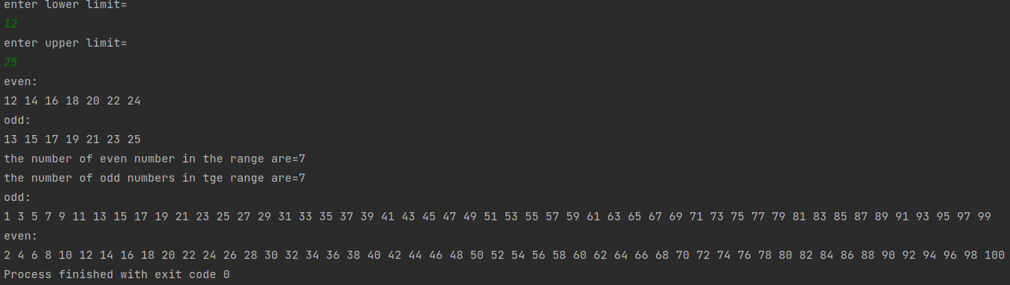

**Conclusion:**

By writing this code, I learnt how to create objects and write simple programs using multiple classes. I also realised that in a single code file, there can be only one public class.