**Experiment 3b**

**Aim:** Derive the circle from class shape. Find the area/perimeter of the circle whose PI value is constant. Use super keyword to initialize the assumed parameter.

**Theory:** The ****super**** keyword in Java is a reference variable which is used to refer immediate parent class object. Whenever you create the instance of subclass, an instance of parent class is created implicitly which is referred by super reference variable.

**Algorithm:**

1. public class areaper{ public static void main(String args[]){
2. Scanner sc = new Scanner(System.in)
3. create object c of class circle [ circle c = new circle() ]
4. ask user for radius and store it in int r
5. call c.per(r) and c.ar(r)
6. create class shape{ double pi=3.141,perimeter,area}
7. create class circle extends shape{
8. void per(int r){ super.perimeter= 2*(super.pi)*r} and void ar(int r){super.area=(super.pi)*r*r}

**Code:**

import java.util.*;

public class areaper{

public static void main(String args[]){

Scanner sc = new Scanner(System.in);

circle c = new circle();

System.out.print("enter radius= ");

int r = sc.nextInt();

c.per(r);

c.ar(r);

}

}

class shape{

double pi=3.141,perimeter,area;

}

class circle extends shape{

void per(int r){

super.perimeter= 2*(super.pi)*r;

System.out.println("the perimeter is "+super.perimeter);

}

void ar(int r){

super.area=(super.pi)*r*r;

System.out.println("the area is "+super.area);

}

}

**Output:**

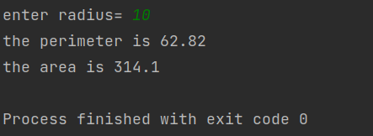

**Conclusion:**

Through this program, I learnt how inheritance works. How a child class can inherit the properties and characteristics of a parent class by using the keyword “super”.