**Experiment 2b**

**Aim:** Write a class ‘Student’ with the following specifications:

Data Members:

String studName : Name of student

String sid : Unique ID of the student

percentage : Percentage of student (Choose appropriate data-type)

Create a constructor to define the values for these data members. Also create a method which inputs the students marks calculates his final percentage, and prints an appropriate grade (A,B,C,D).

**Theory:** In this program we have to use encapsulation and print the data of a student i.e their name, id, percentage and grade.

**Algorithm:**

1. public class stuinfo{public static void main(String[] args){
2. Scanner sc = new Scanner (System.in)
3. create new object Student s= new Student()
4. enter name and store in String name, enter ID and store in String id, enter the number of subjects and store in int n. call function float perc=marks(n)
5. in function marks, ask for marks in each subject.
6. run a for loop from 0 to n, add the marks m in c. After the loop ends, return c/n as the percentage.
7. s.setName(name), s.setsid(id), s.setpercentage(perc)
8. in class Student{ define private String studName, sid float percentage

Student(){ studName="Samarth";

sid="2021600023";

percentage=98;

1. public void setName(String newName){

this.studName=newName;

}

public void setsid(String newsid){

this.sid=newsid;

}

public void setpercentage(float perc){

this.percentage=perc;

}

public String getName(){

return studName;

}

public String getsid(){

return sid;

}

public float getpercentage(){

return percentage;

}

**Code:**

import java.util.*;

class Student{

private String studName,sid;

private float percentage;

Student(){ //constructor

studName="Samarth";

sid="2021600023";

percentage=98;

}

public void setName(String newName){

this.studName=newName;

}

public void setsid(String newsid){

this.sid=newsid;

}

public void setpercentage(float perc){

this.percentage=perc;

}

public String getName(){

return studName;

}

public String getsid(){

return sid;

}

public float getpercentage(){

return percentage;

}

}

public class stuinfo{ //driver class

public static void main(String args[]){

Scanner sc = new Scanner(System.in);

Student s = new Student();

System.out.println("enter your name: ");

String name = sc.next();

System.out.println("enter your ID: ");

String id = sc.next();

//int perc=sc.nextFloat();

System.out.println("enter the number of subjects: ");

int n=sc.nextInt();

float perc=marks(n);

s.setName(name);

s.setsid(id);

s.setpercentage(perc);

System.out.println("Name= "+s.getName());

System.out.println("ID= "+s.getsid());

System.out.println("Percentage= "+s.getpercentage());

if((int)perc>=90){

System.out.println("Grade=A");

}

else if((int)perc>=80 && (int)perc<90){

System.out.println("Grade=B");

}

else if ((int)perc>=70 && (int)perc<80) {

System.out.println("Grade=C");

}

else {

System.out.println("Grade=D");

}

}

public static float marks(int n){

System.out.print("enter the marks in each subject: ");

Scanner sc = new Scanner(System.in);

float c=0,m;

for(int i=0;i<n;i++){

m=sc.nextInt();

c=c+m;

}

return c/n;

}

}

**Output:**

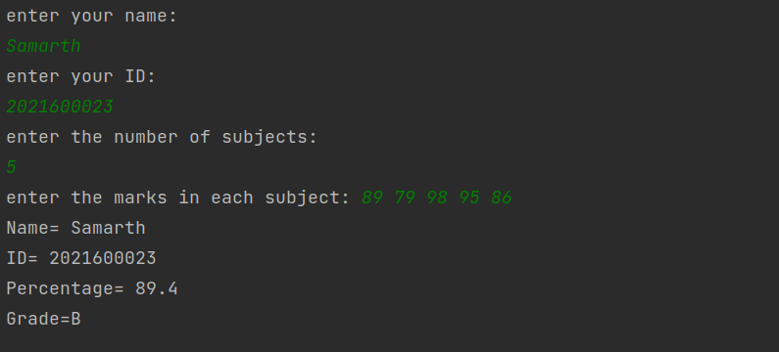

**Conclusion:**

by writing this program, I learnt how to use encapsulation. The concept of public and private access specifiers became more clear to me, and i also learnt how get and set methods work in java

**Samarth Gupta**

**2021600023**

**C2 AI-ML**