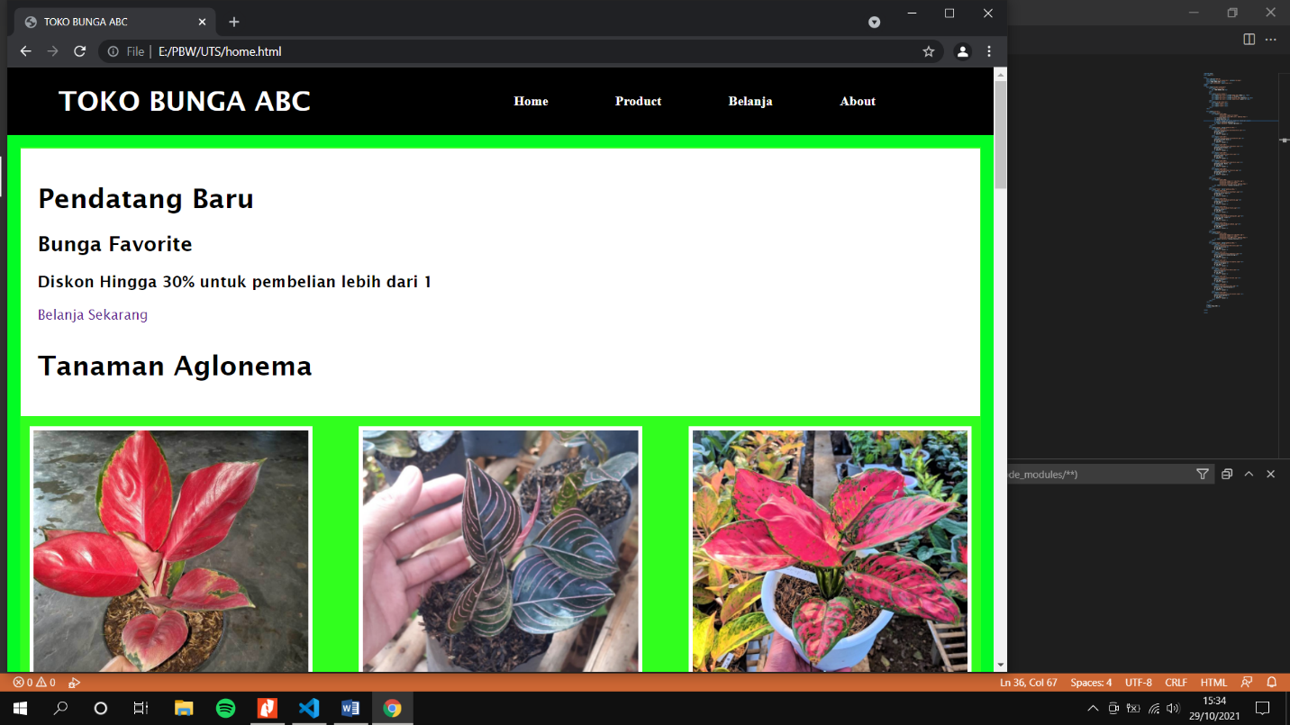

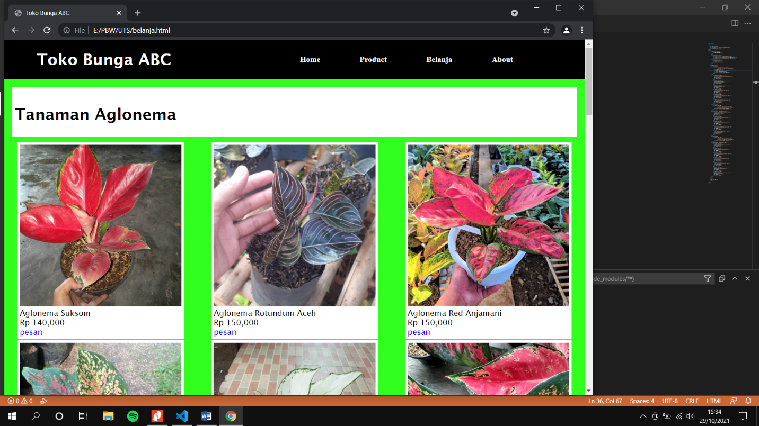

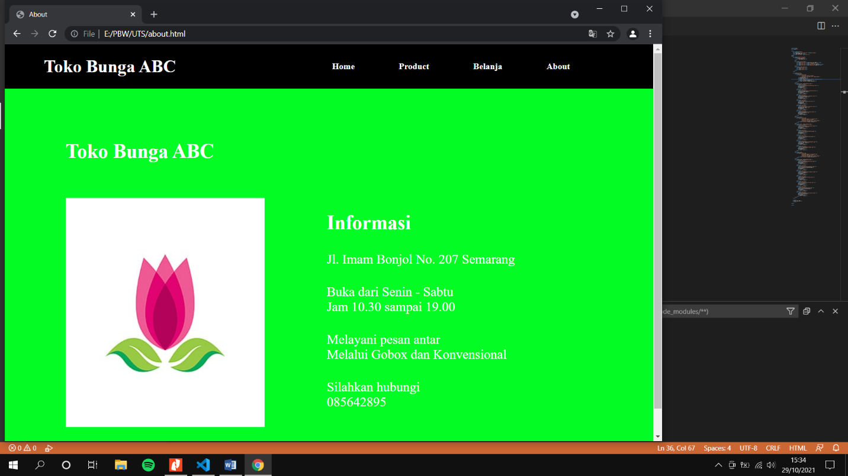

1. Home HTML

<!DOCTYPE html>

<html lang="en">

<head>

<meta charset="UTF-8">

<meta http-equiv="X-UA-Compatible" content="IE=edge">

<title>TOKO BUNGA ABC</title>

<link rel="stylesheet" href="home.css">

</head>

<body>

<div class="navbar-container">

<div class="title-shop">

<h1 >TOKO BUNGA ABC</h1>

</div>

<br>

<div class="button-header">

<div class="nav-list"><a href="home.html">Home</a> </div>

<div class="nav-list"><a href="#">Product</a></div>

<div class="nav-list"><a href="belanja.html">Belanja</a></div>

<div class="nav-list"><a href="about.html">About</a></div>

</div>

<div class="burger-menu-nav">

<div class="line1"></div>

<div class="line2"></div>

<div class="line3"></div>

</div>

</div>

<div class="col-12">

<div class="head1" >

<div style="width:100%;

background-repeat:no-repeat;

background-size:100% auto; padding:20px;">

<h1>Pendatang Baru</h1>

<h2>Bunga Favorite</h2>

<h3>Diskon Hingga 30% untuk pembelian lebih dari 1</h3>

<a href="#">Belanja Sekarang</a>

<h1 class="aglomena">Tanaman Aglonema</h1>

</div>

</div>

<div class="head1" style="padding:10px;" >

<div style="width:30%">

<img src="img/aglonema/aglonemasuksom.jpg"><br>

Aglonema Suksom<br>

Rp 140,000<br>

<a href="#">pesan</a>

</div>

<div style="width:30%">

<img src="img/aglonema/rotundumaceh.jpg"><br>

Aglonema Rotundum Aceh<br>

Rp 150,000<br>

<a href="#">pesan</a>

</div>

<div style="width:30%">

<img src="img/aglonema/redajamani.jpg"><br>

Aglonema Red Anjamani <br>

Rp 150,000<br>

<a href="#">pesan</a>

</div>

<div style="width:30%">

<img src="img/aglonema/venus.jpg"><br>

Aglonema Venus <br>

Rp 150,000<br>

<a href="#">pesan</a>

</div>

<div style="width:30%">

<img src="img/aglonema/superwhite.jpg"><br>

Aglonema Super White <br>

Rp 150,000<br>

<a href="#">pesan</a>

</div>

<div style="width:30%">

<img src="img/aglonema/redcocin.jpg"><br>

Aglonema Red Chocin <br>

Rp 150,000 <br>

<a href="#">pesan</a>

</div>

</div>

<div class="head1" >

<div style="width:100%;

background-image:url('img/toko.png');

background-repeat:no-repeat;

background-size:100% auto; padding:20px;">

<h1 class="aglomena">Tanaman Caladium</h1>

</div>

</div>

<div class="head1" style="padding:10px;" >

<div style="width:30%">

<img src="img/caladium/aceofheart.jpg"><br>

Caladium ace of heart<br>

Rp 140,000<br>

<a href="#">pesan</a>

</div>

<div style="width:30%">

<img src="img/caladium/pinklove.jpg"><br>

Caladium pink love<br>

Rp 150,000<br>

<a href="#">pesan</a>

</div>

<div style="width:30%">

<img src="img/caladium/fiesta.jpg"><br>

Caladium fiesta<br>

Rp 150,000<br>

<a href="#">pesan</a>

</div>

<div style="width:30%">

<img src="img/caladium/greenspider.jpg"><br>

Caladium green spider<br>

Rp 150,000<br>

<a href="#">pesan</a>

</div>

<div style="width:30%">

<img src="img/caladium/candium.jpg"><br>

Caladium candidum<br>

Rp 150,000<br>

<a href="#">pesan</a>

</div>

</div>

<div class="head1" >

<div style="width:100%;

background-image:url('img/toko.png');

background-repeat:no-repeat;

background-size:100% auto; padding:20px;">

<h1 class="aglomena">Tanaman Monstera</h1>

</div>

</div>

<div class="head1" style="padding:10px;" >

<div style="width:30%">

<img src="img/monstera/deliciosa.jpg"><br>

Monstera Deliciosa<br>

Rp 140,000<br>

<a href="#">pesan</a>

</div>

<div style="width:30%">

<img src="img/monstera/andasonii.jpg"><br>

Monstera Adansonii(Janda Bolong)<br>

Rp 150,000<br>

<a href="#">pesan</a>

</div>

<div style="width:30%">

<img src="img/monstera/variegata1.jpeg"><br>

Monstera Variegata<br>

Rp 150,000<br>

<a href="#">pesan</a>

</div>

<div style="width:30%">

<img src="img/monstera/dubia.jpg"><br>

Monstera Dubia<br>

Rp 150,000<br>

<a href="#">pesan</a>

</div>

<div style="width:30%">

<img src="img/monstera/obliqua.jpg"><br>

Monstera Obliqua<br>

Rp 150,000<br>

<a href="#">pesan</a>

</div>

<div style="width:30%">

<img src="img/monstera/thai.jpg"><br>

Monstera Thai Constellation<br>

Rp 150,000<br>

<a href="#">pesan</a>

</div>

<div style="width:30%">

<img src="img/monstera/borsigiana.jpeg"><br>

Monstera Borsigiana<br>

Rp 150,000<br>

<a href="#">pesan</a>

</div>

</div>

</div>

<footer>

<p>Toko Bunga ABC</p>

</footer>

</body>

</html>

1. **Belanja HTML**

<!DOCTYPE html>

<html lang="en">

<head>

<meta charset="UTF-8">

<meta http-equiv="X-UA-Compatible" content="IE=edge">

<title>Toko Bunga ABC</title>

<link rel="stylesheet" href="belanja.css">

</head>

<body>

<div class="navbar-container">

<div class="title-shop">

<h1>Toko Bunga ABC</h1>

</div>

<br>

<div class="button-header">

<div class="nav-list"><a href="home.html">Home</a> </div>

<div class="nav-list"><a href="#">Product</a></div>

<div class="nav-list"><a href="belanja.html">Belanja</a></div>

<div class="nav-list"><a href="about.html">About</a></div>

</div>

<div class="burger-menu-nav">

<div class="line1"></div>

<div class="line2"></div>

<div class="line3"></div>

</div>

</div>

<div class="col-12">

<div class="head1">

<div style="width:100%;">

<h1 class="aglomena">Tanaman Aglonema</h1>

</div>

</div>

<div class="head1" style="padding:10px;">

<div style="width:30%">

<img src="img/aglonema/aglonemasuksom.jpg"><br>

Aglonema Suksom<br>

Rp 140,000<br>

<a href="#">pesan</a>

</div>

<div style="width:30%">

<img src="img/aglonema/rotundumaceh.jpg"><br>

Aglonema Rotundum Aceh<br>

Rp 150,000<br>

<a href="#">pesan</a>

</div>

<div style="width:30%">

<img src="img/aglonema/redajamani.jpg"><br>

Aglonema Red Anjamani <br>

Rp 150,000<br>

<a href="#">pesan</a>

</div>

<div style="width:30%">

<img src="img/aglonema/venus.jpg"><br>

Aglonema Venus <br>

Rp 150,000<br>

<a href="#">pesan</a>

</div>

<div style="width:30%">

<img src="img/aglonema/superwhite.jpg"><br>

Aglonema Super White <br>

Rp 150,000<br>

<a href="#">pesan</a>

</div>

<div style="width:30%">

<img src="img/aglonema/redcocin.jpg"><br>

Aglonema Red Chocin <br>

Rp 150,000 <br>

<a href="#">pesan</a>

</div>

</div>

<div class="head1">

<div style="width:100%;

background-image:url('img/toko.png');

background-repeat:no-repeat;

background-size:100% auto; padding:20px;">

<h1 class="aglomena">Tanaman Caladium</h1>

</div>

</div>

<div class="head1" style="padding:10px;">

<div style="width:30%">

<img src="img/caladium/aceofheart.jpg"><br>

Caladium ace of heart<br>

Rp 140,000<br>

<a href="#">pesan</a>

</div>

<div style="width:30%">

<img src="img/caladium/pinklove.jpg"><br>

Caladium pink love<br>

Rp 150,000<br>

<a href="#">pesan</a>

</div>

<div style="width:30%">

<img src="img/caladium/fiesta.jpg"><br>

Caladium fiesta<br>

Rp 150,000<br>

<a href="#">pesan</a>

</div>

<div style="width:30%">

<img src="img/caladium/greenspider.jpg"><br>

Caladium green spider<br>

Rp 150,000<br>

<a href="#">pesan</a>

</div>

<div style="width:30%">

<img src="img/caladium/candium.jpg"><br>

Caladium candidum<br>

Rp 150,000<br>

<a href="#">pesan</a>

</div>

</div>

<div class="head1">

<div style="width:100%;

background-image:url('img/toko.png');

background-repeat:no-repeat;

background-size:100% auto; padding:20px;">

<h1 class="aglomena">Tanaman Monstera</h1>

</div>

</div>

<div class="head1" style="padding:10px;">

<div style="width:30%">

<img src="img/monstera/deliciosa.jpg"><br>

Monstera Deliciosa<br>

Rp 140,000<br>

<a href="#">pesan</a>

</div>

<div style="width:30%">

<img src="img/monstera/andasonii.jpg"><br>

Monstera Adansonii( Janda Bolong )<br>

Rp 150,000<br>

<a href="#">pesan</a>

</div>

<div style="width:30%">

<img src="img/monstera/variegata1.jpeg"><br>

Monstera Variegata<br>

Rp 150,000<br>

<a href="#">pesan</a>

</div>

<div style="width:30%">

<img src="img/monstera/dubia.jpg"><br>

Monstera Dubia<br>

Rp 150,000<br>

<a href="#">pesan</a>

</div>

<div style="width:30%">

<img src="img/monstera/obliqua.jpg"><br>

Monstera Obliqua<br>

Rp 150,000<br>

<a href="#">pesan</a>

</div>

<div style="width:30%">

<img src="img/monstera/thai.jpg"><br>

Monstera Thai Constellation<br>

Rp 150,000<br>

<a href="#">pesan</a>

</div>

<div style="width:30%">

<img src="img/monstera/borsigiana.jpeg"><br>

Monstera Borsigiana<br>

Rp 150,000<br>

<a href="#">pesan</a>

</div>

</div>

</div>

<footer>

<p>Toko Bunga ABC</p>

</footer>

</body>

</html>

1. **About HTML**

<!DOCTYPE html>

<html lang="en">

<head>

<meta charset="UTF-8">

<meta http-equiv="X-UA-Compatible" content="IE=edge">

<meta name="viewport" content="width=device-width, initial-scale=1.0">

<title>About</title>

<link rel="stylesheet" href="about.css">

</head>

<body>

<div class="navbar-container">

<div class="title-shop">

<h1 >Toko Bunga ABC</h1>

</div>

<br>

<div class="button-header">

<div class="nav-list"><a href="home.html">Home</a> </div>

<div class="nav-list"><a href="#">Product</a></div>

<div class="nav-list"><a href="belanja.html">Belanja</a></div>

<div class="nav-list"><a href="about.html">About</a></div>

</div>

<div class="burger-menu-nav">

<div class="line1"></div>

<div class="line2"></div>

<div class="line3"></div>

</div>

</div>

<div class="container_2">

<div class="you_know_me_title">

<h1 class="text-portofolio">Toko Bunga ABC</h1>

</div>

<div class="you_know_me_data">

<img src="img/logo toko.jpg">

<div class="you_know_me_isi">

<h1 class="you_know_me_quote">

Informasi

</h1>

<p class="first_tag">

Jl. Imam Bonjol No. 207 Semarang

<br>

</p>

<p class="first_tag">

Buka dari Senin - Sabtu

<br>

Jam 10.30 sampai 19.00

</p>

<p class="first_tag">

Melayani pesan antar

<br>

Melalui Gobox dan Konvensional

</p>

<p class="first_tag">

Silahkan hubungi

<br>

085642895

</p>

</div>

</div>

</div>

</body>

</html>

1. **Home CSS**

* {

box-sizing: border-box;

}

body {

margin:0;

background-color: rgb(2, 252, 36);

}

img {

width: 100%;

height: auto;

}

.row:after {

display: flex;

flex-direction: column;

}

.aglomena {

padding-top: 10px;

}

.navbar-container {

display: flex;

justify-content: space-around;

align-items: center;

background-color: rgb(0, 0, 0);

min-height: 10vh;

}

.navbar-container .header_button {

display: flex;

padding-right: 50px;

padding-left: 50px;

}

.button-header {

display: flex;

flex-direction: row;

position: relative;

justify-content: space-between;

}

.button-header .nav-list {

margin-right: 80px;

}

.nav-list a {

font-family: Montserrat;

font-weight: 700;

color: white;

text-decoration: none;

}

.title-shop h1{

color: white;

}

[class*="col-"] {

float: left;

padding: 15px;

}

.col-1 {width: 8.33%;}

.col-2 {width: 16.66%;}

.col-3 {width: 25%;}

.col-4 {width: 33.33%;}

.col-5 {width: 41.66%;}

.col-6 {width: 50%;}

.col-7 {width: 58.33%;}

.col-8 {width: 66.66%;}

.col-9 {width: 75%;}

.col-10 {width: 83.33%;}

.col-11 {width: 91.66%;}

.col-12 {width: 100%;}

html {

font-family: "Lucida Sans", sans-serif;

}

.header {

background-color: rgb(49, 255, 30);

color: #ffffff;

padding: 15px;

}

.footer {

background-color: rgb(49, 255, 30);

color: #ffffff;

text-align: center;

font-size: 12px;

padding: 15px;

}

.head1 {display:flex;

background-color:rgb(49, 255, 30);

flex-wrap:wrap;

justify-content:space-between;

align-content:space-between;

}

.head1 > div {

flex-wrap:wrap;

margin:1px;

padding:5px;

background-color:white;

}

a {text-decoration:none;}

.burger-menu-nav {

display: none;

}

.burger-menu-nav div {

width: 25px;

height: 3px;

background-color: white;

margin: 5px;

}

@media (max-width: 768px){

body {

overflow-x: hidden;

}

.row:after {

display: flex;

flex-direction: column;

}

.button-header {

position: absolute;

right: 0px;

height: 92vh;

top: 8vh;

background-color: rgb(49, 255, 30) ;

display: flex;

flex-direction: column;

justify-content: center;

align-items: center;

width: 50%;

transform: translateX(100%);

}

.burger-menu-nav {

display: block;

}

}

1. **Belanja CSS**

* {

box-sizing: border-box;

}

body {

margin:0;

background-color: rgb(49, 255, 30);

}

img {

width: 100%;

height: auto;

}

.row:after {

display: flex;

flex-direction: column;

}

.aglomena {

padding-top: 10px;

}

.navbar-container {

display: flex;

justify-content: space-around;

align-items: center;

background-color: rgb(0,0,0);

min-height: 10vh;

}

.navbar-container .header_button {

display: flex;

padding-right: 50px;

padding-left: 50px;

}

.button-header {

display: flex;

flex-direction: row;

position: relative;

justify-content: space-between;

}

.button-header .nav-list {

margin-right: 80px;

}

.nav-list a {

font-family: Montserrat;

font-weight: 700;

color: white;

text-decoration: none;

}

.title-shop h1{

color: white;

}

[class*="col-"] {

float: left;

padding: 15px;

}

.col-1 {width: 8.33%;}

.col-2 {width: 16.66%;}

.col-3 {width: 25%;}

.col-4 {width: 33.33%;}

.col-5 {width: 41.66%;}

.col-6 {width: 50%;}

.col-7 {width: 58.33%;}

.col-8 {width: 66.66%;}

.col-9 {width: 75%;}

.col-10 {width: 83.33%;}

.col-11 {width: 91.66%;}

.col-12 {width: 100%;}

html {

font-family: "Lucida Sans", sans-serif;

}

.header {

background-color: #9933cc;

color: #ffffff;

padding: 15px;

}

.footer {

background-color: white ;

color: #ffffff;

text-align: center;

font-size: 12px;

padding: 15px;

}

.head1 {display:flex;

background-color:rgb(49, 255, 30);

flex-wrap:wrap;

justify-content:space-between;

align-content:space-between;

}

.head1 > div {

flex-wrap:wrap;

margin:1px;

padding:5px;

background-color:white;

}

a {text-decoration:none;}

.burger-menu-nav {

display: none;

}

.burger-menu-nav div {

width: 25px;

height: 3px;

background-color: white;

margin: 5px;

}

@media (max-width: 768px){

body {

overflow-x: hidden;

}

.row:after {

display: flex;

flex-direction: column;

}

.button-header {

position: absolute;

right: 0px;

height: 92vh;

top: 8vh;

background-color: #0A479B ;

display: flex;

flex-direction: column;

justify-content: center;

align-items: center;

width: 50%;

transform: translateX(100%);

}

.burger-menu-nav {

display: block;

}

}

1. **About CSS**

* {

box-sizing: border-box;

}

body {

margin:0;

background-color:rgb(2, 252, 36) ;

}

.navbar-container {

display: flex;

justify-content: space-around;

align-items: center;

background-color: rgb(0, 0, 0);

min-height: 10vh;

}

.navbar-container .header_button {

display: flex;

padding-right: 50px;

padding-left: 50px;

}

.button-header {

display: flex;

flex-direction: row;

position: relative;

justify-content: space-between;

}

.button-header .nav-list {

margin-right: 80px;

}

.nav-list a {

font-family: Montserrat;

font-weight: 700;

color: white;

text-decoration: none;

}

.title-shop h1{

color: white;

}

.title-portofolio {

padding-top: 30px;

padding-bottom: 20px;

}

.text-portofolio {

font-family: Montserrat;

font-weight: 700;

font-size: 36px;

color: white;

}

.content_img_prt {

margin-top: 50px;

width: 210px;

}

.container_2 {

display: flex;

flex-direction: column;

padding-left: 110px;

padding-top: 69px;

padding-bottom: 75px;

background-color: rgb(2, 252, 36);

}

.you_know_me_title {

margin-bottom: 40px;

}

.you_know_me_isi {

margin-left: 113px;

}

.you_know_me_data {

display: flex;

flex-direction: row;

}

.you_know_me_quote {

font-family: Montserrat;

font-weight: 600;

font-size: 36px;

color: white;

margin-bottom: 32px;

}

.first_tag {

font-family: Montserrat;

font-weight: 400;

font-size: 24px;

color: white;

margin-bottom: 32px;

}

.container_3 {

background-color: #0A479B;

padding-top: 120px;

padding-bottom: 80px;

padding-left: 120px;

}

.contact_me {

display: flex;

flex-direction: row;

}

.contact_me_isi {

margin-left: 70px;

}

.contact_me_title {

font-family: Montserrat;

font-weight: 700;

font-size: 36px;

color: white;

}

.contact_me_pgh {

margin-top: 40px;

font-family: Montserrat;

font-weight: 300;

font-size: 24px;

color: white;

}

.btn_lets_discuss {

margin-top: 45px;

}

.burger-menu-nav {

display: none;

}

.burger-menu-nav div {

width: 25px;

height: 3px;

background-color: white;

margin: 5px;

}

@media (max-width: 768px){

body {

overflow-x: hidden;

}

.row:after {

display: flex;

flex-direction: column;

}

.button-header {

position: absolute;

right: 0px;

height: 92vh;

top: 8vh;

background-color: #0A479B ;

display: flex;

flex-direction: column;

justify-content: center;

align-items: center;

width: 50%;

transform: translateX(100%);

}

.burger-menu-nav {

display: block;

}

}