Date: ______________

To,
The Registrar
AMET University (Academy of Maritime Education and Training)
135, East Coast Road, Kanathur, Chennai – 603112, Tamil Nadu

Subject: Proposal to redesign and maintain the AMET CEII website (aceii.in) in-house as a student internship project.

Respected Sir/Madam,
We are a team of five third-year students of B.Sc. Artificial Intelligence and Machine Learning at AMET University. As part of our programme, we have acquired practical skills in web development, cloud deployment, user-interface design and the use of AI tools — and we would like to put these skills to work for our own university.
We are writing to propose a complete redesign of the website of the AMET Centre for Entrepreneurship, Innovation and Incubation (AMET CEII), aceii.in, and to take over its ongoing maintenance in-house. At present this work is carried out by an external third-party agency. We believe that a student team, guided by the CEII and a faculty mentor, can deliver a world-class redesign and maintain it at a fraction of the recurring cost — while gaining real, industry-grade experience.
To demonstrate our seriousness, we have already built a working prototype of the redesigned site, which can be viewed at amet-ceii.vercel.app. This proposal document sets out the background, the proposed solution, a detailed maintenance plan, and the internship arrangement we are requesting.
We would be grateful for the opportunity to present this proposal to you in person. We thank you for your time and consideration.

Yours sincerely,
The Student Project Team — B.Sc. AI & ML (Third Year), AMET University

[ Names & register numbers on the team page overleaf ]

Contents

1. Executive Summary
The AMET Centre for Entrepreneurship, Innovation and Incubation (CEII) is the university’s startup incubator, with a stated focus on the maritime sector and the blue economy. Its current website, aceii.in, is functional but minimal and is maintained by an external vendor.
We propose to:
- Redesign the website into a modern, professional, mobile-friendly platform that reflects CEII’s ambition to be a leading maritime incubation cell.
- Maintain the site in-house through a structured student internship, replacing the recurring third-party arrangement.
- Document and hand over the system so that future student batches can continue the work — building lasting capability within the university.
A working prototype is already live at amet-ceii.vercel.app. The redesign expands the site from a handful of pages to ten well-structured pages, adds an online application and enquiry system, and introduces a distinctive maritime visual identity — all built on free and low-cost, industry-standard tools.

2. The Proposing Team
We are five third-year B.Sc. Artificial Intelligence and Machine Learning students. Our programme has equipped us with programming, web-development, cloud and AI skills that map directly onto this project. Proposed roles are shown below (names and register numbers to be completed by the team):
Student name | Register number | Role on the project
[ Full name ] | [ Reg. no. ] | Team Lead & Full-stack Developer
[ Full name ] | [ Reg. no. ] | Front-end & UI/UX Developer
[ Full name ] | [ Reg. no. ] | Content & Data Manager
[ Full name ] | [ Reg. no. ] | Quality Assurance & Testing
[ Full name ] | [ Reg. no. ] | Deployment & Maintenance (DevOps)

Faculty mentor (proposed): ____________________________ Reporting to: AMET CEII

3. Background — The CEII Website Today
The following details are drawn directly from the current CEII website and materials:
Organisation | AMET Centre for Entrepreneurship, Innovation and Incubation (AMET CEII)
Website | aceii.in
Vision | Foster entrepreneurship and innovation with a focus on maritime-sector business ideas to boost economic contribution.
Mission | “Empower young innovators by fostering creative thinking and providing essential support, guidance, and resources to help them navigate challenges and achieve sustainable growth during their startup journey.”
Current pages | Home, Portfolio, Events, Apply Now, Contact, Blog, and a link to AMET University.
CEII team | Mr. G. Nirmal Raj (CEO); Dr. Anitha Rexalin Devaraj (Director, IIC); Mr. V. Velavan (Incubation Associate).
Contact | aceii@ametuniv.ac.in · +91 94863 03654, +91 96296 95776 · 135 SH 49, Kanathur Reddykuppam, Tamil Nadu 603112.

4. Why a Redesign — Problem & Opportunity
The current website serves its basic purpose, but it under-represents the ambition of a maritime incubation cell. We see the following gaps and opportunities:
- Limited depth: key information a founder looks for — incubation programmes, facilities, mentors, success stories — is not presented in detail.
- Dated first impression: the design does not yet convey a ‘leading incubator’ image to founders, investors and partners.
- External dependency: every content change (a new event, a new startup, an updated contact) must go through a third-party vendor — adding cost and delay.
- Missed engagement: there is no rich, guided online application or enquiry experience to capture and organise interest from founders.
The opportunity is to turn the website into CEII’s strongest ambassador — and to bring its upkeep inside the university, where it becomes both cheaper and a live learning platform for students. Our prototype (amet-ceii.vercel.app) already demonstrates what this can look like.

5. The Proposed Solution

5.1 A ten-page site built around the founder’s journey
Page | Purpose
Home | Bold introduction to CEII, the maritime focus, key highlights and clear calls to action.
About | Vision, mission (as above), story, values and the CEII’s place within AMET University.
Programs | The incubation journey — pre-incubation, incubation, acceleration and always-on community support.
Portfolio | Startups incubated at CEII, filterable by sector (ocean-tech, logistics, aquaculture, etc.).
Events | Demo days, workshops, hackathons and the annual calendar.
Team & Mentors | The CEII team (real) and the mentor / advisor network.
Resources | Facilities, labs, funding routes, legal and IP support, and partner networks.
Journal (Blog) | Articles, founder stories and blue-economy insight.
Apply | A short, guided multi-step application form for founders.
Contact | All contact details, location map and an enquiry form.
Note: the prototype currently shows clearly-labelled sample content (e.g., example startups and events). During the project, all such placeholders will be replaced with real information supplied by the CEII.

5.2 Key features
- Distinctive maritime identity — a professional ‘harbour’ theme (deep-ocean palette, nautical detailing) fitting a maritime university.
- Fully mobile-responsive — works cleanly on phones, tablets and desktops.
- Online application & enquiry system — submissions are emailed directly to aceii@ametuniv.ac.in.
- Fast and accessible — lightweight pages, good search-engine visibility, readable for everyone.
- Easy to update — a shared design system means content can be changed quickly and consistently.

5.3 Prototype preview
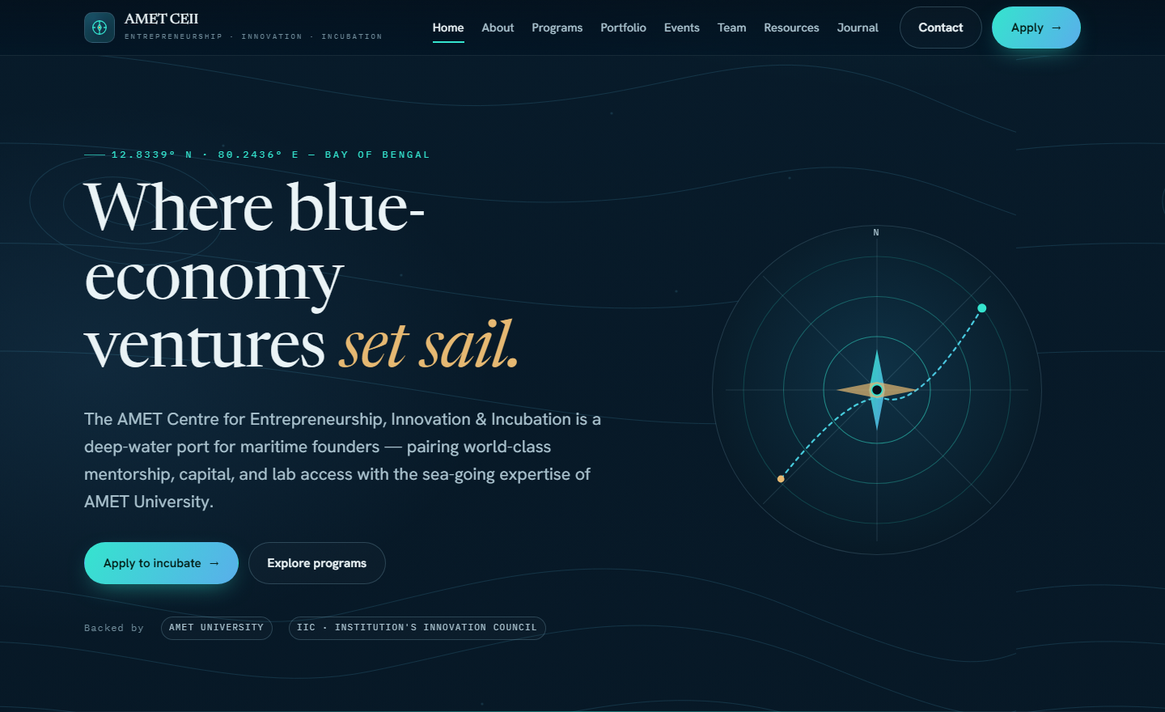
Figure 1 — Redesigned Home page (working prototype).
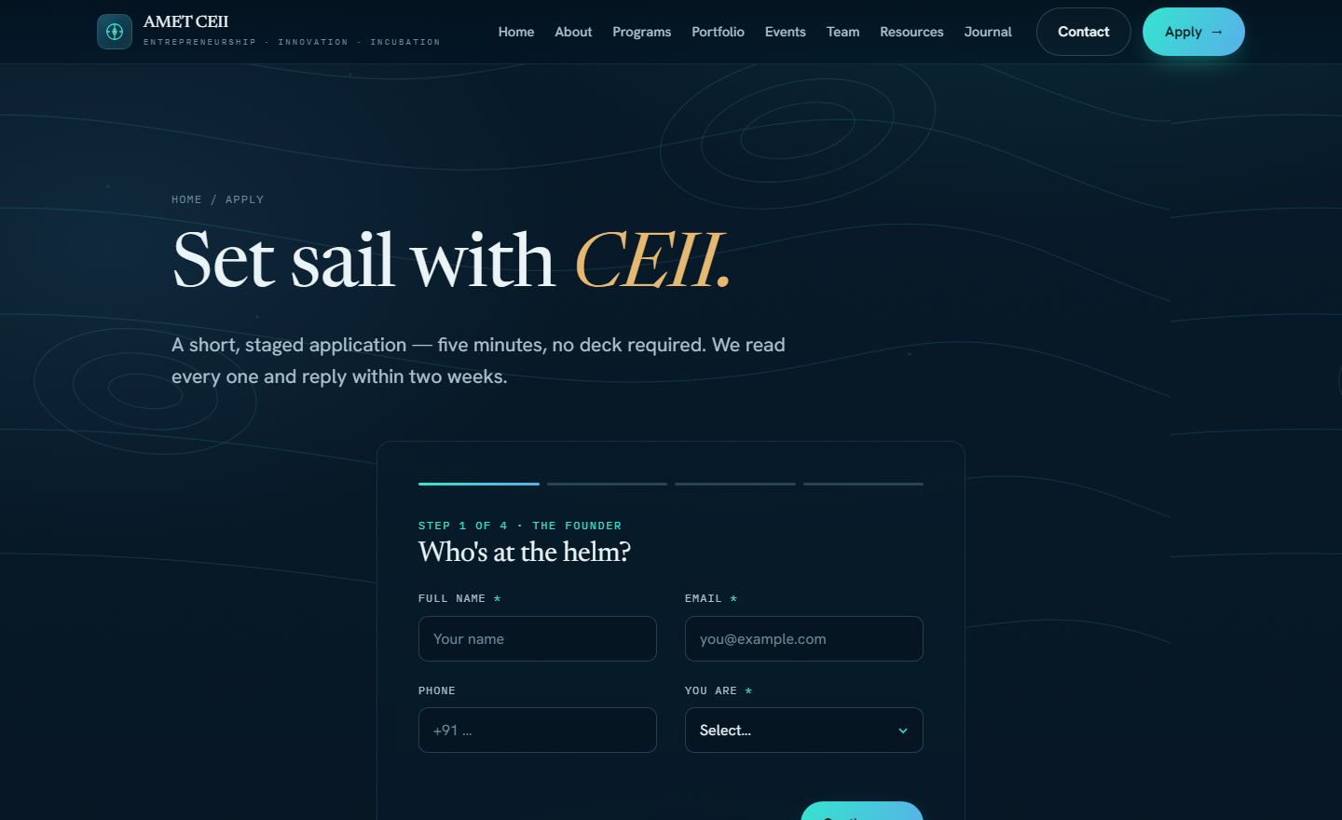
Figure 2 — Guided multi-step Apply form (working prototype).
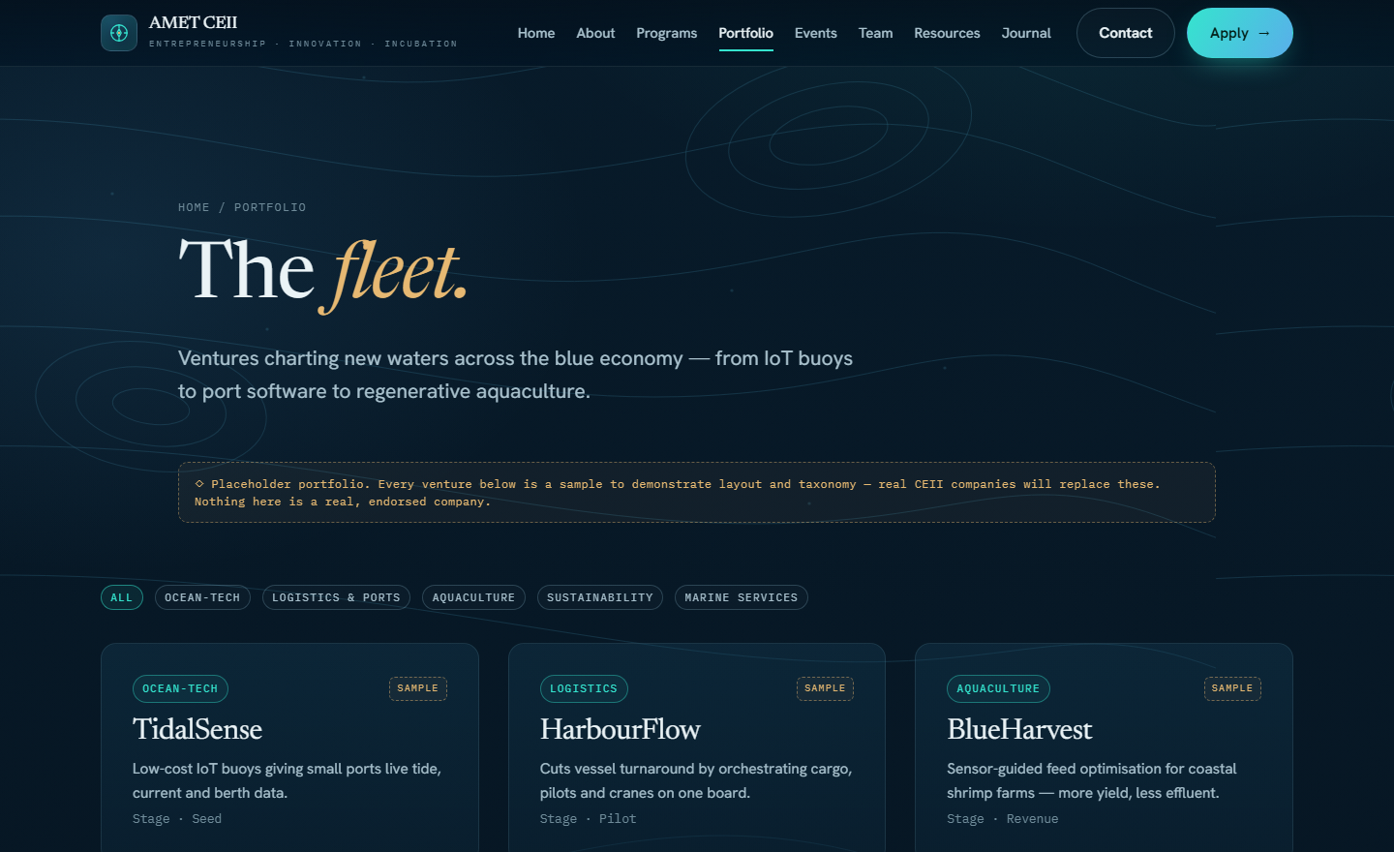
Figure 3 — Portfolio page with sector filters (sample content shown).

6. Technology & Approach
We use industry-standard, well-supported and cost-effective tools — the same technologies used by professional teams:
Layer | Tool | Why
Website | HTML, CSS, JavaScript | Fast, reliable, no heavy frameworks to maintain.
Hosting | Vercel (free / low-cost tier) | Automatic deployment, HTTPS and global speed.
Application email | Serverless function + email service | Delivers form submissions to CEII’s inbox.
Version control | Git & GitHub | Safe history, teamwork and easy rollback.

7. In-House Students vs. Third-Party Vendor
Factor | External vendor (current) | Student team (proposed)
Recurring cost | Ongoing development / maintenance fees. | Near-zero — only hosting & domain (largely free-tier).
Turnaround | Requests routed through an outside agency; slower. | Same-day / same-week updates by the on-campus team.
Domain knowledge | Limited familiarity with CEII’s day-to-day. | Students are inside the university and its context.
Institutional value | Money leaves the university. | Builds student skills & a reusable in-house capability.
Continuity | Dependent on the vendor relationship. | Documented & handed to the next student batch.

8. Maintenance Plan

8.1 Why ongoing maintenance is needed
A website is not a one-time build — it needs regular care to stay accurate, secure and useful. For CEII specifically:
- Content changes constantly — new events, new startups in the portfolio, new team members, new blog posts.
- Applications and enquiries must be monitored so no founder is missed.
- Security, software updates and backups must be kept current.
- Uptime and links must be checked so the site is always available and correct.

8.2 Maintenance schedule
Frequency | Activity | Owner
As needed | Publish new events, startups, news and content sent by CEII. | Content & Data Manager
Weekly | Check application / enquiry submissions; verify all forms and links work. | QA & Testing
Monthly | Software / dependency updates, backup, uptime & performance review. | Deployment & Maintenance
Each semester | Design & content review with CEII; plan improvements. | Team Lead + CEII

8.3 Continuity & handover
To ensure the site outlives any one student batch, we will maintain clear written documentation (setup, update and deployment guides) and conduct a formal knowledge-transfer to the next team of AI-ML students each year, coordinated by the faculty mentor. This turns website upkeep into a repeatable, institutionalised student activity.

9. Internship Request
We request that this work be recognised and supported as an official internship for the five team members, under the guidance of the CEII and a faculty mentor. We propose:
Duration | One semester for the redesign & launch, followed by ongoing maintenance as a rolling internship.
Reporting | To the AMET CEII, with a faculty mentor for academic oversight.
Deliverables | Launched redesigned website; migrated real content; maintenance & handover documentation; training for the next batch.
Recognition | Internship certificate / academic credit as per university norms.
Learning outcomes | Real-world web development, project management, client interaction and DevOps — directly relevant to AI-ML careers.

10. Project Timeline
Phase | Activity | Indicative duration
Phase 1 | Approval, content gathering from CEII, finalise design. | Weeks 1–3
Phase 2 | Build all pages, migrate real content, set up application email. | Weeks 3–6
Phase 3 | Review & testing with CEII (user acceptance). | Weeks 6–7
Phase 4 | Launch / domain cut-over to aceii.in. | Week 8
Phase 5 | Ongoing maintenance & improvements. | Continuous

11. Budget & Cost Savings
The proposal is designed to minimise cost to the university. The main running costs are hosting and the domain, both of which are free or nominal on the tools we use.
Item | Indicative cost
Website hosting (Vercel free / hobby tier) | ₹0 – nominal
Domain renewal (aceii.in — already owned) | Existing annual renewal only
Student development & maintenance | Internship (no vendor fee)
Current third-party vendor cost avoided | [ current annual vendor cost ] — saved
The figure for the current vendor cost is left for the university to fill in; the essential point is that the recurring development and maintenance fee is replaced by an internship at effectively no additional cash cost.

12. Risks & Mitigation
Risk | How we mitigate it
Students graduate / batch changes | Documentation + annual handover to the next AI-ML batch.
Academic workload clashes | Five members share the load; clear roles; realistic schedule.
Content accuracy | All real content is approved by CEII before publishing; nothing is invented.
Downtime / errors | Version control allows instant rollback; monthly checks and backups.

13. Conclusion & Request
A strong website is essential for an incubation cell that wants to attract founders, investors and partners in the maritime and blue-economy space. We are confident that we can deliver this for CEII — to a high standard, at minimal cost, and as a living learning experience for students of our own university.
We respectfully request approval to proceed with this redesign and to be recognised as interns for its delivery and maintenance. We would be glad to present the live prototype and answer any questions at your convenience.

Prototype: amet-ceii.vercel.app Team contact: ____________________________

