Project Report of

ODD Attendance

Made By -

**Syed Danish Nabeel**

**Table of Contents**

1. Introduction……………………………………………….1

**1.1 Purpose……………………………………………………………………………………………….....1**

**1.2 Intended Audience…………………………………………………………………………………..1**

**1.3 Scope Of The Project……………………………………………………………………………...1**

**1.4 References ……………………………………………………………………………………………..1**

**1.5 Overview Of The Document…………………………………………………………………….1**

2. Overall Description………………………………………..2

**2.1 Product Perspective……………………………………………………………………………..2**

**2.2 Product Functions………………………………………………………………………………….2**

**2.3 Assumptions and Dependencies……………………………………………………………4**

3. Specific Requirements…………………………………….4

**3.1 External Interfacce Requirement (User Interfaces)……………………………4**

**3.2 Functional Requirements……………………………………………………………………..12**

**3.3 Non-Functional Requirements……………………………………………………………..16**

4. Other Requirements……………………………………...17

5. UML And Other Diagrams…………………………………18

6. Conclusion……………………………………………….24

**1. Introduction:**

* 1. **PURPOSE**

The purpose of this document is to present a detailed description of ODD Attendance Software. The development of software was inspired by the idea to relieve Teachers of work that goes in taking attendance on an Excel Sheet (.xlsx file). The software automates the process of attendance taking as much as possible with some added advanced features for today’s world

* 1. **Intended Audiences**

The document is intended for the Users i.e. Teachers, Coder and Developer, Project manager, Tester, Debugger.

* 1. **Scope of the Project**

This software will be a major Improvement in Attendance taking field. It is designed in such a way that any teacher can take attendance in a class without any noise i.e. no need for teachers to shout Roll numbers and no need for a student to answer by shouting. The software adapts to today’s modern world as teacher’s don’t need to carry the Attendance Excel Sheet with them too, They should just have the software’s exe file that will be enough to get them going as they can download their file from cloud storage through this software.

The whole attendance taking process has been tried to confine within the functionality of arrow keys only. The software also shows detailed description of student’s attendance status in a friendly color coded format for the ease of understanding.

Also, the Teacher can notify selected students through SMS or E-mail about their attendance status which is a highlight of this software.

Thus it automates majority of the task in a very Teacher-friendly way.

* 1. **References**

IEEE. IEEE STD 830-1998 IEEE Recommended Practice for Software Requirements Specifications. IEEE Computer Society, 1998.

* 1. **Overview of the Document**

The rest of this SRS is organized as follows: Section 2 gives an overall brief description of the software. It gives what level of proficiency is expected of the user and some assumptions and dependencies that are assumed. Section 3 gives detailed specific requirements which the software is expected to deliver. Functional requirements are shown. Some performance requirements and design constraints are also given.

**2. Overall Description**

**2.1 Product Perspective**



***Take Attendance & features***

**ODD Attendance Software**

***operates***

***Teacher***

Our system basically has just 1 actor i.e. the Teacher. The software doesn’t need to be installed on the system. It is just a stand-alone exe file which a user can carry in any form (pen drives, Hard-drives etc.)and the excel file is also not necessary to be carried always. It just need a personal computer’s operating system and a internet connection to run though. The PC’s screen needs to be shown on the projector screen of the class and the students can give attendance accordingly as their name flashes on the screen which is easily visible even to the back-benchers of the class. They can see their Attendance status on screen in clear and bold format insuring transparency in the system.

At the end the whole class get to see the report containing list of absentees etc. and the intended students are notified accordingly through popular means of communication. At last the excel sheet is edited by the software and uploaded or saved accordingly.

**2.2 Product Functions**

The functions of the Product can be summarized in 3 stages: Open, Do, Done. Therefore the name of the software is ODD (Open, DO, Done) Attendance. All the stages perform a set of function concerned with that stage. A brief description of all the function list in a particular stage are given below:-

**2.2.1 OPEN Stage**

* Downloading Excel file: If the file is not present in the Hard drive of the system the user has the option to download the excel file from Google drive by clicking a ‘Download file’ button
* Select File: After the file has been downloaded, the teacher must select the Excel file by clicking on ‘Select file button’. The file should be in the given predefined format otherwise the software won’t function as it is intended to be.
* Sum & Debar: The sum and percentage of classes attended & Debar column can be filled in by clicking on ‘Sum’ and ‘Debar’ button. Therefore if those columns aren’t filled in user’s given Excel file in predefined format, then it can be filled with the help of these function.

**2.2.2 DO Stage**

* Take Attendance with four Arrow keys only: In this stage the attendance is taken with the help for four arrow keys only.
* Confirmation for Debarring:The user can have the control for deciding whether a student should be debarred or not, rather than relying on strict rules for Debarring.
* Display of Yesterday’s & Today’s Status:The student’s are shown their respective status in view-friendly color coded format which is clearly & easily visible to back benchers. Green means Good and Red means Bad.

**2.2.3 DONE Stage**

* Display Report: The full attendance report for that day and the debarred list is always shown in this stage. So that student or teacher can cross check for errors in report if any. If found, the teacher can correct it by going back to Do stage.
* Notify Students through SMS/E-mail: The Absentees & debarred students can be informed or warned immediately by the Teacher through popular means of communication.
* Upload/Save:The Updated Excel file can finally be uploaded back to Google Drive or saved in the Hard-drive.

**2.3 Assumptions and dependencies**

* The software should be made to run on a PC or Laptop’s Operating System.
* The system should have a working Web Browser and an Internet Connection.
* The user should have a Google account and a fair knowledge of how to use and Handle Google Drive and basic knowledge of handling files in PC’s
* The Excel Sheet should be in predefined format as given in section 3. The sum and percentage of attendance and debar status must be updated on the sheet otherwise should be done with the help of the software
* A Projector is needed in the classroom for most effective implementation of this software
* The Debar conditions on this software is:
* If attendance is Less than 75%
* If consecutively absent for 5 days.
* Green is Good. Red is Bad.
* The Excel workbook should have a second sheet containing student’s mobile number and E-mail ids for notification purpose.
* The updated Excel sheet is saved as <filename>_ODD.xlsx, because if any error occurs the original file shouldn’t be harmed.
* The software requires Python .7.9 & 3.5, tkinter, openpyxl, Twilio API, google-api-python-client for running but its standalone exe file contains it all so no need for installing all these, enhancing its portability.

**3. Specific Requirements**

**3.1 External Interface Requirement (User Interface)**

This section will explore the Graphical User Interface of this software step-by-step. The whole process of this software has been divided effectively in 3 stages: OPEN, DO, DONE, which is the beauty of this software. Therefore it contains three very user-friendly and easily understandable Interfaces as shown below:

**3.1.1 Predefined Format of Excel Sheet**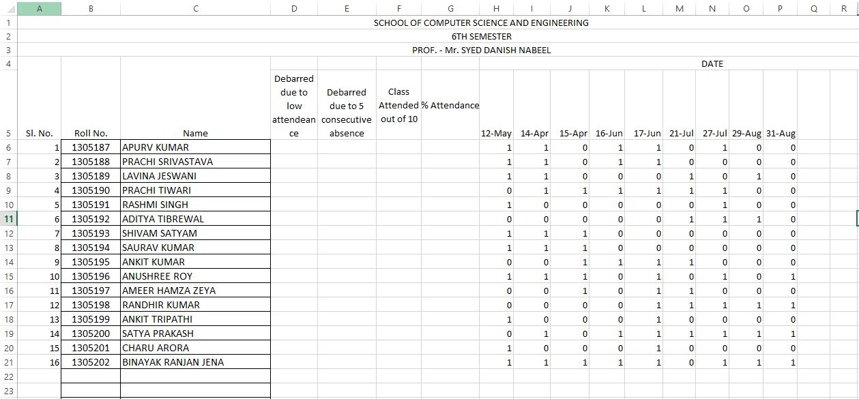

**Sheet -1**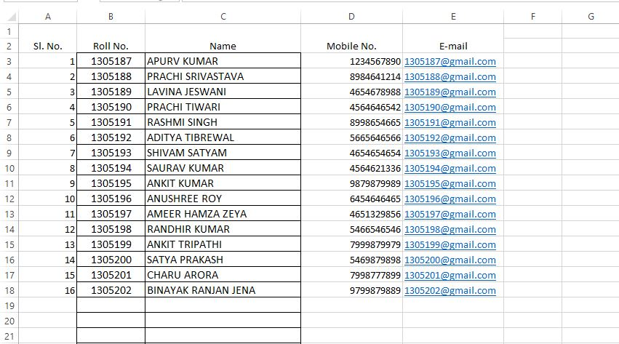

**Sheet-2**

**3.1.2 OPEN Stage**

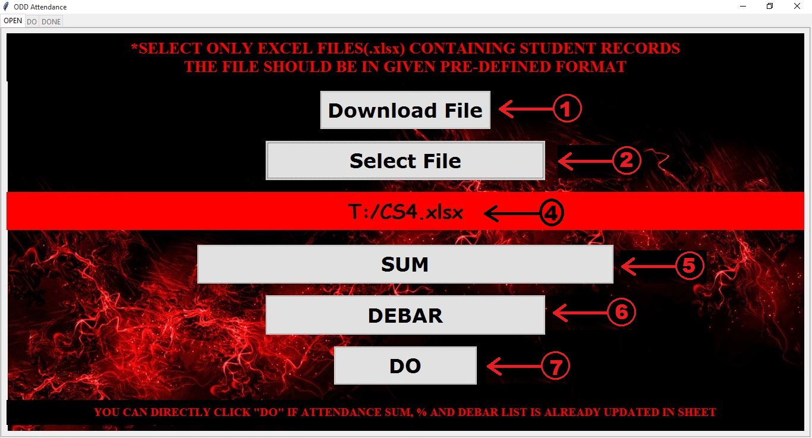

**Reference Table for all Label’s functionalities**

|  |  |  |
| --- | --- | --- |
| Sl. No. | Type | Function |
| 1. | **Button** | **Download excel file from Google Drive** |
| 2. | **Button** | **Select an excel file from system Hard-drive** |
| 4. | **Label** | **Show the path of selected file** |
| 5. | **Button** | **Edit the excel file to show Attendance’s sum and % of every student till date and save as <filename>_ODD.xlsx** |
| 6. | **Button** | **Edit the excel file to show every student’s Debar status a/c to rules till date and save as <filename>_ODD.xlsx** |
| 7. | **Button** | **Procced to take Attendance**  **Note:- Directly click this button after selecting file if you have applied sum & debar on your file before** |

**3.1.3 SUM, % and Debar Updated Sheet <filename>_ODD.xlsx**

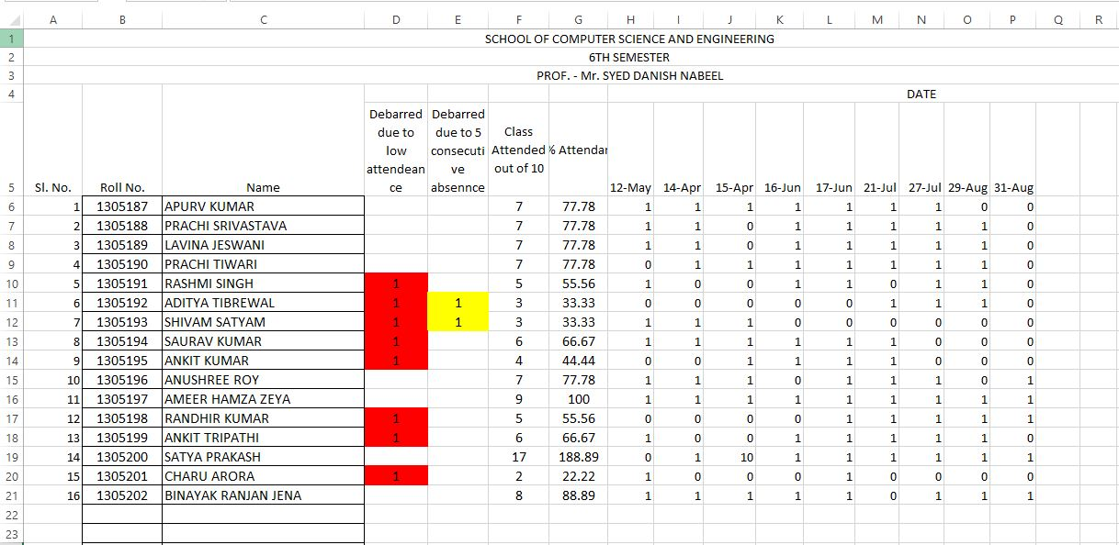

**3.1.4 DO Stage**

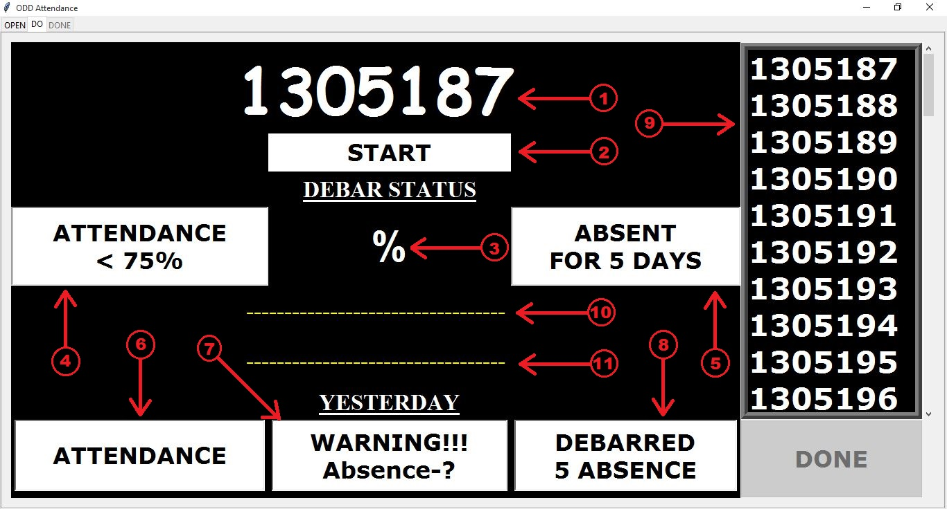

**Reference Table for all Label’s Functionalities**

|  |  |  |  |
| --- | --- | --- | --- |
| Sl. No. | Function | Green Label | Red Label |
| 1. | **Current Roll number call** | **---** | **---** |
| 2. | **Today’s Status of Previous Roll no. and all its status shown below** | **Present** | **Absent** |
| 3. | **Attendance % till date** | **---** | **---** |
| 4. | **Debar due to <75% Attendance till date** | **Not Debarred** | **Debarred** |
| 5. | **Debar due to continuous 5 absence till date** | **Not Debarred** | **Debarred** |
| 6. | **Yesterday’s Attendance** | **Present** | **Absent** |
| 7. | **Yesterday warned for continuous Absence** | **No warning** | **Warned for 3 /4 absence** |
| 8. | **Yesterday Debarred due to continuous 5 absence** | **Not Debarred** | **Debarred** |
| 9. | **List of Attendance status for 10 previous roll no. for that day** | **Present** | **Absent** |
| 10. | **Warning for continuous 3/4 absence for today** | **---** | **---** |
| 11. | **Warning if 75% < Attendance % < 80%** | **---** | **---** |

**Example**

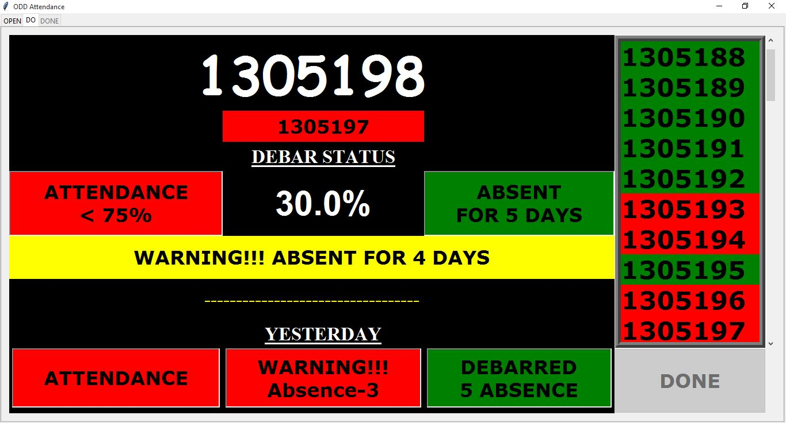

**Derivation from Example**

|  |  |  |
| --- | --- | --- |
| Sl. No. | Label Color | Significance |
| 1. | **---** | **1305198 is the current Roll call** |
| 2. | **Red** | **1305197(Previous Roll call) is absent that day and his current status is all reflected below** |
| 3. | **---** | **1305197 has 30% attendance till date** |
| 4. | **Red** | **1305197 is debarred because Attendance < 75%** |
| 5. | **Green** | **1305197 is not debarred due to continuous 5 absence** |
| 6. | **Red** | **1305197 was absent yesterday** |
| 7. | **Red** | **1305197 was warned yesterday for continuous 3 absence** |
| 8. | **Green** | **1305197 was not Debarred yesterday due to continuous 5 absence** |
| 9. | **Green/Red** | **Green signifies that roll no. is present while red signifies absence** |
| 10. | **Yellow** | **1305197 is warned today for continuous 4 absence** |
| 11. | **---** | **1305197 is not warned for 75% < attendance% < 80% as he /she is already debarred due to attendance<75%** |

**3.1.5 Done Stage**

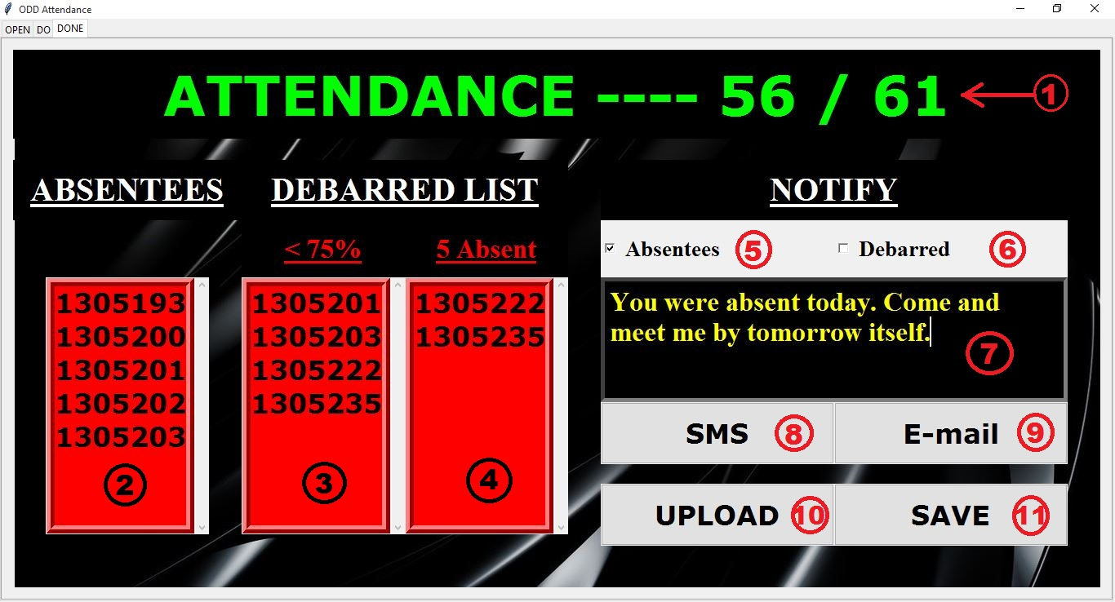

**Reference for all Label’s Functionalities**

|  |  |  |
| --- | --- | --- |
| Sl. No. | Type | Function |
| 1. | **Label** | **Show current strength of class** |
| 2. | **List** | **List of Absentees** |
| 3. | **List** | **List of students debarred due to Attendance<75%** |
| 4. | **List** | **List of Student’s debarred due to continuous 5 absence** |
| 5. | **Checkbox** | **Whether to send the message to Absentees or not** |
| 6. | **Checkbox** | **Whether send the message to debarred student’s or not** |
| 7. | **Message box** | **Compose the message to be send as SMS/E-mail** |
| 8. | **Button** | **Send the message as SMS** |
| 9. | **Button** | **Send the message as E-mail** |
| 10. | **Button** | **Upload the file with today’s attendance on Google Drive** |
| 11. | **Button** | **Save the file with today’s attendance as <filename>_ODD.xlsx** |

**3.1.6 Final Excel sheet saved as <filename>_ODD.xlsx**

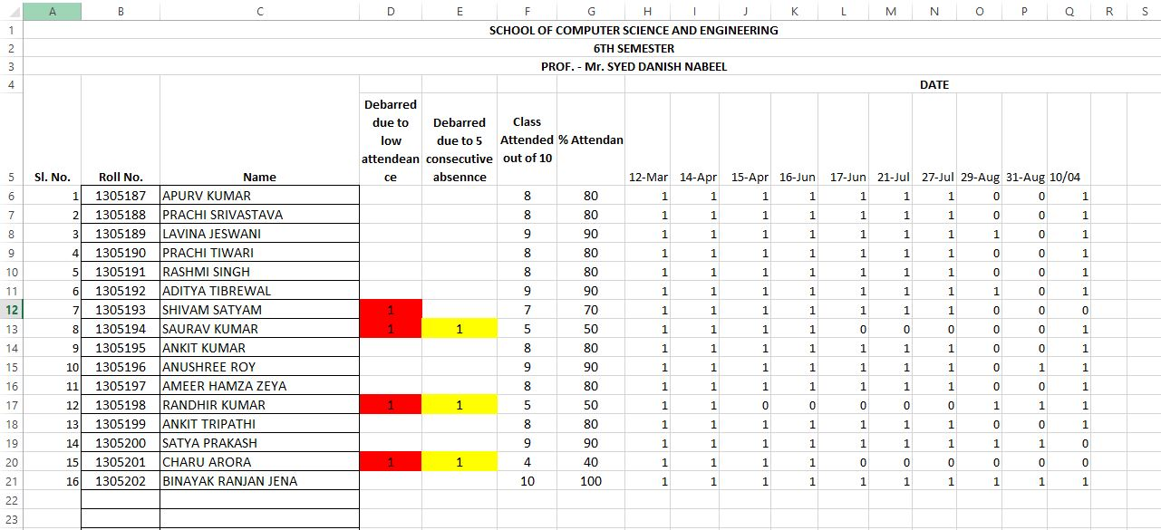

Note:-See a new column of Attendance has been added after taking Attendance

**3.2 Functional Requirements**

**3.2.1 Downloading and Selecting an Excel file**

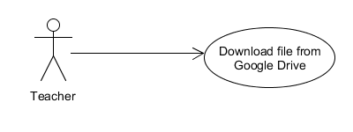

*Description:* The teacher has the option to download an Excel file containing class’s attendance record from Google’s online cloud storage Google drive and then select the file for attendance. On clicking the ‘Download file’ button, first the software asks you to open your Google account in your default web browser if you didn’t already and then it asks the user permission to access those files. If given the list of files are displayed and user can download any .xlsx file to the same location as of exe file

*Input:*  Permission for Software to access Google Drive files and select a file to download

*Output:* The selected is downloaded to the same location as exe file.

**3.2.2 Calculating Sum, Attendance percentage & Debar Status**

*Description:* The software calculates the sum and percentage of attendance and status of debar and according to that updates the sheet with name <filename>_ODD.xlsx so as to get the Excel sheet in the intended format as it won’t work perfectly if the excel sheet is not in the predefined format. If above ones are already updates then user can directly proceed to DO stage.

*Input:* Excel sheet in predefined format with empty Sum, % & Debar columns

*Output:* Updated Excel sheet with Sum, % and Debar columns filled.

**3.2.3 Take Attendance with four arrow keys only**

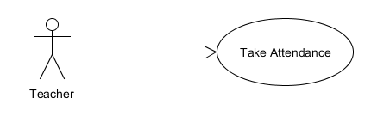

*Description:* The Roll number of each student is flashed in bold on the projector screen (if connected) and in return the student is to respond by raising his hand signifying his presence in class. Thus eliminating the cause for teacher to shout Roll number and for the student to shout for his presence. The whole attendance taking process is done through the use of four arrow keys only giving the teacher freedom to look away from keyboard while giving attendance unlike using other keys while typing. This counters the process of proxy marking quite effectively. Right arrow marks present, Left arrow marks absent, Up Arrow is for scrolling to above Roll number and Down Arrow is for scrolling to Below Roll Numbers.

*Input:* Attendance status of students through arrow keys.

*Output:* List of students classified on the basis of attendance given.

**3.2.4 Confirmation for Debarring**

*Description:* If the teacher needs, then rather relying on strict rules of machines, the software will ask every time for confirmation whether the teacher wants to debar the concerned student. In this software the rules for Debarring are :- 1, The attendance is below 75% 2. Absence for 5 consecutive classes.

*Input:*Yes or No for whether the system should debar the student.

*Output:* Accordingly mark the student Debar or not.

**3.2.5 Display Yesterday’s and Today’s Attendance status**

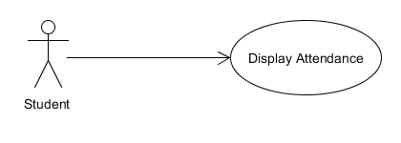

*Description:* The software display the Attendance status of each and every student in a friendly color coded format where green means all the good things while red means bad. After a while student needn’t see on the board attentively for status just a quick flash of the color will relay the information. It also simultaneously displays the attendance of last 10 Roll numbers.

*Input:*Attendance of student through Arrow Keys.

*Output:* Display of student’s attendance status in a view-friendly color coded format

**3.2.6 Display Report**

**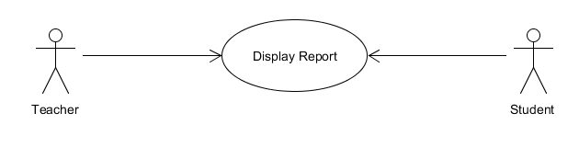***Description:* The software display the final report for the day’s attendance showing that day’s absentees & debarred student’s list to all the people in class in clear and bold format and also the strength of that day’s class. If the student or teacher finds any error, the teacher can go back to DO stage and correct the error.

*Input:*Attendance of student through Arrow Keys.

*Output:*List of Absentees and Debarred Students.

**3.2.7 Notify Student’s through SMS/E-mail**

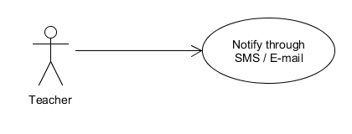

*Description:* The students are notified immediately through SMS/E-mail accordingly by Teacher. So that they are warned before any major attendance shortage happens to them. The teacher can compose the message he/she wants to communicate in DONE stage only and send it with a single button click.

*Input:* The message and the intended students(Absentees or Debarred) to whom the message is to be communicated

*Output:* SMS/E-mail is sent accordingly.

**3.2.8 Upload/Save the file**

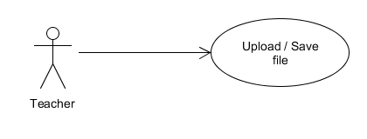

*Description:* The Teacher can upload the file on the Google Drive with a single button click or save the updated excel sheet on the working system (where the exe files is located) as he/she wishes and then go on for another attendance or quit the application.

*Input:*Click Upload or Save button.

*Output:* The updated excel is uploaded/saved accordingly.

**3.3 Non-Functional Requirements**

**3.3.1 Performance Requirements:**

The system should be capable of running Python 3.5 scripts or system should be compatible to install Python 3.5. Performance of the system depends on the response time and the speed of the data submission. The response time of the system is direct and the application is real-time. Having a windows OS is an added advantage as it runs smoothly on it

A web browser and a working Internet Connection (needed for downloading and uploading file and for notifying students) is required only if you want execute function associated to it. Attendance can be taken and saved in a file on drive without those also.

**3.3.2 Safety Requirements:**

* In case if any error occurs by chance or software gets stuck just close it and restart it again. As the new information is updated on a new excel sheet (<filename._ODD.xlsx>) so the original file remains unharmed.
* If the new updated excel file looks good rename it with the original one after deleting the original excel file.
* Keep all the .exe, .py etc. files given with the software in the same folder along with the attendance Excel sheet if any.
* Every downloading or uploading file path will be the path of exe file by default.
* After Clicking Download, Upload, SMS or Email Button wait till it shows the process has been completed successfully.

**3.3.3 Software Quality Attributes:**

The system will have a simple and user-friendly environment. Users will be able to understand and use all the features of the software easily. Any action will be performed with just a few clicks and arrow keys.

**4. Other Requirements**

* For ideal working conditions for the teachers who carry all their classes Attendance Excel sheet in their Pen Drive class to class. It is required of them to keep all the software files and attendance Excel sheet for no confusion. So as it is a standalone executable file it can run (on any system which can run Python 3.5) without the need of a setup. Just user has to plug-in the pen-drive and click on the executable file and he/she is good to go for attendance.
* For the maximum efficiency of attendance taking Process, it is required for the teacher to project the computer’s screen of the software on the Projector Screen.
  + The Student’s whose Roll number shows up simply has to raise his hands. The teacher can press right arrow giving present to the student without the need to constantly see on keyboard or screen.
  + Thus the next Roll number shows up and if nobody raises their hand at a roll number mark them absent by pressing Left Arrow.
  + If their arises a need to alter attendance of an already passed roll number, simply scroll up to that roll number using Up Arrow and alter it and return back using Down Arrow.
  + The last ten roll number from current roll number can also review their attendance.
  + At last when attendance report shows up, everyone can cross check.
* The ideal way to take attendance is the following way:-

The teacher should just bring the stand-alone exe file of software in the pen-drive with or without the excel files. If excel files aren’t there in the pen-drive, the teacher can download it from Google drive and then start the attendance taking process by projecting the DO stage through Projector. The roll no. at the top of that screen is the present Roll call, so the teacher doesn’t need to shout Roll Numbers, just the student with that roll number needs to respond by only raising a hand (no need to shout present sir) as the fonts will definitely be visible to anyone, even back-benchers. If no one raises a hand that means that roll no. is absent. The teacher can also easily see the hands raised and simultaneously mark the attendance (This minimizes the proxies) because now the teacher is not compelled to see the keyboard because the whole functionality is limited to four arrow keys and anyone can handle them with their eyes closed. Thus everyone gives attendance this way and every time the previous roll no. can see their whole attendance status on the projector screen.

**5. UML and other diagrams**

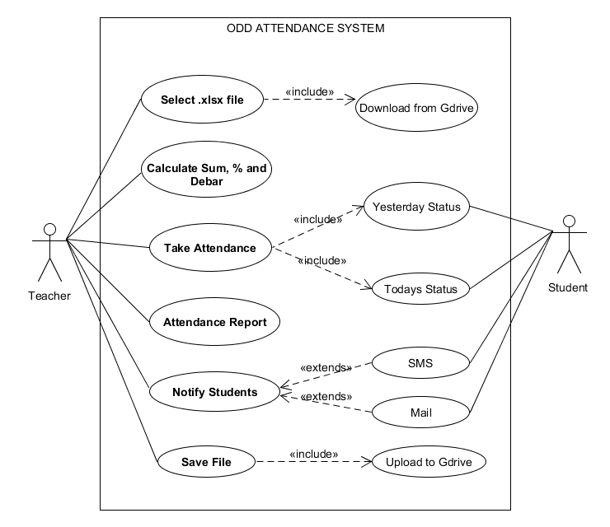

**USE CASE DIAGRAM**

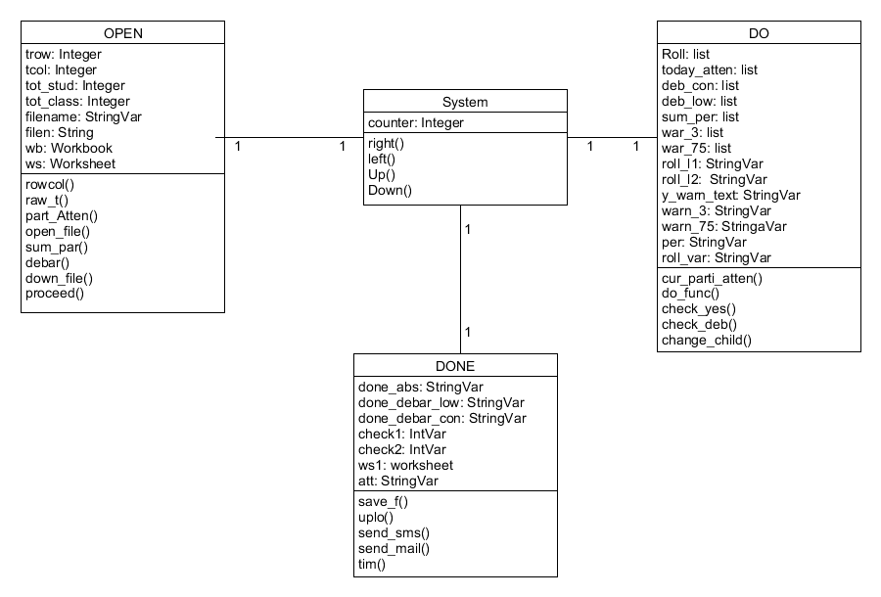

**CLASS DIAGRAM**

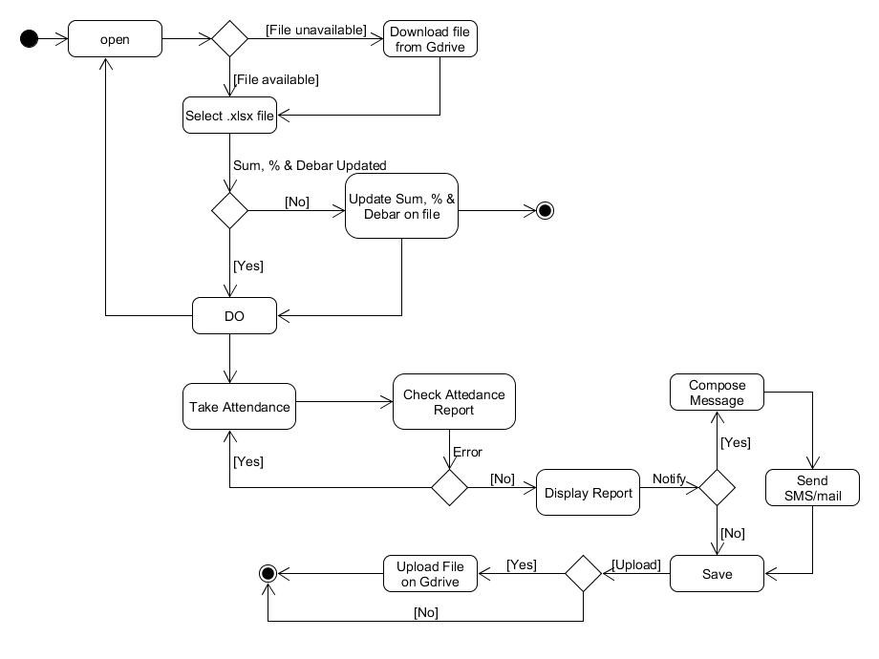

**ACTIVITY DIAGRAM**

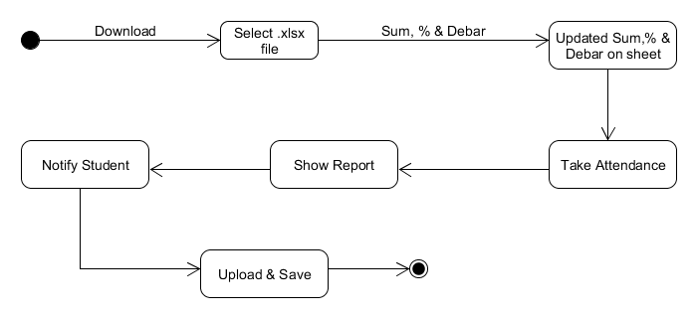

**STATE-CHART DIAGRAM**

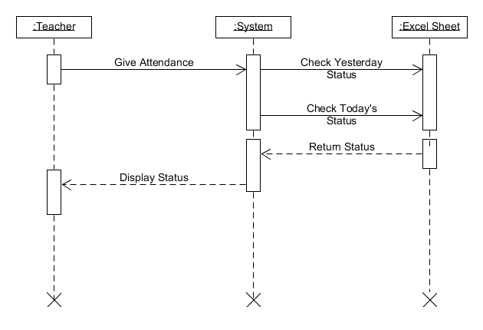

**SEQUENCE DIAGRAM FOR TAKING ATTENDANCE**

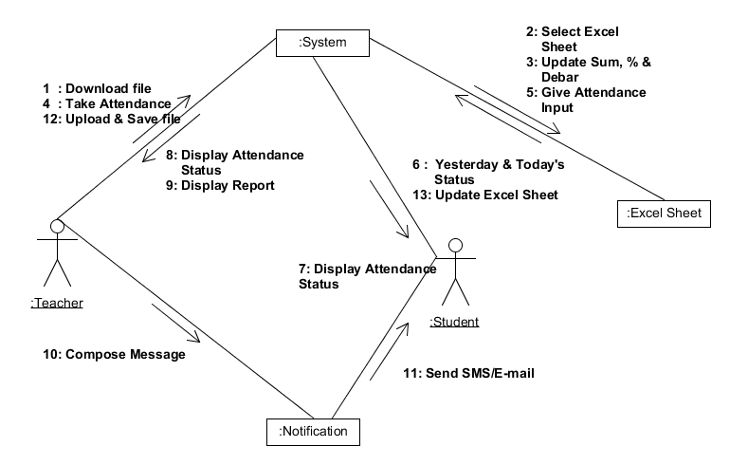**COLLABORATION DIAGRAM**

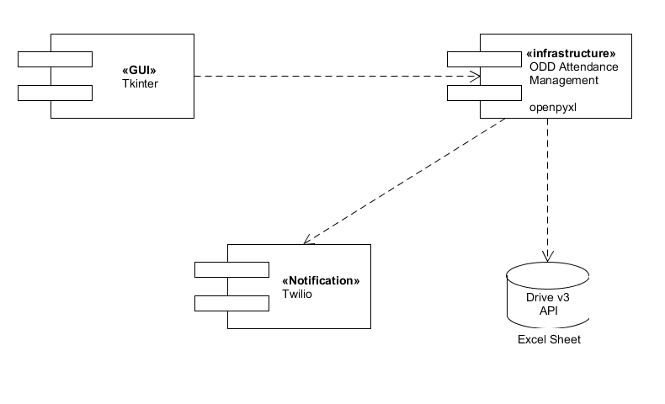

**COMPONENT DIAGRAM**

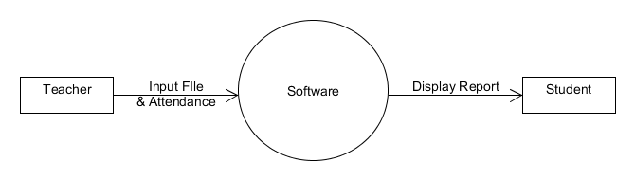**LEVEL 0 DFD**

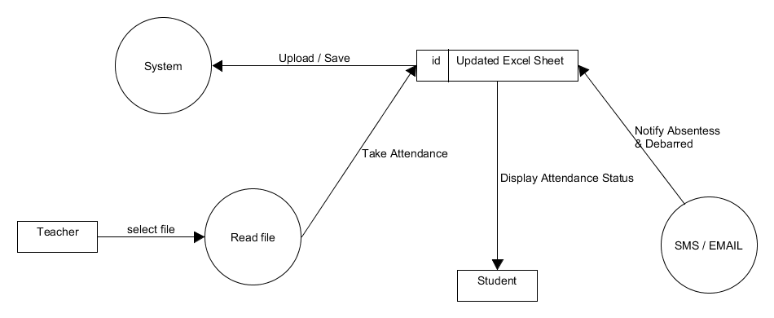**LEVEL 1 DFD**

**6. Conclusion**

The aim of the project was to automate the process of taking attendance as much as possible and to complete the process with maximum efficiency and as less noise as possible. The software should be a helpful aid to any Teacher with or without technical background to store day to day class attendance in a excel sheet without the need of opening it manually and updating it. Notifying the students is just a first step to the vast scope of advanced features we can to it in future versions.