|  |  |  |  |  |  |  |  |  |  |  |  |  |  |  |  |  |  |  |  |  |  |  |  |  |  |  |  |  |  |  |
| --- | --- | --- | --- | --- | --- | --- | --- | --- | --- | --- | --- | --- | --- | --- | --- | --- | --- | --- | --- | --- | --- | --- | --- | --- | --- | --- | --- | --- | --- | --- |
| 学号 | 姓名 | 思想品德素质分25 | | | | | | | | | | | 专业素质分 60 | | | | | 文体素质 15% | | | | | | | | | | | 总分 | 名次 |
| 基本分80 | 加分 | | | | 减分 | | | | 得分(B) | B25 | 基本分 | 加分 | | 得分(B) | B60 | 基本分72 | 加分 | | | | 减分 | | | | 得分(C) | C15 |
| 1~5 | 6~10 | 11~15 | 16~ | 1~5 | 6~10 | 10~15 | 16~ | 自辅修分 | 学术技能分 | 1~5 | 6~10 | 11~15 | 16~ | 1~5 | 6~10 | 11~15 | 16~ |
| 1930302 | 蔡舜因 |  | 5分 |  |  |  |  |  |  |  |  |  |  |  |  |  |  |  |  |  |  |  |  |  |  |  |  |  |  |  |
|  |  |  |  |  |  |  |  |  |  |  |  |  |  |  |  |  |  |  |  |  |  |  |  |  |  |  |  |  |  |  |
|  |  |  |  |  |  |  |  |  |  |  |  |  |  |  |  |  |  |  |  |  |  |  |  |  |  |  |  |  |  |  |
|  |  |  |  |  |  |  |  |  |  |  |  |  |  |  |  |  |  |  |  |  |  |  |  |  |  |  |  |  |  |  |

（自行排版）

综测分加分认定依据（上传照片，注明是什么原因加分）：

**！！！请注意，只写加分减分项即可，请大家根据综合素质测评把那发将自己相对应的加分放到对应表格位置，**

**属于思想品德素质分放到思想品德素质分上**

**思想道德素质测评加分：**

**参加公益服务，无偿献血**

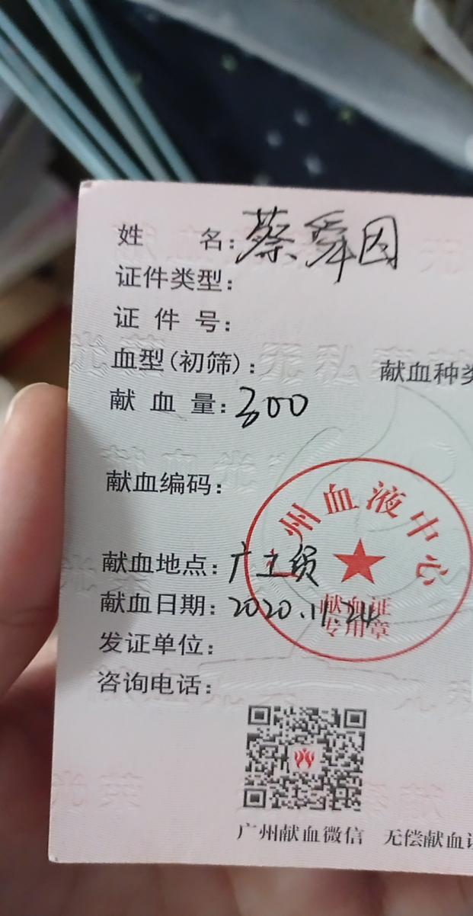

**专业素质加分：**

**文体素质测评加分：**