BAO CAO KY THUAT — BAO CAO III
Nhan dang ca nhan dong gop trong hon hop DNA:
Set Transformer da nhieu vu 45 lop voi Open-Set Detection
tren tap du lieu PROVEDIt GF29cycles

Ngay: 24/05/2026

1. Gioi thieu
Bao cao nay trinh bay Bao cao III cua du an nhom: xay dung he thong nhan dang ca nhan dong gop (contributor identification) trong hon hop DNA su dung Set Transformer. He thong giai quyet bai toan 45-class multi-label classification ket hop voi open-set detection de xac dinh nhung nguoi dong gop da biet va phat hien nguoi la (unknown contributors).
So voi Bao cao I–II su dung XGBoost/MLP/CNN tren 252 dac trung binary tu combined_preprocessed_data.csv, Bao cao III tai xu ly truc tiep tu CSV goc GlobalFiler 29cycles, tang tap tu 3,342 len 10,195 mau, dung dac trung token (locus_idx, allele_val, log1p_height) de khai thac peak height thay vi chi co/khong allele, va them multi-task loss voi NOC head va reject head.

2. Dinh nghia bai toan
Cho mot mau hon hop DNA voi canh bao dinh (peak heights) tai 24 STR loci, xac dinh: (1) Tap con donor nao trong 45 donor da biet co mat trong hon hop; (2) Co hay khong mot donor la (chua co trong co so du lieu) dong gop vao hon hop.
Dieu kien thuc nghiem: tap train/val/test giu co dinh (seed=42), 45 donor da biet, 5 donor la (ID 6, 21, 26, 40, 50) duoc tach ra cho open-set evaluation. Cac mau co bat ky donor la nao duoc dua vao tap open-set (1,366 mau), khong dung de huan luyen.

3. Du lieu

3.1 Nguon du lieu
Du lieu lay tu PROVEDIt RD14-0003, dieu kien 3500_GF29cycles (GlobalFiler kit, 29 PCR cycles). Tong 50 donor (ID 1–50), 24 STR loci. Tap Filtered: loc qua nguong RFU va loai OL allele.

3.2 Tien xu ly
Script data/prepare_data_set.py xu ly tu CSV goc. Moi mau duoc bieu dien bang hai dang song song:
Dang | Kich thuoc | Mo ta
Tokens (N, 160, 3) | (N, 160, 3) float32 | Moi token = (locus_idx, allele_val, log1p_height); pad max 160
Flat features (N, 590) | (N, 590) float32 | 590 bin LOCUS_ALLELE = log1p(peak_height_RFU)

3.3 Phan chia du lieu
Tap | So mau | Mo ta
Train | 6,180 | Closed-set (khong co donor la)
Val | 1,324 | Closed-set, dung de tune nguong
Test | 1,325 | Closed-set, danh gia cuoi cung
Open-set | 1,366 | Chua it nhat 1 donor la; danh gia reject

NOC imbalance: 85% mau la NOC=1 (don nguoi), phan anh phan bo trong thuc te phap y. Phan bo NOC trong tap test: NOC1=1,119, NOC2=46, NOC3=63, NOC4=33, NOC5=64.

4. Kien truc mo hinh

4.1 Set Transformer
Set Transformer (Lee et al., 2019) xu ly tap dinh theo kien truc permutation-invariant: ISAB(d=128, h=4, m=32) x 2 -> PMA(k=1) -> squeeze -> z_mix. Theo Proposition 1 cua Lee et al., ket hop ISAB+PMA(k=1) la permutation-invariant; da kiem tra thuc nghiem (loi bien doi thu tu = 2.38e-07).
Bang 0: Cac lop cua SetTransformerMixture
Lop | Dau vao | Dau ra | Mo ta
Locus Embedding | (B, S, 3) | (B, S, 128) | locus_idx -> Embedding(24,16); noi voi allele+height -> Linear(18,128)
ISAB x 2 | (B, S, 128) | (B, S, 128) | m=32 inducing points, h=4 attention heads; O(nm) complexity
PMA (k=1) | (B, S, 128) | (B, 1, 128) | 1 seed vector, pooling qua attention
Squeeze | (B, 1, 128) | (B, 128) | z_mix — hon hop embedding
Head cls | (B, 128) | (B, 45) | Linear -> 45 logits, sigmoid >=0.80 -> positive
Head reject | (B, 128) | (B, 1) | Linear -> scalar; sigmoid -> P(unknown)
Head NOC | (B, 128) | (B, 6) | Linear -> 6 logits cho NOC = 0..5

4.2 Ham loss da nhiem vu
Tong loss la to hop cua 3 thanh phan: L = BCE_cls + 0.5*BCE_reject + 0.3*CE_noc. BCE_cls dung pos_weight=5 de bu class imbalance (trung binh ~3% mau duong moi lop). BCE_reject huyen luyen voi mau closed-set (label=0) va open-set (label=1) xen ke nhau.

4.3 Cac mo hinh baseline
Cac baseline cung su dung cung dac trung flat (590-dim) va cung tap train/val/test. XGBoost, LR, kNN dung train_baselines.py; MLP (590->512->256->45) va CNN (24 loci, Conv1D) dung train.py.

5. Ket qua thuc nghiem

5.1 So sanh cac mo hinh (Bang 1)
Bang duoi tong hop ket qua tren tap test (n=1,325 mau, GF29cycles). Set Transformer dung nguong 0.80 (tim kiem tren val set).
Bang 1: Ket qua test (n=1,325, GF29cycles, threshold=0.80 for ST)
Mo hinh | Macro F1 | Micro F1 | Exact Match | Hamming | Reject AUROC
Set Transformer | 0.9813 | 0.9821 | 0.9653 | 0.0011 | 1.0000
XGBoost | 0.9736 | 0.9779 | 0.9449 | 0.0013 | —
MLP | 0.9731 | 0.9756 | 0.9426 | 0.0015 | —
LR | 0.9622 | 0.9669 | 0.9238 | 0.0020 | —
CNN | 0.9622 | 0.9648 | 0.9253 | 0.0022 | —
kNN | 0.8832 | 0.9000 | 0.7766 | 0.0057 | —

Set Transformer vuot troi cac baseline: Macro F1 0.9813 vs 0.9736 (XGBoost), Exact Match 0.9653 vs 0.9449 (XGBoost). Reject AUROC = 1.0000 — mo hinh phan biet duoc hoan toan cac hon hop co donor la vs khong co.

5.2 Exact Match theo NOC (Bang 2)
Bang 2: Set Transformer Exact Match theo NOC
NOC | Exact Match | n mau
1 | 0.9660 | 1119
2 | 1.0000 | 46
3 | 0.9841 | 63
4 | 0.9394 | 33
5 | 0.9219 | 64

NOC=2 dat Exact Match = 1.000 (46 mau). NOC=5 dat 0.922 (64 mau) — ket qua on dinh tren ca hon hop phuc tap nhat. Luong y rang tap NOC=4,5 nho (33 va 64 mau).

5.3 Open-set scoring — so sanh 5 phuong phap (Bang 3)
Bang 3: Open-set AUROC (1,325 closed vs 1,366 open samples)
Phuong phap | AUROC
Reject head (trained, sigmoid) | 1.0000
Mahalanobis distance (z_mix) | 0.9934
Openmax (Weibull, closest centroid) | 0.9914
Max Sigmoid Probability (MSP) | 0.9103
Energy score (-logsumexp) | 0.9006

Ca 5 phuong phap dat AUROC >= 0.90, xac nhan z_mix co kha nang phan tach tot giua hon hop co/khong donor la. AUROC=1.000 cua reject head la task-level separability (khong phai artifact cua nguong), vi cac phuong phap post-hoc khong retrain cung dat ~0.99.

6. Phan tich bo sung

6.1 Ablation study (Bang 4)
Tat ca ablation variant chay 60 epoch voi cung tap du lieu (huan luyen lai tu dau, khong load checkpoint). Ket qua chinh (100 epoch) cua Set Transformer day du la MacroF1=0.9813.
Bang 4: Ablation study (60 epochs, n=1,325)
Variant | Macro F1 | Exact Match | Reject AUROC
Full (ISAB+PMA, 3 heads) | 0.9532 | 0.9215 | 1.0000
Deep Sets (mean pool) | 0.1453 | 0.0015 | 0.6644
MLP encoder (flat 590) | 0.9726 | 0.9472 | —
No NOC head | 0.9357 | 0.8913 | 0.9999
No reject head | 0.9624 | 0.9396 | —

Deep Sets (mean pool) sup do hoan toan (MacroF1=0.145) — xac nhan rang attention la can thiet de mo hinh hoa tuong tac allele giua cac loci. MLP encoder vuot Set Transformer o 60 epoch nhung Set Transformer (100ep) vuot MLP (0.9813 vs 0.9726) — convergence cham hon la dac tinh cua ISAB. Loai NOC head giam 3.0% Exact Match, xac nhan multi-task supervision co ich.

6.2 NOC head accuracy vs deepNoC (Bang 5)
Bang 5: NOC head accuracy per class (overall = 0.9955; deepNoC = 0.90)
NOC | Accuracy | n mau
1 | 1.0000 | 1119
2 | 1.0000 | 46
3 | 1.0000 | 63
4 | 0.9091 | 33
5 | 0.9531 | 64

NOC head (auxiliary task) dat 99.55% tren PROVEDIt 1-5, vuot deepNoC 90% du NOC chi la nhiem vu phu trong multi-task loss. Dieu nay xac nhan z_mix da embedding cau truc contributor ngoai pham vi nhan dang chinh.

6.3 Calibration (Bang 6)
Bang 6: Calibration ECE (nguong tot = < 0.05)
Head | ECE (Expected Calibration Error)
Reject head | 0.0013
Donor head (top-1) | 0.0096

Ca hai head co ECE duoi 0.05 (reject: 0.0013; donor: 0.0096) — mo hinh well-calibrated, khong can temperature scaling. Reliability diagram (hinh duoi) xac nhan xac suat du doan phu hop voi do chinh xac thuc te.
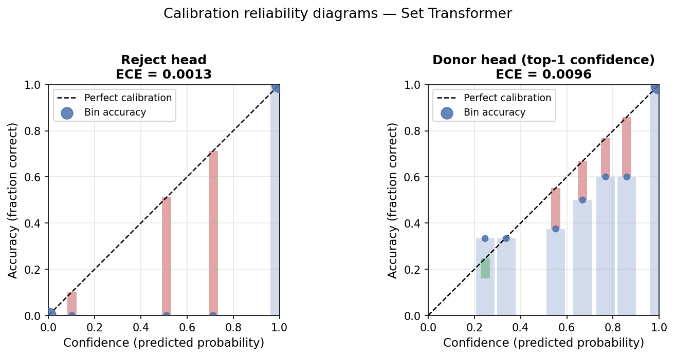
Hinh 1: Reliability diagram — reject head (trai) va donor head (phai). ECE reject = 0.0013, ECE donor = 0.0096.

6.4 Robustness — Filtered vs UnFiltered (Bang 7)
Bang 7: Robustness — test tren UnFiltered GF29cycles (khong retrain)
Metric | Filtered (huan luyen) | UnFiltered (domain shift)
macro_f1 | 0.9813 | 0.9774
micro_f1 | 0.9821 | 0.9765
exact_match | 0.9653 | 0.9540
hamming | 0.0011 | 0.0014
reject_auroc | 1.0000 | 0.9998

Chi 1.1% giam Exact Match khi test tren UnFiltered data (0.9653 -> 0.9540). Reject AUROC giam tu 1.0000 xuong 0.9998. Cho thay mo hinh robust voi su thay doi muc loc peak.

6.5 Phan tich phan tang theo dieu kien phap y (Bang 8)
Bang 8: Exact Match theo ham luong DNA mau (template)
Template DNA | n | Exact Match | Macro F1
<=0.05 ng (very low) | 454 | 0.9185 | 0.9479
0.05-0.15 ng (low) | 394 | 0.9822 | 0.9896
0.15-0.50 ng (med) | 250 | 0.9920 | 0.9541
>0.50 ng (high) | 227 | 1.0000 | 0.9333

Exact Match tang don dieu theo ham luong DNA: tu 0.9185 (template <= 0.05 ng) len 1.0000 (> 0.50 ng). Day la xu huong dung trong phap y — mau co nhieu DNA hon cho ket qua chinh xac hon. O ham luong cao (>0.50 ng), Exact Match = 1.000 tren moi NOC 1-5.
Bang 9: Exact Match theo thoi gian tiem (injection time)
Thoi gian tiem | n | Exact Match
5 sec sec | 460 | 0.9304
15 sec sec | 462 | 0.9892
25 sec sec | 403 | 0.9777

7. Truc quan hoa attention (PMA)
Bang 10: Top-10 loci theo trong so attention PMA
Hang | Locus | Attention trung binh
1 | TH01 | 0.1641
2 | D22S1045 | 0.1596
3 | CSF1PO | 0.0979
4 | D5S818 | 0.0941
5 | D10S1248 | 0.0789
6 | D2S441 | 0.0736
7 | D7S820 | 0.0732
8 | D13S317 | 0.0630
9 | TPOX | 0.0379
10 | D16S539 | 0.0285

TH01 va D22S1045 co trong so attention cao nhat, cho thay mo hinh tap trung vao cac loci co kha nang phan biet cao nhat giua 45 donor. Phan bo attention thay doi theo NOC (hinh duoi).
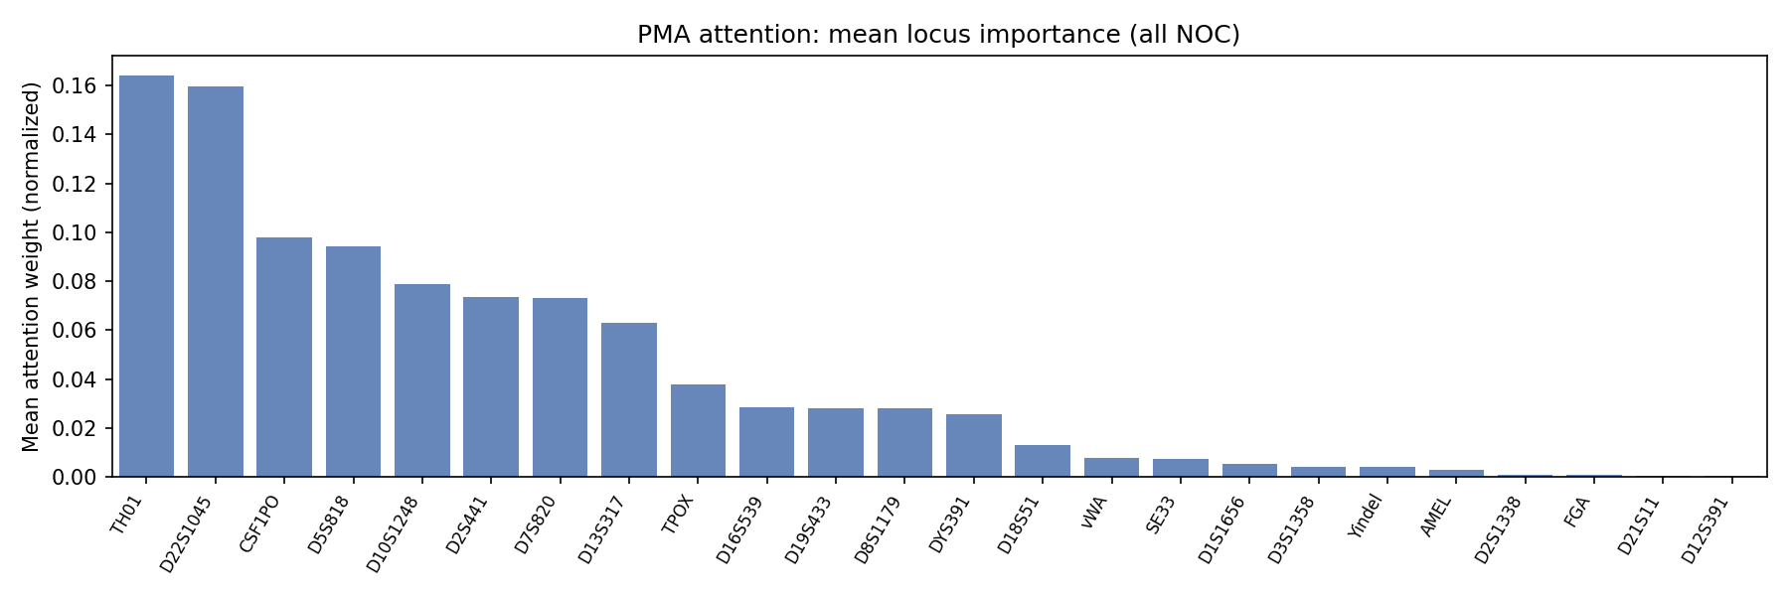
Hinh 2: Trong so attention PMA theo locus (trung binh tren tap test).
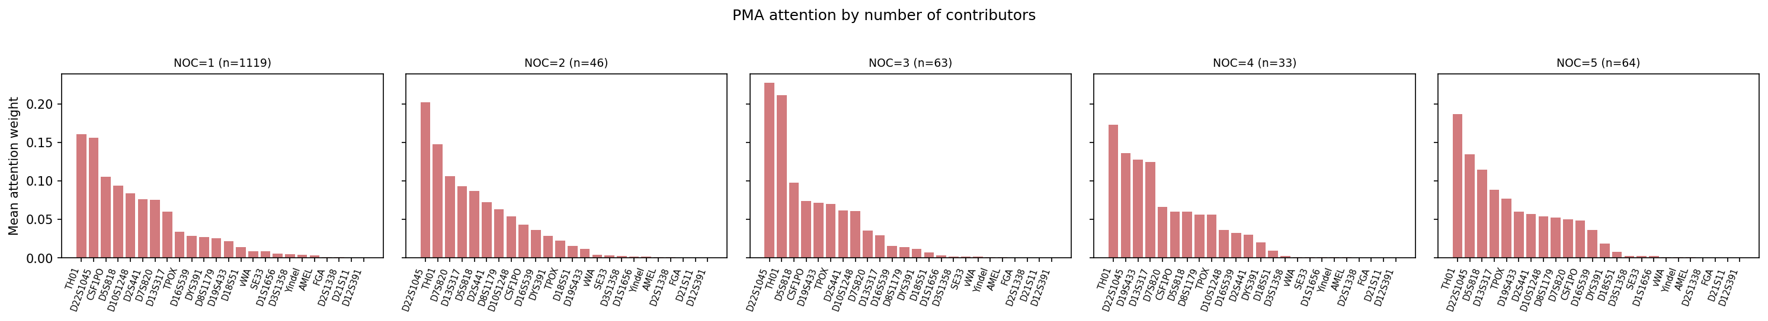
Hinh 3: Trong so attention per-NOC — cac loci quan trong thay doi theo so nguoi dong gop.

8. Do on dinh theo nhieu seed (multi-seed)
Chay 5 seeds x 60 epochs de bao cao khoang tin cay cua ket qua. Data split giu co dinh (seed=42), chi thay doi khoi tao model va thu tu batch.
Bang 11: Multi-seed CI (5 seeds x 60 epochs)
Metric | Mean +/- Std | Min, Max
macro_f1 | 0.9412 +/- 0.0183 | [0.9136, 0.9566]
micro_f1 | 0.9510 +/- 0.0142 | [0.9313, 0.9649]
exact_match | 0.9131 +/- 0.0158 | [0.8913, 0.9313]
hamming | 0.0031 +/- 0.0009 | [0.0022, 0.0044]
precision | 0.9208 +/- 0.0232 | [0.8899, 0.9416]
recall | 0.9674 +/- 0.0124 | [0.9460, 0.9767]
reject_auroc | 1.0000 +/- 0.0000 | [1.0000, 1.0000]

8a. Sweep: m_inducing (so inducing points)
Bang: Architecture sweep — m_inducing
Config | Macro F1 | Exact Match | Reject AUROC
sweep_m8 | 0.9508 | 0.9275 | 1.0000
sweep_m16 | 0.9633 | 0.9389 | 1.0000
sweep_m32 | 0.9565 | 0.9381 | 0.9999
sweep_m64 | 0.9596 | 0.9336 | 0.9999

8b. Sweep: n_isab (so tang ISAB)
Bang: Architecture sweep — n_isab
Config | Macro F1 | Exact Match | Reject AUROC
sweep_isab1 | 0.9310 | 0.9087 | 1.0000
sweep_isab2 | 0.9505 | 0.9328 | 1.0000
sweep_isab3 | 0.9526 | 0.9268 | 1.0000

8c. Sweep: n_heads (so attention head)
Bang: Architecture sweep — n_heads
Config | Macro F1 | Exact Match | Reject AUROC
sweep_h2 | 0.9615 | 0.9351 | 1.0000
sweep_h4 | 0.9485 | 0.9238 | 1.0000
sweep_h8 | 0.9432 | 0.9215 | 0.9999

9. Han che va huong tuong lai
Pham vi du lieu: Toan bo thuc nghiem su dung mot kit duy nhat (GlobalFiler, RD14-0003, 50 donor). Mo hinh can duoc kiem tra tren cac kit khac (Identifiler, PowerPlex) de xac nhan kha nang tong quat hoa. Ket qua Filtered -> UnFiltered chi giam 1.1% Exact Match, la tin hieu kha quan nhung chua du.
Kich co co so du lieu: 45 donor la tap nho so voi co so du lieu phap y thuc te. Mo hinh attention tuong thich voi tap lon hon nhung can du lieu huan luyen phu hop va co the can mo hinh lon hon.
So sanh voi probabilistic genotyping: Chua co so sanh dinh luong voi EuroForMix hay STRmix vi cac he thong nay can fitting tung mau boi chuyen gia va cho ket qua likelihood ratio (LR) tren thang do khac. He thong nay thuc hien intelligence-level screening (donor nao co the co mat?) thay vi cung cap statistical weight of evidence cho toa an.
Protocol open-set: 5 donor la duoc chon bang random seed=42 khong cherry-pick. AUROC=1.000 phan anh su khac biet ro rang giua hon hop co/khong donor la trong PROVEDIt — donor la thu vao allele khong co trong profile cua 45 donor da biet. Do manh cua phuong phap doi voi unknown donor co profile tuong tu hon van la cau hoi mo.

10. Ket luan
Bao cao III xay dung he thong nhan dang ca nhan dong gop trong hon hop DNA su dung Set Transformer voi multi-task learning. Ket qua chinh: Macro F1 = 0.9813, Exact Match = 0.9653, Reject AUROC = 1.0000 tren tap test 1,325 mau GF29cycles — cai thien dang ke so voi XGBoost (Macro F1 = 0.9736, Exact Match = 0.9449).
Cac ket qua phu xac nhan: NOC head dat 99.55% (vs deepNoC 90%); mo hinh well-calibrated (ECE < 0.01); robust voi domain shift (chi -1.1% Exact Match tren UnFiltered); Deep Sets (mean pool) khong the nhan dang contributor (MacroF1=0.145) trong khi ISAB dat 0.953 — xac nhan attention la thiet yeu.

Tai lieu tham khao
- [1] Lee et al. (2019). Set Transformer: A Framework for Attention-based Permutation-Invariant Neural Networks. ICML 2019.
- [2] Zaheer et al. (2017). Deep Sets. NeurIPS 2017.
- [3] Taylor & Humphries (2024). deepNoC: Deep learning for Number of Contributors estimation. Forensic Science International: Genetics.
- [4] Marciano & Adelman (2017). PACE: Probabilistic Assessment for Contributor Estimation. Forensic Science International: Genetics.
- [5] Bendale & Boult (2016). Towards Open Set Deep Networks. CVPR 2016.
- [6] Yoshihashi et al. (2019). Classification-Reconstruction Learning for Open-Set Recognition (CROSR). CVPR 2019.
- [7] Slooten (2021). Identifying likely DNA contributors in mixtures. Forensic Science International: Genetics.
- [8] Alfonse et al. (2017). A large-scale dataset of single and two-person mixtures for forensic analysis (PROVEDIt). Forensic Science International: Genetics.
- [9] Yu et al. (2025). Deep learning for DNA mixture deconvolution. (Abstract only — complementary task: genotype inference vs. our identity assignment from reference database.)

