Laporan Praktikum 2. TCP/IP Model
Kegiatan: Identifikasi OSI Layer DNS www.pens.ac.id
Nama: Ananda Syafriel Saputra
NRP: 5325600013

Data Layer
Application layer
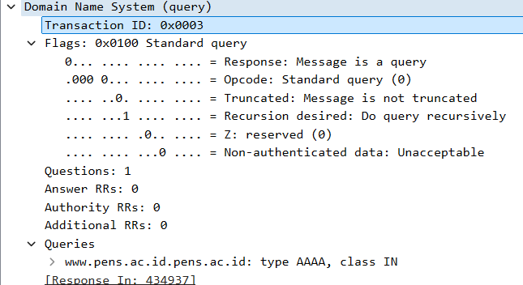
Host-to-host layer
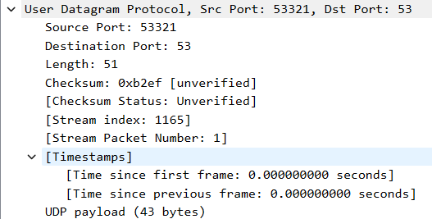
Internetwork layer
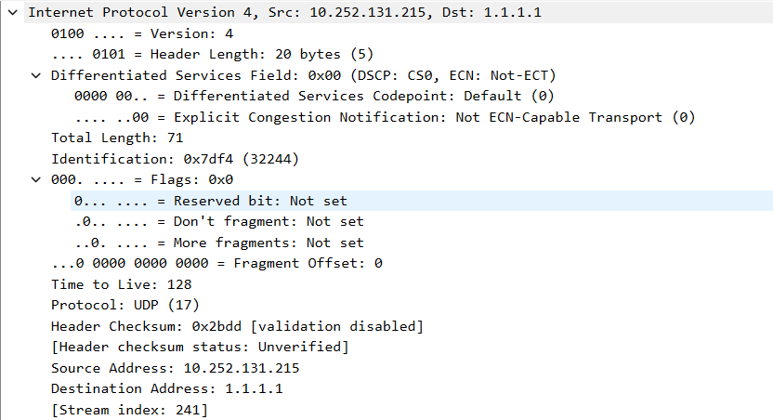
Network Interface layer
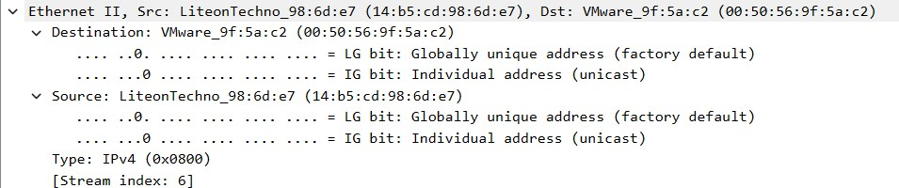
Laporan Praktikum 2. TCP/IP Model
Kegiatan: Identifikasi OSI Layer FTP newfs.pens.ac.id Nama: Ananda Syafriel Saputra
NRP: 5325600013

Data Layer
Application layer
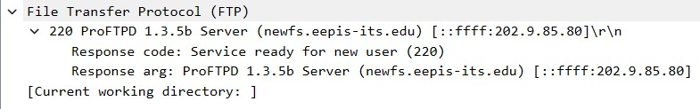
Host-to-host layer
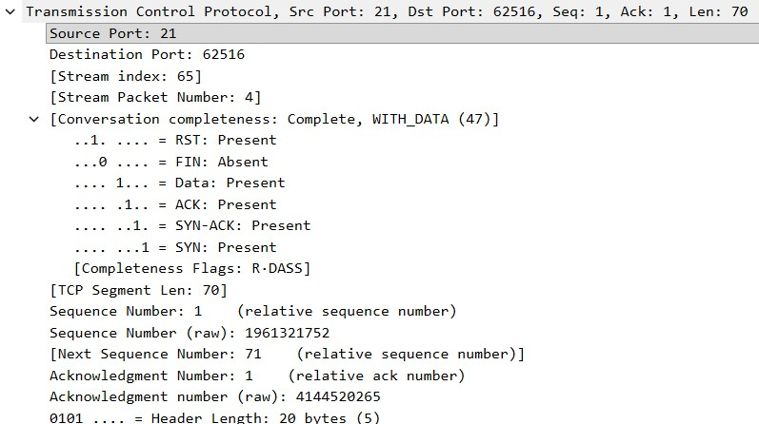
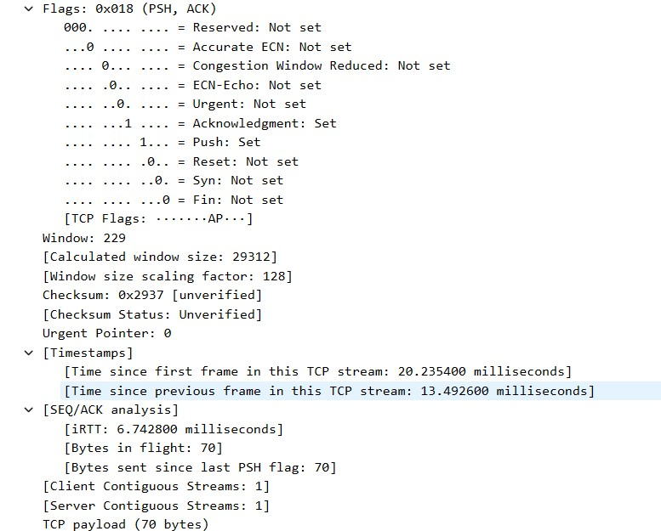
Internetwork layer
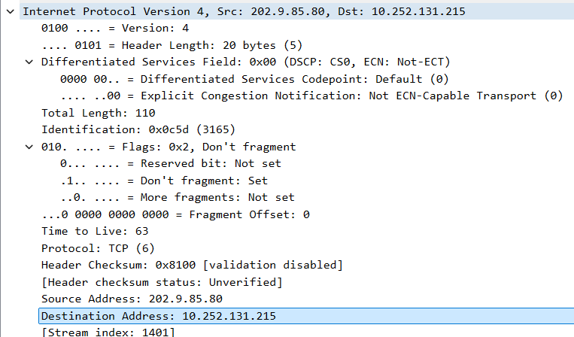
Network Interface layer : Identifikasi OSI Layer HTTP
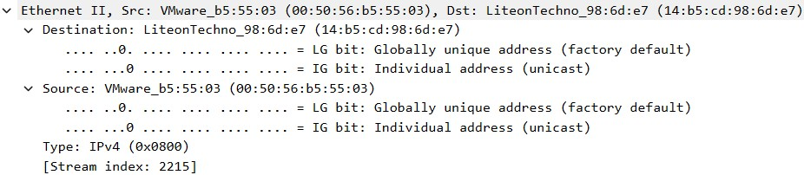
Laporan Praktikum 2. TCP/IP Model
Kegiatan: Identifikasi OSI Layer HTTP http://www.pens.ac.id
Nama: Ananda Syafriel Saputra
NRP: 5325600013

Data Layer
Application layer
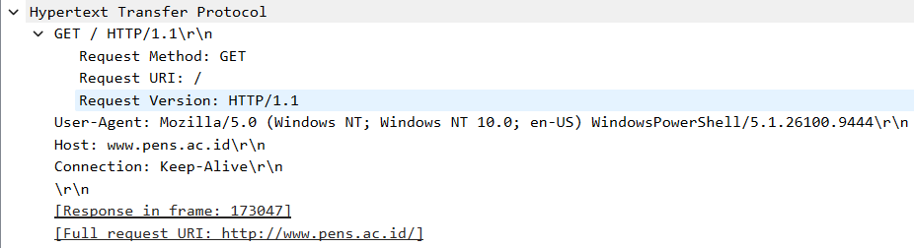
Host-to-host layer
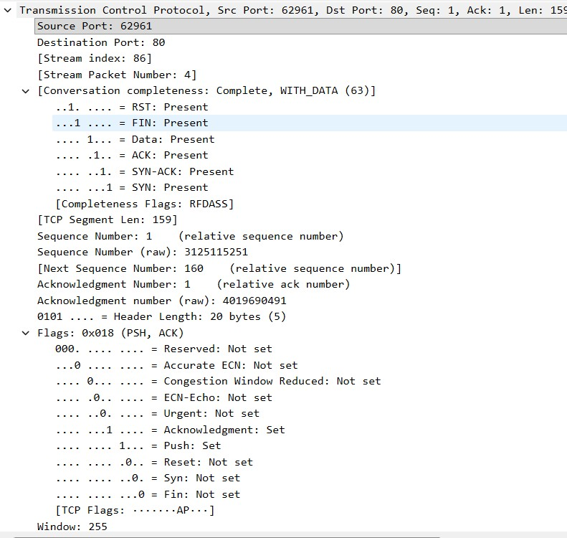
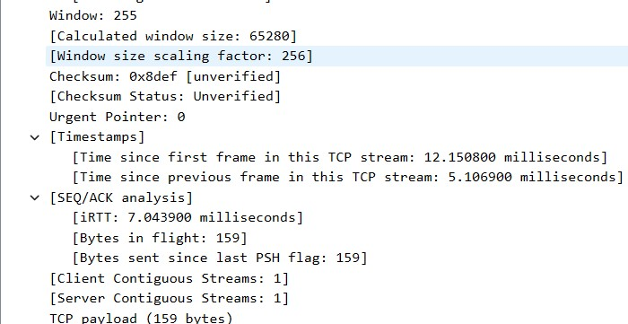
Internetwork layer
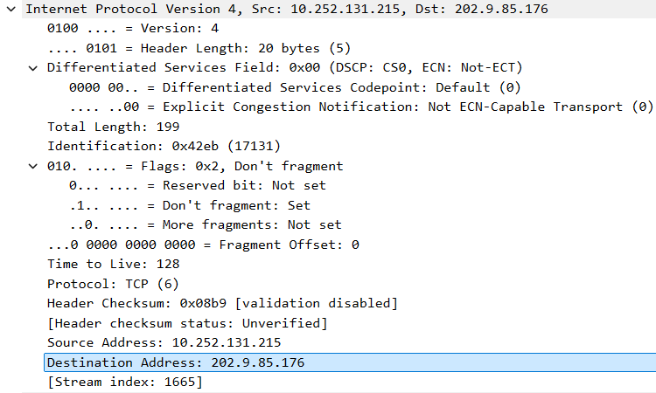
Network Interface layer
