

**TENTATIVE**

|  |  |
| --- | --- |
| **Time** | **Progress** |
| **8.00-10.00** | **Pembukaan** |
| **10.00-12.00** | **Minum** |
| **12.00-2.00** | **Persembahan** |
| **2.00-4.00** | **Majlis Penutup** |

Contents

Contents i

Revisions iii

1 Introduction 1

1.0 Document Purpose **Error! Bookmark not defined.**

1.1 Product Scope 1

1.2 Intended Audience and Document Overview 2

1.3 Definitions, Acronyms and Abbreviations 2

1.4 References and Acknowledgments 2

2 Overall Description 3

2.0 Product Perspective 3

2.1 Product Functionality 4

2.2 Users and Characteristics 5

2.3 Operating Environment 5

2.4 Design and Implementation Constraints 5

2.5 User Documentation 5

2.6 Assumptions and Dependencies 6

3 System Features 7

3.1 USE CASE DIAGRAM 7

3.2 USE CASE DESCRIPTION 8-23

4 Other Non-functional Requirements 24

4.0 Performance Requirements 24

4.1 Safety and Security Requirements 24

4.2 Software Quality Attributes 24

5 Other Requirements 25-33

Appendix A – REQUIREMENT MODELS 34

1. BUSINESS ACTIVITY DIAGRAM 34-41

2. CLASS DIAGRAM 42

3. SYSTEM SEQUENCE DIAGRAM 43-47

Appendix B - Group Log 48-50

Revisions

| Version | Primary Author(s) | Description of Version | Date Completed |
| --- | --- | --- | --- |
| Version 1.0 | Muhammad Syahin bin Md Syah | Information about the revision. This table does not need to be filled in whenever a document is touched, only when the version is being upgraded. | 12/12/2018 |

# 

# Introduction

**1.0 Document Purpose**

The main purpose of System Requirements Specifications (SRS) documentation is to describe the functional and non-functional requirement regarding Employee’s Mobility System (EMS) at SK Mendapat. This document has been developed after Vision and Scope Documentation. The objectives of EMS is to ease all the employee for applying a leave and meeting more systematic and orderly manner which is more organized, secured and reduce time to apply and fill in the activities form. Others, an admin get easier to search and update the employee’s activities. With the existing system, it will helps the flow of system more smoothly in operation also the data will be saved in the system to be more secured and accurate rather than using manual system. Thus, it will explain the purpose and features, interfaces, capabilities of the system and the constraint under which it must operate.

**1.1 Product Scope**

The scope of the project is provide information for admin to view and modify the details for better record keeping in the system. Currently, SK Mendapat is using manual system where all the employee has to fill up the forms to apply a leave and a meeting. Thus, we have come out with a great idea by developing a system for employee’s mobility. Employees can apply a leave or meeting by filling in application form online, save their details in system and even can see their activities story. Others, admin and employees are able to login to the system but the only who can update the activities, view the details and print the information to generate a report is an admin.

**1.2 Intended Audience and Documented Overview**

The target audiences for this document are developers, project manager, programmers, designers and client. The purpose of this document is to describe the system requirement specification for EMS. This document also can be reference to the new employee and admin in order to comprehend the flow of the system. Several modelling have been described in the documentation including Use Case Diagram, Use Case description, Activity Diagram, System Sequence Diagram and Domain Class Diagram.

**1.3** **Definitions, Acronyms and Abbreviation**

|  |  |
| --- | --- |
| **Acronym** | **Definition** |
| SRS | Software Requirement Specification |
| EMS | Employee Mobility System |
| SDD | Software Design Description |
| REQ | Requirement |
| SSD | System Sequence Diagram |
| VD | Vision Document |
| SDP | Software Development Plan |

Table 1 : Definition, acronyms and abbreviation

1.4 Document Conventions

1.5 References and Acknowledgments.

* Satzinger, J. W., Robert B. Jackson, & Stephan D. Burd. (2012). In Introduction to Systems Analysis and Design. Joe Sabatino.
* Vision document.

# 2 Overall Description

## 2.0 Product Perspective

EMS carry two main function for user which are to store data systematically and display properly. When store data, it helps to store data for the long period of time and can be seen in bigger view. It can be view the information from the past, current and in the future. For display, the information can be view more properly and can be easily understood.

Based on the current system, at certain time the higher management will issue an instruction to the principle to attend a meeting for the employee. The principle will inform the selected employee to attend the meeting. Then, the clerk will list down the employee’s name, date, venue at the whiteboard manually every day. For the employee’s leave application, the teacher need to fill up a leave application form manually. Then the clerk will inform to the principle to approve it and need to be written on the whiteboard. However, the space for information that need to be written in the whiteboard are limited and the previous information need to be erase for the new information.

The current system will take a longer time because all the process are doing manually. Since all the data is written in a whiteboard manually, so it will take risk on data lost when the user are accidently erase the information from the whiteboard. The written data may also cause misunderstanding because of different handwriting and writing mistake by the user.

Business problem to be solved for this school is how to manage the mobility of the employee more efficiently so that the user can manage the employee’s schedule more easily. For the future system, it will ease the user to by shorten the process. Written in computerize form are easily to read compare to in handwriting form. In addition, the new system can produce report the number of employee that not occur in school on a certain month.

## 2.1 Product Functionality

|  |  |  |
| --- | --- | --- |
| **No** | **Use Case** | **Description** |
| 1. | Add employee account | Admin create new employee account to the system. |
| 2. | Remove employee account | Admin delete employee account that are not needed. |
| 3. | View mobility | Admin view all the mobility information. |
| 4. | Search mobility | Admin search the mobility information. |
| 5. | Create report | Admin login the system by using admin ID and password.  Choose to display report by search date or employee ID.  Admin generate a report for daily or monthly.  (for more specific details can refer use case description below) |
| 6. | Update employee activity | Only admin can update the information of the activities. |
| 7. | Delete employee activity | Admin delete employee mobility’s information from the system. |
| 8. | Apply activity | Employee login the system by using employee ID and password. Then, choose between to apply activity or leave.  Employee apply activity by entering activity information.  (for more specific details can refer use case description below) |
| 9. | Apply leave | Employee login the system by using employee ID and password. Then, choose between to apply mobility or leave.  Employee apply leave by entering leaves information.  (for more specific details can refer use case description below) |
| 10. | View employee mobility | Employee only can view their own mobility details. |
| 11. | Search employee mobility | Employee only can view their own mobility details. |

## 2.2 Users and Characteristics

|  |  |  |
| --- | --- | --- |
| **Users** | **Admin** | **Employee** |
| **Frequency of use** | High frequency | High frequency |
| **Security and access** | Can access by admin ID and password. | Can access by staff ID and password. |

## 2.3Operating Environment

|  |  |
| --- | --- |
| **Item** | **Description** |
| **Operating system** | Windows 10 |
| **Language** | Java, HTML |
| **Tool** | Microsoft Office, Photoshop, draw.io(open source) |
| **Database** | Oracle |

## 2.4 Design and Implementation Constraints

For software constraint, have lack of knowledge and skill to use a tools. Tools development also do not stable and reliable. For design the interface, we need to know how to use the software and what software are suitable to use. For hardware constraint, when the system must run over the internet, all the hardware shall require to connect such as modem or Ethernet cross cable.

## 2.5User Documentation

User manual by providing the explanation and step how to use the system.

## 2.6Assumptions and Dependencies

**Assumptions**:

The staff of the administration department does not have IT background and lacks of intelligence in managing in computer system.

**Dependencies**:

We will use modern technology in developing a secure and safe system for our client. The modern technologies uses are commonly been use by many people that help for the school management to understand easier. Our system consumes only a small amount of cost in order to develop our system. Our system will have a guideline to help the school management on how to interact with the system and managing it.

# 3 System Features

## 3.1 USE CASE DIAGRAM

## USE CASE DESCRIPTION

### UC100: Register Employee

|  |  |  |  |
| --- | --- | --- | --- |
| Use Case ID: | UC100 | | |
| Use Case Name: | Register Employee | | |
| Created By: | Muhammad Syahin bin Md Syah | Last Updated By: | Nur Alisha binti Baharim |
| Date Created: | 8 Novermber 2018 | Date Last Updated: | 2 December 2018. |

|  |  |  |
| --- | --- | --- |
| Actor: | Admin | |
| Description: | Admin create a new employee account by entering all information | |
| Preconditions: | 1. Admin must login into the system  2. Admin enter the information of the employee into the form | |
| Post conditions: | Information of employee must be registered | |
| Priority: | High | |
| Frequency of Use: | Low | |
| Normal Course of Events: | Actor | System |
| 1. Admin login into the system  2. Admin choose the register segment.  3. Admin enter the teacher information.   * Name of the teacher * Position * Password * Teacher Id | 1.1 System will display the login form for admin to log in into the system.  3.1 System displays the registration form for admin to fill up the teacher’s information.  3.2 Check the validity for the information. <E1><E2>  3.3 System notifies the admin either the information successfully registered or not.  3.4 System create the new employee’s account. |
| Exceptions: | .<E1>Admin enter more than 4 character for employee’s ID  <E2>Employee’s Information is incomplete. | <E1.1> System will display message for the admin:   * “ID mesti 4 digit dan bermula dengan huruf “A”= admin , “E” untuk guru.   <E.2.1> System display message for staff:   * “Sila isikan nama anda” * “Sila pilih jawatan anda ” * “Sila isikan ruangan ID” * “Sila masukkan kata laluan” |
| Alternative Courses: | N/A | |
| Includes: | N/A | |
| Special Requirements: | N/A | |
| Assumptions: | N/A | |
| Notes and Issues: | N/A | |

### UC101: Remove Employee Account

|  |  |  |  |
| --- | --- | --- | --- |
| Use Case ID: | UC101 | | |
| Use Case Name: | Remove Employee Account | | |
| Created By: | Muhammad Syahin bin Md Syah | Last Updated By: | Nur Alisha binti Baharim |
| Date Created: | 8 November 2018 | Date Last Updated: | 2 December 2018 |

|  |  |  |
| --- | --- | --- |
| Actor: | Admin | |
| Description: | Admin remove employee account from the system | |
| Preconditions: | 1. Admin must login into the system  2. Admin view list of the employee | |
| Post conditions: | Account of that particular employee must be remove from the system | |
| Priority: | High | |
| Frequency of Use: | Low | |
| Normal Course of Events: | Actor | System |
| 1. Admin login into the system  2. Admin select list employee to view all the employee in the system.  3. Admin select the employee who want to delete from the system. | 1.1 System will display the login form for admin to log in into the system.  2.1 System displays all the employee in the system  3.1 Confirmation of the admin to delete  3.2 System delete the teacher information  3.3 System notify the admin either the information successfully deleted or not. |
| Exceptions: | N/A | N/A |
| Alternative Courses: | N/A | |
| Includes: | N/A | |
| Special Requirements: | N/A | |
| Assumptions: | N/A | |
| Notes and Issues: | N/A | |

### UC102: View all mobility

|  |  |  |  |
| --- | --- | --- | --- |
| Use Case ID: | UC102 | | |
| Use Case Name: | View all mobility | | |
| Created By: | Muhammad Syahin bin Md Syah | Last Updated By: | Nur Alisha binti Baharim |
| Date Created: | 8 November 2018 | Date Last Updated: | 2 December 2018 |

|  |  |  |
| --- | --- | --- |
| Actor: | Admin | |
| Description: | Admin view the information about the mobility by individual employee or different employee | |
| Preconditions: | 1. Admin must login into the system  2. Information of list employee must be available.  3. Information of individual employee list activity view must be available.  4. Information of the different employee list activity view must be available. | |
| Post conditions: | Information of the view will be displayed. | |
| Priority: | High | |
| Frequency of Use: | High | |
| Normal Course of Events: | Actor | System |
| 1.A. Admin login into the system  2.A. Admin select list of employee    3.A. Admin select a particular employee to see the mobility of the employee  Other method  1.B. Admin login into the system  2.B. Admin select list activity of employee | 1. A.1. System will display the login form for admin to log in into the system.  2.A.1 System displays all the employee in the system  3. A.1. System will display all the employee’s mobility  1. B.1 System will display the login form for admin to log in into the system.  2. B.1 System will display all the employee mobility in the system. |
| Exceptions: | N/A | N/A |
| Alternative Courses: | N/A | |
| Includes: | N/A | |
| Special Requirements: | N/A | |
| Assumptions: | N/A | |
| Notes and Issues: | N/A | |

### UC103: Search Employee Mobility

|  |  |  |  |
| --- | --- | --- | --- |
| Use Case ID: | UC103 | | |
| Use Case Name: | Search Employee Mobility | | |
| Created By: | Fathur Rahman bin Kamsani | Last Updated By: | Nur Alisha binti Baharim |
| Date Created: | 8 November 2018 | Date Last Updated: | 2 December 2018 |

|  |  |  |
| --- | --- | --- |
| Actor: | Admin | |
| Description: | Admin search the information about the mobility by individual employee or different employee | |
| Preconditions: | 1. Admin must login into the system  2. Information of list employee must be available.  3. Information of individual employee list activity view must be available.  4. Information of the different employee list activity view must be available. | |
| Post conditions: | Information of the view will be displayed. | |
| Priority: | High | |
| Frequency of Use: | High | |
| Normal Course of Events: | Actor | System |
| 1.A Admin login into the system  2.A Admin select list employee    3.A Admin select a particular employee to see the mobility of the employee  4. A Admin enter information to be search either by start date, end date, or by mobility name.  Other method  1.B Admin login into the system  2.B Admin select list activity of employee.  3.B Admin enter information that be search either by id, name of employee, start date, end date, mobility name, type of mobility or employee.  Other method  1.C Admin login into the system  2.C Admin select list activity of employee.  3.C Admin select the mobility based on today or month or year. | 1. A.1 System will display the login form for admin to log in into the system.  2.A.1 System displays all the employee in the system  3.A.1 System will display that employee’s mobility  4. A.1 System will display the employee mobility details if start date, end date and mobility name found. If not the system will ask the admin to re-enter the information.  4.A.2 Check the validity of the information<E1.A>  4. A.3 System display what been search about.  1. B.1 System will display the login form for admin to log in into the system.  2.B.1 System will display all the employee’s mobility  3. B.1 System will display the employee mobility details if start date, end date and mobility name found. If not the system will ask the admin to re-enter information.  3.B.2 Check the validity of the information <E1.B> <E2.B>  4.1 System will display the employee’s mobility that been search.  1. C.1 System will display the login form for admin to log in into the system.  2.C.1 System will display all the employee’s mobility  3. C.1 System will display all the employee mobility based on what the admin selected the view. |
| Exceptions: | N/A | N/A |
| Alternative Courses: | N/A | |
|  | <E1.A> Admin enter invalid employee information into the form.  <E1.B> Admin enter invalid employee information into the form. | <E1.A> System display message to the admin     * “Ralat , ruangan tarikh mula mingikut format DD/MM/YYYY “ * “Ralat , ruangan tarikh akhir mingikut format DD/MM/YYYY “   <E2.B.1> System display message to the admin   * “Ralat , ruangan ID ini   perlu mengikut format A1234”   * “Ralat , ruangan tarikh mula mengikut format DD/MM/YYYY “ * “Ralat , ruangan tarikh akhir mengikut format DD/MM/YYYY “ |
| Includes: | N/A | |
| Special Requirements: | N/A | |
| Assumptions: | N/A | |
| Notes and Issues: | N/A | |

### UC104: Create Report Mobility

|  |  |  |  |
| --- | --- | --- | --- |
| Use Case ID: | UC103 | | |
| Use Case Name: | Create Report Mobility | | |
| Created By: | Fathur Rahman bin Kamsani | Last Updated By: | Nur Alisha binti Baharim |
| Date Created: | 8 November 2018 | Date Last Updated: | 2 December 2018 |

|  |  |  |
| --- | --- | --- |
| Actor: | Admin | |
| Description: | Admin print the information about the mobility by what they search. | |
| Preconditions: | 1. Admin must login into the system.  2. Information of the different employee list activity view must be available. | |
| Post conditions: | Report of the employee mobility be displayed.. | |
| Priority: | High | |
| Frequency of Use: | Medium | |
| Normal Course of Events: | Actor | System |
| 1. Admin indicate desire to view the employee mobility based on what it search and select report option  2. Admin select for print process | 1.1 System will generate a report  2.1 System will print the report of mobility employee.  . |
| Exceptions: | N/A | N/A |
| Alternative Courses: | N/A | |
| Includes: | N/A | |
| Special Requirements: | N/A | |
| Assumptions: | N/A | |
| Notes and Issues: | On the report, there will be addition information on the number of employee involved. | |

### UC105: Update Employee Mobility

|  |  |  |  |
| --- | --- | --- | --- |
| Use Case ID: | UC105 | | |
| Use Case Name: | Update Employee Mobility | | |
| Created By: | Muhammad Syahin bin Md Syah | Last Updated By: | Nur Alisha binti Baharim |
| Date Created: | 11 November 2018 | Date Last Updated: | 2 December 2018 |

|  |  |  |
| --- | --- | --- |
| Actor: | Admin | |
| Description: | Admin update the mobility information. Employee cannot update their own mobility | |
| Preconditions: | 1. Admin must login into the system  2. Information of individual employee list in the system. | |
| Post conditions: | Information of the mobility will be updated. | |
| Priority: | High | |
| Frequency of Use: | Medium | |
| Normal Course of Events: | Actor | System |
| 1. Admin indicate desire to update the employee mobility’s information  2. Admin select list employee    3. Admin select a particular employee to see the mobility of the employee  4. Admin select the option update the employee.  5. Admin update the form. | 1.1 System will display the login form for admin to log in into the system.  2.1 System displays all the employee in the system  3.1 System will display all the employee’s mobility  4.1 System will display the mobility form of that employee.  5.1 System will save the updated mobility information. |
| Exceptions: | N/A | N/A |
| Alternative Courses: | N/A | |
| Includes: | N/A | |
| Special Requirements: | N/A | |
| Assumptions: | N/A | |

### UC106: Delete the Employee Mobility

|  |  |  |  |
| --- | --- | --- | --- |
| Use Case ID: | UC106 | | |
| Use Case Name: | Delete the Employee Mobility | | |
| Created By: | Muhammad Syahin bin Md Syah | Last Updated By: | Nur Alisha binti Baharim |
| Date Created: | 11 November 2018 | Date Last Updated: | 9 December 2018 |

|  |  |  |
| --- | --- | --- |
| Actor: | Admin | |
| Description: | Admin delete employee mobility’s information from the system. | |
| Preconditions: | 1. Admin must login into the system  2. Information of individual employee list activity view must be available.  3. Information of the different employee list activity view must be available. | |
| Post conditions: | Information of the employee mobility’s information will be delete. | |
| Priority: | Medium | |
| Frequency of Use: | Low | |
| Normal Course of Events: | Actor | System |
| 1. Admin login into the system  2.Admin select list of employee    3. Admin select a particular employee.  4. Admin select the employee ‘s mobility that want to delete | 1.1 System will display the login form for admin to log in into the system.  2.1 System displays all the employee in the system  3.1 System will display all the employee’s mobility  4.1 System will delete the particular |
| Exceptions: | N/A | -N/A |
| Alternative Courses: | N/A | |
| Includes: | N/A | |
| Special Requirements: | N/A | |
| Assumptions: | N/A | |
| Notes and Issues: | N/A | |

### UC200: Apply Activity

|  |  |  |  |
| --- | --- | --- | --- |
| Use Case ID: | UC200 | | |
| Use Case Name: | Apply Mobility | | |
| Created By: | Muhammad Faris Bin Ahmad | Last Updated By: | Nur Alisha binti Baharim |
| Date Created: | 1 December 2018 | Date Last Updated: | 6 December 2018 |

|  |  |  |
| --- | --- | --- |
| Actor: | Employee | |
| Description: | Employee apply activity by entering the form in the system. | |
| Preconditions: | 1. Employee must login into the system | |
| Post conditions: | Information of the activity will be save. | |
| Priority: | High | |
| Frequency of Use: | High | |
| Normal Course of Events: | Actor | System |
| 1. Employee login into the system  2. Employee select apply activity option.    3. Employee enter the activity form with consist of name of the activity, purpose (optional), start date, end date, venue, postcode and state. | 1.1 System will display the login form for admin to log in into the system.  2.1 System displays the mobility form.  3.1 System notifies the employee either the information successfully registered or not. |
| Exceptions: | N/A | N/A |
| Alternative Courses: | N/A | |
| Includes: | N/A | |
| Special Requirements: | N/A | |
| Assumptions: | N/A | |
| Notes and Issues: | N/A | |

### 3.2.9 UC201: Apply Leave

|  |  |  |  |
| --- | --- | --- | --- |
| Use Case ID: | UC201 | | |
| Use Case Name: | Apply Leave | | |
| Created By: | Muhammad Faris Bin Ahmad | Last Updated By: | Nur Alisha binti Baharim |
| Date Created: | 1 December 2018 | Date Last Updated: | 6 December 2018 |

|  |  |  |
| --- | --- | --- |
| Actor: | Employee | |
| Description: | Employee apply leave by entering the form in the system. | |
| Preconditions: | 1. Employee must login into the system  2. Information of leave form. | |
| Post conditions: | Information of the view will be displayed. | |
| Priority: | High | |
| Frequency of Use: | High | |
| Normal Course of Events: | Actor | System |
| 1. Employee login into the system  2. Employee select apply leave option.    3. Employee enter the leave form with consist of name of the activity , purpose (optional) , start date , end date, venue , postcode and state. | 1.1 System will display the login form for admin to log in into the system.  2.1 System displays the leave form.  3.1 System notifies the admin either the information successfully registered or not. |
| Exceptions: | N/A | N/A |
| Alternative Courses: | N/A | |
| Includes: | N/A | |
| Special Requirements: | N/A | |
| Assumptions: | N/A | |
| Notes and Issues: | N/A | |

### 3.3.0 UC202: View Employee Mobility

|  |  |  |  |
| --- | --- | --- | --- |
| Use Case ID: | UC202 | | |
| Use Case Name: | View Employee Mobility | | |
| Created By: | Muhammad Faris Bin Ahmad | Last Updated By: | Nur Alisha binti Baharim |
| Date Created: | 8 December 2018 | Date Last Updated: | December 2018 |

|  |  |  |
| --- | --- | --- |
| Actor: | Employee | |
| Description: | Employee view the information about the mobility of themselves. | |
| Preconditions: | 1. Employee must login into the system.  2. List of information of employee activity view must be available. | |
| Post conditions: | Information of the mobility will be displayed. | |
| Priority: | High | |
| Frequency of Use: | High | |
| Normal Course of Events: | Actor | System |
| 1. Employee login into the system  2.Employee select list of mobility activity | 1.1 System will display the login form for admin to log in into the system.  2.1 System will display the employee mobility in the system . |
| Exceptions: | N/A | N/A |
| Alternative Courses: | N/A | |
| Includes: | N/A | |
| Special Requirements: | N/A | |
| Assumptions: | N/A | |
| Notes and Issues: | - | |

### 3.3.1 UC203: Search Employee Mobility

|  |  |  |  |
| --- | --- | --- | --- |
| Use Case ID: | UC203 | | |
| Use Case Name: | Search Employee Mobility | | |
| Created By: | Muhammad Syahin bin Md Syah | Last Updated By: | Nur Alisha binti Baharim |
| Date Created: | 1 December 2018 | Date Last Updated: | 6 December 2018 |

|  |  |  |
| --- | --- | --- |
| Actor: | Employee | |
| Description: | Employee search the information about the mobility of themselves | |
| Preconditions: | Admin must login into the system  List activity or leave information of the employee | |
| Post conditions: | Information of the view will be displayed. | |
| Priority: | High | |
| Frequency of Use: | High | |
| Normal Course of Events: | Actor | System |
| 1. Employee login into the system  2. Employee select list of mobility    3. Employee enter the search form to see the mobility of the employee with consist of start date, end date and name of the mobility | 1.1 System will display the login form for admin to log in into the system.  2.1 System displays the employee mobility in the system  3.1 System will display the result of searching n the system . |
| Exceptions: | N/A | N/A |
| Alternative Courses: | N/A | |
| Includes: | N/A | |
| Special Requirements: | N/A | |
| Assumptions: | N/A | |
| Notes and Issues: | N/A | |

# Other Non-functional Requirements

## Performance Requirements

The Teacher’s Mobility System are developed based on Software Development Process (SDLC) which it starts with planning, analysis, design, implementation and testing. The development process will take 1 and half year to be completed. The system need a compatible size of database as the information of the asset will increase from time to time.

## Safety and Security Requirements

Any devices that connect to the computer of the Teacher’s Mobility System must not contains any harm, virus or malware that can harm and damage the hardware or the software in the computer. This is to ensure that the system is safe to use without any damage or loss may be happen.

For the security requirement, the system is using staff ID and password in order for them to access the system. Only the authenticated user are allowed to use the system to protect any loss or damaged towards information of mobility. The admin only can view the report, update, or delete of mobility system. This is because admin who is the top management in the school want to know why there is a change of the mobility and do not want the information of the mobility change frequently.

## Software Quality Attributes

|  |  |
| --- | --- |
| Usability: | * The interface of the system must be easy to use and understandable for the users. * The word have to be clear and the color is suitable to the users. |
| Adaptability | * System requires network connection to functioning well for the business process. |
| Reliability | * The system is reliable because it provides safety in order to prevent any unauthorized access. |
| Portability | * JavaScript, PHP, HTML, CSS is language that will be used to design website, which can be used in many software. |

5 Others Requirement

**5.1 PROTOTYPE**

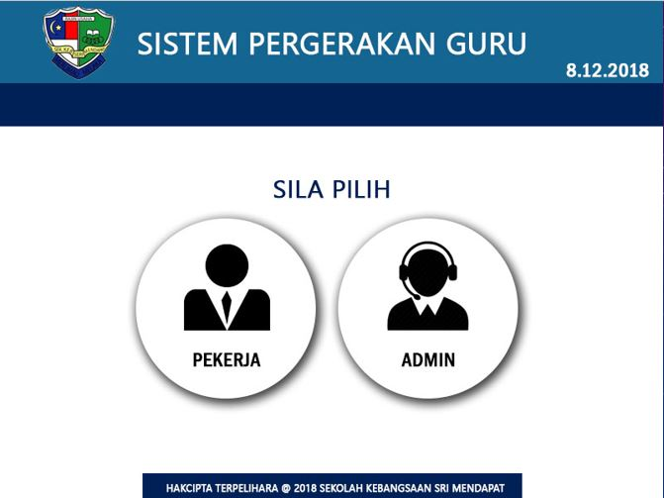

*Figure 4.1: Select user type*

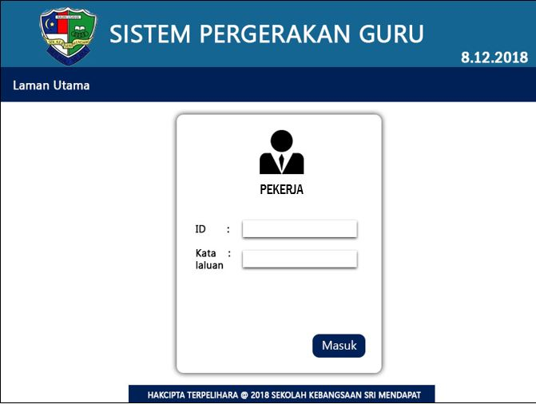

*Figure 4.2: Login from employee*

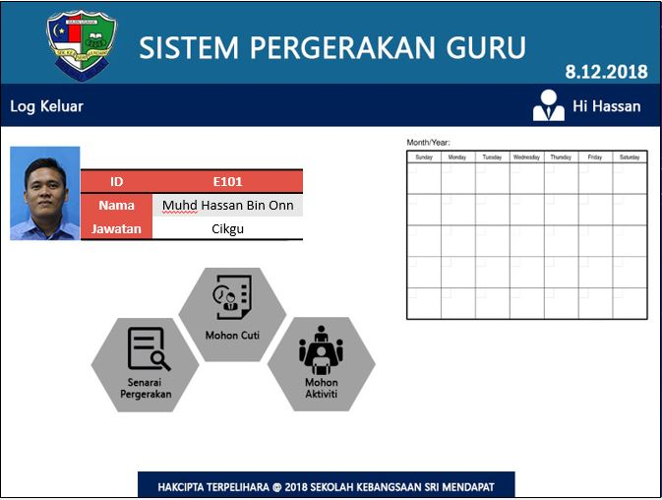

*Figure 4.3: Employee main page*

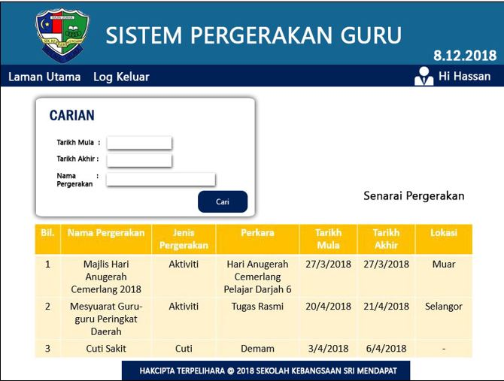

*Figure 4.4: Employee mobility list in employee account*

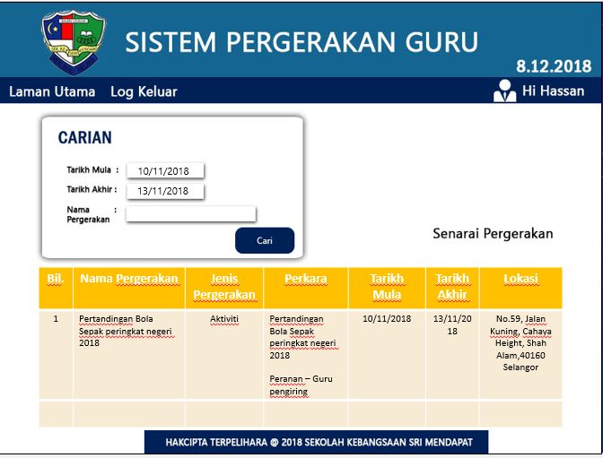

*Figure 4.5: Search employee mobility list*

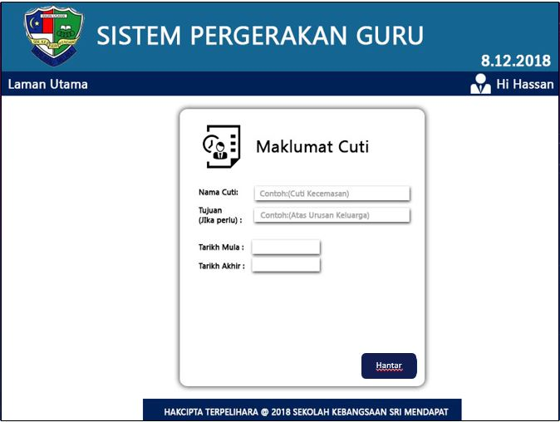

*Figure 4.5: Employee leave application form*

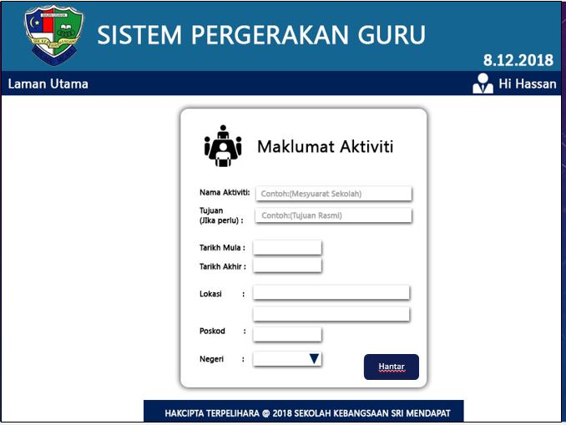

*Figure 4.6: Employee activity application form*

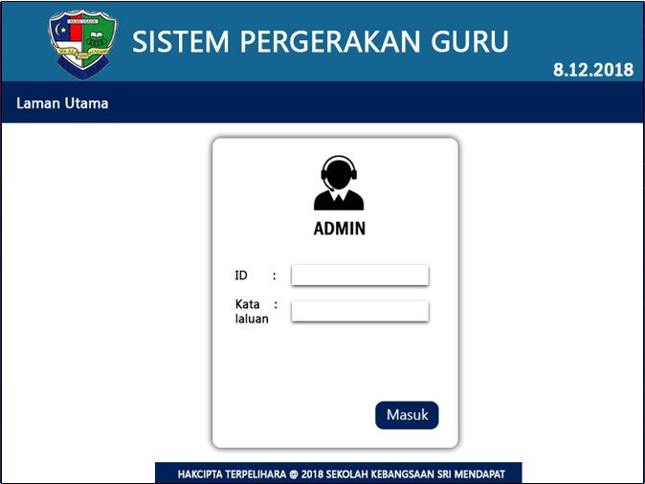

*Figure 4.7: Login from admin*

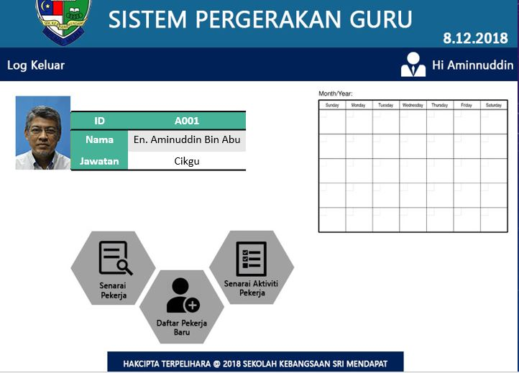

*Figure 4.8: Admin main page*

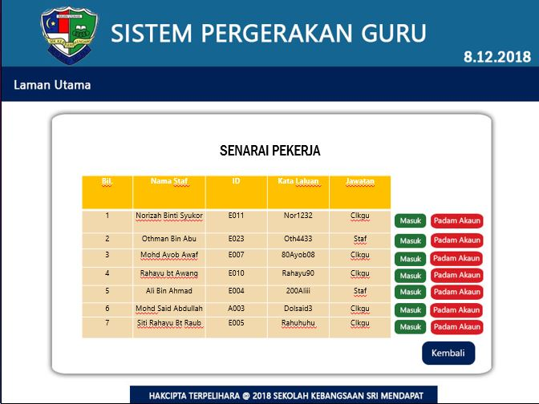

*Figure 4.9: Employee account list*

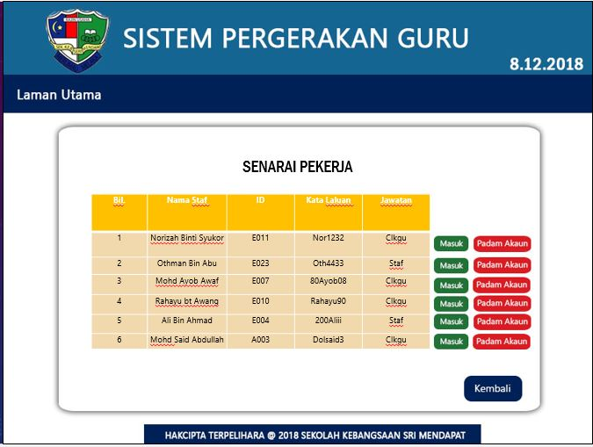

*Figure 4.10: Delete employee account*

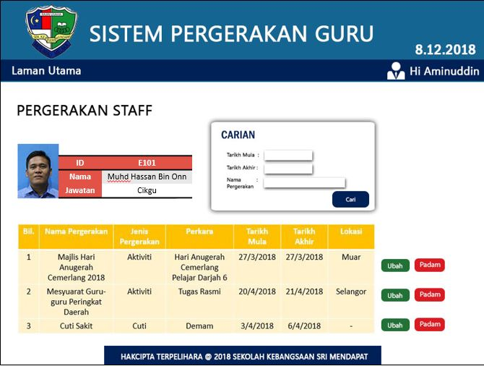

*Figure 4.11: Employee mobility activity*

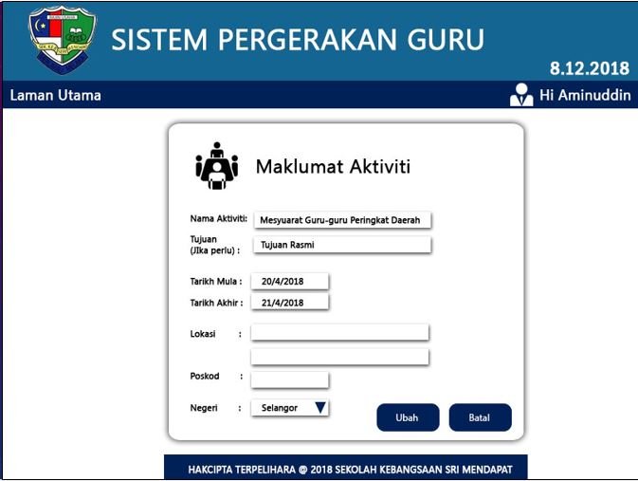

*Figure 4.12: Edit employee mobility activity*

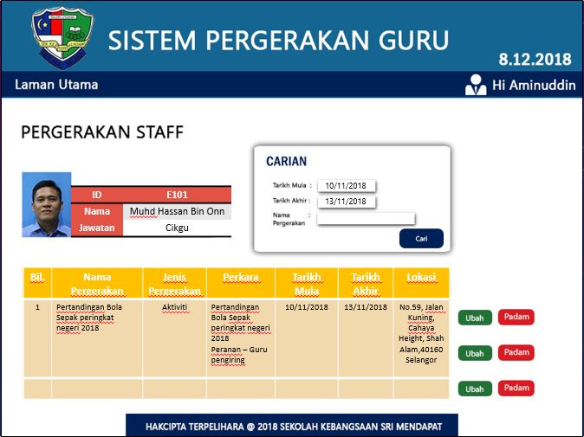

*Figure 4.13: Search specific employee mobility activity*

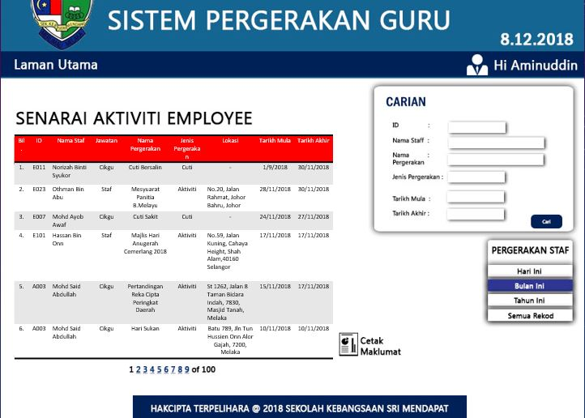

*Figure 4.14: List all employee activity*

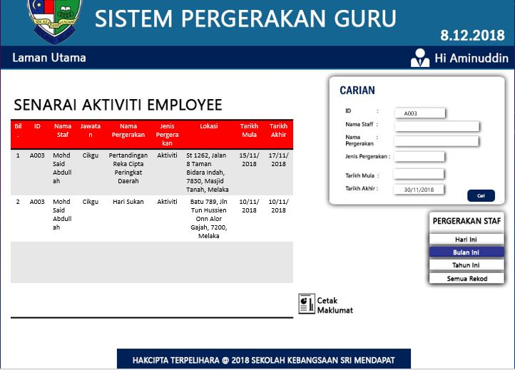

*Figure 4.15: Searching in list all employee activity*

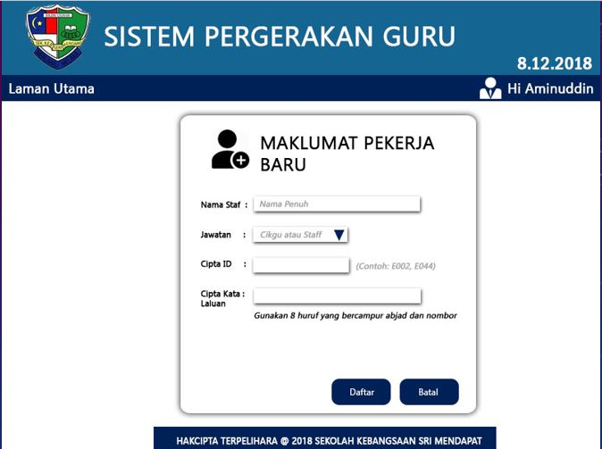

*Figure 4.16: Register new employee account*

Appendix A – REQUIREMENT MODELS

## BUSINESS ACTIVITY DIAGRAM

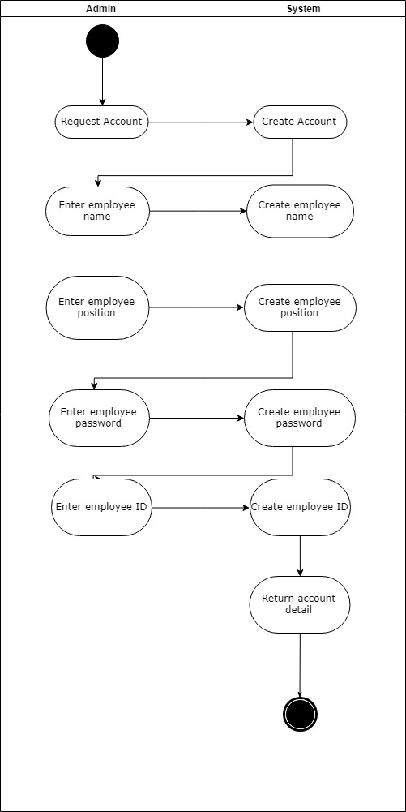

*Table 1 : Add employee account*

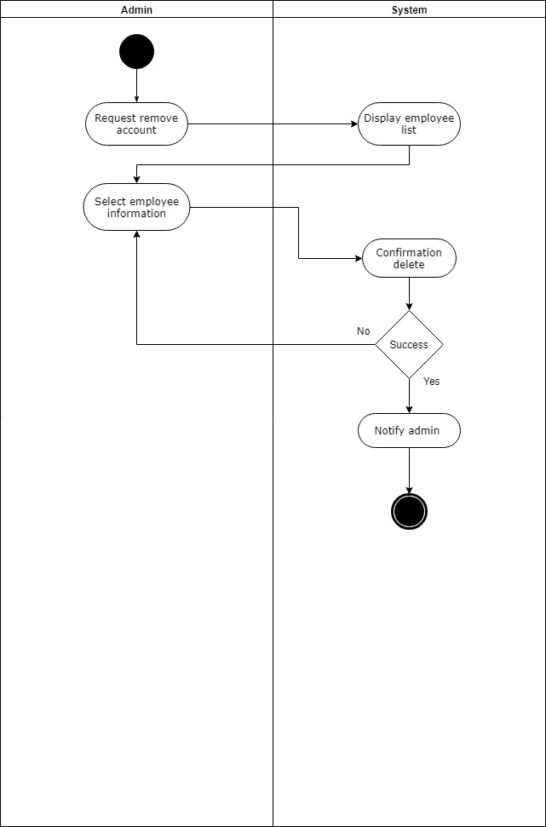

*Table 2 : Remove Employee Account*

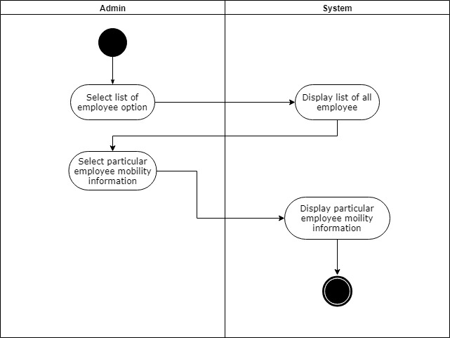

*Table 3 : View all mobility*

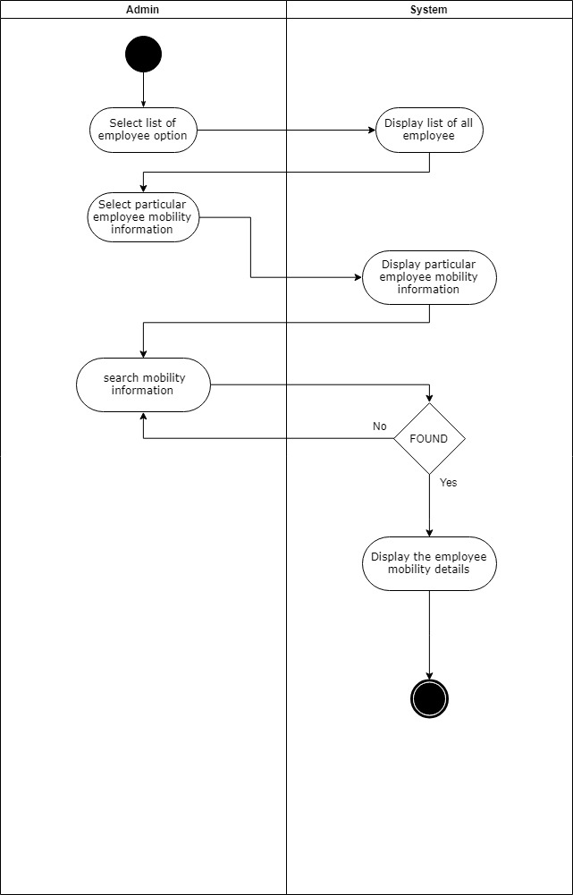

*Table 4 : Search Employee Mobility*

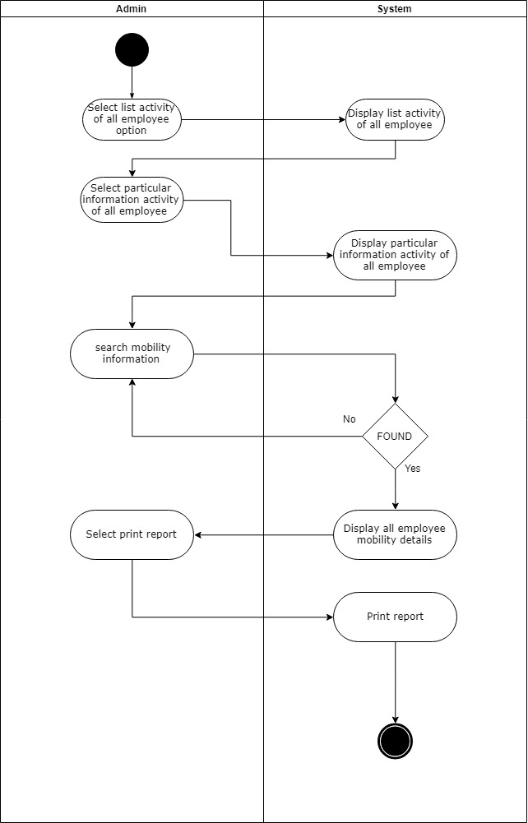

*Table 5 : Create Report Mobility*

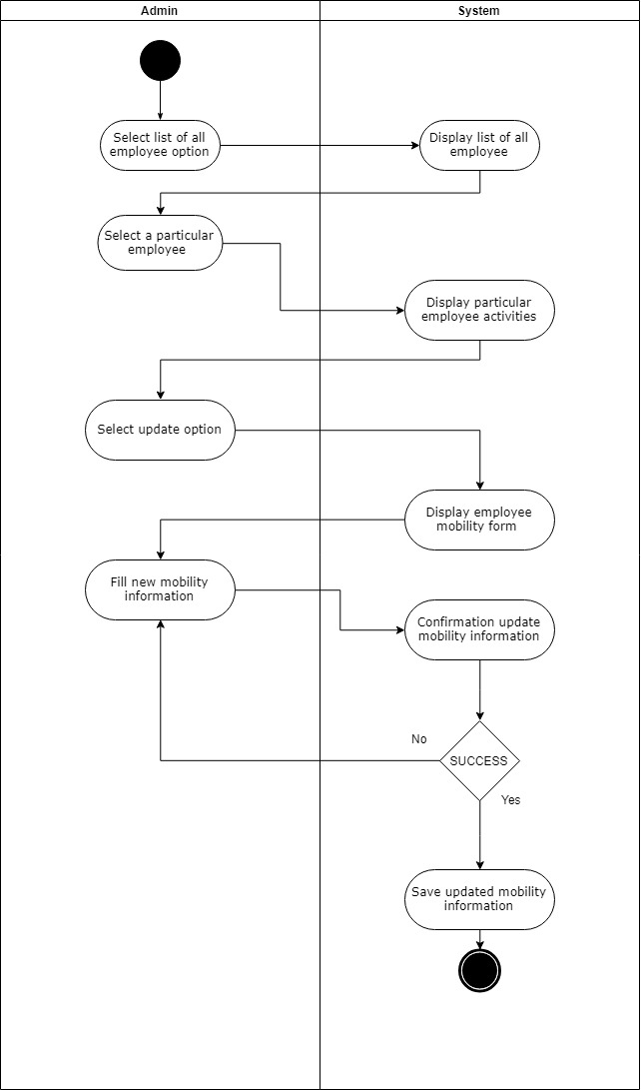

*Table 6 : Update Employee Mobility*

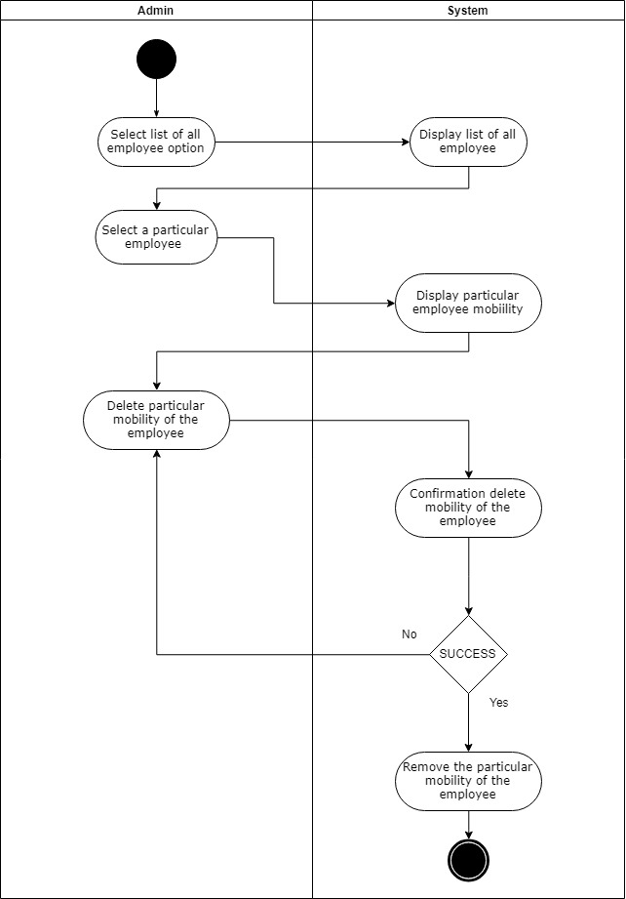

*Table 7 : Delete the Employee Mobility*

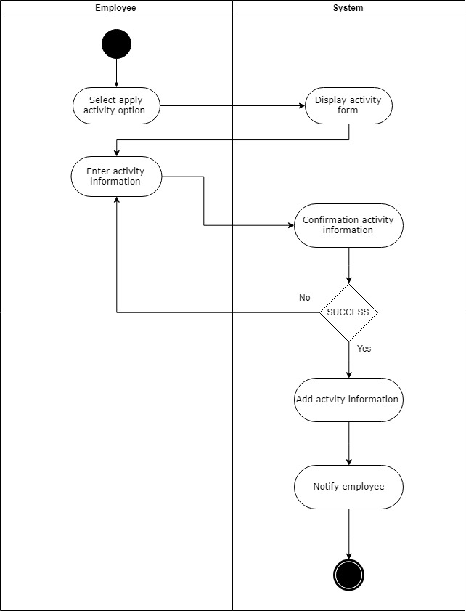

*Table 8 : Apply Activity*

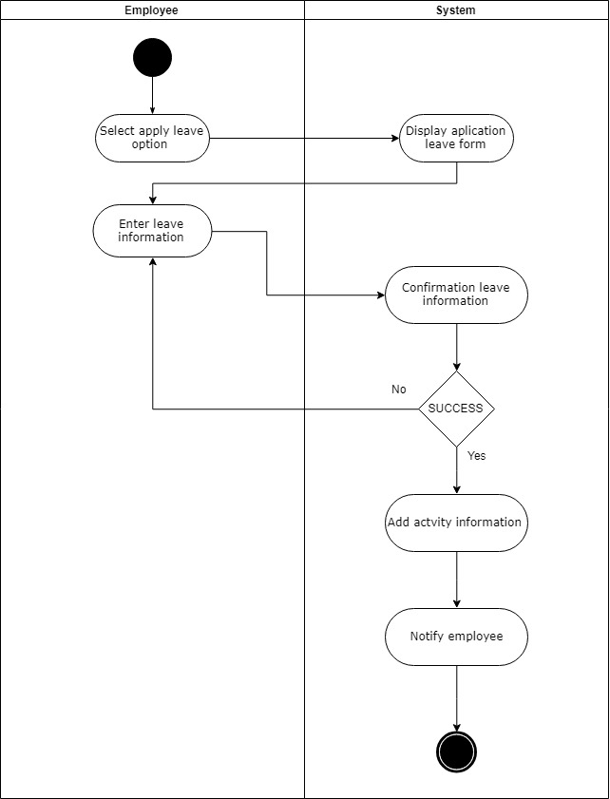

*Table 9 : Apply Leave*

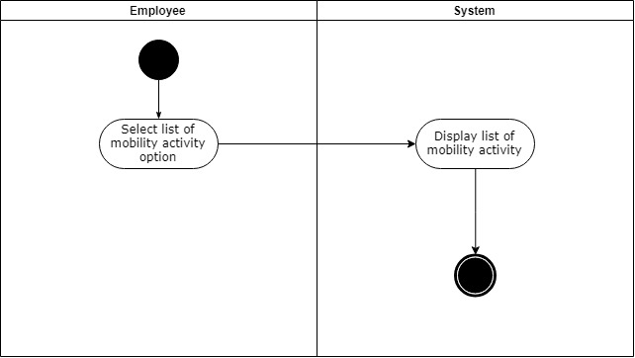

*Table 10 : View Employee Mobility*

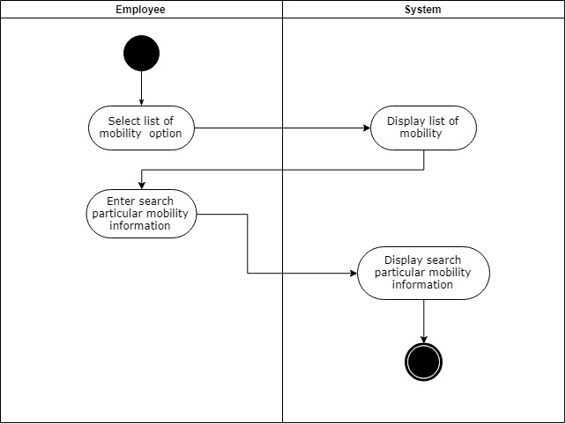

*Table 11 : Search Employee Mobility*

## DOMAIN CLASS DIAGRAM

## SYSTEM SEQUENCE DIAGRAM

Administration can:

1 Add Employee Account

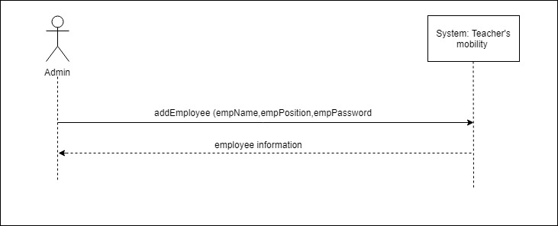

2. Remove Employee’s Account

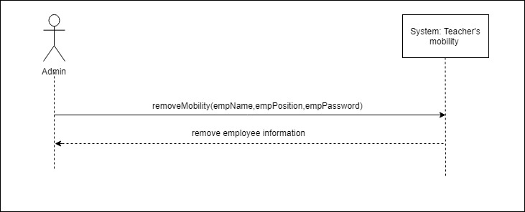

3. View Employee’s Information

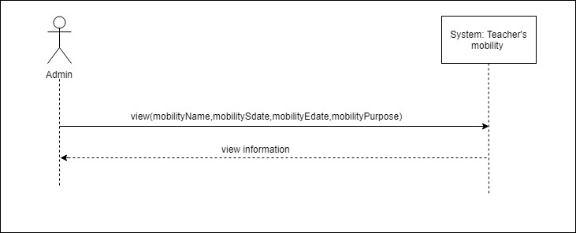

4. Search Employee’s Information

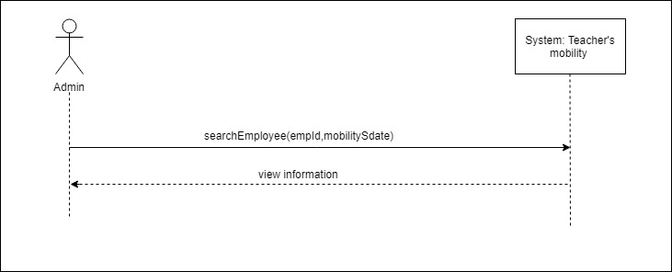

5. Create Report

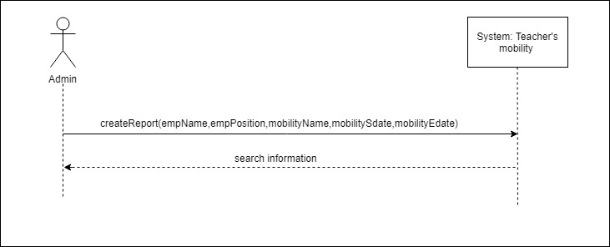

6. Update Employee’s Mobility

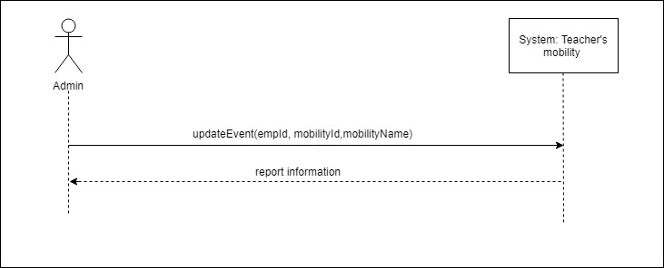

7. Delete Employee’s Mobility

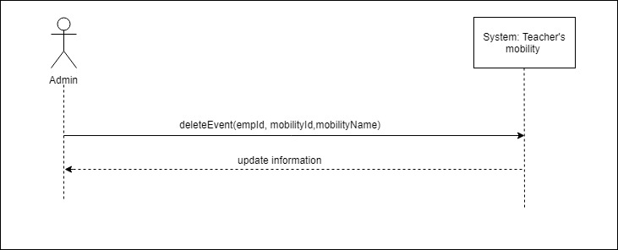

**Employee can:**

1. Fill Activity Form

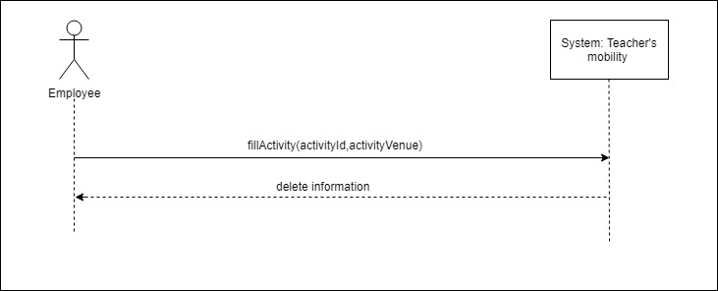

2. Fill Leave Form

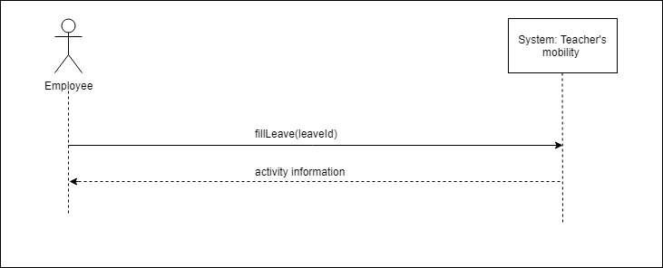

3. View Personal Mobility

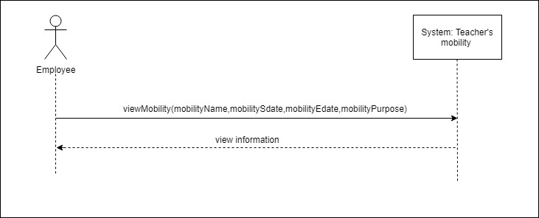

Appendix B - Group Log

|  |  |
| --- | --- |
|  |  |

**DISCUSSION AND INTERVIEW AGENDA**

|  |  |  |  |
| --- | --- | --- | --- |
| Date: | 18/10/ 2018 | Location: | Sk Seri Mendapat, Mendapat, 77300, Merlimau, Melaka |
| Time: | 12 p.m |  |  |

**Setting**

Objective of Interview

To collect requirement from stakeholder.

User Participants

Cikgu Aminuddin , Cikgu Zaharin

Project Team Participants

Muhammad Syahin bin Md Shah , Fathur Rahman bin Kamsani , Nursaidatul Shazwani binti Zainodin , Nur Alisha binti Baharim , Muhammad Faris bin Ahmad.

**Interview/Discussion**

* What is the current problem that the school has?
* What is the system that exist in the school?
* What system that you preferred?
* What do you want to insert in the system?
* What problem that exist when you manage the system?
* How the school managed the system?
* What type of system that exist in the school?

**Follow-Up**

Date and time of next meeting or follow-up session

20 Novermber 2018, at 1.00 p.m

**DISCUSSION AND INTERVIEW AGENDA**

|  |  |  |  |
| --- | --- | --- | --- |
| Date: | 20/11/ 2018 | Location: | Sk Seri Mendapat  No. 1, Kampung Seri Mendapat, 77300, Merlimau, Melaka |
| Time: | 12 p.m |  |  |

**Setting**

Objective of Interview

To collect requirement from stakeholder.

User Participants

Cikgu Aminuddin , Cikgu Zaharin

Project Team Participants

Muhammad Syahin bin Md Shah , Fathur Rahman bin Kamsani , Nursaidatul Shazwani binti Zainodin , Nur Alisha binti Baharim , Muhammad Faris bin Ahmad.

**Interview/Discussion**

* How the step to system mobility are be done ?
* Confirmation of requirement ?

**Follow-Up**

Project Manager contact with the stakelholder through phone