1. Muhammad Nazmi bin Omar (2018440562)
2. Muhammad Syahin bin Md Shah (2018638896)
3. Muhammad Faris bin Ahmad (2018674464)
4. Fathur Rahman bin Kamsani (2018638728)
5. Mohamad Arif bin Mahat (2018402202)

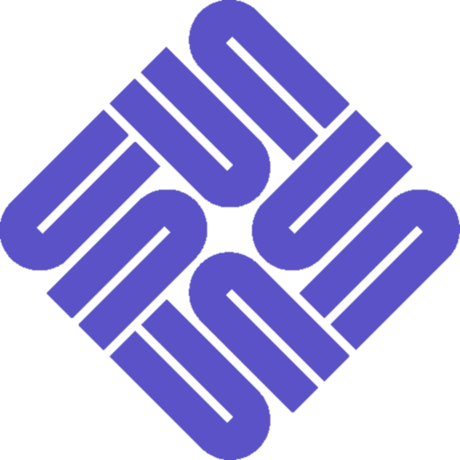

*SUN Microsystem Logo*

**Gestalt Principile applied: SIMILARITY**

The SUN logo only constitutes a ‘U’, arranged in a loop. However, when together, the reverted ‘U’s look like they are forming the word ‘SUN’ on all the four sides of the quadrilateral.

**Gestalt Principile applied: CLOSURE**

The SUN logo seem like have a square shape, but does not have line that form a square.