We are all Canadian
Living in this Land
If you were a Canadian
You would understand

Why we love our country
And why we are so proud
We are proud Canadians
And we will shout it out loud

You Are Cordially Invited to
Celebrate Canada Day

&
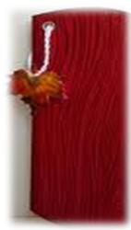




Enjoy Celebration during Afghan Senior
Regular Meeting, Food & Canada day Cake
At Gordon Presbyterian Church on June 25 2014

From 12:30 to 3:00

