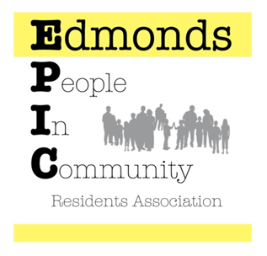

epicreza@gmail.com
www.epiccommunity.ca

May 3, 2015
Mr. Peter Julian, MP & Mr. Raj Chouhan, MLA
Dear Peter and Raj,
EPIC, Edmonds People in Community Residents Association would like to take this opportunity to say a huge “Thank You” for the ad that was placed in the Burnaby Newsleader on Thursday, April 30, 2015 supporting the Edmonds Clean Sweep.
Your encouragement and support means so much to us.
You both live such busy lives and it warms our hearts that you give of your precious time to spend it attending our efforts to build community in the Edmonds area of Burnaby.
Best regards,
Lindy McQueen
Chair Edmonds People in Community Residents Association 604 525 6876

