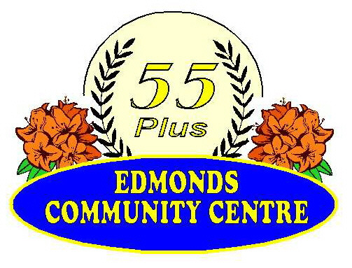
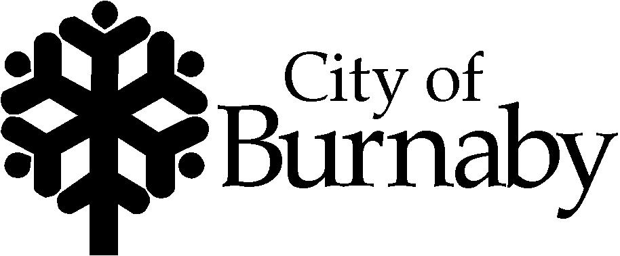
Edmonds Community Centre
7433 Edmonds Street, Burnaby
Tel: 604-297-4838
Fax: 604-540-6983

September 15, 2014

Dear Mr. Peter Julian:

Edmonds Seniors Society in conjunction with Edmonds Services for 55+ holding their annual Remembrance Day Service on Saturday, November 8th at Edmonds Community Centre (7433 Edmonds Street).

A full service to honour our fallen heroes is conducted, followed by refreshments.

The service commences at 1:00 pm sharp. We would like to extend an invitation for you to join in the service by being an honoured guest. Please RSVP no later than October 17, 2014. Also, please let us know if you would like to share a few words with those in attendance or lay a wreath.

If you have any questions or concerns with regard to the service, please do not hesitate to ask. We hope you are able to join us in honouring those who have served in the wars and thank you for your support.

Sincerely,

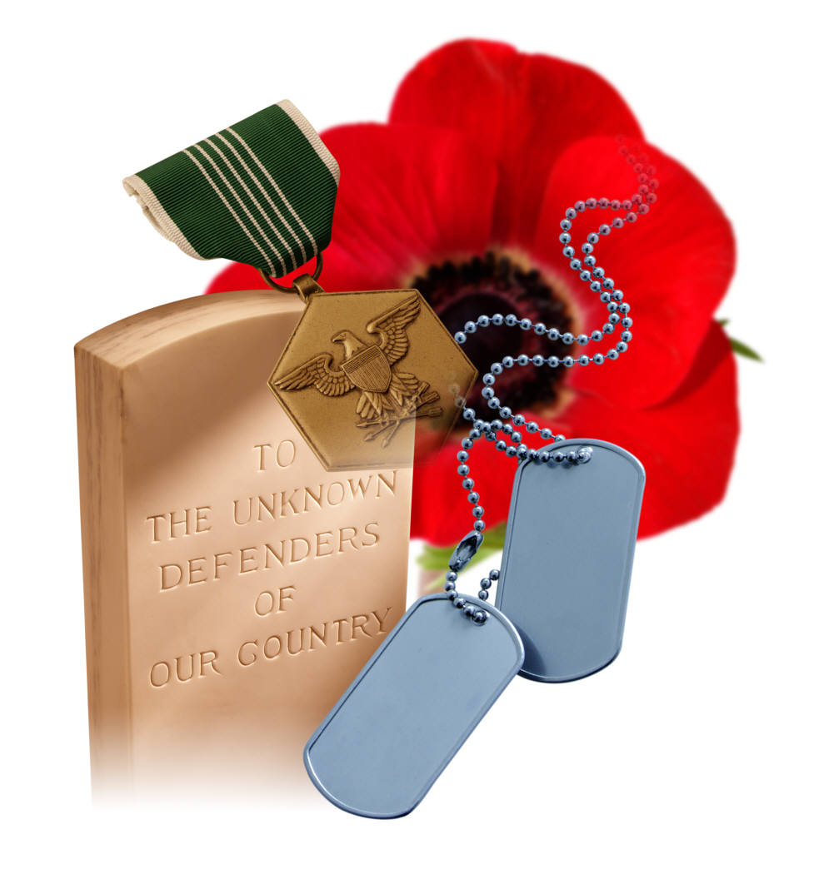
Kelli Tibbles
Recreation Leader 1
Edmonds Community Centre
kelli.tibbles@burnaby.ca
604-297-4404

