# UNIT 4

**READING COMPREHENSION “STRESS”**

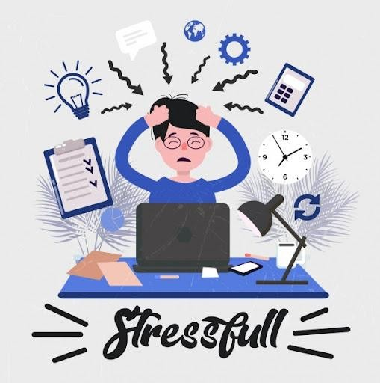

# Task 1. Work in pairs and discuss the following questions:

* What comes to mind when you hear the word –stress?
* How often do you suffer from stress?
* What situations are especially stressful for you?
* What are the main symptoms of stress?
* What do you do to cope with stress?

# Task 2. Agree or disagree with the following statements:

* Stress sometimes motivates us to perform well, but it can also be harmful if we become over-stressed and it interferes with our ability to get on with our normal life.
* Stress, itself, is not an illness, but it can certainly contribute to illness, some of them serious.

# STRESS

The study of the relationships between mind and body bring us to examining the role of stress in both mental and physical functioning. The term “stress”, as it is currently used was introduced by Hans Selye in 1936, who defined it as ―the non- specific response of the body to any demand for change”. He had observed in experiments that laboratory animals subjected to acute but different noxious Physical and emotional stimuli (deafening noise, blaring light, extremes of heat or cold) all exhibited the same pathologic changes of stomach ulcerations, enlargement of the adrenals. So, the term stress refers to pressure or force placed on a body.

In psychology, we use the term stress to refer to a pressure or demand that is placed on an organism to adapt or adjust**. A stressor** is a source of stress. Stressors (or stresses) include psychological factors, such as examinations in school and problems in social relationships, and life changes, such as the death of a loved one, divorce, or a job termination. They also include **daily hassles,** such as traffic jams, and physical environmental factors, such as exposure to extreme temperatures or noise levels. The term stress should be distinguished from distress, which refers to a state of physical or mental pain or suffering. Some amount of stress is probably healthy for us; it helps keep us active and **alert**. But stress that is prolonged or intense can **overtax** our coping ability and lead to states of emotional distress, such as **anxiety** or depression, and to physical complaints, such as fatigue and headaches.

We all experience stress at times. It can sometimes help to motivate us to get a task finished, or **perform well**. But stress can also be harmful if we become over- stressed and it interferes with our ability to get on with our normal life.

When we face a stressful event, our bodies respond by activating the nervous system and releasing hormones such as adrenalin and cortisol. These hormones cause physical changes in the body which help us to react quickly and to get through the stressful situation effectively. This is sometimes called the

‗fight or flight‘ response. The hormones increase our heart rate, breathing, blood pressure, metabolism and muscle tension. Thus, the signs of stress can include: headaches, sleep disturbance, insomnia, indigestion, diarrhea, anxiety, anger, depression, feeling out of control, feeling moody, difficulty concentrating, low self-esteem, **lack of** confidence. The scientists distinguish different types of stress. Sometimes stress can be specific to the demands and pressures of a particular

situation, such as a deadline, a performance or facing up to a difficult challenge or traumatic event.

This type of stress often gets called **acute stress**. Some people seem to experience acute stress over and over. This is sometimes referred to as **episodic acute stress**. This kind of repetitive stress episodes may be due to a series of very real stressful **challenges**, for example, losing a job, health problems. The third type of stress is called **chronic stress**. It involves pressures and worries that seem to go on forever, with little hope of **letting up.** Chronic stress is very harmful to people‘s health and happiness. People can sometimes **get used to** chronic stress, and may feel they do not notice it so much, it has a negative effect on their relationships and health.

To conclude, we should mention that it is very important **to handle the stress** in healthy ways. More than that it is helpful to be capable of identifying early warning signs in your body that tell you when you are getting stressed.

# Task 3. Find the details in the text.

1. The definition of the term “stress”.
2. Who and how defined the term “stress”?
3. What are stressors? Find examples.
4. What is distress?
5. Is stress useful or harmful?
6. The signs of stress.
7. Types of stress.

# Task 4. Fill in prepositions:

1. The term **“**stress” was introduced … Hans Selye in 1936.
2. A stressor is a source … stress.
3. The term stress should be distinguished …distress.
4. Some amount of stress is sometimes healthy … us.
5. We all experience stress … times.
6. Stress interferes … our ability to get on with our normal life.
7. Adrenalin and cortisol cause physical changes … the body.
8. Chronic stress is very harmful … people‘s health and happiness.
9. People can sometimes get used … chronic stress.
10. Chronic stress has a negative effect … the relationships and health.