1. Import all python modules that are required.

We have to import webdriver also.

pip3 install flask

pip3 install pymysql

pip3 install datetime

pip3 install pandas

pip3 install time

pip3 install selenium

pip3 install re

1. Download chrome geckodriver 32 or 64 bit based on your computer.
2. Create Tables in MySQL.

Below are the 8 tables are required.

* CREATE TABLE abhibus_operator_master_id(operator varchar(100),id int)
* CREATE TABLE redbus_operator_master_id(operator varchar(100),id int)
* CREATE TABLE abhibus_operators_data_datewise(operator varchar(100),pick_time varchar(25),date varchar(25),site varchar(20), rid int)
* CREATE TABLE redbus_operators_data_datewise(operator varchar(100),pick_time varchar(25),date varchar(25),site varchar(20), rid int)
* CREATE TABLE both_operators(operator varchar(100), no_of_services int, id int,site varchar(100))
* create table display_data(sno int,operator varchar(200),abhibus_inventory int,redbus_inventory int,difference int,abhibus_operation_time varchar(200),redbus_operation_time varchar(200),status varchar(200),comment varchar(200),date varchar(20),route varchar(200),scraped_time varchar(200))
* create table bus_opr_count(date varchar(20),route varchar(200),bus_count int,opr_count int)
* create table location(citynames varchar(200))

1. After Creating Tables in the sql,In MySql go to schemas under Navigation which is present on the left side 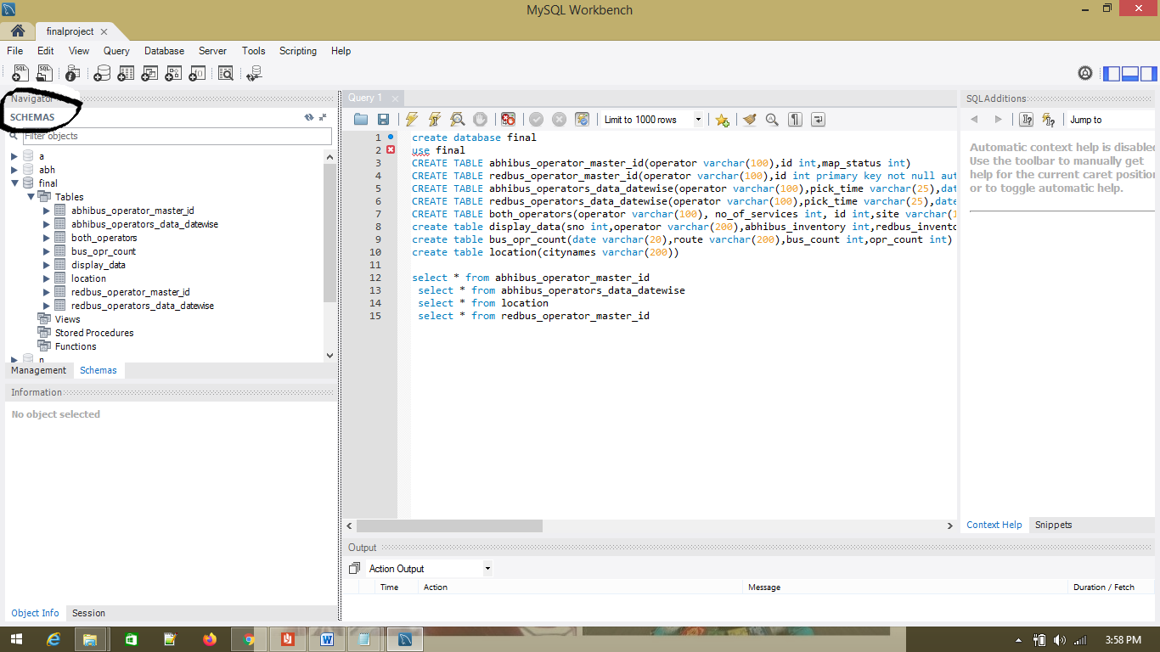
2. After going to schemas go to your database name a go to tables

Final🡪tables.

1. After going to tables go to abhibus_operator_master_id and right click on it and press on table data import wizard, Now go to competition analysis folder and to data and click on abhibus_operator_master_id then the csv file is imported to the database. Same process we have to do it for redbus_operator_master_id and location tables.
2. For location table import citynames.
3. We have to make some changes in python file i.e.,cofig_file.py

* Under password=”” we have to enter the password that we have given to the Mysql
* Under database=”” we have enter database name.

1. Now open command prompt and set path
2. After setting the path run python app.py because it is the main file.
3. After running we will get a IPlink i.e., 127.0.0.1:5000 we have to copy that link and paste it in google chrome