|  |
| --- |
| **DATABASE THEORY AND DESIGN**  **CS 5332**  **SUMMER 2019**  **PROJECT - 1**  **SUBMITTED TO : Dr C. J. Hwang**  **SUBMITTED BY: SRUTHI SINDHU SYAMALA**  **TEXAS STATE ID: A04929032** |
|  |

Dream House DataBase

Branch Table:

create table Branch (branchNo varchar(4) NOT NULL PRIMARY KEY, street varchar(25), city varchar(15),postcode varchar(8));

insert into Branch values('B005','22 Deer Rd','London','SW1 4Eh');

insert into Branch values('B007','16 Argyll St','Aberdeen','AB2 3SU');

insert into Branch values('B003','163 Main St','Glasgow','G11 9QX');

insert into Branch values('B004','32 Manse Rd','Bristol','BS99 INZ');

insert into Branch values('B002','56 Clover Dr','London','NW10 6EU');

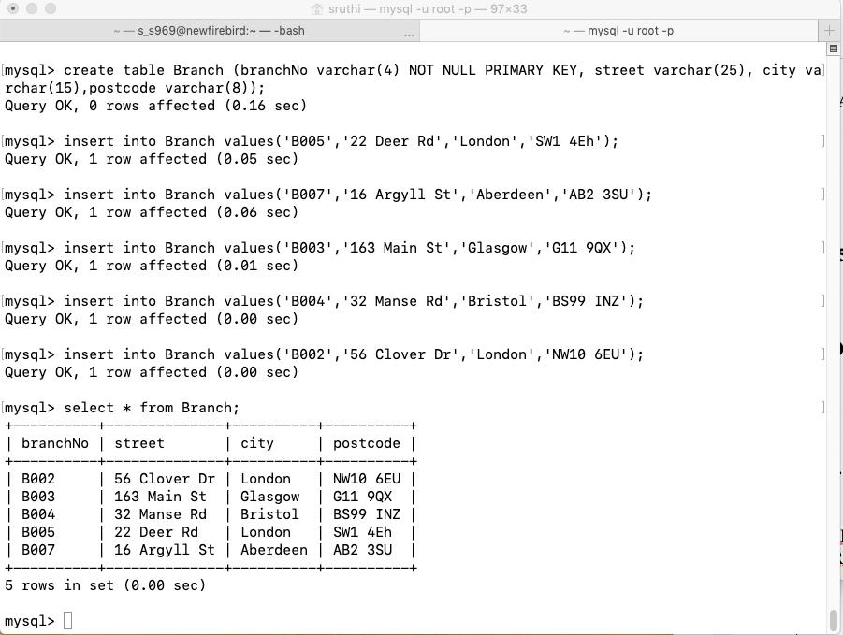

Desc Branch;

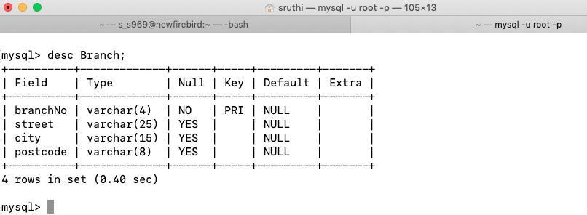

**Staff Table**

create table Staff (staffNo varchar(4) PRIMARY KEY,fName varchar(25),IName varchar(25),position varchar(25),sex varchar(1), DOB date, salary int, branchNo varchar(4), FOREIGN KEY (branchNo) REFERENCES Branch(branchNo));

insert into Staff values('SL21','John','White','Manager','M','1945-10-01',30000,'B005');

insert into Staff values('SG37','Ann','Beech','Assistant','F','1960-11-10',12000,'B003');

insert into Staff values('SG14','David','Ford','Supervisor','M','1954-03-24',18000,'B003');

insert into Staff values('SA9','Mary','Howe','Assistant','F','1958-02-19',9000,'B007');

insert into Staff values('SG5','Susan','Brand','Manager','F','1940-06-03',24000,'B003');

insert into Staff values('SL41','Julie','Lee','Assistant','F','1965-06-13',9000,'B005');

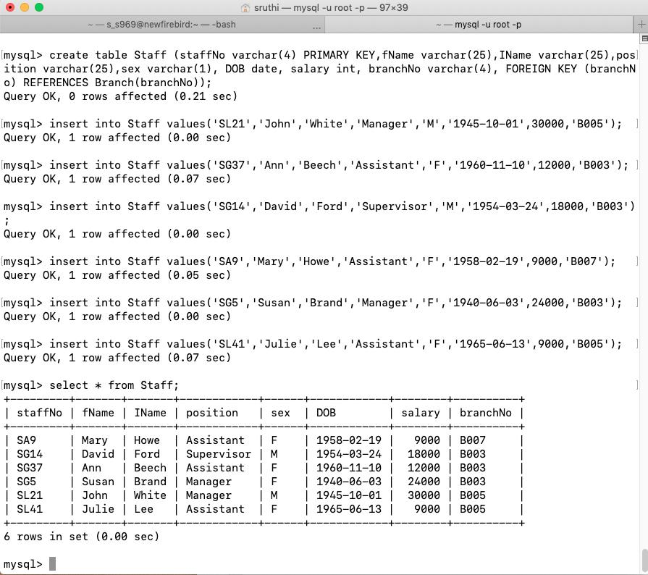

Desc Staff;

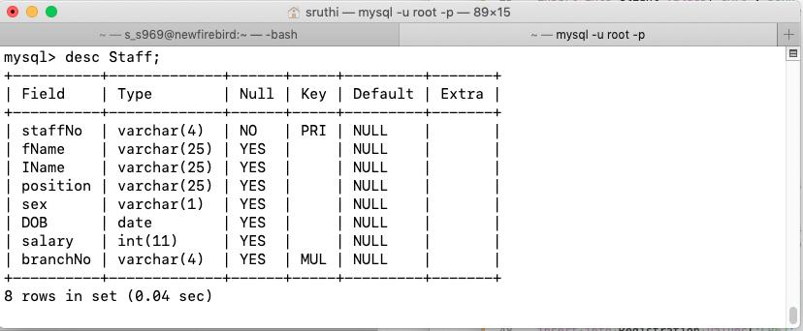

**PropertyForRent Table**

create table PropertyForRent (propertyNo varchar(4) PRIMARY KEY,street varchar(25), city varchar(15), postcode varchar(8),type varchar(25), rooms integer,rent integer, ownerNo varchar(4), staffNo varchar(4),branchNo varchar(4),FOREIGN KEY (ownerNo) REFERENCES PrivateOwner(ownerNo),FOREIGN KEY (staffNo) REFERENCES Staff(staffNo),FOREIGN KEY (branchNo) REFERENCES Branch(branchNo));

insert into PropertyForRent values('PA14','16 Holhead','Aberdeen','AB7 5SU','House',6,650,'CO46','SA9','B007');

insert into PropertyForRent values('PL94','6 Argyll St','London','NW2','Flat',4,400,'CO87','SL41','B005');

insert into PropertyForRent values('PG4','6 Lawrence St','Glasgow','G11 9QX','Flat',3,350,'CO40','','B003');

insert into PropertyForRent values('PG36','2 Manor Rd','Glasgow','G32 4QX','Flat',3,375,'CO93','SG37','B003');

insert into PropertyForRent values('PG21','18 Dale Rd','Glasgow','G12','House',5,600,'CO87','SG37','B003');

insert into PropertyForRent values('PG16','5 Novar Dr','Glasgow','G12 9AX','Flat',4,450,'CO93','SG14','B003');

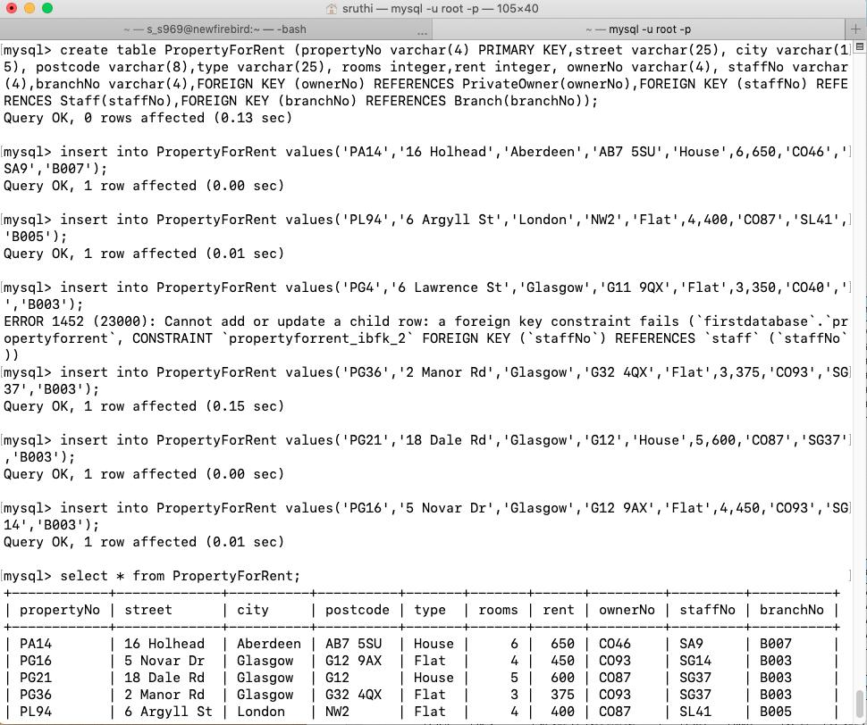

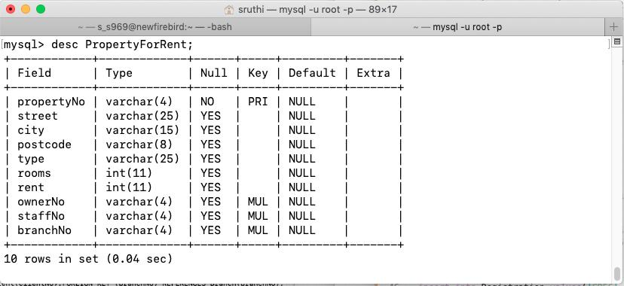

**ClientTable**

create table Client(clientNo varchar(4) PRIMARY KEY, fName varchar(25), lName varchar(25),telNo varchar(12), prefType varchar(25), maxRent integer, email varchar(25));

insert into Client values('CR76','John','Kay',0207-774-5632,'Flat',425,'john.kay@gmail.com');

insert into Client values('CR56','Aline','Stewart',0141-848-1825,'Flat',350,'astewart@hotmail.com');

insert into Client values('CR74','Mike','Ritchie',01475-392178,'House',750,'mritchie01@yahoo.co.uk');

insert into Client values('CR62','Mary','Tregear',01224-196720,'Flat',600,'mary@hotmail.co.uk');

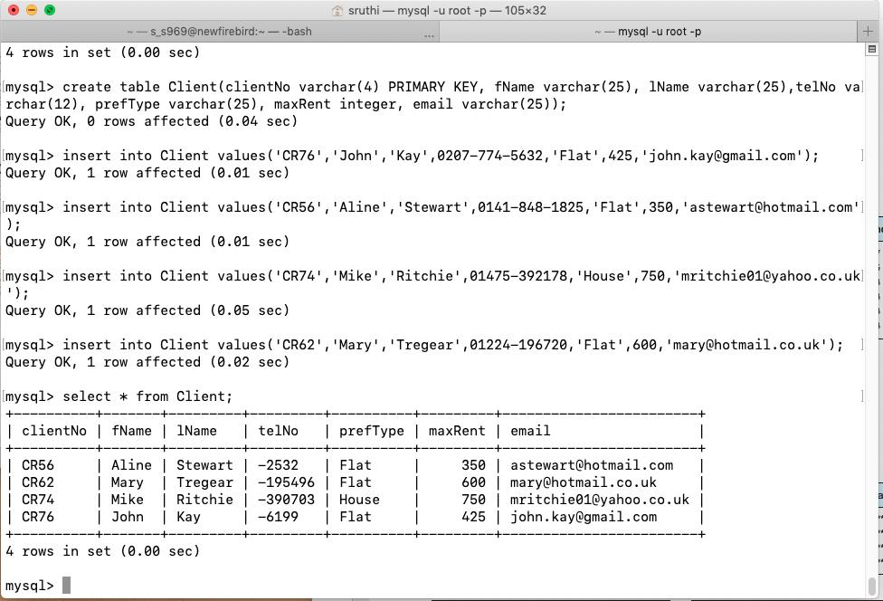

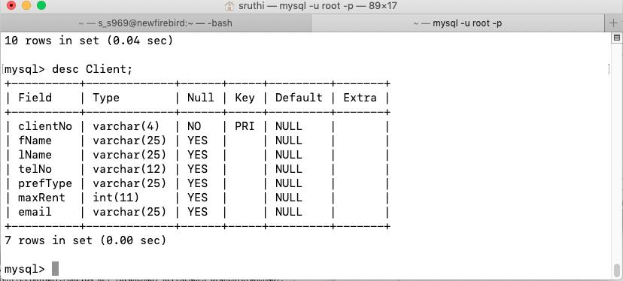

**PrivateOwner Table**

create table PrivateOwner (ownerNo varchar(4) PRIMARY KEY, fName varchar(25),IName varchar(25), address varchar(50),telNo varchar(12),eMail varchar(25),password varchar(25));

insert into PrivateOwner values('CO46','Joe','Keogh','2 Fergus Dr,Aberdeen AB2 7SX',01224-861212,'jkeogh@lhh.com','********');

insert into PrivateOwner values('CO87','Carol','Ferrel','6 Achray St,Glasgow G32 9DX',0141-357-7419,'cfarrel@gmail.com','********');

insert into PrivateOwner values('CO40','Tina','Murphy','63 Well St,Glasgow G42',0141-943-1728,'tinam@hotmail.com','********');

insert into PrivateOwner values('CO93','Tony','Shaw','12 ParkPl,Glasgow G4 0QR',0141-225-7025,'tony.shaw@ark.com','********');

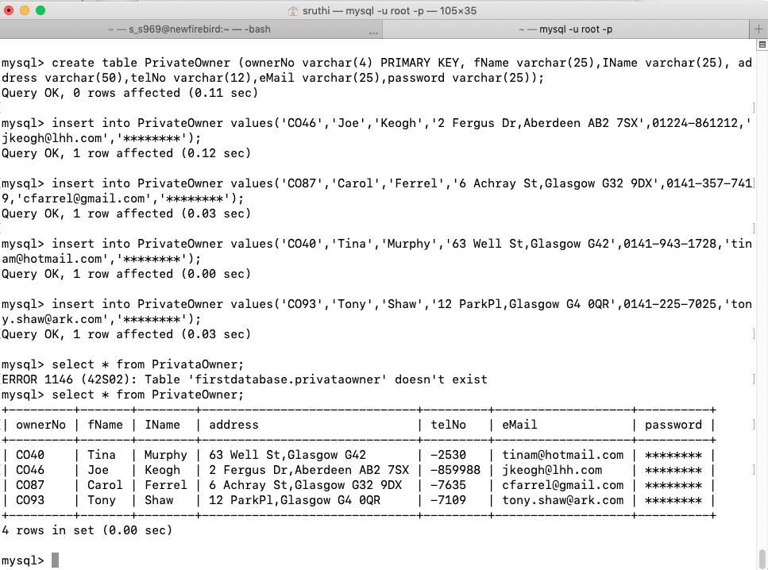

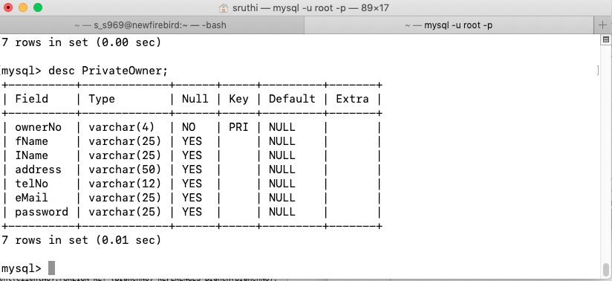

**Viewing Table**

create table Viewing (clientNo varchar(4),propertyNo varchar(4), viewDate Date,comment varchar(25),FOREIGN KEY (clientNo) REFERENCES Client(clientNo),FOREIGN KEY (propertyNo) REFERENCES PropertyForRent(propertyNo));

insert into Viewing values('CR56','PA14','2013-05-24','too small');

insert into Viewing values('CR76','PG4','2013-04-20','too remote');

insert into Viewing values('CR56','PG4','2013-05-26','');

insert into Viewing values('CR62','PA14','2013-05-14','no dining room');

insert into Viewing values('CR56','PG36','2013-04-28','');

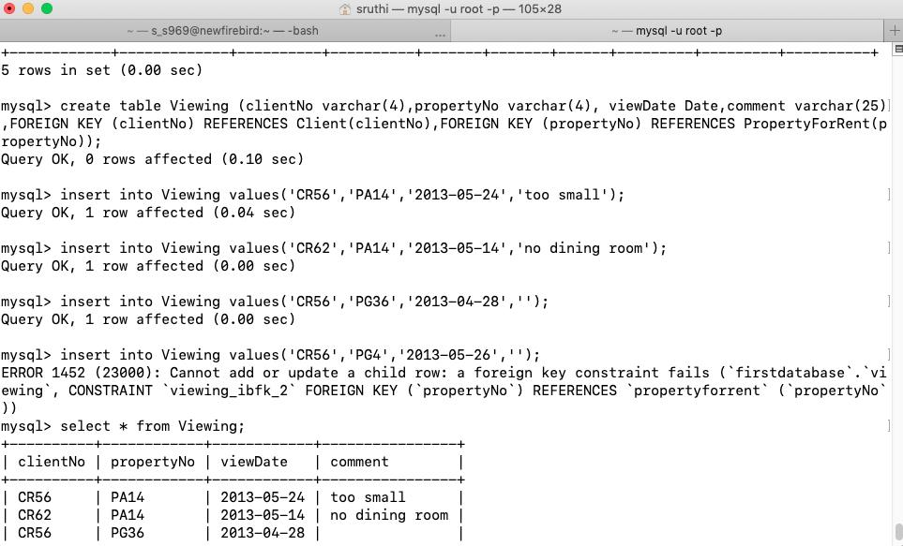

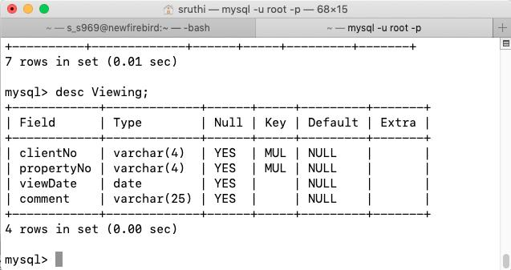

**Registration Table**

create table Registration(clientNo varchar(4),branchNo varchar(4),staffNo varchar(4),dateJoined Date,FOREIGN KEY (clientNo) REFERENCES Client(clientNo),FOREIGN KEY (branchNo) REFERENCES Branch(branchNo),FOREIGN KEY (staffNo) REFERENCES Staff(staffNo));

insert into Registration values('CR76','B005','SL41','2013-01-02');

insert into Registration values('CR56','B003','SG37','2012-04-11');

insert into Registration values('CR74','B003','SG37','2011-11-16');

insert into Registration values('CR62','B007','SA9','2012-04-07');

