**Test Cases:**

**Registration**

|  |  |  |  |
| --- | --- | --- | --- |
| **ID** | **TEST CASE** | **USER INPUT** | **PASS CRITERIA** |
| 1 | User Registration | User selects already existing username | Display message to choose different user |
| 2 | User Registration | User enters different password in password confirm fields | Display message thatPassword and Confirm Password do not match |
| 3 | User Registration | User forgets to enter a particular required field | Display message Please fill out this field |
| 4 | User Registration | User enters all the details successfully | You have registered successfully |

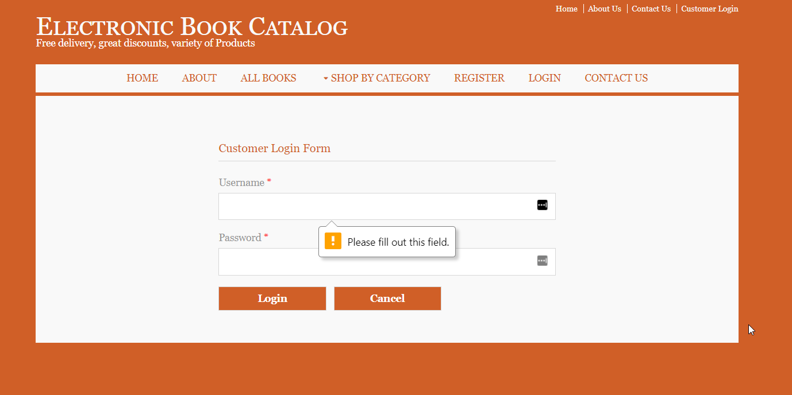

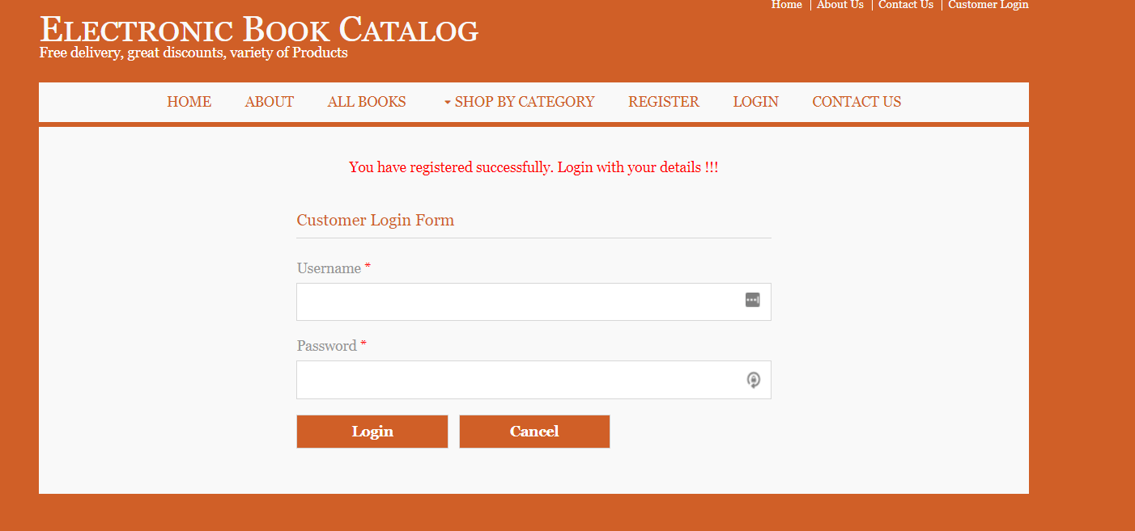

**Login**

|  |  |  |  |
| --- | --- | --- | --- |
| **ID** | **TEST CASE** | **USER INPUT** | **PASS CRITERIA** |
| 1 | User Login | User enters a wrong username | Display message Invalid User/Password. Please try again |
| 2 | User Login | User enters a wrong password | Display message Invalid User/Password. Please try again |
| 3 | User Login | User enters correct username and password | User logs in successfully |

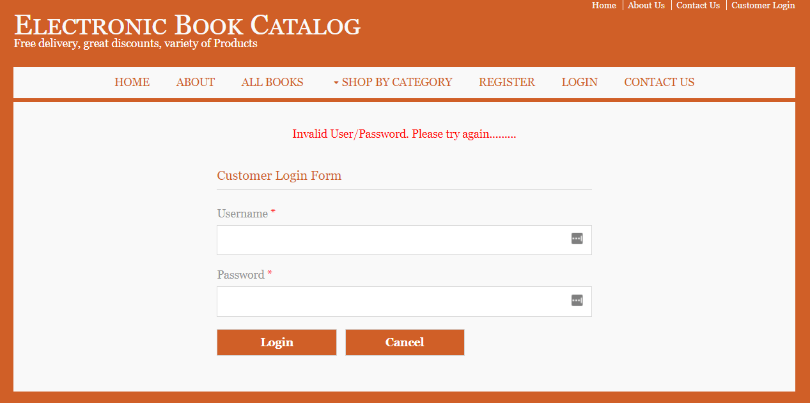

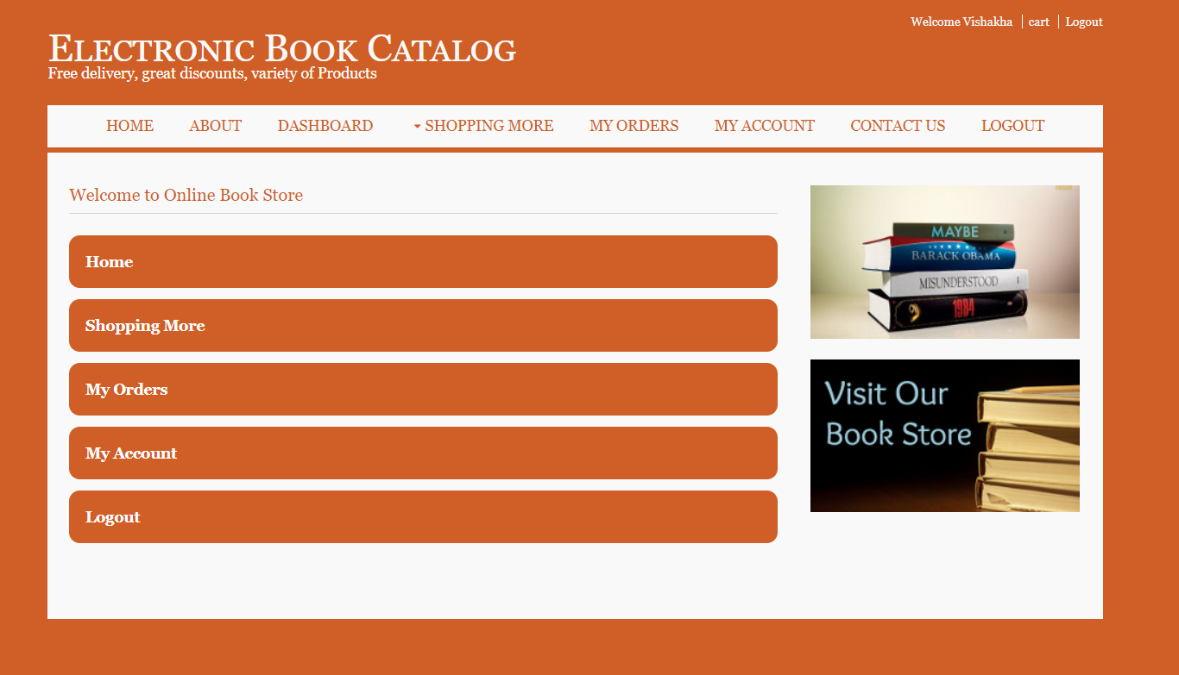

**Add to Cart**

|  |  |  |  |
| --- | --- | --- | --- |
| **ID** | **TEST CASE** | **USER INPUT** | **PASS CRITERIA** |
| 1 | Add to Cart | User selects a book and add to cart button | Book is added to the shopping cart |
| 2 | Add to Cart | Guest selects a book and clicks a add to cart button | User should create an account |

**Edit Cart**

|  |  |  |  |
| --- | --- | --- | --- |
| **ID** | **TEST CASE** | **USER INPUT** | **PASS CRITERIA** |
| 1 | Edit Cart | User changes the quantity of the book | Quantity and the total cost should be updated |
| 2 | Edit Cart | User deletes a book from shopping cart | Books and total cost of cart should be updated |
| 3 | Edit Cart | User selects a new book to shopping cart | Books and total cost of cart should be updated |

**Searching the Book**

|  |  |  |  |
| --- | --- | --- | --- |
| **ID** | **TEST CASE** | **USER INPUT** | **PASS CRITERIA** |
| 1 | Search Book | User searches the book by name | Display the books by that name |
| 2 | Search Book | User searches the book by Author | Display the books by author name |
| 3 | Search Book | User searches the book by ISBN number | Display the books by ISBN number |

**Make Payment**

|  |  |  |  |
| --- | --- | --- | --- |
| **ID** | **TEST CASE** | **USER INPUT** | **PASS CRITERIA** |
| 1 | Make Payment | User can make payment by giving all his credit card details | Display the order confirmation receipt |
| 2 | Make Payment | User forgets to enter a particular required field | Display message Please fill out all the required fields |

**Manage Orders**

|  |  |  |  |
| --- | --- | --- | --- |
| **ID** | **TEST CASE** | **USER INPUT** | **PASS CRITERIA** |
| 1 | Delete an order | User can delete a particular order | Display message Oder has been deleted |
| 2 | Check an order | User verifies its order by viewing the order report | Order report displayed |

