**Junit Test Case for Customer**

**import** **static** org.junit.Assert.*;

**import** org.junit.Assume;

**import** org.junit.Ignore;

**import** org.junit.Test;

**public** **class** CustomerTest {

@Test

**public** **void** testGetCustomerDetails() {

System.*out*.println("Get Customers details");

}

@Test

**public** **void** testLoginDetails() {

System.*out*.println("Get Login details");

}

//@Ignore

@Test

**public** **void** testCheckUserNameExits() {

Assume.*assumeTrue*(**false**);

System.*out*.println("Username");

}

}

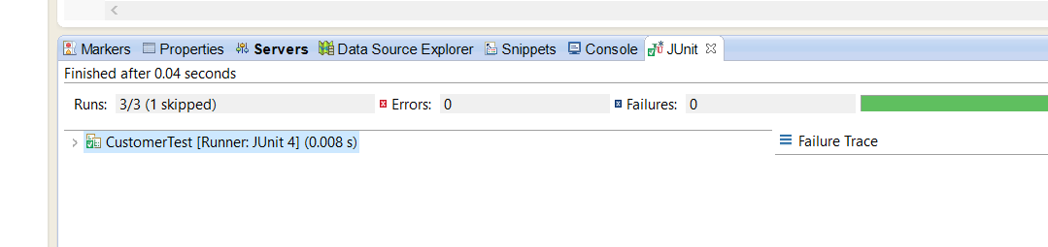

**Junit Test Case for Login**

**package** Model;

**import** **static** org.junit.Assert.*;

**import** java.util.Arrays;

**import** java.util.Collection;

**import** org.junit.Test;

**import** org.junit.runner.RunWith;

**import** org.junit.runners.Parameterized;

**import** org.junit.runners.Parameterized.Parameters;

@RunWith(Parameterized.**class**)

**public** **class** LoginTest {

**private** **static** **final** String[][] *Object* = **null**;

String username;

String password;

//Build constructor

**public** LoginTest(String username, String password)

{

**this**.username = username;

**this**.password = password;

}

@Test

**public** **void** test() {

System.*out*.println(username+"------"+password);

}

@Parameters

**public** **static** Collection<Object[]> getData()

{

Object[][] data = **new** Object[3][2];

//1st row

data[0][0]= "01";

data[0][1]= "11";

//2nd row

data[1][0]= "02";

data[1][1]= "12";

//3rd row

data[2][0]= "03";

data[2][1]= "13";

**return** Arrays.*asList*(data);

}

}

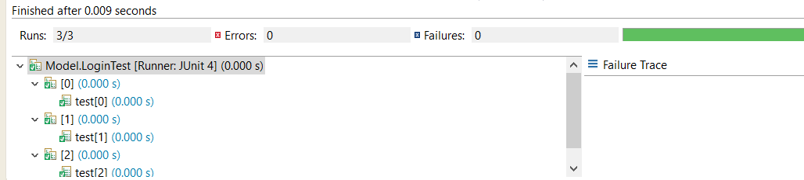

**Junit Test Case for Order**

**package** Model;

**import** **static** org.junit.Assert.*;

**import** org.junit.Test;

**public** **class** OrderTest {

**private** Order cart;

**private** Order item1;

**private** Order item2;

**private** Order item3;

@Test

**public** **void** test() {

cart = **new** Order();

item1 = **new** Order();

item2 = **new** Order();

item3 = **new** Order();

}

**public** **void** testAddItem()

{

cart.getOrderDetails(2000);

item1.getAllOrder(0);

item1.getOrderDetails(2400);

item3.getAllOrderItems("abc");

}

}

