

**FACULTY OF COMPUTER SCIENCE AND INFORMATION TECHNOLOGY**

BACHELOR OF INFORMATION TECHNOLOGY WITH HONORS (BIT)

**SESSION 2 2024/2025**

**BIT21503 |** WEB DEVELOPMENT

**SECTION 2**

**LAB ASSIGNMENT 1**

**STUDENT’S NAME AND MATRIX NUMBER:**

NURIZZATI SYAMIMI BINTI ZAIHAN - CI230054

**LECTURER’S NAME:**

DR. NUR ARIFFIN BIN MOHD ZIN

1. 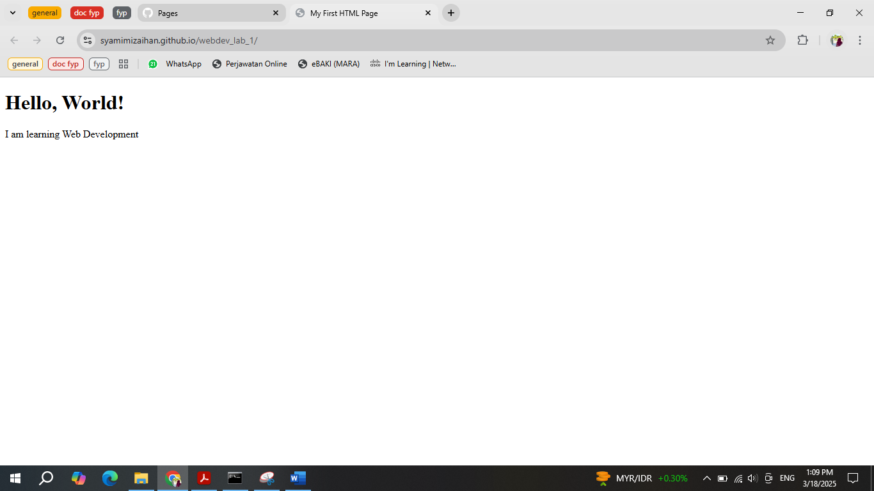The screenshot of your website
2. The screenshot of your GitHub repository

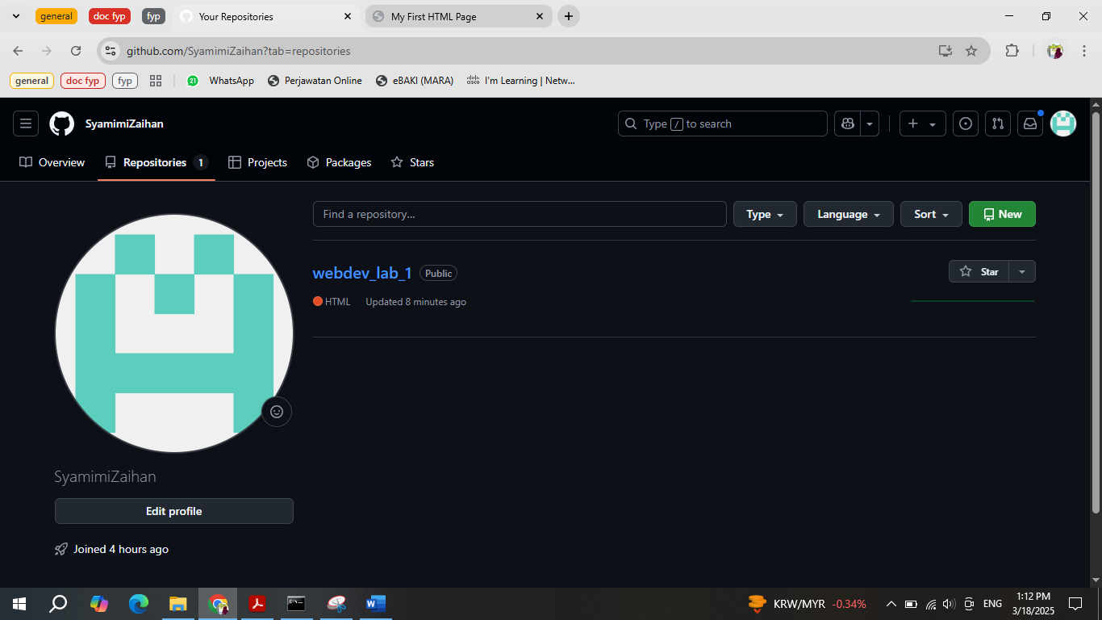

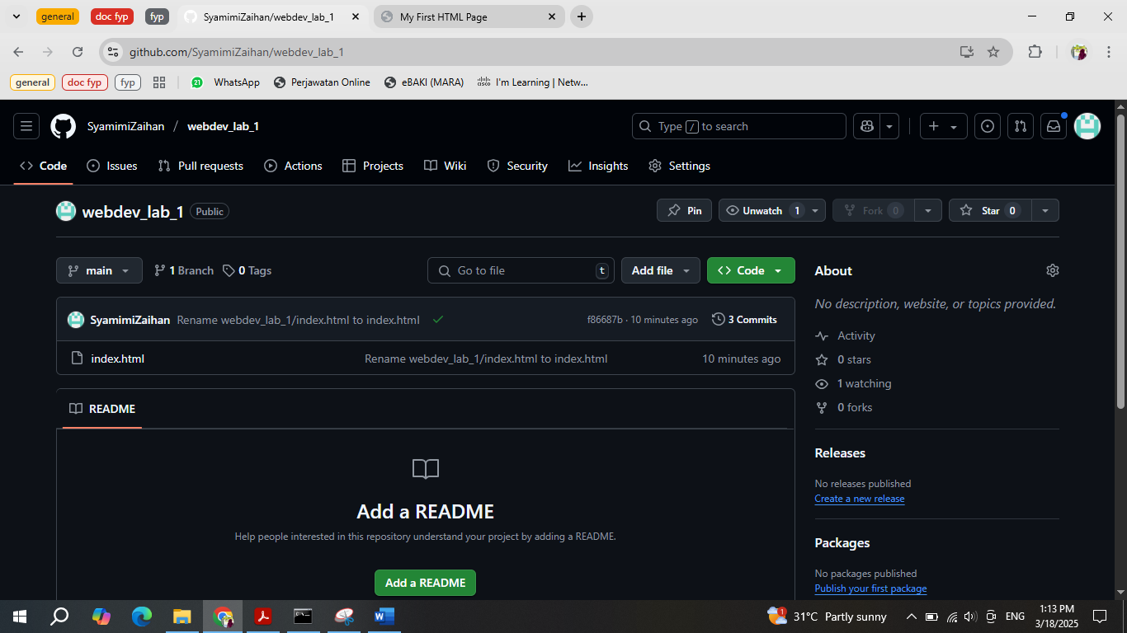

1. The link generated in Step 12.1

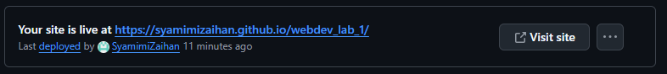The link : <https://syamimizaihan.github.io/webdev_lab_1/>