FOOD DEMAND FORECASTING
& SURPLUS ESTIMATION
A Machine Learning Based Decision-Support System for Food Preparation Planning
PROJECT DOCUMENTATION
Presented by Appikatla Syam Kumar
B.Tech – CSE (AI & ML)
NRI Institute of Technology, Vijayawada
Internship Organization: SENSORSPINE Private Limited
2026

DECLARATION
I hereby declare that this project documentation titled “Food Demand Forecasting & Surplus Estimation” is a record of the work carried out by me during my internship at SENSORSPINE Private Limited. The project focuses on developing a machine learning based decision-support system for forecasting food demand and estimating potential surplus or shortage based on planned preparation quantity.

CERTIFICATE
This is to certify that Appikatla Syam Kumar, a student of B.Tech – CSE (AI & ML), NRI Institute of Technology, Vijayawada, has completed the project titled “Food Demand Forecasting & Surplus Estimation” as part of the internship at SENSORSPINE Private Limited.
Project Guide / Mentor: ____________________

TABLE OF CONTENTS
1. Project Overview 5
2. Problem Statement 5
3. Project Objectives 5
4. Technologies and System Requirements 6
4.1 Technologies Used 6
4.2 System Requirements 6
5. Dataset and Data Understanding 6
5.1 Data Quality 7
6. Data Preprocessing and Feature Engineering 8
6.1 Time-Based Feature Engineering 8
6.2 Training and Testing Split 9
7. Exploratory Data Analysis 9
7.1 Price and Demand Relationship 9
7.2 Promotional Indicators 9
8. Machine Learning Approach 10
8.1 Gradient Boosting Model 10
9. Model Evaluation and Results 10
10. Final Model and Model Saving 11
11. Potential Surplus / Shortage Estimation 11
12. Recommended Preparation Quantity 11
13. Streamlit Application 12
14. System Architecture and Workflow 14
15. Testing and Validation 14
16. CI/CD and Deployment 15
17. Project Structure 16
18. Limitations 16
19. Future Improvements 17
20. Conclusion 17
21. References 18

1. PROJECT OVERVIEW
The Food Demand Forecasting & Surplus Estimation project is a machine learning based decision-support system designed to help food-serving organizations plan preparation quantities more effectively. The system uses historical food order data along with factors such as week, center, meal, prices, and promotional indicators to predict expected demand. The predicted demand is then compared with the planned preparation quantity to estimate potential surplus or potential shortage. The system also provides a recommended preparation quantity using an adjustable safety buffer and presents the results through an interactive Streamlit dashboard.

2. PROBLEM STATEMENT
Food demand can vary significantly across different days, meals, and service centers. Preparing too much food can result in potential surplus, while preparing too little can lead to potential shortage. Manual estimation based only on past experience may not consistently account for factors such as meal type, center, pricing, promotional activities, and changing demand patterns. Therefore, there is a need for a data-driven system that can forecast expected food demand and support better preparation planning.

3. PROJECT OBJECTIVES
- To analyze historical food demand data and identify important demand patterns.
- To develop a machine learning model for forecasting expected food demand.
- To compare predicted demand with planned preparation quantity.
- To estimate potential surplus or potential shortage for better preparation planning.
- To provide a recommended preparation quantity using a configurable safety buffer.
- To build an interactive Streamlit dashboard for practical decision support.

4. TECHNOLOGIES AND SYSTEM REQUIREMENTS

4.1 Technologies Used
Technology | Purpose
Python | Data processing and machine learning
Pandas | Dataset loading, cleaning and analysis
NumPy | Numerical operations and feature engineering
Scikit-learn | Preprocessing, model training and evaluation
Matplotlib | Data visualization
Plotly | Interactive visualizations
Streamlit | Interactive web application
Joblib | Saving and loading trained models
Git & GitHub | Version control and source-code management
GitHub Actions | Automated CI/CD workflow
Streamlit Cloud | Application deployment

4.2 System Requirements
The project can be developed and executed on a standard computer system with Python installed. A modern web browser is required to access the Streamlit application. Internet connectivity is required for GitHub-based version control and cloud deployment.

5. DATASET AND DATA UNDERSTANDING
The project uses a food demand dataset containing historical order information. The dataset contains 1,999 records and 9 original columns.
The main columns are:
Column | Description
id | Unique record identifier
week | Week number of the observation
center_id | Identifier of the food service center
meal_id | Identifier of the meal
checkout_price | Price at which the meal was ordered
base_price | Base price of the meal
emailer_for_promotion | Indicates email promotion
homepage_featured | Indicates homepage promotion
num_orders | Number of orders and prediction target

The target variable of the project is num_orders.

5.1 Data Quality
The dataset was examined for missing values, duplicate records and invalid target values. No missing values or duplicate records were identified, and the target variable did not contain zero or negative values.
The dataset contains 77 centers, 51 meal types and 145 weeks of historical observations.
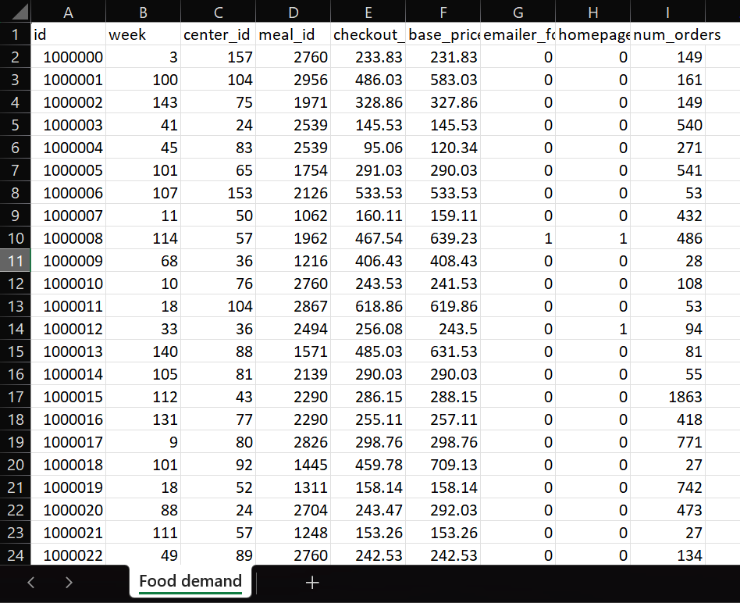
Figure 1: Dataset Sample

6. DATA PREPROCESSING AND FEATURE ENGINEERING
Data preprocessing was performed before training the machine learning models.
The id column was removed because it is only an identifier and does not provide useful predictive information.
The categorical variables center_id and meal_id were converted into numerical representations using One-Hot Encoding. The encoding was configured with handle_unknown="ignore" so that previously unseen categories can be handled safely during prediction.
Numerical variables such as week, prices and promotional indicators were passed directly to the model.

6.1 Time-Based Feature Engineering
To represent the cyclical nature of weekly demand, two additional features were created:
- week_sin
- week_cos
These features represent the week in a cyclical form and help the model capture repeating time-related patterns.

6.2 Training and Testing Split
A time-based split was used instead of a random split to better represent real-world forecasting.
- Training data: Weeks 1–116
- Training records: 1,572
- Testing data: Weeks 117–145
- Testing records: 427
This approach allows the model to learn from earlier observations and evaluate performance on later observations.

7. EXPLORATORY DATA ANALYSIS
Exploratory Data Analysis was performed to understand the distribution of demand and the relationships between important variables.
The average number of orders was approximately 258 meals, while the median was approximately 148 meals. The maximum observed demand was 12,137 orders, showing that demand is strongly right-skewed.
The average checkout price was approximately 327.30, while the average base price was approximately 347.97.

7.1 Price and Demand Relationship
The correlation between checkout price and number of orders was approximately -0.232, indicating a negative association between these variables in the dataset.
The correlation between base price and number of orders was approximately -0.170.
These values indicate association within the observed data and should not be interpreted as proof of causation.

7.2 Promotional Indicators
The dataset also contains two promotional indicators: email promotion and homepage featuring.
The average demand was higher in records where promotional indicators were present. For example, records with email promotion had an average demand of approximately 641 orders, compared with approximately 227 orders without email promotion.
Similarly, homepage-featured records had an average demand of approximately 583 orders, compared with approximately 220 orders for records without homepage featuring.
These results represent observed associations in the dataset.

8. MACHINE LEARNING APPROACH
The project evaluated multiple regression algorithms for food demand forecasting.
The following models were tested:
- Random Forest Regressor
- Extra Trees Regressor
- Gradient Boosting Regressor
The models were trained using the preprocessed dataset and evaluated on the time-based test set.

8.1 Gradient Boosting Model
The final model uses Gradient Boosting Regression with the following configuration:
- Number of estimators: 300
- Learning rate: 0.05
- Maximum depth: 5
- Random state: 42
Gradient Boosting was selected for the final system because it produced the highest R² and the lowest RMSE among the tested models.

9. MODEL EVALUATION AND RESULTS
Three evaluation metrics were used:
- Mean Absolute Error (MAE)
- Root Mean Squared Error (RMSE)
- R² Score
Model | MAE | RMSE | R²
Random Forest | 129.57 | 216.50 | 0.4974
Extra Trees | 113.72 | 202.30 | 0.5612
Gradient Boosting | 113.96 | 191.36 | 0.6074

The Gradient Boosting model achieved an R² score of 0.6074 and an RMSE of 191.36 on the test set.
Although Extra Trees achieved a slightly lower MAE, Gradient Boosting achieved the strongest overall combination of RMSE and R² among the tested models and was therefore used in the application.

10. FINAL MODEL AND MODEL SAVING
After model evaluation, the selected Gradient Boosting model was saved using Joblib.
Two model-related files were generated:
- food_demand_model.pkl
- preprocessor.pkl
The preprocessor is responsible for transforming input features in the same way as during model training. The trained model then receives the transformed features and produces the predicted demand.
Saving these components allows the Streamlit application to load the trained system without retraining the model every time the application starts.

11. POTENTIAL SURPLUS / SHORTAGE ESTIMATION
The project compares predicted demand with the planned preparation quantity.
The calculation is:
Potential Surplus / Shortage = Planned Quantity − Predicted Demand
If the result is positive, the system identifies a potential surplus.
If the result is negative, the system identifies a potential shortage.
If the result is close to zero, the planned quantity is close to the predicted demand.
It is important to note that this value represents an estimated planning gap between planned quantity and predicted demand. It does not represent measured or confirmed food waste.

12. RECOMMENDED PREPARATION QUANTITY
The application allows the user to provide a safety buffer.
The recommended preparation quantity is calculated as:
Recommended Quantity = Predicted Demand × (1 + Safety Buffer / 100)
For example, if the predicted demand is 500 meals and the safety buffer is 5%, the recommended quantity becomes approximately 525 meals.
The result is rounded up to a whole number because food preparation quantities are represented as complete meals.
This feature allows users to adjust preparation planning according to their operational requirements.

13. STREAMLIT APPLICATION
The trained model was integrated into an interactive Streamlit application.
The application allows users to provide:
- Center
- Meal
- Week
- Checkout price
- Base price
- Email promotion
- Homepage featuring
- Planned preparation quantity
- Safety buffer
After entering these values, the application generates the predicted demand.
The dashboard displays:
- Predicted demand
- Planned quantity
- Potential surplus or shortage
- Recommended preparation quantity
- Demand level
- Historical demand trend
- Model performance information
The application is designed to provide an easy-to-understand interface so that users do not need to directly interact with Python code or the machine learning model.
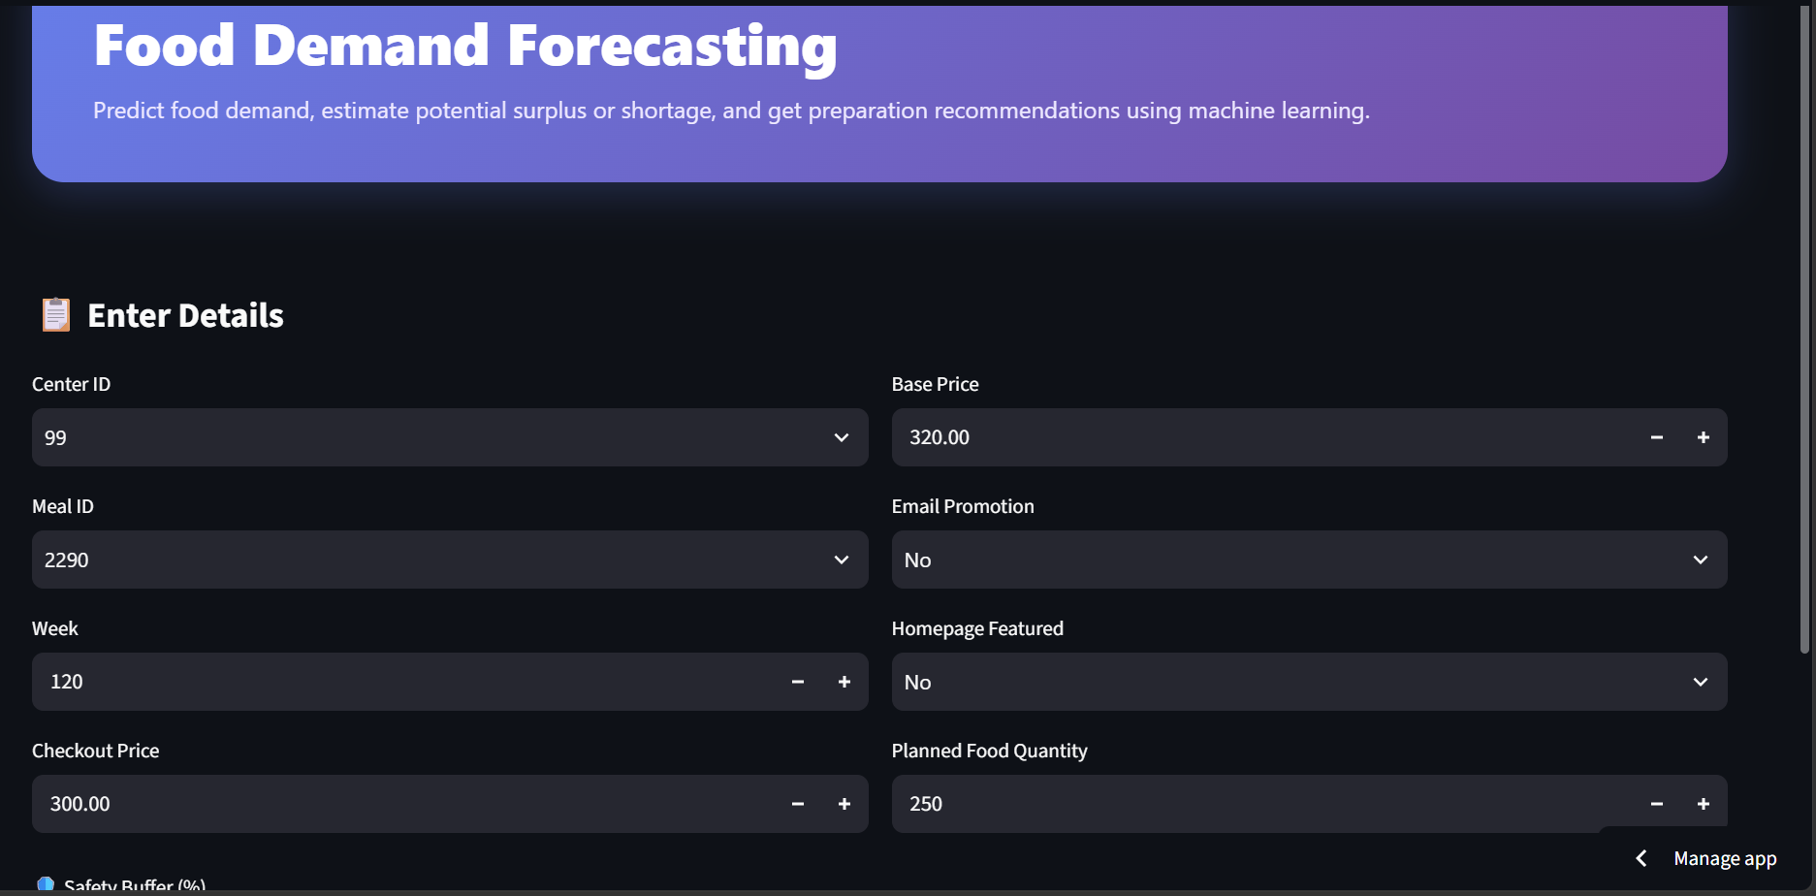
Figure 2: Streamlit Application – Input Form
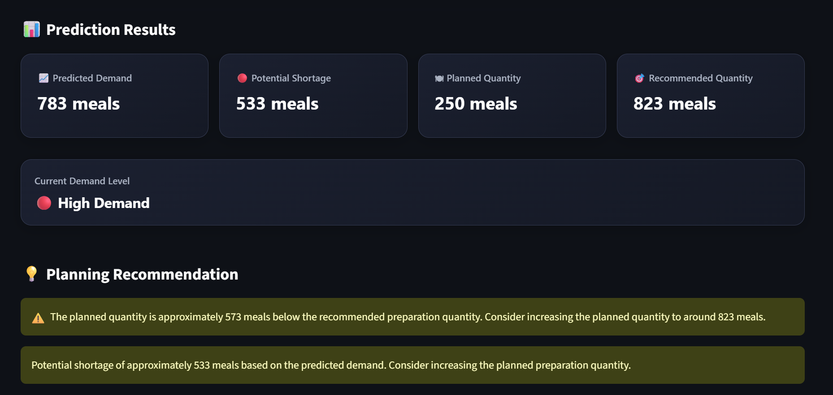
Figure 3: Streamlit Application – Prediction Results
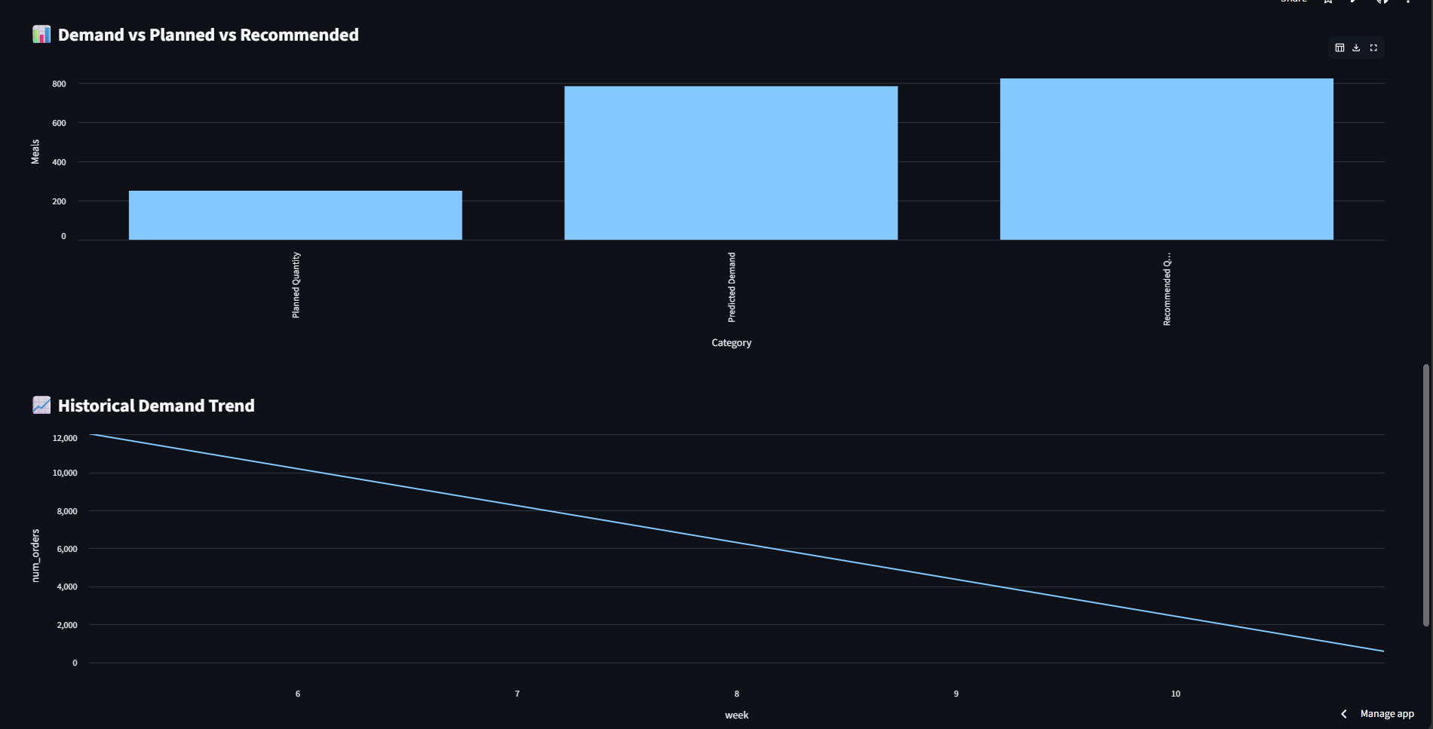
Figure 4: Streamlit Application – Demand Visualization

14. SYSTEM ARCHITECTURE AND WORKFLOW
The overall system follows the workflow below:
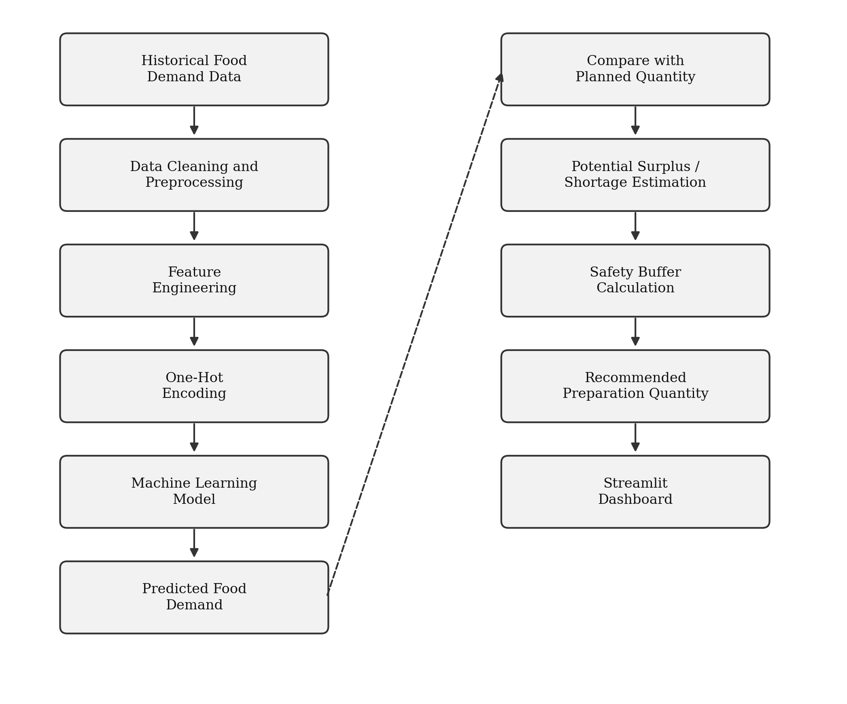
Figure 5: System Architecture and Workflow
The architecture separates data preparation, model prediction and user interaction into different stages.

15. TESTING AND VALIDATION
Testing was performed to verify important application calculations.
Automated tests were created for:
- Recommended quantity calculation
- Potential surplus calculation
- Potential shortage calculation
- Low demand classification
- Medium demand classification
- High demand classification
A total of 6 automated tests were implemented.
All six tests passed successfully during local testing.
The application code was also checked for Python syntax errors as part of the continuous integration workflow.

16. CI/CD AND DEPLOYMENT
Git and GitHub were used for version control.
GitHub Actions was configured to automatically execute the project validation workflow when changes are pushed to the repository or submitted through a pull request.
The CI workflow performs:
- Repository checkout
- Python environment setup
- Dependency installation
- Python syntax validation
- Automated test execution
The application was deployed using Streamlit Cloud and connected to the GitHub repository.
Live application: https://food-demand-forecasting-1.streamlit.app/
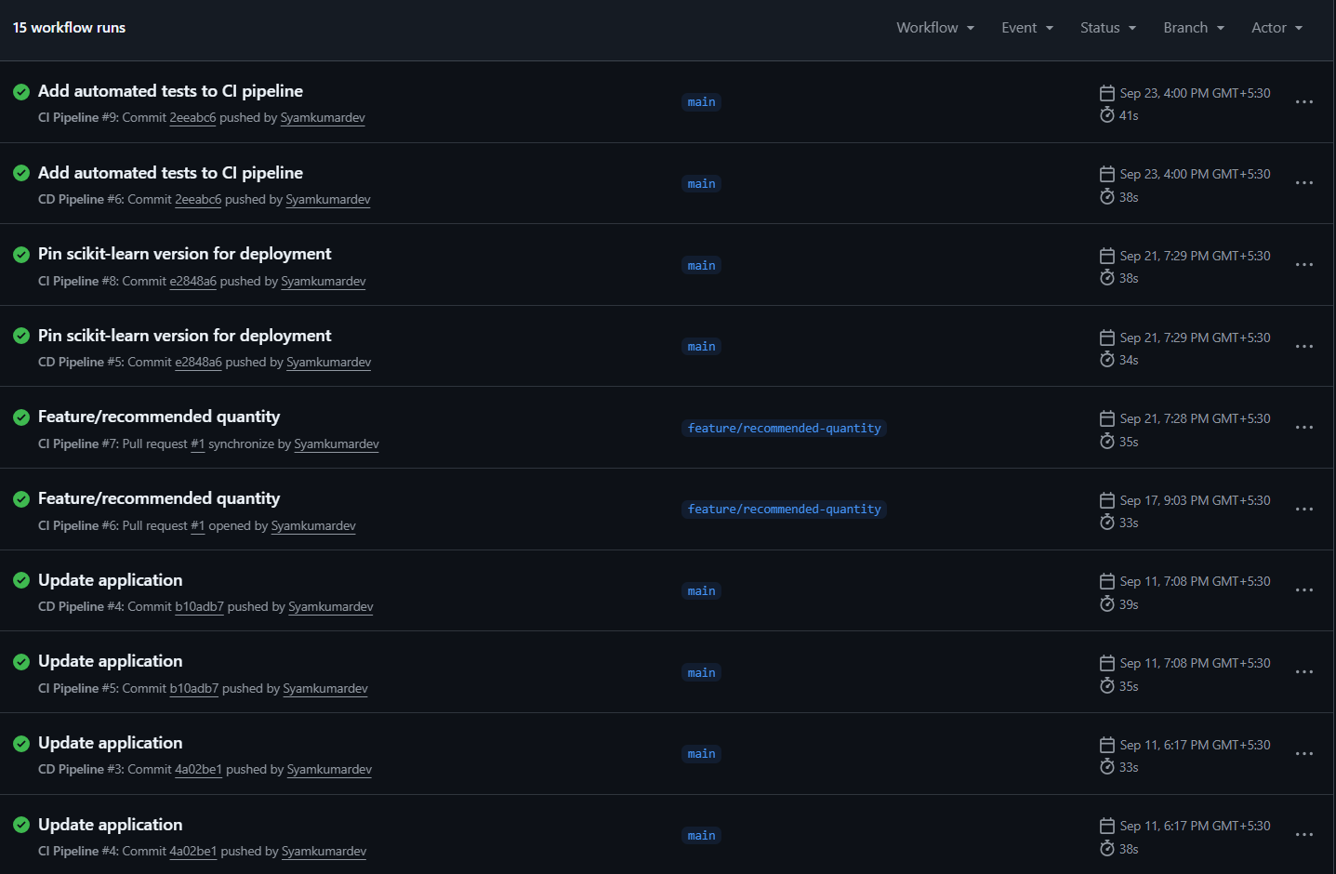
Figure 6: GitHub Actions CI/CD Workflow

17. PROJECT STRUCTURE
The project follows a modular structure:
Food_Demand_Forecasting/
│
├── data/
│ └── Food demand.csv
│
├── notebooks/
│ └── 01_eda.ipynb
│
├── models/
│ ├── food_demand_model.pkl
│ └── preprocessor.pkl
│
├── app/
│ └── app.py
│
├── tests/
│ └── test_app.py
│
├── .github/
│ └── workflows/
│ ├── ci.yml
│ └── cd.yml
│
├── requirements.txt
└── README.md

This structure separates the dataset, experimentation, trained models, application code, tests and deployment configuration.

18. LIMITATIONS
The current system has several limitations.
- The model is trained using the available historical dataset and may not generalize equally to completely different food-service environments.
- The dataset does not directly provide all possible real-world factors that can influence demand, such as weather, holidays, special events or sudden operational changes.
- The potential surplus or shortage value is a planning estimate and does not represent measured food waste.
- The model performance can change when new data becomes available.
- The current application focuses on demand prediction and preparation planning rather than complete inventory or food-waste management.

19. FUTURE IMPROVEMENTS
The system can be extended in several ways:
- Incorporate weather information.
- Include holidays and special events.
- Add day-of-week and seasonal features.
- Integrate real-time sales or order data.
- Add inventory tracking.
- Add historical prediction monitoring.
- Compare multiple forecasting models automatically.
- Add model retraining when new data becomes available.
- Add role-based dashboards for managers and staff.
- Integrate database storage for prediction history.
- Add advanced explainability features to understand important demand factors.

20. CONCLUSION
The Food Demand Forecasting & Surplus Estimation project demonstrates how machine learning can support data-driven food preparation planning.
Historical food demand data was analyzed and multiple regression models were evaluated.
Among the tested models, Gradient Boosting achieved an R² score of 0.6074 and an RMSE of 191.36 on the time-based test set.
The trained model was integrated into a Streamlit application that allows users to forecast expected demand, compare it with planned preparation quantity, estimate potential surplus or shortage, and calculate a recommended preparation quantity using a safety buffer.
The project provides a practical prototype for supporting food preparation decisions and can be further improved by incorporating additional real-world factors and continuous data updates.

21. REFERENCES
- Scikit-learn Documentation – Machine Learning in Python.
- Pandas Documentation – Python Data Analysis Library.
- NumPy Documentation – Numerical Computing with Python.
- Streamlit Documentation – Python Framework for Data Applications.
- Joblib Documentation – Python Object Persistence.
- GitHub Documentation – Version Control and GitHub Actions.
- Matplotlib Documentation – Data Visualization in Python.
- Plotly Documentation – Interactive Data Visualization.

